NAT_R 8001: Decision Analysis for Research and Management of Natural Resources
Fall 2025 Syllabus
Class Information:
NAT_R 8001, Class number: 65119
1 Credit
1 day/wk (2 hr block) for 8 weeks (August 25 - October 21)
Time and location: Tuesdays 2-4pm, ABNR 210

Instructor
Dr. Brielle Thompson, The School of Natural Resources
303G Anheuser-Busch Natural Resources building
brielle.thompson@missouri.edu
personal website: https://briellekthompson.github.io/personal_site/

Course website: https://briellekthompson.github.io/NATR_8001_DecisionAnalysis_Fall25_Mizzou/

Course Overview
Natural resource management involves making difficult decisions. Familiar natural resource problems may include decisions on how many acres of land must be protected, how an endangered species should be reintroduced, whether an agency should conduct more monitoring of an invasive species. The decision analysis field offers tools like Structured Decision Making (SDM) to help frame, structure, and identify solutions for such problems. Various Federal and State fish and wildlife agencies are increasingly using SDM to ensure a streamlined, fair, unbiased, repeatable, transparent, and organized decision-making process.
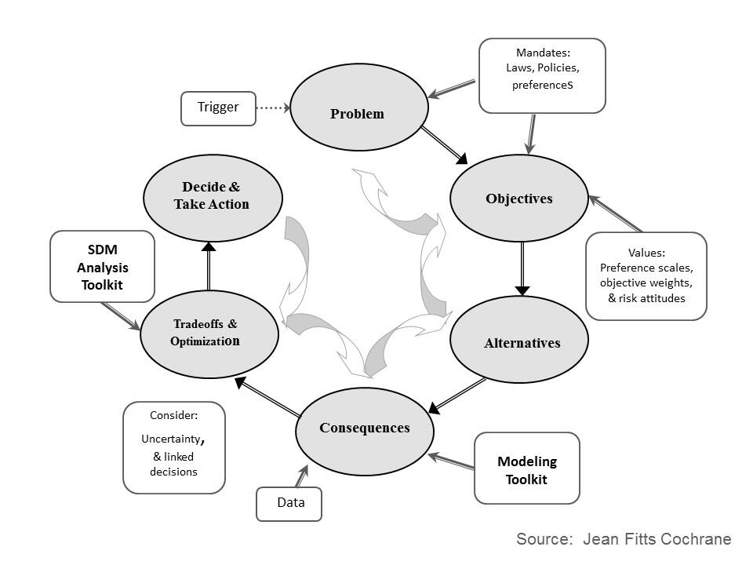
This class will introduce Decision analysis/SDM and its key components (PrOACT): Problem framing- describing the natural resource management problem; articulating Objectives; developing management Alternatives; using forecasting tools to evaluate the Consequences, or outcomes, of alternatives, and using Tradeoff methods to identify management alternatives when decisions involve multiple competing objectives.

Topics to be covered include decision structuring, influence diagramming, decision trees, optimization, multi-criteria decision analysis, value of information, and adaptive management.

Throughout the course the instructor will provide real-world case study examples and discuss how decision analysis may apply to graduate students’ projects.

Learning Objectives:
- Identify the circumstances when Structured Decision Making could be useful
- Comprehend key principles of Structured Decision Making (e.g., PrOACT, adaptive management)
- Understand graphical models of natural resource decisions (e.g., objective hierarchies, influence diagrams, decision trees)
- Identify tools that could be used for decision situations involving multiple objectives, uncertainty, risk, and repeated decisions
- Apply the PrOACT process to graduate research topics with rapid prototyping

Prerequisites:
Graduate standing in natural or cultural resources or related field or instructor consent.

Text: Weekly readings will be emailed to you a week in advance

Format:
The course will meet for a 2-hour block each week. The class will be a mix of lectures covering fundamental concepts and techniques, and student-led discussions. The majority of each class time will be lecture based with small activities worked into the lecture. The final 15-30 minutes for each class time will be a “skill check” where students, in groups, will answer questions regarding the material learned in the first portion of the class. The final week will involve informal student presentations.

Schedule (subject to change)
Week | Topic | PrOACT Step | Readings
1 – 8/26 | Motivation for Structured Decision Making  - Quick PrOACT Story | N/A | Gregory et al. 2012 Chapter 1
2 –  9/2 | Problem framing for natural resource decisions  Tools discussed: Problem framing | Problem framing | Runge et al. 2020 Chapter 2 (Smith)
3 –  9/9 | Identifying and quantifying objectives for management decisions  Tools discussed: Objectives hierarchy | Objectives | Gregory et al. 2012 Chapter 4
4 –  9/16 | Developing management alternatives and using models to identify the consequences of alternatives  Tools discussed: Influence diagram, portfolios and strategy tables | Alternatives, Consequences | Gregory et al. 2012 Chapter 7
5 –  9/23 | Making tradeoffs amongst objectives  Tools discussed: Multi-Criteria Decision Analysis, swing weighting | Tradeoffs | Runge et al. 2020 Chapter 5 (Converse)
6 –  9/23 | Decisions under uncertainty part 1  - Tools discussed: Decision trees, value of information | Advanced topic | Gregory et al. 2012 Chapter 10
7 –  10/14  (10/7 canceled) | Decisions under uncertainty part 2 and risk  - Tools discussed: Adaptive management, risk profiles  *Some final presentations will occur today | Advanced topic | Gregory et al. 2012 Chapter 10 &  Runge et al. 2020 Chapter 13 (Runge)
8 –  10/21 | Rapid prototyping student presentation (Final Assignment) | All steps | None
*Note, Brielle will be attending TWS Annual Conference October 6-9 and the final week of class is pushed to October 21st

Grading (100 total points)

Final course letter grades will be based on the total accumulation of points earned in the three categories outlined below (total = 100 points). The grading scale for this course is:
A (4.0) = 90-100, B (3.0) = 80-89, C (2.0) = 70-79, D (1.0) = 60-69, F (0) = < 60.

Categories:
- Participation: 40 points (5 points/ each 8 week)
- Skills check: 28 points (4 points/ 7 week)
- Rapid prototyping: 32 points

- Participation: 40 points (5 points per week). Please see the information below about the absence policy for this course.

Participation grading per week (5 points)
Point | Description
5 | Attended class or emailed me that you are missing class
3 | Did not attend class, emailed me that you are missing class, but you have already missed 4 classes
0 | Absent and did not notify instructor

- Skills check: 28 points (4 points per weeks 1-7)

Skills check grading per week (4 points)
Point | Description
4 | Completed the skills check exercise for this week, either during class or by submitting responses via email
2 | Answered/submitted a skills check exercise from a different week
0 | Did not complete skills check exercise

- Rapid prototyping: 32 points

During the final week of class, each student will be expected to informally discuss (~5 minutes) how components of decision analysis/ Structured Decision Making could be applied to their current graduate research project. The rapid prototyping grading rubric is found at the end of the syllabus. You will be expected to email me your PowerPoint presentation.
Absences policy
This course is heavily discussion-based. Regular attendance is crucial, and it is expected that you will attend the final week of class. If you are unable to attend class due to illness, conferences, or other valid reasons, you will be expected to turn in a word document by Monday the following week with your answers to the skills check exercise (see lecture PowerPoints and slides labeled -skills check, and the skills check documents on the course website). Completing this assignment will fulfill participation and skill check requirements that week (aka full points). If you made arrangements with me to zoom into class you must stay engaged during class and be active in the zoom chat. If you miss > 4 class periods, you will start to earn less participation points (see grading section above).

Office hours
I will hold weekly office hours 1x per week for an hour in my office, ABNR 303G (Wednesdays 9:30-10:30am). I can be available for other in person or zoom meetings upon request (please give 24 hours in advance notice). In general, I will respond to any questions via email within 24 hours.

Use of Generative AI:
In this course, the use of GenAI software is permitted solely to ask questions of material described in class. GenAI software can be used to help you organize your final presentation but cannot be used to generate slides. GenAI cannot be used during classroom exercises including activities and skill checks. As a reminder, AI-generated content can be inaccurate,​ offensive, or biased.

Important Course Registration Dates:
- Last Day to change grading option: September 1
- Last Day to drop a course without a grade: September 11
- Last Day to withdraw: October 14

Other MU Policies and Services

Intellectual Pluralism: The University community welcomes intellectual diversity and respects student rights. Students who have questions or concerns regarding the atmosphere in this class (including respect for diverse opinions) may contact the departmental chair or divisional director; the director of the Office of Academic Integrity; the MU Equity Office, or equity@missouri.edu. All students will have the opportunity to submit an anonymous evaluation of the instructor(s) at the end of the course.

Title IX: University of Missouri policies prohibit discrimination on the basis of race, color, national origin, ancestry, religion, sex, gender, gender identity, gender expression, sexual orientation, pregnancy, age, genetic information, disability and protected veteran status. Discrimination includes any form of unequal treatment such as denial of opportunities, harassment, and violence. Sex-based violence includes rape, sexual assault, unwanted touching, stalking, dating/interpersonal violence, and sexual exploitation.
If you experience discrimination, you are encouraged (but not required) to report the incident to the MU Office for Civil Rights & Title IX. Learn more about your rights and options at civilrights.missouri.edu or call 573-882-3880. You also may make an anonymous report online.

Students may also contact the Relationship & Sexual Violence Prevention (RSVP) Center, a confidential resource, for advocacy and other support related to rape or power-based personal violence at rsvp@missouri.edu or 573-882-6638, or go to rsvp.missouri.edu. Both the Office for Civil Rights & Title IX and the RSVP Center can provide assistance to students who need help with academics, housing, or other issues.

No Recording Allowed: University of Missouri System Executive Order No. 38 lays out principles regarding the sanctity of classroom discussions at the university. The policy is described fully in section 200.015 of the Collected Rules and Regulations. In this class, students may not make audio or video recordings of course activity, except students permitted to record as an accommodation under section 240.040 of the Collected Rules. All other students who record and/or distribute audio or video recordings of class activity are subject to discipline in accordance with provisions of section 200.020 of the Collected Rules and Regulations of the University of Missouri pertaining to student conduct matters.
Those students who are permitted to record are not permitted to redistribute audio or video recordings of statements or comments from the course to individuals who are not students in the course without the express permission of the faculty member and of any students who are recorded. Students found to have violated this policy are subject to discipline in accordance with provisions of section 200.020 of the Collected Rules and Regulations of the University of Missouri pertaining to student conduct matters.

Academic Dishonesty: The University strives to prepare students for lives of personal and professional integrity. Academic integrity is fundamental to the activities and principles of a university. All members of the academic community must be confident that each person's work has been responsibly and honorably acquired, developed, and presented. Any effort to gain an advantage not given to all students is dishonest whether or not the effort is successful. The academic community regards breaches of the academic integrity rules as extremely serious matters. Sanctions for such a breach may include academic sanctions from the instructor, including failing the course for any violation, to disciplinary sanctions ranging from probation to expulsion. When in doubt about plagiarism, paraphrasing, quoting, collaboration, or any other form of cheating, consult the course instructor.

Students with Disabilities: If you anticipate barriers related to the format or requirements of this course, if you have emergency medical information to share with me, or if you need to make arrangements in case the building must be evacuated, please let me know as soon as possible.
If disability related accommodations are necessary (for example, a note taker, extended time on exams, captioning), please establish an accommodation plan with the MU Disability Center, S5 Memorial Union, 573-882-4696, and then notify me of your eligibility for reasonable accommodations. For other MU resources for persons with disabilities, click on "Disability Resources" on the MU homepage.

Student Support Statement: Students can encounter challenges that may impact their performance in their academic programs. The School of Natural Resources (SNR) is committed to supporting students who encounter these challenges.

Any student who cannot afford groceries or access sufficient food to eat, or who lacks a safe and stable place to live is urged to contact Nicole Logue (loguejn@missouiri.edu), 2500 MU Student Center, or contact staff in the SNR Office of Academic Programs (573-882-7045), 124 ABNR Bldg., for a list of resources and support. In addition, the MU Tiger Pantry (https://tigerpantry.missouri.edu/) is a free resource with a food pantry and personal care items, located at 1400 S Rock Quarry Rd #8.

The University of Missouri also provides health resources and financial counseling to help you during difficult times. These resources include:
- Student Health Center (www.studenthealth.missouri.edu or 573-882-7481)
- Counseling Center (www.counseling.missouri.edu or 573-882-6601)
- Psychological Services Clinic (https://psychology.missouri.edu/psychological-services-clinic; 573-882-4677)
- Student Financial Aid Office (https://financialaid.missouri.edu/ or 573-882-7506)
- Office for Financial Success (https://ofsmizzou.org/ or 573-882-2173)
- Missouri Crisis text line (Text HAND to 839863 or call 1-888-761-4357, available 24/7)

For more general university policies see https://provost.missouri.edu/faculty-affairs/syllabus-information/
NAT_R 8001: Decision Analysis
Rapid Prototyping Evaluation Rubric Name: _______________________
(32% of Final Grade) Points Possible: 32

Grading Criteria | Descriptors | Points
Problem framing (Pr) | Provides a slide(s) on the problem framing step for the natural resource decision. | ___/4
Objectives (O) | Provides a slide(s) on the objectives identified for the natural resource decision | ___/4
Alternatives (A) | Provides a slide(s) on the alternatives developed for the natural resource decision  (includes strategy table or portfolio table) | ___/4
Consequences (C) | Provides a slide(s) that explains how models or experiments will be used to calculate the performance of the alternatives in terms of the objectives. | ___/4
Tradeoffs (T) + advanced tools | Provides a slide(s) that explains how tradeoffs between objectives may be dealt with.  Include one additional decision analysis tool that could be incorporated to help make your decision (e.g., adaptive management, value of information, risk profiles) | ___/4
Presentation timing | Presents within 5 minutes | ___/4
Slide organization | Identifies each step of PrOACT in the presentation and has appropriate visuals included | ___/4
Delivery | Displayed good preparedness for this presentation and spoke clearly and engaged the audience | ___/2
Presentation submission | Emailed the instructor a copy of your final presentation | ___/2
 | Total points | ___/32

Instructor comments:

©Stevens & Levi, 2004 (Adapted from http://tiny.cc/u4FN2 by Schueller & Alkhas, 2010)

