Rapid protype SDM problem

Problem framing:

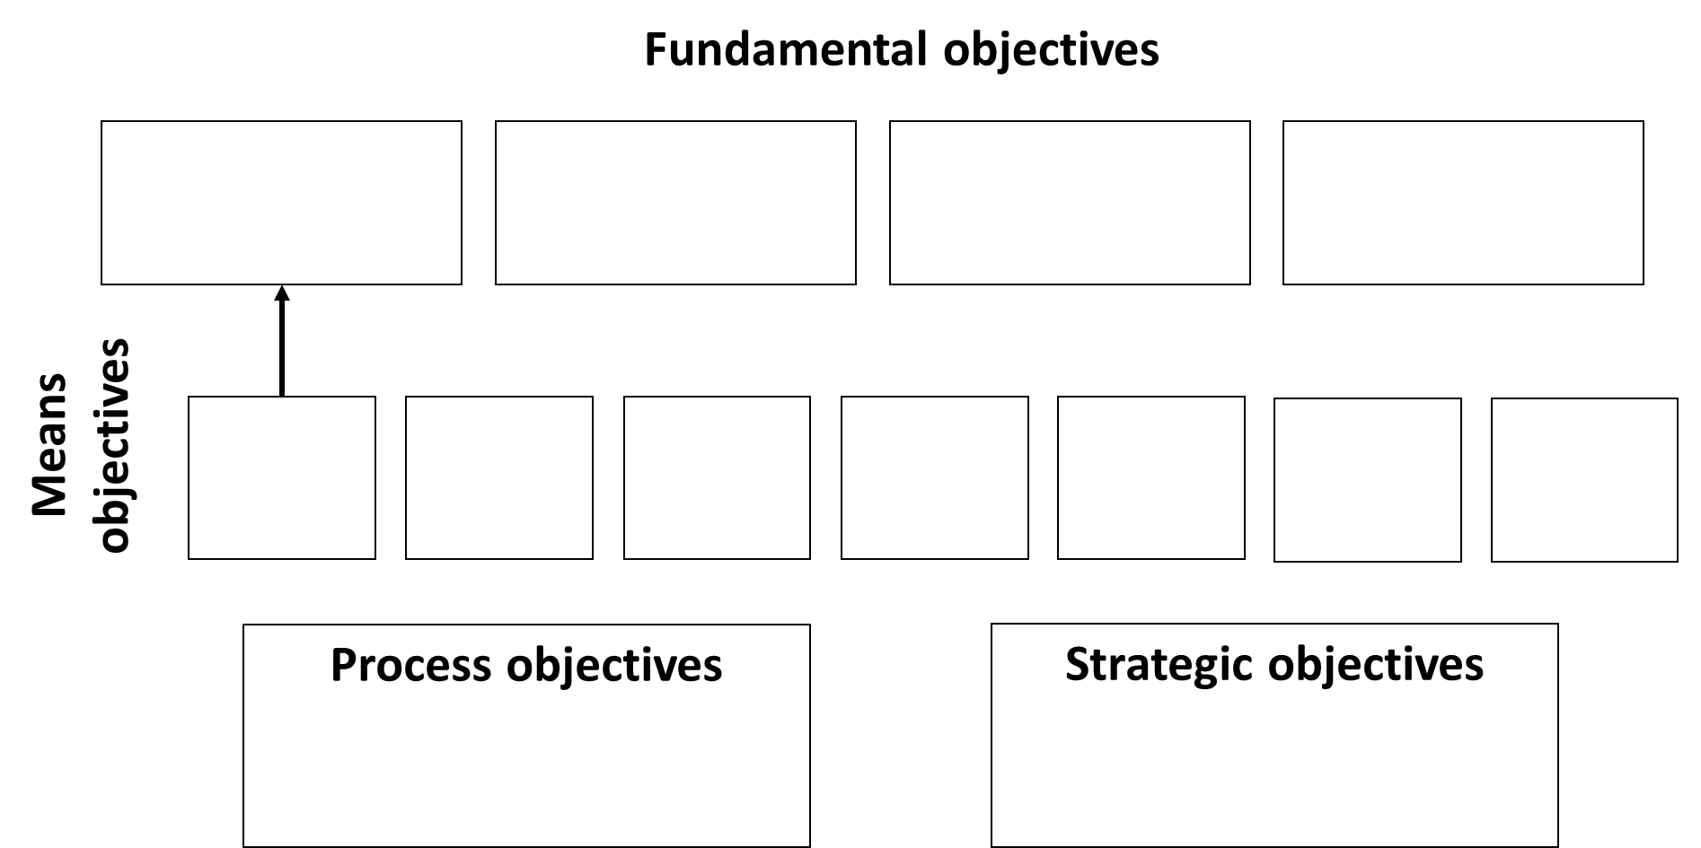
Objectives:

Alternatives:
Themes:

Consequences:
Influence diagram - Actions (rectangles), stochastic factors (ovals), intermediate factors (rounded rectangles), objectives (hexagons)
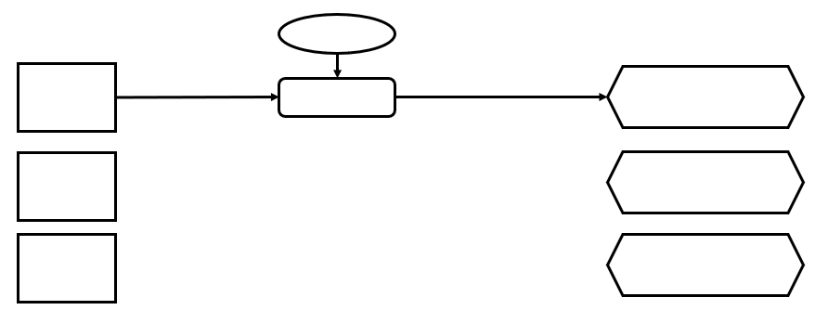

Tradeoffs:

