CIS310

Brad Riggs

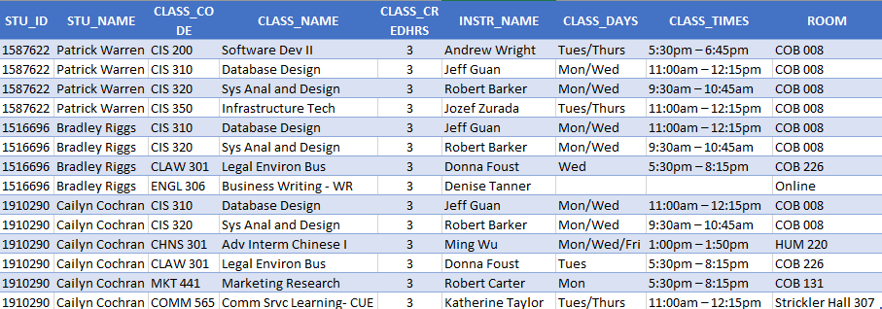

C. Every column except STU_ID and CLASS_CODE are redundant. Everything related to the class should be in its own table with the CLASS_CODE as the primary key. The class code should have the section number included to distinguish between the different sections of the same class. The STU_ID should be in its own table with the student name and other personal information. The only thing needed in the student schedule table would be STU_ID and CLASS_CODE(with the section number included). If the other information is kept in the student schedule, the data is going to be in 2 different places creating redundancies.

Assuming there are 3 tables with the current setup: STUDENT, CLASSES, STUDENT SCHEDULE. If the student name “Bradley Riggs” changes, it will need to be updated in both the STUDENT table and every instance in the STUDENT SCHEDULE table. This would be an update anomaly since there are multiple areas/tables where the information will need to be updated. The same thing goes for the columns CLASS_NAME through ROOM. Those should already be included in the CLASSES table. This creates another update anomaly since if any of those fields need to be updated, it will need to be updated in the STUDENT SCHEDULE and CLASSES table. Since the CLASS_NAME fields use abbreviations, there is a good chance there will be inconsistencies.