Brad Riggs

Due Date: Wednesday, October 11, 2017

CIS310-01

Assignment 6

1. **Draw the dependency diagram for the P6.3 on page 238**



1. **Is the table in 1NF? Why or why not?**

Yes, the table is in 1NF because each row is unique and a primary key has been defined. This table contains a composite primary key.

1. **Is the table in 2NF? Why or why not? If the table is not in 2NF, normalize the table so that the resulting database is in 2NF.**

This table is not currently in 2NF because it contains partial dependencies. Each partial dependency should form a new table.







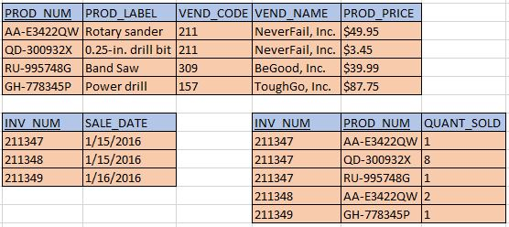

1. **Is the database above in 3NF? Why or why not? If it is not 3NF, normalize the table so that the resulting database in in 3NF.**

The table is not currently in 3NF because it contains a transitive dependency.







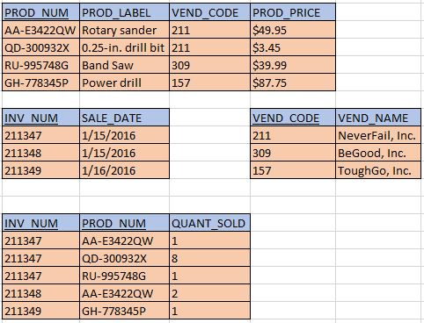

1. **Use the following tables in step 4 to create a Crow’s Foot ERD.**

