The following model was trained on just 5000 emails over 5 authors.
HIDDEN_LAYER_SIZE = 2000
BATCH_SIZE = 32
N_ITERATIONS = 101
model = nn.Sequential(
nn.Linear(num_features, HIDDEN_LAYER_SIZE),
nn.ReLU(),
nn.Linear(HIDDEN_LAYER_SIZE, HIDDEN_LAYER_SIZE),
nn.ReLU(),
nn.Linear(HIDDEN_LAYER_SIZE, 5),
).to(DEVICE)
Total time training 6.39870 seconds
Final train loss: 0.10700687766075134
Final test loss: 0.011411610059440136
Final train accuracy: 0.959
Final test accuracy: 0.9456
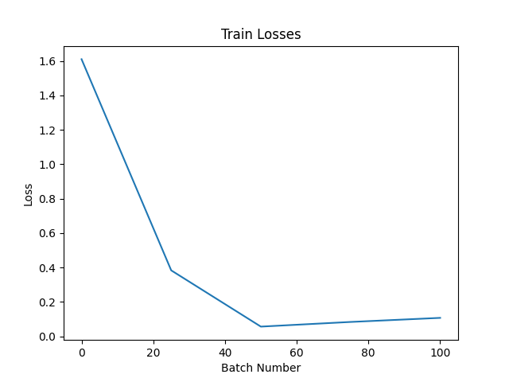
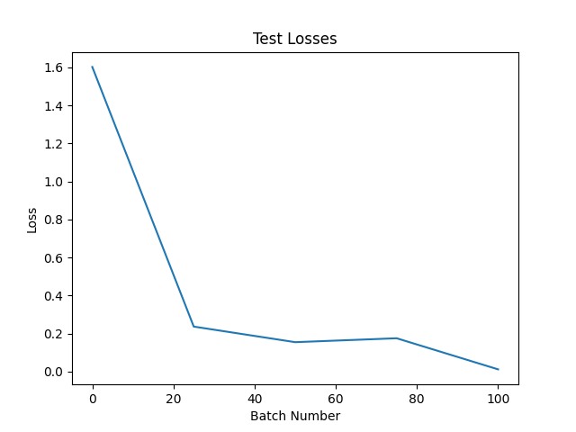

The following model was trained on 20,000 emails over 20 authors.
HIDDEN_LAYER_SIZE = 2000
BATCH_SIZE = 32
N_ITERATIONS = 101
model = nn.Sequential(
nn.Linear(num_features, HIDDEN_LAYER_SIZE),
nn.ReLU(),
nn.Linear(HIDDEN_LAYER_SIZE, HIDDEN_LAYER_SIZE),
nn.ReLU(),
nn.Linear(HIDDEN_LAYER_SIZE, 5),
).to(DEVICE)
Total time training 14.52335 seconds
Final train loss: 1.1148784160614014
Final test loss: 1.7233622074127197
Final train accuracy: 0.77295
Final test accuracy: 0.747
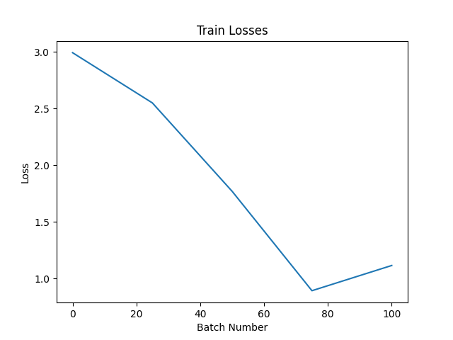
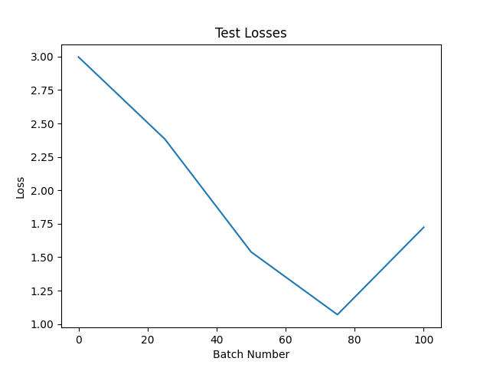

HIDDEN_LAYER_SIZE = 2000
BATCH_SIZE = 32
N_ITERATIONS = 1001
model = nn.Sequential(
nn.Linear(num_features, HIDDEN_LAYER_SIZE),
nn.ReLU(),
nn.Linear(HIDDEN_LAYER_SIZE, HIDDEN_LAYER_SIZE),
nn.ReLU(),
nn.Linear(HIDDEN_LAYER_SIZE, NUM_AUTHORS),
).to(DEVICE)
Total time training 148.99640 seconds
Final train loss: 0.016068482771515846
Final test loss: 0.8277631402015686
Final train accuracy: 0.9483
Final test accuracy: 0.8568
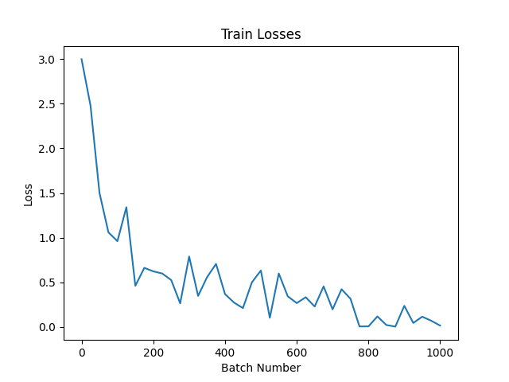
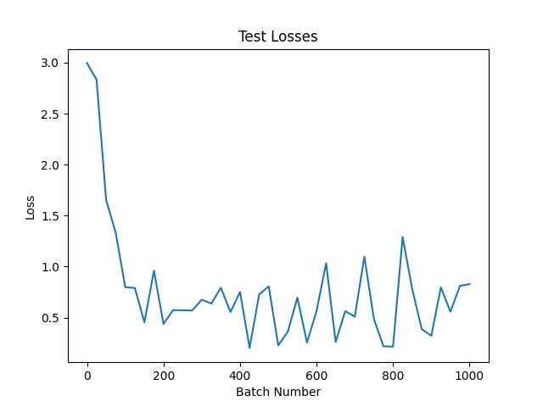

HIDDEN_LAYER_SIZE = 4000
BATCH_SIZE = 32
N_ITERATIONS = 1001
model = nn.Sequential(
nn.Linear(num_features, HIDDEN_LAYER_SIZE),
nn.ReLU(),
nn.Linear(HIDDEN_LAYER_SIZE, HIDDEN_LAYER_SIZE),
nn.ReLU(),
nn.Linear(HIDDEN_LAYER_SIZE, NUM_AUTHORS),
).to(DEVICE)
Total time training 1500.79673 seconds
Final train loss: 0.04387139156460762
Final test loss: 0.46747273206710815
Final train accuracy: 0.9505
Final test accuracy: 0.8582
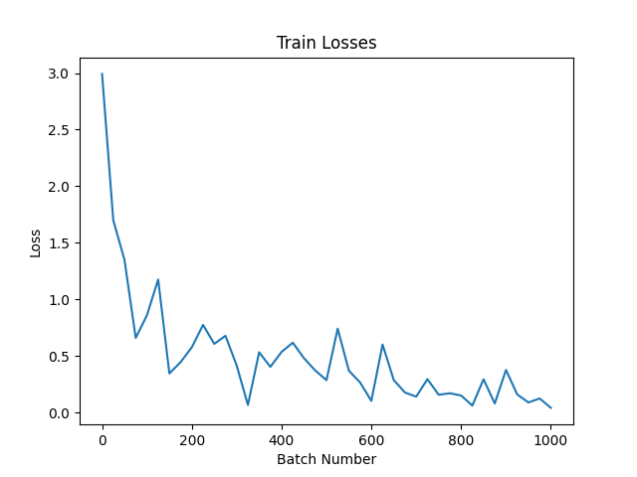
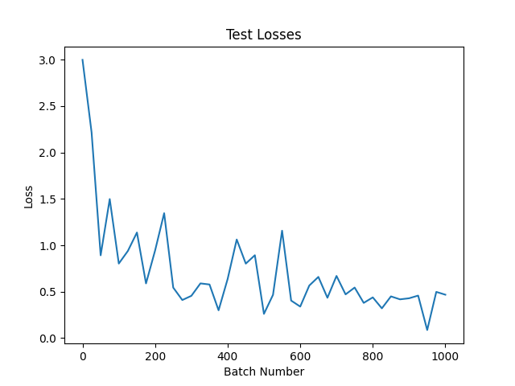
HIDDEN_LAYER_SIZE = 2000
BATCH_SIZE = 32
N_ITERATIONS = 1251
model = nn.Sequential(
nn.Linear(num_features, HIDDEN_LAYER_SIZE),
nn.ReLU(),
nn.Linear(HIDDEN_LAYER_SIZE, HIDDEN_LAYER_SIZE),
nn.ReLU(),
nn.Linear(HIDDEN_LAYER_SIZE, NUM_AUTHORS),
).to(DEVICE)
Total time training 178.40218 seconds
Final train loss: 0.07856053858995438
Final test loss: 0.3288824260234833
Final train accuracy: 0.95925
Final test accuracy: 0.8618
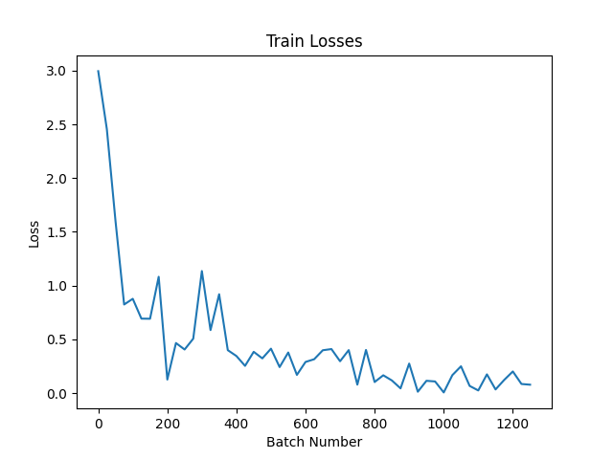
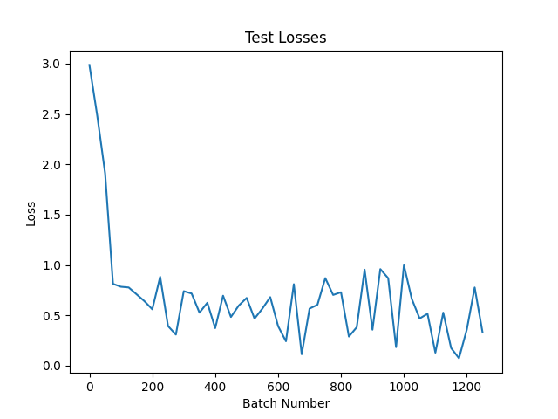

HIDDEN_LAYER_SIZE = 500
BATCH_SIZE = 32
N_ITERATIONS = 1251
model = nn.Sequential(
nn.Linear(num_features, HIDDEN_LAYER_SIZE),
nn.ReLU(),
nn.Linear(HIDDEN_LAYER_SIZE, HIDDEN_LAYER_SIZE),
nn.ReLU(),
nn.Linear(HIDDEN_LAYER_SIZE, HIDDEN_LAYER_SIZE),
nn.ReLU(),
nn.Linear(HIDDEN_LAYER_SIZE, HIDDEN_LAYER_SIZE),
nn.ReLU(),
nn.Linear(HIDDEN_LAYER_SIZE, HIDDEN_LAYER_SIZE),
nn.ReLU(),
nn.Linear(HIDDEN_LAYER_SIZE, NUM_AUTHORS),
).to(DEVICE)
Total time training 61.04696 seconds
Final train loss: 0.3652348518371582
Final test loss: 0.9031391739845276
Final train accuracy: 0.89695
Final test accuracy: 0.7926
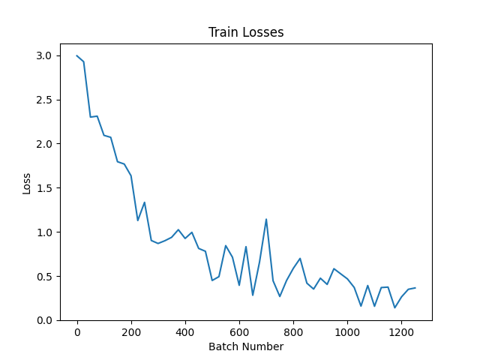
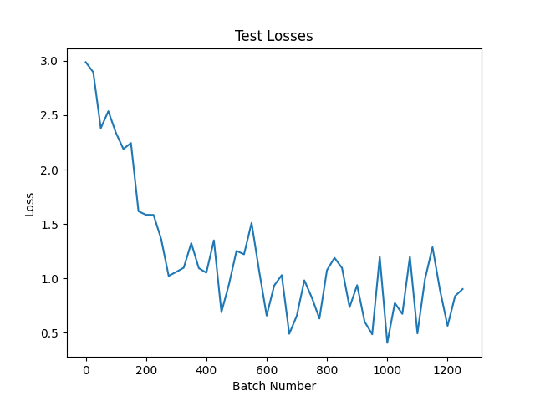

HIDDEN_LAYER_SIZE = 500
BATCH_SIZE = 32
N_ITERATIONS = 2501
model = nn.Sequential(
nn.Linear(num_features, HIDDEN_LAYER_SIZE),
nn.ReLU(),
nn.Linear(HIDDEN_LAYER_SIZE, HIDDEN_LAYER_SIZE),
nn.ReLU(),
nn.Linear(HIDDEN_LAYER_SIZE, HIDDEN_LAYER_SIZE),
nn.ReLU(),
nn.Linear(HIDDEN_LAYER_SIZE, HIDDEN_LAYER_SIZE),
nn.ReLU(),
nn.Linear(HIDDEN_LAYER_SIZE, HIDDEN_LAYER_SIZE),
nn.ReLU(),
nn.Linear(HIDDEN_LAYER_SIZE, NUM_AUTHORS),
).to(DEVICE)
Total time training 126.00173 seconds
Final train loss: 0.11812710762023926
Final test loss: 0.5263305902481079
Final train accuracy: 0.953
Final test accuracy: 0.8326
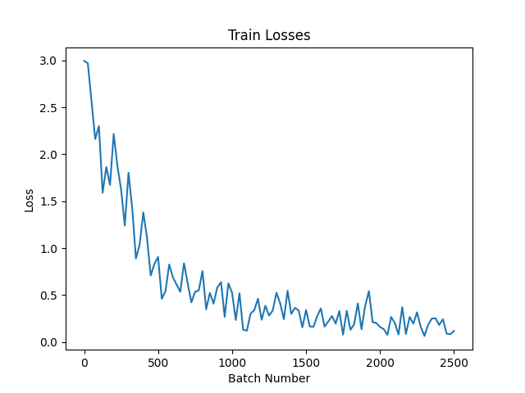
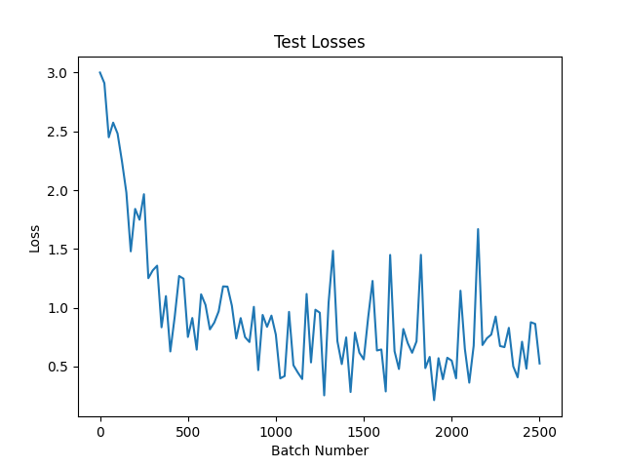
HIDDEN_LAYER_SIZE = 500
BATCH_SIZE = 32
N_ITERATIONS = 5001
model = nn.Sequential(
nn.Linear(num_features, HIDDEN_LAYER_SIZE),
nn.ReLU(),
nn.Linear(HIDDEN_LAYER_SIZE, HIDDEN_LAYER_SIZE),
nn.ReLU(),
nn.Linear(HIDDEN_LAYER_SIZE, HIDDEN_LAYER_SIZE),
nn.ReLU(),
nn.Linear(HIDDEN_LAYER_SIZE, HIDDEN_LAYER_SIZE),
nn.ReLU(),
nn.Linear(HIDDEN_LAYER_SIZE, HIDDEN_LAYER_SIZE),
nn.ReLU(),
nn.Linear(HIDDEN_LAYER_SIZE, NUM_AUTHORS),
).to(DEVICE)
Total time training 240.50658 seconds
Final train loss: 0.10297995805740356
Final test loss: 0.8075591325759888
Final train accuracy: 0.97835
Final test accuracy: 0.8458
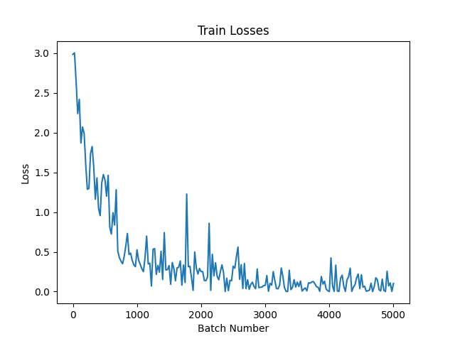
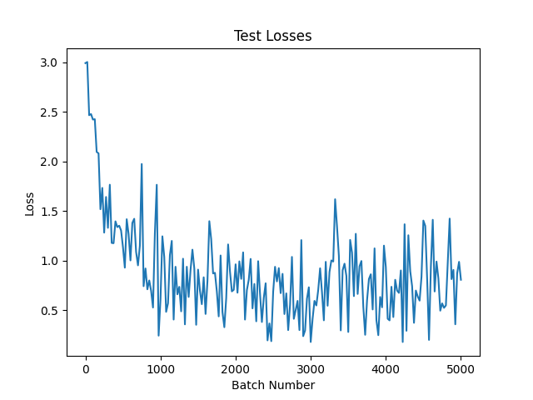

HIDDEN_LAYER_SIZE = 500
BATCH_SIZE = 32
N_ITERATIONS = 10001
model = nn.Sequential(
nn.Linear(num_features, HIDDEN_LAYER_SIZE),
nn.ReLU(),
nn.Linear(HIDDEN_LAYER_SIZE, HIDDEN_LAYER_SIZE),
nn.ReLU(),
nn.Linear(HIDDEN_LAYER_SIZE, HIDDEN_LAYER_SIZE),
nn.ReLU(),
nn.Linear(HIDDEN_LAYER_SIZE, HIDDEN_LAYER_SIZE),
nn.ReLU(),
nn.Linear(HIDDEN_LAYER_SIZE, HIDDEN_LAYER_SIZE),
nn.ReLU(),
nn.Linear(HIDDEN_LAYER_SIZE, NUM_AUTHORS),
).to(DEVICE)
Total time training 521.92186 seconds
Final train loss: 0.19100871682167053
Final test loss: 1.4217405319213867
Final train accuracy: 0.9835
Final test accuracy: 0.8338
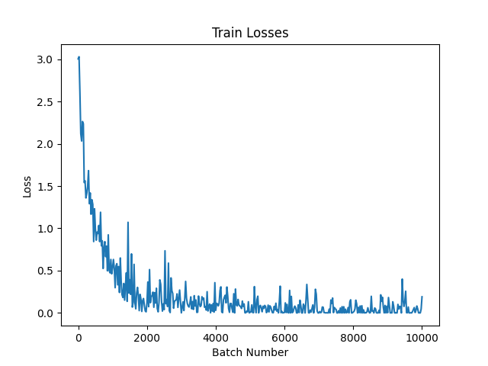
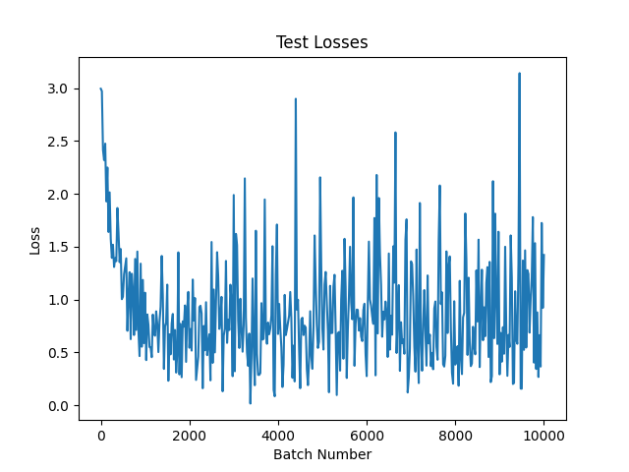

HIDDEN_LAYER_SIZE = 250
BATCH_SIZE = 32
N_ITERATIONS = 2501
model = nn.Sequential(
nn.Linear(num_features, HIDDEN_LAYER_SIZE),
nn.ReLU(),
nn.Linear(HIDDEN_LAYER_SIZE, HIDDEN_LAYER_SIZE),
nn.ReLU(),
nn.Linear(HIDDEN_LAYER_SIZE, HIDDEN_LAYER_SIZE),
nn.ReLU(),
nn.Linear(HIDDEN_LAYER_SIZE, HIDDEN_LAYER_SIZE),
nn.ReLU(),
nn.Linear(HIDDEN_LAYER_SIZE, HIDDEN_LAYER_SIZE),
nn.ReLU(),
nn.Linear(HIDDEN_LAYER_SIZE, HIDDEN_LAYER_SIZE),
nn.ReLU(),
nn.Linear(HIDDEN_LAYER_SIZE, HIDDEN_LAYER_SIZE),
nn.ReLU(),
nn.Linear(HIDDEN_LAYER_SIZE, HIDDEN_LAYER_SIZE),
nn.ReLU(),
nn.Linear(HIDDEN_LAYER_SIZE, HIDDEN_LAYER_SIZE),
nn.ReLU(),
nn.Linear(HIDDEN_LAYER_SIZE, NUM_AUTHORS),
).to(DEVICE)
Total time training 82.69351 seconds
Final train loss: 0.39444199204444885
Final test loss: 0.7808356285095215
Final train accuracy: 0.9135
Final test accuracy: 0.783
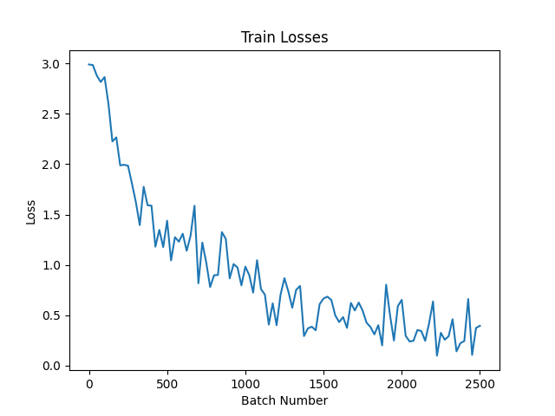
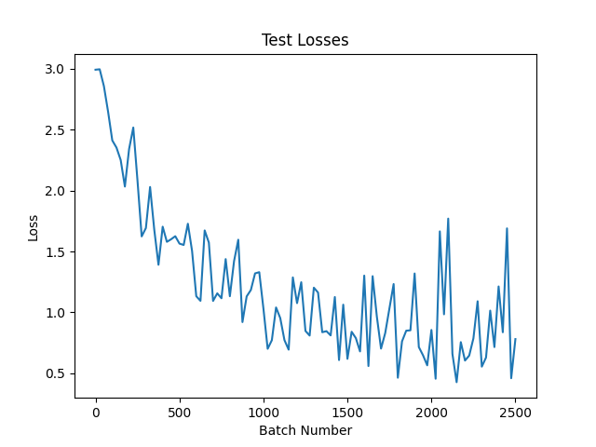

HIDDEN_LAYER_SIZE = 250
BATCH_SIZE = 32
N_ITERATIONS = 5001
model = nn.Sequential(
nn.Linear(num_features, HIDDEN_LAYER_SIZE),
nn.ReLU(),
nn.Linear(HIDDEN_LAYER_SIZE, HIDDEN_LAYER_SIZE),
nn.ReLU(),
nn.Linear(HIDDEN_LAYER_SIZE, HIDDEN_LAYER_SIZE),
nn.ReLU(),
nn.Linear(HIDDEN_LAYER_SIZE, HIDDEN_LAYER_SIZE),
nn.ReLU(),
nn.Linear(HIDDEN_LAYER_SIZE, HIDDEN_LAYER_SIZE),
nn.ReLU(),
nn.Linear(HIDDEN_LAYER_SIZE, HIDDEN_LAYER_SIZE),
nn.ReLU(),
nn.Linear(HIDDEN_LAYER_SIZE, HIDDEN_LAYER_SIZE),
nn.ReLU(),
nn.Linear(HIDDEN_LAYER_SIZE, HIDDEN_LAYER_SIZE),
nn.ReLU(),
nn.Linear(HIDDEN_LAYER_SIZE, HIDDEN_LAYER_SIZE),
nn.ReLU(),
nn.Linear(HIDDEN_LAYER_SIZE, NUM_AUTHORS),
).to(DEVICE)
Total time training 145.39345 seconds
Final train loss: 0.23715372383594513
Final test loss: 2.6107230186462402
Final train accuracy: 0.94895
Final test accuracy: 0.808
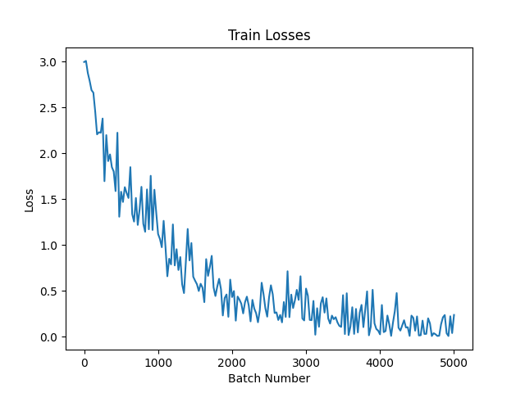
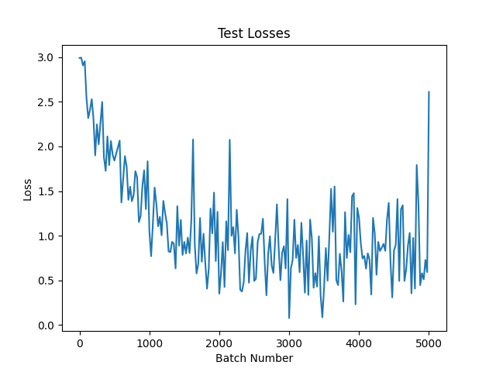

HIDDEN_LAYER_SIZE = 500
BATCH_SIZE = 32
N_ITERATIONS = 5001
model = nn.Sequential(
nn.Linear(num_features, HIDDEN_LAYER_SIZE),
nn.ReLU(),
nn.Linear(HIDDEN_LAYER_SIZE, HIDDEN_LAYER_SIZE),
nn.ReLU(),
nn.Linear(HIDDEN_LAYER_SIZE, HIDDEN_LAYER_SIZE),
nn.ReLU(),
nn.Linear(HIDDEN_LAYER_SIZE, HIDDEN_LAYER_SIZE),
nn.ReLU(),
nn.Linear(HIDDEN_LAYER_SIZE, HIDDEN_LAYER_SIZE),
nn.ReLU(),
nn.Linear(HIDDEN_LAYER_SIZE, HIDDEN_LAYER_SIZE),
nn.ReLU(),
nn.Linear(HIDDEN_LAYER_SIZE, HIDDEN_LAYER_SIZE),
nn.ReLU(),
nn.Linear(HIDDEN_LAYER_SIZE, HIDDEN_LAYER_SIZE),
nn.ReLU(),
nn.Linear(HIDDEN_LAYER_SIZE, HIDDEN_LAYER_SIZE),
nn.ReLU(),
nn.Linear(HIDDEN_LAYER_SIZE, NUM_AUTHORS),
).to(DEVICE)
Total time training 259.03604 seconds
Final train loss: 0.1319478154182434
Final test loss: 1.4548461437225342
Final train accuracy: 0.95405
Final test accuracy: 0.8114
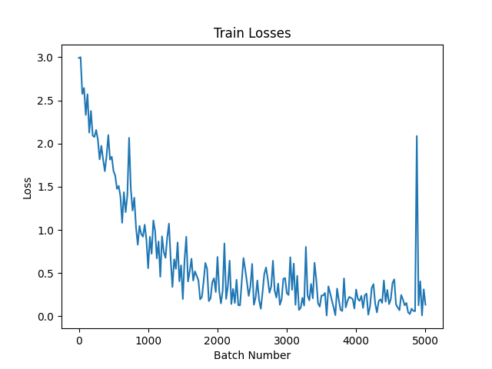
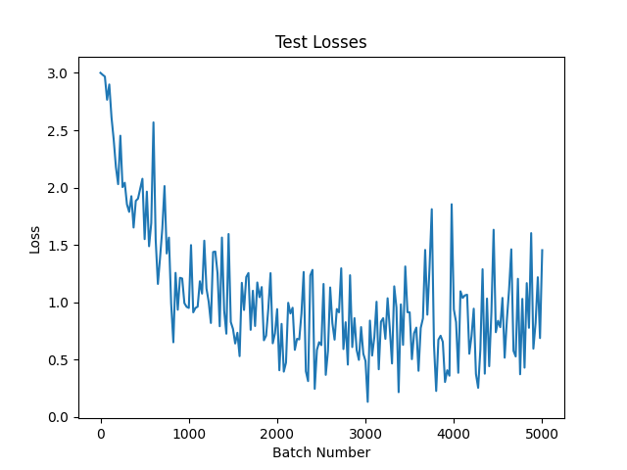

HIDDEN_LAYER_SIZE = 500
BATCH_SIZE = 32
N_ITERATIONS = 7501
model = nn.Sequential(
nn.Linear(num_features, HIDDEN_LAYER_SIZE),
nn.ReLU(),
nn.Linear(HIDDEN_LAYER_SIZE, HIDDEN_LAYER_SIZE),
nn.ReLU(),
nn.Linear(HIDDEN_LAYER_SIZE, HIDDEN_LAYER_SIZE),
nn.ReLU(),
nn.Linear(HIDDEN_LAYER_SIZE, HIDDEN_LAYER_SIZE),
nn.ReLU(),
nn.Linear(HIDDEN_LAYER_SIZE, HIDDEN_LAYER_SIZE),
nn.ReLU(),
nn.Linear(HIDDEN_LAYER_SIZE, HIDDEN_LAYER_SIZE),
nn.ReLU(),
nn.Linear(HIDDEN_LAYER_SIZE, HIDDEN_LAYER_SIZE),
nn.ReLU(),
nn.Linear(HIDDEN_LAYER_SIZE, HIDDEN_LAYER_SIZE),
nn.ReLU(),
nn.Linear(HIDDEN_LAYER_SIZE, HIDDEN_LAYER_SIZE),
nn.ReLU(),
nn.Linear(HIDDEN_LAYER_SIZE, NUM_AUTHORS),
).to(DEVICE)
Total time training 430.87339 seconds
Final train loss: 0.18275155127048492
Final test loss: 0.7938746213912964
Final train accuracy: 0.9647
Final test accuracy: 0.8216
