**Product Design Specification (PDS)**

Group 17

Brigham Webster

Jose Alvarez

Jens Evans

Sarah Mehler

**Executive Summary / Concept of Operations**

The Child’s Bank is a device that counts coins and displays the amount of money accrued. The bank is intended as a learning and motivation device for children, to help them keep track of how much money they have saved. To use the piggy bank, you put coins into the slot(s), and the bank automatically keeps a record of what has been entered.

**Brief Market Analysis**

The intended audience are parents who are interested in teaching their children about money. The competition would be conventional piggy banks. Our product is different because it not only helps children save money but also teaches them and is interactive. This will sell for about 20 dollars because the processing requirements are low which will require a simple chip. The device will also have a simple mechanical design for the coin storage that will be easily mass produced and batteries are sold separately.

**Requirements**

MUST

* Count coins (pennies, nickels, dimes, and quarters)
* Store Coins
* Be easy to use
* Display the amount of money that has been added in a clear and obvious way
* Use atmega328 processor
* Be PCB-based with 25% surface mount components

SHOULD

* Run on a battery
* Have an attractive enclosure
* Make the Mario coin sound when you insert a coin

MAY

* Sort coins
* Be able to set a goal
* Have a 3D printed animal-shaped enclosure

**System Architecture**

**High Level Block Diagram**

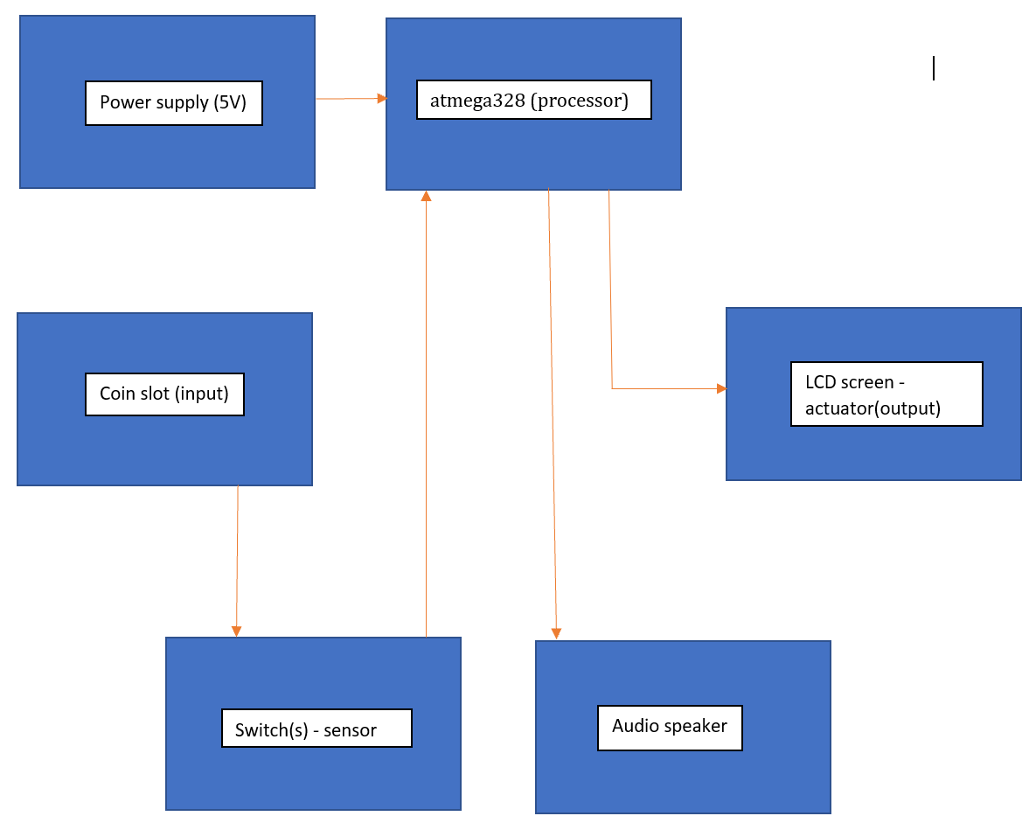

**Design Specification**

* The sensor will be a switch with enough sensitivity to be set by the weight of a coin.
* The processor will be an ATMEGA328
* The things that will be actuated are the inputs to the LCD screen
* The power supply will be about 5 Volts (Battery or USB)
* The mechanical design may be a wooden box with coin slots cut in and a lid to open it if we do not hit our must or may goals for a better box.
* We are going to use the Arduino development environment