How Be Right works 23 October 2026
A repair request moves between the lanes from left to right. The thick box is the step where the customer says yes: nothing is sent or charged before it. Dashed arrows show what is shared: the technician on the way, and the partner shops near the job.
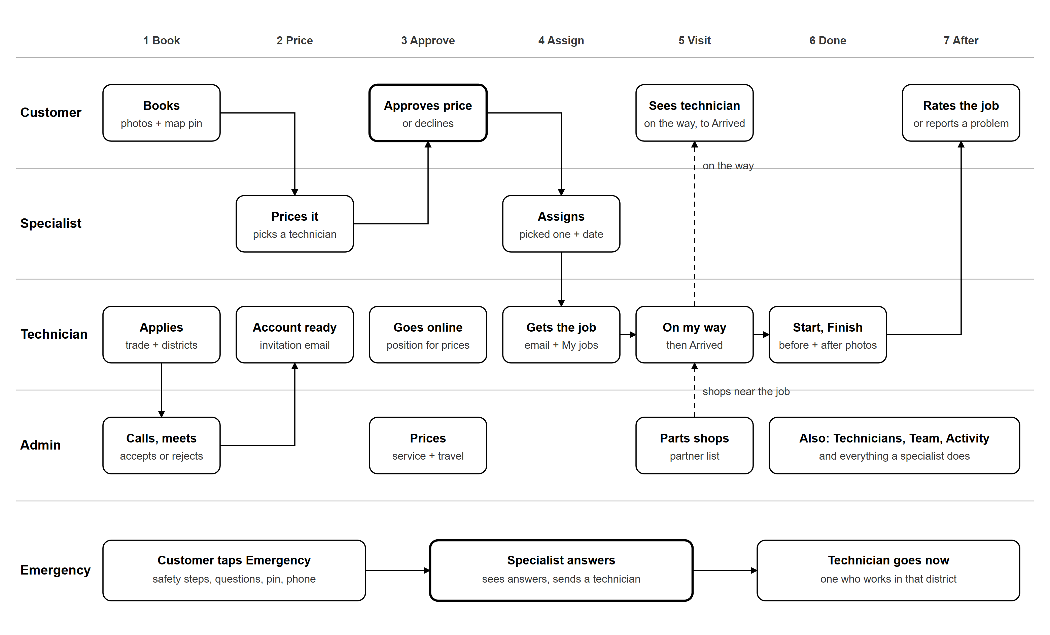
What each role can do 23 October 2026
Customer  Website and app, own account  - Create an account (all fields required)  - Book: 14 services + Other, questions, photos, date, map pin  - Approve or decline the price (asked to confirm)  - Cancel before the visit; once scheduled, ask to cancel  - See the technician on the way, until they arrive  - Rate the job; report a problem within 7 days  - Emergency: safety steps and quick questions, no account needed  - My account: profile, details, email, password, delete | Specialist  Dashboard: Requests, Emergencies, Technicians  - Requests: review, preparation note  - Suggested technicians, each with a price, nearest first  - Only technicians who work in the request's district  - Assign (the priced technician is ready) and schedule  - Follow jobs (updates within 10 seconds)  - Close a request, or charge the $10 visit fee  - Emergencies: see the customer's answers, send a technician  - Technicians: look and contact only | Technician  Added by an admin after a meeting  - Apply: trade, districts, experience, tools, transport, photo  - Go online (Available): position shared with the team  - Starting point in My account, used when offline  - My jobs: To do and Done tabs, one job at a time  - 4 steps: On the way, Start, Finish, Done  - On my way: the customer sees them until Arrived  - Before and after photos (required); report no repair  - Parts shops near each job; profile with photo and rating | Admin  Admin area: everything a specialist does, plus  - Applications: call, meet, accept or reject  - Technicians: districts, transport, documents, remove  - Prices: service prices, travel per km, max distance  - Exception: send a technician outside their districts  - Parts shops: add, edit, hide, delete  - Team: add staff, change roles, reset two-step  - Customers, Overview figures, Activity log  - Sign-in: password + authenticator code
Key rules
Price  Service price + travel (rate per km for the technician's transport, times km by road). Rounded up, never below the lowest price or the $10 visit fee. The specialist can change it; the customer sees one total. | Districts  Technicians pick the districts they work in. A request's district comes from its map pin. Outside their districts: not suggested, and only an admin can make an exception. | Distance  From where the technician is when they are Available (online), otherwise from the starting point they set in My account. | Visit fee and damage  $10 only if no repair happens (otherwise it is inside the price). Damage is the technician's responsibility; if they cannot fix it, Be Right does.
Everything works on the website and in the phone app, in English and Arabic. Emails go out at each step once the email service is set up. Payments are not in the app yet.

