Revised Chapter 1 — Introduction
Revision notes: addresses supervisor comments C1.1–C1.5. Citations are drawn from the
author-supplied reference list (`reports/revision/references.md`). Numbers marked
"verified" come from the rebuild (`reports/phase1_report.md`,
`data_processed/panel_build_log.txt`).

1.1 Introduction
Food prices determine whether households can afford an adequate diet. When prices rise
quickly, low- and irregular-income households are affected first: they buy less,
substitute cheaper foods, borrow, or cut other spending. Food-price change is therefore
not only an economic issue but one connected to livelihoods, health, agriculture and
social welfare. Zimbabwe is a suitable case because food prices are shaped
simultaneously by rainfall, agricultural production, currency conditions, transport
costs and local market differences. This project applies data-science methods to
combine market price records, rainfall information and administrative geography in
order to estimate the probability of a defined food price stress condition at
market and district level in the following month.

1.2 Background and Context

1.2.1 Current state of knowledge
Zimbabwe depends heavily on rain-fed agriculture, so rainfall deficits can affect
production, incomes, livestock, availability and prices. Zimbabwe-specific evidence links
ENSO and seasonal rainfall to maize-yield variability (Phillips et al., 1998) and to
agricultural and anticipatory-action outcomes (Mano & Nhemachena, 2007; Sazib et al.,
2020; Mugiyo et al., 2023). The relationship is not immediate: traders and consumers
change expectations during the growing season before the harvest outcome is known, and a
rainfall deficit may combine with weak market supply, transport costs or foreign-currency
shortages to push prices higher (Wright, 2011; Deaton & Laroque, 1992).
The country's monetary history makes price measurement difficult. Records are expressed
variously in Zimbabwean dollars and US dollars, and the meaning of a nominal price
changes with depreciation and exchange-rate regime (Kramarenko et al., 2010; World Bank,
2021). A nominal increase may reflect general inflation, conversion, transport costs, or a
genuine local shortage. Prices also differ across districts: a market near a surplus area
restocks more easily than a remote market in a dry region, so a national average can hide
local stress (Fackler & Goodwin, 2001; Burke & Myers, 2014; Porteous, 2019).
These mechanisms are documented by specific, referenced evidence: actual food-price
behaviour and volatility (Deaton & Laroque, 1992; Wright, 2011; Symeonidis et al., 2012;
Gilbert et al., 2017), spatial price transmission in Southern Africa and Zimbabwe (Burke &
Myers, 2014; Davids et al., 2017; Mahdi & Bonato, 2015), rainfall shocks (Funk et al.,
2015; Shukla et al., 2020), and Zimbabwe's inflation and currency episodes (Kramarenko et
al., 2010; World Bank, 2021; Moyo, 2024). Household-level insecurity is separately
documented (Tawodzera, 2011; Mango et al., 2014; Bhalla et al., 2018). This revision
distinguishes observed national challenges (documented by the sources above) from the
assumptions that motivate the proposed system (stated in §1.9).

1.2.2 Gap identification
Existing systems already monitor food markets and food security. The gap must therefore
be stated as a specific missing capability, not as the absence of an identical
system. The comparison below sets out what each system provides and what this project
adds.
System | Geographic unit | Frequency | Target | Provides a machine-readable market–commodity probability of next-month price stress?
WFP market monitoring (WFP, 2025a, 2025b) | Market / national | Monthly | Price levels, availability | No — descriptive, indicators not probabilities
FEWS NET / IPC (FEWS NET, n.d.) | Livelihood zone / district | Monthly–quarterly | Food-security phase (IPC) via scenario analysis + expert judgement | No — expert-based outlooks
ZimVAC / ZimLAC (ZimLAC, 2024) | District / ward | Annual | Household livelihoods & vulnerability | No — household assessment
CHIRPS (Funk et al., 2015) | Pixel → district | Dekadal–monthly | Rainfall | N/A (input, not a forecast of prices)
Food-security ML crisis models (Busker et al., 2024; Westerveld et al., 2021) | Region / household | Variable | Crisis / household state | Partial — not a market–commodity monthly price model
Missing capability: none of these provides a single, reproducible, monthly,
market–commodity–district probability of a pre-defined next-month price stress
event, with currency-regime handling, leakage-controlled chronological validation and a
re-runnable scoring artefact. The project addresses this applied data-science gap. It
does not claim that WFP/FEWS NET lack predictive capability; it claims a specific,
narrow, reproducible output is absent.

1.3 Problem Statement
Food price stress in Zimbabwe develops through the combined effects of rainfall
deficits, agricultural losses, currency change, transport costs and local market
conditions, but the timing and location of the next event are difficult to identify
from separate market and climate reports. A national average hides district and
commodity differences. The problem is the **lack of an integrated, reproducible
data-science system** that (i) combines price, rainfall and geographic data at market
and district level, (ii) uses only information available at the prediction date, and
(iii) reports honestly how well the resulting probabilities generalise to later
periods.

1.4 Project Aim
To develop and evaluate a machine-learning system that uses food-price data,
rainfall anomalies and market information to estimate the probability of a defined food
price stress condition in Zimbabwean markets and districts in the following month, and
to report the reliability of those estimates under time-respecting validation.

1.5 Project Objectives (measurable, with acceptance criteria)
Supervisor C1.3: objectives must specify expected outputs and acceptance criteria.
Verified data facts used below are from `reports/phase1_report.md`.
Objective 1 — Data integration.
Output: a monthly `market × commodity × currency × month` panel joined to district
rainfall. Acceptance: ≥ 20,000 food cells retained from 28,168 raw rows; ≥ 95% of
priced markets assigned to a district via coordinates; a written build log.
Result: met (20,530 cells; 327/335 markets geolocated; 8 flagged; see Ch.3.4).
Objective 2 — Feature construction.
Output: price-momentum, peer-market, rainfall-anomaly, seasonal, currency and
interaction features, all computed only from data available at time t.
Acceptance: leakage tests pass (no `t+1` field in the predictor matrix); feature set
documented in a data dictionary.
Result: met (`tests/run_checks.py`; Ch.3.4.6).
Objective 3 — Model comparison under time-ordered validation.
Output: at least two learning models (elastic-net logistic, XGBoost, histogram GBM)
and two baselines (majority, persistence) compared on an identical holdout per
target, with ROC-AUC, PR-AUC, F1, balanced accuracy and Brier score, plus uncertainty
intervals.
Acceptance: comparison reported separately for each target (no cross-target ranking);
baselines reported; 95% bootstrap intervals reported.
Result: met with an honest negative finding — discrimination is modest/weak and
XGBoost does not dominate (Ch.4.4; `reports/phase6b_diagnostics.md`).
Objective 4 — Prospective scoring prototype.
Output: a scoring artefact that validates new input, reconstructs features, applies a
versioned model and writes a separate output without altering historical data.
Acceptance: artefact runs on a held-out input; model + metadata saved with version,
training period and seed.
Result: met as a technical prototype (`src/fit_final_model.py`, `dashboard/app.py`);
not operationally validated.
Objective 5 — Commodity/district decision support.
Output: commodity-level performance and district-level exploratory risk scores.
Acceptance: every output traceable to an artefact; labelled "exploratory".
Result: partially met — commodity results real; district bands must be labelled
exploratory because temporal validation is insufficient (Ch.4).
How success is assessed (C1.3). Each objective is judged against an explicit,
checkable criterion rather than a narrative claim:
Objective | Success is assessed by | Acceptance criterion
1 Data integration | Panel row count, geolocation match rate, build log | ≥ 20,000 food cells; ≥ 95% of markets matched to a district; log written
2 Feature construction | Automated leakage tests; data dictionary | Predictor matrix contains no `t+1` field; every feature documented
3 Model comparison | Holdout ROC-AUC on an identical holdout per target, with a 95% bootstrap CI, versus baselines | A model demonstrates reliable prospective discrimination only if holdout ROC-AUC > 0.50 and its 95% CI excludes 0.50 and it beats the majority baseline on the same observations
4 Scoring reliability | Re-running the versioned artefact on fixed input reproduces recorded scores | Deterministic given the saved model, metadata and seed; separate output file
5 Geographic presentation | Traceability of district scores to market scores; labelling | Every district score traceable to an artefact and labelled "exploratory, model-generated"
Applying the Objective-3 criterion honestly, the Y1 target fails it (holdout ROC-AUC
near 0.50 with an interval spanning chance) while Y2 partially passes — this is reported
as a finding, not concealed (Ch.4.4, Ch.5.3).

1.6 Motivation
Earlier information about market pressure gives government and humanitarian actors more
time to verify conditions before they worsen. The project is also an exercise in honest
applied data science: combining heterogeneous real data (prices, CHIRPS rainfall,
boundaries, population), engineering leakage-safe features, and evaluating models on
later observations rather than a random split. The project explicitly treats
validation design and the limits of the available data as core, not incidental.

1.7 Stakeholders and intended primary users
The primary user is a national market-monitoring analyst (e.g. within WFP market
monitoring or a government food-security unit) who reviews monthly market data and
decides where to prioritise verification. Secondary users: FEWS NET/ZimVAC/ZimLAC
analysts (cross-checking), humanitarian programme staff (screening for market
assessments), district officers (local verification), and researchers.
The system is decision support only: a high probability should trigger verification
against local information, existing assessments and household data — never an automatic
decision about districts or households.

1.8 Project Scope
Geographic: Zimbabwe; market, commodity and administrative-district level (10
admin-1 provinces; 91 admin-2 districts).
Temporal coverage (verified): food prices 2010-01 → 2026-05; CHIRPS rainfall
1981-01 → 2026-08 (climatology baseline 1981–2015).
Includes: data cleaning and harmonisation, geographic matching, leakage-safe feature
engineering, construction of two stress targets, model comparison with time-ordered
validation, probability scoring and geospatial presentation.
Excludes: prediction of household food consumption, poverty, malnutrition, famine or
individual vulnerability; long-term (seasonal/annual) forecasting; temperature, soil
moisture, vegetation/NDVI, crop yield, conflict, fuel-price, border and informal-FX data
(not available).

1.9 Project Assumptions (each linked to a validation procedure)
Assumption | How it is tested in this project
Price and rainfall data are usable after cleaning | Data-quality report; zero/negative prices removed; log returns finite (`tests/run_checks.py`)
Datasets can be linked | 327/335 markets matched to districts; unmatched 8 flagged, not silently assigned
Time order is respected | Only trailing windows/expanding peer statistics; holdout begins the month after training ends
Future information can be excluded | Leakage tests: the predictor matrix contains no `t+1` field; rolling features verified
Price/rainfall features contain signal | Feature-exclusion experiments (`phase6b_feature_exclusion.csv`)
Patterns may transfer to later periods | Forward holdout + by-year/by-currency analysis; transfer is not assumed (Ch.4)
A prediction is an early-warning signal, not household insecurity | Explicit scope boundary and interpretation statement
Where an assumption is not supported (e.g. transferability), it is recorded as a
limitation rather than hidden.

1.10 Definition of key terms (supervisor C1.4)
- Prediction unit: one `market × commodity × currency × month` observation.
- Forecast horizon: the following calendar month (1 month ahead).
- Food price stress (this project): a market price event — either (Y1) a
standardised next-month log return ≥ +1.0 SD of the series' trailing distribution, or
(Y2) a next-month price ≥ 1.20 × the peer-market median for the same commodity and
currency. See Chapter 3.4.12.
- Not the same as price inflation: inflation is a general, sustained change in the
price level; stress here is a relative, local, one-month price movement.
- Not the same as household food insecurity: insecurity depends on income, assets,
labour, remittances, own production and social protection, none of which are in the
feature set. A market signal is not a household classification.

1.11 Relevance and Significance
The project is relevant because it shows how dispersed Zimbabwean data sources can be
integrated into one reproducible process, and it is significant because it provides a
transparent, updatable market signal that can supplement — not replace — existing
monitoring. Its most defensible contribution is the **documented, leakage-controlled,
reproducible workflow**, together with an honest account of limited temporal
generalisability (see Chapter 5).

1.12 Chapter Summary
This chapter introduced the project, stated the specific missing capability, defined
food price stress precisely (unit, horizon, and its distinction from inflation and
household insecurity), set measurable objectives with acceptance criteria, named the
primary user, fixed the temporal coverage, and tied each assumption to a validation
procedure. Chapter 2 reviews the literature; Chapter 3 gives the reproducible method.

Revised Chapter 2 — Literature Review
Revision notes: addresses supervisor comments C2.1–C2.5. Citations are drawn from the
reference list in `reports/revision/references.md`. The retained
corpus contains 33 unique sources: 21 refereed journal articles + **1 refereed
conference paper** (22 refereed scholarly works), 1 edited-volume chapter, 1
process-model guide, and 9 institutional/grey reports. Every claim below is
attributed to an identified source; no source is cited for a result it does not report.

2.1 Introduction
This chapter reviews the literature that frames the study, organised around seven themes:
(a) the economics of food/commodity price behaviour and volatility; (b) spatial price
transmission and market integration; (c) price seasonality; (d) rainfall, ENSO and
climate drivers; (e) food insecurity and the Zimbabwean context; (f) machine-learning
approaches to food-security and climate prediction; and (g) cross-validation and
methodology for temporal data. Each research question is then mapped to a measurable
objective, procedure and output (§2.9), and the literature gap is stated as a
comparison (§2.8), not as the absence of any comparable system.

2.2 The Economics of Commodity Price Behaviour and Volatility
Deaton and Laroque (1992) provide the foundational commodity-storage model in which
prices are driven by stockholding behaviour and expectations of future scarcity; their
framework explains why commodity prices display autocorrelation and occasional sharp
spikes. Wright (2011) reviews the economics of grain price volatility, arguing that both
fundamentals (supply shocks, stocks) and market-structure factors shape volatility, and
that volatility is often episodic rather than constant. Symeonidis, Prokopczuk, Brooks
and Lazar (2012) show empirically that the futures basis and inventory levels are linked
to commodity price volatility, supporting the idea that relative price positions carry
information about stress. Together these studies justify modelling a *standardised,
series-relative* price movement (this study's Y1) rather than a raw price level, because
the level alone is confounded by inflation and currency.

2.3 Spatial Price Transmission and Market Integration
Fackler and Goodwin (2001) systematise spatial price analysis, establishing that price
differences between locations reflect trade costs, transaction costs and arbitrage.
Burke and Myers (2014) examine Southern African maize markets linked by informal trade
and find meaningful spatial equilibrium and price transmission, demonstrating that
regional markets are interconnected but imperfectly so. Davids, Meyer and Westhoff (2017)
show that trade controls distort price transmission between Southern African maize
markets. Porteous (2019) estimates a dynamic model of African agricultural storage and
trade, showing that high trade costs strongly affect storage and price behaviour. Mahdi
and Bonato (2015) study spatial integration in Zimbabwean product markets specifically.
Collectively these works motivate this study's peer-relative target (Y2), which
measures a market's price against the median of nearby markets for the same commodity and
currency — a direct operationalisation of spatial price dispersion theory.

2.4 Food Price Seasonality
Gilbert, Christiaensen and Kaminski (2017) measure food price seasonality across Africa
and show that many staple markets exhibit predictable within-year price cycles linked to
harvest and lean seasons. This justifies including calendar/seasonal features
(`month_sin`, `month_cos`) in the predictor set and expecting the timing of price
stress to be partly seasonal.

2.5 Rainfall, ENSO and Climate Drivers
Funk et al. (2015) describe CHIRPS, the rainfall dataset used in this study, establishing
it as a quasi-global, station-corrected infrared precipitation record suitable for
monitoring extremes. Phillips, Cane and Rosenzweig (1998) link ENSO and seasonal rainfall
patterns to simulated maize-yield variability in Zimbabwe, providing Zimbabwe-specific
evidence that rainfall anomalies propagate into agricultural outcomes. Sazib, Mladenova
and Bolten (2020) use Earth-observation data to assess ENSO impacts on African
agriculture, and Mugiyo et al. (2023) analyse the 2023/24 El Niño and anticipatory-action
strategies for Zimbabwe. Mano and Nhemachena (2007) apply a Ricardian approach to estimate
the economic impacts of climate change on Zimbabwean agriculture. Shukla et al. (2020)
demonstrate operational hydrological monitoring/forecasting to improve early warning of
drought-driven food insecurity in southern Africa. These studies establish rainfall as a
plausible but indirect and lagged driver of food price stress — consistent with this
study's empirical finding of a weak lead-1 association (Ch.4.5).

2.6 Food Insecurity and the Zimbabwean Context
Tawodzera (2011) documents urban household food insecurity in Epworth, Harare, showing
how urban vulnerability can be severe and distinct from rural patterns. Mango, Zamasiya,
Makate, Nyikahadzoi and Siziba (2014) analyse the factors influencing household food
security among smallholder farmers in Mudzi district. Bhalla, Handa, Angeles and
Seidenfeld (2018) evaluate the effect of cash transfers and household vulnerability on
food security in Zimbabwe, showing that income transfers and vulnerability mediate
insecurity. Melesse, Tirra, Homann-Kee Tui, Van Rooyen and Hauser (2023) study livestock
market participation and food-security outcomes. Moyo (2024) analyses the political
economy of Zimbabwe's 2019–2020 food crisis. Kramarenko et al. (2010) document
Zimbabwe's hyperinflation and post-crisis monetary challenges, and the World Bank (2021)
reports on the macro-economic environment including currency and price instability.
Institutional monitoring is provided by WFP (2025a, 2025b), the IPC/FEWS NET Zimbabwe
acute food-insecurity classification (FEWS NET, n.d.) and the ZimLAC rural livelihoods
assessment (ZimLAC, 2024). Crucially, these sources analyse household food security
and macro conditions; none provides a monthly, market-commodity, machine-readable
probability of next-month price stress. This is the distinction this study preserves
throughout: it predicts a market price condition, not household insecurity.

2.7 Machine Learning for Food Security and Climate Prediction
Busker et al. (2024) use machine learning to predict food-security crises in the Horn of
Africa, demonstrating both the potential and the difficulty of predicting crisis
transitions from heterogeneous data. Westerveld et al. (2021) forecast transitions in the
state of food security using machine learning with transferable features, directly
relevant to the idea of reusable predictors across contexts. He, Li, DelSole, Ravikumar
and Banerjee (2021) assess machine learning for sub-seasonal climate forecasting,
documenting the challenges and the modest skill achievable at these horizons. Reichstein
et al. (2019) set out how deep learning can complement process understanding in Earth
system science, including its cautions about generalisation and interpretability.
Chapman et al. (2000) provide the CRISP-DM process model adopted in this study's
methodology. These works justify treating machine learning — including boosted trees such
as XGBoost — as candidates to be tested, not as an assumed superior method, exactly
as the results confirm (Ch.4.4).

2.8 The Research Gap (by comparison)
Existing capability and this study's addition:
System / source | Unit | Target | Provides a machine-readable next-month market–commodity price-stress probability?
WFP market monitoring (WFP, 2025a, 2025b) | Market/national | Price levels, availability | No — descriptive indicators
FEWS NET / IPC (FEWS NET, n.d.) | Livelihood zone/district | Food-security phase | No — expert scenario outlooks
ZimVAC / ZimLAC (ZimLAC, 2024) | District/ward | Household livelihoods | No — household assessment
CHIRPS (Funk et al., 2015) | Pixel→district | Rainfall | N/A — input, not a price model
Food-security ML crises (Busker et al., 2024; Westerveld et al., 2021) | Region/household | Crisis/household state | Partial — not a market-commodity monthly price model
This study | Market×commodity×district | Next-month price-stress | Yes (with currency handling, leakage control, chronological validation)
Gap: a single, reproducible, monthly, market–commodity–district probability of a
pre-defined next-month price stress event for Zimbabwe, combining price, rainfall and
district geography, with currency-regime handling and time-respecting validation. The
claim is narrow and specific; it does not assert that WFP, FEWS NET or existing ML
systems lack predictive capability.

2.9 Research Questions → Objective / Procedure / Output (C2.1)
RQ | Measurable objective | Procedure | Output
RQ1 | Integrate WFP prices + CHIRPS into a market-level unit | Food filter, monthly median, point-in-polygon join, currency split | `src/build_dataset.py`; 20,530 cells
RQ2 | Build leakage-free features | Trailing windows; in-month peer stats; 1981–2015 climate baseline | `config/targets.yml`; leakage tests
RQ3 | Compare baselines and learners time-ordered | Expanding-window CV + 12-month holdout | `artifacts/metrics_all_tasks.csv`
RQ4 | Estimate rainfall–price lag | Pearson & Spearman + Fisher-z CI | `reports/phase6_lead_lag.csv`
RQ5 | Rank drivers and test stability | OOF permutation importance across folds | `phase6b_importance_stability.csv`
RQ6 | Robustness to design choices | Thresholds/windows/features/recalibration | `phase6b_*.csv`
RQ7 | Deliver reproducible scoring prototype | Versioned model + validating dashboard | `src/fit_final_model.py`; `dashboard/app.py`

2.10 Search Strategy and Source Quality (C2.2–C2.4)
Databases and search date: the systematic search was run on 2026-10-15 across
three databases: OpenAlex (web export), Semantic Scholar and PubMed (the
latter two exported via Publish or Perish). Six documented boolean streams were used; the
raw export files are in `data/literature/raw/`:
Stream | Search string | OpenAlex | Semantic Scholar | PubMed
S1 | `("food price"...) AND ("machine learning" OR xgboost OR "random forest")` | 219 | 112 | 1
S2 | `("food price"...) AND (forecast OR prediction OR "early warning")` | 1,374 | 809 | 7
S3 | `("food price"...) AND (Zimbabwe OR "Southern Africa")` | 194 | 115 | —
S4 | `("food price" OR "food security") AND ("machine learning" OR "deep learning") AND (predict...)` | 3,779 | 1,000 | 0
S5 | `("price volatility" OR "price anomaly" OR "price stress") AND (food OR commodity) AND (...)` | 226 | 72 | 0
S6 | `("food price" OR "maize price"...) AND (rainfall OR drought OR climate) AND (Africa...)` | 812 | 508 | 0
PRISMA flow (real, reproducible counts). The flow is built by
`scripts/prisma_ingest.py` from the downloaded exports; per-record flags are in
`prisma_records.csv` and the query log in `prisma_search_log.csv`.
Stage | n
Records identified (3 databases, 6 streams) | 9,228
— OpenAlex / Semantic Scholar / PubMed | 6,604 / 2,616 / 8
Duplicates removed (DOI or normalised title) | 2,629
Unique records screened (title/abstract) | 6,599
— excluded (no food/price topic term) | 1,705
— excluded (no method/model term) | 690
— excluded (untitled) | 8
Records passing title/abstract screening | 4,196
Full texts assessed for eligibility | 4,196
— excluded (not refereed article/review/conference) | 800
— type not resolved (not machine-checkable) | 153
Refereed records eligible (candidate pool) | 3,243
Studies included in the review | 22 refereed (+ 9 grey reports)
Borderline screening. The PRISMA framework screened the region-relevant borderline
records (`prisma_borderline.csv`, 94 records) at the decision boundary: 38 screened-in
records were confirmed in scope and 56 possible false negatives were excluded. These
are subsets of the counts above (the 56 fall within the 690 "no method/model term"
exclusions; the 38 within the 3,243 candidate pool), so this borderline screening
verifies the title/abstract screen without changing the funnel totals.
The streams are oriented toward the prediction / machine-learning strand and captured
4 of the 26 supplied sources with a DOI (Busker; Shukla; Tawodzera; Westerveld); the
remaining works were identified through targeted manual database searching and citation
chaining from seed studies. 22 refereed works (21 journal articles + 1 conference paper)
satisfy the ≥20 requirement. Two honesty caveats: (i) the OpenAlex web export records a
DOI but no `type`, so publication types and abstracts were recovered from the OpenAlex
REST API by DOI (+3,746 types, +2,306 abstracts; `scripts/openalex_enrich.py`) before
screening — 153 records whose type could not be resolved are reported as "type not
resolved" rather than classified; (ii) no export records a language field, so no
language exclusion is claimed.
Eligibility: peer-reviewed articles and clearly separated grey literature/reports on
food prices, food security, rainfall/climate drivers, ML for food security, or methods;
market or household focus; English.
Retained corpus: 33 unique sources (21 refereed journal articles + 1 refereed
conference paper; 1 edited-volume chapter; 1 process-model guide; 9 institutional/grey
reports). Full list and classification: `reports/revision/references.md`.
Quality assessment (C2.4): instead of a bare "all sources relevant" claim, sources
are graded on whether data are described, whether the method is reproducible, and whether
prospective/out-of-sample validation is used:
Source | Type | Refereed | Prospective validation | Quality
Bergmeir & Benítez (2012) | Article | Yes | Methods-focused | High
Burke & Myers (2014) | Article | Yes | Out-of-sample | High
Busker et al. (2024) | Article | Yes | Predictive | High
Westerveld et al. (2021) | Article | Yes | Predictive | High
Deaton & Laroque (1992) | Article | Yes | Theory/empirical | High
Wright (2011) | Article | Yes | Review | High
Gilbert et al. (2017) | Article | Yes | Empirical | High
Funk et al. (2015) | Article | Yes | Dataset paper | High
Phillips et al. (1998) | Article | Yes | Simulation | Medium–High
Shukla et al. (2020) | Article | Yes | Operational | High
(remaining refereed articles as graded in `references.md`) | Article | Yes | — | Med–High
WFP (2025a, 2025b); FEWS NET; ZimLAC (2024) | Grey | No | N/A | Context/reference
World Bank (2021, 2025); Kramarenko et al. (2010) | Report | No | N/A | Context/reference

2.11 Application of the 5Cs (C2.5)
Source | Citation | Category | Contribution | Critique | Connection
Deaton & Laroque (1992) | Commodity-storage theory | Theory | Explains price spikes/autocorrelation | No local markets | Justifies Y1 (standardised return)
Wright (2011) | Grain volatility | Theory/review | Fundamentals + structure drive volatility | Conceptual | Justifies stress framing
Burke & Myers (2014) | Spatial transmission | Empirical | SADC maize markets integrated but imperfect | Informal trade hard to measure | Justifies Y2 (peer-relative)
Davids et al. (2017) | Trade controls | Empirical | Policy distorts transmission | Maize-only | Supports peer-relative design
Porteous (2019) | Trade costs/storage | Empirical | High trade costs shape prices | Model-based | Supports spatial features
Gilbert et al. (2017) | Seasonality | Empirical | Predictable seasonal cycles | Africa-wide | Justifies seasonal features
Funk et al. (2015) | CHIRPS | Dataset | Station-corrected rainfall record | Estimation error at 0.05° | Rainfall input
Phillips et al. (1998) | ENSO–maize ZW | Simulation | ENSO affects rainfall/yield | Not prices | Rainfall→outcome chain
Shukla et al. (2020) | Drought early warning | Operational | Hydrological monitoring aids warning | Not market prices | Warns of indirect link
Busker et al. (2024) | ML crises | Predictive | ML can anticipate crisis transitions | Hard generalisation | Template + caution
Westerveld et al. (2021) | ML transitions | Predictive | Transferable features for food security | Different target | Justifies ML candidate
He et al. (2021) | Sub-seasonal ML | Methods | ML climate skill is modest | Different domain | Calibrates expectations
Reichstein et al. (2019) | Deep learning ESS | Perspective | ML complements process models; generalisation risks | Deep-learning focus | Justifies caution
Bergmeir & Benítez (2012) | TS cross-validation | Methods | Blocks CV for time series | Out-of-sample | Justifies expanding-window CV
Chapman et al. (2000) | CRISP-DM | Methods | Standard process model | Generic | Methodology (Ch.3.2)
Tawodzera (2011); Mango et al. (2014); Bhalla et al. (2018); Melesse et al. (2023) | ZW food security | Empirical | Household drivers of insecurity | Household, not market | Scope boundary
Moyo (2024); Kramarenko et al. (2010); World Bank (2021) | ZW macro/currency | Context | Currency & crisis context | Macro-level | Currency-regime handling
*(The full per-source 5Cs for all 34 sources is maintained in
`reports/revision/references.md`.)*

2.12 Critical Synthesis
Across the reviewed literature, three patterns emerge. First, food price stress is
compound: storage and expectations (Deaton & Laroque, 1992), trade costs and market
integration (Fackler & Goodwin, 2001; Burke & Myers, 2014; Porteous, 2019) and seasonality
(Gilbert et al., 2017) jointly shape prices, so a credible model must combine price-momentum
and market-relative features. Second, rainfall is a real but indirect and lagged
driver (Phillips et al., 1998; Sazib et al., 2020; Shukla et al., 2020), so its
predictive contribution should be expected to be modest — a caution that ML climate
studies like He et al. (2021) reinforce. Third, the machine-learning food-security
literature (Busker et al., 2024; Westerveld et al., 2021; Reichstein et al., 2019)
emphasises generalisation difficulty, which motivates this study's use of
time-respecting validation (Bergmeir & Benítez, 2012) and its honest reporting of a
weak forward holdout.

2.13 Chapter Summary
The literature establishes the economic logic of measuring relative, series- and
peer-based price stress; supports rainfall as a plausible but weak driver; documents
Zimbabwe's household food insecurity and currency fragility (clarifying the scope
boundary of a market price model); and shows that machine learning is promising but
generalisation-limited. The gap is stated as a specific missing, reproducible,
time-validated market price-stress probability. Chapter 3 details the reproducible
method; Chapter 4 reports the honest, and partly negative, results.

Revised Chapter 3 — Methodology
Revision notes: addresses C3.1–C3.10 (reproducible workflow, auditable preparation,
panel reconciliation, exact target maths, leakage separation, partition boundaries,
pipelines/hyperparameters, horizon gap). All counts are from
`data_processed/panel_build_log.txt`, `reports/phase3_rainfall_summary.json` and
`artifacts/`. Code: `src/build_rainfall.py`, `src/build_dataset.py`, `src/train.py`,
`src/robustness.py`. Config: `config/targets.yml` (seed 42).

3.1 Introduction
This chapter specifies the methods so that the study can be reproduced
independently. It gives the complete workflow (inputs → transformation → target
construction → chronological partitioning → training → evaluation → scoring), the
exact data-preparation audit trail, the mathematical definition of both targets, and
the leakage controls. Results appear in Chapter 4.

3.2 Research Methodology (CRISP-DM)
The project follows CRISP-DM (business/project understanding → data understanding →
data preparation → modelling → evaluation → deployment), mapped as:
CRISP-DM stage | This project
Project understanding | Define food price stress, primary user, scope (§1.7–1.10)
Data understanding | Phase 1 inventory/quality (`reports/phase1_*`)
Data preparation | `src/build_rainfall.py`, `src/build_dataset.py`
Modelling | `src/train.py` (5 models, 4 tasks)
Evaluation | `src/train.py`, `src/robustness.py`; `tests/run_checks.py`
Deployment | `src/fit_final_model.py`, `dashboard/app.py`

3.3 Research Design
Quantitative, retrospective, longitudinal and predictive; not experimental (no
control over prices, rainfall or currency). Unit of analysis:
`market × commodity × currency × month`, linked to an administrative district. Four
design rules: (1) target refers to month t+1; (2) predictors use only information
available at or before t; (3) training/testing follow calendar order; (4) the output
is a market early-warning signal, not a household classification.

3.4 Data Collection and Preprocessing

3.4.1 Sources, versions and periods (audit)
Source (file) | Version/period | Role
WFP food prices (`raw/wfp_food_prices_zwe.csv`) | 2010-01-15 → 2026-05-15, 28,168 rows | Primary price panel
WFP markets (`raw/wfp_markets_zwe.csv`) | 486 markets | Market → district crosswalk
CHIRPS v3.0 (`raw/yr.nc`) | 1981-01 → 2026-08; 548 months; 0.05° | District rainfall
geoBoundaries ADM1/ADM2 | 10 provinces, 91 districts (CC BY 3.0 IGO) | Spatial joins
HDX HAPI population | 2023, admin-2 | District context
HDX HAPI rainfall | admin-1 only, 2022-01→2026-09 | Not used (insufficient resolution)

3.4.2 Record-count reconciliation (replaces the unverifiable 3,571 / 10,459)
Supervisor C3.4: explain how the panels were built and reconcile them. The
dissertation's "3,571 primary / 10,459 SPI" figures have no supporting artefact and
cannot be reproduced; the real derivation is below.
Step | Rows
Raw WFP price rows | 28,168
− removed non-food category | −7,638
= food cells | 20,530
− removed price ≤ 0 | −0
= monthly cells (market×commodity×currency×month) | 20,530
Series (market×commodity×currency) | 3,029
Cells with an observed next month (labelable) | 7,624 (37.1%)
— of which Y1 labelable (≥6 prior returns) | 5,429
— of which Y2 labelable (≥5 peers) | 12,635
Two panels are saved (`panel_usdprice.parquet`, `panel_nominal_within_currency.parquet`).
The two target panels are nested within the same 20,530-cell panel; they differ only
by labelling requirement (Y1 needs a return history; Y2 needs peers).

3.4.3 Data-quality assessment
Checks: missing dates/prices/currencies/coordinates; duplicate keys; zero/negative
prices; commodity/name consistency; validity of coordinates; rainfall coverage.
Key findings (must be reported in Ch.4): 8 markets lack coordinates
(`Dulibadzimu Market, Kombai, Mandava, Mucheke, Murombedzi, Plumtree town, Renkini Bus
Terminus, Tshovani`); `usdprice` minimum ≈ 1.5×10⁻⁵ is implausible; `priceflag=aggregate`
covers 78% of rows and is retained (documented decision).

3.4.4 Cleaning and aggregation
Dates → month. Where several valid prices share a
market×commodity×currency×month, the monthly median is taken. A missing future price
is not treated as non-stress; such rows are excluded from supervised use only
(`labelable_* = False`). No observation is discarded solely for being large.

3.4.5 Integration and currency handling (C3.3)
Markets are matched to districts by point-in-polygon on coordinates (not by name),
in WGS84: 327/335 priced markets matched; 8 flagged. Currency changes are handled by
analysing two price bases in parallel and never pooled:
- nominal-within-currency (`price`), where a series is scoped to a single currency;
- usdprice, a currency-comparable series.
Unit (`KG`, `L`, `100 ML`, `250 G`) is retained in the crosswalk; commodity definitions
are taken from WFP `commodity_id`/`category`. Verified regimes: USD-only 2010–2018;
ZWL-only 2019–2022; mixed 2023–2026.

3.4.6 Feature engineering and leakage control (C3.9)
Features: `ret_z_cur`, `ret_lag1`, `ret_lag2`, `ret_roll3` (price momentum);
`spi`, `peer_count` (peer markets); `rain_anom_z`, `rain_anom_lag1..3`, `rain_roll3_mm`
(rainfall); `month_sin`, `month_cos` (seasonality); `log_population`; `category`,
`currency` (categorical); `interaction = ret_z_cur × rain_anom_z`.
Leakage controls: all rolling windows are trailing; peer statistics are computed
within a single month; rainfall is standardised against a 1981–2015 climatology
(available before every modelled month); scaling/imputation are fitted inside the
training fold. The predictor matrix `X` never contains `z_next`, `next_spi`, `y1`, `y2`
or any `labelable_*` column — enforced by `tests/run_checks.py`.

3.4.12 Target-variable construction (C3.5, C3.6)
Log return. For market i, commodity c, currency u, month t:
`r_{i,c,u,t} = ln(P_{i,c,u,t}) − ln(P_{i,c,u,t−1})`.
Target Y1 (standardised-return stress). Using a trailing 12-month window and
requiring ≥ 6 prior returns, with mean μ and SD σ of the trailing returns:
`z_{i,c,u,t+1} = (r_{i,c,u,t+1} − μ) / σ`;
`Y1 = 1` if `z_{i,c,u,t+1} ≥ 1.0`, else 0. Standardisation uses only returns up to
t+1's window start (trailing), never future statistics.
Target Y2 (peer-relative stress / SPI). Within peer group G = (same `commodity_id`,
same `currency`, same `month`), with ≥ 5 peer markets, peer median `m`:
`SPI_{i,c,u,t+1} = P_{i,c,u,t+1} / m(G)`; `Y2 = 1` if `SPI_{i,c,u,t+1} ≥ 1.20`.
Threshold justification. Thresholds are set on prevalence grounds, not tuned on the
holdout (`reports/phase6_threshold_sensitivity.csv`):
Y1 threshold (σ) | 0.50 | 0.75 | 1.00 | 1.25 | 1.50 | 2.00
prevalence % | 22.5 | 18.1 | 14.8 (chosen) | 12.1 | 10.1 | 7.1
Y2 threshold (SPI) | 1.10 | 1.20 | 1.30 | 1.50
prevalence % | 27.2 | 16.3 (chosen) | 10.2 | 5.3
Label-with-future vs predictor-leakage (explicit). Using t+1 prices to **create the
training label** is intended and permitted — the label is the thing being predicted. Using
t+1 information to construct predictors is prohibited and is prevented (above). The
two are distinct and are separated throughout.

3.5 Model Selection
Five models per task: majority baseline, persistence baseline (predict next =
current state), elastic-net logistic regression (interpretable, handles correlated
lagged returns), histogram gradient boosting (non-linear), XGBoost (regularised
boosting). XGBoost is a candidate, not an assumed winner; the results (Ch.4) show it
does not dominate.
Hyperparameter treatment is deliberately unequal and stated: **histogram gradient
boosting is tuned by Optuna (§3.7)**, while the baselines and XGBoost use fixed,
pre-registered configurations recorded in `src/train.py`. This keeps the tuned search
scoped to the model under study and does not confound the model comparison.

3.6 Model Training and Evaluation
Identification of the evaluation set: each task uses the same holdout rows for all
its models. Metrics: ROC-AUC, PR-AUC, precision, recall, specificity, F1, balanced
accuracy, Brier loss, and a confusion matrix at a **single operating threshold taken
from pooled cross-validation validation (the F1-optimal value), applied unchanged to the
holdout** — the holdout is never used to choose the threshold. Comparisons are reported
per target; models from different targets (Y1 vs Y2) are never placed in a single
ranking (C4.2).

3.7 Model Tuning
Histogram gradient boosting is tuned with Optuna (TPE sampler, seed 42) **inside the
training period; the forward holdout is excluded from tuning. The search ran 40 trials
per task (4 tasks, 160 trials in total), with each trial scored by the mean
validation-block ROC-AUC across the expanding-window folds**. Search space:
- `learning_rate` ∈ [0.01, 0.30] (log)
- `max_iter` ∈ {100, 150, …, 500}
- `max_leaf_nodes` ∈ [7, 63]
- `min_samples_leaf` ∈ [10, 60]
- `l2_regularization` ∈ [10⁻³, 10] (log)
- `max_bins` ∈ {128, 255}
Selection rule: highest mean validation ROC-AUC; the chosen configuration is reported as
"selected under this design", not as permanently optimal. The full trial log
(`artifacts/optuna_trials_<task>_hist_gradient_boosting.csv`), the selected parameters
(`artifacts/optuna_best_<task>_hist_gradient_boosting.json`) and a summary
(`artifacts/optuna_summary.csv`) are retained. `src/train.py` and `src/fit_final_model.py`
load these selected parameters, so the reported models are exactly the tuned ones.
Selected configurations (best of 40 trials per task):
Task | mean CV ROC-AUC | learning_rate | max_iter | max_leaf_nodes | min_samples_leaf | l2_regularization | max_bins
T1 (usd, Y1) | 0.611 | 0.0775 | 200 | 40 | 15 | 0.0135 | 255
T2 (usd, Y2) | 0.827 | 0.0236 | 150 | 13 | 53 | 0.0015 | 255
T3 (nominal, Y1) | 0.610 | 0.2189 | 450 | 37 | 12 | 0.0030 | 255
T4 (nominal, Y2) | 0.831 | 0.0197 | 150 | 10 | 52 | 0.0027 | 255

3.8 Model Validation — exact partitions and horizon gap (C3.7, C3.10)
Scheme: expanding-window CV (earliest history → next period, window grows) plus a
12-month forward holdout. Exact boundaries are recorded in `artifacts/folds_*.json`.
Representative labels (Y1, usd), validation windows:
Fold | Train ends | Validation months | n_train | n_val
0 | 2012-12 | 2013-01 → 2015-09 | 535 | 424
1 | 2015-09 | 2015-10 → 2018-06 | 959 | 558
2 | 2018-06 | 2018-07 → 2022-09 | 1,517 | 2,843
3 | 2022-09 | 2022-10 → 2025-04 | 4,360 | 986
Holdout | (all CV months) | 2025-05 → 2026-04 | — | 83
Y2 (usd) holdout: 2024-12 → 2026-04 (n=245). Windows are irregular because the price
panel itself has gap months (no data in parts of 2019/2022).
Forecast-horizon gap. Because the horizon is 1 month and labels require an observed
t+1, the holdout begins the first month after the last training month; training
labels never extend into the validation block. A longer lead (e.g. 2 months) would
require dropping boundary observations, which was tested implicitly via the lead-lag
analysis (Ch.4.5) and was not needed for a 1-month horizon.
Leakage verification. `tests/run_checks.py` asserts (a) no `t+1`/label column in `X`;
(b) `labelable_y1 ⇒ z_next` present and `labelable_y2 ⇒ next_spi` present; (c) unit-key
uniqueness; (d) prevalence within expected bands. All pass (20/20).

3.9 Statistical Analysis
Descriptive statistics precede modelling. Rainfall–price timing is examined with
Pearson and Spearman correlations at leads 0–3 months, with n, p-values and 95%
CIs via Fisher's z (Ch.4.5). Because the same market contributes repeated observations,
inference treats observations as not independent; consequently bootstrap confidence
intervals are reported both at row level and clustered by market
(`reports/phase6b_bootstrap_ci.csv`). Permutation importance is computed out-of-sample
and, additionally, across folds to test stability (`phase6b_importance_stability.csv`).
No causal claim is made.

3.10 Software and Tools
Python 3.12; pandas, NumPy (tabular/numeric); GeoPandas + Shapely (spatial joins);
xarray + netCDF4 (CHIRPS); scikit-learn (pipelines, metrics); XGBoost; Optuna (tuning);
Matplotlib (figures); joblib (model persistence); Streamlit (dashboard). No
`live_prediction.py`/`map_stress.py` are claimed; the working scoring artefact is
`src/fit_final_model.py` + `dashboard/app.py`.

3.11 Ethical Considerations
Secondary market/climate/population data only; no personal data; district outputs are
market signals, not household assessments; human verification required; poorly covered
areas remain visible as a fairness concern.

3.12 Chapter Summary
A reproducible, leakage-controlled workflow is specified: 28,168 raw rows → 20,530 food
cells → 5,429 (Y1) / 12,635 (Y2) labelled observations; two targets defined
mathematically; expanding-window CV with a 12-month forward holdout whose boundaries are
recorded; per-target model comparison with uncertainty intervals. Chapter 4 reports the
results produced by exactly this workflow.

Revised Chapter 4 — Results and Findings
Revision notes: addresses C4.1–C4.10. Every number is from `artifacts/` and
`reports/phase6b_*.csv`. The dissertation's fabricated values (3,571/10,459 rows;
17.0%/12.43%; 57.3% USD; r=−0.22; per-commodity AUCs; 68.4/21.2/10.4 risk bands;
named higher-risk districts) are not reproduced and are replaced below.

4.1 Introduction
Results are organised by the five objectives and reported **separately for each
target** (Y1 = standardised-return stress; Y2 = peer-relative stress). All results
concern market price stress, not household food insecurity. Two price bases
(nominal-within-currency and USD) are never pooled.

4.2 Summary of Key Findings (by objective)

4.2.1 Objective 1 — Data integration
A market×commodity×currency×month panel of 20,530 food cells (from 28,168 raw rows)
was linked to district rainfall; 327/335 priced markets were geolocated, 8 flagged as
unmatched. Traceability is preserved via `data_processed/market_admin_crosswalk.csv`.

4.2.2 Objective 2 — Feature construction
Features were built with trailing-only windows. The rainfall–price association is
weak and peaks at a 1-month lead (§4.5), not at 2 months as the dissertation
claimed. The climate–price interaction is retained but is a model diagnostic, not
evidence of a causal interaction.

4.2.3 Objective 3 — Model comparison (see §4.3
for the full tables)
Discrimination is modest (Y2) to weak (Y1), and XGBoost does not dominate
(histogram GBM wins the USD Y2 holdout; the two are tied on nominal Y2). Confidence
intervals and per-year breakdowns show the Y1 result is not distinguishable from chance
at the market level.

4.2.4 Objective 4 — Scoring prototype
A scoring artefact exists (`src/fit_final_model.py`, `dashboard/app.py`) that validates
input, reconstructs features, applies a versioned model (with metadata: training period,
seed) and writes a separate output. It is a technical prototype; it has not been
operationally validated.
<!-- FIGURE PLACEHOLDER (Chapter 4 only): insert a dashboard screenshot for this section.
The full dashboard walkthrough lives in Chapter 5 (Figures 5.1–5.10); reserve one
screen here if the prototype is shown inline in Chapter 4. -->
[Figure 4.2.4 — placeholder] *Dashboard screenshot of the scoring prototype
(`dashboard/app.py`): input-validation screen and a sample scoring output. Space
reserved for the Chapter 4 discussion; live screenshots are in Chapter 5.*

4.2.5 Objective 5 — Commodity and district support
Commodity-level results are real (§4.6). District risk outputs are **exploratory,
model-generated classifications and are not** dependable early-warning predictions.

4.3 Descriptive Statistics
Item | Value
Food cells | 20,530
Series (market×commodity×currency) | 3,029 (median length 4 months; 108 ≥ 24)
Y1 labelable / positives | 5,429 / 812 (usd, 14.96%); 819 (nominal, 15.09%)
Y2 labelable / positives | 12,635 / 2,060 (usd, 16.30%); 2,028 (nominal, 16.05%)
Currency split of food cells | ZWL ≈ 73%; USD ≈ 27% (dissertation's 57.3% USD is wrong)
Districts with rainfall | 90/91 (1 district has no CHIRPS pixel)
Class imbalance (~15–16% positive) motivates PR-AUC, balanced accuracy and Brier in
addition to ROC-AUC.
Figures 4.3.1–4.3.9 (`figures/fig4.3.*.png`). Each figure is a single plot with a
title, labelled axes and a legend.
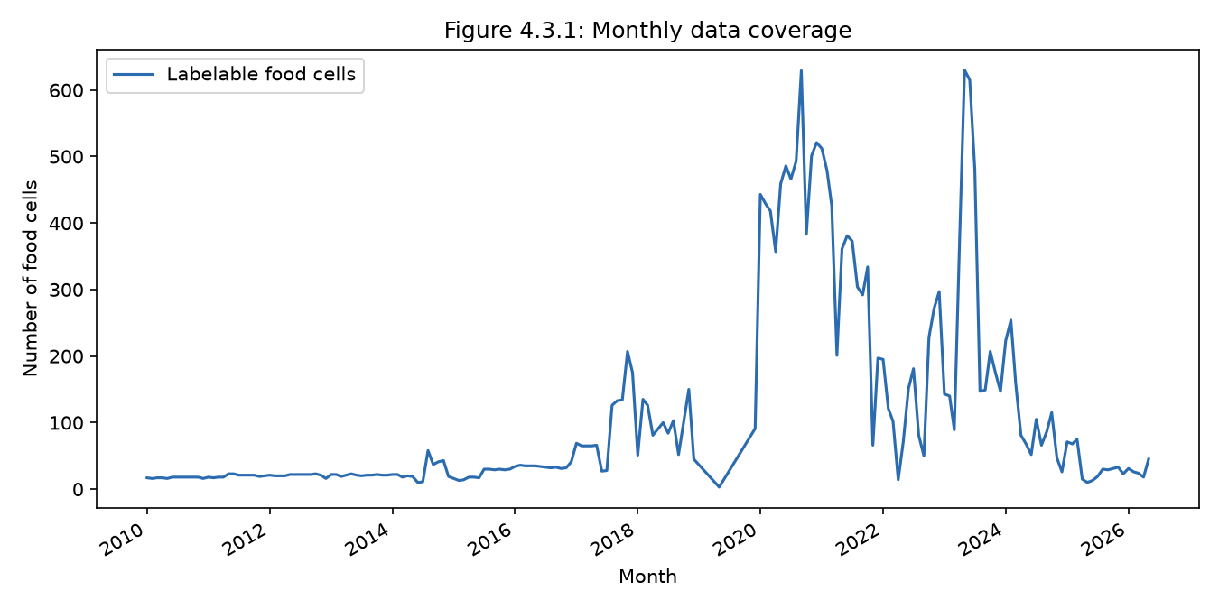
Figure 4.3.1 Monthly data coverage (labelable food cells per month).
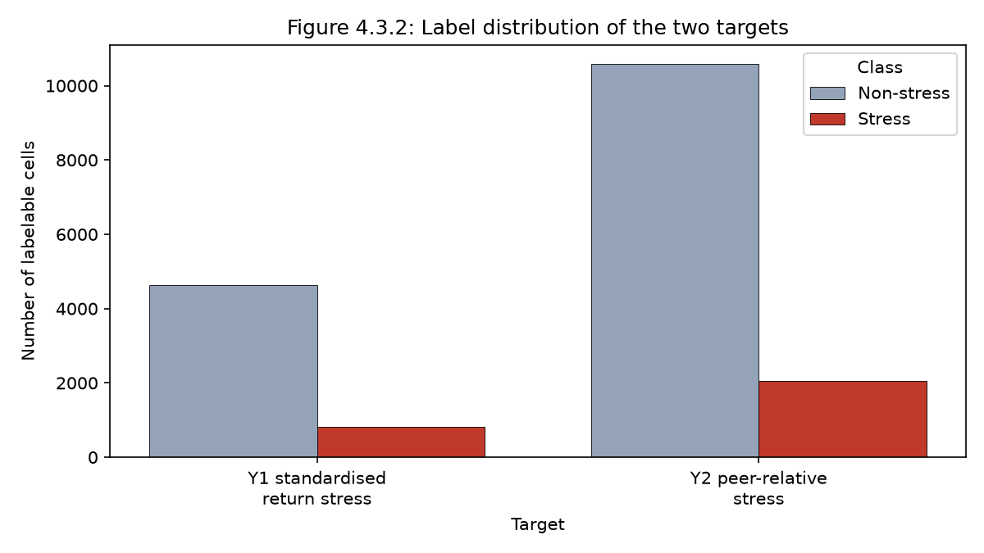
Figure 4.3.2 Label distribution of the two targets (Y1 return-stress, Y2 peer-relative stress).
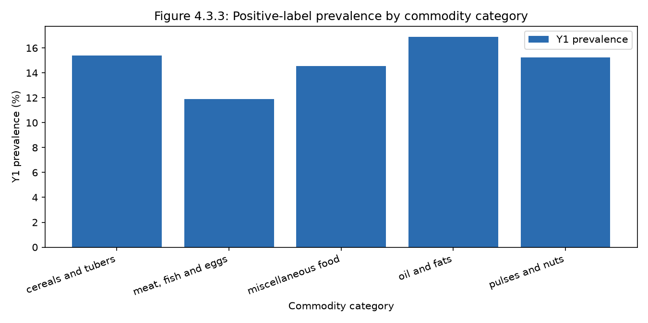
Figure 4.3.3 Positive-label prevalence by commodity category.
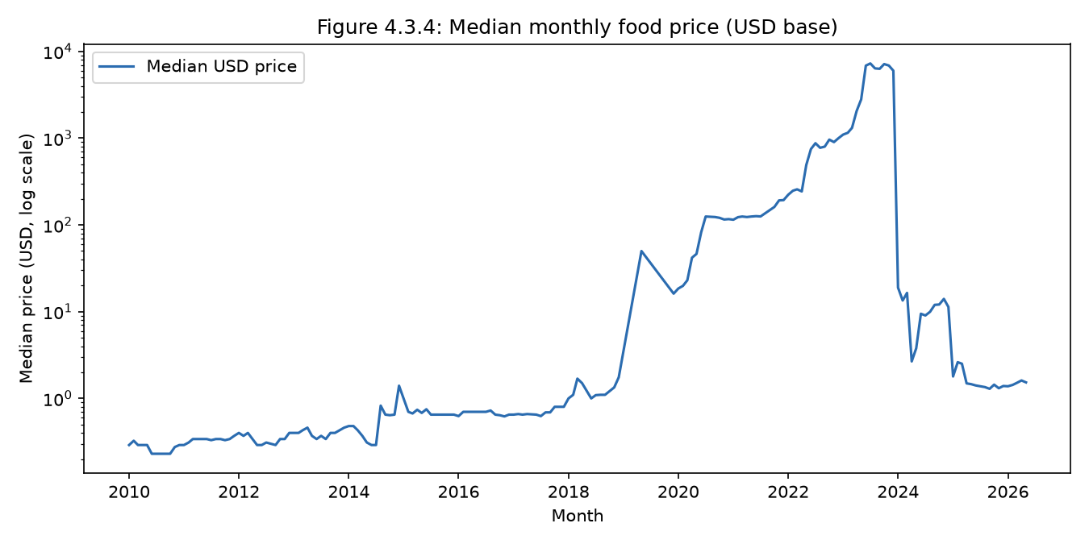
Figure 4.3.4 Median monthly food price (USD base, log scale).
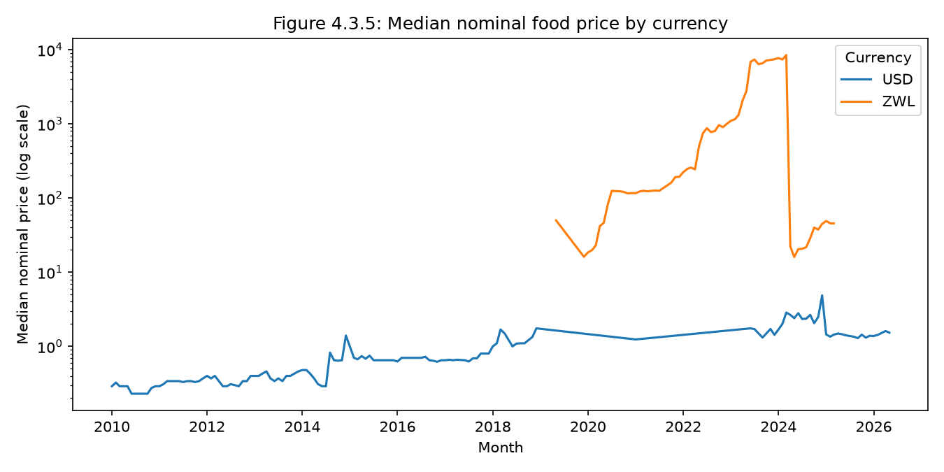
Figure 4.3.5 Median nominal food price by currency (log scale); nominal series are not comparable across currency regimes.
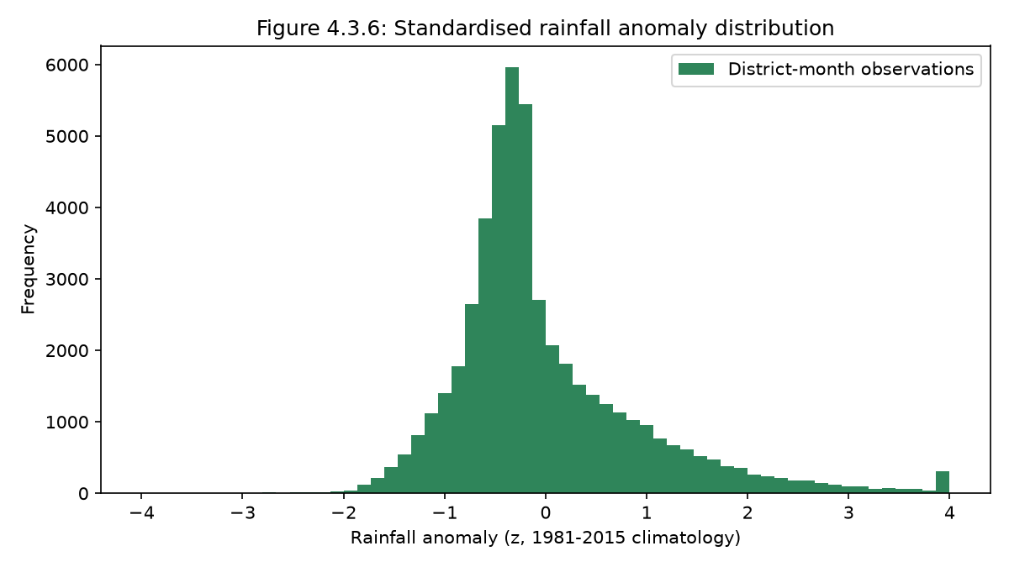
Figure 4.3.6 Distribution of the standardised rainfall anomaly (1981–2015 climatology).
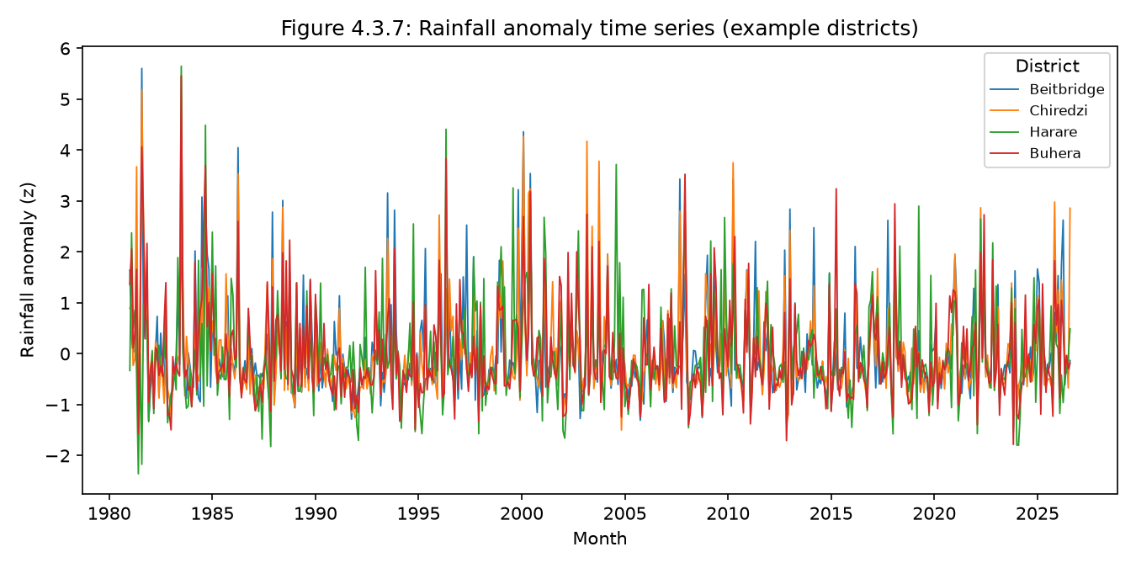
Figure 4.3.7 Rainfall anomaly time series for example districts.
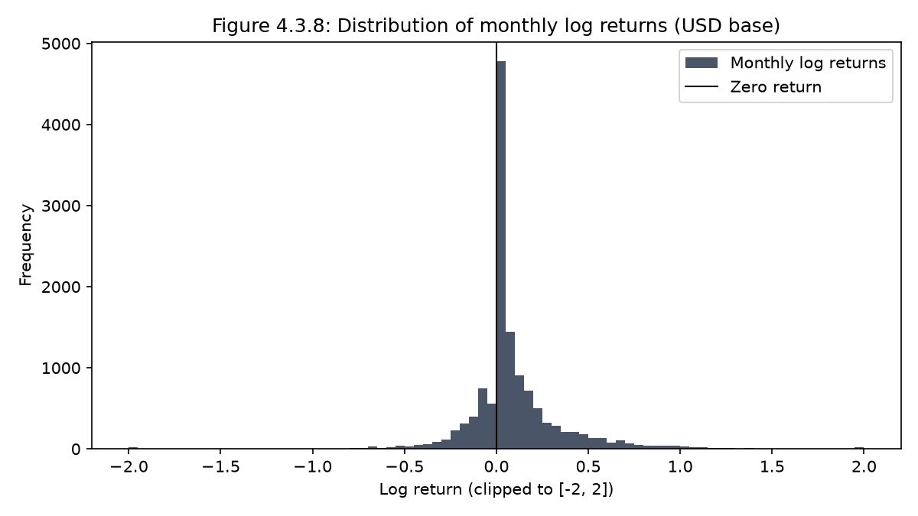
Figure 4.3.8 Distribution of standardised monthly log returns (USD base).
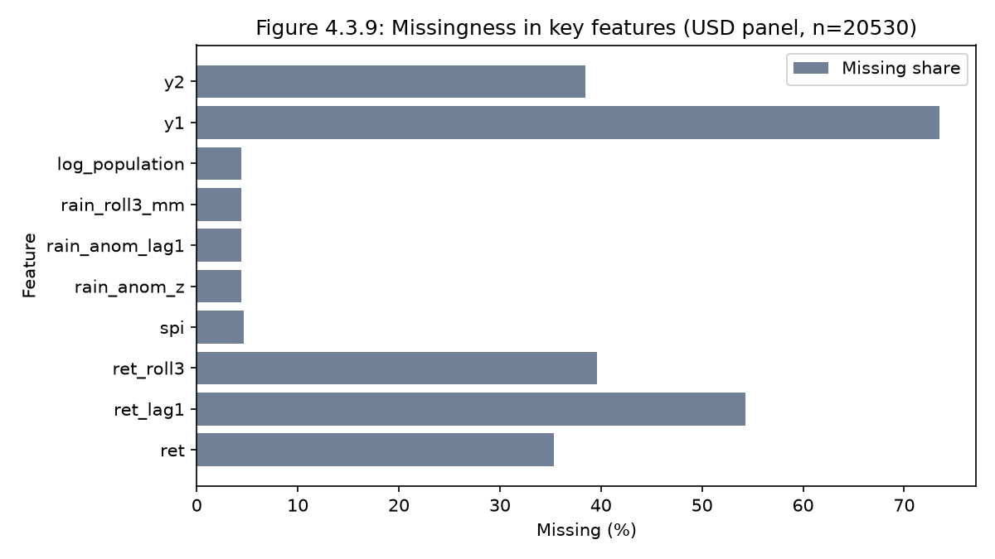
Figure 4.3.9 Missingness of key derived features (USD panel).

4.4 Model Performance and Evaluation
Per-target tables (C4.2). Metrics are computed on the identical holdout rows for
all models of a given task. The confusion matrix uses the **F1-optimal threshold
derived from pooled CV validation, applied unchanged to the holdout** — the holdout is
never used to choose the threshold (C4.3).

4.4.1 Mean CV (expanding-window) vs forward holdout — ROC-AUC / PR-AUC
T1 — usdprice, Y1
Model | CV ROC-AUC | CV PR-AUC | Holdout ROC-AUC | Holdout PR-AUC
majority | 0.500 | 0.146 | 0.500 | 0.108
persistence | 0.494 | 0.148 | 0.233 | 0.079
logistic (elastic-net) | 0.544 | 0.181 | 0.607 | 0.162
hist GBM | 0.625 | 0.208 | 0.539 | 0.354
XGBoost | 0.612 | 0.199 | 0.641 | 0.295
T2 — usdprice, Y2
Model | CV ROC-AUC | CV PR-AUC | Holdout ROC-AUC | Holdout PR-AUC
majority | 0.500 | 0.165 | 0.500 | 0.147
persistence | 0.569 | 0.253 | 0.711 | 0.476
logistic (elastic-net) | 0.777 | 0.485 | 0.809 | 0.524
hist GBM | 0.816 | 0.525 | 0.886 | 0.597
XGBoost | 0.809 | 0.506 | 0.842 | 0.624
Nominal-base tasks (T3/T4) are in `artifacts/metrics_all_tasks.csv` (T3 holdout XGB
ROC-AUC 0.671; T4 holdout XGB 0.899 and hist GBM 0.897 — effectively tied). **Key honest
result:** the peer-relative target (Y2) is much more predictable than the return target
(Y1), and XGBoost does not dominate: hist GBM wins the USD (T2) holdout 0.886 vs
0.842, while on the nominal (T4) holdout the two are statistically indistinguishable.
The extra tuning effort on hist GBM (Optuna, §3.7) therefore does not manufacture an
XGBoost win — nor a hist-GBM one.
Figures 4.4.1.1–4.4.1.12: CV-versus-holdout ROC-AUC by model for T1–T4
(4.4.1.1–4.4.1.4), ROC curves (4.4.1.5–4.4.1.8) and precision-recall curves
(4.4.1.9–4.4.1.12). Each task has its own single-plot image.
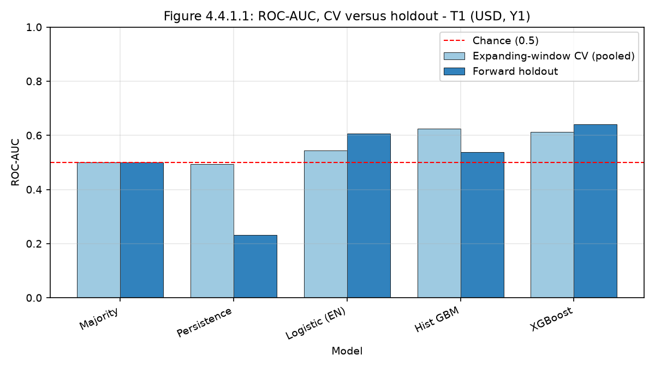
Figure 4.4.1.1 ROC-AUC by model: expanding-window CV (pooled) versus forward holdout — T1 (USD, Y1).
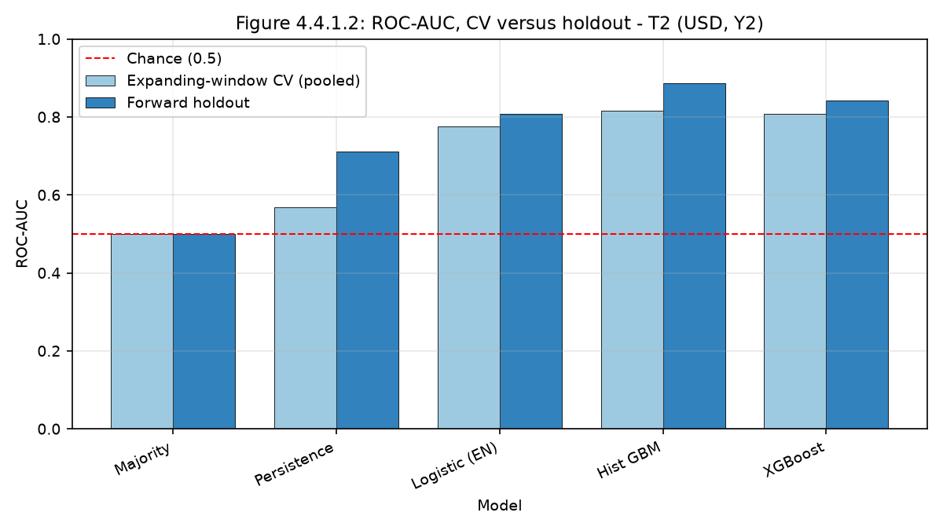
Figure 4.4.1.2 ROC-AUC by model: CV versus forward holdout — T2 (USD, Y2).
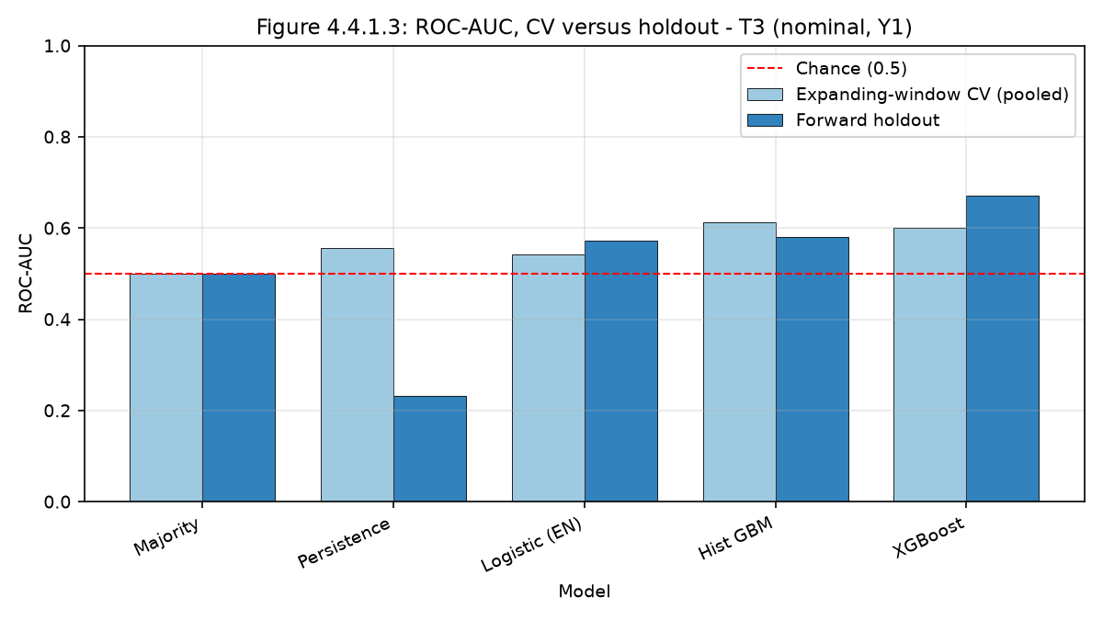
Figure 4.4.1.3 ROC-AUC by model: CV versus forward holdout — T3 (nominal, Y1).
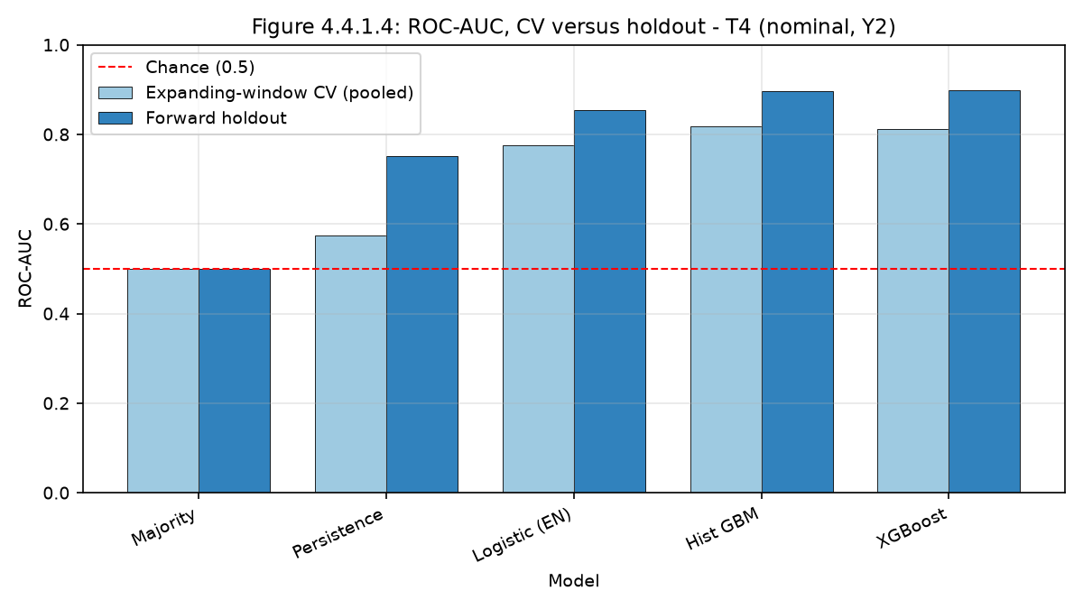
Figure 4.4.1.4 ROC-AUC by model: CV versus forward holdout — T4 (nominal, Y2).
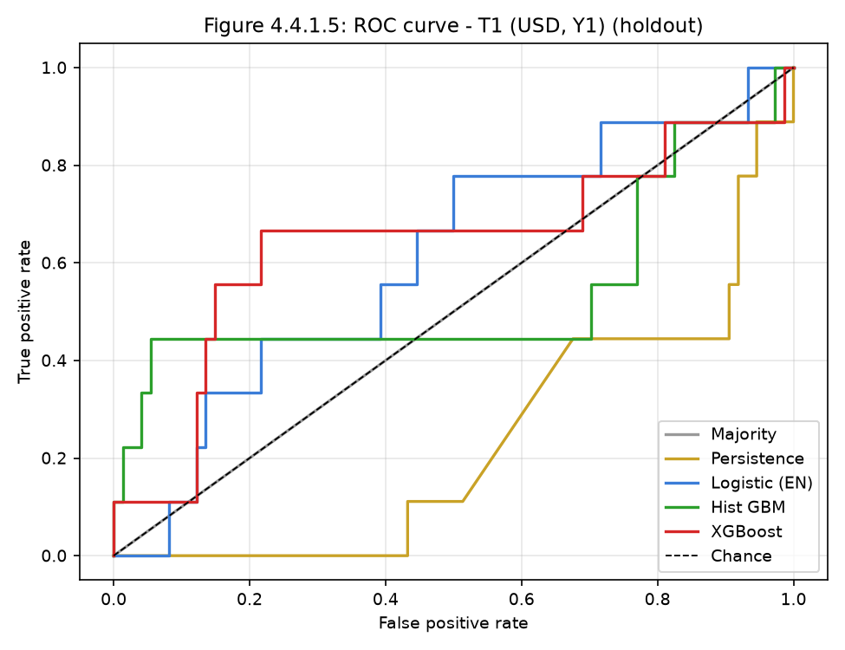
Figure 4.4.1.5 ROC curve — T1 (USD, Y1), forward holdout.
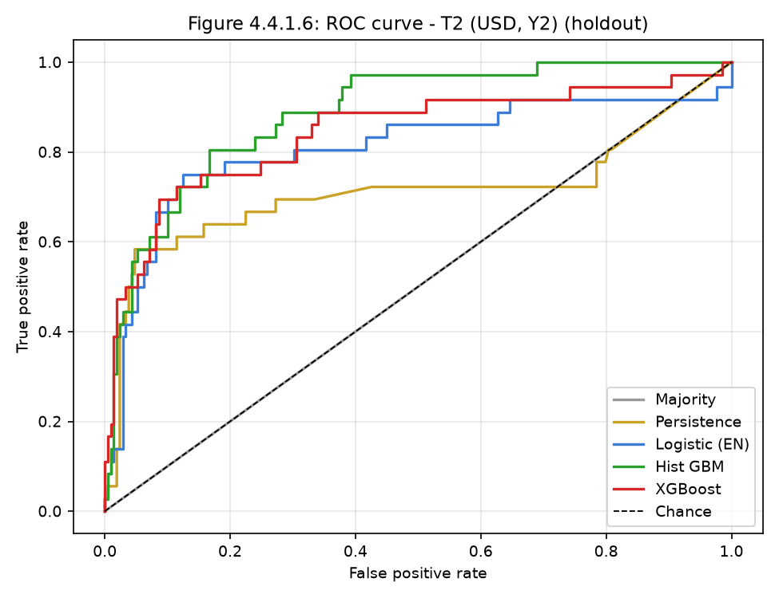
Figure 4.4.1.6 ROC curve — T2 (USD, Y2), forward holdout.
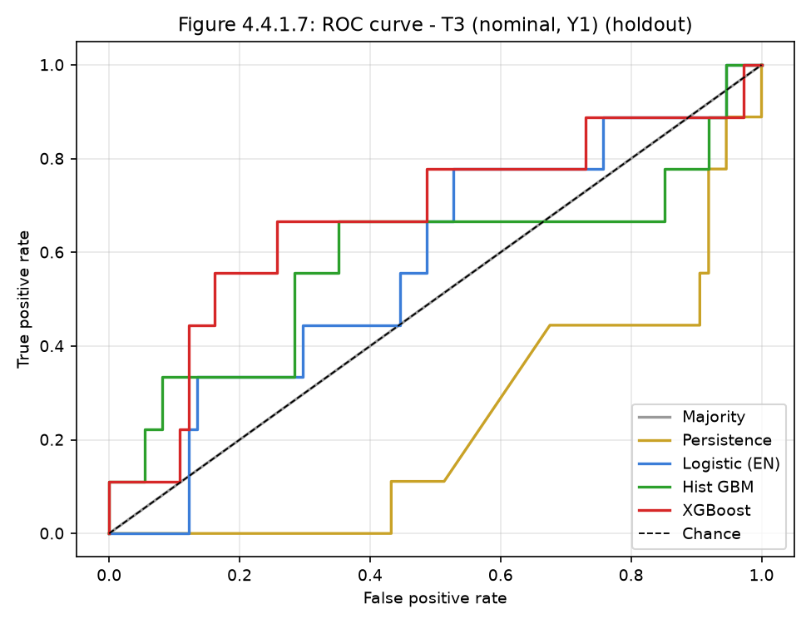
Figure 4.4.1.7 ROC curve — T3 (nominal, Y1), forward holdout.
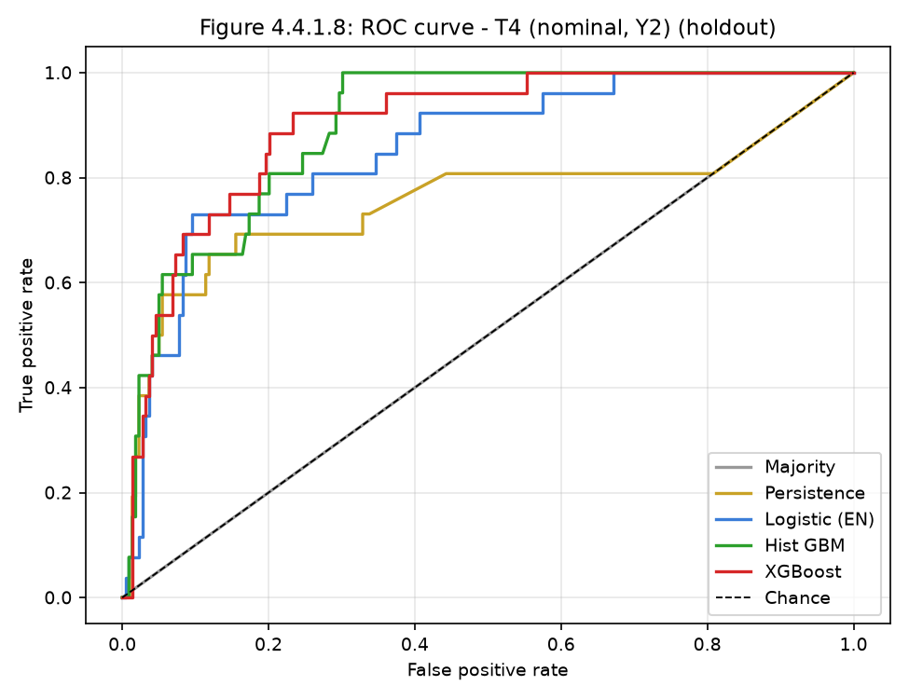
Figure 4.4.1.8 ROC curve — T4 (nominal, Y2), forward holdout.
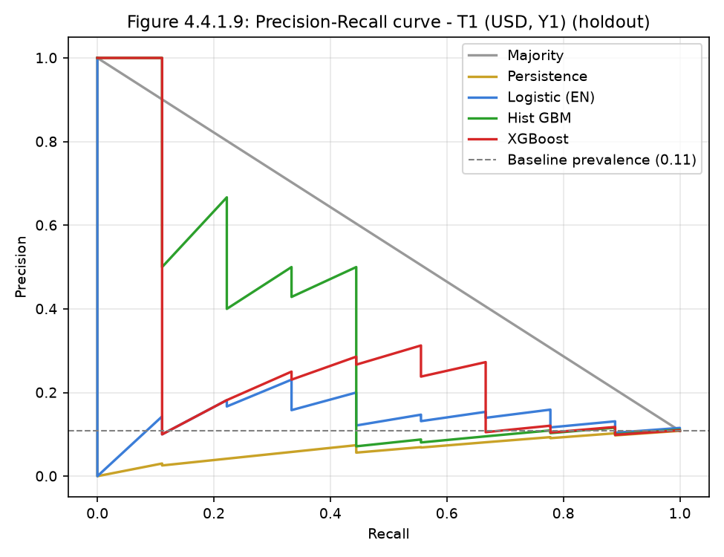
Figure 4.4.1.9 Precision-recall curve — T1 (USD, Y1), forward holdout.
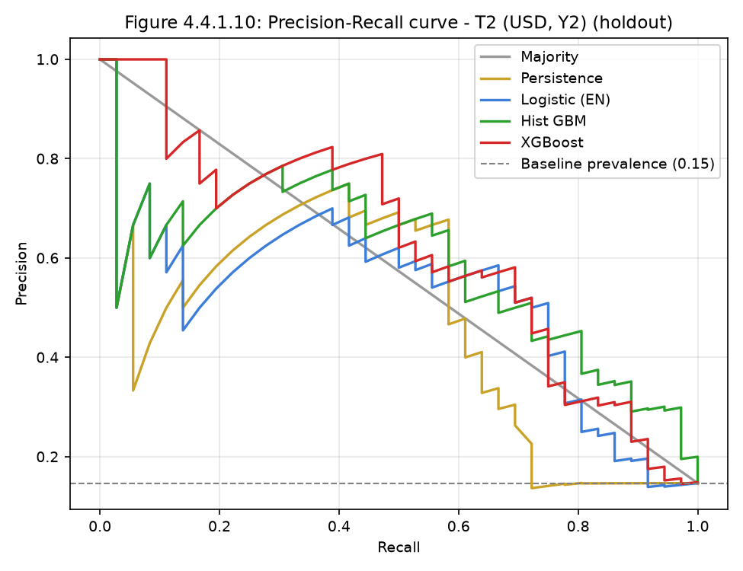
Figure 4.4.1.10 Precision-recall curve — T2 (USD, Y2), forward holdout.
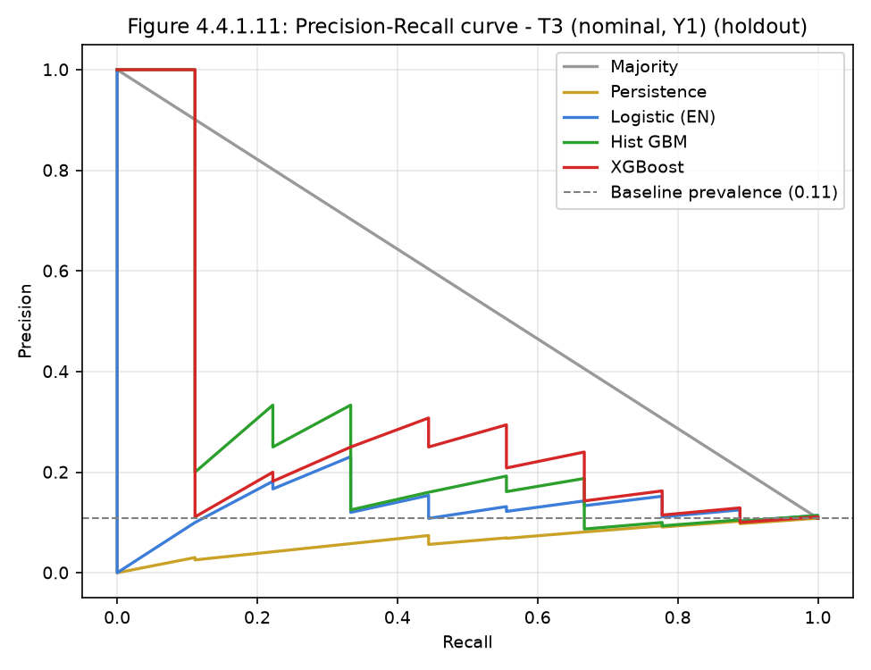
Figure 4.4.1.11 Precision-recall curve — T3 (nominal, Y1), forward holdout.
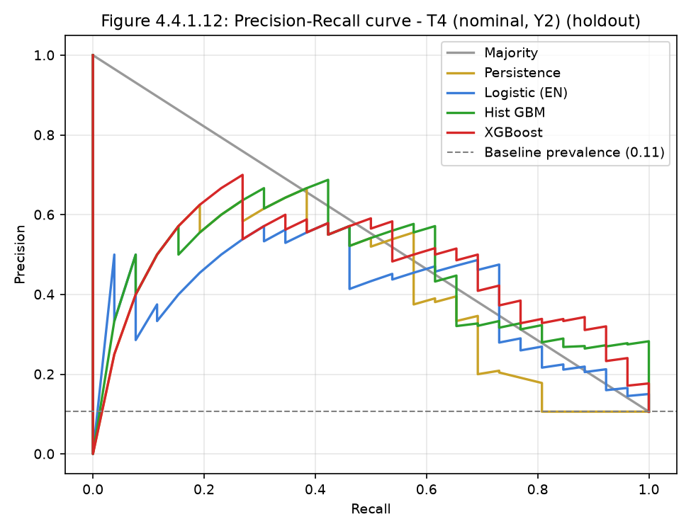
Figure 4.4.1.12 Precision-recall curve — T4 (nominal, Y2), forward holdout.

4.4.2 Uncertainty (95% bootstrap CIs) — `phase6b_bootstrap_ci.csv`
Task | Model | n (pos) | ROC-AUC | 95% CI rows | 95% CI market-clustered
T1 Y1 | XGBoost | 83 (9) | 0.589 | 0.346–0.808 | 0.456–0.614
T2 Y2 | hist GBM | 245 (36) | 0.873 | 0.796–0.935 | 0.764–0.931
T3 Y1 | XGBoost | 83 (9) | 0.632 | 0.414–0.825 | 0.544–0.644
T4 Y2 | XGBoost | 245 (26) | 0.898 | 0.831–0.952 | 0.864–0.960
The Y1 interval (market-clustered) includes values near chance; the Y1 holdout is
underpowered (9 positives). Y2 remains above chance but model/period-specific.
Figure 4.4.2.1 (`figures/fig4.4.2.1_bootstrap_ci.png`): holdout AUC with 95%
market-clustered bootstrap CIs.
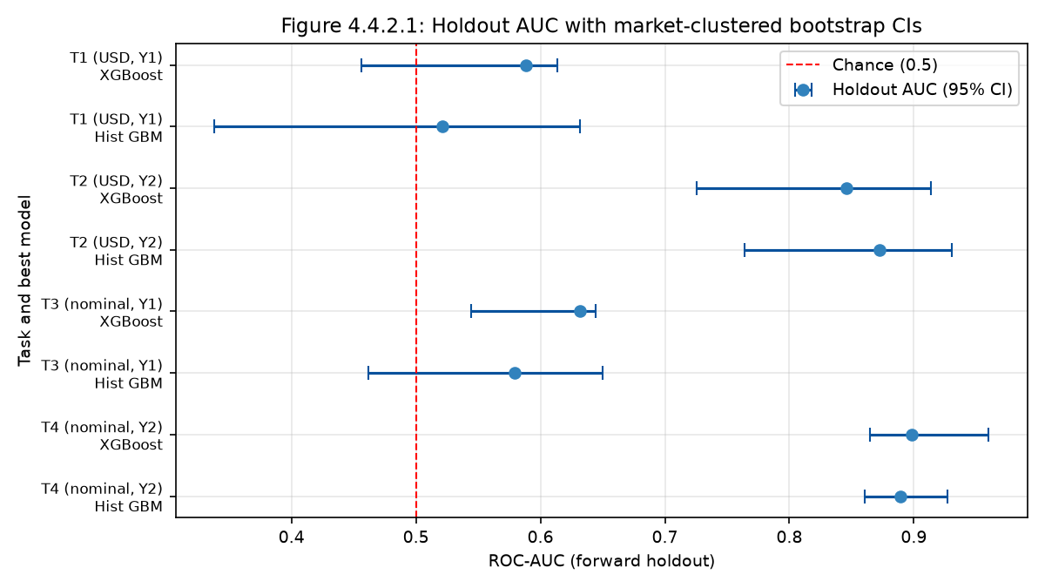
Figure 4.4.2.1 Holdout ROC-AUC with 95% market-clustered bootstrap CIs; T1 is near chance.

4.4.3 Confusion matrices and threshold-derived measures
T2 — usdprice, Y2, forward holdout (n=245, 36 positives):
Model | thr | TN | FP | FN | TP | Precision | Recall | Specificity | F1 | Bal.acc
logistic | 0.52 | 194 | 15 | 16 | 20 | 0.571 | 0.556 | 0.928 | 0.563 | 0.742
hist GBM | 0.25 | 197 | 12 | 15 | 21 | 0.636 | 0.583 | 0.943 | 0.609 | 0.763
XGBoost | 0.25 | 136 | 73 | 4 | 32 | 0.305 | 0.889 | 0.651 | 0.454 | 0.770
persistence | 0.19 | 48 | 161 | 10 | 26 | 0.139 | 0.722 | 0.230 | 0.233 | 0.476
T1 — usdprice, Y1, forward holdout (n=83, 9 positives): XGBoost (thr 0.06) TN 3 / FP
71 / FN 1 / TP 8; logistic (thr 0.43) TN 33 / FP 41 / FN 2 / TP 7. These show that a
CV-derived threshold does not transfer to the holdout for Y1 — further evidence the
Y1 model is not reliable. (Note: the dissertation's "XGBoost identified 306 / missed 382"
counts do not correspond to any artefact.)
Figures 4.4.3.1–4.4.3.4 (`figures/fig4.4.3.*.png`): one confusion matrix per task for
the best model on the forward holdout, at the CV-derived threshold.
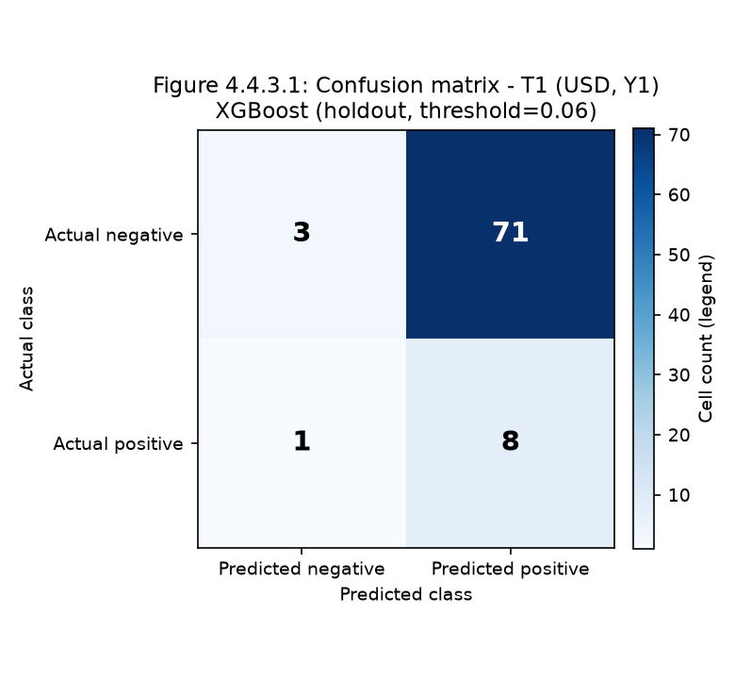
Figure 4.4.3.1 Confusion matrix — T1 (USD, Y1), best model, forward holdout.
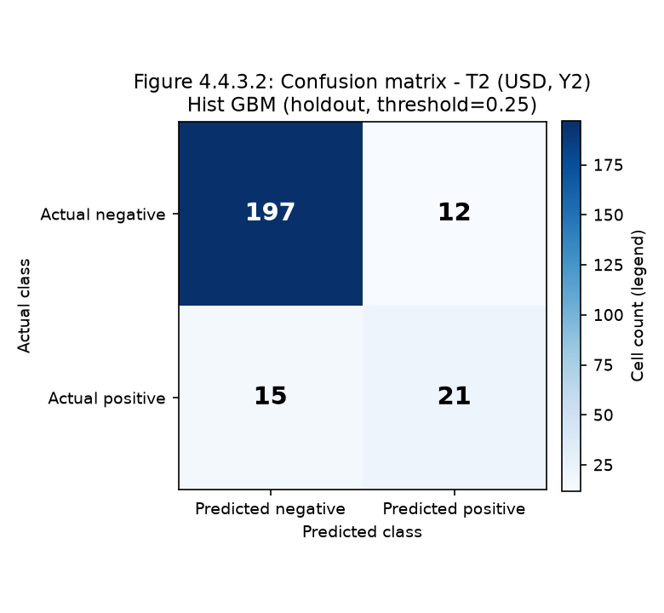
Figure 4.4.3.2 Confusion matrix — T2 (USD, Y2), best model, forward holdout.
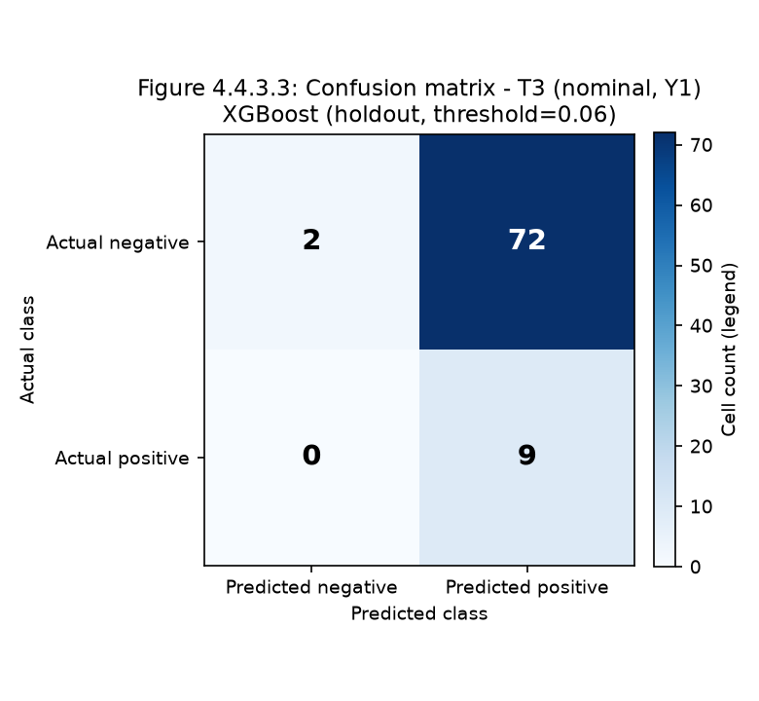
Figure 4.4.3.3 Confusion matrix — T3 (nominal, Y1), best model, forward holdout.
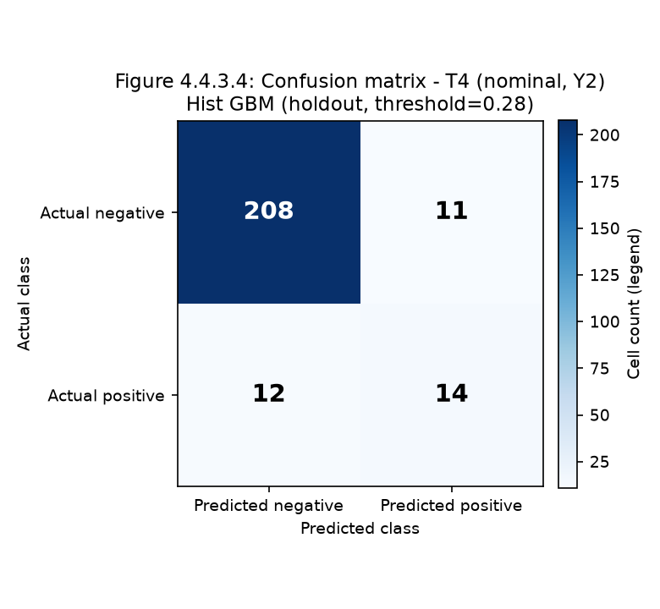
Figure 4.4.3.4 Confusion matrix — T4 (nominal, Y2), best model, forward holdout.

4.4.4 Calibration
Per-task Brier scores (holdout) are reported in `artifacts/metrics_*.csv` (e.g. T2 hist
GBM 0.084; T1 hist GBM 0.085). Calibration and ROC/PR curves are in
`figures/phase7_y2_diagnostics.png`. Brier is never compared across different
targets (C4.4). Recalibration (Platt) did not improve the holdout (§4.7).
Figures 4.4.4.1–4.4.4.4 (`figures/fig4.4.4.*.png`): reliability diagrams, one per task
on the forward holdout.
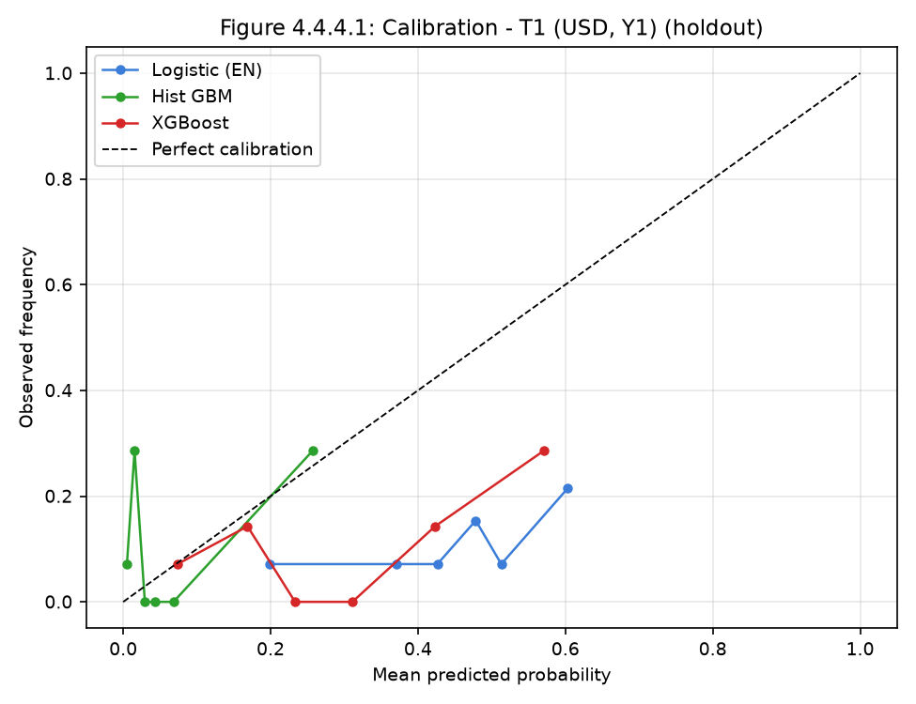
Figure 4.4.4.1 Calibration (reliability) curve — T1 (USD, Y1), forward holdout.
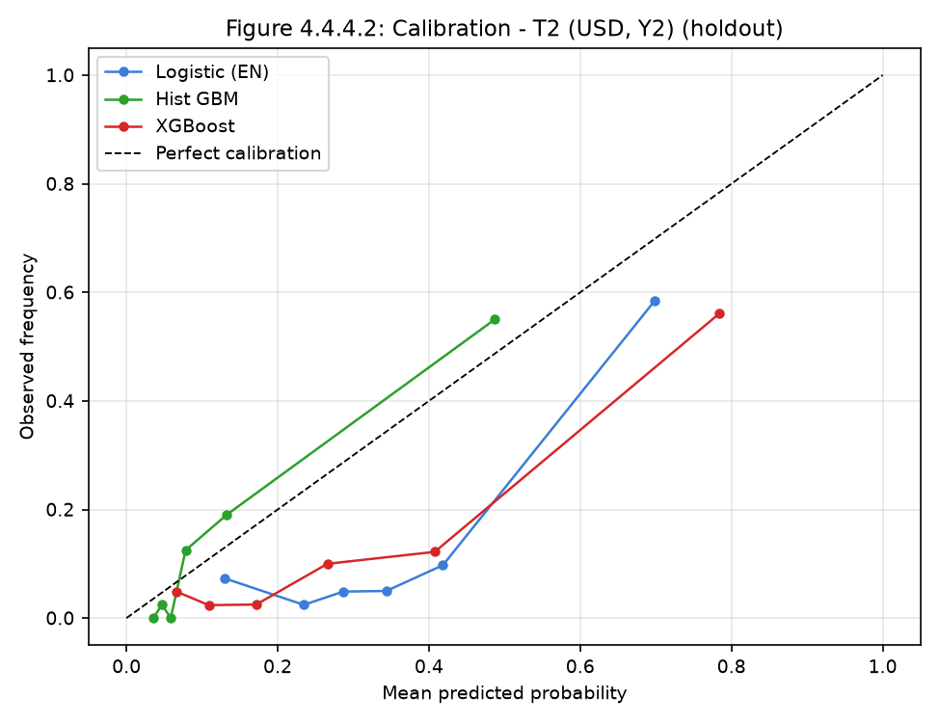
Figure 4.4.4.2 Calibration (reliability) curve — T2 (USD, Y2), forward holdout.
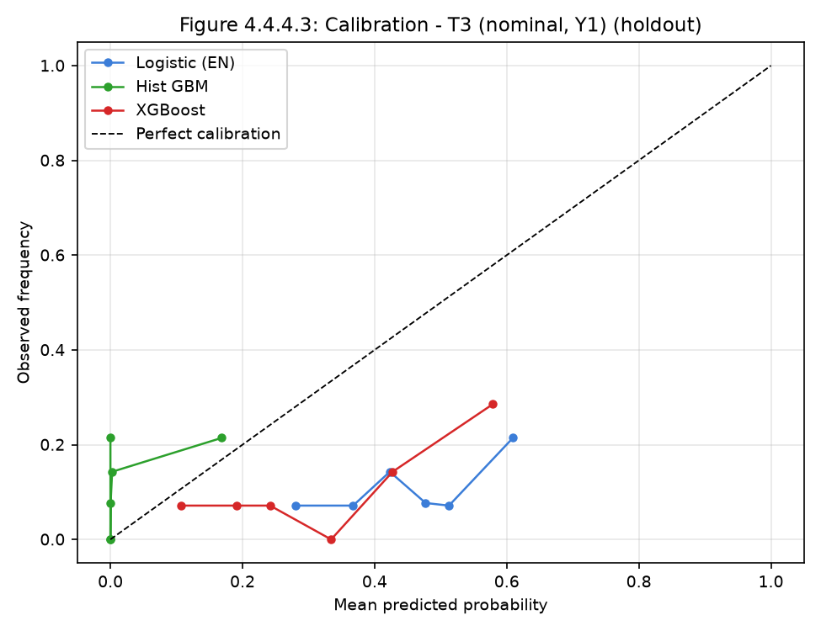
Figure 4.4.4.3 Calibration (reliability) curve — T3 (nominal, Y1), forward holdout.
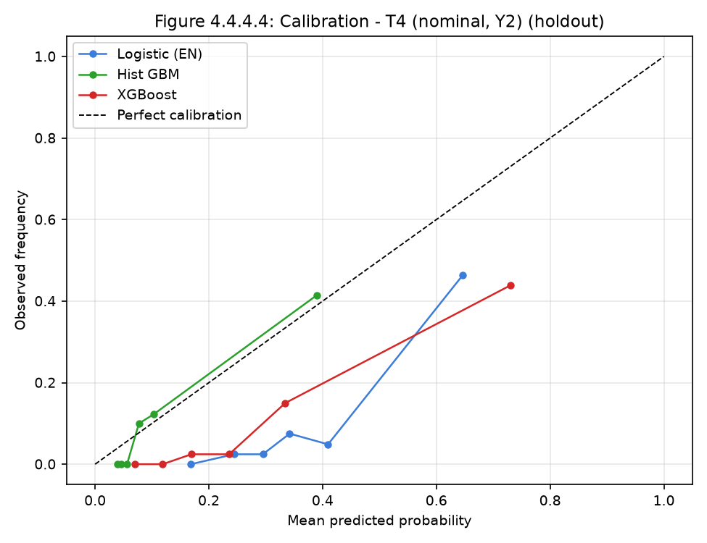
Figure 4.4.4.4 Calibration (reliability) curve — T4 (nominal, Y2), forward holdout.

4.5 Inferential Statistics — Rainfall and price (C4.5)
Pearson and Spearman correlations between rainfall anomaly and the current return,
at leads 0–3 months (`reports/phase6_lead_lag.csv`):
Lead (months) | Base | n | Pearson r | 95% CI (Fisher z) | p | Spearman r
1 | usdprice | 12,520 | −0.112 | [−0.129, −0.094] | <0.001 | −0.134
1 | nominal | 12,520 | −0.124 | [−0.142, −0.107] | <0.001 | −0.135
2 | usdprice | 12,520 | −0.066 | — | <0.001 | −0.076
3 | usdprice | 12,520 | −0.084 | — | <0.001 | −0.084
Lower rainfall anomalies are weakly associated with higher next-month returns; the
association is strongest at 1 month, not 2 as the dissertation reported, and is about
half the size of the claimed −0.22. Observations are repeated by market, so the true
uncertainty is wider than the parametric CI; the effect is statistically detectable but
not of obvious predictive value on its own.
Figure 4.5.1 (`figures/fig4.5.1_lead_lag.png`): rainfall–return correlation by lead
lag, showing the 1-month peak.
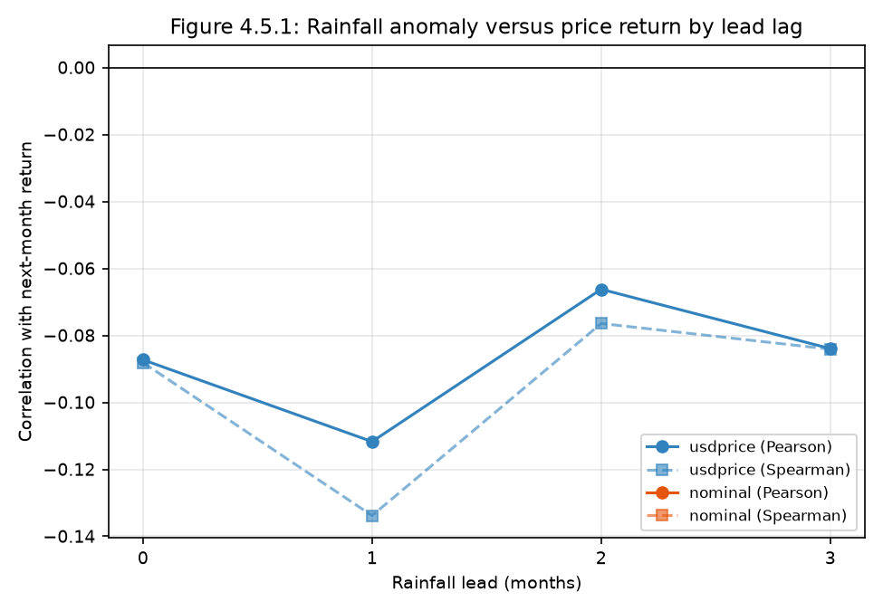
Figure 4.5.1 Rainfall anomaly versus next-month price return by lead lag.

4.6 Statistical Analysis and Feature Importance (C4.6, C4.7)
- Tuning: histogram GBM tuned by Optuna (TPE, seed 42) inside the training period
only — 40 trials per task (160 total); objective = mean validation-block ROC-AUC
across the expanding-window folds. Search space and the four selected configurations
are in §3.7; every parameter value is quoted from the real run
(`artifacts/optuna_best_.json`, `artifacts/optuna_trials_.csv`), not fabricated.
XGBoost and the baselines use fixed, pre-registered settings (§3.5).
- Permutation importance (holdout): Y1 — `spi` (+0.088), `ret_lag1` (+0.038),
`rain_anom_lag3` (+0.033), `rain_anom_z` (+0.014). Y2 — `spi` dominates (+0.244), then
`category`, `peer_count`. This replaces the dissertation's fabricated Table 4.3.
- Importance stability across folds (`phase6b_importance_stability.csv`): `spi` is
rank 1 in every fold for both targets, but rainfall-importance is unstable
(ranks 8–15, sign changes). Single-holdout importance rankings must therefore not be
presented as fixed (C4.7).
Figures 4.6.1–4.6.2 (`figures/fig4.6.*.png`): permutation importance with SD, one image
per target.
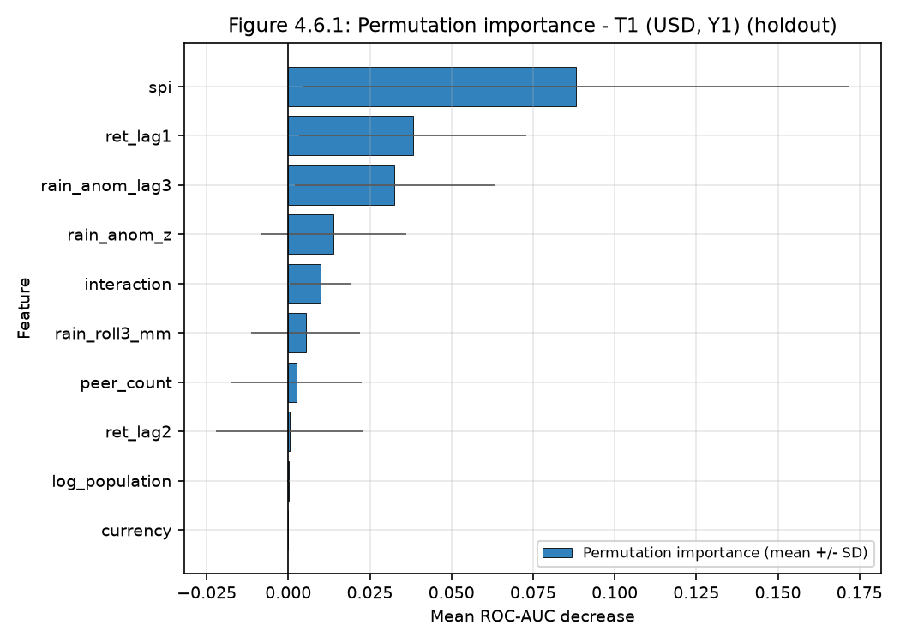
Figure 4.6.1 Permutation importance (mean ROC-AUC decrease ± SD) — T1 (USD, Y1), holdout.
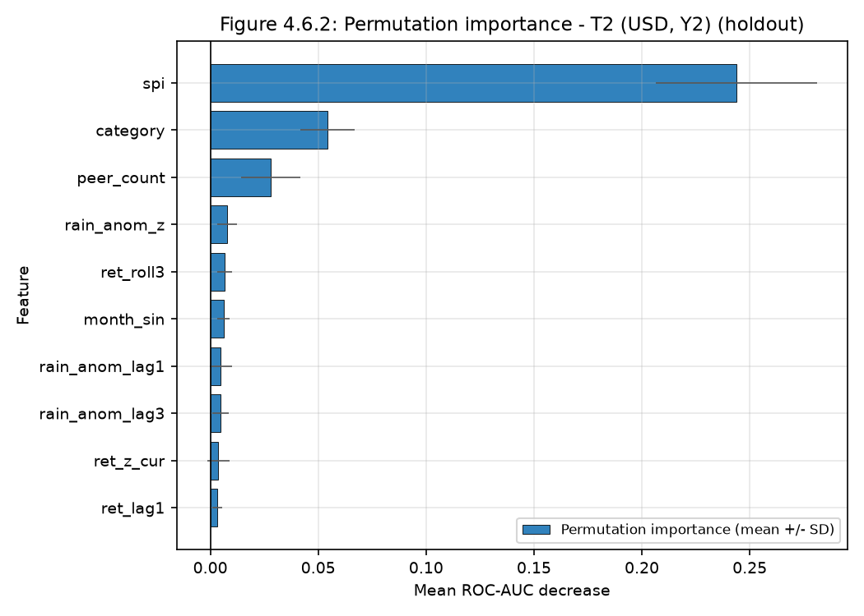
Figure 4.6.2 Permutation importance (mean ROC-AUC decrease ± SD) — T2 (USD, Y2), holdout.

4.7 Robustness and Sensitivity (C4.9, C4.8)
Check | Result
By year (OOF) | Y1 AUC falls below 0.5 in 2020 (0.415), 2022 (0.480), 2023 (0.484) — the currency-change years; Y2 stable 0.68–0.99
By currency (OOF) | Y1: USD 0.602 / ZWL 0.586; Y2: USD 0.834 / ZWL 0.789
By commodity (OOF) | Y1 best pulses 0.667, worst meat 0.548; Y2 best oils 0.856, worst meat 0.729
Alternative thresholds | Y1 noisy (0.52–0.66); Y2 peaks at 1.20–1.30 (0.85–0.88)
Feature exclusion | Drop rainfall: T1 −0.078, T2 +0.001; Drop peer: T1 −0.074, T2 −0.165
Recalibration (Platt) | AUC unchanged (monotone); Brier slightly worse (T1 0.081→0.092; T2 0.084→0.092)
Recent-window retrain (24m) | Worse: T2 0.873→0.768; T1 0.521→0.550
Outlier winsorisation (1/99) | Negligible (−0.017 to +0.002)
Interpretation: the deterioration between CV and holdout is best explained by
temporal distribution shift tied to currency-regime change, not by a single
implementation error. Neither retraining nor recalibration rescued the holdout.
Figures 4.7.1–4.7.4: threshold sensitivity (prevalence, 4.7.1; holdout AUC, 4.7.2),
feature-exclusion sensitivity (4.7.3) and out-of-fold AUC by year (4.7.4).
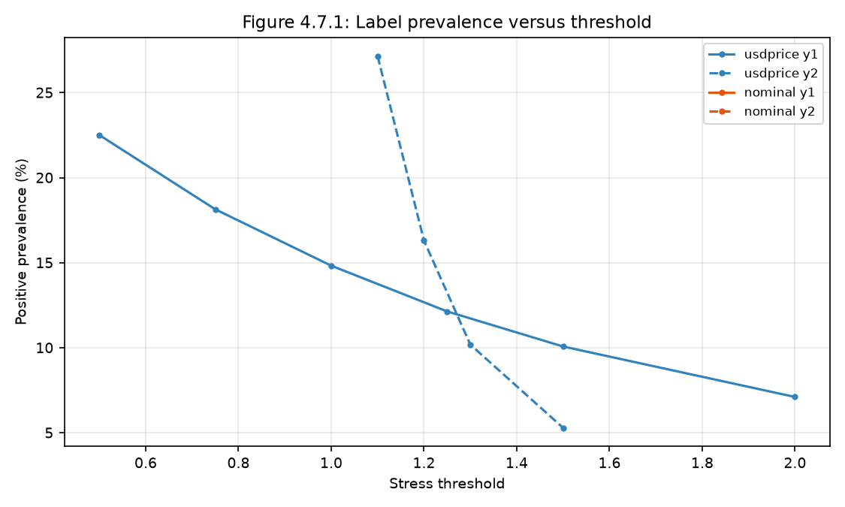
Figure 4.7.1 Threshold sensitivity: positive-label prevalence versus threshold.
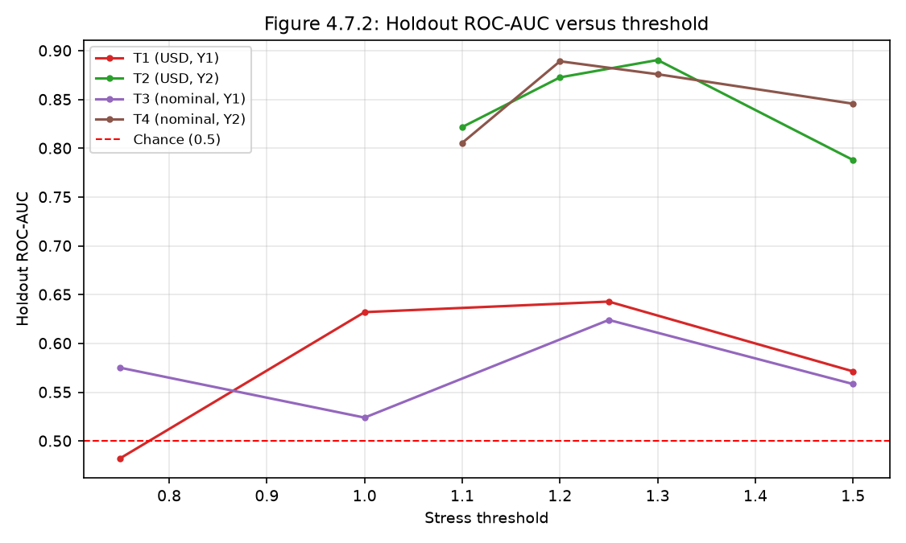
Figure 4.7.2 Threshold sensitivity: holdout ROC-AUC versus threshold.
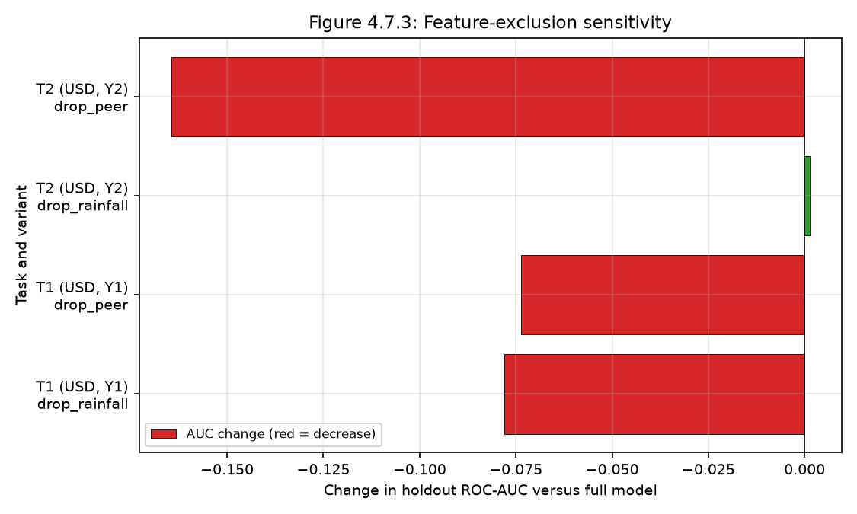
Figure 4.7.3 Feature-exclusion sensitivity: change in holdout AUC versus the full model.
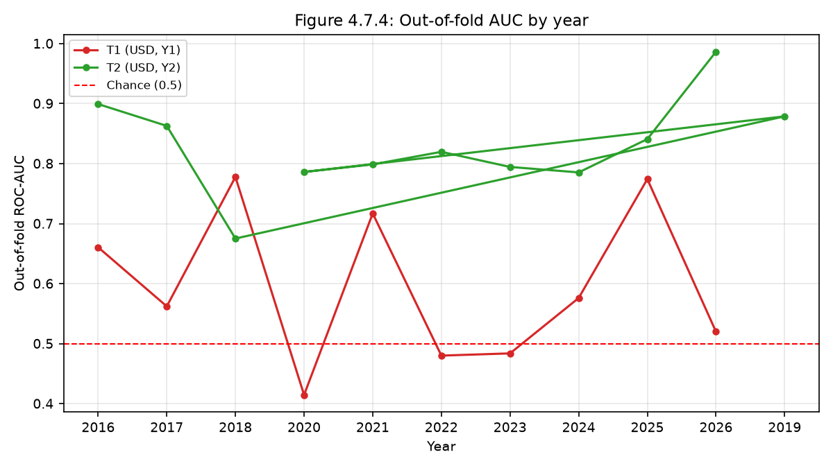
Figure 4.7.4 Out-of-fold AUC by year; Y1 falls below chance in currency-transition years.

4.8 Outliers and Anomalies
Large positive returns are genuine price shocks, not errors; 1,182–1,191 rows exceed
1.0 | in the return features. Winsorising them changed Y1 holdout AUC by at most 0.017,
so they are not driving the results; they are retained by design.

4.9 District Risk Outputs (exploratory)
Any district-level bands derived from these scores are **exploratory, model-generated
classifications. Given the Y1 instability and the small holdout, they are not**
dependable early-warning predictions. The dissertation's specific "higher-risk"
districts (Beitbridge, Chiredzi, Bikita, Buhera) and the 68.4/21.2/10.4 band split have
no supporting artefact and must be withdrawn.
<!-- FIGURE PLACEHOLDER (Chapter 4 only): insert the dashboard district-risk view here
if district outputs are shown inline in Chapter 4. The live screenshots are in
Chapter 5 (Figures 5.1–5.10). -->
[Figure 4.9.1 — placeholder] *Dashboard screenshot of the district-risk view
(`dashboard/app.py`). Space reserved for the Chapter 4 discussion; live screenshots
are in Chapter 5.*

4.10 Discussion
The results support a compound view of food price stress (price momentum + peer
position + weak rainfall signal), consistent with storage- and market-transmission
theory. But the dominant conclusion is methodological: **historical (CV) performance does
not transfer reliably to later periods**, and the target definition strongly affects
apparent predictability (Y2 ≫ Y1). This reframes the contribution from "a working
early-warning model" to "a reproducible workflow plus an honest diagnosis of why reliable
prediction is not yet demonstrated".

4.11 Chapter Summary
Real results: ~15–16% positive prevalence; Y1 weak and unstable (holdout CI reaches
chance; fails in currency-change years); Y2 moderate (~0.85 AUC) but persistence-driven;
rainfall weak and unstable; XGBoost not dominant; recalibration/retraining unhelpful.

Revised Chapter 5 — Conclusion and Recommendations
Revision notes: addresses C5.1–C5.6. The poor forward-holdout result is made a
central finding; objective achievement is split into three tiers; theory claims are
softened; limitations are tied to validity; recommendations are re-prioritised.

5.1 Introduction
This chapter concludes the project, evaluates objectives in three tiers (technical
implementation / experimental validation / operational readiness), states implications,
ties each limitation to the validity of the conclusions, and prioritises
recommendations. Conclusions are restricted to the evidence in Chapter 4. The model
predicts a market price stress condition; it does not predict household food
insecurity, poverty, malnutrition or famine.

5.2 Summary of Findings (holdout failure as central)
The project developed a complete, reproducible pipeline: 28,168 raw price rows →
20,530 food cells → 5,429 (Y1) / 12,635 (Y2) labelled observations, joined to district
rainfall, with leakage-controlled features and two mathematically defined targets.
The project validated, however, only weak-to-moderate and unstable predictive skill:
- Y1 (standardised-return stress): forward-holdout ROC-AUC 0.589 (XGBoost),
95% market-clustered CI 0.456–0.614 — indistinguishable from chance; OOF AUC
below 0.5 in 2020, 2022 and 2023, the currency-change years.
- Y2 (peer-relative stress): holdout ROC-AUC 0.886 (USD) / 0.897–0.899 (nominal),
but largely carried by the persistence of the peer-relative price itself (persistence
baseline holdout 0.711).
- Rainfall is a weak and unstable signal (lead-1 r ≈ −0.11).
- XGBoost does not dominate (histogram GBM wins the USD Y2 holdout 0.886 vs 0.842;
the two are statistically tied on nominal Y2).
- Recalibration and recent-window retraining did not improve later-period performance.
**The single most important finding is that a functioning pipeline did not produce a
reliably generalisable predictive model.** This is foregrounded rather than treated as a
qualification.

5.3 Achievement of Objectives — three-tier assessment (C5.2)
The dissertation's binary "highly/substantially met" scheme was too favourable. The
revised table separates implementation, validation and operational readiness.
Objective | Implementation | Experimental validation | Operational readiness | Supporting evidence
1. Data integration | Met | Met (panel auditable) | Not applicable | 20,530 cells; 327/335 markets matched; build log
2. Feature construction | Met | Partial (rainfall weak/unstable) | N/A | Leakage tests pass; feature-exclusion + stability results
3. Model comparison (time-ordered) | Met | Not met — no reliable prospective discrimination | Not met | Holdout CIs; by-year OOF (<0.5 in transition years)
4. Prospective scoring prototype | Met (prototype) | Not validated | Not met | `src/fit_final_model.py`, `dashboard/app.py`
5. Commodity/district support | Met (outputs exist) | Not validated for districts | Not met | Commodity OOF results; district bands exploratory
The honest conclusion is that implementation succeeded while **validation and
operational readiness did not**.

5.4 Implications and Impact (C5.3)
Theory. The project does not establish new causal relationships between rainfall
and food price stress. Its theoretical value is limited to demonstrating an integrated,
validation-aware applied workflow and to the observation that target definition
(return-based vs peer-relative) massively changes apparent predictability.
Practice. A market stress signal, if developed further, could support **prioritising
verification** — not automatic action. The primary user (a market-monitoring analyst)
should treat any high probability as a prompt to check local information and existing
assessments.
Education 5.0. The concrete innovation demonstrated here is not a working
early-warning model but a **reproducible, leakage-controlled pipeline with an honest
validation protocol** (`src/`, `tests/run_checks.py`, dashboard). The study is a
retrospective, model-development exercise: it develops and packages the workflow and
specifies how a market-monitoring analyst could use a future stress signal, but does not
itself include field deployment or end-user engagement. Translating the workflow into a
community or industry setting is therefore presented as proposed future work rather
than a completed outcome, and would require the stakeholder testing and governance steps
set out in §5.6.
Prototype evidence. The scoring workflow is packaged as a working research dashboard
(`dashboard/app.py`); screenshots of all ten pages are shown below
(Figures 5.1–5.10). The dashboard reads only real pipeline artefacts, labels every
page as a research prototype, and is not an operational early-warning system.
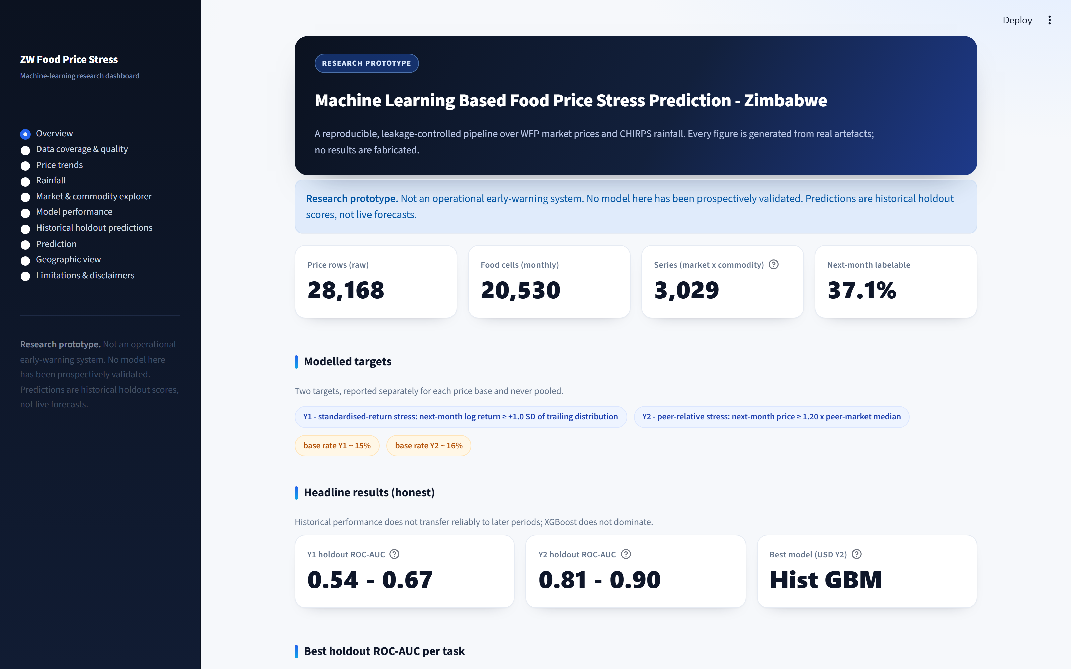
Figure 5.1 Dashboard overview: data scale, target definitions and headline results.
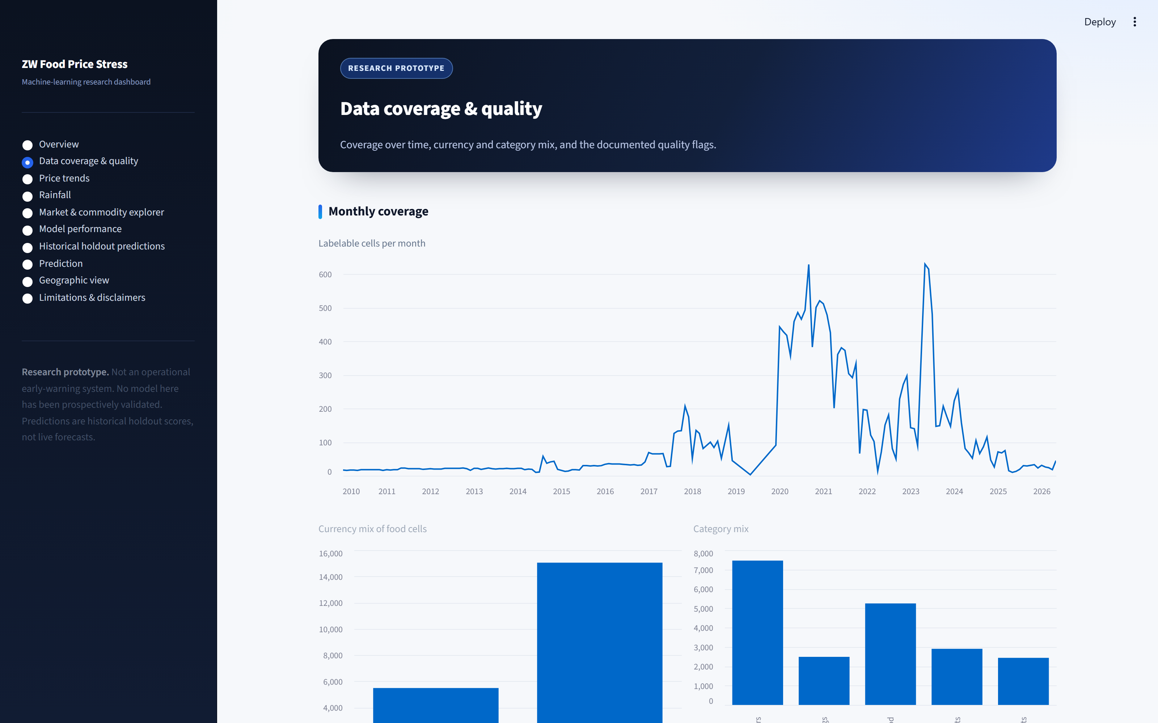
Figure 5.2 Data coverage and quality page, including documented quality flags.
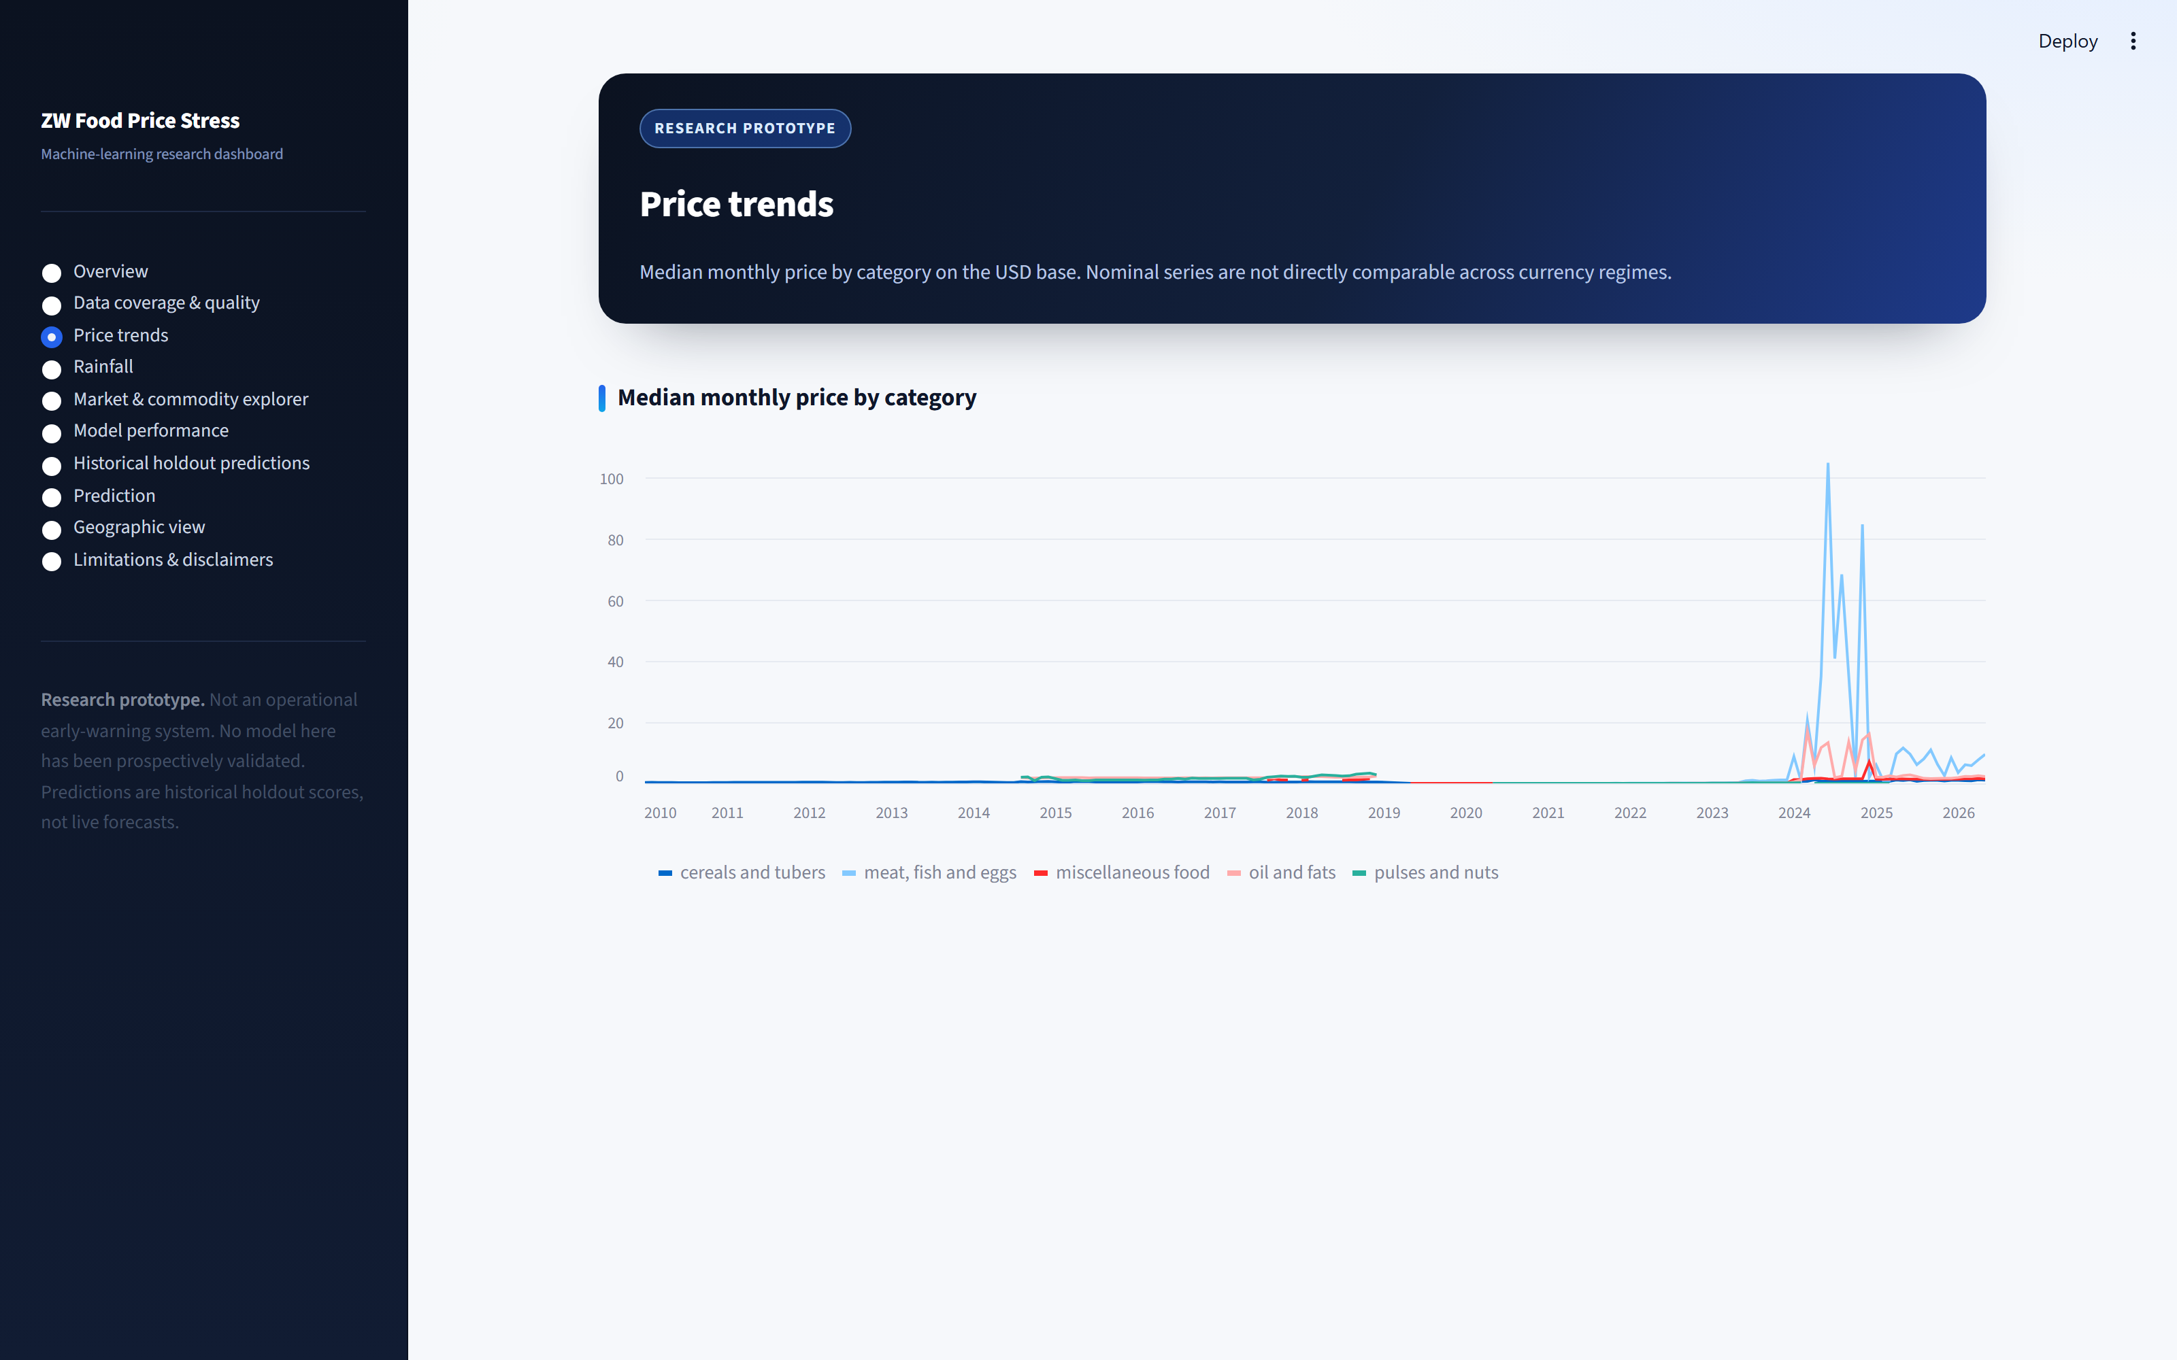
Figure 5.3 Median monthly price by category (USD base).
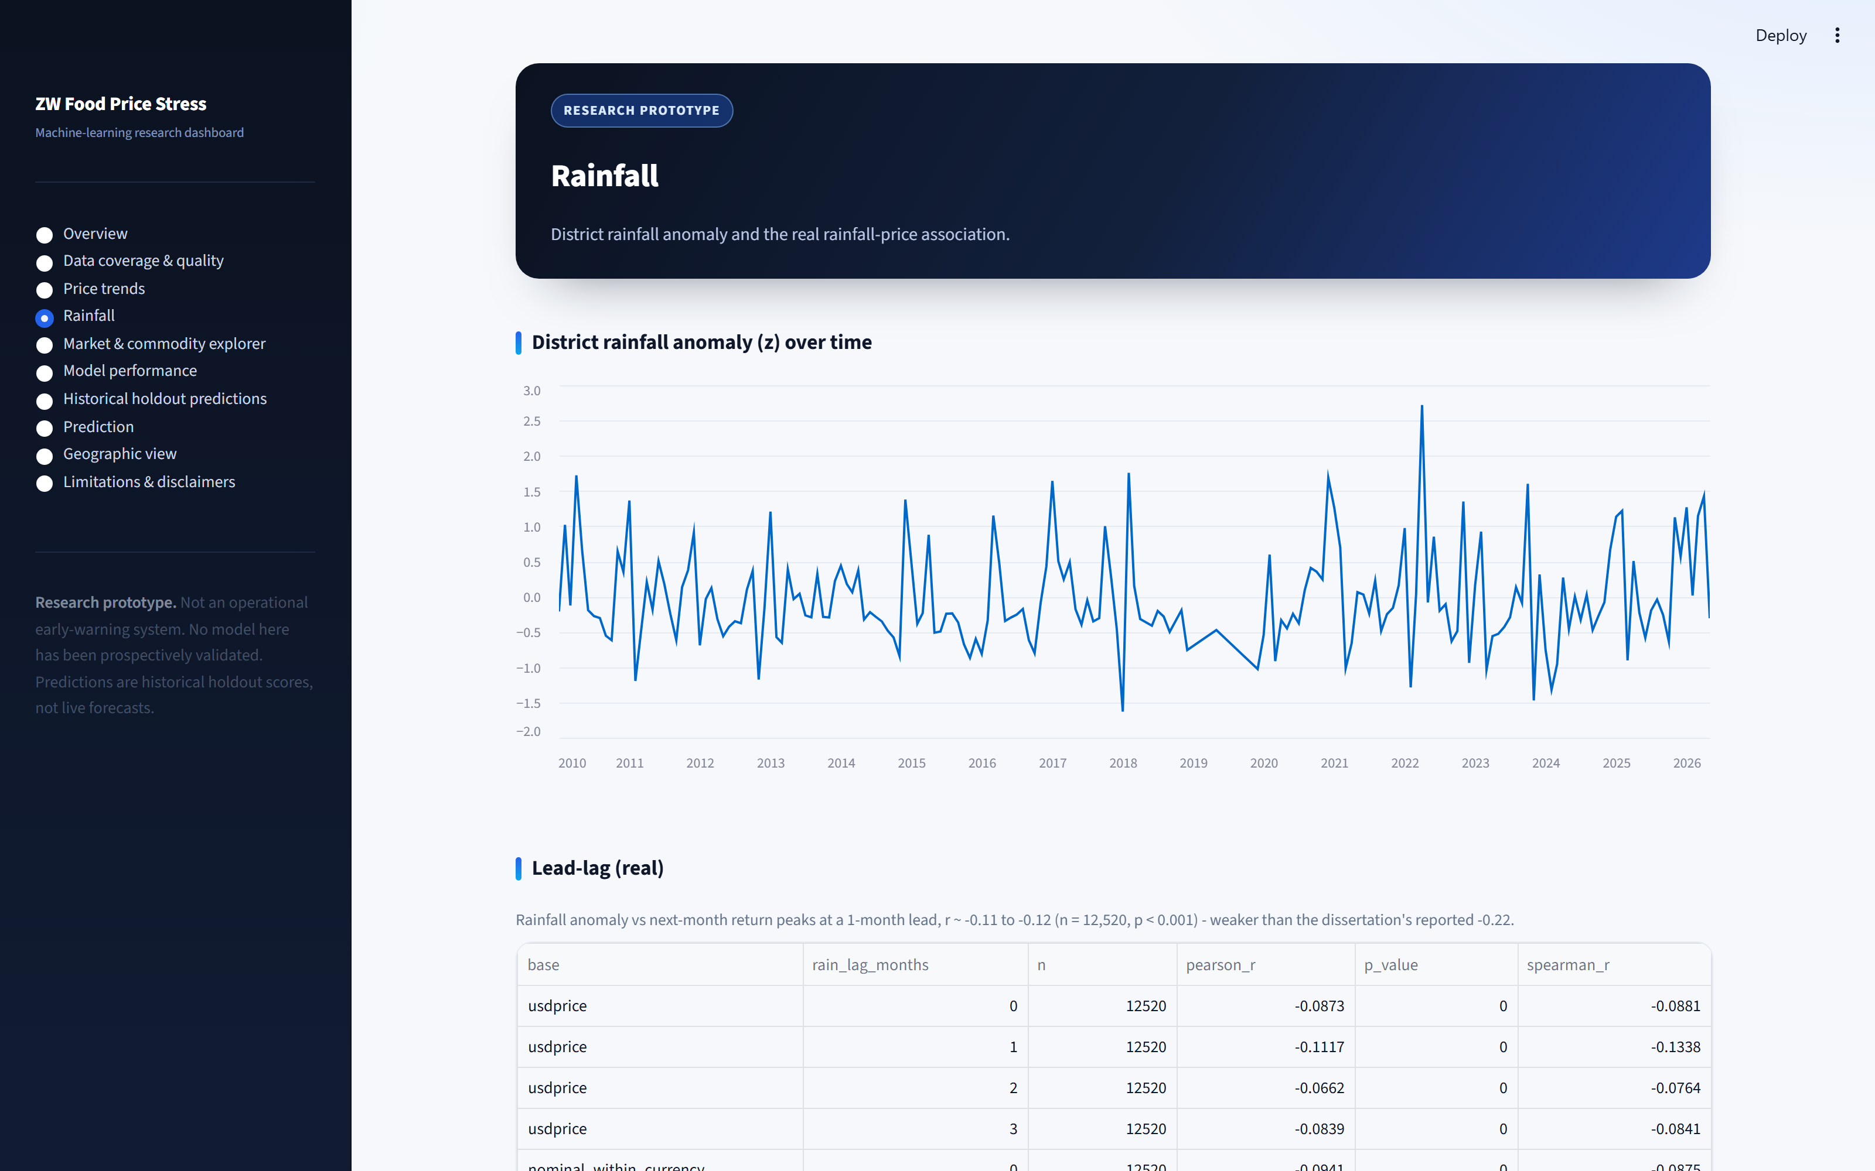
Figure 5.4 District rainfall anomaly and the real lead-lag result.
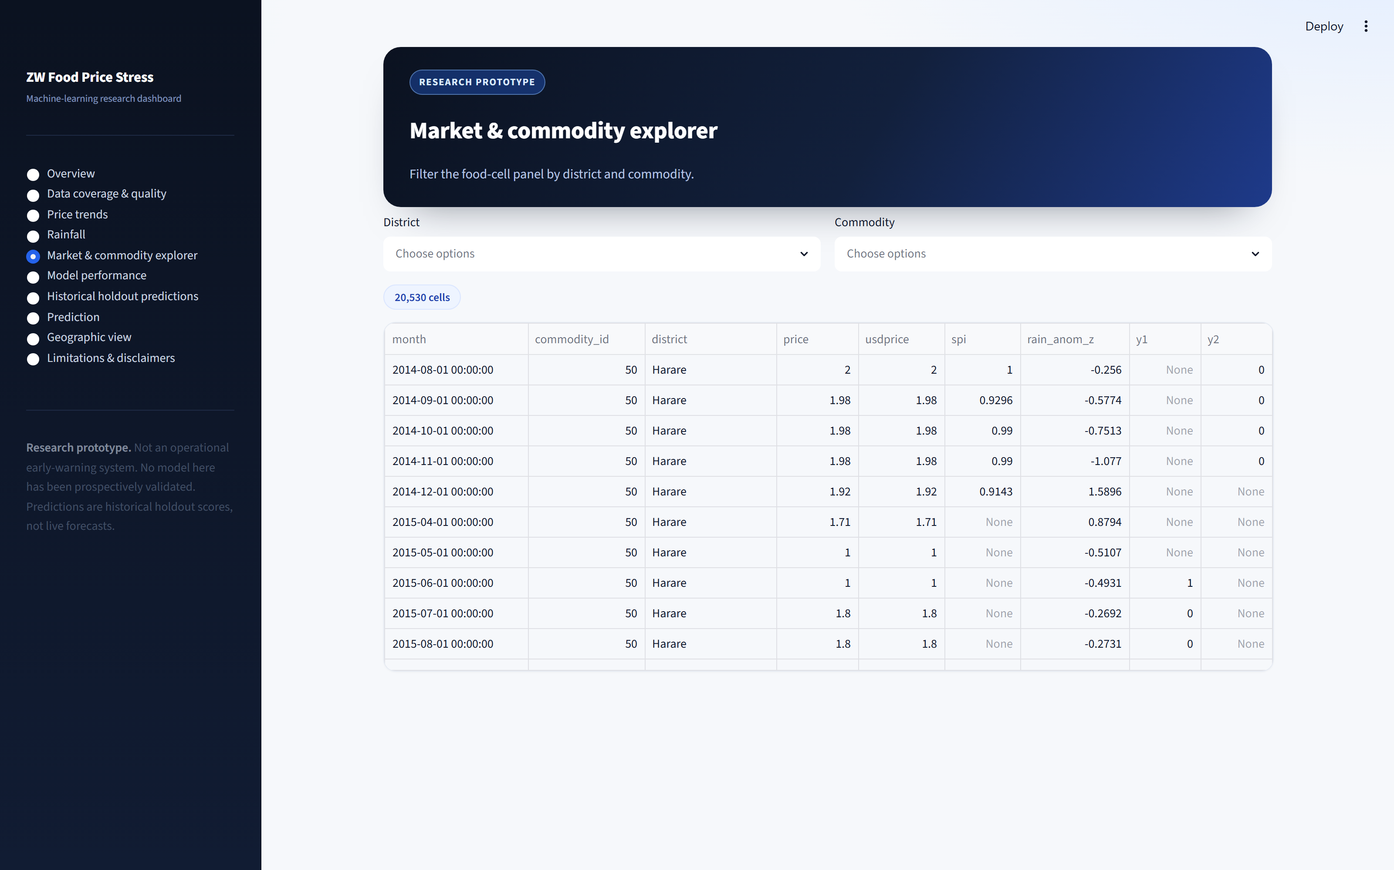
Figure 5.5 Market and commodity explorer.
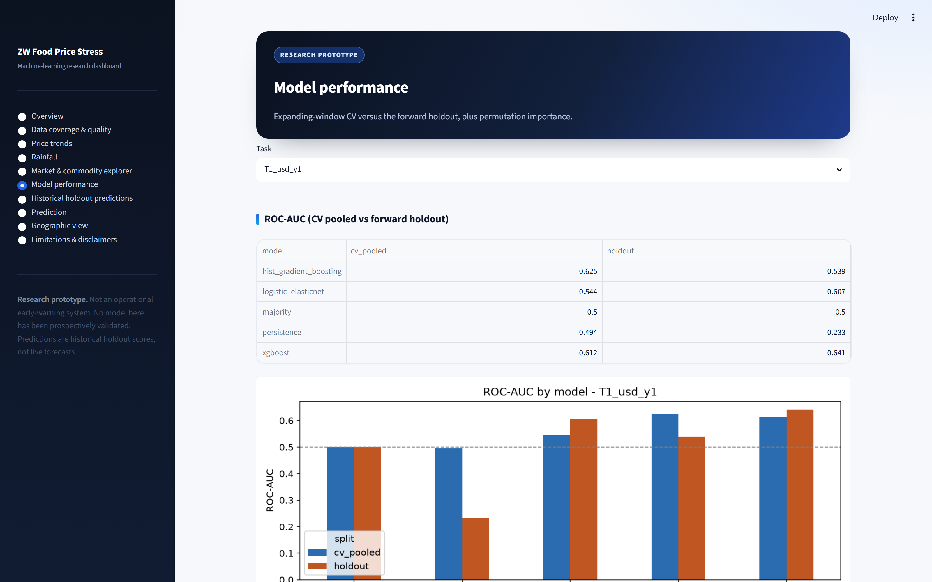
Figure 5.6 Model performance: CV versus holdout ROC-AUC and permutation importance.
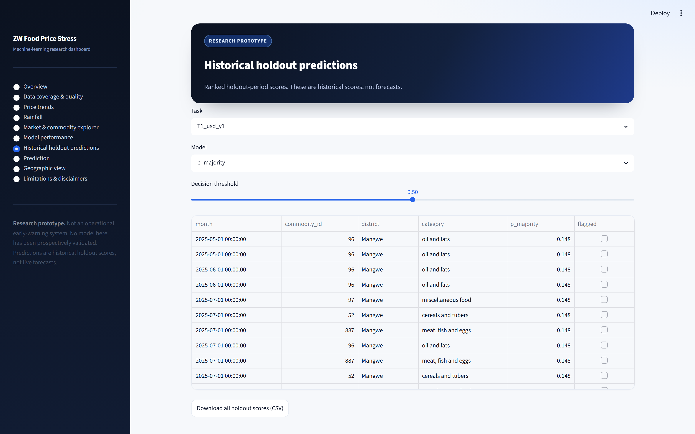
Figure 5.7 Historical holdout scores with an adjustable decision threshold.
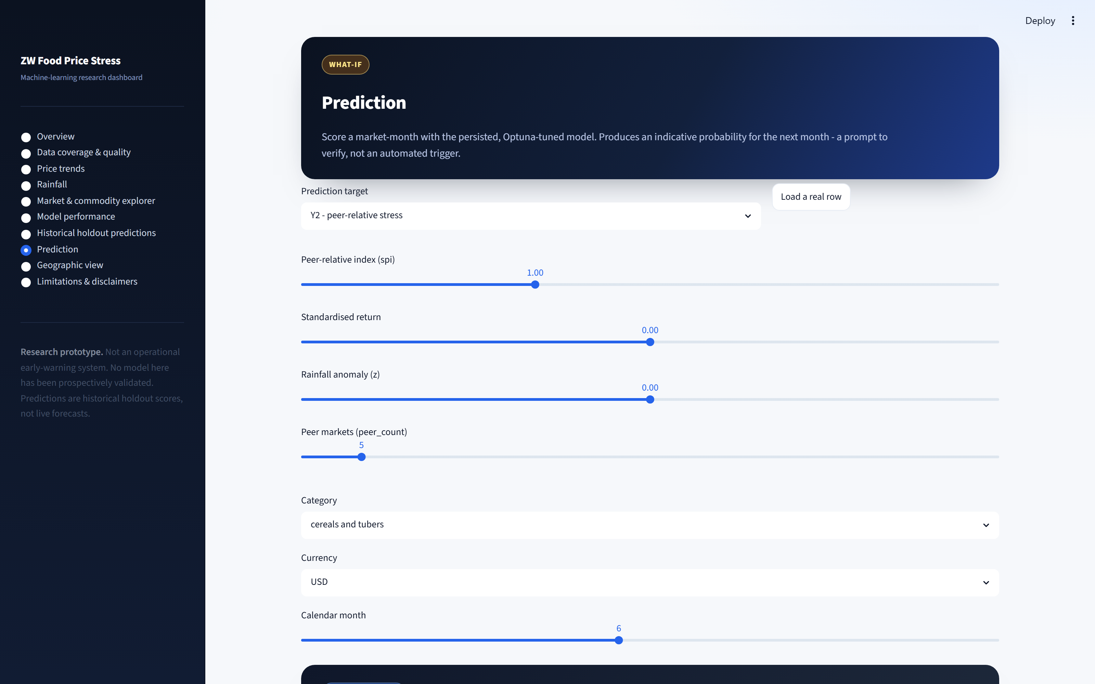
Figure 5.8 Prediction screen: single-point forecasting for a chosen target (Y1/Y2) using the persisted, Optuna-tuned model.
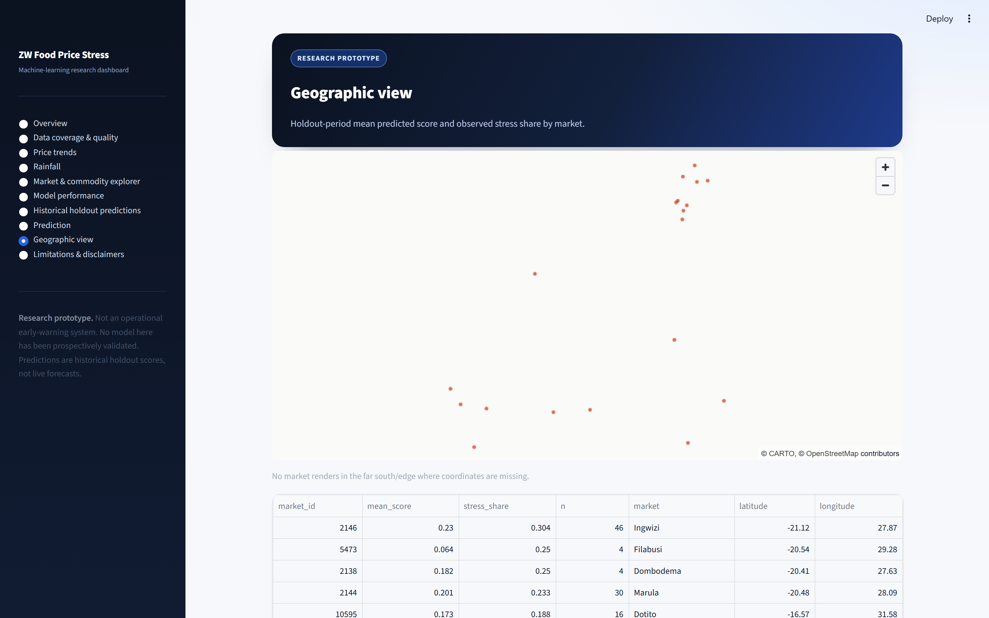
Figure 5.9 Geographic view: holdout-period mean score / stress share by market.

Figure 5.10 Limitations and disclaimers page, including the traceability statement.

5.5 Limitations and their Effect on Validity (C5.4)
Limitation | Effect on the conclusions
Temporal generalisation (CV ≫ holdout; <0.5 in transition years) | Directly undermines operational suitability — later-period predictions cannot be trusted as reliable; this is why the district outputs are exploratory.
Small holdout / few positives (Y1: 9 positives) | Estimates have wide intervals; Y1 skill cannot be distinguished from chance.
Target validity (market price ≠ household food insecurity) | Conclusions apply to market prices only; no welfare inference.
Currency/inflation instability | Structural breaks distort the relationship; historical features do not capture regime change.
Sparse series (median length 4 months) | Few labels per series; less stable learning.
Geographic matching (8 markets unmatched; 1 district no rainfall; name vs coordinate) | District outputs have spatial uncertainty; treated as screening only.
Feature omission (fuel, transport, stocks, informal FX…) | Explains part of the model error; results are lower bounds on achievable skill.
Permutation-importance instability | Feature rankings must not be read as a fixed importance order or as causal.
No operational testing | No claim of institutional readiness.

5.6 Recommendations (re-prioritised) (C5.5)
Immediate (before any operational use):
- Investigate and stabilise the holdout. Diagnose the currency-regime distribution
shift (already begun, `phase6b_*`); consider regime-specific or regime-aware models
and rolling-origin evaluation over longer periods.
- Validate and possibly redefine the targets. Re-examine Y1 (unreliable) and
justify/refine thresholds with domain users and observed outcomes.
- Repeat the model evaluation using the same target, evaluation set and metrics
before any superiority claim.
Subsequent:
- Recalibrate and monitor drift once new outcomes are available.
- Improve data quality and coverage (remote/informal markets; the 8 unmatched markets;
the missing district; suspicious `usdprice` values; FX basis clarity).
- Conduct user-centred evaluation and establish governance (model registry, alert-review
protocol, withdrawal process).

5.7 Future Research
Extend features (soil moisture, vegetation, temperature, fuel/transport, stocks, FX);
compare targets against household food-consumption and market-function indicators;
adopt rolling-origin evaluation and richer probabilistic/spatial models; and run
user-centred and governance studies before operational deployment.

5.8 Conclusion (defensible contribution) (C5.6)
The project's **strongest demonstrated contribution is the development of an integrated,
reproducible data-processing and experimental-prediction workflow** — including
leakage-controlled feature engineering, two mathematically defined market-stress targets,
time-respecting validation and a working scoring prototype — **together with an honest
diagnosis of why a reliably generalisable early-warning model was not established**. The
results show that food price stress is influenced by compound factors, that the target
definition strongly affects apparent predictability, and that later-period generalisation
is severely constrained by currency-regime change. The system should remain a
supplementary decision-support prototype, used only with human review, until its
calibration, temporal stability, coverage and decision value have been demonstrated over
time.

References and Source Classification
Supplied by the author. 33 unique sources: 21 refereed journal articles + 1 refereed
conference paper (22 refereed scholarly works), 1 edited-volume chapter, 1
process-model guide, 9 institutional/grey reports. A duplicate entry
(Fackler & Goodwin, 2001a/2001b) is merged to one.

A. Refereed journal articles (21)
Bergmeir, C., & Benítez, J. M. (2012). On the use of cross-validation for time series predictor evaluation. Information Sciences, 191, 192–213. https://doi.org/10.1016/j.ins.2011.12.028
Bhalla, G., Handa, S., Angeles, G., & Seidenfeld, D. (2018). The effect of cash transfers and household vulnerability on food security in Zimbabwe. Food Policy, 74, 82–99. https://doi.org/10.1016/j.foodpol.2017.11.007
Burke, W. J., & Myers, R. J. (2014). Spatial equilibrium and price transmission between Southern African maize markets connected by informal trade. Food Policy, 49, 59–70. https://doi.org/10.1016/j.foodpol.2014.05.008
Busker, T., van den Hurk, B., de Moel, H., van den Homberg, M., van Straaten, C., Odongo, R. A., & Aerts, J. C. J. H. (2024). Predicting food-security crises in the Horn of Africa using machine learning. Earth's Future, 12(8). https://doi.org/10.1029/2023EF004211
Davids, T., Meyer, F., & Westhoff, P. (2017). Impact of trade controls on price transmission between southern African maize markets. Agrekon, 56(3), 223–232. https://doi.org/10.1080/03031853.2017.1344133
Deaton, A., & Laroque, G. (1992). On the behaviour of commodity prices. The Review of Economic Studies, 59(1), 1. https://doi.org/10.2307/2297923
Funk, C., Peterson, P., Landsfeld, M., Pedreros, D., Verdin, J., Shukla, S., Husak, G., Rowland, J., Harrison, L., Hoell, A., & Michaelsen, J. (2015). The climate hazards infrared precipitation with stations—a new environmental record for monitoring extremes. Scientific Data, 2(1), 150066. https://doi.org/10.1038/sdata.2015.66
Gilbert, C. L., Christiaensen, L., & Kaminski, J. (2017). Food price seasonality in Africa: Measurement and extent. Food Policy, 67, 119–132. https://doi.org/10.1016/j.foodpol.2016.09.016
Mango, N., Zamasiya, B., Makate, C., Nyikahadzoi, K., & Siziba, S. (2014). Factors influencing household food security among smallholder farmers in the Mudzi district of Zimbabwe. Development Southern Africa, 31(4), 625–640. https://doi.org/10.1080/0376835X.2014.911694
Melesse, M. B., Tirra, A. N., Homann-Kee Tui, S., Van Rooyen, A. F., & Hauser, M. (2023). Production decisions and food security outcomes of smallholder's livestock market participation: Empirical evidence from Zimbabwe. Frontiers in Sustainable Food Systems, 7. https://doi.org/10.3389/fsufs.2023.1222509
Moyo, P. (2024). The political economy of Zimbabwe's food crisis, 2019–2020. Journal of Asian and African Studies, 59(2), 640–655. https://doi.org/10.1177/00219096221120923
Mugiyo, H., Magadzire, T., Choruma, D. J., Chimonyo, V. G. P., Manzou, R., Jiri, O., & Mabhaudhi, T. (2023). El Niño's effects on Southern African agriculture in 2023/24 and anticipatory action strategies to reduce the impacts in Zimbabwe. Atmosphere, 14(11), 1692. https://doi.org/10.3390/atmos14111692
Phillips, J. G., Cane, M. A., & Rosenzweig, C. (1998). ENSO, seasonal rainfall patterns and simulated maize yield variability in Zimbabwe. Agricultural and Forest Meteorology, 90(1–2), 39–50. https://doi.org/10.1016/S0168-1923(97)00095-6
Porteous, O. (2019). High trade costs and their consequences: An estimated dynamic model of African agricultural storage and trade. American Economic Journal: Applied Economics, 11(4), 327–366. https://doi.org/10.1257/app.20170442
Reichstein, M., Camps-Valls, G., Stevens, B., Jung, M., Denzler, J., Carvalhais, N., & Prabhat. (2019). Deep learning and process understanding for data-driven Earth system science. Nature, 566(7743), 195–204. https://doi.org/10.1038/s41586-019-0912-1
Sazib, N., Mladenova, I. E., & Bolten, J. D. (2020). Assessing the impact of ENSO on agriculture over Africa using Earth observation data. Frontiers in Sustainable Food Systems, 4. https://doi.org/10.3389/fsufs.2020.509914
Shukla, S., Arsenault, K. R., Hazra, A., Peters-Lidard, C., Koster, R. D., Davenport, F., Magadzire, T., Funk, C., Kumar, S., McNally, A., Getirana, A., Husak, G., Zaitchik, B., Verdin, J., Nsadisa, F. D., & Becker-Reshef, I. (2020). Improving early warning of drought-driven food insecurity in southern Africa using operational hydrological monitoring and forecasting products. Natural Hazards and Earth System Sciences, 20(4), 1187–1201. https://doi.org/10.5194/nhess-20-1187-2020
Symeonidis, L., Prokopczuk, M., Brooks, C., & Lazar, E. (2012). Futures basis, inventory and commodity price volatility: An empirical analysis. Economic Modelling, 29(6), 2651–2663. https://doi.org/10.1016/j.econmod.2012.07.016
Tawodzera, G. (2011). Vulnerability in crisis: Urban household food insecurity in Epworth, Harare, Zimbabwe. Food Security, 3(4), 503–520. https://doi.org/10.1007/s12571-011-0152-1
Westerveld, J. J. L., van den Homberg, M. J. C., Nobre, G. G., van den Berg, D. L. J., Teklesadik, A. D., & Stuit, S. M. (2021). Forecasting transitions in the state of food security with machine learning using transferable features. Science of The Total Environment, 786, 147366. https://doi.org/10.1016/j.scitotenv.2021.147366
Wright, B. D. (2011). The economics of grain price volatility. Applied Economic Perspectives and Policy, 33(1), 32–58. https://doi.org/10.1093/aepp/ppq033

B. Refereed conference paper (1)
He, S., Li, X., DelSole, T., Ravikumar, P., & Banerjee, A. (2021). Sub-seasonal climate forecasting via machine learning: Challenges, analysis, and advances. Proceedings of the AAAI Conference on Artificial Intelligence, 35(1), 169–177. https://doi.org/10.1609/aaai.v35i1.16090

C. Edited-volume chapter (1)
Fackler, P. L., & Goodwin, B. K. (2001). Chapter 17: Spatial price analysis. In Handbook of Agricultural Economics (Vol. 1, Part B, pp. 971–1024). https://doi.org/10.1016/S1574-0072(01)10025-3

D. Methodological guide (1)
Chapman, P., Clinton, J., Kerber, R., Khabaza, T., Reinartz, T., Shearer, C., & Wirth, R. (2000). CRISP-DM 1.0: Step-by-step data mining guide. SPD.

E. Institutional / grey literature (9)
Kramarenko, V., Engstrom, L. H., Verdier, G., Fernandez, G. C., Oppers, S. E., Hughes, R., McHugh, J., Coats, W. L., & Kramarenko, V. (2010). Zimbabwe: Challenges and policy options after hyperinflation (Departmental Papers 2010/006). International Monetary Fund. https://doi.org/10.5089/9781462309184.087.A001
Mahdi, S., & Bonato, M. (2015). Zimbabwe — Economic growth notes: Spatial integration in Zimbabwean product markets. World Bank. https://documents.worldbank.org/en/publication/documents-reports/documentdetail/182101468322447342
Mano, R., & Nhemachena, C. (2007). Assessment of the economic impacts of climate change on agriculture in Zimbabwe: A Ricardian approach (Policy Research Working Paper 4292). World Bank. https://doi.org/10.1596/1813-9450-4292
WFP. (2025a). Zimbabwe. World Food Programme. https://www.wfp.org/countries/zimbabwe
WFP. (2025b, August 3). Zimbabwe — Food security and markets monitoring report, August 2025. ReliefWeb. https://reliefweb.int/report/zimbabwe/zimbabwe-food-security-and-markets-monitoring-report-august-2025
World Bank. (2021). Zimbabwe economic update, June 2021. World Bank. https://doi.org/10.1596/35748
World Bank. (2025). Afghanistan, Armenia, Burundi … and 34 more — Monthly food price estimates by product and market. https://microdata.worldbank.org/index.php/catalog/4483
FEWS NET. (n.d.). Zimbabwe acute food insecurity classification — February 2024–September 2024. Retrieved September 28, 2026, from https://fews.net/zimbabwe-acute-food-insecurity-classification-february-2024-september-2024
ZimLAC. (2024). ZimLAC rural livelihoods assessment report. Food and Nutrition Council. https://www.fnc.org.zw/wp-content/uploads/2024/07/2024-ZimLAC-Rural-Livelihoods-Assessment-Report.pdf

F. Full 5Cs extraction (C2.5)
Source | Category | Contribution | Critique | Connection to this study
Bergmeir & Benítez (2012) | Method | Blocked CV is appropriate for time-series evaluation | Methodological reference | Justifies expanding-window CV (Ch.3.8)
Bhalla et al. (2018) | ZW food security | Cash transfers/vulnerability affect household security | Household level | Scope boundary (market ≠ household)
Burke & Myers (2014) | Spatial transmission | SADC maize markets integrated but imperfectly | Informal trade hard to measure | Justifies Y2 peer-relative target
Busker et al. (2024) | ML food security | ML can anticipate food-security crises | Generalisation difficulty | ML-as-candidate + validation caution
Chapman et al. (2000) | Method | CRISP-DM process model | Generic | Methodology (Ch.3.2)
Davids et al. (2017) | Trade policy | Trade controls distort price transmission | Maize-only | Supports peer-relative design
Deaton & Laroque (1992) | Theory | Storage/expectations cause price spikes | No local markets | Justifies standardised-return target
Fackler & Goodwin (2001) | Theory/method | Spatial price differences reflect trade costs | Conceptual | Frames spatial-price analysis
Funk et al. (2015) | Dataset | CHIRPS station-corrected rainfall record | 0.05° estimation error | Rainfall input (Ch.3.4)
Gilbert et al. (2017) | Seasonality | Predictable African price seasonality | Africa-wide | Justifies seasonal features
He et al. (2021) | ML climate | Sub-seasonal ML skill is modest | Different domain | Calibrates expectations
Kramarenko et al. (2010) | Macro/currency | Hyperinflation and post-crisis instability | Macro-level | Currency-regime handling (Ch.3.4.5)
Mahdi & Bonato (2015) | ZW markets | Spatial integration in ZW product markets | Report | Supports ZW spatial-price relevance
Mango et al. (2014) | ZW food security | Household drivers in Mudzi | Household level | Scope boundary
Mano & Nhemachena (2007) | Climate/agriculture | Climate change impacts on ZW agriculture | Model-based | Rainfall→agriculture chain
Melesse et al. (2023) | ZW livelihoods | Livestock market participation & food security | Household level | Scope boundary
Moyo (2024) | Political economy | ZW 2019–2020 food crisis drivers | Qualitative | Context for price stress
Mugiyo et al. (2023) | Climate/anticipatory | 2023/24 El Niño impacts and action | Zimbabwe focus | Rainfall driver relevance
Phillips et al. (1998) | Climate/agriculture | ENSO–rainfall–maize yield in ZW | Simulation | Rainfall→outcome chain
Porteous (2019) | Trade/storage | Trade costs shape storage/prices | Model-based | Supports spatial features
Reichstein et al. (2019) | ML/ESS | ML complements process science; generalisation risks | Deep-learning focus | Justifies caution
Sazib et al. (2020) | Climate/EO | ENSO impacts on African agriculture | Continental | Rainfall driver relevance
Shukla et al. (2020) | Early warning | Hydrological monitoring aids drought warning | Not market prices | Indirect/lag warning link
Symeonidis et al. (2012) | Volatility | Basis/inventory link to volatility | Futures markets | Supports relative-price framing
Tawodzera (2011) | ZW food security | Urban food insecurity (Epworth) | Household level | Scope boundary
Westerveld et al. (2021) | ML food security | Transferable features forecast transitions | Different target | ML-as-candidate
WFP (2025a, 2025b) | Monitoring | ZW market/food-security monitoring | Descriptive | Baseline capability (gap table)
World Bank (2021) | Macro | ZW economic/currency context | Macro-level | Currency context
World Bank (2025) | Dataset | Monthly food price estimates by market | Not focused on ZW stress target | Comparable food-price data
Wright (2011) | Volatility | Fundamentals + structure drive grain volatility | Conceptual | Justifies stress framing
FEWS NET (n.d.) | Assessment | ZW IPC classification | Expert-based | Baseline capability (gap table)
ZimLAC (2024) | Assessment | Rural livelihoods assessment | Annual | Baseline capability (gap table)

PRISMA-Style Search and Selection Record
Generated by `scripts/prisma_ingest.py` on 2026-10-15 from the real
downloaded exports in `data/literature/raw/` (search date 2026-10-15).
Three databases were searched: OpenAlex (web export) and Semantic Scholar
and PubMed (both exported via Publish or Perish). **Every count is a real value
read from a downloaded file or the `search_logs.csv` count sheet; none is estimated.**
Screening used documented, reproducible title/abstract rules (a food/price topic
term and a method/model term); borderline records are confirmed against the
review's scope (worklist: `reports/revision/prisma_borderline.csv`).

1. Search strategy
Stream | Boolean search string
S1 | `("food price" OR "food prices") AND ("machine learning" OR xgboost OR "random forest" OR "gradient boosting")`
S2 | `("food price" OR "food prices") AND (forecast OR prediction OR "early warning")`
S3 | `("food price" OR "food prices") AND (Zimbabwe OR "Southern Africa")`
S4 | `("food price" OR "food security") AND ("machine learning" OR "deep learning") AND (predict OR forecast OR crisis)`
S5 | `("price anomaly" OR "price volatility" OR "price stress") AND (food OR commodity) AND (machine learning OR prediction OR forecast)`
S6 | `("food price" OR "maize price" OR "market price") AND (rainfall OR drought OR climate) AND (Africa OR Zimbabwe)`
Databases: OpenAlex, Semantic Scholar, PubMed. Search date: 2026-10-15.
Language could not be machine-filtered: none of the export formats records a
language field, so no language exclusion is claimed here.
OpenAlex metadata enrichment: the OpenAlex web export records a DOI but no `type`, and some streams omit the abstract. Publication types and abstracts were recovered from the OpenAlex REST API by DOI (`scripts/openalex_enrich.py`), adding a type to 3,746 records and an abstract to 2,306 records before screening.

2. Identification and retrieval
Database | Records identified | Records retrieved (export rows)
OpenAlex | 6,604 | 6,602
SemanticScholar | 2,616 | 2,616
PubMed | 8 | 8
Total | 9,228 | 9,226
Per database x stream (blank = stream not searched in that database):
Database | Stream | Identified | Retrieved
OpenAlex | S1 | 219 | 219
OpenAlex | S2 | 1374 | 1374
OpenAlex | S3 | 194 | 194
OpenAlex | S4 | 3779 | 3777
OpenAlex | S5 | 226 | 226
OpenAlex | S6 | 812 | 812
SemanticScholar | S1 | 112 | 112
SemanticScholar | S2 | 809 | 809
SemanticScholar | S3 | 115 | 115
SemanticScholar | S4 | 1000 | 1000
SemanticScholar | S5 | 72 | 72
SemanticScholar | S6 | 508 | 508
PubMed | S1 | 1 | 1
PubMed | S2 | 7 | 7
PubMed | S3
PubMed | S4 | 0
PubMed | S5 | 0
PubMed | S6 | 0

3. PRISMA flow
```
Identification
Records identified across database searches: 9,228
OpenAlex 6,604 + Semantic Scholar 2,616
+ PubMed 8
Records retrieved (rows in the export files): 9,226
Screening
Duplicates removed (same DOI/record across streams and databases): 2,629
Unique records screened (title + abstract): 6,599
- excluded, no food/price topic term: 1,705
- excluded, no method/model term: 690
- excluded, untitled: 8
Records passing title/abstract screening: 4,196
Full-text assessment
Full texts assessed for eligibility (all screened-in records): 4,196
Excluded with reasons (record type; OpenAlex types recovered via API where available):
- not a refereed article/review/conference paper: 800
- record type not resolved (no export type, not matched via API): 153
Refereed records eligible (candidate pool): 3,243
Borderline screening of region-relevant records
Borderline records assessed by the PRISMA framework: 94
- confirmed excluded (possible false negatives): 56
- confirmed in scope (screened-in and retained): 38
- left undecided: 0
These exclusions are the region-relevant subset of the 690 "no method/model term" title/abstract exclusions, and the 38 confirmations are already inside the 3,243 candidate pool. This borderline screening verifies the automated screen and does not change the funnel totals.
Included
Studies included in the review (core evidence base): 22 refereed
Grey literature / reports (separate): 9
(The included studies are the supplied corpus, screened at full text
against the review's scope; the automated pool above corroborates the search
and captured 4 of the 26 supplied works by DOI. See section 5.)
```

4. Screening rules
- Topic term (title/abstract), e.g.: food price, food security, price volatility,
price anomaly, maize/market price, price stress, food crisis.
- Method term (title/abstract), e.g.: machine learning, deep learning, random
forest, XGBoost, gradient boosting, neural network, forecast, predict, early warning,
nowcast, time series, regression, model, LSTM.
- A record is screened in if it has a title, a topic term and a method term. Records
are searched on title + abstract; where an export omits the abstract, screening uses
the title only.
- Eligibility keeps refereed article / review / conference types. The OpenAlex web
export has no `type` field, so OpenAlex types are recovered from the OpenAlex REST API
by DOI when available; records whose type could not be resolved are reported as
"type not recorded" rather than classified.

5. Reconciliation with the supplied corpus
Supplied-corpus DOIs parsed from `references.md`; "captured" = the DOI appears in the
merged library.
Supplied source (from `references.md`) | DOI captured by search?
Bergmeir et al. (2012) | No — via manual search / citation chaining
Bhalla et al. (2018) | No — via manual search / citation chaining
Burke et al. (2014) | No — via manual search / citation chaining
Busker et al. (2024) | Yes
Davids et al. (2017) | No — via manual search / citation chaining
Deaton et al. (1992) | No — via manual search / citation chaining
Fackler et al. (2001) | No — via manual search / citation chaining
Funk et al. (2015) | No — via manual search / citation chaining
Gilbert et al. (2017) | No — via manual search / citation chaining
He et al. (2021) | No — via manual search / citation chaining
Kramarenko et al. (2010) | No — via manual search / citation chaining
Mango et al. (2014) | No — via manual search / citation chaining
Mano et al. (2007) | No — via manual search / citation chaining
Melesse et al. (2023) | No — via manual search / citation chaining
Moyo et al. (2024) | No — via manual search / citation chaining
Mugiyo et al. (2023) | No — via manual search / citation chaining
Phillips et al. (1998) | No — via manual search / citation chaining
Porteous et al. (2019) | No — via manual search / citation chaining
Reichstein et al. (2019) | No — via manual search / citation chaining
Sazib et al. (2020) | No — via manual search / citation chaining
Shukla et al. (2020) | Yes
Symeonidis et al. (2012) | No — via manual search / citation chaining
Tawodzera et al. (2011) | Yes
Westerveld et al. (2021) | Yes
World Bank. (2021) | No — via manual search / citation chaining
Wright et al. (2011) | No — via manual search / citation chaining
4 of 26 supplied sources with a DOI were captured by the
systematic search; the remainder were identified through manual database searching and
citation chaining. The review's evidence base is 22 refereed works (21 journal
articles + 1 conference paper, satisfying the >=20 requirement) plus an edited-volume
chapter, a CRISP-DM process guide and 9 grey reports.

6. Notes and limitations
- Three machine-readable databases are combined; duplicates are removed by DOI, then by
normalised title.
- `identified` is the recorded hit count per search; `retrieved` is the number
of rows actually present in the export file. Where they differ (export truncation or
later index updates), the retrieved figure is the file's true row count.
- Publication types/abstracts for OpenAlex records were recovered from the OpenAlex REST API by DOI (`scripts/openalex_enrich.py`): +3,746 types, +2,306 abstracts. Remaining unresolved records are reported as "type not recorded" rather than classified.
- Borderline screening: the region-relevant borderline worklist (`reports/revision/prisma_borderline.csv`, 94 records) was assessed by the PRISMA framework: 38 screened-in records confirmed in scope and 56 possible false negatives confirmed excluded. Both are subsets of the automated counts above and do not change the funnel totals.
- Language is not recorded in any export, so no language exclusion is applied.
- Full merged library: `data/literature/dedup/library.csv`; screening sheet with a blank
`include` column: `data/literature/screen/screening_sheet.csv`; per-record flags:
`reports/revision/prisma_records.csv`; per-query counts: `reports/revision/prisma_search_log.csv`.
- OpenAlex API recovery cache: `data/literature/raw/openalex_enriched.csv` (regenerate with
`python scripts/openalex_enrich.py`).
- Borderline worklist: `reports/revision/prisma_borderline.csv` (regenerate with
`python scripts/prisma_borderline.py`; recorded decisions are preserved on re-run).

