Serbia
Belgrade Waste-to-Energy PPP: Turning a Liability into a Climate Asset
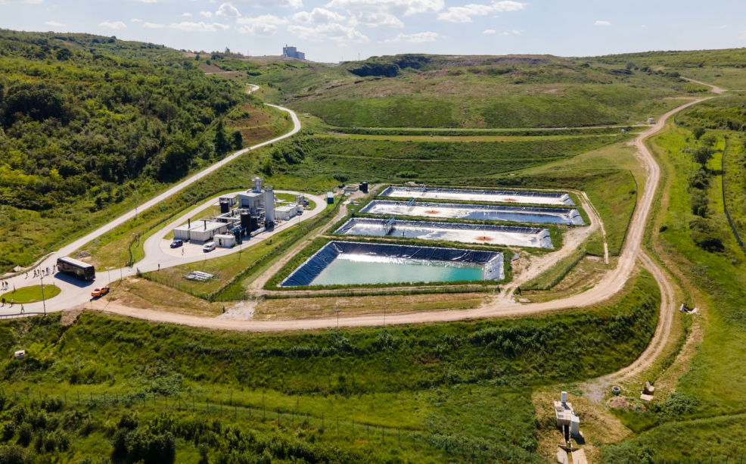
CASE SNAPSHOT
  SECTOR  Solid Waste Management |   COUNTRY  Serbia |   TIMELINE  2017: 25-year PPP contract signed |   COST  EUR 400 million  (EUR 290m from IFIs) |   RESULT  - 210,000 tons CO₂e reduced annually - equivalent to taking 46,000 cars off the road.  - Mountains of accumulated trash at Vinča converted into green space while generating clean energy.  - 30 MW electricity and 56 MW heat generated from waste, serving a large number of households.

CASE STUDY SUMMARY
Belgrade Waste-to-Energy PPP: Turning a Liability into a Climate Asset

THE OBJECTIVE
To remediate one of the world's most polluting waste sites and transform Belgrade's waste management system through an integrated public-private partnership that delivers environmental restoration, sustainable energy production, and certified carbon emission reductions. The project would ultimately convert the mountains of accumulated trash at Vinča into green space while generating clean energy for Belgrade's households.

THE CHALLENGE
The Vinča landfill, spanning 40 hectares near the Danube River just 15 kilometers from central Belgrade, had become Europe's largest unmanaged open dump site by 2015. Ranked among the 50 most polluted dumpsites in the world by the International Solid Waste Association, the facility handled 90% of Belgrade's waste - roughly 1,500 tons of household waste and 3,000 tons of construction waste daily.  After absorbing more than 10 million tons of waste over four decades, the landfill had reached capacity and transformed into an environmental emergency. Mountains of trash towered over 70 meters high in some places. Frequent fires, landslides, and uncontrolled methane emissions plagued the site, while untreated leachate contaminated groundwater and nearby agricultural areas before discharging into the Danube, affecting downstream communities. With only one year of landfill capacity remaining, the city faced a crisis.  Serbia is an EU candidate, but before it can join, it must invest an estimated USD18 billion to meet environmental standards. The remediation of the Vinca landfill will contribute to the transformation of Serbia’s environmental infrastructure.  Drivers for Change  - Europe's largest unmanaged open dump, with waste piles over 70 meters high, creating environmental and health concerns for Belgrade's ~1.7 million residents.  - Only one year of landfill capacity remaining, with frequent fires, landslides, and leachate contaminating the Danube River.  - The city lacked in-house expertise in modern waste treatment and sought a private partner with both the financing capacity and operational know-how to deliver an affordable, long-term solution.  Outcome Needed  To transform one of the world's most polluting waste sites into a modern, EU-compliant waste management system that generates clean energy while reducing greenhouse gas emissions - demonstrating that emerging markets can achieve global environmental standards through innovative financing. | 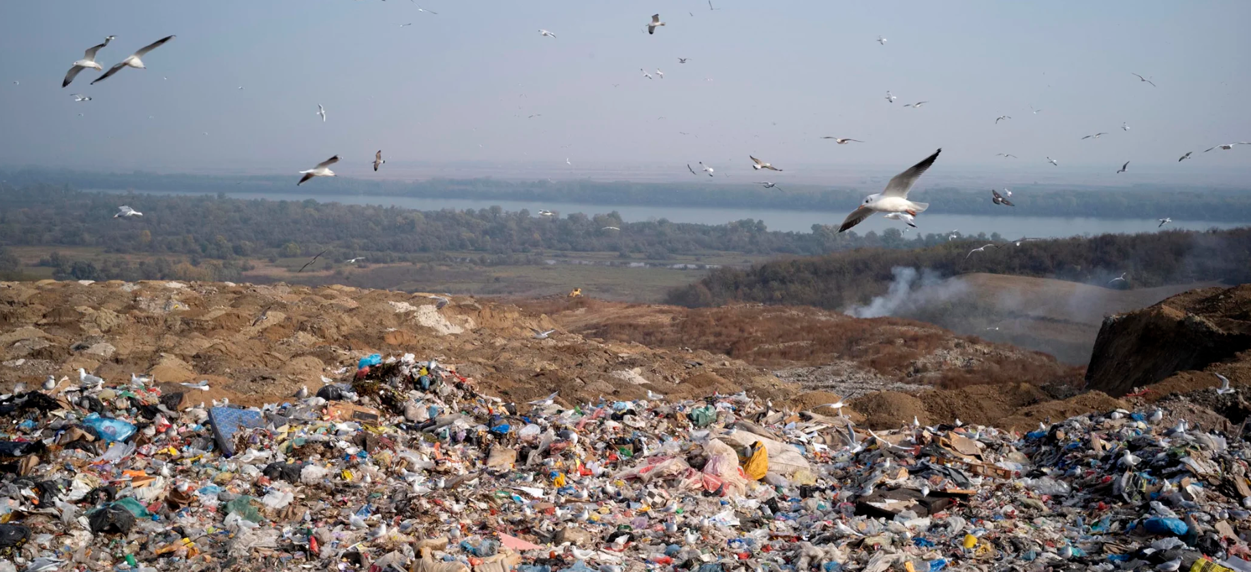
THE SOLUTION
In 2015, the City of Belgrade partnered with IFC to design an integrated public-private partnership that would fundamentally reimagine the city's relationship with waste. After four years of careful preparation, rather than treating waste as a problem requiring disposal, the solution reconceptualized it as a resource that could contribute to environmental restoration and energy production. |  | 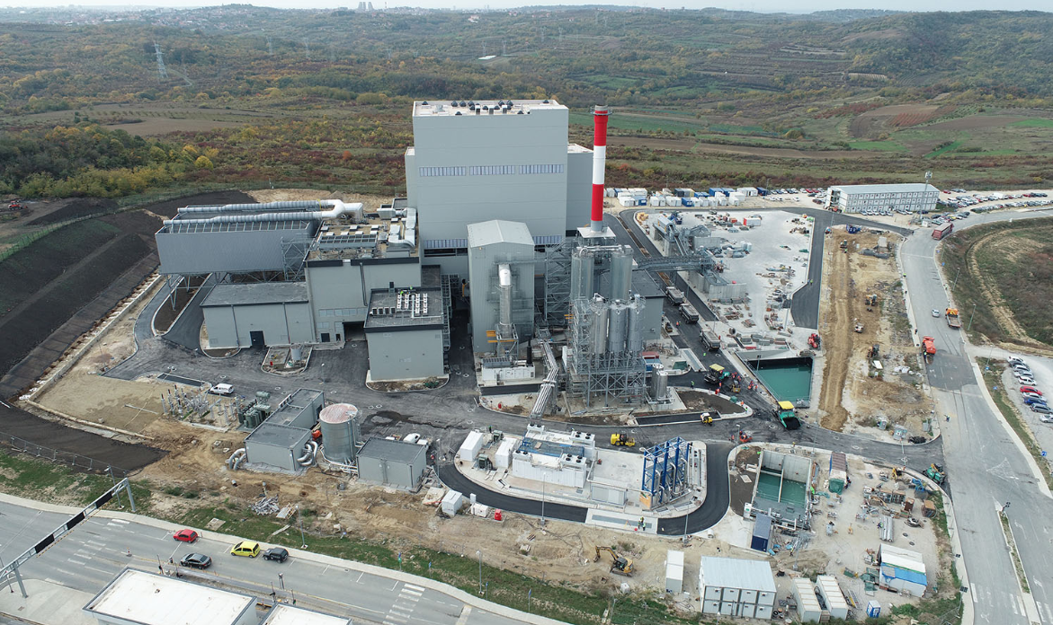
The PPP Structure
Following a competitive dialogue with several pre-qualified bidders, the City of Belgrade awarded a 25-year DBFO (Design-Build-Finance-Operate) contract in 2017 to Beo Čista Energija d.o.o., a special-purpose vehicle formed by Veolia (formerly SUEZ) of France, ITOCHU Corporation of Japan, and Marguerite Fund II, a pan-European equity fund based in Luxembourg.
The contract bundled the remediation of the legacy landfill - including management of accumulated pollution - with the development of revenue-generating greenfield assets. This innovative structure transformed an environmental liability into a bankable infrastructure investment.

Integrated Facility Components
- Waste-to-energy facility: Processes up to 340,000 tons of municipal waste annually (approximately 66% of Belgrade's total waste), converting it into 30 MW of electricity serving approximately 30,000 households and 56 MW of thermal energy providing heat for 60,000 households.
- New EU-compliant sanitary landfill: 7 million cubic meters capacity with high-quality lining, gas collection, and leachate treatment systems designed to prevent future pollution.
- Construction and demolition waste recycling facility: Processes approximately 200,000 tons of waste annually, recovering construction materials that would otherwise require disposal.
- Landfill gas-to-energy facility: Captures methane from both the legacy site and the new landfill, converting it to useful energy while eliminating one of the most potent sources of greenhouse gas emissions.

Blended Finance Structure
The project attracted diversified international financing from IFC, EBRD, and the Austrian Development Bank (OeEB), with concessional funding from the Canada-IFC Blended Climate Finance Program helping to de-risk the investment and keep tariffs affordable.

In addition, guarantees were provided by MIGA to cover investors against political risks. These guarantees protected investor capital without requiring a sovereign guarantee, making the project attractive to private participants. Guaranteed energy purchase agreements enabled structuring of debt repayment and profit forecasting.

APPROACH TO ENVIRONMENT
Meeting International Environmental Standards
The Belgrade project demonstrates that emerging market infrastructure can achieve - and be certified against - the highest international environmental standards. Every component of the project was designed to meet EU environmental requirements, positioning Serbia closer to its EU accession goals while delivering immediate environmental benefits.
The new sanitary landfill incorporates high-quality lining, gas collection, and leachate treatment systems that prevent contamination of groundwater and the Danube River - addressing one of the legacy site's most damaging impacts. The waste-to-energy facility meets European emissions standards, processing waste that would otherwise decompose in an uncontrolled manner releasing methane and other pollutants.

Decarbonizing Through Waste-to-Energy
The project's approach to decarbonization addresses emissions at multiple points. The waste-to-energy facility eliminates methane emissions that would result from uncontrolled decomposition - methane being a greenhouse gas with warming potential far exceeding carbon dioxide. By generating electricity and heat from waste, the facility displaces fossil fuel generation that would otherwise be required to meet Belgrade's energy needs.

Carbon Credit Certification

The Belgrade Waste Management PPP received Gold Standard Carbon Credit Accreditation, providing independent verification that the project delivers genuine, measurable emissions reductions. With annual reductions of 210,000 tons CO₂ equivalent, the certification enables the project to generate revenue through the voluntary carbon market, contributing to Serbia's decarbonization goals while creating an additional revenue stream for the project.

THE ENABLERS
City Leadership and Commitment
The City of Belgrade provided the administrative and policy frameworks necessary for a 25-year PPP, including relocation of former residents of the Vinča landfill settlement.

World Bank Group Structuring
IFC's PPP transaction advisory department acted as the City of Belgrade's lead transaction advisor from 2014. After four years of careful preparation, the team helped structure a bankable contract that attracted five pre-qualified bidders. IFC subsequently participated as a lender alongside EBRD and OeEB. MIGA's guarantees helped provide comfort to investors without the need for a sovereign guarantee, which had a positive impact on Serbia's fiscal space.

Private Sector Expertise
The contract was awarded to a consortium with an established track record of joint development in similar waste-to-energy projects.

Comprehensive Contract Structure
The PPP contract included guaranteed revenue streams: waste management fees from the City of Belgrade, a 25-year heat purchase agreement with district heating company, and a 12-year power-purchase agreement with Serbian national electric utility EPS.
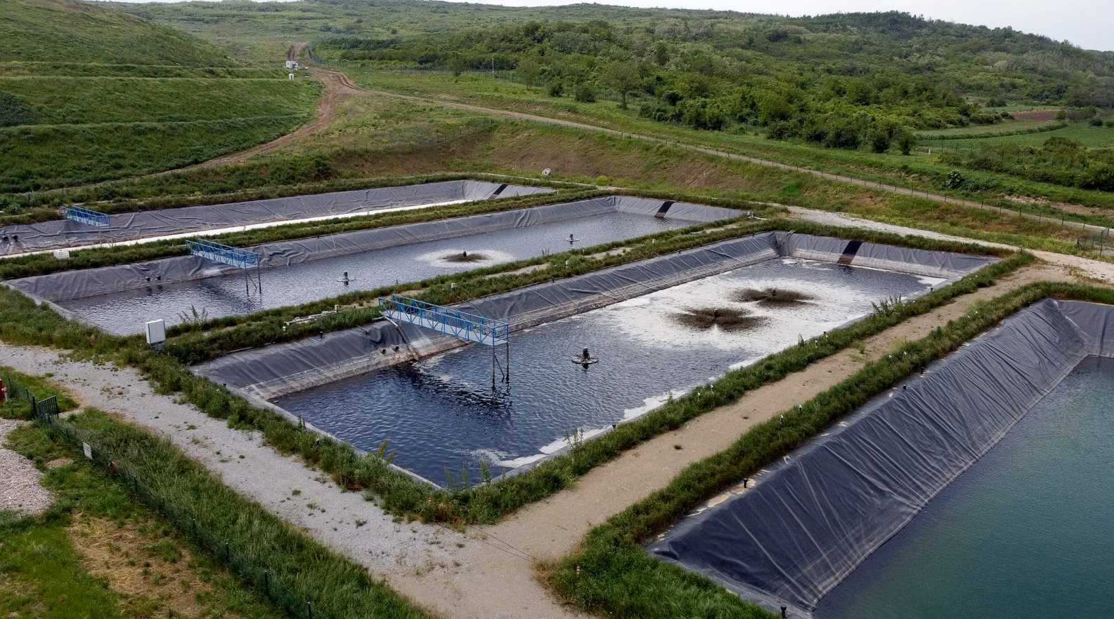

THE RESULT
The Belgrade Waste Management project became fully operational in July 2024, delivering measurable results across environmental, energy, and social dimensions:
Environmental Outcomes
- 210,000 tons CO₂e reduced annually - equivalent to taking nearly 46,000 cars off the road - certified under Gold Standard accreditation
- Legacy Vinča landfill - Europe's largest open dump - transformed into EU-compliant facility
- Mountains of accumulated trash being converted into green space; improved air and water quality across Belgrade region
Energy Production
- 30 MW of clean electricity serving approximately 30,000 Belgrade households
- 56 MW of thermal energy - heating delivered to approximately 60,000 households
Waste Processing Capacity
- Waste-to-energy facility processes up to 340,000 tons of municipal waste annually - 66% of Belgrade's total waste
- Recycling facility processes approximately 200,000 tons of construction and demolition waste per year
Economic and Social Impact
- Approximately 720 jobs during construction and 120 permanent operational positions
- Capacity building within city personnel and environmental awareness among Belgrade residents
- Improved working conditions for waste management workers

QII PRINCIPLES IN ACTION
QII.3: Environment
The Belgrade Waste Management project exemplifies how infrastructure investment can deliver environmental transformation when environmental standards are embedded from project conception through operation.
The project demonstrates application of strong environmental standards at international levels - achieving EU compliance and carbon credit certification in an emerging market context. This shows that quality environmental infrastructure is achievable regardless of starting conditions when proper financing structures, technical expertise, and governance frameworks are in place.
The decarbonization approach - converting waste from an emissions source into an energy resource while capturing methane - illustrates how infrastructure can actively contribute to climate goals.

Connections to Other QII Principles
Beyond its environmental achievements, the Belgrade project demonstrates how quality infrastructure requires alignment across multiple dimensions. The project's success depended on strong governance foundations: a carefully structured 25-year PPP that bundled environmental remediation with revenue-generating assets, making the project attractive to private investors. The transformation also delivers economic efficiency by turning waste from a disposal cost into an energy revenue stream, while job creation and improved conditions for surrounding communities address social inclusion.
Related Materials

- IFC Story: Belgrade's Waste-to-Energy Project Sparks Environmental Renaissance
- Global Infrastructure Hub: Belgrade Waste-to-Energy PPP Case Study
- World Economic Forum: Urban Transformation Case Study - Belgrade (2024)
- Beo Čista Energija: Gold Standard Certification Announcement

