

**Android Assignment-1**

Mobile Application Guidelines

|  |  |
| --- | --- |
| * **Guidelines** | |
| * Your weekend assignment is your chance to demonstrate to us what you’ve learnt during your week in training and what quality of work we can expect from you going forward. * You’ll be producing an application and presenting it to us on Monday morning. * This application should be built on the following requirements specified, we want to see you build a product that you’re interested in and enthusiastic about and build it to the best of your abilities. * You don’t have to hand in a completely finished product, you can hand in a completed section of an on-going project, as long as what you hand in is an appropriate achievement and works properly. | | | |
| * **Assignment Checklist** | |  | |
| No | Task | Required | Required |
| 1 | Activity | Yes | Create a main activity: Login. The user needs to enter the username and password. |
| 2 | Screen Orientation (Data Persistence) | Yes | The application must persist the data when the portrait or landscape mode is choosen. |
| 3 | Local Database | Yes | SQLite, GreenDAO, Otto, ActiveAndroid or any other DB library can be used  user and synchronize server data locally |
| 4 | Fragments | Yes | Manager screen, view all screen. |
| 5 | Shared Preferences | Yes | Login credentials using remember me checkbox. |
| 6 | Passing Data | Yes | Username must be passed from Login to welcome screen. |
| 7 | User Interface Controls | Yes | Use spinner for choosing user login, checkbox, Datetime picker. |
| 11 | Version Control (CI) | Yes | Push your completed assignment |
| 18 | Packaging (Code organization) | Yes | Files to be placed to functionality |
| 19 | Error handling | Yes | App should not crash or give ANR |
| 20 | Commenting | Yes | Javadoc must be created |
| 21 | Conventions Followed | Yes | Variables, objects, resources must be initialised to the rule |

|  |  |
| --- | --- |
| * **Assessment** |  |
| * How well you’ve grasped the technologies covered in training. This will be judged on how well you’ve moulded the knowledge to fit the situation. i.e. I want to see an implementation that fits with your application, not just the code I’ve given you hammered in where it fit. * A good understanding of touch-first thinking in the UI design of your application. I’d like to see an application that is well designed for a mobile platform, with appropriate controls and user interactions. * Good and appropriate use of the tools available both within the default environment and online. * Use of technologies and functionalities outside of the training syllabus. * Good use of the time given. Depending on the scale of the application you’re designing, I don’t always expect to see a completely finished product. | |

Home Screen

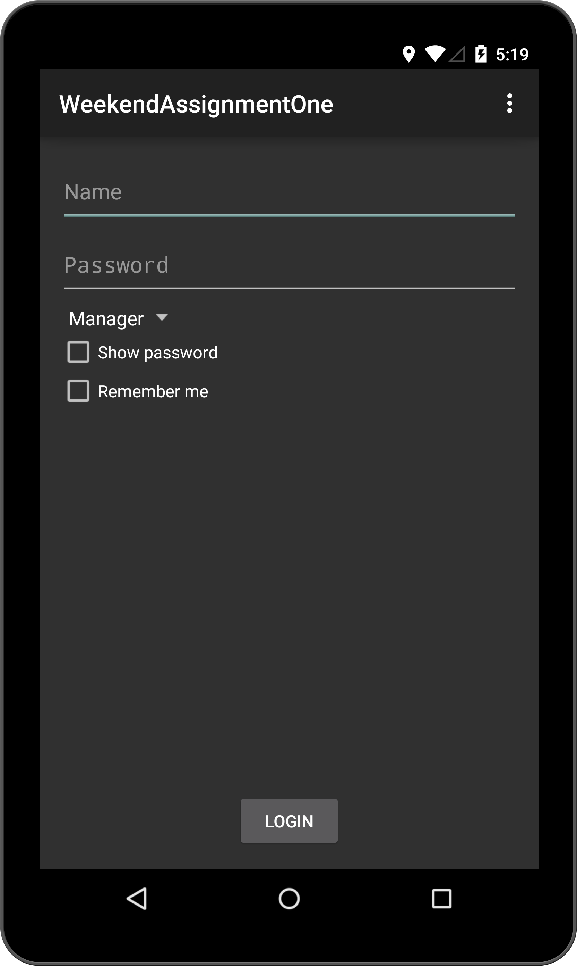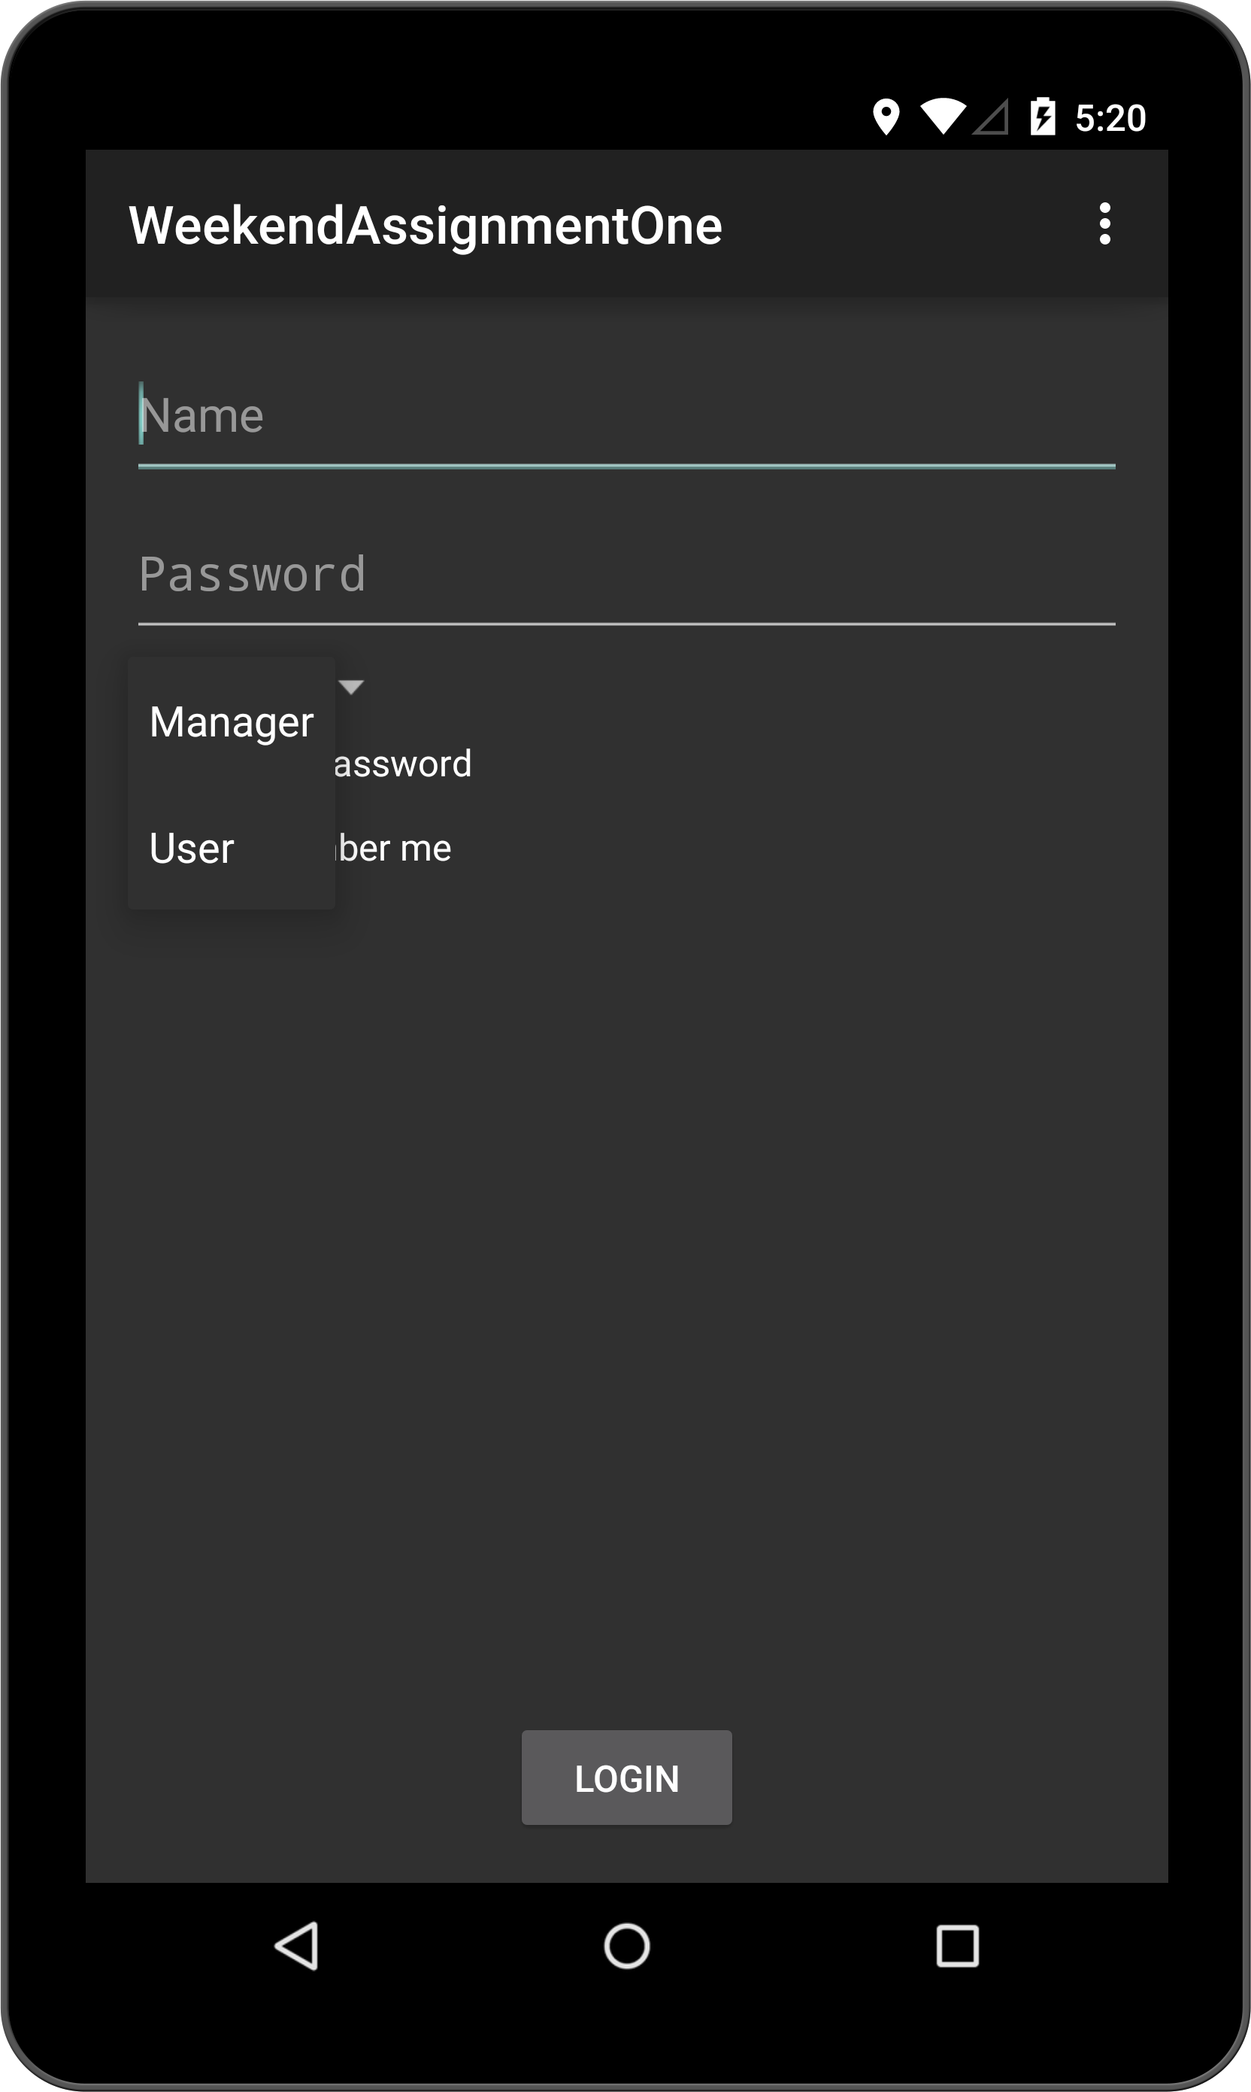

Add User Fragment (Country and Date of bithpickers)

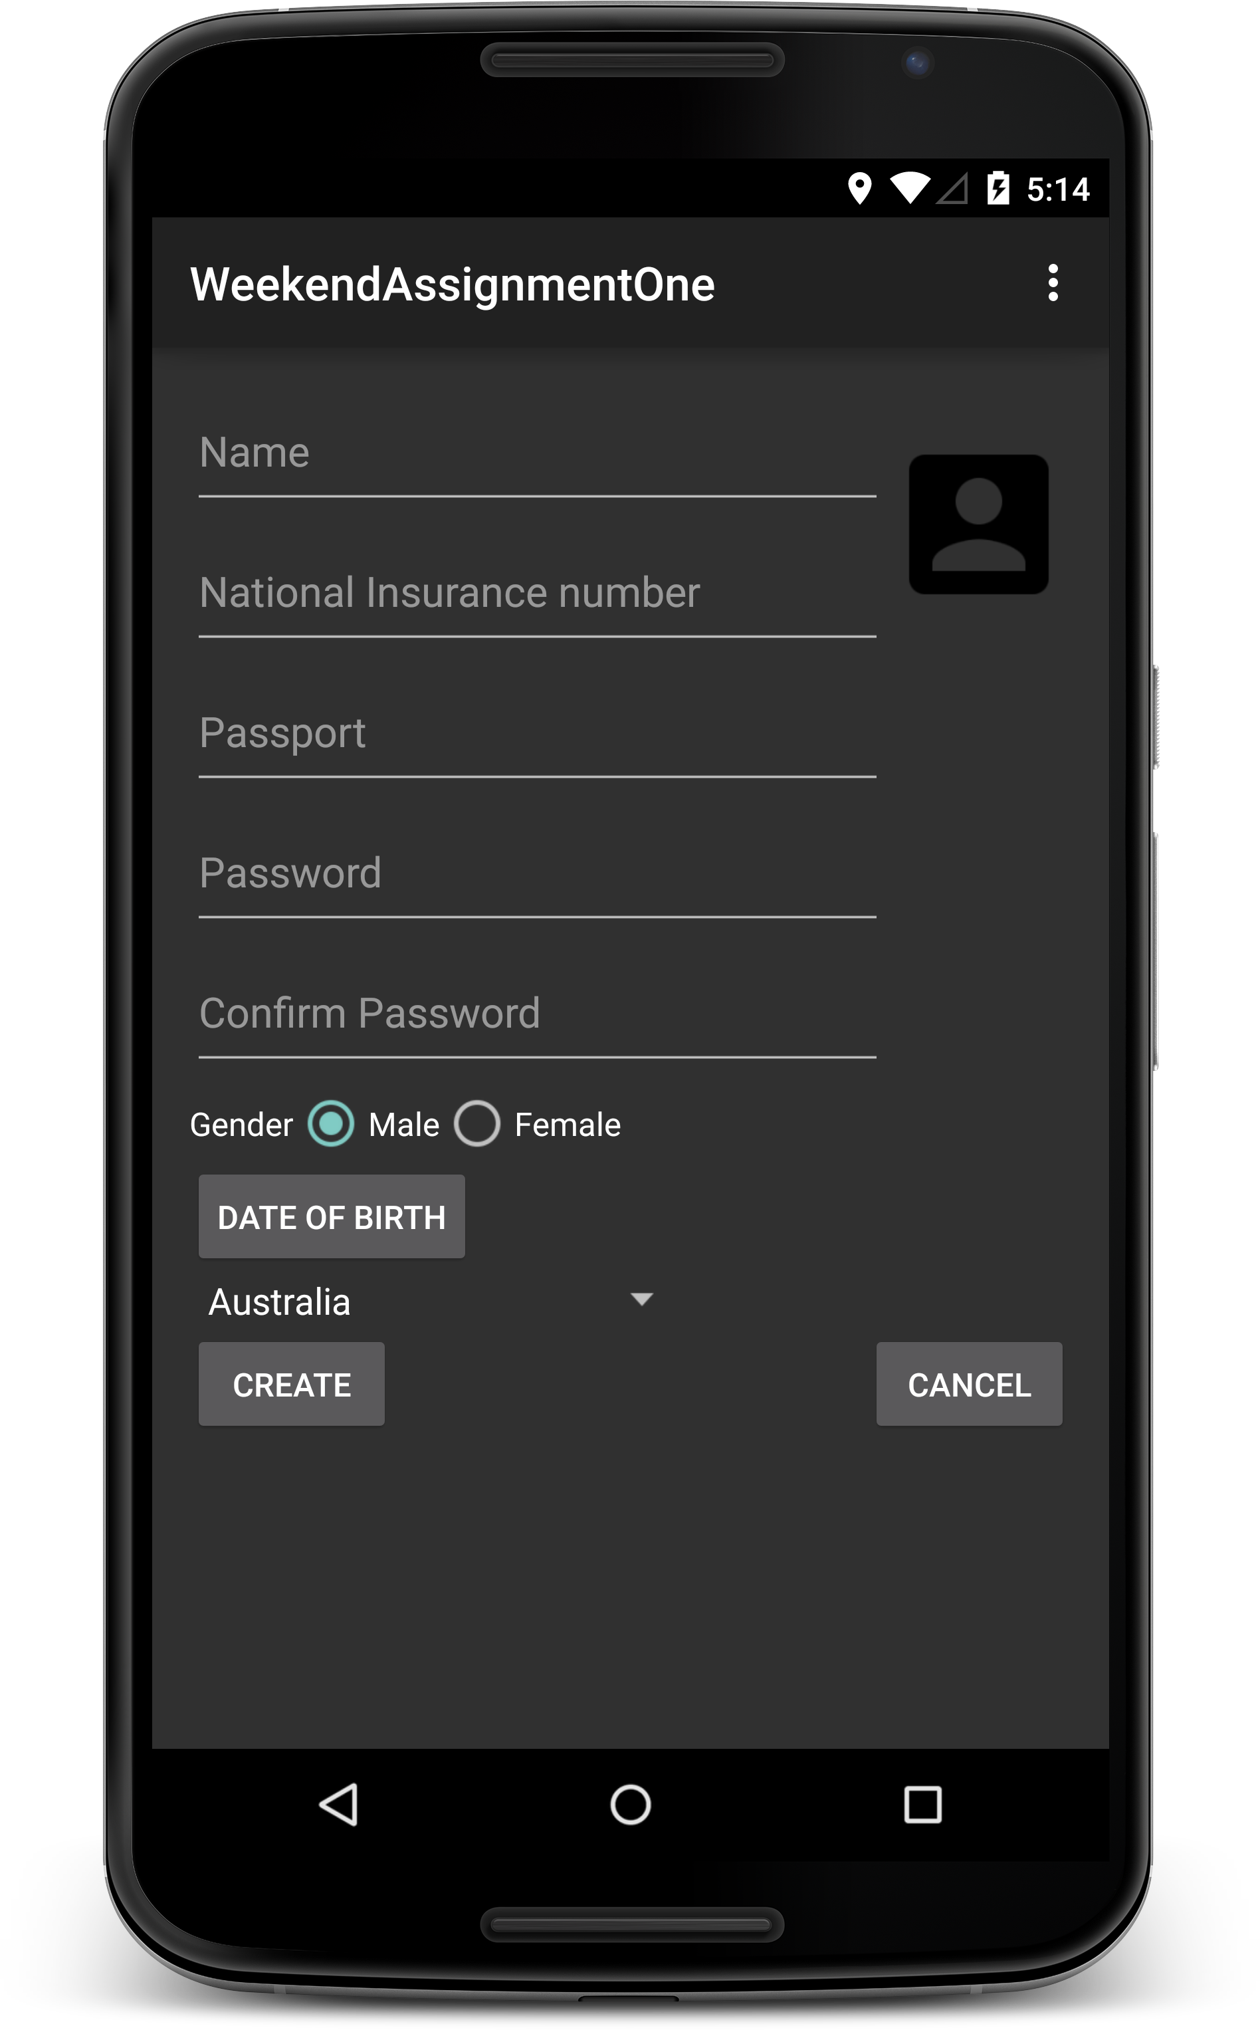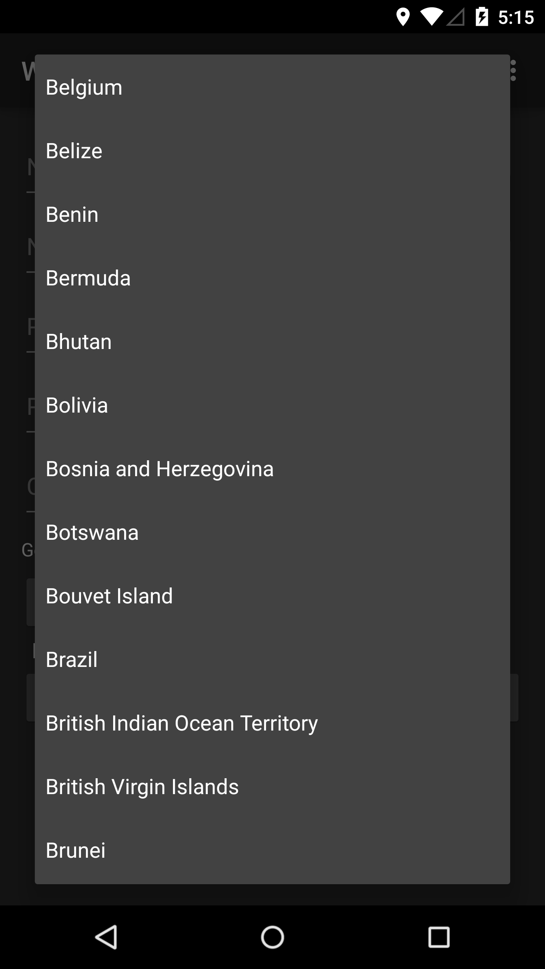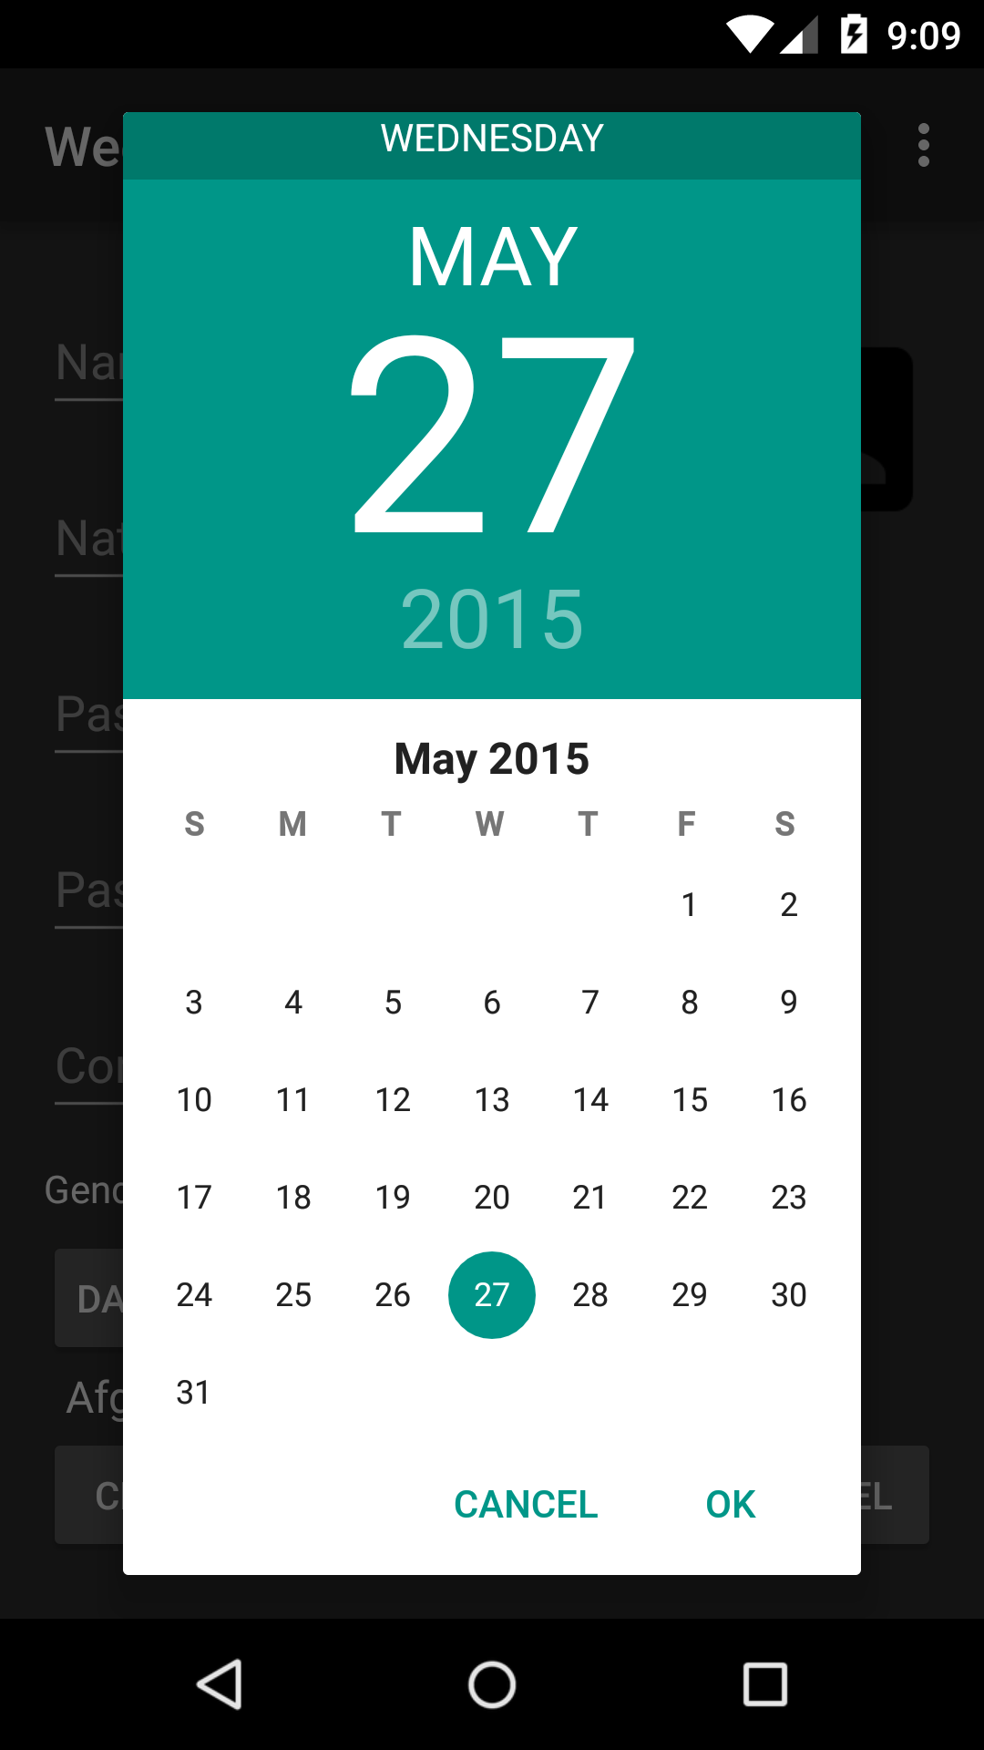

Manager_User_Control Screen: The manager can add , update or delete user. Use actionbar and fragments. The data must be stored in SQLIte database.

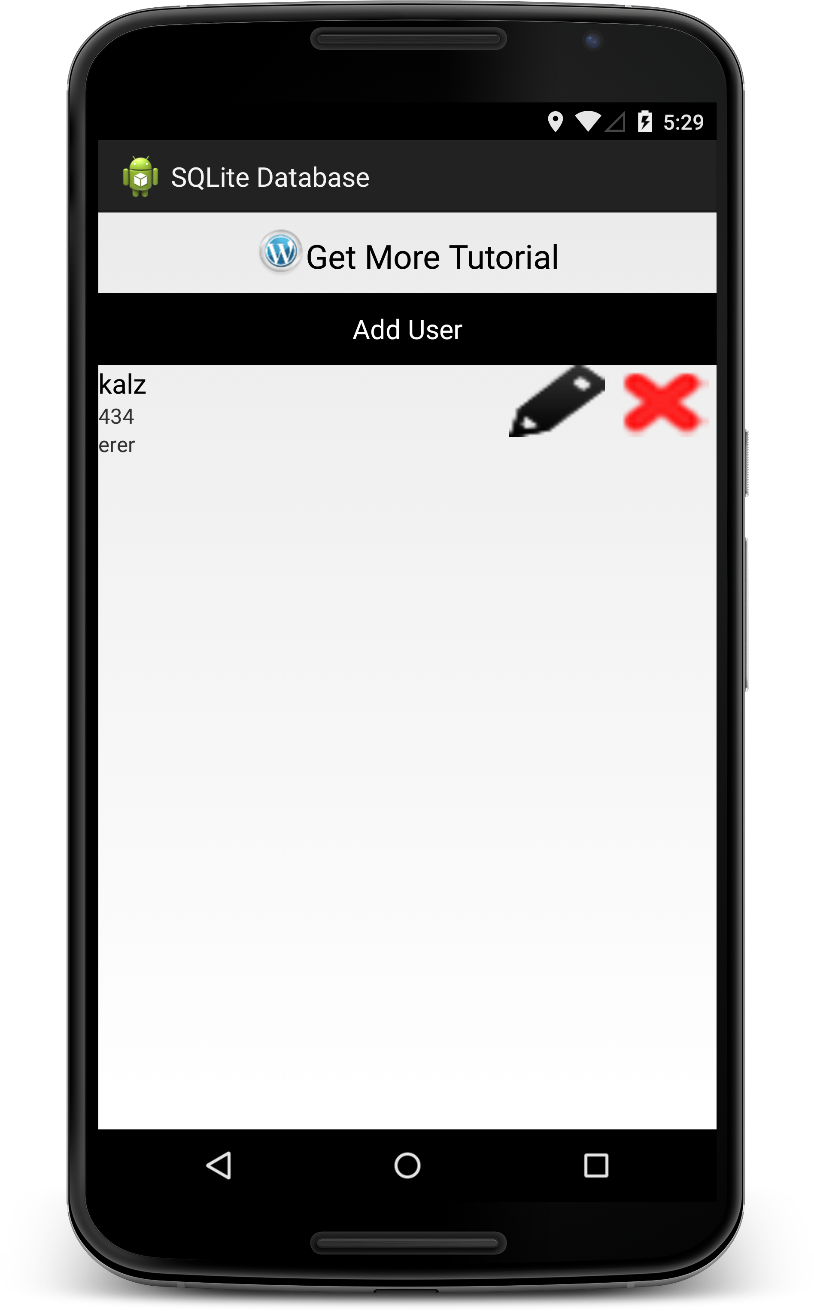

Logout_icon