School of Computing
Department of Computer Science and Intelligent Systems (CINTEL)
SRM Institute of Science and Technology, Kattankulathur – 603 203
Architecture Document
──────────────────────────────────────────────────────────
CropXpert
An IoT-Enabled, Machine Learning-Driven Precision Agriculture Platform
with Multilingual Farmer Support Portal
Team Members | Adnan Nagdiwala (RA2311026010119) | Chandra Bhayal (RA2311026010072)
Project Guide | Dr. R. Siva, Department of CINTEL, SRMIST Kattankulathur
Domain | IoT + Machine Learning + Web Development
Academic Year | 2024-25 | Minor Project (21CSP302L)
Project Status | Guide Accepted | Sprint 1: Done | Sprint 2: In Progress
SDG Alignment | SDG 2: Zero Hunger | SDG 15: Life on Land | SDG 9: Innovation

1. Introduction and Architectural Methodology
CropXpert is an end-to-end precision agriculture platform engineered for Indian smallholder farmers. It integrates real-time IoT soil sensing, a machine learning crop recommendation engine, a market intelligence layer, a government scheme advisory portal, and a multilingual conversational bot into a single, affordable hardware-software solution (hardware BOM approximately INR 3,600). This document presents the complete system architecture using the seven canonical UML views mandated for Review 1: System Overview, Use Case, Class, Data Flow (Level 0 and Level 1), Component, Sequence, and Deployment diagrams.

1.1 Selected Architecture: Microservices over a MQTT Event Bus
After evaluating Monolithic, Serverless, and Microservices patterns against CropXpert's functional requirements, the team selected a Microservices architecture orchestrated via an MQTT publish-subscribe event bus. The three primary justifications are listed below.
- Independent deployability: The ML inference service, the Market Intelligence scorer, and the Scheme Advisory module are deployed as separate FastAPI routers, allowing the 4.7 MB Random Forest model to be updated without restarting the Scheme portal.
- Heterogeneous hardware integration: The Arduino/ESP32 field node communicates over lightweight MQTT, while the React PWA consumes a REST/JSON API. A monolithic architecture would couple these two very different transport protocols unnecessarily.
- Offline resilience: The LoRa SX1276 extension (v2.0 roadmap) requires a gateway-to-broker relay pattern natively supported by MQTT's broker topology but would require significant rework in a serverless or monolithic design.

1.2 Architecture Style Justification

Architecture | Pros | Cons | CropXpert Decision
Microservices ✓ Selected | Independent deploy; MQTT decouples IoT from API | Distributed tracing overhead | Selected — MQTT bus + FastAPI microservices is the optimal fit
Monolithic | Simple single deployment | ML update requires full app restart | Rejected — ML, bot, and scheme portal must update independently
Event-Driven | Fully async, spike-resilient | Overkill for v1.0 concurrent load | Partially adopted — MQTT is event-driven; REST for sync ops
Serverless | Zero infra management | Cold-start >500 ms kills 2.3 ms ML SLA | Rejected — ML inference latency requirement is incompatible

2. System Architecture Overview
Figure 1 presents the complete seven-layer system architecture of CropXpert. The horizontal layers are ordered from the physical hardware at the top (closest to the field) down to the external government and weather data APIs at the bottom. Data flows primarily downward (sensor data through ML inference to farmer recommendation) and upward (API responses through scoring to dashboard), with a lateral MQTT bus connecting the edge and backend layers.
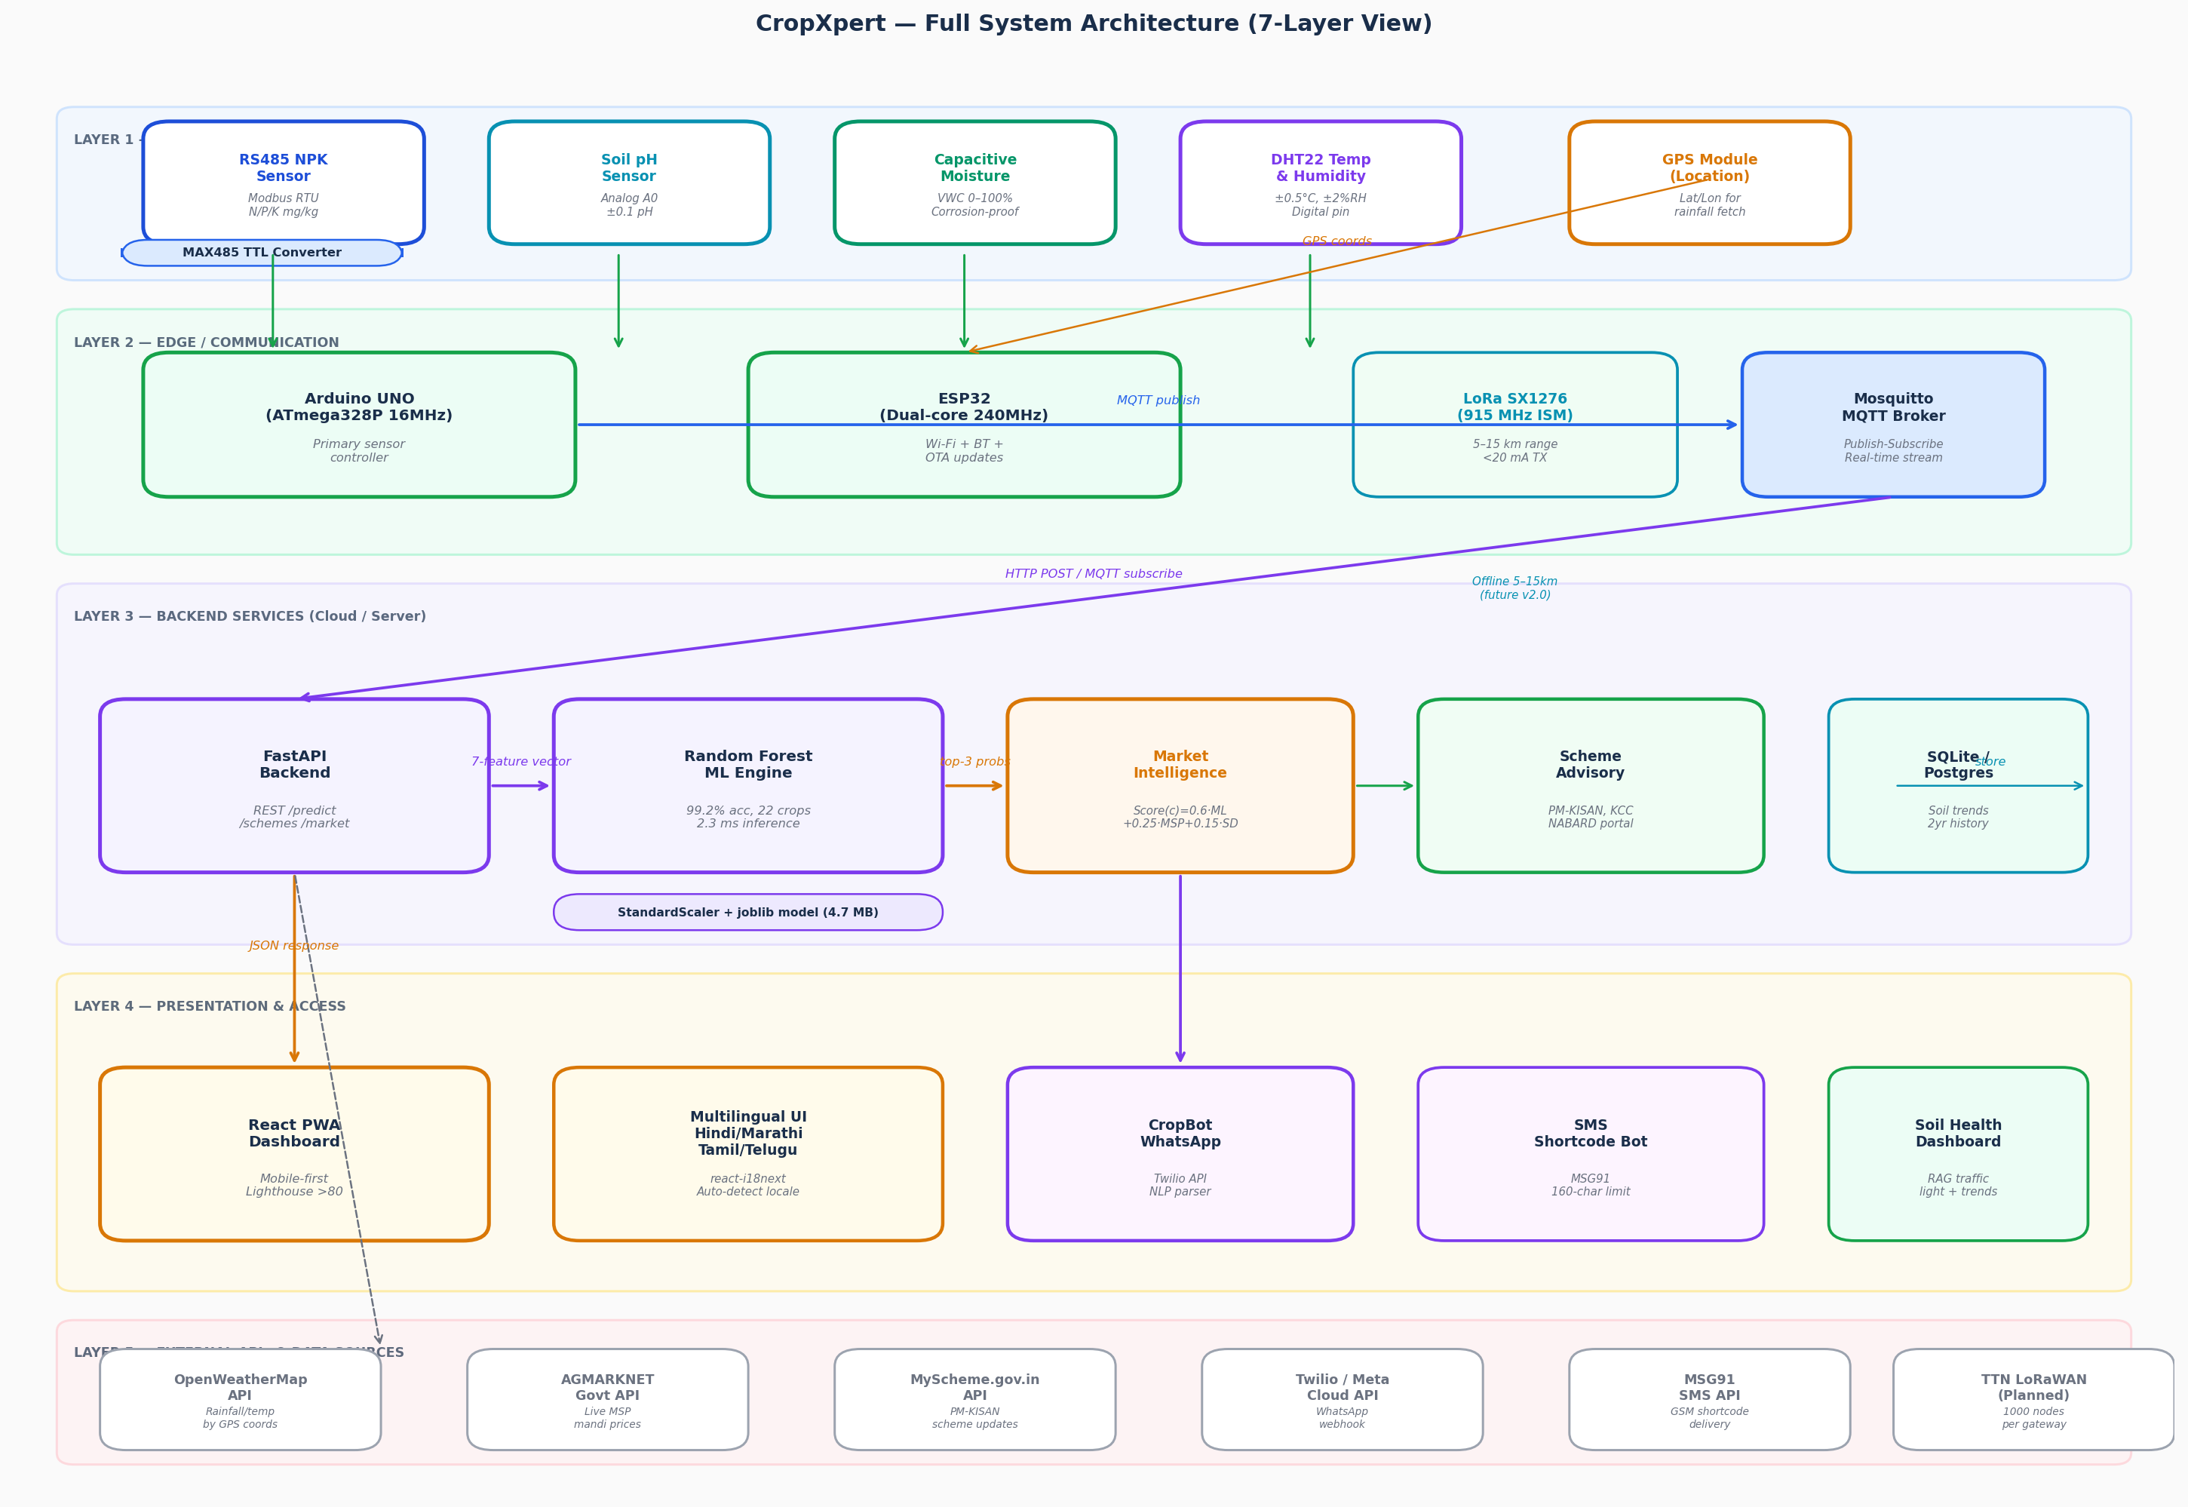
Figure 1: CropXpert Full System Architecture — Seven-Layer View
Layer 1 (Physical Sensing) houses the four field sensors: an RS485 NPK sensor communicating over the Modbus RTU protocol via the MAX485 converter, an analog soil pH sensor on Arduino pin A0, a capacitive soil moisture sensor, and a DHT22 temperature and humidity sensor. A GPS module provides coordinates for auto-fetching rainfall data from OpenWeatherMap, eliminating manual entry.
Layer 2 (Edge/Communication) contains the Arduino UNO as the primary sensor controller and the ESP32 as the Wi-Fi and future LoRa gateway. The Mosquitto MQTT broker receives sensor payloads on the topic cropxpert/farm/{farm_id}/sensors and forwards them to the backend.
Layers 3-5 handle ML inference (Random Forest, 2.3 ms, 99.2% accuracy), market intelligence (AGMARKNET MSP scoring), and multilingual presentation (React PWA in Hindi, Marathi, Tamil, Telugu; WhatsApp bot via Twilio; SMS shortcode via MSG91 for zero-smartphone access).

3. Use Case Diagram
Figure 2 captures all actors and their interactions with CropXpert within the system boundary. Five actors are identified: the primary Smallholder Farmer (smartphone-equipped), the SMS/Basic Phone User (feature phone, no internet), the Arduino/ESP32 Sensor Node (automated publisher), the External APIs (AGMARKNET, OpenWeatherMap, MyScheme.gov.in), and the Agricultural Officer/Admin (content management).
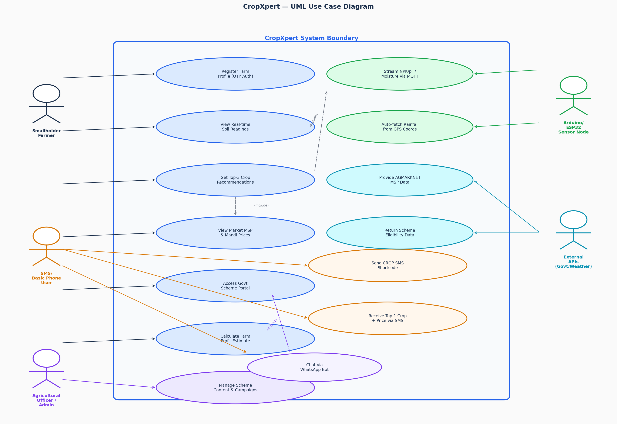
Figure 2: CropXpert UML Use Case Diagram — Actors and System Boundary
Key use case relationships: (1) an include dependency between Get Top-3 Crop Recommendations and View Market MSP & Mandi Prices, since every recommendation mandatorily fetches live market prices; (2) an include dependency between Get Recommendations and Stream NPK/pH/Moisture via MQTT, since the recommendation process depends on fresh sensor data; and (3) an extend relationship from Chat via WhatsApp Bot to the base Farmer recommendation flow, representing the optional conversational channel. The SMS shortcode bot serves the identical core use case for non-smartphone users through a stripped-down 160-character interface.

4. Class Diagram
Figure 3 presents the core domain model as a UML class diagram. Eight primary classes are defined with full attribute types, visibility indicators, and method signatures consistent with the Python/FastAPI implementation.
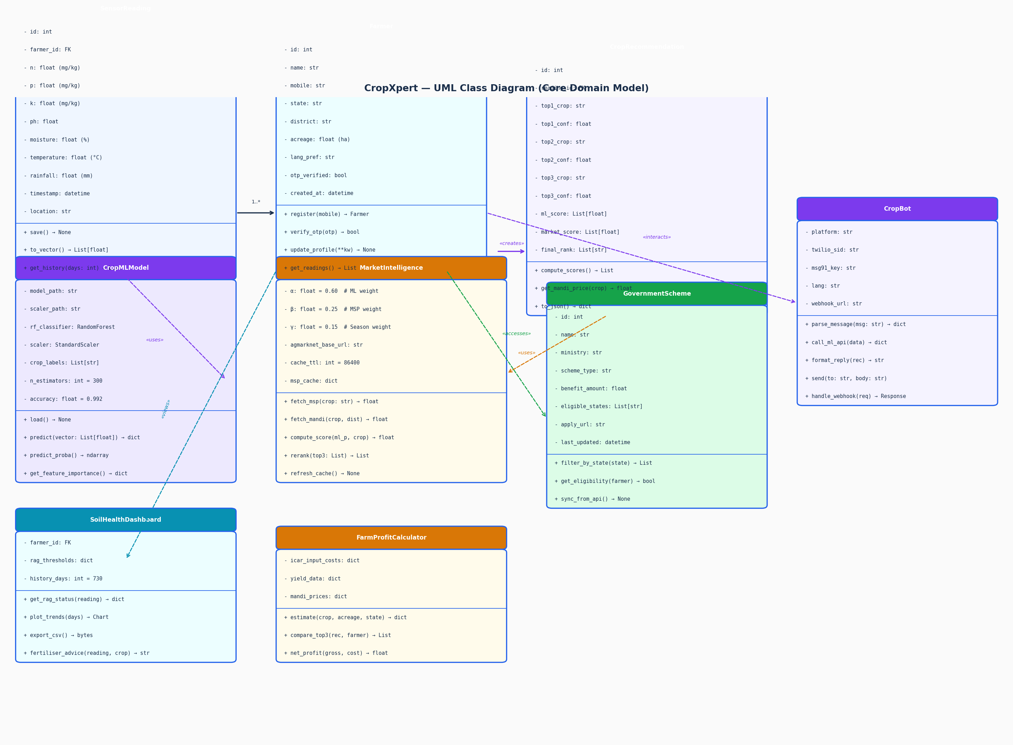
Figure 3: CropXpert UML Class Diagram — Core Domain Model
- SensorReading: Persists the raw 7-feature measurement tuple (N, P, K, pH, moisture, temperature, rainfall) with timestamp and GPS location. The to_vector() method normalises the reading for ML inference.
- Farmer: Stores the farm profile, language preference, and OTP-verified mobile authentication. The 1..* association to SensorReading represents the historical log of all readings for a given farm.
- CropMLModel: Wraps the serialised Random Forest classifier and StandardScaler. The predict() method accepts a 7-float vector and returns a dictionary of crop-to-probability mappings sorted by confidence.
- CropRecommendation: Stores both raw ML probability scores and final market-adjusted scores, enabling full audit trails that show why the ML rank may have differed from the final recommendation.
- MarketIntelligence: Implements the weighted scoring formula Score(c) = alpha * P_ML(c) + beta * MSP_Index(c) + gamma * SeasonDemand(c) with configurable weights and a 24-hour SQLite-backed MSP cache.
- GovernmentScheme: Stores PM-KISAN, Fasal Bima Yojana, KCC, and NABARD scheme attributes with state-level eligibility filtering. Synced monthly from the MyScheme.gov.in API.
- CropBot: Abstracts the WhatsApp (Twilio) and SMS (MSG91) transport layer. The parse_message() method extracts N/P/K/pH values from unstructured multilingual natural language text.
- SoilHealthDashboard and FarmProfitCalculator: Provide per-farmer trend visualisation and financial planning using ICAR crop input cost tables cross-referenced with AGMARKNET mandi prices.

5. Data Flow Diagram (DFD)
Figure 4 presents the CropXpert DFD at two levels. The Level 0 Context Diagram (left) identifies all external entities and the data crossing the system boundary. The Level 1 diagram (right) decomposes the system into its six internal processes (P1-P6) and six data stores (D1-D6).
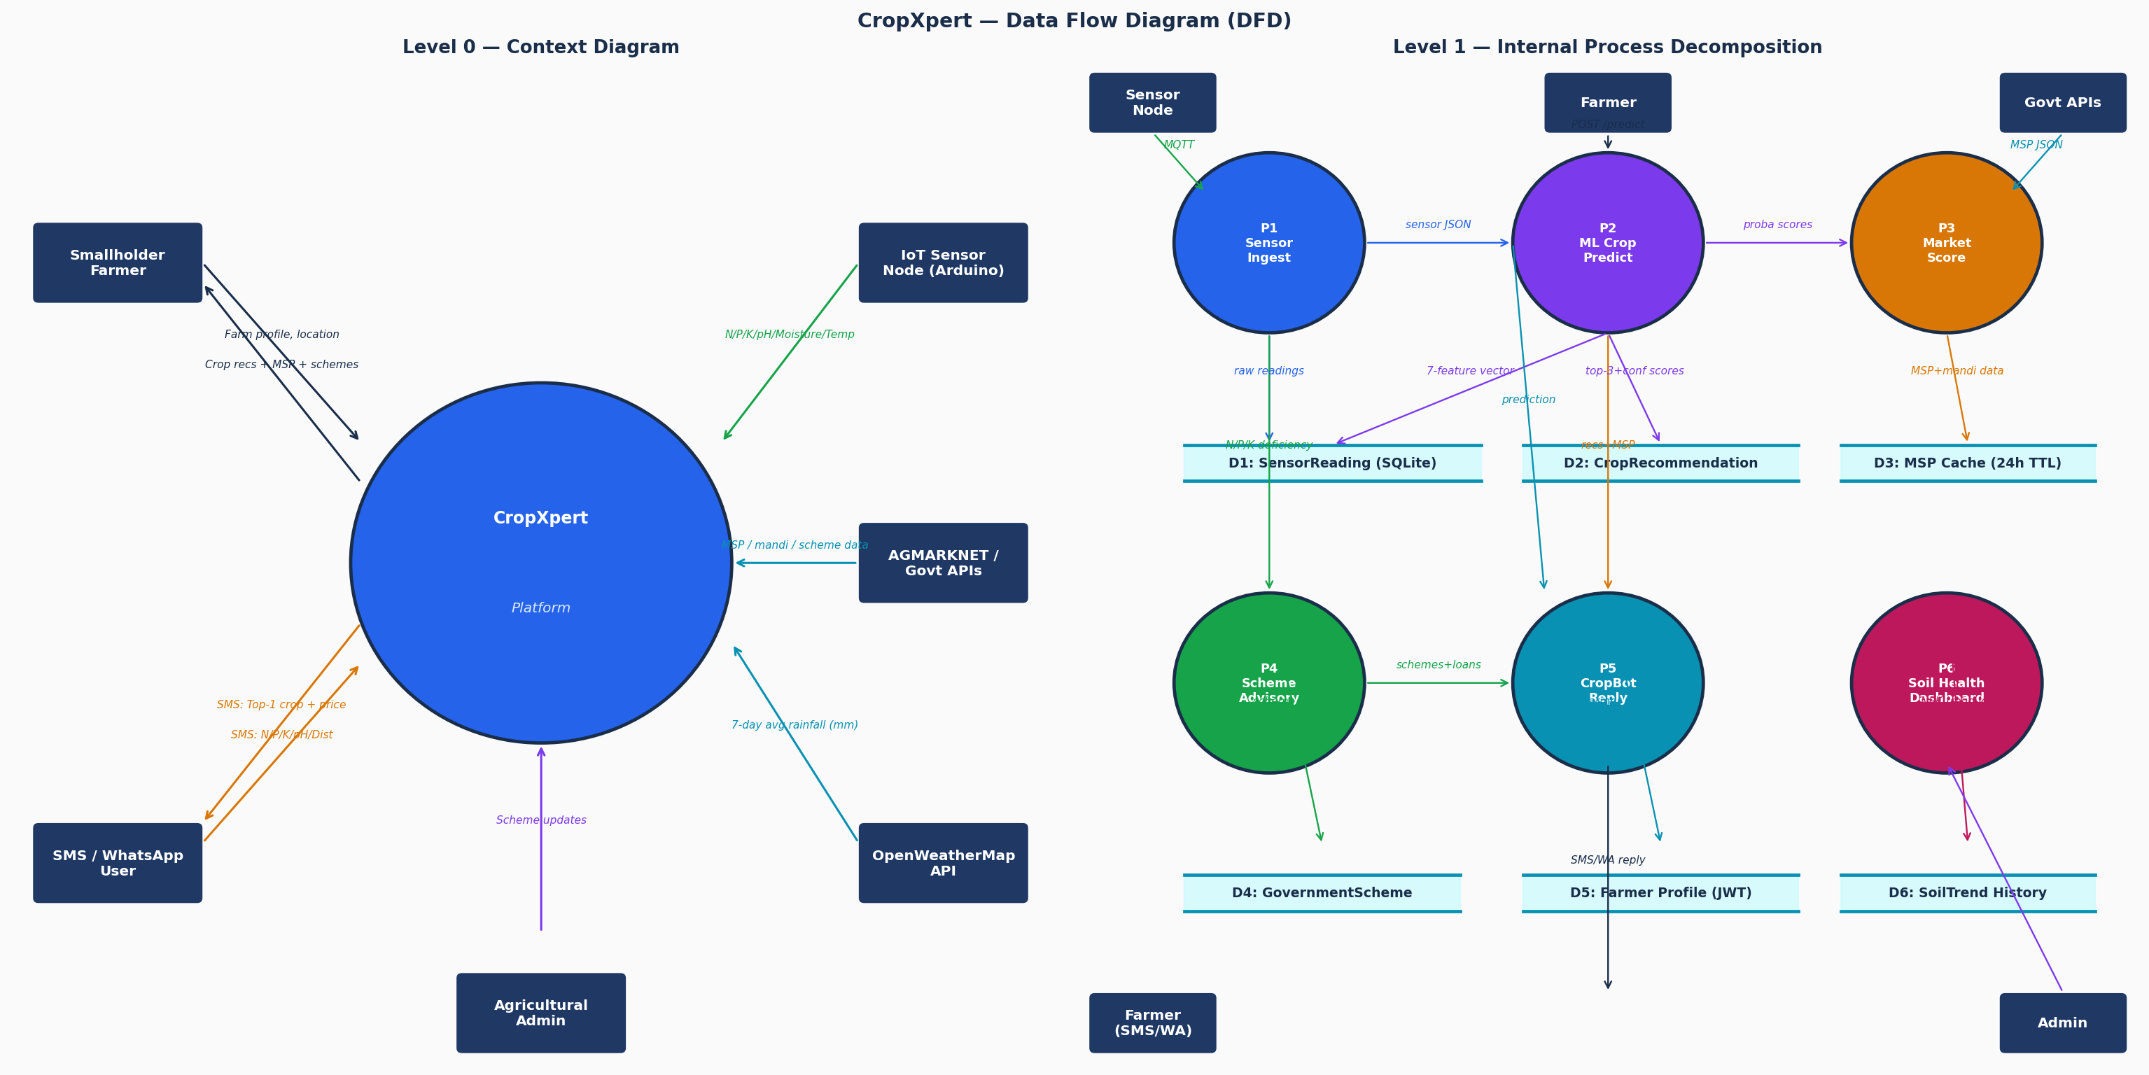
Figure 4: CropXpert Data Flow Diagram — Level 0 (Context) and Level 1 (Internal)

5.1 Level 0 — External Data Flows
- Smallholder Farmer to system: farm profile and GPS location. System to farmer: crop recommendations with MSP data, scheme eligibility, and loan guidance.
- SMS/WhatsApp User to system: CROP N90 P42 K43 PH6.5 DIST PUNE shortcode text. System to user: top-1 crop plus mandi price within a 160-character SMS reply.
- IoT Sensor Node to system: real-time N/P/K/pH/moisture/temperature published as MQTT payloads on the cropxpert/farm/{id}/sensors topic.
- AGMARKNET and Government APIs to system: live MSP and mandi arrival data fetched asynchronously every 24 hours.
- OpenWeatherMap API to system: 7-day average rainfall for the farmer GPS coordinates, cached for 6 hours to avoid rate-limit violations.

5.2 Level 1 — Internal Processes
- P1 Sensor Ingest: Receives raw MQTT payloads, parses Modbus RTU NPK frames, normalises moisture ADC readings, and writes SensorReading records (D1) to SQLite with under 50 ms write latency.
- P2 ML Crop Predict: Reads the 7-feature vector from D1, applies StandardScaler, invokes Random Forest predict_proba(), and writes the top-3 crop probabilities to D2.
- P3 Market Score: Fetches MSP data from AGMARKNET and caches in D3 (24-hour TTL). Applies the alpha/beta/gamma weighted formula to re-rank the top-3 output from P2.
- P4 Scheme Advisory: Queries D4 (GovernmentScheme) filtered by the farmer's state and returns eligibility-ranked scheme cards with direct government application URLs.
- P5 CropBot Reply: Parses WhatsApp/SMS messages, routes internally through P2 and P3, and formats the response within platform constraints (WhatsApp: rich card; SMS: 160 characters).
- P6 Soil Health Dashboard: Reads historical records from D6, computes Red/Amber/Green thresholds per nutrient against ICAR optimal ranges, and generates trend charts via Chart.js.

6. Component Diagram
Figure 5 presents the software component view of CropXpert, organised into eight subsystems. Each component box carries the UML stereotype icon and inter-component interfaces are labelled with the protocol or data format used.
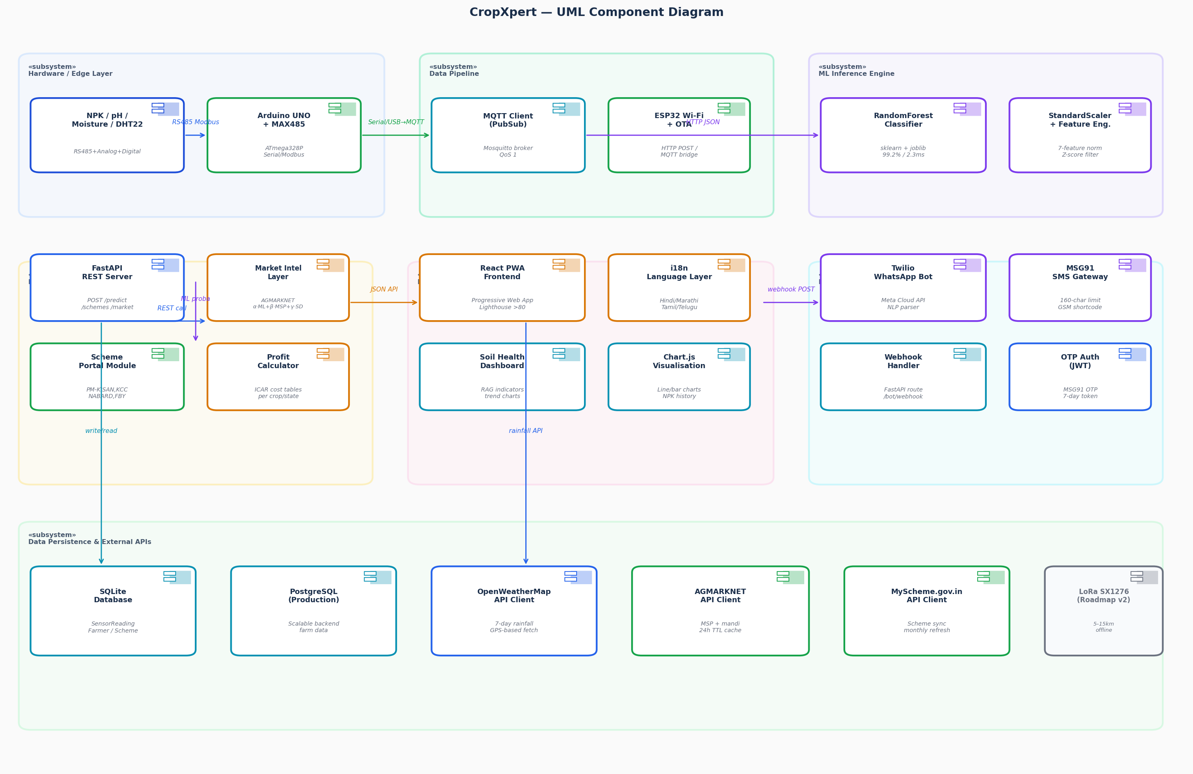
Figure 5: CropXpert UML Component Diagram — Software Architecture
- Hardware to Pipeline: The MAX485 module converts RS485 Modbus RTU frames to UART TTL signals consumed by the Arduino UNO, which bridges the serial output to the Mosquitto MQTT broker over ESP32 Wi-Fi.
- Pipeline to ML Engine: FastAPI subscribes to MQTT and passes the validated 7-float vector, after Pydantic schema enforcement, to the CropMLModel component loaded in-process via joblib. This achieves under 200 ms p95 API latency including network overhead.
- ML Engine to Business Logic: The top-3 probabilities are passed to the Market Intelligence component, which enriches them with cached AGMARKNET prices and returns a re-ranked recommendation list.
- Business Logic to Presentation: The React PWA consumes FastAPI REST endpoints over HTTPS/JSON and uses react-i18next with four JSON translation bundles to render the full UI in the farmer's locale.
- Business Logic to Bot: Twilio webhook and MSG91 POST events to a dedicated /bot/webhook FastAPI route. The CropBot normalises the incoming message, routes it through the ML pipeline, and returns a formatted text reply.

7. Sequence Diagram — End-to-End Recommendation Flow
Figure 6 presents the dynamic interaction sequence for the primary use case: a farmer opening the CropXpert dashboard, the system ingesting fresh sensor data via MQTT, performing ML inference, enriching the result with market prices, and rendering the final multilingual recommendation. Twenty numbered messages are traced across eight lifelines.
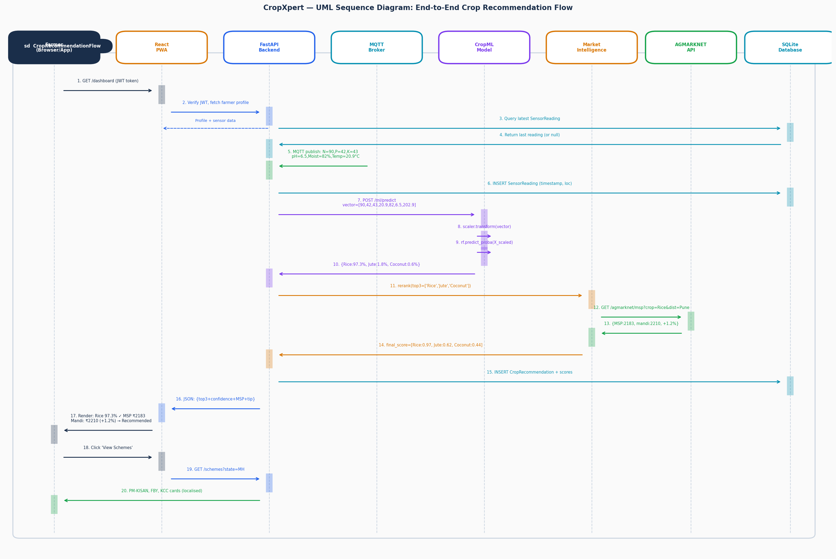
Figure 6: CropXpert UML Sequence Diagram — Crop Recommendation Request/Response Flow
- Phase 1 – Session establishment (messages 1-4): The farmer's browser sends a JWT-authenticated GET /dashboard request. FastAPI verifies the token, fetches the farmer profile from PostgreSQL, and returns the last cached SensorReading.
- Phase 2 – Sensor push (messages 5-6): The ESP32 publishes N=90, P=42, K=43, Temp=20.9 C, Humidity=82%, pH=6.5, Rainfall=202.9 mm over MQTT. FastAPI writes it to the SensorReading table.
- Phase 3 – ML prediction (messages 7-10): FastAPI passes the 7-feature vector to CropMLModel. The scaler normalises the input, Random Forest returns top-3 probabilities: Rice 97.3%, Jute 1.8%, Coconut 0.6%.
- Phase 4 – Market scoring (messages 11-14): MarketIntelligence fetches Rice MSP (INR 2,183/quintal) from AGMARKNET, obtains the Pune mandi arrival price (INR 2,210, +1.2% above MSP), and computes final weighted scores. Rice retains the top position.
- Phase 5 – Response rendering (messages 15-20): The complete recommendation is stored in CropRecommendation, returned to the React PWA in JSON, and rendered in the farmer's selected language. The farmer then accesses the Scheme portal and receives PM-KISAN, Fasal Bima Yojana, and KCC cards localised to Maharashtra.

8. Deployment Diagram
Figure 7 presents the physical deployment topology of CropXpert across five node types, from the field-level IoT device to cloud servers and external government APIs. The 3D node boxes follow UML 2.5 deployment diagram notation and communication links are labelled with the protocol used.
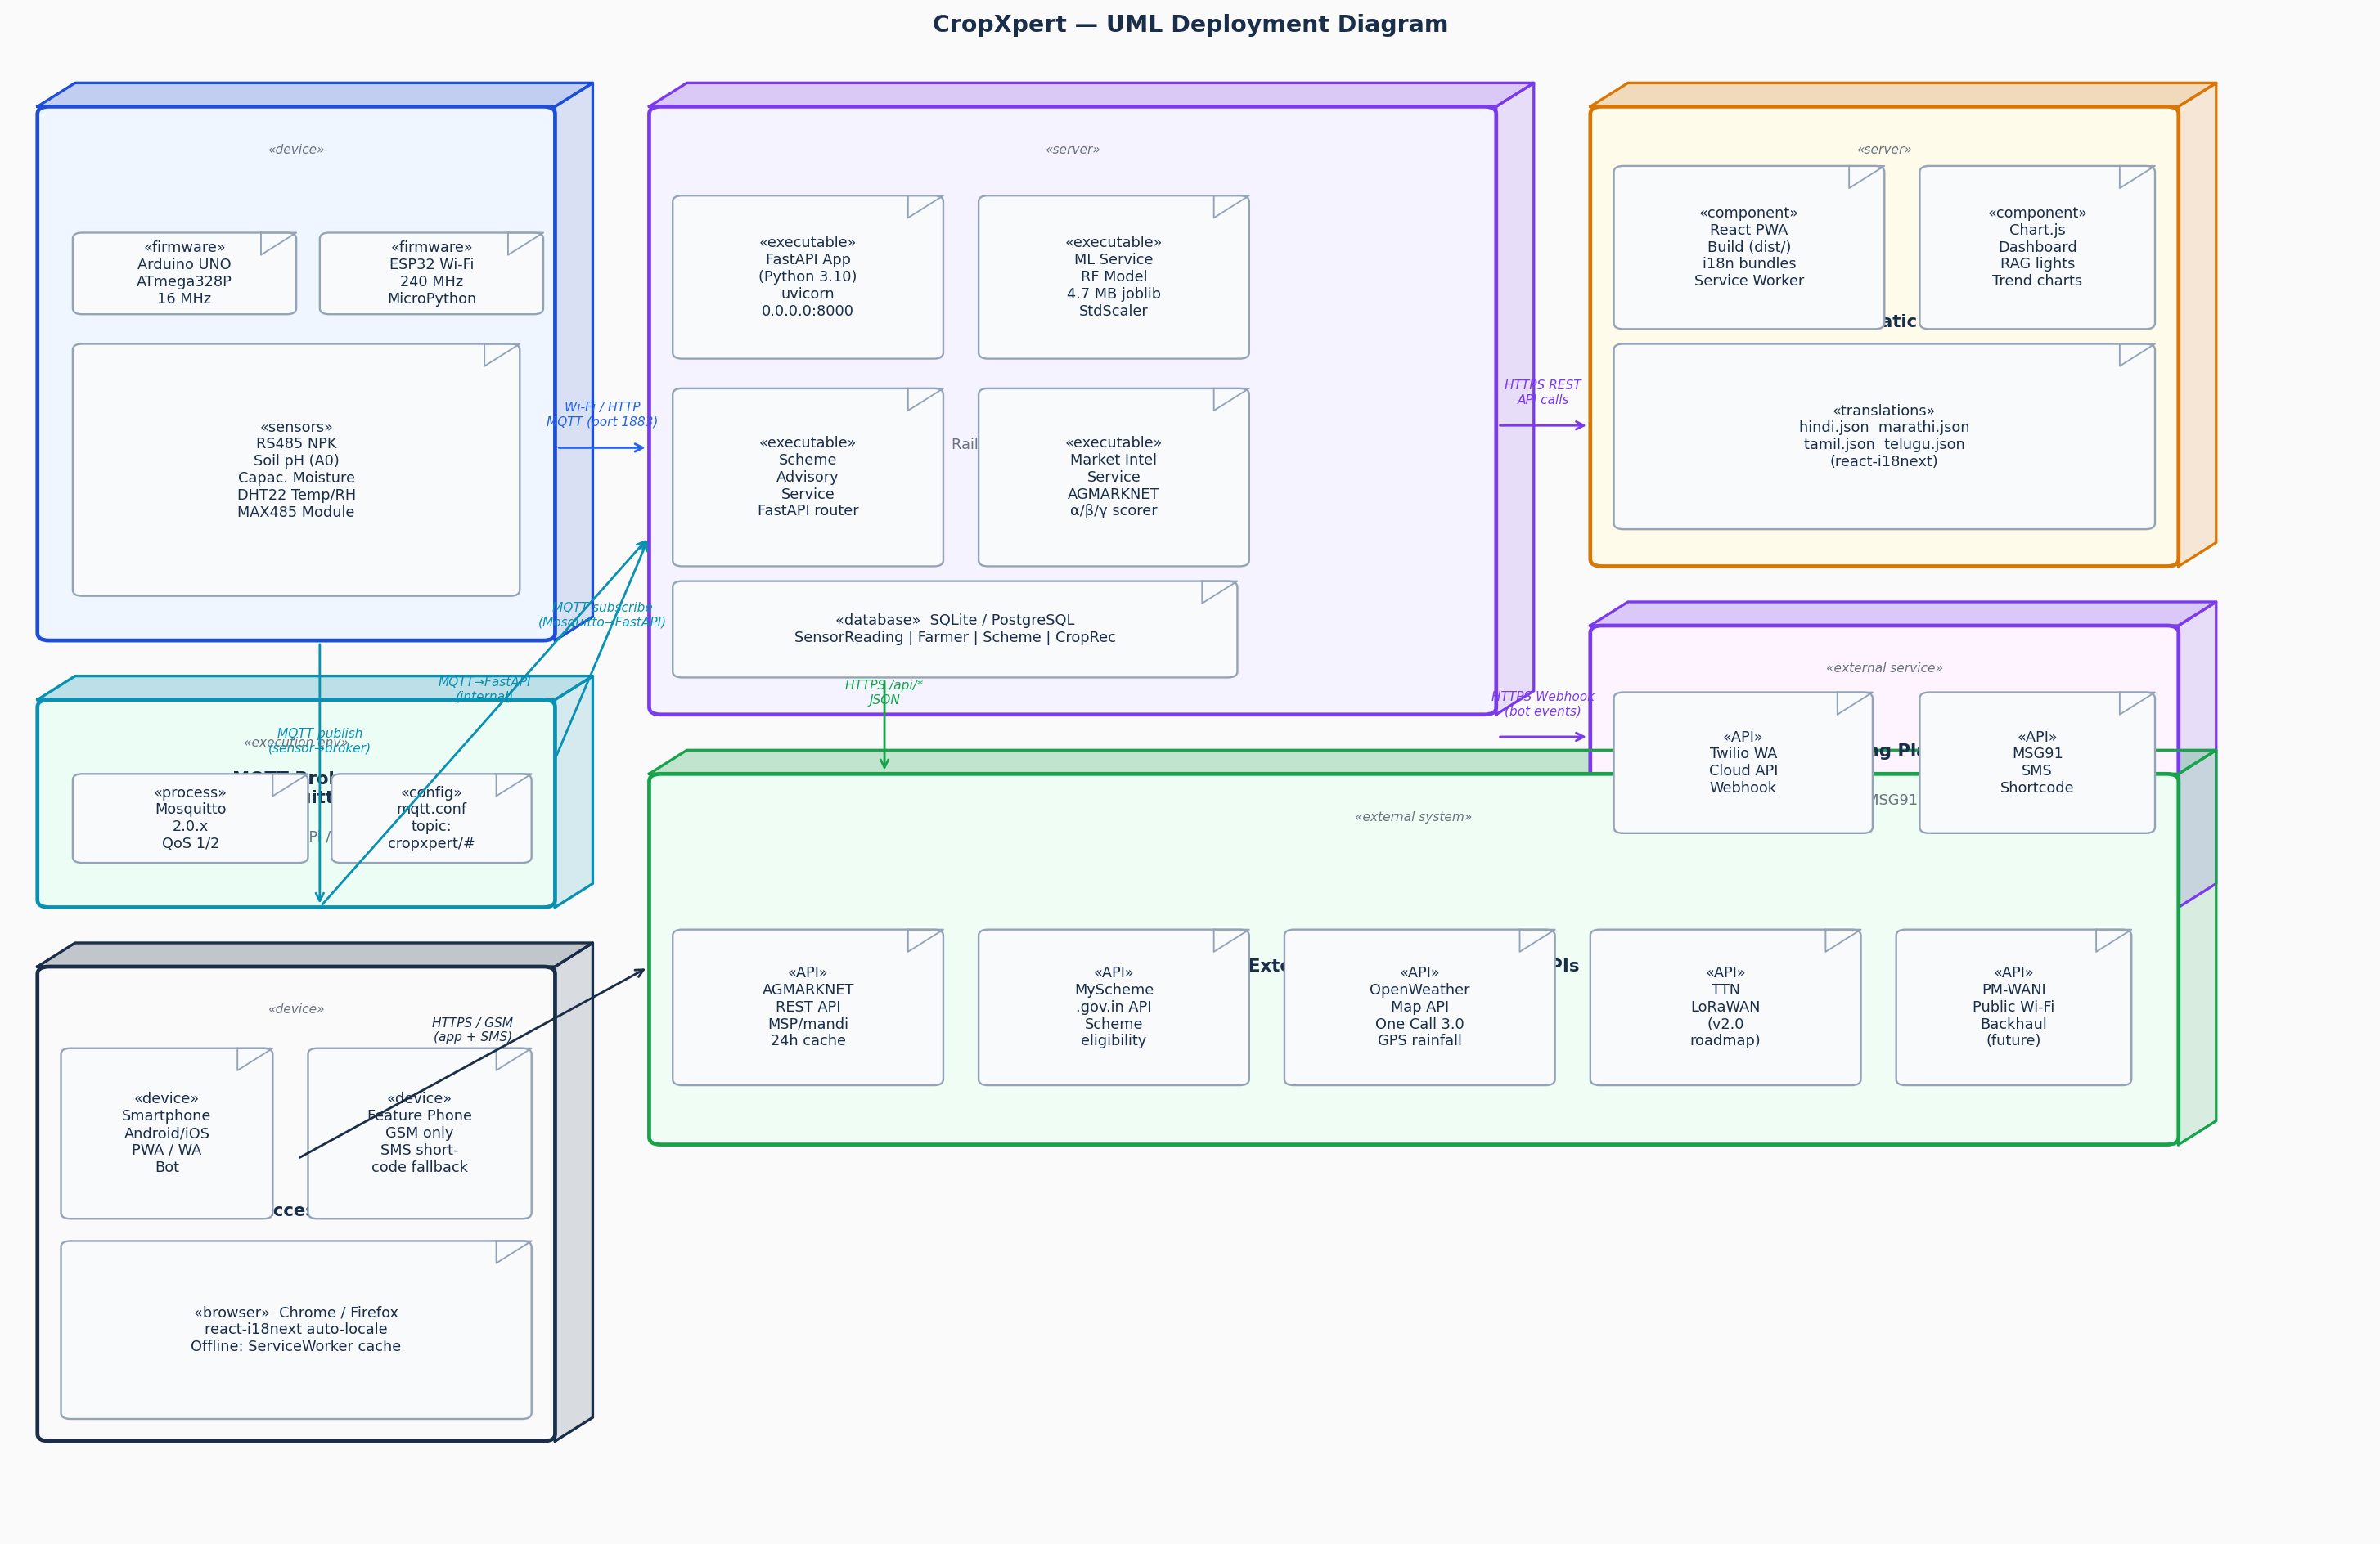
Figure 7: CropXpert UML Deployment Diagram — Physical Infrastructure
- CropXpert Field Unit (device node): The physical INR 3,600 hardware assembly deployed at the farm. Hosts the Arduino UNO firmware for Modbus RTU sensor reading and the ESP32 firmware for MQTT publish and OTA updates. Future v2.0 adds LoRa SX1276 for 5-15 km offline transmission.
- MQTT Broker (execution environment): Mosquitto 2.0.x running on a Raspberry Pi or small VPS, managing the cropxpert/# topic hierarchy with QoS 1 guaranteed delivery over TCP port 1883.
- Cloud Server (server node): Railway.app or AWS EC2 t3.micro running four Python processes: FastAPI app (port 8000), ML Service (RF model loaded at startup), Scheme Advisory Service, and Market Intelligence Service. SQLite for development; PostgreSQL for production.
- CDN / Static Host (server node): Vercel or Netlify hosts the React PWA build artifacts including four i18n translation JSON bundles and the Chart.js dashboard. The Service Worker enables offline access to the last recommendation without internet connectivity.
- Farmer Access Devices (device node): Android/iOS smartphones access the PWA via Chrome or Firefox; OTP authentication via MSG91. Basic feature phones (GSM only) use the SMS shortcode and receive a 160-character SMS reply with no data plan required.

9. Hardware Bill of Materials and Technology Stack

9.1 Hardware Bill of Materials

Component | Description | Qty | Cost (INR)
Arduino UNO (ATmega328P) | Primary microcontroller | 1 | ₹400
RS485 NPK Sensor (Modbus RTU) | N/P/K soil measurement | 1 | ₹1,800
Analog Soil pH Sensor | Soil acidity measurement | 1 | ₹500
Capacitive Moisture Sensor | Volumetric water content | 1 | ₹150
DHT22 Temperature/Humidity | Ambient sensing | 1 | ₹150
MAX485 TTL Converter Module | RS485–UART bridge | 1 | ₹50
ESP8266 Wi-Fi Module | Cloud data transmission | 1 | ₹200
Enclosure + PCB + Misc. | Field-ready assembly | — | ₹350
LoRa SX1276 (Extension v2.0) | 5–15 km rural connectivity | 1 | ₹1,500
 |  | Total (Current): | ≈ ₹3,600
 |  | Total (with LoRa): | ≈ ₹5,100

9.2 Software Technology Stack

Layer | Technology | Purpose
Firmware | C++ (Arduino IDE) / MicroPython (ESP32) | Sensor interfacing, MQTT client, OTA firmware updates
ML / Data Science | Python 3.10, Scikit-learn, XGBoost, LightGBM, Pandas, NumPy, Joblib | Model training, inference pipeline, preprocessing
Backend API | FastAPI (Python), Uvicorn, Pydantic, SQLAlchemy | REST endpoints, input validation, async I/O
Message Broker | Mosquitto MQTT 2.0.x (QoS 1) | Real-time sensor data streaming
Database | SQLite (dev) / PostgreSQL 15 (production) | Sensor history, farm profiles, scheme records
Frontend | React 18 PWA, react-i18next, Chart.js, Tailwind CSS | Multilingual dashboard, offline service worker, charts
Bot / Messaging | Twilio API (WhatsApp), MSG91 (SMS, OTP) | CropBot, shortcode fallback, OTP authentication
External APIs | OpenWeatherMap, AGMARKNET, MyScheme.gov.in | Rainfall, MSP/mandi prices, government schemes
Deployment | Railway.app / AWS EC2, Vercel / Netlify, ESP32 OTA | Cloud hosting, CDN, over-the-air firmware updates
LoRa (Roadmap) | ESP32 + LoRa SX1276, LoRaWAN TTN, RAK2245 Gateway | 5–15 km offline connectivity for no-4G villages

10. Machine Learning Model Evaluation
Five classifiers were trained and evaluated under 5-fold stratified cross-validation with GridSearchCV hyperparameter tuning on the same 70%-15%-15% stratified train-validation-test split of the Indian Crop Recommendation Dataset (2,200+ augmented samples, 22 crop classes).

Model | Accuracy | F1-Score | Model Size | Inference | Status
Random Forest (Selected) | 99.2% | 0.992 | 4.7 MB | 2.3 ms | ✓ Selected
XGBoost | 98.7% | 0.987 | 8.2 MB | 3.1 ms | Evaluated
LightGBM | 98.5% | 0.985 | 6.8 MB | 2.8 ms | Evaluated
SVM (RBF Kernel) | 97.8% | 0.979 | 12 MB | 8.4 ms | Evaluated
MLP (128-64-32) | 97.1% | 0.972 | 2.1 MB | 4.5 ms | Evaluated

Random Forest was selected as the production model for four reasons: (1) highest accuracy of 99.2% on the 22-class test set; (2) smallest serialised model size at 4.7 MB; (3) lowest inference latency at 2.3 ms mean, critical for real-time embedded deployment; and (4) superior interpretability through feature importance scores that can be communicated to farmers and validated by agronomists.

10.1 Feature Importance
- Rainfall (28.4%): The most discriminative feature. Rice requires greater than 200 mm average rainfall while Cotton tolerates under 100 mm. Auto-fetched from OpenWeatherMap using farmer GPS coordinates.
- Humidity (21.7%): Influences disease susceptibility and water stress. DHT22 provides plus/minus 2-5% RH accuracy sufficient for ML inference.
- pH (16.3%): Determines nutrient availability. Optimal range varies from pH 5.5 (Coffee) to pH 7.5 (Chickpea). Analog pH sensor with buffer calibration provides plus/minus 0.1 accuracy.
- Temperature (10.7%): Controls growing season boundaries. DHT22 plus/minus 0.5 degrees Celsius accuracy meets the classification task requirement.
- Nitrogen, Phosphorus, Potassium (9.8%, 7.2%, 8.1%): NPK together account for 25.1% of predictive power, directly justifying the RS485 NPK sensor investment at INR 1,800.

11. Novel Architectural Contributions

11.1 Market-Aware Recommendation Engine
All prior systems reviewed in the literature recommend crops based solely on agro-climatic suitability. CropXpert introduces a Market Intelligence Layer that queries AGMARKNET for live Minimum Support Price and mandi arrival data. The final crop ranking applies the formula:
Score(c) = 0.60 x P_ML(c) + 0.25 x MSP_Index(c) + 0.15 x SeasonDemand(c)
A crop with high ML confidence but suppressed market price is ranked below a slightly less agronomically optimal but economically viable alternative. The alpha/beta/gamma weights are configurable by the agricultural officer via an admin panel, enabling state-specific tuning.

11.2 Vernacular-First Multilingual Interface
CropXpert implements a multilingual output layer covering Hindi (UP, MP, Bihar), Marathi (Maharashtra), Tamil (Tamil Nadu), and Telugu (Andhra Pradesh, Telangana) covering over 400 million farmers who cannot read English. Language is auto-detected from the browser locale using react-i18next and can be manually toggled. All ML outputs, scheme details, fertiliser advisory, and loan guidance are fully localised.

11.3 LoRa + ESP32 Offline Extension (v2.0 Roadmap)
The planned v2.0 hardware revision replaces the ESP8266 Wi-Fi link with an ESP32 plus LoRa SX1276 at 915 MHz ISM band, delivering 5-15 km transmission range at under 20 mA current draw. A single RAK2245 LoRaWAN gateway can aggregate up to 1,000 sensor nodes, with PM-WANI public Wi-Fi infrastructure serving as the internet backhaul. This targets states where agricultural 4G penetration remains below 45%.

12. Non-Functional Requirements and Quality Attributes

12.1 Performance Targets
- ML inference latency: under 5 ms (achieved: 2.3 ms mean).
- FastAPI /predict endpoint p95 latency: under 200 ms including network overhead.
- MQTT sensor publish-to-dashboard refresh: under 2 seconds end-to-end.
- React PWA First Contentful Paint: under 2 s on 3G (Lighthouse mobile score target greater than 80).
- AGMARKNET API cache hit rate: greater than 90% during normal operation (24-hour TTL).

12.2 Reliability and Fault Tolerance
- MQTT QoS 1 guarantees at-least-once delivery. Duplicate detection on the backend ensures idempotent inserts into the SensorReading table.
- Graceful degradation: If AGMARKNET API is unavailable, the market score falls back to MSP_Index = 0 and the pure ML ranking is returned with a user notification. If OpenWeatherMap fails, a manual rainfall entry UI is presented.
- PWA Service Worker caches the last recommendation and sensor dashboard offline, ensuring farmers can access their most recent advisory without internet connectivity.

12.3 Security
- Authentication: OTP-based mobile login via MSG91. JWT tokens with 7-day expiry. HTTPS enforced on all API endpoints. OTPs never stored in plain text.
- Input validation: Pydantic schema enforcement rejects out-of-range sensor values (e.g., pH greater than 14, N greater than 1999 mg/kg) before they reach the ML model.
- Data privacy: Farmer GPS coordinates are used only for rainfall API queries and are not stored beyond the session, in compliance with the Digital Personal Data Protection Act 2023 framework.

────────────────────────────────────────────────────────────────────────────────
Document prepared for B.Tech Third Year Minor Project Review 1 — 21 February 2026
Department of Computer Science and Intelligent Systems (CINTEL), SRMIST Kattankulathur
Guide: Dr. R. Siva | Team: Adnan Nagdiwala (119) & Chandra Bhayal (072)

