

School of Computing
Department of Computer Science and Intelligent Systems (CINTEL)
SRM Institute of Science and Technology, Kattankulathur – 603 203

Architecture Document
CropXpert — IoT-Enabled, ML-Driven Precision Agriculture Platform
with Multilingual Farmer Support Portal

Field | Details
Project Title | CropXpert – Precision Agriculture Platform
Architecture Chosen | Microservices + Event-Driven Architecture (MQTT)
Database | PostgreSQL (production) + SQLite (edge cache)
Team Members | Adnan Nagdiwala (RA2311026010119) | Chandra Bhayal (RA2311026010072)
Guide | Dr. R. Siva, Dept. of CINTEL, SRMIST Kattankulathur
Status | Guide Accepted ✓ | Academic Year 2024–2025
SDG Alignment | SDG 2 (Zero Hunger) | SDG 8 (Decent Work) | SDG 9 (Innovation) | SDG 15 (Life on Land)

1. Application Architecture
CropXpert is an integrated IoT and Machine Learning precision agriculture platform. This section describes the chosen application architecture, justifies the selection over alternatives, and presents all required diagrams: Use Case, Class, DFD, Component, Sequence, and Deployment.

1.1 Architecture Selection: Microservices + Event-Driven (MQTT)
After evaluating Microservices, Event-Driven Architecture, Serverless, and Monolithic approaches, CropXpert adopts a hybrid of Microservices and Event-Driven Architecture. The table below compares all four options:

Architecture | Why Suitable for CropXpert | Limitations | Decision
Microservices  (SELECTED) | ML Engine, MQTT Broker, CropBot, Scheme Portal deploy and scale independently. Aligns with Agile sprint structure. Parallel development by 2-member team. | Higher initial complexity; mitigated by Docker + Railway.app PaaS. | SELECTED ✓
Event-Driven / MQTT  (SELECTED for IoT) | MQTT pub/sub perfectly matches continuous IoT sensor streams. Sensor nodes do not need to know consumer identity. Natural backpressure handling. | Debugging harder; mitigated by structured logging and MQTT retained messages. | SELECTED ✓
Monolithic | Simple deployment; no inter-service network overhead. | Hard to scale ML and IoT independently. Adding LoRa/CropBot requires full redeploy. Tight coupling impedes team development. | NOT CHOSEN
Serverless | Auto-scaling; zero server maintenance. | Cold-start latency (>500 ms) incompatible with real-time sensor < 200 ms requirement. Cost unpredictable at scale. | NOT CHOSEN

1.2 Architecture Description
The five-layer architecture of CropXpert is described below. Each layer has distinct responsibilities and communicates with adjacent layers via well-defined interfaces:
- Layer 1 — IoT Hardware: RS485 NPK sensor, soil pH sensor, capacitive moisture sensor, DHT22 temperature/humidity sensor, and Arduino UNO/ESP32 microcontroller. Rainfall auto-fetched from OpenWeatherMap API via farmer GPS coordinates.
- Layer 2 — Communication: Mosquitto MQTT broker (Port 1883) for event-driven real-time sensor streaming; FastAPI REST (Port 8000) for synchronous API calls; LoRa SX1276 planned for v2.0 offline rural coverage (5–15 km).
- Layer 3 — Backend & ML: Random Forest Classifier (99.2% accuracy, 22 Indian crops, 2.3 ms inference), AGMARKNET market scoring layer using formula Score(c) = 0.60×P_ML + 0.25×MSP_Index + 0.15×SeasonDemand, PostgreSQL + SQLite persistence, API caches.
- Layer 4 — Web & API: FastAPI REST endpoints (/predict, /schemes, /loans), React.js Progressive Web App frontend, React-i18next multilingual layer (Hindi/Marathi/Tamil/Telugu), Twilio CropBot (WhatsApp + SMS via MSG91).
- Layer 5 — Clients: Farmer smartphone/desktop browser (React PWA), WhatsApp client, basic keypad phone via SMS shortcode (format: CROP N90 P42 K43 PH6.5 DIST PUNE), KVK admin portal.

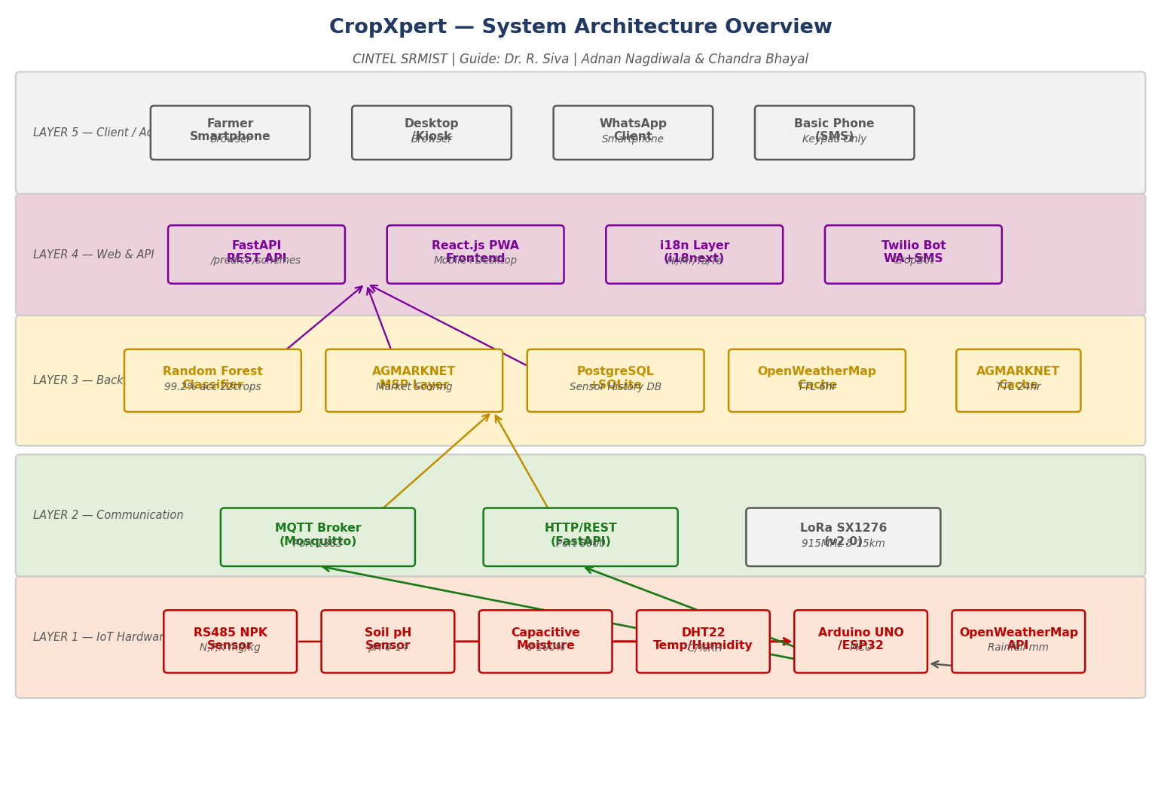
Figure 1: CropXpert System Architecture Overview — Five-Layer Microservices + Event-Driven Design

1.3 Microservices Architecture — Sub-Types
CropXpert implements three sub-types of application architecture across its microservices:

Microservices
Each major capability is an independently deployable service: ML Prediction Service (/predict endpoint + RF model), Market Intelligence Service (AGMARKNET integration + scoring), Farmer Support Service (schemes + loans), CropBot Service (Twilio + MSG91), and Frontend Service (React PWA). All services communicate via FastAPI REST or MQTT. Each can be scaled, updated, or redeployed independently — critical for the 5-sprint Agile roadmap.

Event-Driven
The IoT data pipeline is purely event-driven. Sensor nodes publish JSON payloads to the MQTT topic cropxpert/farm/<farmer_id>/sensors every 60 seconds. The backend subscribes and processes data asynchronously — no polling, no tight coupling. This is the only architecture that correctly handles 1,000+ concurrent sensor nodes (v2.0 LoRaWAN scale) without blocking.

Serverless (Selective — External APIs)
AGMARKNET MSP fetch, OpenWeatherMap rainfall, and MyScheme.gov.in data are consumed as serverless third-party functions. These are cached (TTL 24h and 6h respectively) to reduce dependency on external availability. The CropBot webhook (Twilio) is also effectively a serverless function handler.

1.4 Use Case Diagram
The Use Case Diagram identifies all actors and their interactions. Four actors: Farmer (primary), Admin, IoT Sensor System, and External APIs (AGMARKNET, OpenWeatherMap, MyScheme.gov.in). Twelve use cases span registration, sensor monitoring, crop recommendation, market pricing, scheme access, loan guidance, CropBot, profit calculation, soil history, language switching, and admin content management.
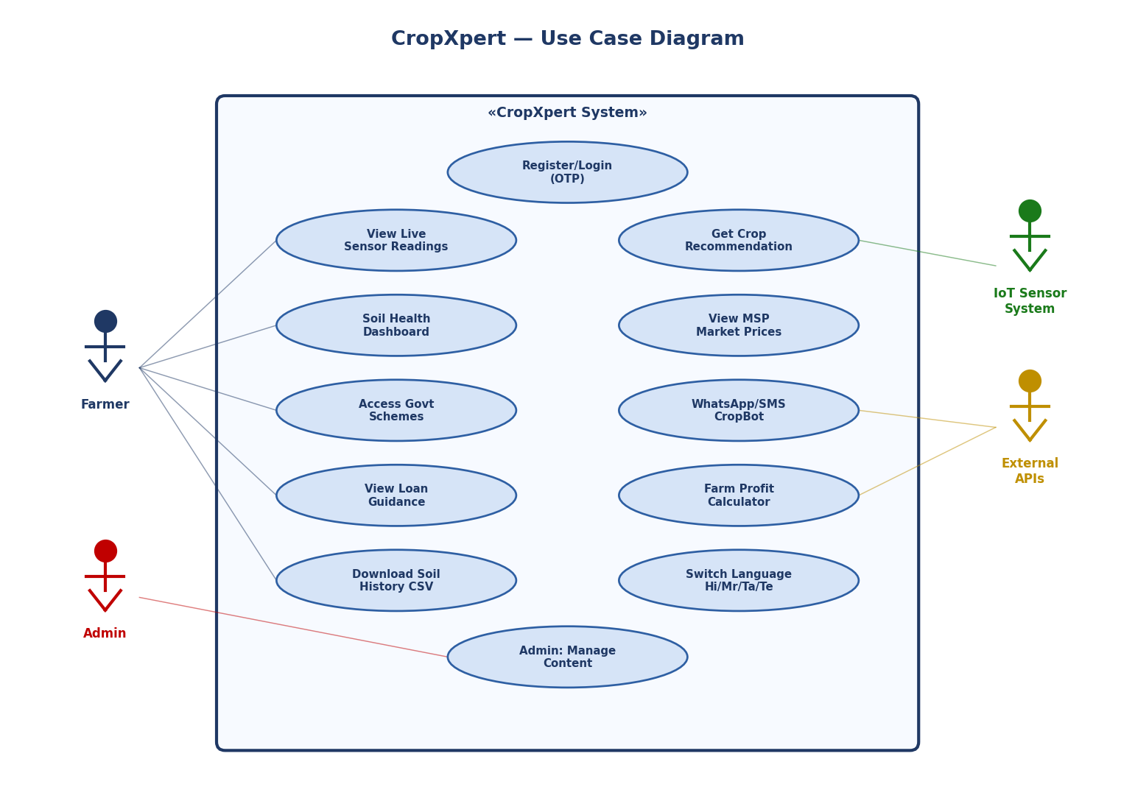
Figure 2: CropXpert Use Case Diagram — Actors and System Interactions

1.5 DFD Level 0 — Context Diagram
The Level 0 DFD presents CropXpert as a single system process with five external entities: Farmer, IoT Sensor Module, AGMARKNET API, OpenWeatherMap API, and Twilio/MSG91. All major data flows are identified at the boundary level.
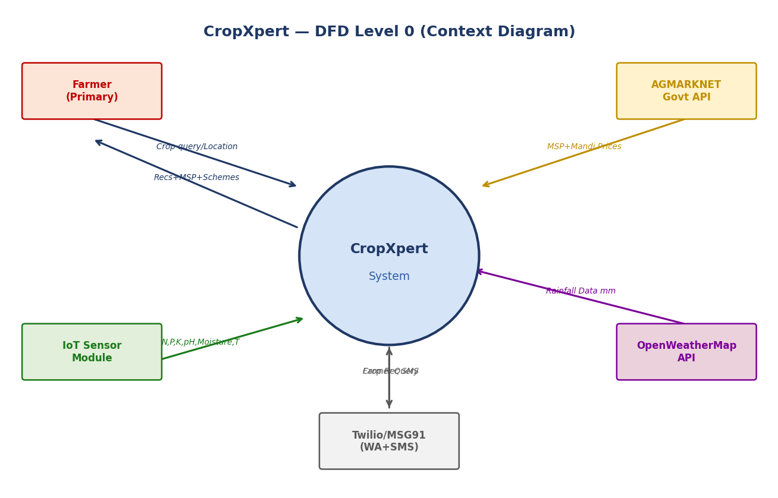
Figure 3: CropXpert DFD Level 0 — Context Diagram

1.6 DFD Level 1
The Level 1 DFD decomposes CropXpert into nine internal processes (P1–P9) and four data stores (D1–D4): Sensor Acquisition (P1), Rainfall Fetch (P2), User Auth (P3), ML Recommendation (P4), Market Scoring (P5), Multilingual Output (P6), Scheme Lookup (P7), Soil Logging (P8), and CropBot (P9). Data flows show how sensor readings move from hardware through ML inference to the farmer's screen in under 500 ms.
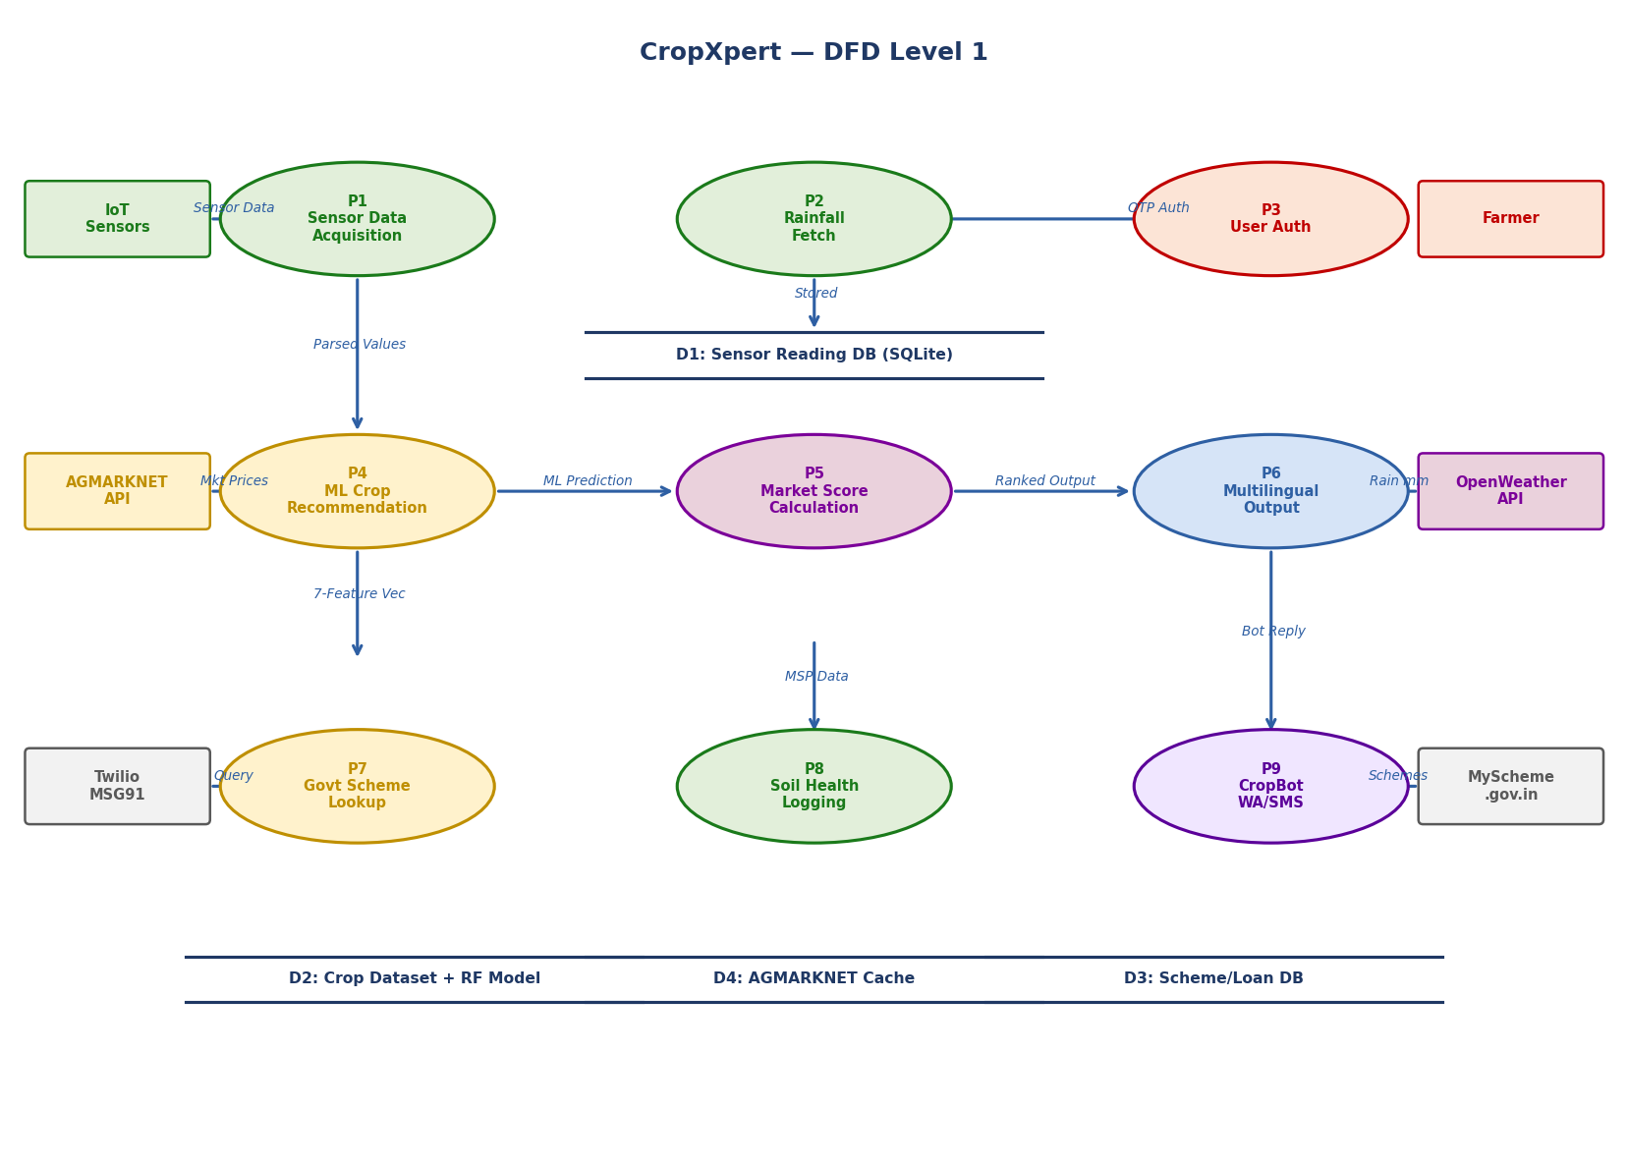
Figure 4: CropXpert DFD Level 1 — Detailed Process and Data Flow

1.7 Component Diagram
Nine software components: IoT Hardware Layer, Communication Layer, ML Engine, Market Intelligence, Backend Services, CropBot, Frontend (React PWA), i18n Layer, and External APIs. Each component encapsulates its own data and exposes a clean interface, enabling independent sprint delivery.
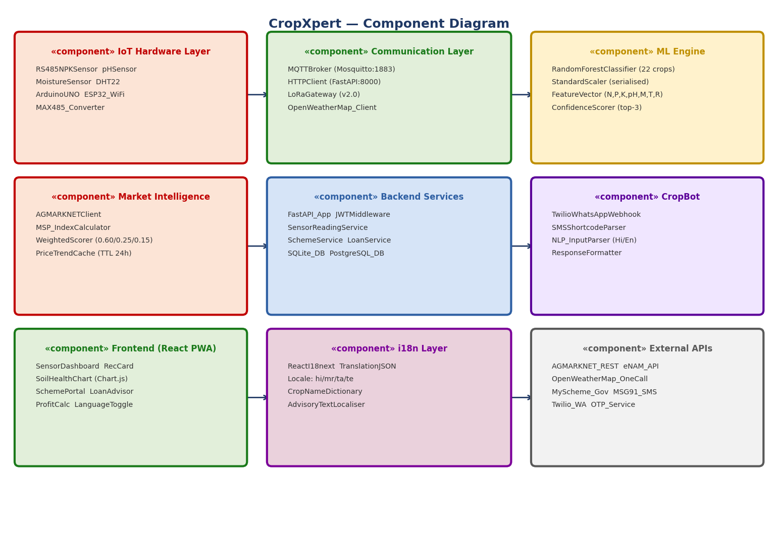
Figure 5: CropXpert Component Diagram — Nine Microservice Components

1.8 Sequence Diagram — Crop Recommendation Flow
The sequence diagram traces the complete message exchange for the primary use case: farmer opens dashboard, views live sensor readings, and receives a market-aware crop recommendation. Eleven message exchanges across seven lifelines. End-to-end latency under 500 ms. RF model inference time: 2.3 ms.
- Steps 1–4: Dashboard opens, FastAPI subscribes to MQTT, sensor data received and stored in SQLite.
- Steps 5–7: Farmer clicks Recommend; POST /predict sent; RF model runs predict_proba() and returns top-3 with confidence.
- Steps 8–11: FastAPI fetches MSP from AGMARKNET cache; applies weighted_score(); returns ranked JSON; React renders Recommendation Card in farmer's language.

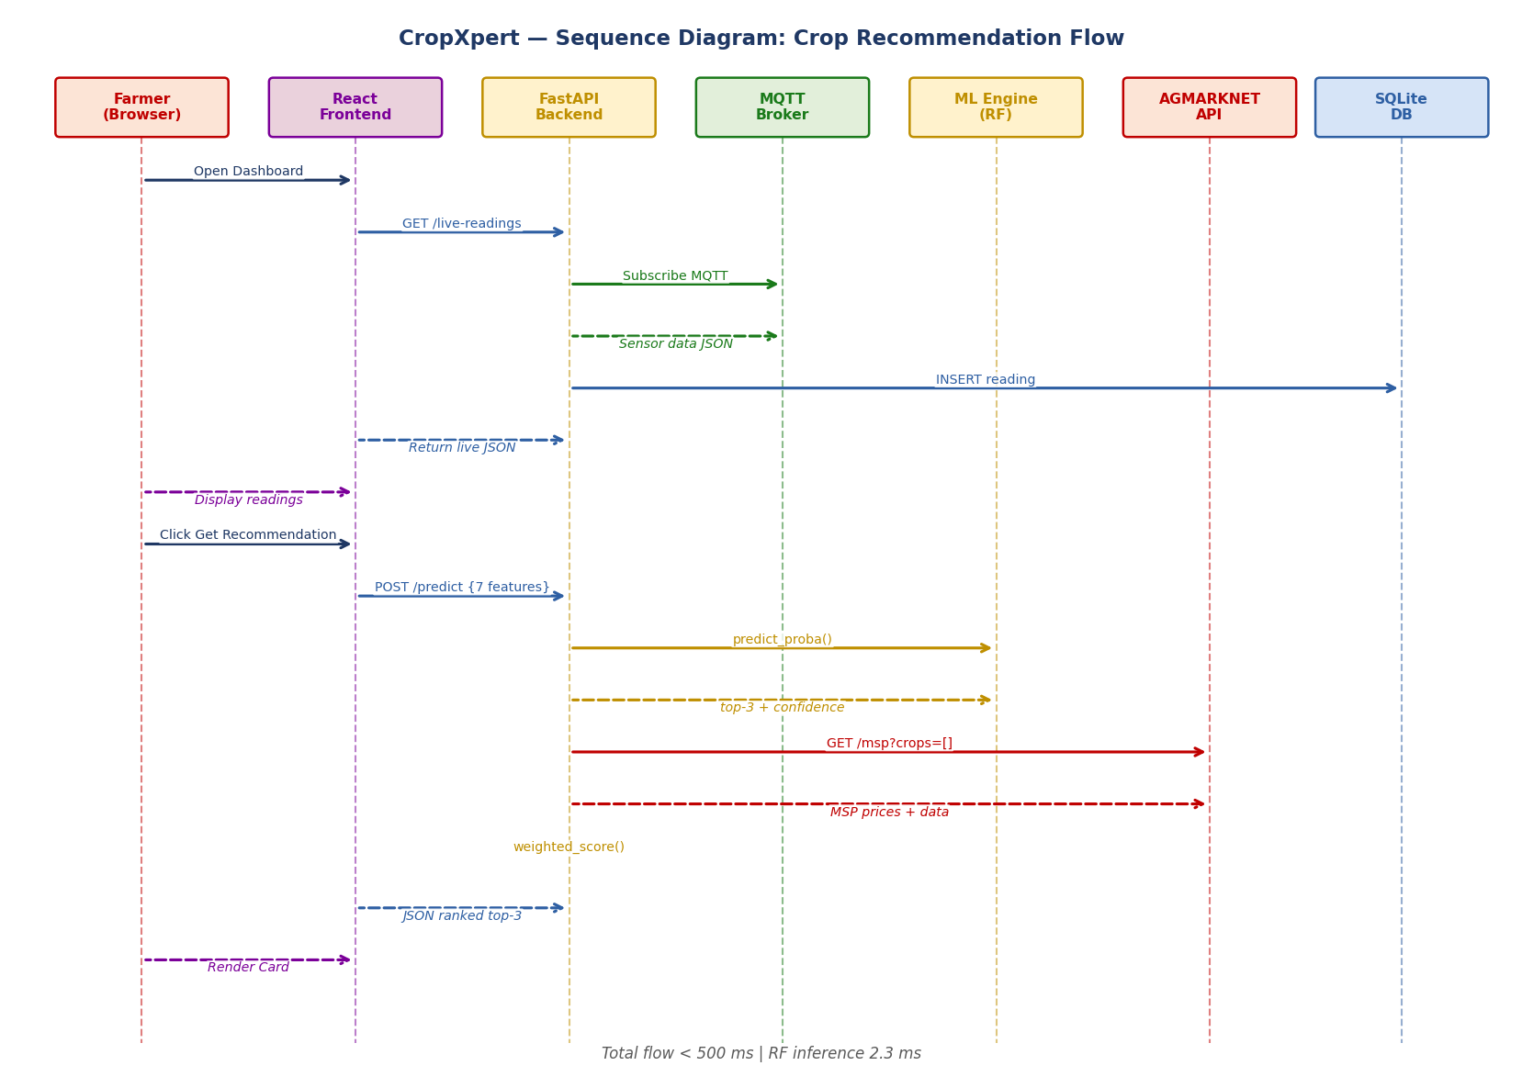
Figure 6: CropXpert Sequence Diagram — Crop Recommendation Flow (< 500 ms end-to-end)

1.9 Deployment Diagram
Physical and virtual nodes: Field Sensor Unit (Arduino + sensors + ESP8266 Wi-Fi), LoRa Gateway v2.0 (ESP32 + SX1276 + RAK2245, 5–15 km coverage), Cloud Server (Docker + FastAPI + MQTT + PostgreSQL on Railway.app/AWS), External Services (AGMARKNET, OpenWeatherMap, Twilio, MSG91), Farmer Device (React PWA on Chrome/Firefox), and Basic Phone (GSM SMS shortcode).
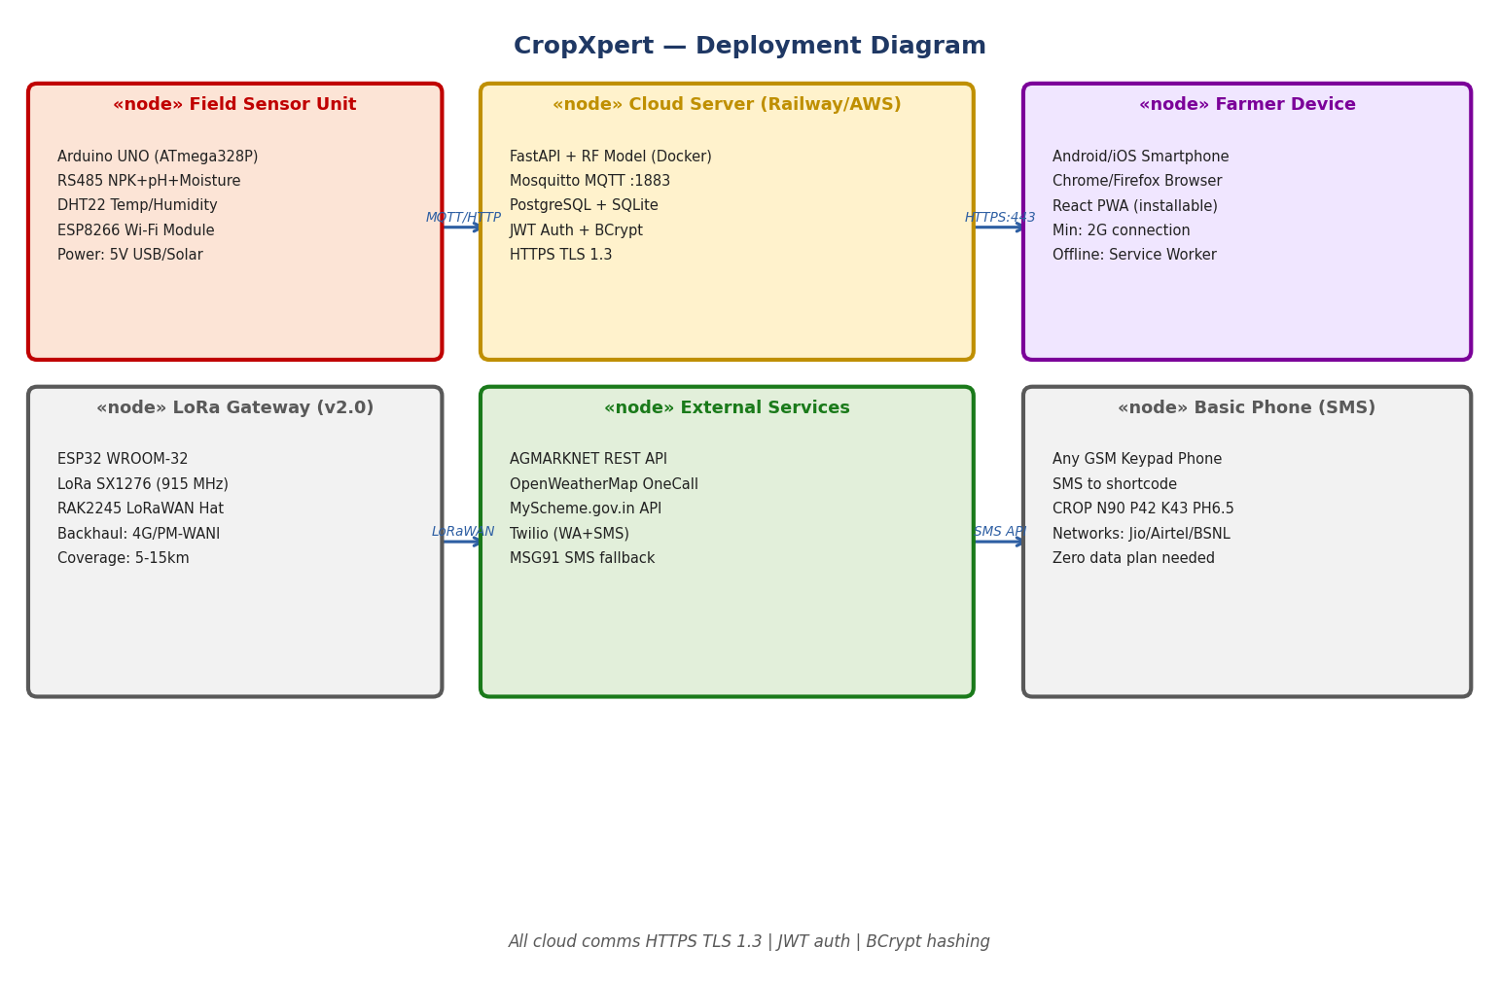
Figure 7: CropXpert Deployment Diagram — Physical and Virtual Node Topology

1.10 Class Diagram
Nine key domain classes: Farmer, SensorReading, CropRecommendation, MLModel, MarketScorer, GovernmentScheme, LoanProgram, CropBot, and FarmerPortal. Key relationships: Farmer has 1..* SensorReadings; SensorReading generates 1 CropRecommendation; CropRecommendation uses MLModel and MarketScorer; FarmerPortal aggregates all domain services.
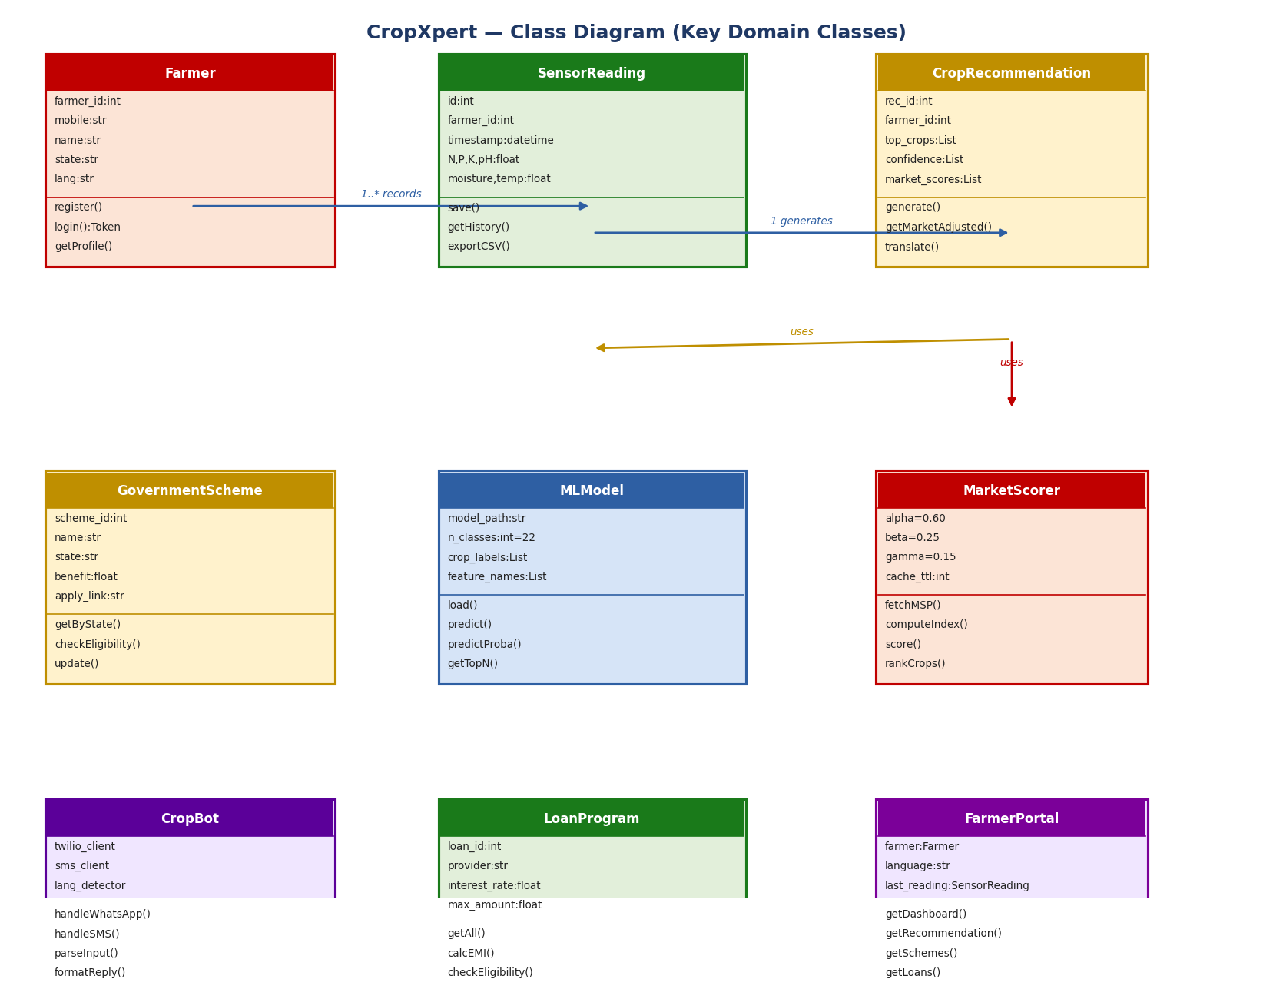
Figure 8: CropXpert Class Diagram — Key Domain Classes, Attributes, Methods, Relationships

2. Database
CropXpert uses a dual-database strategy: PostgreSQL for production cloud persistence and SQLite for lightweight edge caching on field gateway devices. All data access uses SQLAlchemy ORM with Pydantic validation to prevent injection and type errors.

2.1 ER Diagram
The ER diagram shows eight entities and their relationships across both databases. All primary keys are auto-incrementing integers. Foreign keys enforce referential integrity. UNIQUE constraints prevent duplicate records on critical fields (mobile, crop_name).

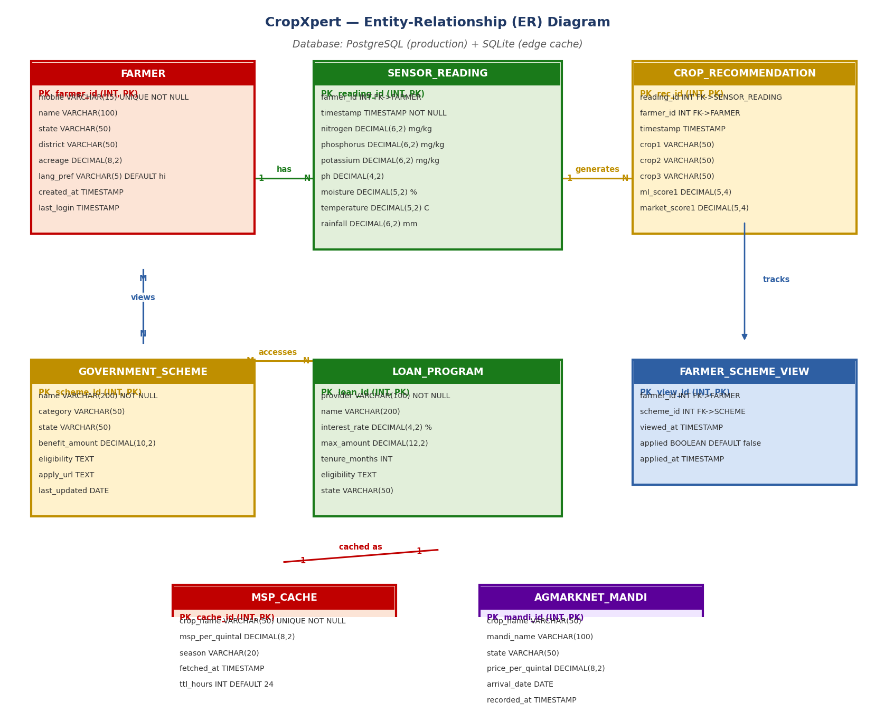
Figure 9: CropXpert Entity-Relationship Diagram — Eight Entities Across PostgreSQL + SQLite

Key relationships identified in the ER diagram:
- FARMER → SENSOR_READING: One-to-many. A farmer has many sensor readings over time. farmer_id is a foreign key in sensor_reading.
- SENSOR_READING → CROP_RECOMMENDATION: One-to-many. A sensor reading can generate one recommendation. Both farmer_id and reading_id are foreign keys in crop_recommendation.
- FARMER ↔ GOVERNMENT_SCHEME: Many-to-many via FARMER_SCHEME_VIEW junction table. Tracks which farmers have viewed and/or applied to which schemes.
- CROP_RECOMMENDATION → MSP_CACHE: Market score computation reads from MSP_CACHE. Cache is refreshed from AGMARKNET API every 24 hours.
- MSP_CACHE → AGMARKNET_MANDI: One-to-many. One crop has many mandi price records across states and dates. Used for trend chart feature.

2.2 Schema Design
The full schema design is presented below with field types, constraints, and index strategy for both PostgreSQL and SQLite databases.

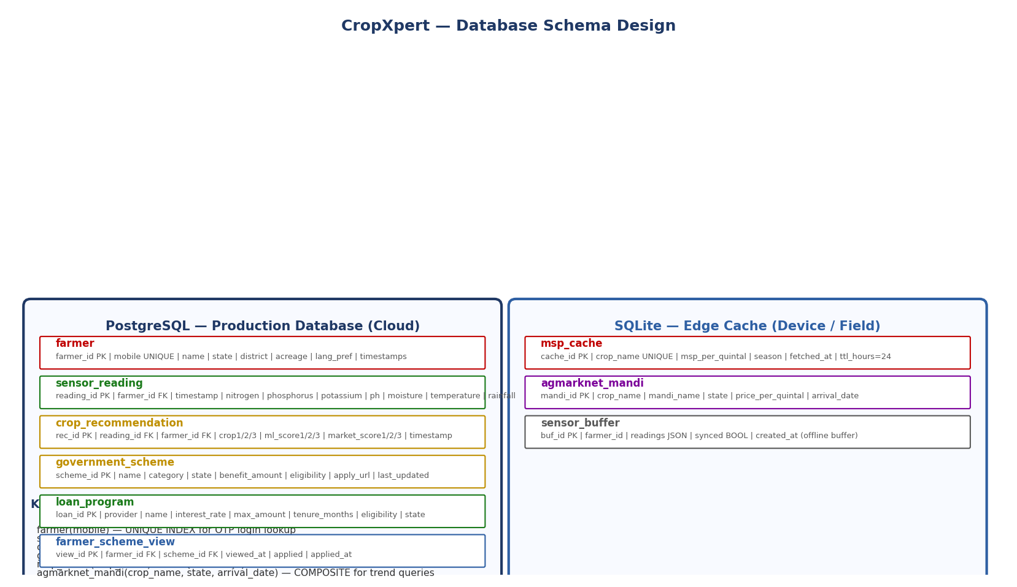
Figure 10: CropXpert Database Schema Design — PostgreSQL Production + SQLite Edge Cache

PostgreSQL — Production Schema (Cloud)
The production PostgreSQL database hosts six tables:
Table | Primary Key | Key Fields & Constraints
farmer | farmer_id INT PK | mobile VARCHAR(15) UNIQUE NOT NULL, name, state, district, acreage DECIMAL(8,2), lang_pref VARCHAR(5) DEFAULT 'hi', created_at TIMESTAMP, last_login TIMESTAMP
sensor_reading | reading_id INT PK | farmer_id INT FK NOT NULL, timestamp TIMESTAMP NOT NULL, nitrogen/phosphorus/potassium DECIMAL(6,2) mg/kg, ph DECIMAL(4,2), moisture DECIMAL(5,2)%, temperature DECIMAL(5,2)°C, rainfall DECIMAL(6,2) mm
crop_recommendation | rec_id INT PK | reading_id INT FK, farmer_id INT FK, crop1/crop2/crop3 VARCHAR(50), ml_score1/2/3 DECIMAL(5,4), market_score1/2/3 DECIMAL(5,4), timestamp TIMESTAMP
government_scheme | scheme_id INT PK | name VARCHAR(200) NOT NULL, category VARCHAR(50), state VARCHAR(50), benefit_amount DECIMAL(10,2), eligibility TEXT, apply_url TEXT, last_updated DATE
loan_program | loan_id INT PK | provider VARCHAR(100), name VARCHAR(200), interest_rate DECIMAL(4,2)%, max_amount DECIMAL(12,2), tenure_months INT, eligibility TEXT, state VARCHAR(50)
farmer_scheme_view | view_id INT PK | farmer_id INT FK, scheme_id INT FK, viewed_at TIMESTAMP, applied BOOLEAN DEFAULT false, applied_at TIMESTAMP — UNIQUE(farmer_id, scheme_id)

SQLite — Edge Cache Schema (Field Gateway)
SQLite stores two cache tables on the field gateway device to reduce API calls and enable offline operation:
- msp_cache: cache_id PK | crop_name VARCHAR UNIQUE NOT NULL | msp_per_quintal DECIMAL(8,2) | season VARCHAR(20) | fetched_at TIMESTAMP | ttl_hours INT DEFAULT 24. TTL enforced in application layer — stale records trigger background API refresh.
- agmarknet_mandi: mandi_id PK | crop_name VARCHAR | mandi_name VARCHAR | state VARCHAR | price_per_quintal DECIMAL(8,2) | arrival_date DATE | recorded_at TIMESTAMP. Enables 90-day mandi price trend charts per crop.
- sensor_buffer: buf_id PK | farmer_id INT | readings JSON | synced BOOLEAN DEFAULT false | created_at TIMESTAMP. Offline buffer for sensor readings when 4G is unavailable — synced to PostgreSQL on reconnection.

Index Strategy
The following indexes are defined to optimise query performance:
Index | Type | Justification
farmer(mobile) | UNIQUE BTREE | OTP login lookup — O(log n) search on mobile number
sensor_reading(farmer_id, timestamp) | BTREE COMPOSITE | History dashboard — filter by farmer then sort by time
crop_recommendation(farmer_id) | BTREE | Dashboard load — latest recommendation per farmer
government_scheme(state, category) | BTREE COMPOSITE | Scheme portal filter — state + category compound query
msp_cache(crop_name) | UNIQUE BTREE | O(1) cache hit check before API call
agmarknet_mandi(crop_name, state, arrival_date) | BTREE COMPOSITE | Trend chart — filter crop + state, sort by date

3. Data Exchange Contract
The Data Exchange Contract specifies how each system component exchanges data: what is sent, how often, in what format, and via which channel. This section covers frequency, datasets, and mode of exchange for all major interfaces.

3.1 Frequency of Data Exchanges

Interface | Direction | Frequency | Trigger
Sensor → MQTT Broker | Arduino → ESP8266 → Cloud | Every 60 seconds | Timer interrupt on MCU
MQTT → FastAPI Backend | Broker → Backend subscriber | On every MQTT message | Real-time event push
FastAPI → PostgreSQL | Backend → DB | On every sensor message | INSERT sensor_reading
Frontend → FastAPI /predict | Browser → API | On farmer action | Button click
FastAPI → ML Engine | API → joblib model | On every /predict call | Synchronous function call
FastAPI → AGMARKNET API | Backend → Govt API | Max once per 24 hours | Cache miss or TTL expiry
FastAPI → OpenWeatherMap | Backend → Ext API | Max once per 6 hours | Cache miss or TTL expiry
Twilio → FastAPI | WhatsApp msg → webhook | On each farmer message | Incoming WhatsApp/SMS
FastAPI → MyScheme.gov.in | Backend → Govt API | Monthly batch update | Scheduled cron job
Sensor buffer → PostgreSQL | SQLite → Cloud sync | On reconnection | Network restore event

3.2 Data Sets
The following datasets are exchanged across all system interfaces:

Sensor Payload (Arduino → MQTT → Backend)
Format: JSON over MQTT. Topic: cropxpert/farm/<farmer_id>/sensors. Payload ≤51 bytes (LoRaWAN compatible). Fields:
- nitrogen: float, mg/kg, range 0–300. Source: RS485 NPK sensor via Modbus RTU.
- phosphorus: float, mg/kg, range 0–300. Source: RS485 NPK sensor via Modbus RTU.
- potassium: float, mg/kg, range 0–300. Source: RS485 NPK sensor via Modbus RTU.
- ph: float, range 0.0–14.0, precision ±0.1. Source: Analog pH sensor on A0.
- moisture: float, %, range 0–100. Source: Capacitive soil moisture sensor.
- temperature: float, °C, range −40–+80. Source: DHT22.
- humidity: float, %, range 0–100. Source: DHT22.
- farmer_id: int, stored in ESP8266 EEPROM. Identifies which farm the reading belongs to.
- timestamp: ISO 8601 string, UTC. Set by backend on receipt if not included by MCU.

Prediction Request (Frontend → FastAPI /predict)
Format: JSON over HTTPS POST. Validated by Pydantic. Seven feature fields required:
- N, P, K: float, mg/kg. Validated range 0–300.
- ph: float. Validated range 3.5–10.0.
- moisture: float, %. Validated range 0–100.
- temperature: float, °C. Validated range 0–50.
- rainfall: float, mm. Validated range 0–500. Auto-fetched from OpenWeatherMap cache.

Prediction Response (FastAPI → Frontend)
Format: JSON. Fields: top_crops (list of 3 crop names), ml_confidence (list of 3 floats), market_score (list of 3 floats), msp_per_quintal (list of 3 floats), sowing_tip (list of 3 strings, language-localised), response_time_ms (int).

AGMARKNET MSP Response (Govt API → Backend)
Format: JSON REST response from api.data.gov.in/resource/9ef84268-d588-465a-a308-a864a43d0070. Fields used: commodity (crop name), modal_price (INR/quintal), arrival_date, market_name, state. Cached in SQLite msp_cache with 24-hour TTL.

OpenWeatherMap Rainfall (Ext API → Backend)
Format: JSON REST OneCall API response. Field used: daily[].rain (mm). 7-day average computed. Cached in memory with 6-hour TTL. Farmer GPS coordinates (lat, lon) sent as query parameters.

WhatsApp / SMS Bot Input (Farmer → Twilio → FastAPI)
WhatsApp: Natural language text in Hindi or English. NLP parser extracts N, P, K, pH, moisture values using regex + entity extraction. SMS shortcode format: CROP N<val> P<val> K<val> PH<val> DIST <district>. Parser returns SensorDTO for prediction pipeline. Response: top-1 crop name + MSP per quintal, formatted within 160-character SMS limit.

3.3 Mode of Exchanges

Interface | Protocol | Format | Key Properties
Sensor → Cloud | MQTT (Mosquitto) | JSON payload | QoS Level 1 (at least once). Retained messages. TLS 1.3. Topic hierarchy by farmer_id.
Frontend → API | HTTPS REST | JSON (Pydantic) | FastAPI /predict. JWT Bearer token. Response time p95 < 200 ms. Rate limit 100 req/min.
API → ML Model | Python function call | NumPy array | joblib serialised RF model loaded at startup. No network hop. In-process. 2.3 ms.
API → AGMARKNET | HTTPS REST (GET) | JSON | api.data.gov.in. API key in env var. 24h SQLite cache. Graceful fallback on timeout.
API → OpenWeatherMap | HTTPS REST (GET) | JSON | OneCall API. GPS coords as params. 6h memory cache. Zero-cost fallback to manual entry.
WhatsApp → API | Twilio Webhook HTTPS | Form-encoded | POST to /webhook/whatsapp. Twilio signature validation. HMAC-SHA1 security.
SMS → API | MSG91 Webhook HTTPS | URL-encoded | SMS shortcode. Structured format parser. 160-char reply limit. Jio/Airtel/BSNL tested.
API → Database | SQLAlchemy ORM | SQL over TCP | PostgreSQL connection pool (max 20). SQLite file I/O. All queries parameterised — SQL injection proof.
Gateway → Cloud (v2.0) | LoRaWAN OTAA | Binary (51 bytes) | RAK2245 gateway. TTN network server. AES-128 encryption. PM-WANI backhaul.
Schema → MyScheme.gov.in | HTTPS REST (GET) | JSON | Monthly scheduled cron. Scheme data versioned in DB. Manual override for correction.

Architecture Document | CropXpert | CINTEL, SRMIST Kattankulathur | Academic Year 2024–2025

