Deep Learning for Iberian Climate-Resilient Agriculture: LSTM Networks for Multivariate Crop Yield Forecasting in Portugal
Samuel Ayomide Olaniyan (Student ID: 29386)
Practical Machine Learning / Aprendizagem Automatica Aplicada, Instituto Superior de Agronomia, ULisboa

Introduction
Climate change is introducing growing volatility into agricultural production across southern Europe, with Portugal facing increasing exposure to prolonged droughts and shifting precipitation patterns. Reliable crop yield forecasting is an important tool for protecting food security and supporting agricultural planning in this context, yet traditional statistical approaches often struggle to capture the non-linear, time dependent relationships between climate variables and agricultural outputs.
This project investigates whether a deep learning approach, specifically a Long Short-Term Memory (LSTM) recurrent neural network, can effectively forecast crop yield (kg/ha) in Portugal using historical climate and agronomic data, and whether such an approach offers meaningful advantages over a more conventional machine learning baseline (Random Forest Regression) on a small, real world agricultural dataset.
I focused on three crops of agronomic relevance to Portugal: grapes, potatoes, and wheat, using 34 years (1990 to 2023) of national level yield, pesticide use, and climate data. Beyond simply applying an LSTM to this problem, this project also serves as a practical case study in the challenges of applying sequence models to genuinely small, low frequency time series data, a common situation in agricultural and environmental machine learning where annual reporting cycles limit dataset size regardless of how many years of history are available.

Data
The dataset for this project was compiled from two primary sources. Crop yield and pesticide use data were obtained from FAOSTAT, the statistical database of the Food and Agriculture Organization of the United Nations, using their publicly available bulk data downloads. Climate data, specifically monthly average temperature and precipitation, was obtained from the NASA POWER (Prediction Of Worldwide Energy Resources) API, using the geographic coordinates of mainland Portugal.
I originally intended to source climate data from the World Bank Climate Change Knowledge Portal, as referenced in my project proposal. I switched to NASA POWER instead because it provides monthly rather than annual climate data at no cost and without authentication. This finer temporal resolution allows the model to capture seasonal and lagged climate effects on yield, such as the impact of a dry growing season, which directly supports the sequence dependency challenge identified in my proposal.
I focused on three crops: grapes, potatoes, and wheat, filtered from the full FAOSTAT dataset for Portugal, covering the years 1990 to 2023 (34 years per crop, 102 rows in total before sequence construction).
Data cleaning and feature engineering steps included the following. First, the FAOSTAT yield dataset was filtered to Portugal, the three selected crops, and the “Yield” element, producing one row per crop per year with yield measured in kg/ha. Second, the FAOSTAT pesticide dataset was filtered to Portugal and the “Agricultural Use” element for “Pesticides (total),” producing one row per year measured in tonnes. It is important to note that pesticide use is reported at the national level in FAOSTAT rather than per crop, meaning the same yearly pesticide figure is applied across all three crops for a given year. This is a limitation of the source data rather than a modelling choice, and it means the model cannot distinguish crop specific pesticide application differences. Third, monthly climate data from NASA POWER was aggregated into growing season features by averaging temperature and summing precipitation across March to September, the agronomically relevant window for the crops studied. I chose growing season aggregation rather than a full yearly average because averaging across all twelve months would dilute the signal from drought or excess rainfall occurring specifically during the growing period, which is the effect most relevant to yield outcomes. I also chose not to use all twelve months as separate features, since doing so would have added a large number of additional columns relative to the size of the dataset, increasing the risk of overfitting.
Finally, all three sources were merged on year (and additionally on crop for the yield data) into a single table containing crop, year, yield, pesticide use, growing season average temperature, and growing season total precipitation.

Data Organization
Because an LSTM requires sequential input rather than single year snapshots, I converted the flat crop year table into sliding window sequences. For each crop, I used a window of five past years of features (pesticide use, growing season average temperature, and growing season total precipitation) to predict the yield of the sixth year. This window was then slid forward one year at a time across each crop's full history, producing 29 sequences per crop and 87 sequences in total across the three crops.
I split the data chronologically rather than randomly, in order to avoid data leakage from future years into the training process, a concern I identified explicitly in my project proposal. Sequences predicting a target year of 2016 or earlier were assigned to the training set, sequences predicting target years between 2017 and 2020 were assigned to the validation set, and sequences predicting target years after 2020 were assigned to the test set. This resulted in 66 training sequences, 12 validation sequences, and 9 test sequences.
I am aware that 9 test sequences is a small number, and that this limits how much confidence can be placed in the precision of the reported test metrics. I discuss this limitation further in the Analysis section.
All numerical features and the yield target were standardized (zero mean, unit variance) before training. Critically, the scaler was fit only on the training set and then applied to the validation and test sets, rather than fitting it on the full dataset. Fitting the scaler on the full dataset, including future years, would itself have constituted a subtle form of data leakage, since it would let information about the distribution of future values influence how training data was scaled.
Crop type (grapes, potatoes, wheat) was encoded as an integer ID and used as input to an embedding layer in the model, described in the Methods section, rather than being included directly as a numerical feature.

Methods

LSTM Model
The primary model was a deep learning architecture built in PyTorch, designed to process the five year sequences described in the Data Organization section. The architecture consisted of the following components. An embedding layer mapped each crop's integer ID to a four dimensional learned vector, allowing the model to capture crop specific patterns without manually specifying what those differences are. A single layer LSTM with a hidden size of 8 processed the sequence of three numerical features (pesticide use, growing season temperature, and growing season precipitation) across the five year window, producing a final hidden state intended to summarize the relevant temporal information from that window. This final hidden state was concatenated with the crop embedding, combining the temporal signal with crop specific information. The combined vector was passed through a fully connected layer with 16 units and a ReLU activation, followed by a dropout layer (rate 0.2) for regularization, and a final fully connected layer producing a single yield prediction.
I deliberately kept the model small (hidden size of 8, a single LSTM layer, embedding dimension of 4) given the limited size of the dataset (66 training sequences). A larger model would have had substantially more parameters than training examples, making overfitting highly likely.
The model was trained using the Adam optimizer with a learning rate of 0.01 and weight decay (L2 regularization) of 1e-3, again chosen to reduce overfitting risk on a small dataset. I used full batch gradient descent, updating the model using all 66 training sequences at once each epoch, rather than mini batches, since the dataset was small enough that mini batching offered no computational benefit and would only introduce additional gradient noise. Training used early stopping based on validation loss: if validation loss did not improve for 30 consecutive epochs, training stopped, and the model parameters from the epoch with the lowest validation loss were restored for final evaluation, rather than the parameters from the final epoch. Training ran for a maximum of 300 epochs, though early stopping was triggered earlier in practice.

Random Forest Baseline
To evaluate whether the LSTM's added architectural complexity provided meaningful benefit, I trained a Random Forest Regressor (scikit learn) as a baseline, using 200 trees and a maximum depth of 4. Since Random Forest does not natively process sequential input, each five year window was flattened into a single 15 value feature vector (5 years times 3 features), with the crop ID added as an additional feature. The Random Forest was trained on the same training set and evaluated on the same validation and test sets as the LSTM, using identical scaling, to ensure a fair comparison.

Results
Table 1 below summarizes test set performance for both models, evaluated on the 9 held out sequences corresponding to target years 2021 to 2023.
Table 1: Test Set Performance Comparison
Metric | LSTM | Random Forest
RMSE (kg/ha) | 3921.41 | 3906.29
MAE (kg/ha) | 2646.81 | 2717.28
R² | 0.8204 | 0.8217

Both models achieved very similar performance across all three metrics, with neither model showing a clear advantage over the other.
Table 2 shows the individual predicted and actual yield values for each crop and year in the test set.
Table 2: Predicted versus Actual Yield, Test Set (kg/ha)
Crop | Year | Actual | LSTM Predicted | RF Predicted
Grapes | 2021 | 5567.0 | 4569.1 | 4686.2
Grapes | 2022 | 5139.7 | 4499.8 | 4131.8
Grapes | 2023 | 5686.5 | 4651.6 | 4184.8
Potatoes | 2021 | 24602.4 | 16427.0 | 16688.8
Potatoes | 2022 | 22042.0 | 16408.3 | 16236.5
Potatoes | 2023 | 22450.3 | 16396.8 | 16458.2
Wheat | 2021 | 2422.9 | 1905.1 | 1444.4
Wheat | 2022 | 1994.2 | 1871.3 | 1994.2
Wheat | 2023 | 2046.7 | 2046.7 | 1484.1

Figure 1 below shows predicted versus actual yield across the full timeline (training, validation, and test periods) for each crop separately. A clear pattern is visible for potatoes in particular: both models' predictions remain relatively flat across the 2021 to 2023 test period, while actual yield rose substantially compared to earlier years in the dataset. Grapes and wheat predictions track actual values more closely, though still with noticeable error in some years.
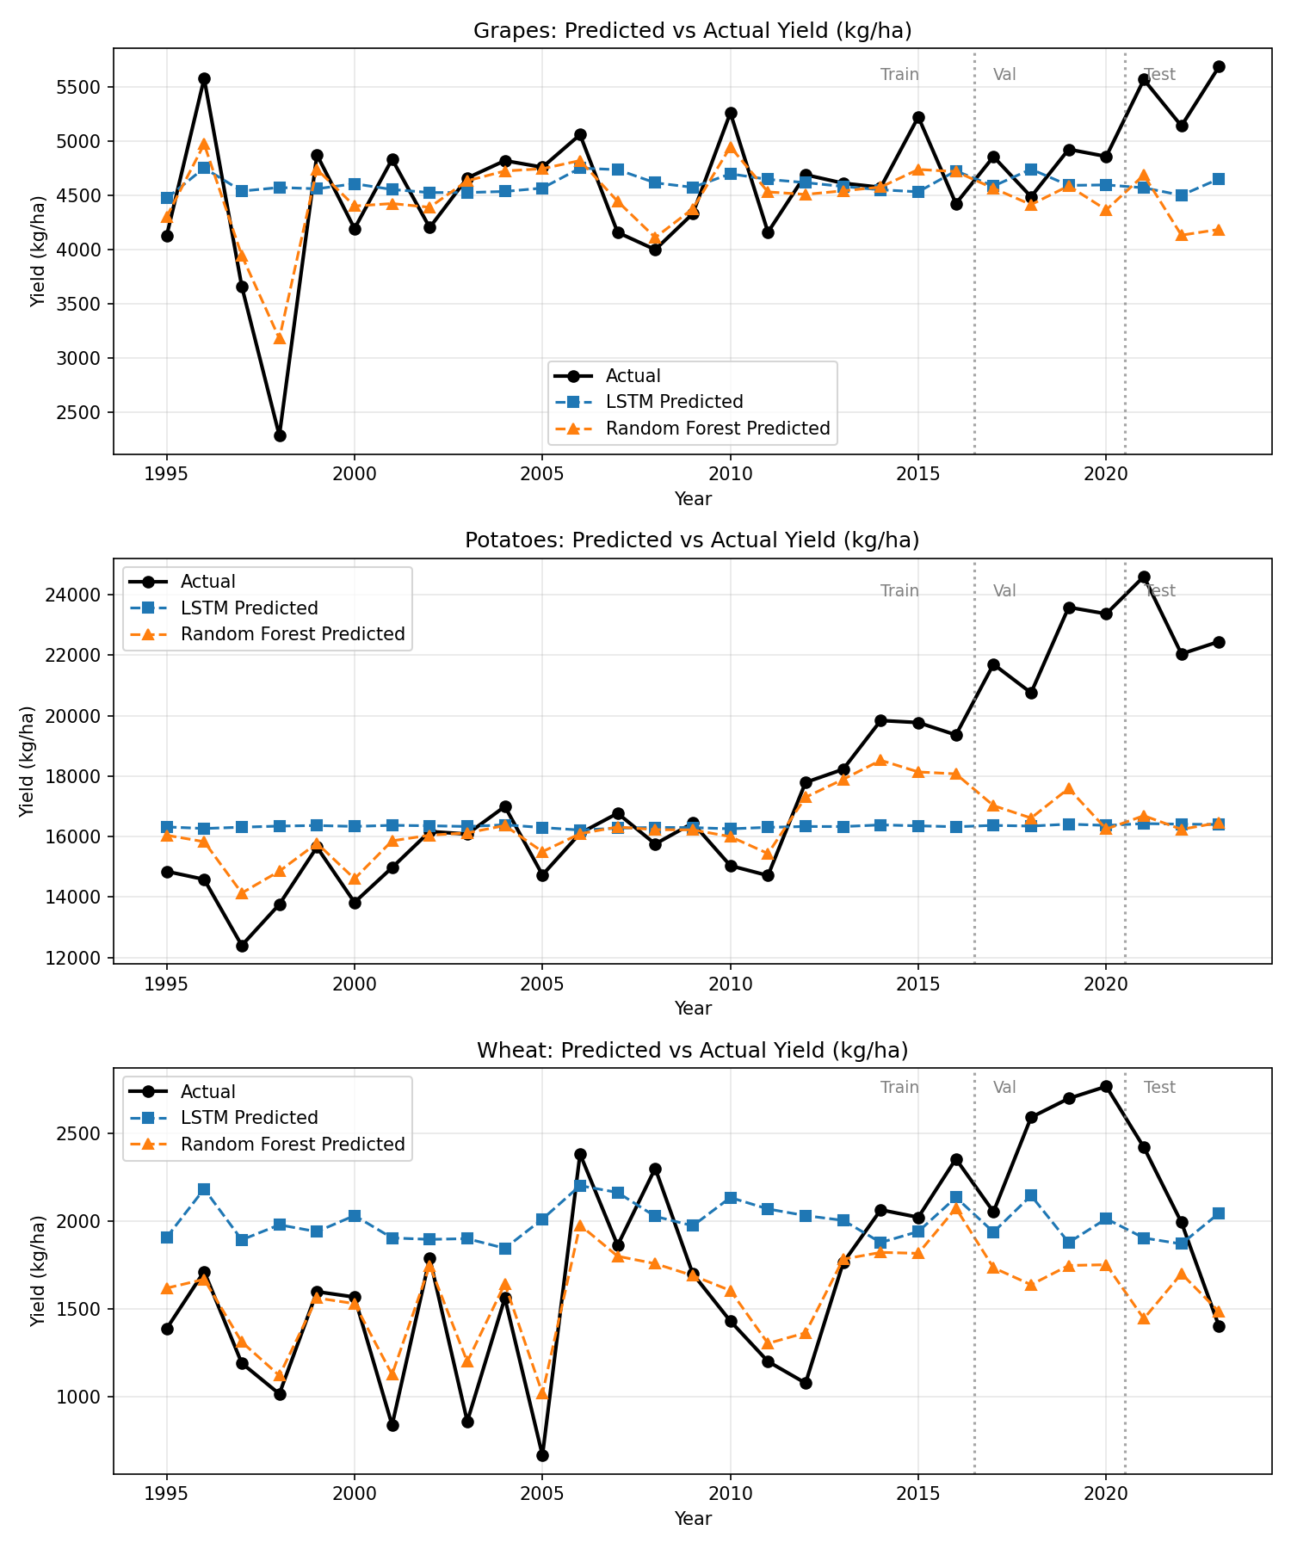
Figure 1: Predicted versus actual yield by crop, 1995 to 2023, with training, validation, and test periods marked.

Analysis
The central finding of this project is that the LSTM did not outperform the Random Forest baseline on this dataset, with both models achieving nearly identical RMSE, MAE, and R² values on the test set. This result is worth discussing honestly rather than treated as a disappointment, since it reflects a real and informative outcome rather than a failure of implementation.
The most likely explanation relates directly to the size of the dataset. With only 66 training sequences, there is limited opportunity for an LSTM to learn the kind of temporal patterns it is designed to exploit. LSTMs generally benefit from having many examples of how a sequence evolves over time, and 29 sequences per crop, each only five years long, is a relatively small amount of temporal information for the model to learn from. A Random Forest, by contrast, does not need to learn temporal structure explicitly. It can perform comparably well simply by learning associations between flattened input values and yield, without needing to model how those values evolve over time. This suggests that, for a dataset of this size, the additional architectural complexity of an LSTM does not translate into additional predictive power.
A more specific and informative pattern emerges when looking at individual predictions rather than aggregate metrics. For potatoes, both models predicted yield values in the test period (2021 to 2023) that were close to the average yield observed in the training period, while actual yield during this period was substantially higher. Looking at the full timeline plot rather than just the test period, the LSTM's predicted line for potatoes is nearly flat across the entire 1995 to 2023 range, suggesting it largely learned to predict close to the average yield rather than meaningfully using the input features for this crop. The Random Forest follows the historical ups and downs somewhat more closely before around 2017, but also flattens out for the test period. This indicates that both models learned the general relationship between climate, pesticide use, and yield as observed historically, but were unable to anticipate a structural change in yield that occurred after the end of the training period. Such a shift could plausibly reflect real world factors not captured in the dataset, such as improved potato varieties, changes in irrigation practices, or other agronomic developments. Since these factors are not represented in the available features, neither model had any basis on which to predict the increase, regardless of architecture. This is a useful illustration of a general limitation of yield forecasting models trained purely on historical climate and pesticide data: they can capture relationships present in their training period but cannot extrapolate trends or shifts that have no precedent in that period.
By contrast, predictions for grapes and wheat tracked actual yield more closely, suggesting that for these crops, the relationship between the available features and yield was more stable across the training and test periods, although both models still tend to underestimate the size of year to year swings, a common pattern in regression models sometimes referred to as regression to the mean.
A further limitation of this analysis concerns the small size of the test set, only 9 sequences in total. With so few test examples, the reported RMSE, MAE, and R² values should be interpreted as a rough indication of performance rather than precise measurements, since a small number of unusually difficult or easy years can have a disproportionate effect on these metrics. The 5567 kg/ha actual yield for grapes in 2021, for example, contributes meaningfully to the overall test error on its own. A larger test set, which would require either a longer historical record or additional countries or regions, would be needed to draw more statistically reliable conclusions.
Finally, it is worth noting that the pesticide use feature, being reported at the national level rather than per crop in FAOSTAT, applies an identical value across all three crops for any given year. This may have limited the model's ability to learn crop specific responses to changes in pesticide use, and represents a constraint of the underlying data source rather than the modelling approach.
Overall, this project demonstrates that, while an LSTM architecture is theoretically well suited to capturing temporal dependencies in climate and agricultural data, its practical advantage over simpler methods depends heavily on having sufficient data to learn from, a condition that annual, country level agricultural statistics do not easily satisfy.

Deployment
A full deployment was not undertaken as part of this project, as it was judged not essential to demonstrating the core research question of comparing an LSTM against a simpler baseline for crop yield forecasting on a limited dataset. However, a natural extension would be a simple web based or notebook based interface allowing a user to select a crop and view forecasted yield for an upcoming year, based on recent climate and pesticide data. Given the modest size of both models, such a tool could run efficiently without requiring specialized infrastructure. This was left as potential future work rather than implemented, in order to prioritize a thorough and honestly evaluated modelling pipeline within the project's time constraints.

References
Food and Agriculture Organization of the United Nations (FAO). FAOSTAT Statistical Database. Available at: https://www.fao.org/faostat/en/
NASA Langley Research Center. POWER (Prediction Of Worldwide Energy Resources) Project. Available at: https://power.larc.nasa.gov/
Pedregosa, F., et al. (2011). Scikit-learn: Machine Learning in Python. Journal of Machine Learning Research, 12, 2825 to 2830.
Paszke, A., et al. (2019). PyTorch: An Imperative Style, High Performance Deep Learning Library. Advances in Neural Information Processing Systems, 32.
Hochreiter, S., and Schmidhuber, J. (1997). Long Short Term Memory. Neural Computation, 9(8), 1735 to 1780.

Contributions
This project was completed individually by Samuel Ayomide Olaniyan (Student ID: 29386), including problem formulation, data collection, data cleaning and feature engineering, model design and implementation (both LSTM and Random Forest baseline), training, evaluation, visualization, and report writing.

