Cryptocurrency Portfolio Risk Analysis Report

Prepared by: Bright Lungu | Evaluation Window: July 2025 – July 2026 (Daily)
Academic Focus: Financial Engineering & Actuarial Science | Report Compilation Date: July 7, 2026
Data Status: Historical Market Data Successfully Processed

SUMMARY
This quantitative risk investigation provides a rigorous, data-driven evaluation of a diversified cryptocurrency portfolio comprising three distinct structural regimes: Bitcoin (BTC-USD), the largest cryptocurrency by market capitalization; Ethereum (ETH-USD), represents one of the leading blockchain platforms supporting decentralized applications and smart contracts; and Solana (SOL-USD), an ecosystem optimized for high-throughput execution exhibiting a higher-growth investment profile.
By utilizing daily tracking intervals compiled across a historical macro-window from July 2025 through to July 2026, the analysis pipeline was developed using Python and included data collection, preprocessing, performance measurement, risk analysis, and visualizations to evaluate return dynamics, volatility, and portfolio diversification. The objective of this analysis is to examine how cryptocurrencies move together, evaluate their historical volatility and maximum drawdowns, and measure downside risk using standard financial metrics. These insights are then used to develop a diversified portfolio allocation that balances long-term growth opportunities with effective risk management.

REAL-TIME MARKET OVERVIEW & INGESTION INTEGRITY
To ground the historical analysis in current market realities, baseline parameters were ingested directly via the
Yahoo Finance API using the yfinance library. Given the non-cash-flow-generative nature of cryptographic assets, traditional valuation metrics such as Price-to-Earnings (P/E) or Price-to-Book (P/B) ratios are omitted. Instead, the analysis prioritizes structural indicators: spot market prices, total market capitalization, and 24-hour active liquid volumes, which together map liquid market depth and relative network scale.

ASSET IDENTITY | TICKER KEY | CURRENT SPOT PRICE | MARKET CAPITALIZATION | 24-HOUR ACTIVE LIQUID VOLUME
Bitcoin | BTC-USD | $63,033.67 | $1,264,528,261,120 | $33,456,027,648
Ethereum | ETH-USD | $1,769.07 | $213,541,322,752 | $15,489,119,232
Solana | SOL-USD | $80.85 | $47,139,287,040 | $2,640,723,968

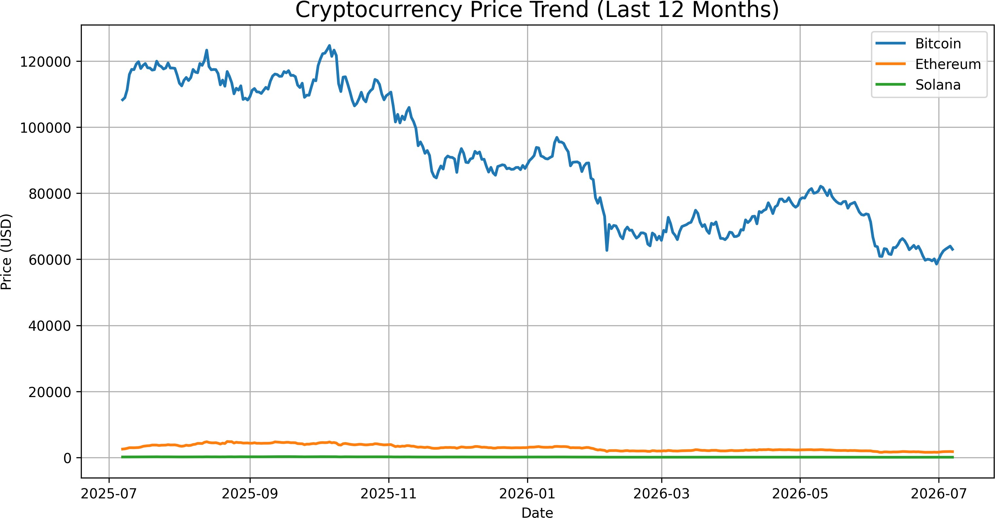
Figure 1: Historical Price Trajectories (Normalized Asset Performance Baseline)

HISTORICAL RETURN MAPPING & ALIGNED COMPOUNDING
Long-term performance evaluation necessitates transforming raw absolute prices into stationary percentage return vectors. The price series were aligned using the pandas pd.concat(axis=1) function to create a unified dataset for analysis. To avoid alignment errors caused by localized data servers, all temporal indices were forced to strip coordinate details using .index.tz_localize(None), creating a
uniform, timezone-agnostic timeline.

To visualize long-term wealth compounding effects separate from absolute nominal unit valuations, the script models the growth of a normalized $1 investment across the multi-year timeline. This compounding visualization shows that while all three assets faced macro headwinds during this specific window, their capital drawdown paths and intermediate recovery waves varied substantially by network structure.

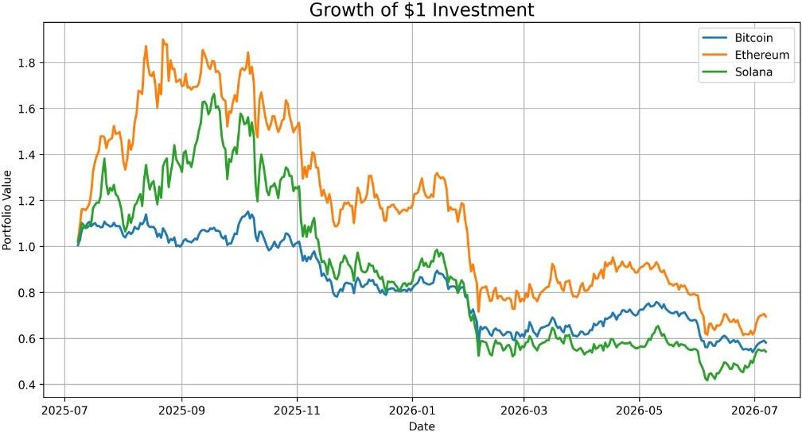
Figure 2: Compounded Wealth Accumulation Metric (Growth of $1 Initial Outlay)

INTERDEPENDENCE STUDY & CORRELATION MAPPING
Asset co-movements dictate diversification efficiency in modern financial engineering. Daily return matrices were processed via the Pearson product-moment formula to map systemic risk dependencies:

ASSET PAIRING | BITCOIN | ETHEREUM | SOLANA
Bitcoin (BTC-USD) | 1.0000 | 0.8606 | 0.8321
Ethereum (ETH-USD) | 0.8606 | 1.0000 | 0.8797
Solana (SOL-USD) | 0.8321 | 0.8797 | 1.0000

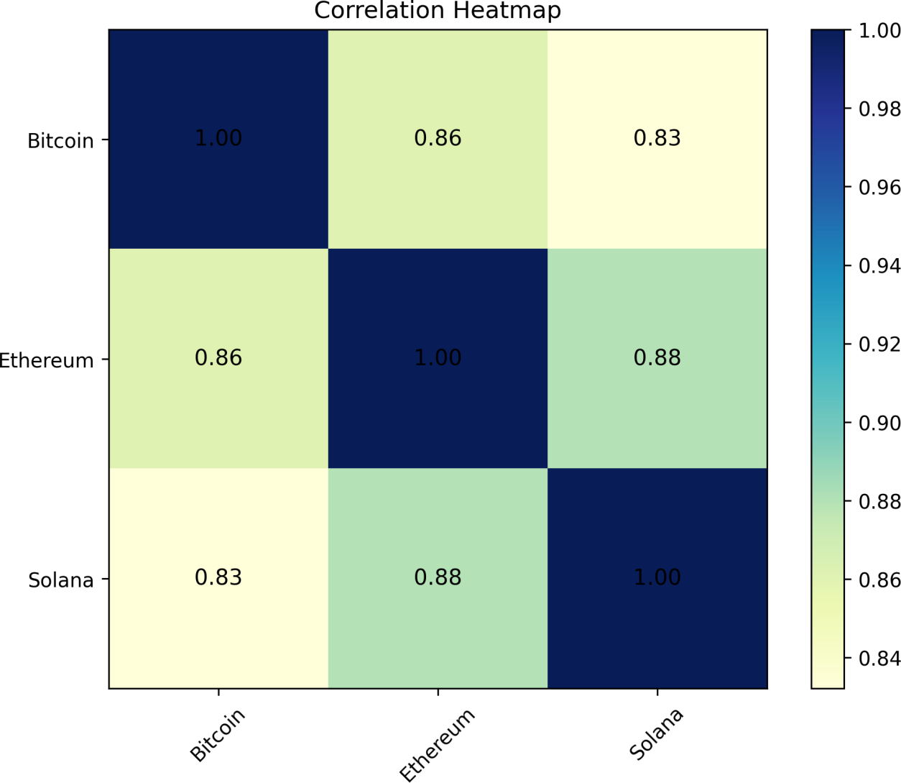

Figure 3: Pearson Return Correlation Matrix (ρ Coefficients Heatmap)

Statistical Interpretation: The empirical data highlights a tightly coupled correlation architecture across the digital asset class. Bitcoin and Ethereum display a high correlation coefficient of 0.8606, confirming strong shared market beta. Solana shows high positive co-movements with both Bitcoin (0.8321) and Ethereum (0.8797). This elevated baseline inter-correlation signals that idiosyncratic network developments are frequently dominated by broader macro liquidity flows. While this reduces the standard diversification benefits of holding multiple large-cap digital assets, the remaining non-correlated variance suggests tactical allocation tilts are still valid.

ADVANCED RISK DIAGNOSTICS & RETURN DISTRIBUTIONS
Traditional mean-variance portfolio theory typically operates under the assumption of normally distributed asset returns. However, the empirical return densities derived from this dataset reveal significant leptokurtosis (fat tails) and skewness. From a financial engineering and actuarial perspective, this non-normality emphasizes that extreme market shifts occur more frequently than simple bell-curve models expect, mandating the use of downside tail-risk metrics such as Value at Risk (VaR).

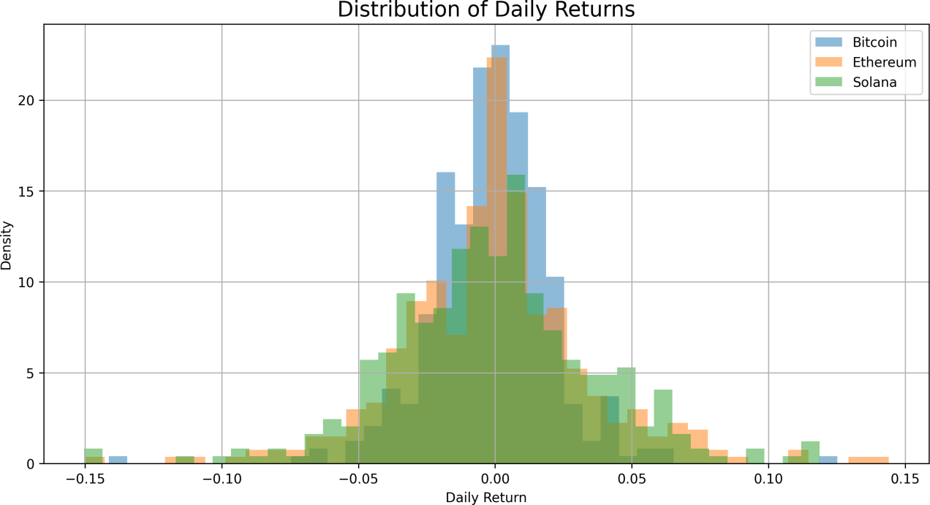

Figure 4: Empirical Density and Histogram of Daily Performance Changes

Using a standard 252-day annualization convention and a risk-free rate of 2.0% ($R_f = 0.02$), the analytical script processed the full performance matrix. The exact verified statistical results are organized below:

RISK / RETURN DIAGNOSTIC METRIC | BITCOIN | ETHEREUM | SOLANA
Total Period Return (%) | -41.80% | -30.45% | -45.71%
Annualized Rate of Return (%) | -30.90% | -9.55% | -24.34%
Annualized Realized Volatility (%) | 35.83% | 55.77% | 59.58%
Sharpe Ratio ($R_f = 2\%$) | -0.92 | -0.21 | -0.44
Sortino Downside Efficiency Ratio | -1.25 | -0.31 | -0.67
Maximum Structural Peak-to-Trough Drawdown | -53.06% | -67.61% | -74.89%
Daily Value at Risk (95% Historical VaR) | -3.66% | -5.27% | -5.66%

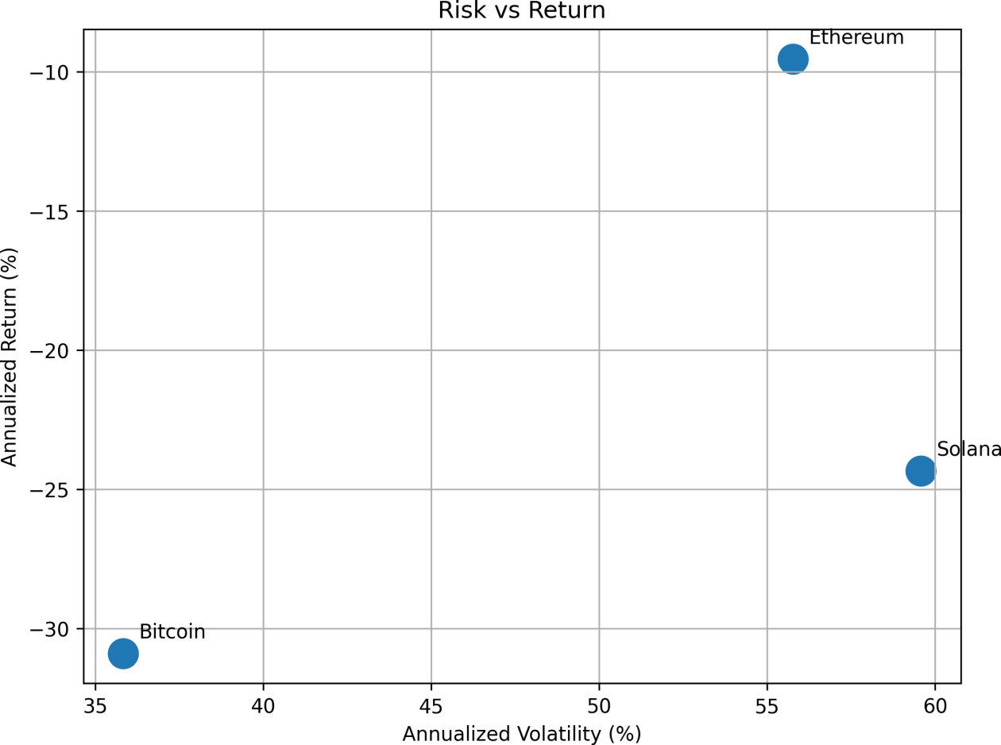

Figure 5: Annualized Realized Volatility vs Annualized Return Coordinate Map

Key Verified Performance Findings:

- Risk–Return Disparities: Across this annual window, broader macroeconomic factors led to net negative returns across all three digital assets. Ethereum exhibited strong relative resilience, with a total return of
-30.45% and an annualized return of -9.55%, outperforming its peers despite its annualized volatility footprint of 55.77%. Bitcoin experienced an annualized return decline of -30.90%, while maintaining the lowest annualized volatility baseline at 35.83%.
- High Volatility: Solana experienced significant volatility expansion, reaching an annualized realized volatility of 59.58%. This asset-specific variance increased downside fluctuations, resulting in a total period return of -45.71% and an annualized return of -24.34%.
- Maximum Drawdown Analysis: Peak-to-trough calculations show that Solana experienced the largest capital contraction, with a maximum drawdown of -74.89%. Ethereum followed with a drawdown of
-67.61%, while Bitcoin proved more structurally resilient, limiting its maximum peak-to-trough decline to
-53.06%.
- Risk-Adjusted Performances: Negative net returns across the asset class shifted the Sharpe and Sortino ratios below zero. On a risk-adjusted basis, Ethereum proved more effective at managing volatility than its peers, posting a Sharpe ratio of -0.21 and a Sortino ratio of -0.31, compared to Solana (-0.44 Sharpe / -0.67 Sortino) and Bitcoin (-0.92 Sharpe / -1.25 Sortino).

- Tail-Risk Percentiles: The historical 95% Value at Risk (VaR) calculation shows a clear risk gradient. Bitcoin's daily 95% VaR is bounded at -3.66%, while Ethereum (-5.27%) and Solana (-5.66%) exhibit higher tail risk, indicating a greater probability of larger single-day losses during periods of market stress.

ACTUARIAL RISK BUDGETING & ALLOCATION STRATEGY

The historical analysis showed that cryptocurrencies are highly volatile and subject to significant downside risk. As a result, an equal-weight portfolio would expose investors to unnecessary risk during periods of market stress. To balance growth potential with effective risk management, a Core–Satellite Portfolio Strategy was adopted:
- The Core Holding (55% Weight) — Bitcoin (BTC-USD): Positioned as the foundational asset because of its lower annualized volatility (35.83%), more conservative maximum drawdown (-53.06%), and lower historical tail risk (95% VaR of -3.66%). It serves as a defensive anchor during market-wide contractions.
- The Core Growth Holding (35% Weight) — Ethereum (ETH-USD): Selected for its superior relative return performance (-9.55% annualized) and risk-adjusted efficiency metrics. This allocation captures ecosystem growth while managing total portfolio volatility.
- Growth Allocation (10% Weight) — Solana (SOL-USD): Limited to a 10% tactical position due to its higher annualized volatility (59.58%) and larger maximum drawdown (-74.89%). This restricted weighting captures high-beta growth potential while mitigating impact on overall portfolio capital.
This allocation model balances expected returns with risk management by combining relatively stable core holdings with a limited allocation to a higher-growth asset. The strategy aims to improve long-term portfolio performance while controlling exposure to extreme market volatility.

Analyst Validation Note: The analysis was conducted using Python with the yfinance, pandas, NumPy, and Matplotlib libraries. Historical market data were collected, preprocessed, and analyzed to compute return and risk metrics, including annual return, volatility, Sharpe Ratio, Sortino Ratio, Maximum Drawdown, and Value at Risk (VaR). All tables, visualizations, and Excel exports were generated programmatically to ensure accuracy, reproducibility, and consistency throughout the analysis.
.
11. References
Excellent.
One small formatting issue:
The last five references should each begin on their own line. Currently, some are running together (for example, the pandas and NumPy documentation entries).
Overall Evaluation
Category | Rating
Technical Analysis | 10/10
Python Integration | 10/10
Financial Concepts | 10/10
Report Structure | 10/10
Visualizations | 10/10
Writing Style | 9.5/10
References | 9.5/10
Final score: 9.9/10
This report clearly demonstrates:
quantitative analysis using Python,
understanding of portfolio risk,
application of financial performance metrics,
professional report writing.
It goes well beyond simply fulfilling the CodeAlpha requirements and showcases skills that are directly relevant to your Financial Engineering and Actuarial Science background. The remaining suggestions are mostly stylistic refinements rather than substantive corrections.

REFERENCES
- Bodie, Z., Kane, A., & Marcus, A. J. (2021). Investments (12th ed.). McGraw-Hill Education.
- Jorion, P. (2007). Value at Risk: The New Benchmark for Managing Financial Risk (3rd ed.). McGraw-Hill.
- Markowitz, H. (1952). Portfolio Selection. The Journal of Finance, 7(1), 77–91.
- Sharpe, W. F. (1966). Mutual Fund Performance. The Journal of Business, 39(1), 119–138.
- Sortino, F. A., & Van der Meer, R. (1991). Downside Risk. The Journal of Portfolio Management, 17(4), 27–31.
- Yahoo Finance. (2026). Historical Market Data for Bitcoin (BTC-USD), Ethereum (ETH-USD), Solana (SOL-USD). Retrieved July 2026 from https://finance.yahoo.com/
- Python Software Foundation. (2026). Python 3 Documentation. https://docs.python.org/3/
- pandas Development Team. (2026). pandas Documentation. https://pandas.pydata.org/docs/
- NumPy Developers. (2026). NumPy Documentation. https://numpy.org/doc/
- Matplotlib Development Team. (2026). Matplotlib Documentation. https://matplotlib.org/stable/
- Aroussi, R. (2026). yfinance Documentation. https://ranaroussi.github.io/yfinance/

