Investment Portfolio Creation Report
A Diversified Investment Portfolio Architecture Worth ₹100,000
Prepared by: Bright Lungu
Academic Specialization: Financial Engineering & Actuarial Science
Internship Track: CodeAlpha Internship – Finance & Investment Analysis
Evaluation Window: July 2026 Baseline
Tools Used: Python (Pandas, NumPy, Matplotlib)
=====================================================================================

Summary
This report presents a hypothetical investment portfolio worth ₹100,000 designed to achieve long-term capital growth while maintaining diversification across stocks, exchange-traded funds (ETFs), and cryptocurrencies. The allocation was developed using quantitative investment principles and informed by previous stock and cryptocurrency analyses performed in Python.

Portfolio Allocation Matrices
The multi-asset allocation structure breaks down capital distribution into individual targets. This distribution ensures no individual security can introduce unmitigated single-point risk to the total fund pool:
Asset Description | Asset Type | Target Weight (%) | Capital Allocation (₹)
Microsoft (MSFT) | Stock | 25% | ₹25,000
Apple (AAPL) | Stock | 20% | ₹20,000
NVIDIA (NVDA) | Stock | 15% | ₹15,000
Vanguard S&P 500 ETF (VOO) | ETF | 15% | ₹15,000
Invesco QQQ ETF (QQQ) | ETF | 10% | ₹10,000
Bitcoin (BTC) | Cryptocurrency | 8% | ₹8,000
Ethereum (ETH) | Cryptocurrency | 5% | ₹5,000
Solana (SOL) | Cryptocurrency | 2% | ₹2,000
Total Portfolio | Combined | 100% | ₹100,000
Portfolio Allocation by Broad Asset Class Layer:
Broad Asset Class | Macro Allocation Percentage (%)
Equities / Corporate Stocks | 60%
Exchange-Traded Funds (ETFs) | 25%
Cryptocurrencies / Digital Assets | 15%

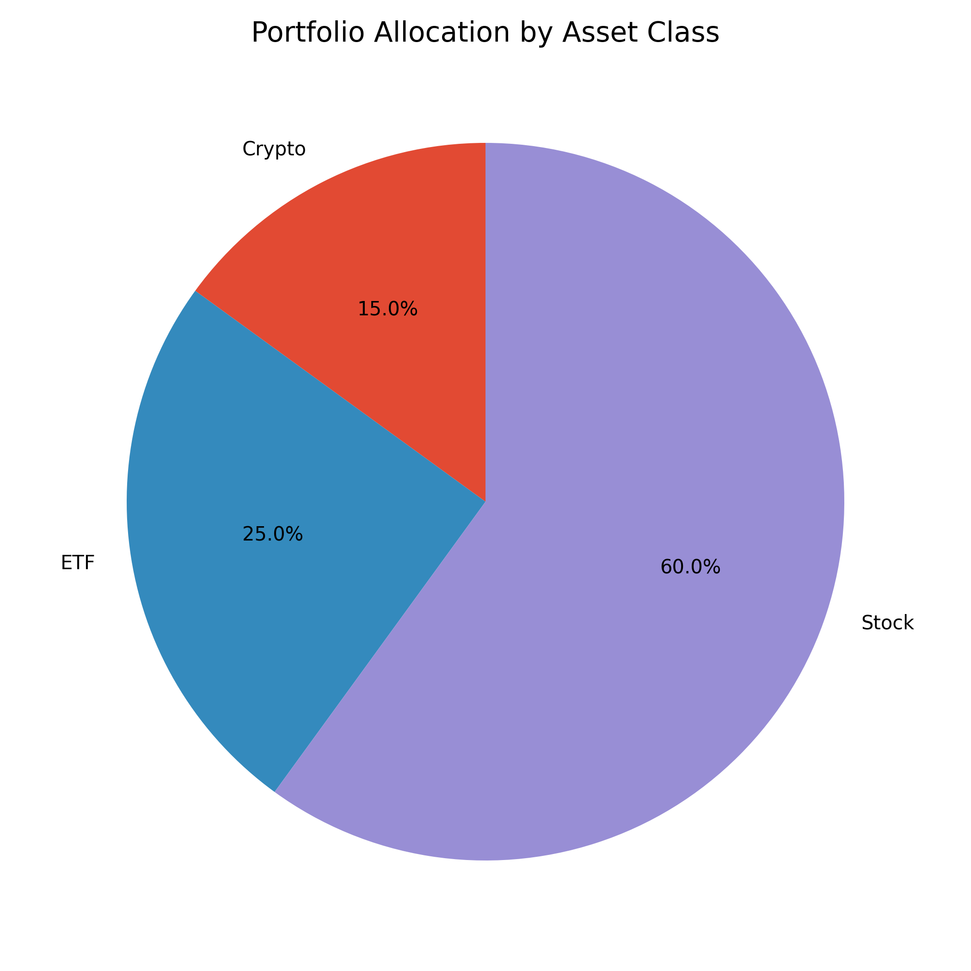
Investment Rationale & Sector Properties

1. Equities / Corporate Stocks (60% Total Weight)
Individual common stocks form the primary engine for capital growth within the model. Allocations are weighted toward established market leaders with proven secular trends:
- Microsoft Corporation (MSFT): Serves as the portfolio's core holding due to its highly consistent corporate earnings, leading enterprise cloud computing infrastructure, and resilient financial buffers.
- Apple Inc. (AAPL): Provides balanced downside protection through its deeply integrated hardware consumer ecosystem, immense liquidity reserves, strong financial position and diversified product ecosystem.
- NVIDIA Corporation (NVDA): Acts as the higher-growth investment, providing direct exposure to structural hardware acceleration and enterprise artificial intelligence trends. Due to its heightened daily fluctuations, its position is bounded at 15%.

2. Exchange-Traded Funds (25% Total Weight)
ETFs are deployed to minimize single-stock vulnerabilities and provide broad market diversification:
- Vanguard S&P 500 ETF (VOO): Tracks the broader S&P 500 Index, distributing tracking risk across 500 large-cap U.S. enterprises across all core industries.
- Invesco QQQ ETF (QQQ): Focuses heavily on the NASDAQ-100 index, capturing top-tier tech innovation without exposing capital to individual company-specific risk.

3. Cryptocurrencies & Digital Assets (15% Total Weight)
Digital currencies provide asymmetric upside options but are strictly contained to preserve structural safety boundaries:
- Bitcoin (BTC): Acts as the primary crypto component due to its status as a digital store of value, largest cryptocurrency by market capitalization, and relatively lower volatility profile compared to alternative tokens.
- Ethereum (ETH): Strengthens decentralized computing exposure through its deeply entrenched smart contract platform, developer ecosystems, and layer-2 solutions.
- Solana (SOL): A higher-risk, higher-growth cryptocurrency included to increase return potential. Because of its historically higher volatility, its allocation is limited to 2% of the total portfolio.

Portfolio Risk Management Characteristics
The proposed architecture demonstrates adherence to disciplined, quantitative fund management principles:
- Diversification: Establishes distinct return boundaries across blue-chip stocks, passive indices, and alternative digital assets.
- Risk Reduction: The higher volatility of cryptocurrencies is balanced by diversified holdings in large-cap stocks and broad-market ETFs, reducing the portfolio's overall exposure to extreme price fluctuations.
- Concentration Control: No single corporate holding exceeds 25% of the capital pool, protecting the investor from sudden specific-issuer corrections.

Conclusion
The proposed ₹100,000 portfolio combines high-quality technology stocks, diversified ETFs, and selected cryptocurrencies to balance long-term capital growth with effective risk management through diversification across multiple asset classes. By diversifying across multiple asset classes, the portfolio aims to achieve long-term capital appreciation while limiting overall portfolio risk.
Analyst Validation Note: Portfolio allocations, calculations, and visualizations were generated using Python. The total investment equals ₹100,000, and all allocations satisfy the requirements of the CodeAlpha Investment Portfolio Creation task.

References
- Bodie, Z., Kane, A., & Marcus, A. J. (2021). Investments (12th ed.). McGraw-Hill Education.
- Jorion, P. (2007). Value at Risk: The New Benchmark for Managing Financial Risk (3rd ed.). McGraw-Hill.
- Markowitz, H. (1952). Portfolio Selection. The Journal of Finance, 7(1), 77–91.
- Yahoo Finance. (2026). Historical Market Data for Microsoft (MSFT), Apple (AAPL), NVIDIA (NVDA), Bitcoin (BTC-USD), Ethereum (ETH-USD), Solana (SOL-USD), Vanguard S&P 500 ETF (VOO), and Invesco QQQ ETF (QQQ). Retrieved July 2026 from https://finance.yahoo.com/
- Python Software Foundation. (2026). Python 3 Documentation. https://docs.python.org/3/
- pandas Development Team. (2026). pandas Documentation. https://pandas.pydata.org/docs/
- NumPy Developers. (2026). NumPy Documentation. https://numpy.org/doc/
- Matplotlib Development Team. (2026). Matplotlib Documentation. https://matplotlib.org/stable/
- Aroussi, R. (2026). yfinance Documentation. https://ranaroussi.github.io/yfinance/

