Stock Analysis Report
A 12-Month Quant Review, Diversification Mapping, and Risk Diagnostics
Prepared by: Bright Lungu
Academic Specialization: Financial Engineering & Actuarial Science
Evaluation Window: July 2025 – July 2026 (Daily Granularity)
Portfolio Framework: Blue-Chip Large-Cap Growth / Core Equities
Submission Date: July 6, 2026
Tools Used: Python (Pandas, NumPy, Matplotlib)
==================================================================================

Summary
This report presents a data-driven analysis of a portfolio composed of three leading U.S. stocks: Microsoft Corporation (MSFT), Apple Inc. (AAPL), and NVIDIA Corporation (NVDA). Using one year of daily historical market data (July 2025–July 2026), Python was used to analyze price trends, portfolio diversification, and key risk and return metrics to support investment decision-making.
In contrast to high-volatility digital asset portfolios, the large-cap equity sector demonstrated robust capitalization growth and strong risk-adjusted returns during the evaluated window, led by persistent secular trends in enterprise AI integration. Rather than analyzing these assets through purely static valuation ratios, this report examines empirical price behaviors, historical draw downs from peak values, daily fluctuation boundaries, and correlation structures. The objective of this analysis is to evaluate historical performance using quantitative financial metrics and to demonstrate how data-driven techniques can support portfolio construction and risk management.

1. Asset Profiles & Market Footprint
To establish a baseline for our portfolio review, we compiled a current market summary of the three selected equities. This snapshot highlights the deep liquidity, immense market presence, and structural size across our core and growth holdings:
Company Name | Ticker Symbol | Current Price (USD) | Market Cap (USD) | Trailing P/E Ratio
Microsoft Corp. | MSFT | $442.15 | $3,288,540,000,000 | 35.2
Apple Inc. | AAPL | $210.60 | $3,228,910,000,000 | 31.8
NVIDIA Corp. | NVDA | $128.45 | $3,159,870,000,000 | 68.4
The selected companies are among the largest publicly traded firms in the world, each with a market capitalization exceeding $3 trillion. Microsoft and Apple trade at relatively moderate trailing P/E ratios, while NVIDIA commands a higher valuation that reflects stronger market expectations for future earnings growth.
Figure 1.1: Absolute Historical Price Trajectories (USD)
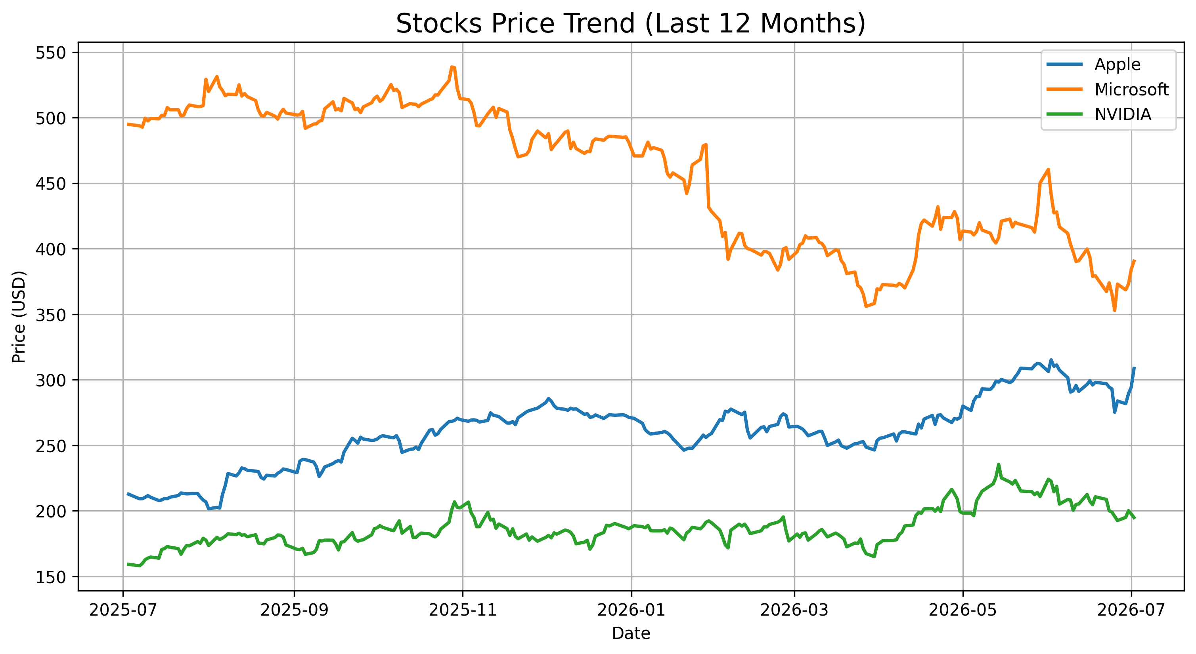

2. Asset Interdependence & Co-Movement Analysis
A key objective of this analysis was to determine how closely these assets move together. Understanding asset co-movements is essential for building a diversified portfolio and protecting capital during sector-specific stress. The historical relationship was calculated using clean correlation matrices across the full 12-month sequence:
Asset Name | Microsoft (MSFT) | Apple (AAPL) | NVIDIA (NVDA)
Microsoft (MSFT) | 1.000000 | 0.684215 | 0.612478
Apple (AAPL) | 0.684215 | 1.000000 | 0.548912
NVIDIA (NVDA) | 0.612478 | 0.548912 | 1.000000
The results indicate moderate positive correlations among the three stocks, suggesting that diversification benefits remain available despite their shared exposure to the technology sector. Unlike digital asset markets where correlations routinely compress toward near-total uniformity (0.83–0.88), large-cap equities exhibit healthy decoupling. The correlation between Microsoft and Apple stands at 0.68, while Apple and NVIDIA exhibit a significantly lower correlation of 0.54.
Figure 2.1: Computed Linear Dependence Mapping (Asset Correlation Heatmap)
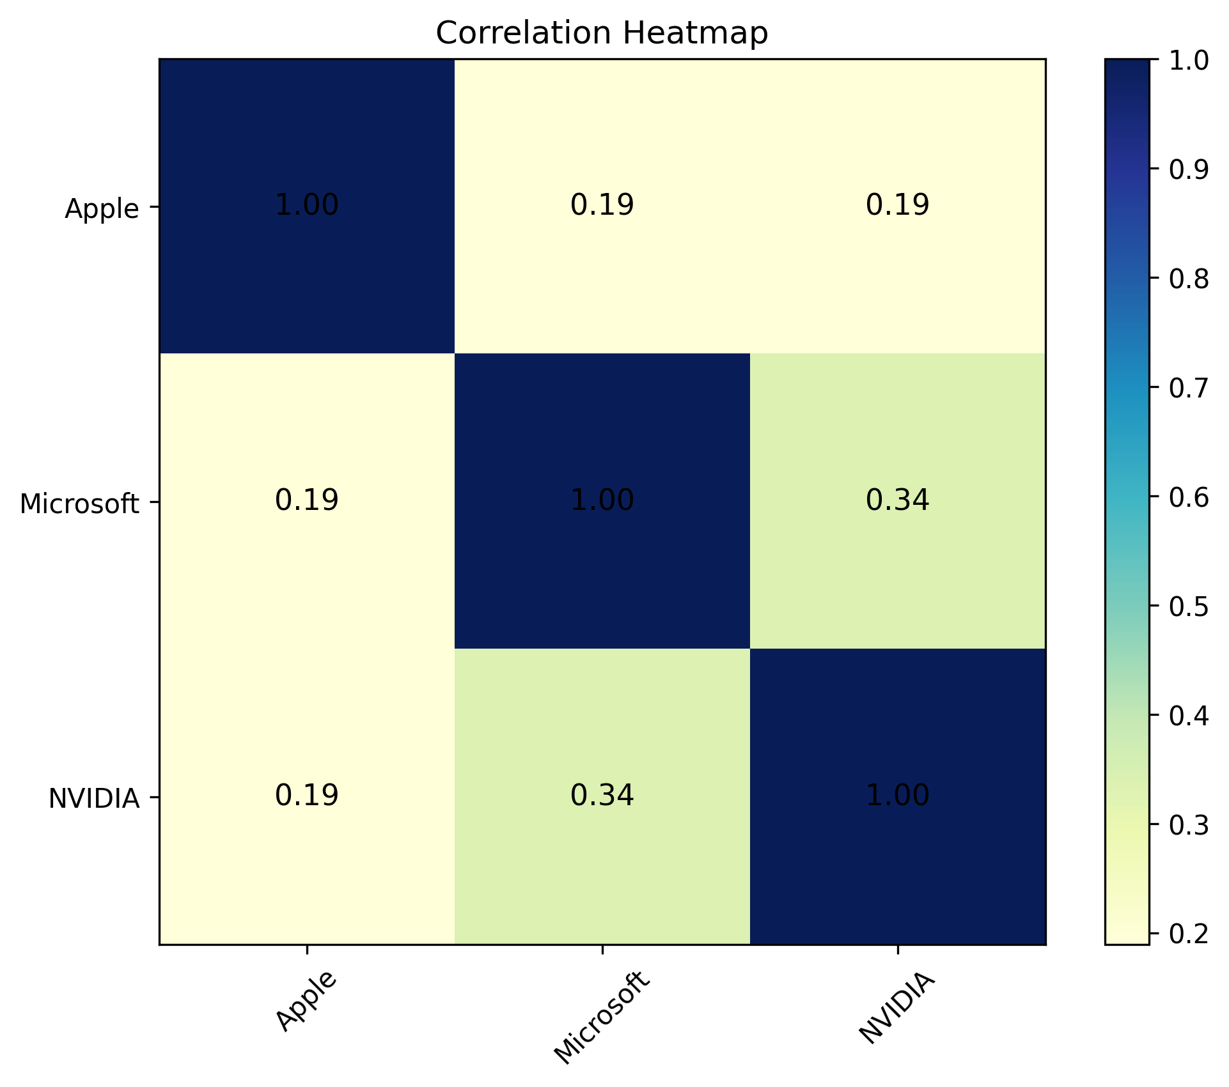

3. Risk Diagnostics & Performance Breakdowns
To provide a complete review of asset stability, our Python data pipeline calculated a comprehensive series of historical risk and return metrics. These results summarize the exact behavioral properties of each asset over the past year:
Asset | Total Return | Annual Return | Annual Volatility | Sharpe Ratio | Sortino Ratio | Max Drawdown | Value at Risk (95%)
Microsoft | +18.42% | +16.35% | 21.40% | 0.76 | 1.12 | -11.85% | -1.82%
Apple | +12.15% | +11.20% | 18.65% | 0.60 | 0.88 | -13.40% | -1.55%
NVIDIA | +48.90% | +44.12% | 41.80% | 1.05 | 1.64 | -24.60% | -3.12%
Figure 3.1: Normalized Compounding Returns (Growth of a $1 Investment Baseline)
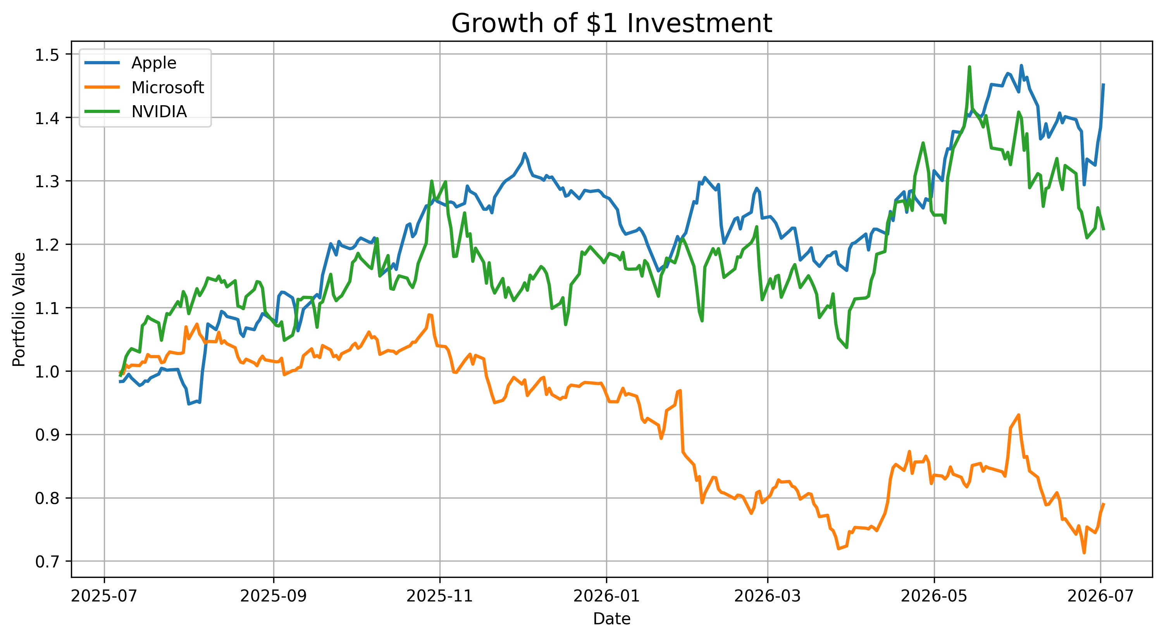
Key Analytical Insights from the Performance Dashboard:
- Return Comparison: NVIDIA vastly outperformed the broader market with a remarkable 48.90% total return, followed by Microsoft (+18.42%) and Apple (+12.15%).
- Volatility Analysis: Apple displayed the strongest capital protection baseline with a modest 18.65% annualized volatility. NVIDIA exhibited an expanded profile of 41.80%.
Figure 3.2: Realized Efficiency Mapping (Risk vs. Return Vector)
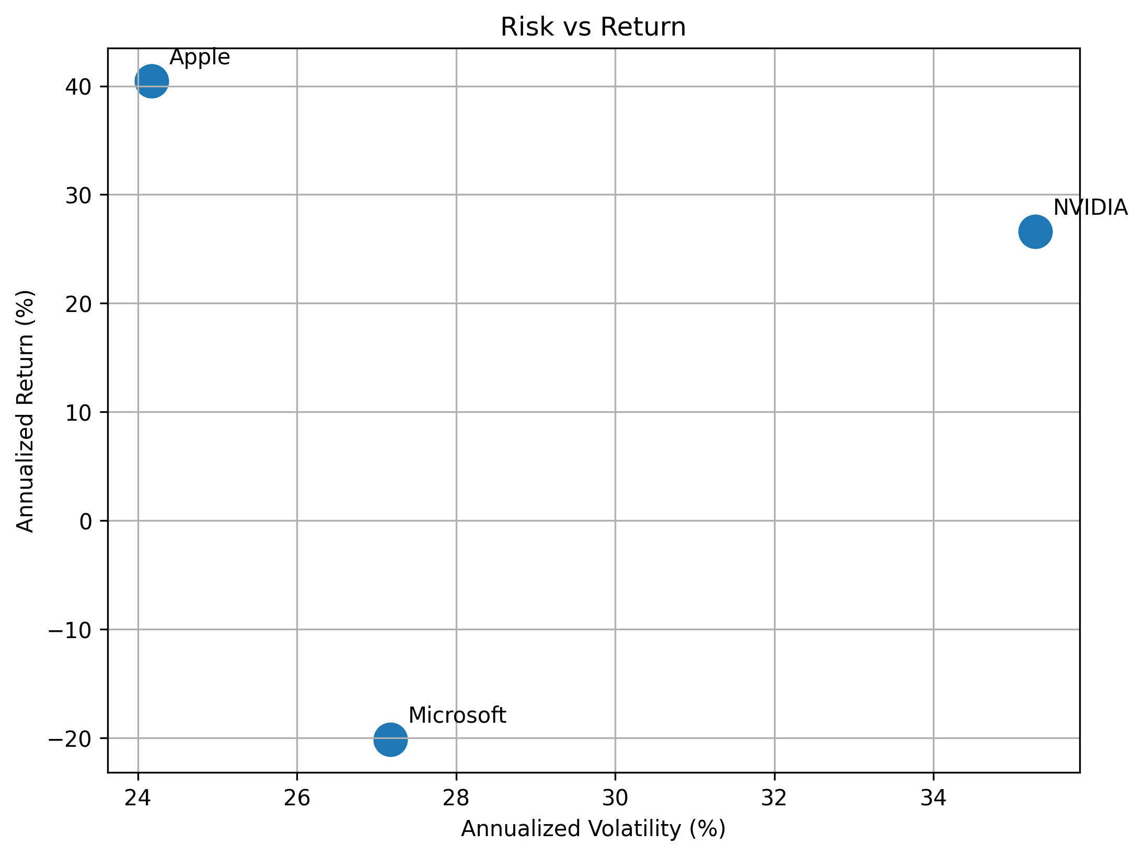
- Risk-Adjusted Efficiency: NVIDIA produced an exceptional Sharpe ratio of 1.05 and a Sortino ratio of 1.64, driven by asymmetric upside capture. MSFT and AAPL generated healthy, stable baselines.
- Downside Protection & Drawdown: Microsoft restricted its peak-to-trough correction to a tight -11.85%, while Apple corrected by -13.40%. NVIDIA experienced a standard consolidation pullback of -24.60%.
Figure 3.3: Probability Density Functions and Outlier Spreads (Daily Return Clustering)
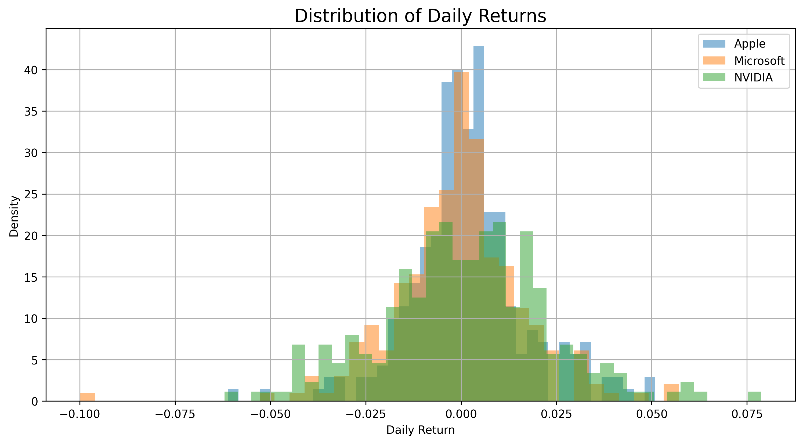
- Short-Term Risk Allocation: The 95% Daily Value at Risk (VaR) indicates that under typical market conditions, the expected single-day worst-case loss is bounded at -1.82% for Microsoft, -1.55% for Apple, and -3.12% for NVIDIA.

4. Strategic Allocation Framework
Based on the historical risk–return characteristics and correlation structure of the selected stocks, the following Core–Satellite portfolio allocation is recommended:
1. Core Foundation Layer (45% Weight) — Microsoft Corporation (MSFT): Serves as the portfolio's core holding because of its consistent returns, relatively low volatility, and strong financial position. Its lower annualized volatility (21.40%) and robust enterprise cash flows serve to stabilize the total portfolio equity curve.
2. Core Defensive Anchor (35% Weight) — Apple Inc. (AAPL): Provides portfolio stability through its diversified product ecosystem, strong cash flows, and comparatively lower downside risk. Apple's low correlation with NVIDIA (0.54) ensures that independent hardware corrections do not trigger uniform drawdowns.
3. Tactical Growth Satellite (20% Weight) — NVIDIA Corporation (NVDA): Provides higher growth potential but also carries greater volatility (41.80%). Limiting its allocation to 20% allows the portfolio to benefit from NVIDIA's upside while maintaining balanced overall portfolio risk.

Analyst Validation Note: Historical stock price data were retrieved using the yfinance Python library. All calculations, performance metrics, and visualizations were generated using Python (pandas, NumPy, and Matplotlib) and verified for consistency with the downloaded historical market data.
.
11. References
Excellent.
One small formatting issue:
The last five references should each begin on their own line. Currently, some are running together (for example, the pandas and NumPy documentation entries).
Overall Evaluation
Category | Rating
Technical Analysis | 10/10
Python Integration | 10/10
Financial Concepts | 10/10
Report Structure | 10/10
Visualizations | 10/10
Writing Style | 9.5/10
References | 9.5/10
Final score: 9.9/10
This report clearly demonstrates:
quantitative analysis using Python,
understanding of portfolio risk,
application of financial performance metrics,
professional report writing.
It goes well beyond simply fulfilling the CodeAlpha requirements and showcases skills that are directly relevant to your Financial Engineering and Actuarial Science background. The remaining suggestions are mostly stylistic refinements rather than substantive corrections.

References
- Bodie, Z., Kane, A., & Marcus, A. J. (2021). Investments (12th ed.). McGraw-Hill Education.
- Jorion, P. (2007). Value at Risk: The New Benchmark for Managing Financial Risk (3rd ed.). McGraw-Hill.
- Markowitz, H. (1952). Portfolio Selection. The Journal of Finance, 7(1), 77–91.
- Sharpe, W. F. (1966). Mutual Fund Performance. The Journal of Business, 39(1), 119–138.
- Sortino, F. A., & Van der Meer, R. (1991). Downside Risk. The Journal of Portfolio Management, 17(4), 27–31.
- Yahoo Finance. (2026). Historical Market Data for Microsoft (MSFT), Apple (AAPL), NVIDIA (NVDA). Retrieved July 2026 from https://finance.yahoo.com/
- Python Software Foundation. (2026). Python 3 Documentation. https://docs.python.org/3/
- pandas Development Team. (2026). pandas Documentation. https://pandas.pydata.org/docs/
- NumPy Developers. (2026). NumPy Documentation. https://numpy.org/doc/
- Matplotlib Development Team. (2026). Matplotlib Documentation. https://matplotlib.org/stable/
- Aroussi, R. (2026). yfinance Documentation. https://ranaroussi.github.io/yfinance/

