Asssignment2
1 Tensorﬂow Softmax (20 points)
(c) (4 points) Carefully study the Model class in model.py. Brieﬂy explain the purpose of placeholder variables and feed dictionaries in tensorﬂow computations. Fill in the implementations for the add placeholders, create feed dict in q1 classifier.py.
Answer:
Placeholder variables: to represent location in a computational graph where data is inserted. These placeholders are used as input, and will be fed data during training.
Feed dictionaries: the feed dictionary mapping placeholders to really input data.

(e) (4 points) Fill in the implementation for add training op in q1 classifier.py.
Explain how TensorFlow’s automatic diﬀerentiation removes the need for us to deﬁne gradients explicitly.
Ansewer: when doing forward for each step, it will define simple step’s gradient for us. And it use backprop to generate gradients. For example, we can define lots of simple computation(like dot prodcut, add,sum) and their gradients, then combine them.
(So long as the computational graph is deﬁned properly, Tensorﬂow can automatically apply back-propagation to compute gradients)
Verify that your model is able to ﬁt to synthetic data by running python q1 classifier.py and making sure that the tests pass.

2 Deep Networks for Named Entity Recognition (35 points)

(5 points) Compute the gradients of J with respect to all the model parameters:
With Regularization:
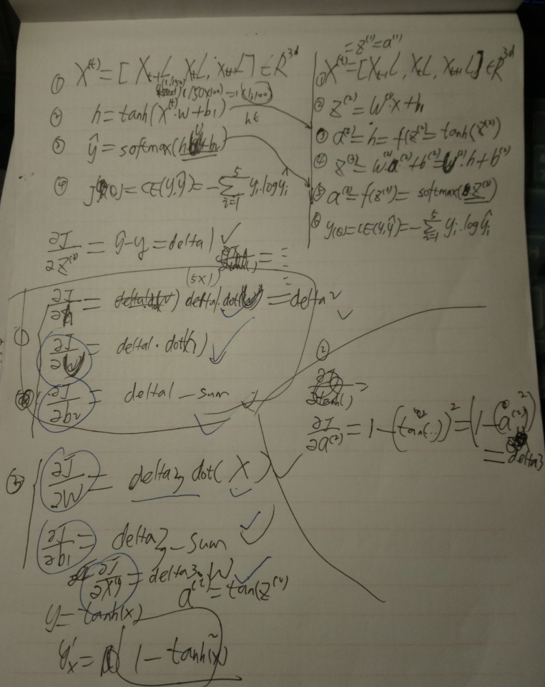

With Regularization:
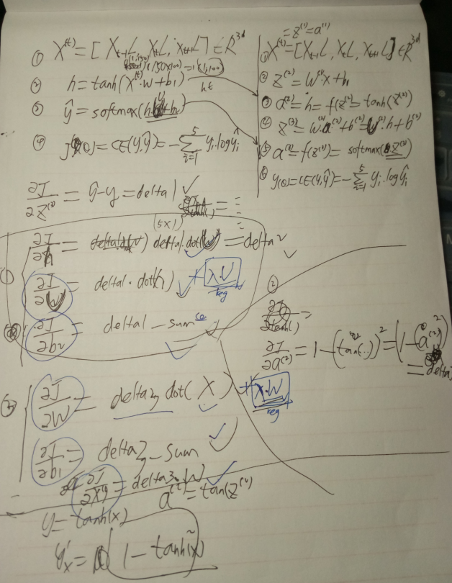

(d) (20 points) In your writeup (i.e. where you’re writing the answers to the written problems), brieﬂy state the optimal hyperparameters you found for your model: regularization, dimensions, learning rate (including time-varying, such as annealing), SGD batch size, etc. Report the performance of your model on the validation set. You should be able to get validation loss below 0.2.
Answer:
Hyperparameters:
embed_size = 50
batch_size = 64
hidden_size = 100
lr =0.001
l2 =0.001
____________________________________________________________________________
label_size = 5
max_epochs =24
early_stopping =2
dropout = 0.9
window_size = 3

(b) (5 points) As you did in Q 2, compute the gradients with for all the model parameters at a single point in time t:
(t) denotes the gradient for the appearance of that parameter at time t. (Equivalently, h(t−1) is taken to be ﬁxed, and you need not backpropagate to earlier timesteps just yet - you’ll do that in part (c)).
Additionally, compute the derivative with respect to the previous hidden layer value:
∂J(t) ∂h(t−1)
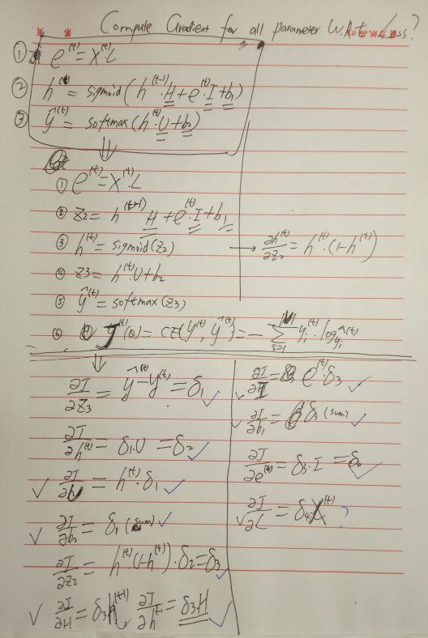

Draw the “unrolled” network for 3 timesteps, and compute the backpropagation-through-time gradients for dH,dI,db1dL at timestep t-1.
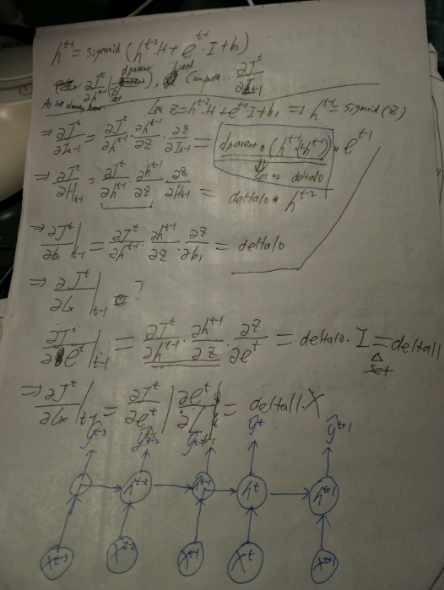

(e) (20 points) Implement the above model in q3 RNNLM.py. Data loaders and other starter code are provided. Follow the directions in the code to understand which parts need to be ﬁlled in. Running python q3 RNNLM.py will run the model. Note that you may not use built-in tensorﬂow functions such as those in the rnn cell module. Train a model on the ptb-train data, consisting of the ﬁrst 20 sections of the WSJ corpus of the Penn Treebank. As in Q 2, you should tune your model to maximize generalization performance (minimize cross-entropy loss) on the dev set. We’ll evaluate your model on an unseen, but similar set of sentences.

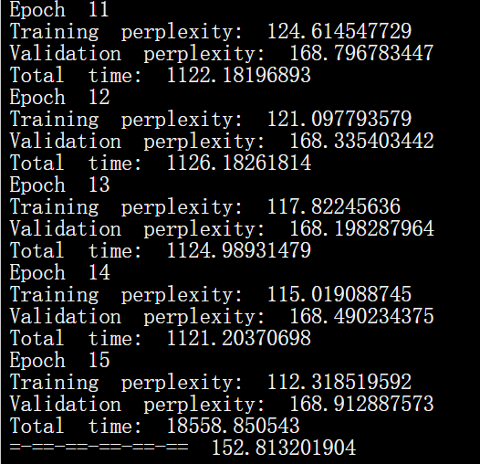

batch_size = 64
embed_size = 50
hidden_size = 100
num_steps = 10
max_epochs =16
dropout = 0.9
lr = 0.001

Generated Sentences:
in palo alto by grand bank <eos>
> this is cherry from united state of america
tokens: [56, 40, 9457, 169, 833, 914, 42, 3410]
this is cherry from united state of america said richard <unk> <eos>
> how are you doing my friend
tokens: [1730, 159, 316, 799, 2810, 2342]
how are you doing my friend of confusion that it is scrapped that a new love is <unk> in washington <eos>
> a lovely child is playing football in the ground in the morning
tokens: [35, 2359, 2390, 40, 2345, 3003, 108, 32, 2719, 108, 32, 616]
a lovely child is playing football in the ground in the morning <unk> <unk> pages $ N million each loss for a security ownership to close a nuclear <eos>
> stock investment is very risky
tokens: [935, 1623, 40, 176, 7271]
stock investment is very risky trading or and the subject of art 's watching things out from a other <unk> research scott <eos>

