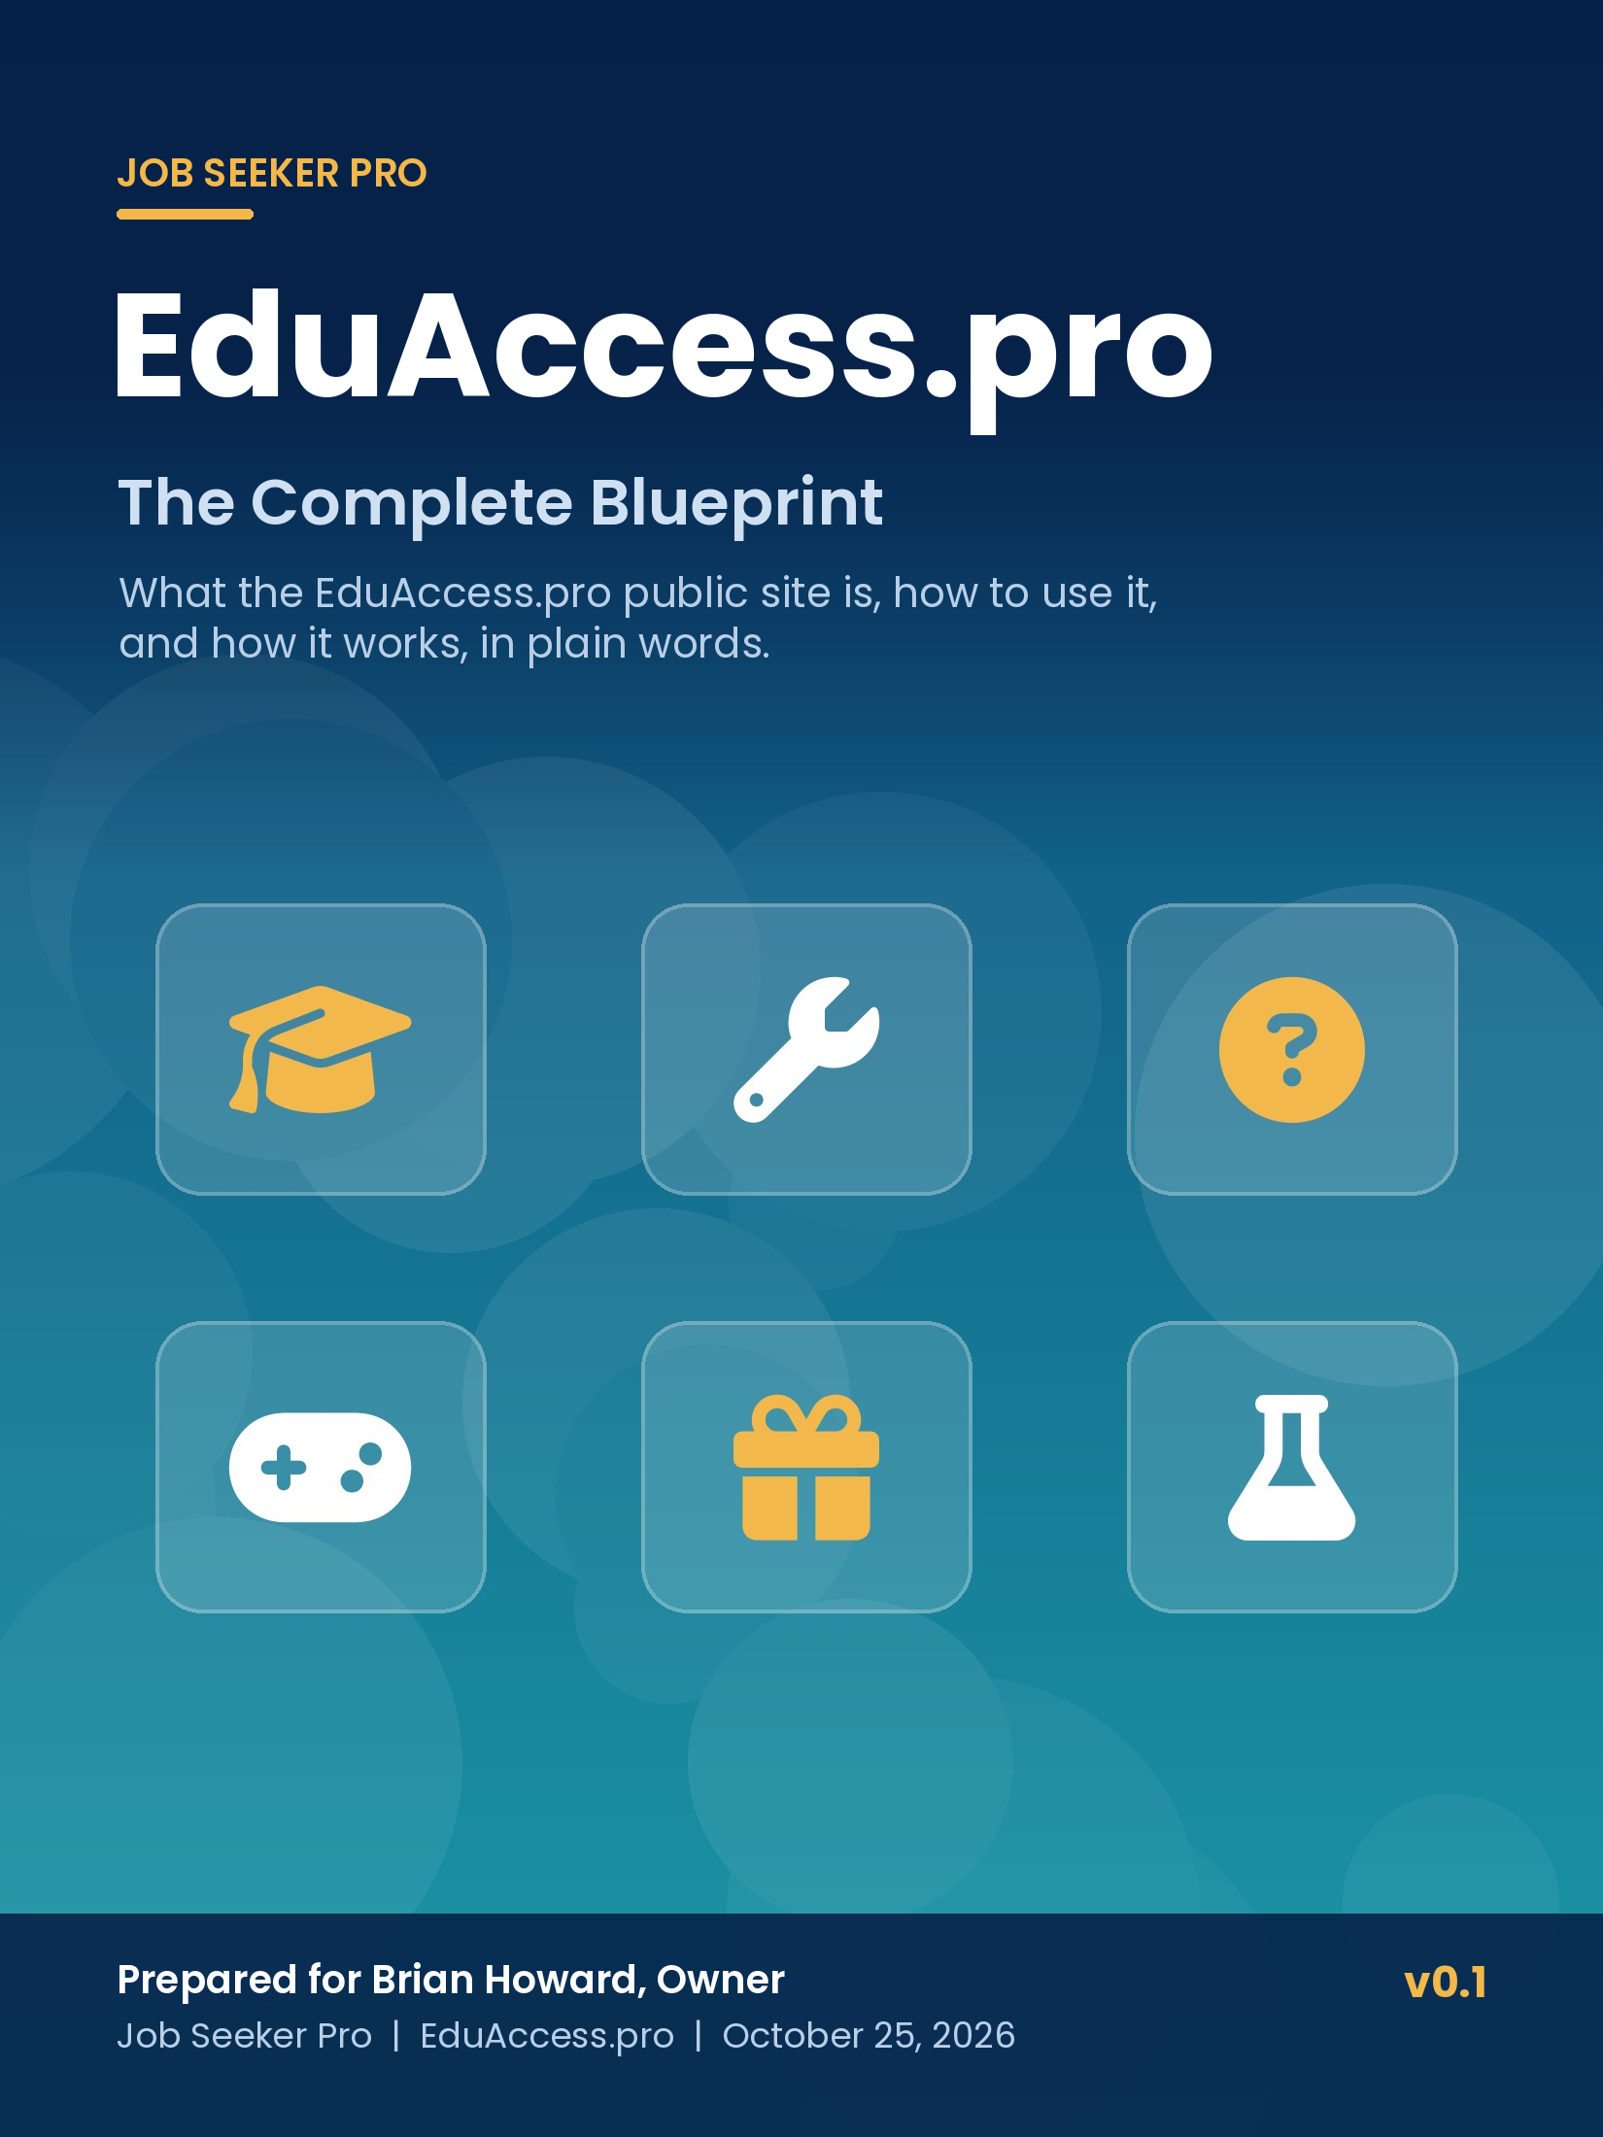
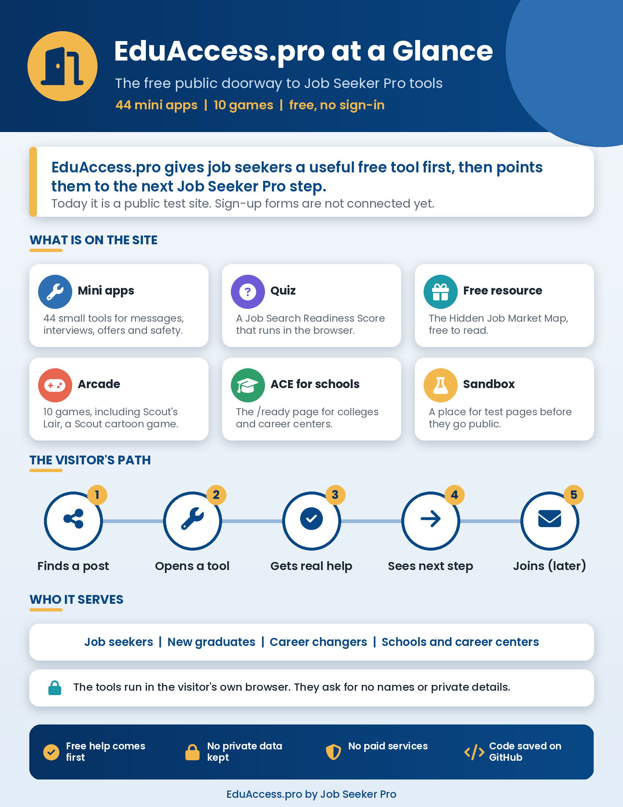

MARKETING BRIEFING, PAGE 2 OF 3

Who EduAccess.pro Helps
EduAccess.pro is the free public website where Job Seeker Pro puts its small tools, quizzes, games and free resources. A visitor can use every tool right away, with no account and no sign-in. It serves three groups.
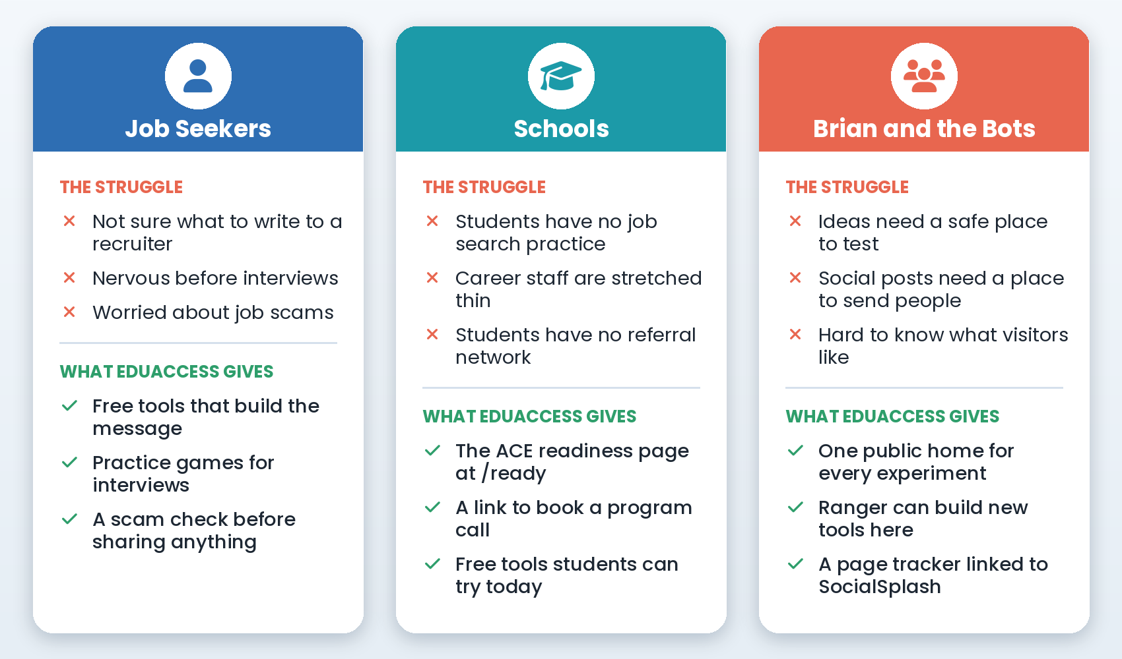

Three reasons it matters
1. It gives real help first. Each tool solves one small job search problem, such as writing a recruiter reply or checking a job offer for scam signs, before it asks the visitor for anything.
2. It keeps visitors safe. The tools run inside the visitor's own browser. They ask for choices, not names or private details, and the site does not store what visitors type.
3. It gives social posts a useful place to send people. SocialSplash and Ranger can point their posts at a real tool, so a reader gets value in one click.

MARKETING BRIEFING, PAGE 3 OF 3

Why EduAccess.pro Matters
Job seekers often search alone for help, and many free tools online ask for an email or personal details before they help at all. EduAccess.pro turns that around. It shows the help first, and only later, once Brian connects the sign-up forms, will it offer a fuller checklist, course or coaching as the next step.
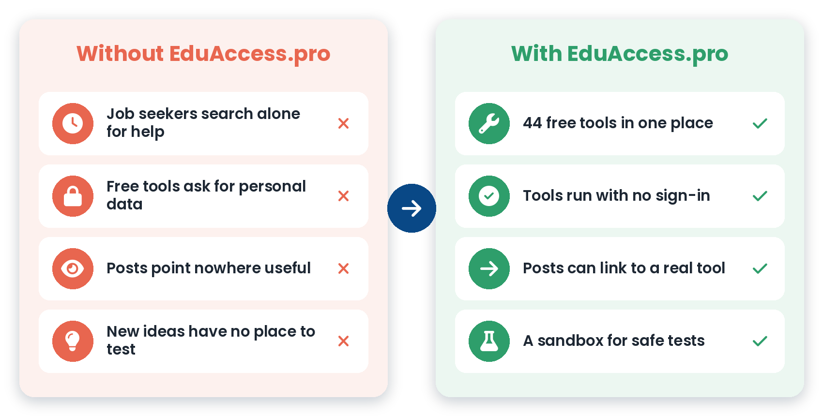

What makes EduAccess.pro different
1. Free and open. There is no sign-in, no paid service and no account to create.
2. Many small tools, one home. 44 mini apps, a readiness quiz, a free resource and 10 arcade games sit on one site.
3. A page for schools. The /ready page explains the ACE Hiring Readiness System to colleges and career centers and lets them book a call or join a webinar.
4. A safe test area. New ideas start in the Sandbox with fake data and move to the public site only after a review.
5. Built in the open. The code lives on GitHub in brihow11/eduaccess-pro-launch, and every change says who wrote it.
The EduAccess.pro promise
Useful help first, for free. No private data taken. A clear next step when the visitor is ready.

PART 1

How to Use EduAccess.pro
A light first version
This blueprint was written on October 25, 2026 from the code on GitHub and a check of the live site. There is no standalone how-to guide for EduAccess.pro yet. When one is written from the real screens, this part will be updated to match it.

Step 1: Open the site
1. Open https://eduaccess.pro in any web browser, on a phone or a computer. Both eduaccess.pro and www.eduaccess.pro work.
2. You do not need to sign in. Every page is public.
3. The menu at the top has four links: Apps, Quizzes, Lead Magnets and Sandbox.

Step 2: Try a free tool
1. Click Apps to see the list of mini tools, or click a tool card on the home page.
2. Pick the choices the tool asks for, such as the situation, the person you are writing to and the tone you want.
3. Read the result the tool builds for you. Copy it and use it in your own message or plan.
4. Click Reset to start over. Nothing you chose is saved after you leave the page.

Step 3: Take the readiness quiz or read the free resource
1. Click Quizzes, then open the Job Search Readiness Score. Check each item that is already true for your job search, and the score shows where you stand. Nothing is sent or saved.
2. Click Lead Magnets, then open the Hidden Job Market Map to read the free guide.

Step 4: Play a game
1. Open https://eduaccess.pro/games to reach the EduAccess Arcade. It is not in the top menu yet, so use the direct link.
2. Pick a game. Most games work with a keyboard, a game controller or touch controls on a phone.
3. Scout's Lair is an original cartoon adventure in 10 scenes, in which Scout rescues job seekers from a faceless hiring machine.
4. High scores are saved only on your own device.

Step 5: Share the page for schools
1. Send colleges and career centers to https://eduaccess.pro/ready.
2. They can watch the ACE overview video. It starts when they click play, with sound.
3. They can click Schedule Program Overview Call, which opens Brian's HubSpot booking page, or sign up for the next program webinar.

Step 6: When something looks wrong
1. A page will not load: wait a minute and reload. If it still fails, tell Howie. The site runs on Railway, and Howie can check it.
2. A tool gives a strange result: click Reset and try again. If it keeps happening, tell Howie which tool and what you picked.
3. You want a new tool or a change: ask Howie, Ranger or Codex. The change is made in its own pull request on GitHub and goes live after it is merged.

PART 2

How EduAccess.pro Works
This part explains what happens behind the scenes, in plain words. Each section has a picture of the steps, then the same steps written out.

2.1 The big picture
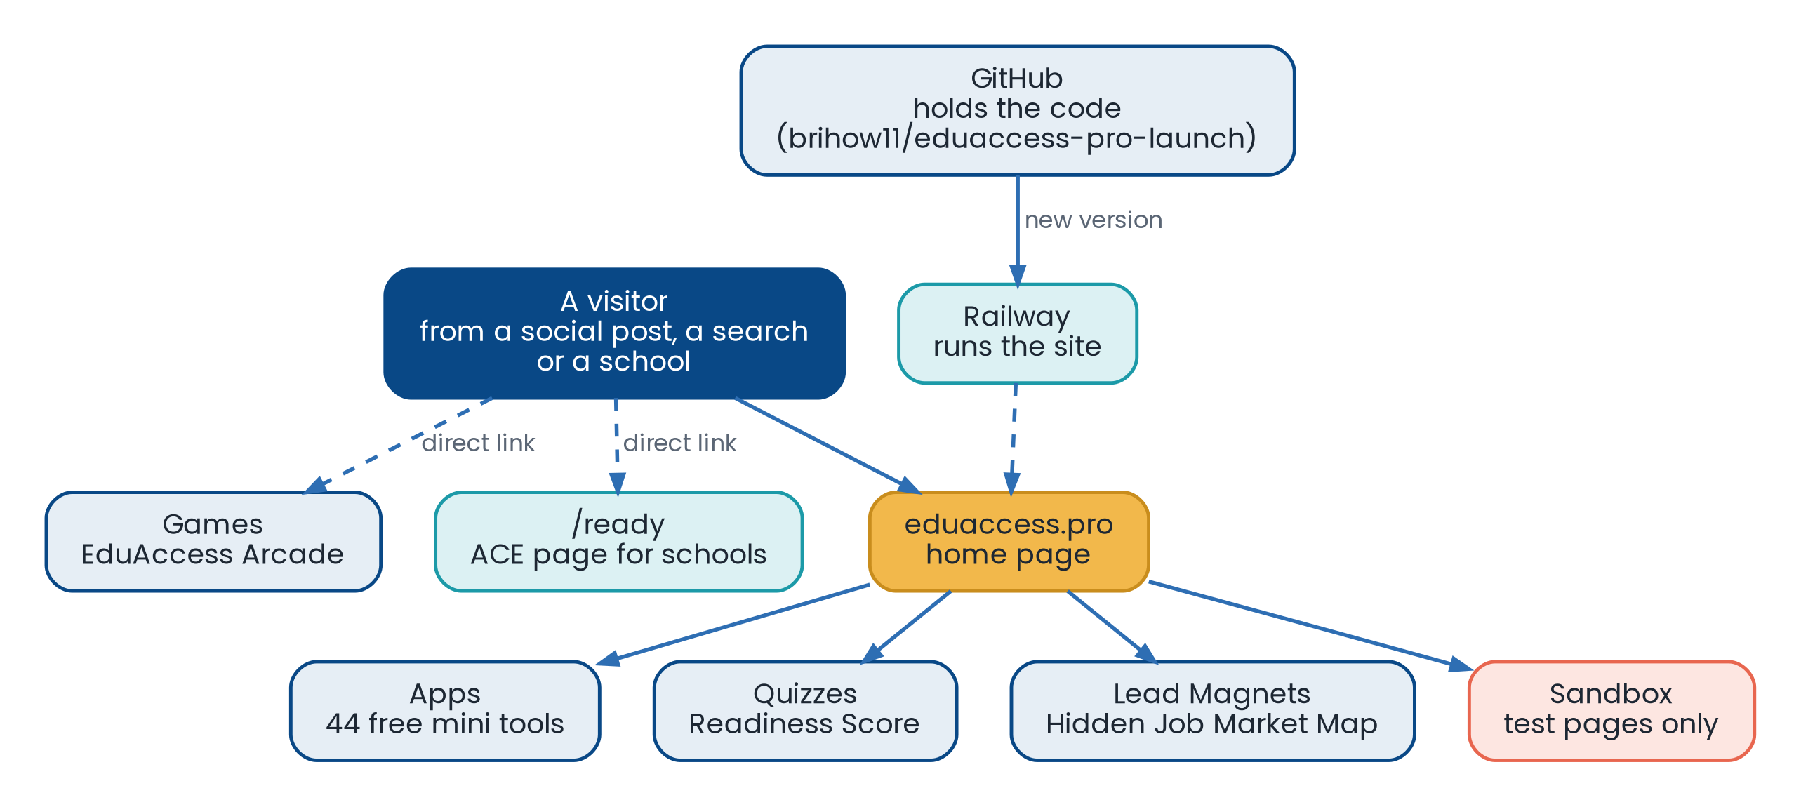
Figure 1. The main parts of EduAccess.pro and how they connect.
1. The visitor. A visitor arrives from a social post, a web search, a school or a direct link.
2. The home page. The home page explains EduAccess.pro and links to Apps, Quizzes, Lead Magnets and the Sandbox.
3. The tools. 44 mini apps, the readiness quiz and the free resource each live on their own page.
4. The arcade and the school page. The Games pages and the /ready page for schools are reached by direct links.
5. Hosting. Railway runs the website. The domain name is managed at Namecheap, and the site uses a secure (HTTPS) address.
6. The code. All pages live on GitHub. When a change is merged, Railway puts the new version live.

2.2 What happens when a visitor uses a tool
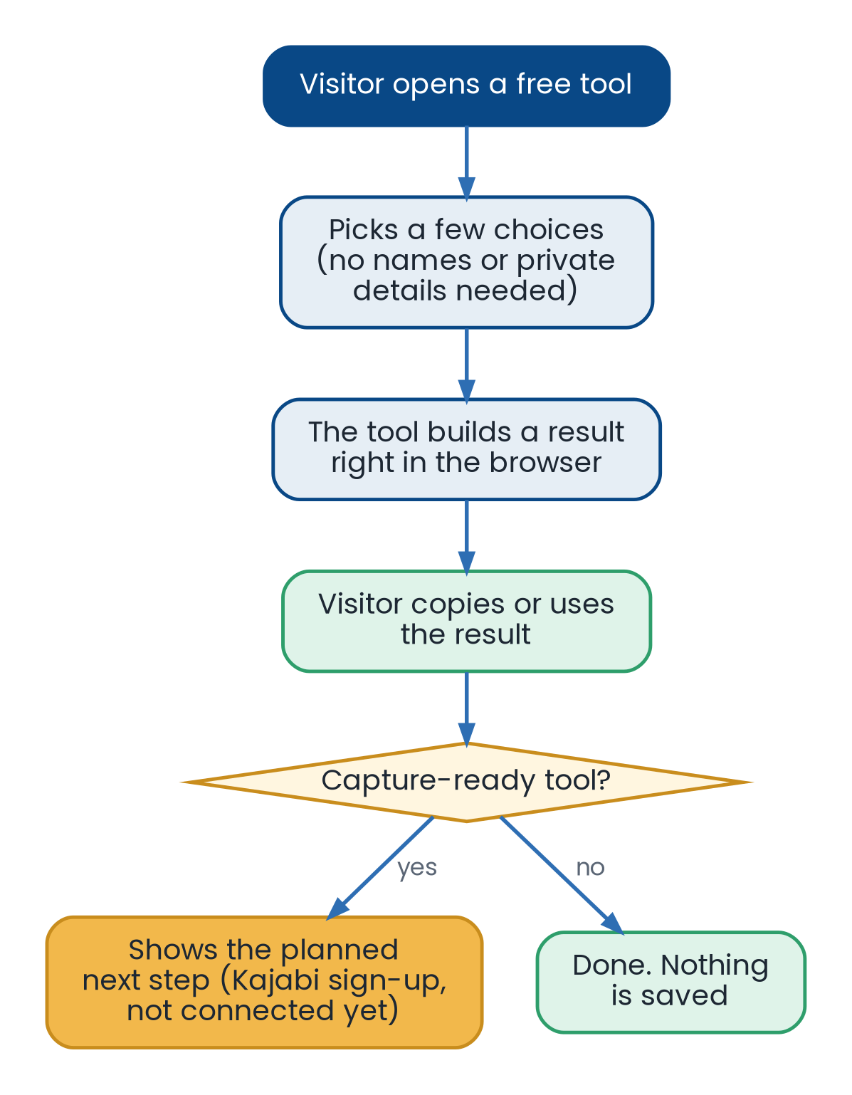
Figure 2. A free tool gives its result first and saves nothing.
1. The visitor opens a free tool.
2. The visitor picks a few choices. The tool does not ask for names, message text or private details.
3. The tool builds a result right in the visitor's browser. Nothing is sent to a database.
4. The visitor copies the result and uses it.
5. Some tools are marked "capture-ready." They show a planned next step, a free set of scripts or a checklist through a Kajabi sign-up form. Those forms are not connected yet, so no email is collected today.
6. Other tools are marked "no capture." They simply end after the result.

2.3 How the page for schools works
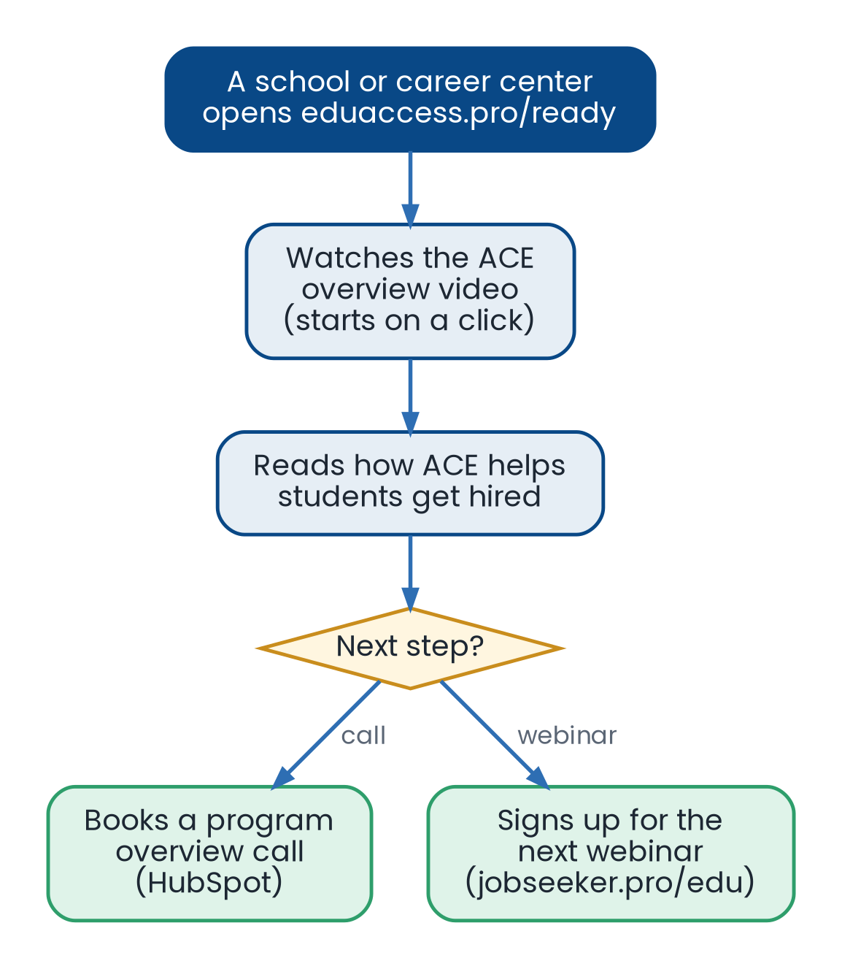
Figure 3. The /ready page leads a school to a call or a webinar.
1. A school or career center opens eduaccess.pro/ready. This page used to live at jobsk.pro and moved here on August 9, 2026.
2. The page shows the ACE Hiring Readiness System: AI, Coaching and Enablement for students.
3. The overview video waits for a click, so it can play with sound. It has play, pause, rewind, stop, mute and progress controls.
4. The visitor can book a program overview call on Brian's HubSpot page or sign up for the next webinar at jobseeker.pro/edu.
5. This page uses Google Analytics to count visits. It needs no database.

2.4 How visits are counted
1. Every page carries the SocialSplash page tracker, added on October 23, 2026. It does not use cookies and does not read anything typed into forms.
2. The tracker helps SocialSplash see which posts send people to which pages.
3. Today the tracker points to SocialSplash's test (staging) server, because SocialSplash is not live yet.
4. Only the /ready page has the Google Analytics tag. The other pages do not have it yet.

2.5 How changes reach EduAccess.pro, and how this blueprint stays current
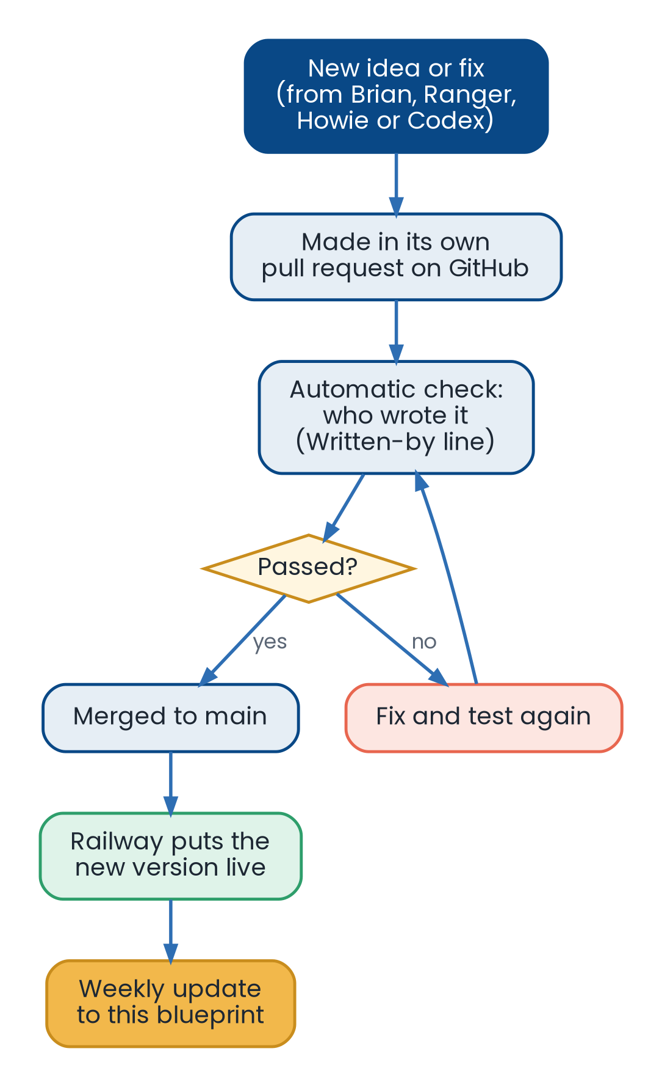
Figure 4. Every change goes through GitHub before it goes live.
1. A change starts with an idea or a fix from Brian, Ranger, Howie or Codex.
2. The change is made in its own pull request on GitHub.
3. An automatic check makes sure the pull request and every change in it say who wrote it (Codex, Howie, Ranger or Barnabas). The change cannot merge without it.
4. The code also has its own tests for the server and the games, which a helper runs before merging.
5. Once merged, Railway puts the new version live.
6. This blueprint is updated in the weekly blueprint refresh.

2.6 Keeping visitors and data safe
1. The site does not store what visitors type, and it does not collect personal or student data.
2. The repository is public, so no private business notes, contact details or passwords may ever be put in it.
3. No paid services, tracking tools, email automation or sign-up routing may be added unless Brian approves that exact plan.
4. Sign-ups, when they come, will use Kajabi forms only, and each one must be tied to an approved offer and follow-up plan.
5. Dependabot watches the code's building blocks and opens security updates.

PART 3

Decisions, Safety and Status

3.1 Key decisions
1. Standing rule: EduAccess.pro is a no-spend launch home. It gives useful value first and points to a fuller Job Seeker Pro next step later.
2. August 9, 2026: the ACE page for schools moved from jobsk.pro to eduaccess.pro/ready, with no Supabase and no database.
3. October 3, 2026: nothing new goes inside Hermes or Ranger code. EduAccess.pro is its own separate site.
4. October 22, 2026: security updates were added, and Dependabot now checks the code's building blocks.
5. October 23, 2026: the SocialSplash page tracker was added to every page.
6. October 24, 2026: Brian's backup rule applies to EduAccess.pro, like every other app.

3.2 Backup and recovery
1. The whole site is code and pictures. All of it lives on GitHub in brihow11/eduaccess-pro-launch, which is the main copy.
2. The public pages use no database, so there is no visitor data to back up.
3. If the site breaks, the fix is to undo the last change on GitHub and let Railway put the earlier version back live.
4. Brian's backup rule (2 copies on the Railway disk, a daily copy to AWS kept 15 days) applies. It is not yet confirmed whether EduAccess.pro has a Railway disk or is part of the nightly AWS copy. See Gaps and risks.

3.3 Safety limits
1. No paid services and no spending without Brian's yes.
2. No personal or student data is collected or stored.
3. No email automation, sign-up routing or new tracking tools unless Brian approves that exact plan.
4. Test pages with made-up data stay in the Sandbox until they are reviewed.
5. Every change must say who wrote it, or it cannot merge.

3.4 Done vs being tested
From a check of the live site and the GitHub code on October 25, 2026. EduAccess.pro has no Feature Board, so this list is written by hand.
Part | Status | What it means
Home page and menu | Live | Opens at eduaccess.pro and www.eduaccess.pro
44 mini apps | Live | Free tools that run in the browser
Readiness quiz and free resource | Live | Public, nothing collected
EduAccess Arcade (10 games) | Live | Direct link only, not in the menu
/ready page for schools | Live | Video, call booking, webinar link
Kajabi sign-up forms | Not started | Planned next step on capture-ready tools
Google Analytics on all pages | Not done | Only /ready has it today
SocialSplash tracker | Live on staging | Points to the SocialSplash test server

3.5 Gaps and risks
1. No sign-ups yet. The Kajabi forms, email follow-up and customer records are not connected, so the site cannot collect leads yet. Brian needs to approve the offer, the form and the follow-up plan first.
2. Tracker on a test server. The page tracker sends visits to SocialSplash's staging server. When SocialSplash goes live, the tracker address must be changed to the live one.
3. Analytics only on one page. The Google Analytics tag is only on /ready, so visits to the other pages are not counted there.
4. Backups not confirmed. It is not known yet whether EduAccess.pro is part of the nightly AWS backup. Howie should check this.
5. Games hard to find. The arcade is not linked from the home page menu.
6. Outside picture. The home page's large top picture loads from another website (Unsplash). If that picture is removed, the top of the page will show only its dark color.
7. Tests are not automatic. Only the Written-by check runs on GitHub by itself. The server and game tests must be run by a helper.
8. Unknowns. Visitor numbers and which tools are used most are not known yet. No standalone how-to guide exists yet.

Plain-words guide
Word | What it means
Mini app | A small free tool on one page that does one job, such as writing a message.
Capture-ready | A tool that will offer a free download through a sign-up form once the form is connected.
Kajabi | The service Job Seeker Pro plans to use for sign-up forms and courses.
Lead magnet | A free guide or checklist that helps a visitor and leads to the next step.
Sandbox | A test area for pages with made-up data, kept apart from the public pages.
Railway | The service that runs the website.
GitHub | The website that stores the code and every change to it.
Page tracker | A small piece of code that counts which pages people visit, without cookies.
ACE | The Job Seeker Pro hiring readiness program for schools: AI, Coaching and Enablement.

Change log
1. 10/25/2026: First EduAccess.pro blueprint built as a light Word document for Brian, in the same layout as the other blueprints. Includes a title page, a full-page infographic, a 3-page marketing briefing, a how-to section, four flow pictures and the back sections on decisions, backups, safety, status and risks. Based on GitHub brihow11/eduaccess-pro-launch main (through pull request 151, merged October 24 at 1:39 PM CT), its README and docs, and a check of the live site on October 25, 2026. Unknown facts are listed under Gaps and risks.

STANDARD FOR EVERY APP

Backup Rules
How EduAccess.pro is backed up. Brian approved this rule on October 24, 2026.
1. Keep 2 on the Railway disk. Each app keeps only its newest 2 backup copies on its own Railway disk. Older copies are removed, so backups never pile up and fill the disk.
2. One copy a day goes to AWS. Every night at 8:45 PM CT, one backup of each app is copied to Amazon S3, in the bucket brihow-jsp-backups in Ohio (us-east-2).
3. AWS keeps 15 days. S3 holds the last 15 daily copies. The nightly job rotates 15 fixed spots, so each night it writes over the oldest copy. A cleanup rule on the bucket also removes anything older than that.
4. Check first, then delete. A copy on the Railway disk is only removed after its AWS copy is confirmed to be the right size and checksum.
5. Restores. Howie runs restores and practice restores using each app's restore guide.
6. Same rule for every app. This applies to Ranger, SocialSplash, BuilderBrain, Scout, Barnabas, EduAccess.pro and any new app.

