**Team Name:** Blue Team

**Team Members:** Riley Dorrington, Robin Tageant, Brianne Hulgan, Joseph Black, Andy

Nguyen

**Case Study:** Bacchus Winery

**Business Rules:**

A Company has many Employees

A Company has many Distributors

A Distributor has many Orders

A Company has many Suppliers

A Supplier has many Supplies

A Company has many Products

Ship Date must be after Order Date

Delivery Date must be After Order and Ship Date

Total Prices are Calculated Automatically

We have set distributors for products to be sold to

We have set suppliers to buy supplies from

No Tables have empty fields.

**ORD:**

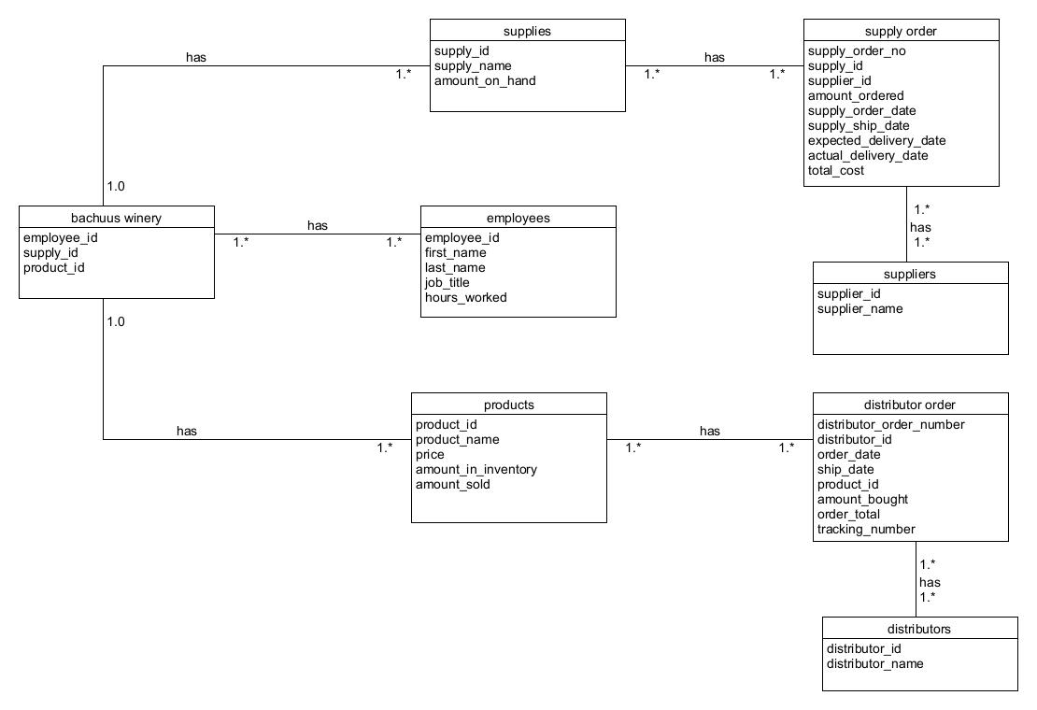

**OUTPUT:**

