**Team Name:** Blue Team

**Team Members:** Riley Dorrington, Robin Tageant, Brianne Hulgan, Joseph Black, Andy

Nguyen

**Case Study:** Bacchus Winery

**Business Rules:**

A Company has many Employees

A Company has many Distributors

A Distributor has many Orders

A Company has many Suppliers

A Supplier has many Supplies

A Company has many Products

Ship Date must be after Order Date

Delivery Date must be After Order and Ship Date

Total Prices are Calculated Automatically

We have set distributors for products to be sold to

We have set suppliers to buy supplies from

No Tables have empty fields.

**ORD:**

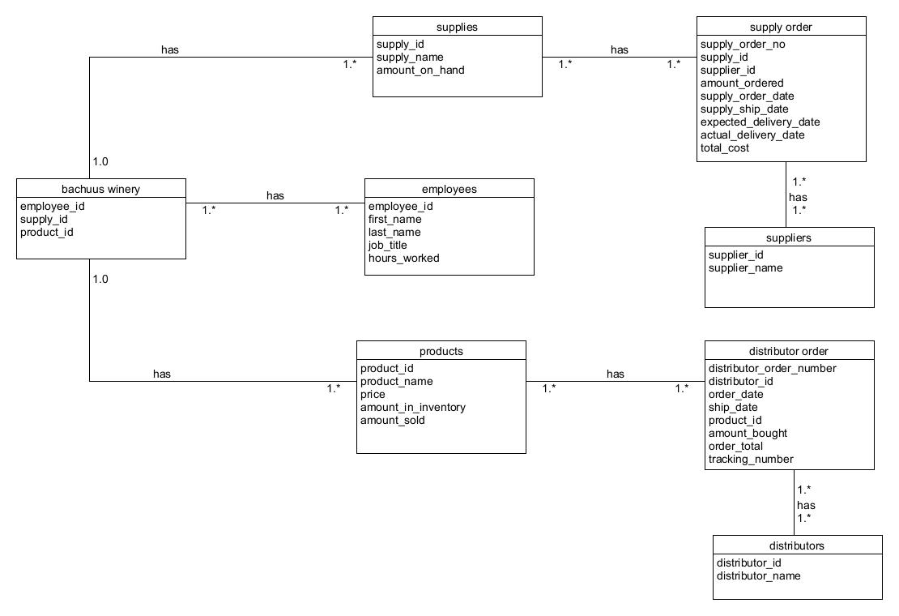

**Report Descriptions:**

**Report #1:**

This record will run a query showing the expected delivery dates and the actual delivery dates of each supply order.

**Report #2:**  
This record creates a join from the “Products” table, “Distributor” table and the “distributor order” table and runs a query displaying the distributor, the wine name and the amount the wine has sold.

**Report # 3:**

This record creates a join combining the “employee” and “hours worked” tables to display each employee and how many hours they have worked over the last four quarters.

**Report Results:**  
