Faculty Information System

Faculty Information System (FIS) is a question- answer engine which takes input queries in form of speech and tries to find out the answer by filling required details. FIS is currently limited to phone number details of faculty members.

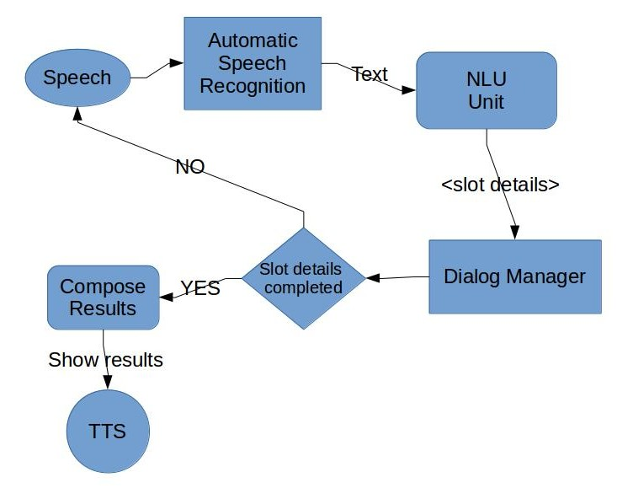
Underlying Technologies:

- CMU Sphinx is used for Automatic Speech Recognition
- The language model (Phoneme dictionary and Possible conversation sentences) is created using US phonemes to suit Indian common nouns that are being used in the application
- The Natural Language Understanding Unit is a rule based parser which filters out unnecessary words and locates the slot details based on syntactical analysis

The dialog manager for FIS is implemented as a simplified Finite State Machine . Everytime it recieves an input from NLU, it tries to fit in the information into the available slots. Currently, already filled slots cannnot be overridden . Once all the slots are filled, the values are checked against the database for validity . After the validity check, the output is queried and passed onto the display manager and Text-to-Speech system in order to show the produced results.

Possible Dialog:

1>Speech = tell me the number of Dr. Kishore Prahallad
|
2>NLU filters out the text and finds the required keywords
|
3>keywords = number, Dr. Kishore Prahallad
|
4>Keywords are submitted to Dialog Manager which verifies the information for ambiguity and availability in DB. It tries to fill the information <number_type> and <faculty_name>.
|
5>If some information is missing Dialog manager initiates a conversation to provide the details, eg. “Please provide a number type”.

|
6>Steps 1-5 are repeated till all the slots are filled.
|
7>Once the slots are complete, Dialog ends.
|
8>Gathered information is sent to DB and results are obtained
|
9>Results are passed to TTS

Following is an analysis of some words and sentences that work based on 5 attempts to each one.

Prathyusha worked on collecting the possible dialog scenarios, synonyms of common nouns and creating of language model.

