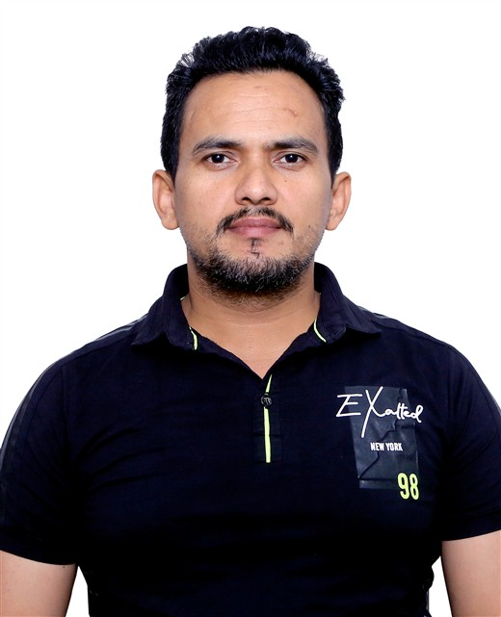  CONTACT  PHONE  +91 9711101482  EMAIL  brijpant88@gmail.com  LOCATION  Faridabad, Haryana – 121005  LINKEDIN  linkedin.com/in/brij-pant-ba8000a4  EDUCATION  Diploma in Multimedia & Web Designing  Arena Animation, Faridabad  B.Com  EIILM University  Senior Secondary (XII)  Haryana Board  LANGUAGES  English • Hindi  INTERESTS  Short video creation • YouTube Shorts • Instagram Reels • Video editing • Chess | BRIJ BHUSHAN PANT  SENIOR FRONTEND DEVELOPER • AI-ASSISTED DEVELOPMENT  13+ YEARS IN IT • 100+ PROJECTS  ■ PROFESSIONAL SUMMARY  A highly experienced Frontend Designer and Developer with 13+ years of overall experience in the IT industry, specializing in creating modern, responsive, pixel-perfect, and visually engaging web experiences.  Possessing strong expertise in HTML5, CSS3, SCSS, Bootstrap, JavaScript, jQuery, WordPress, Laravel Frontend Integration, and React JS, with a proven ability to transform creative concepts and design requirements into high-quality, functional web interfaces.  Experienced in developing responsive websites, customizing and optimizing WordPress themes, designing interactive admin panels and dashboards, creating professional HTML email templates, and implementing engaging CSS animations. Over 7 years of experience in WordPress theme customization and optimization, along with hands-on experience in React JS development.  Also experienced in leveraging AI-powered tools and AI-assisted development workflows to accelerate frontend development, improve productivity, explore creative design solutions, and streamline coding processes.  Passionate about modern web technologies, clean code, creative problem-solving, and delivering exceptional digital experiences.  ■ PROFESSIONAL EXPERIENCE  OCT 2023 – PRESENT  Sr. Frontend Developer  morismedia • Kolkata, West Bengal (Remote)  JUL 2014 – OCT 2023  Sr. HTML Developer  Mind Digital Pvt. Ltd. • New Delhi  JUL 2013 – JUN 2014  HTML Developer  IMI Creation Pvt. Ltd. • Faridabad
LANGUAGES & FRAMEWORKS  HTML5 • CSS3 • SCSS • JavaScript • jQuery • Bootstrap • React JS  CMS & PLATFORMS  WordPress theme customization • Laravel frontend integration • Magento 2  UI SKILLS  Responsive web design • Pixel‑perfect UI development • UI/UX design implementation • CSS Grid and Flexbox • CSS animations • AI-assisted UI development • AI-powered design-to-code  QUALITY  Cross‑browser compatibility • Chrome • Firefox • Safari • IE • Website optimization • Clean and maintainable code  OTHER  Admin dashboards • HTML email templates • Illustrator (basic) • CorelDRAW (basic) | ■ AI-ASSISTED DEVELOPMENT  AI‑powered coding workflows • AI tools integration in web development • AI‑driven website creation and optimization • AI‑assisted debugging and code enhancement • Agentic development workflows  ■ SELECTED PROJECTS
  morismedia.in (India)  Laravel | Sr. Frontend Developer | internationalnewsexpress.com (India)  React | Sr. Frontend Developer
  redlinkgroup.com (Qatar)  Laravel | Sr. Frontend Developer | sarmat.ae (UAE)  Laravel | Sr. Frontend Developer
  mind-rewire.com (India)  Laravel | Sr. Frontend Developer | victoryline.ae (UAE)  Laravel | Sr. Frontend Developer
  Batelco.com (Bahrain)  WordPress | Sr. HTML Developer | Omnipod (United Kingdom)  React | React Frontend Developer
  Koita.com (Dubai, UAE)  WordPress | Sr. HTML Developer | Cosmesurge.com (Sharjah, UAE)  WordPress | Sr. HTML Developer
  Kusumhealthcare.com, Clovedental.in, Eyeqindia.com, Minddigital.com (New Delhi)
  WordPress | Sr. HTML Developer
  Thomabravo2021yearinreview.com (London, UK)  WordPress | Sr. HTML Developer | Super99.in (New Delhi)  Magento 2 | Sr. Frontend Developer

