Assignment No.3
Batch B1
Q1. Formulate and explain: Plane Electromagnetic wave equation in
- free space
- Lossy dielectric
- Good conductor / Conducting medium
Q2. Formulate /Derive Maxwell’s equation in time varying field.
Q3. In free space if$\vec{D}=D_{m}\cos{(wt+βz)}{\hat{a}}_{x}$ . Find$\vec{E}$, $\vec{B}$ and $\vec{H}$ using Maxwell’s equation.
Q4. The following vectors are located in free space:
$$\vec{E}=E_{0}\cos{(wt-βz)}{\hat{a}}_{x}$$
$$\vec{H}=\frac{E_{0}}{η} \cos{(wt-βz)}{\hat{a}}_{y}$$
Find at what condition both vectors will satisfy all four Maxwell’s equation?
Q5. A wave propagating in lossless dielectric medium has components
$\vec{E}=50\cos\left({10}^{8}t-βz\right){\hat{a}}_{x} V/m$
$\vec{H}=1.1\cos\left({10}^{8}t-βz\right){\hat{a}}_{y} A/m$
If the wave is travelling with$v={1.5X10}^{8} m/s$, Find $μ_{r}, ε_{r},α,β,γ and η$ .

Batch B2:

Q1. Organize Boundary Conditions at the interface of two dielectric materials.
Q2. For given Diagram calculate total Capacitance if $ϵ_{r1}=3.2$, $ϵ_{r2}=1.6, d=5mm , S_{1}=10 {mm}^{2} and S_{2}=15 {mm}^{2}$.
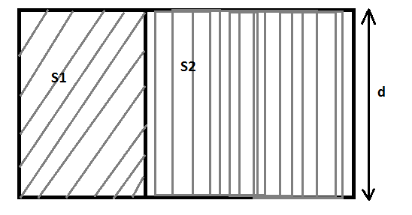
Q3. Formulate /Derive modified ampere’s Circuital law.

Q4. Test whether given equations satisfies the Laplace’s equation or not?
- $V=r\sin{∅}+z$
- $V={4x}^{3}+3y-{4z}^{2}$
Q5. Derive equations of Capacitance for Spherical Capacitor.

Batch B3:
Q1. The Region-1 is described by $μ_{r1}=3$ for x<0 and the other side $μ_{r2}=2.6$. The Magnetic field intensity at interface in region-1 is
$\vec{H}={4\hat{a}}_{x}+3{\hat{a}}_{y}-6{\hat{a}}_{z} A/m$ , Find ${\vec{H}}_{2}$ and $θ_{2}$.
Q2. Explain high dielectric constant material.
Q3. Write short on:
- Current continuity equation
- Point form of Ohm’s Law
Q4. Derive Poisson’s and Laplace’s equation. One dimensional Laplace’s equation is $\frac{∂^{2}V}{{∂x}^{2}}=0$, the boundary conditions are V=9 at x=1 and V=0 at x=10. Find the potential and show the variation with respect to x.
Q5. Formulate /Derive Faraday’s Law in point form and integral form.

Subject In charge
(Prof. Raees Ahmad)

