Auto Irrigation Using Soil Moisture Sensor

The project is intended to provide proper amount of irrigation to agricultural fields by observing the moisture content of soil. The project automates the process of manually irrigating the fields by switching the pump ON/OFF. It is implemented by using an 8051 series microcontroller, programmed such as to collect input signals that measures moisture content of soil through sensing arrangement. Sensing arrangement is made by inserting two stiff metallic rods into the field at some distance. An op-amp is used as a comparator that interfaces microcontroller and the sensing arrangement. On receiving the signal, the microcontroller produces an output that drives a relay and operates the water pump. Also LCD is used which is interfaced with microcontroller for displaying the moisture content of soil and water pump status. Hence the system reduces human intervention and provides required irrigation to field.
The concept in future can be enhanced by integrating GSM technology, such that whenever the water pump switches ON/OFF, an SMS is delivered to the concerned person regarding the status of the pump. We can also control the pump through SMS.

Block Diagram:

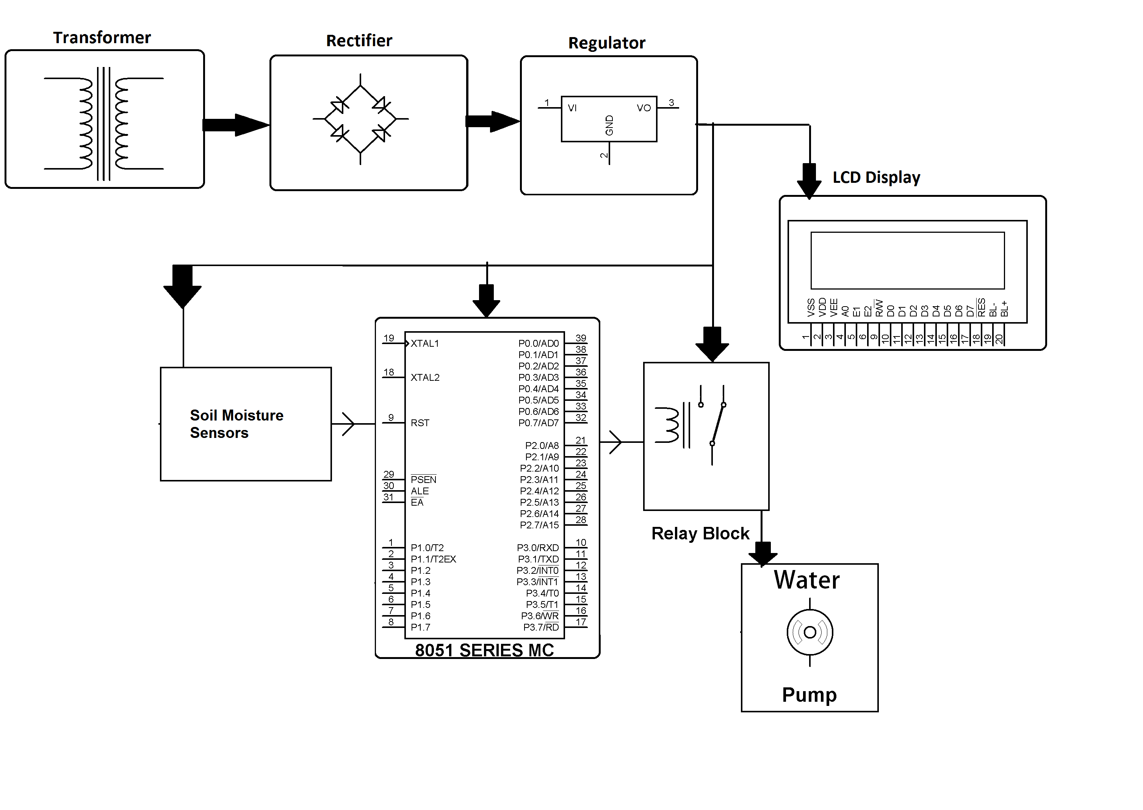

Hardware Specifications
- 8051 series Microcontroller
- Soil Moisture Sensors
- Diodes
- Op amp
- Crystal
- Water Pump
- LCD
- Relay
- LED
- Voltage Regulator
- Transistor

Software Specifications
- Keil µVision IDE
- MC Programming Language: Embedded C

