**A PROJECT REPORT ON**

# Ipo and sme details

**SUBMITTED TO :**

**Geetanjali Group of Colleges**

**FRONT END :**

ASP.NET

**BACK END :**

SQL SERVER

**AFFILIATED BY :**

Saurashtra University

**ACADEMIC YEAR :**

2024-2025

**PROJECT GUIDE :**

**Prof. Malay Dave**

**PREPARED BY :**

**Tankariya Brijesh Jayeshbhai**

**Acknowledgement**

• First of all we are sincerely thanked to Saurashtra University for giving a project as a particular subject.

• I am also greatly grateful to our Geetanjali Group of colleges.

• I am also greatly grateful to our college. We would like to thanks Prof. Brijesh Shah (HOD) for providing us opportunity to prepare this project.

• To complete this project many persons help me. But I am specially thanked to Prof. Malay Dave for guiding my project analysis and development. They help me conceptualized the idea of the project and also helped me in streamline my work by providing me every facility required

• Not only college and guide help me but all the well wisher who gives me excellent support in during project.

• Thank to all.

Your Faith Fully,

Tankariya Brijesh Jayeshbhai

**Preface**

* In 21st Century of Technology, Computer and related service is the most useful, automatic and highly speed of work. B.C.A is course in which practical aspect is important as theoretical aspect. In the present world importance of education is increasing. The project training in a student’s life is like a live experience in the industry. If we have experience then & then we get top of the level.
* Most Important Factor of B.C.A Course is Project Work. The Project Work is Must for Every Student in Different Government or Private Organization during the Study Period.
* I am developing project in 6th Semester of B.C.A I am the student of Geetanjali Group of Colleges Is Affiliated with Saurashtra University, Rajkot.
* I am create this project dynamic and in this project we provide insert and delete operation on admin side and select at client side so user can easily show site. In client side only user review can add other any page can’t perform add operation.
* I have gone through and study necessary information, which is collected and presented in this report. I am trying my best in this project.I have taken almost care that are information provided in the project is true and project is in a smooth running condition and error free.

**Index**

|  |  |  |
| --- | --- | --- |
| **SR.NO** | **TOPIC NAME** | **PAGE NO.** |
| 1 | Project Profile | 5 |
| 2 | Software development life cycle | 6 |
| 3 | Project Requirement | 7 |
| 4 | Technology Requirement | 8 |
| 5 | E-R Diagram | 9 |
| 6 | Data Flow Diagram | 10 |
| 7 | Data Dictionary | 11 |
| 8 | Testcases | 13 |
| 9 | Screenshots | 14 |
| 10 | Future enhancement | 28 |
| 11 | Limitation of project | 29 |
| 12 | Webliography | 30 |
| 13 | Bibliography | 31 |

**Project Profile**

### Project Title :- Ipoandsmedetails

* Development Software :- Visual Studio 2022
* Front End :- ASP.NET
* Back End :- SQL Server
* Academic Year :- 2024-2025
* Developed By :- Tankariya Brijesh Jayeshbhai
* Submitted To :- Geetanjali group of Colleges
* Documentation Tool :- Microsoft Word
* Operating System :- Windows 10

**Software Development Life Cycle**

* Planning and Project Initiation:

Define the purpose and goals of the "ipoandsmedetails" website.

Identify the target audience and their specific needs.

Create a project charter or initiation document.

* Requirements Gathering:

Collect detailed requirements for the website.

Identify the data and content to be displayed.

* System Design:

Create a high-level architecture and system design.

Develop wireframes or prototypes to visualize the website's layout and user interface.

Define the database structure and data models.

Plan for scalability, security, and data privacy.

* Testing:

Perform unit testing to validate individual components and functions.

Conduct integration testing to ensure different modules work together seamlessly.

* Deployment:

Prepare the production environment for hosting the website.

* Maintenance:

Continuously monitor the website's performance, security, and user feedback.

**Project Requirement**

* **Processor :** 8 Bit, 2 core, 1.2 GHz or higher.
* **Ram :** 4GB for development and evaluation use or more.
* **Hard Disk :** 100 MB or More

**Technology Requirement**

* **Platform :** 8 Bit, 2 core, 1.2 GHz or higher.
* **Operating System :** Windows 10 or any
* **Front End Tool :** ASP.NET
* **Back End Tool :**. SQL Server
* **Editing Tool :** Microsoft visual studio 2022
* **Browser :** Internet Explorer or Mozilla Firefox or Google Chrome or Any browser

**E-R Diagram**

An entity Relationship Diagram (ERD) is a data modeling technique that graphically illustrates an information system’s entities and the relationship between those entities . An ERD is a conceptual and representation model of data used to represent the entity from work infrastructure .

Home Page

Admin Page

**Data Flow Diagram**

* **Admin Side :**

Insert Ipo Data

Insert Sme Data

Insert Gmp

Login

Insert Subscription

Insert Company Details

Insert Ipo And Sme Review

Insert Market News

Admin

**Data Dictionary**

Database Tables :

• Ipo

• Sme

• Gmp

• Subscription

• Companydetails

• Ipoandsmereview

• Marketnews

**Ipo :**

|  |  |  |
| --- | --- | --- |
| **Column Name** | **Data Type** | **Constraints** |
| Company Name | nvarchar(50) | **-** |
| Price | nvarchar(50) | **-** |
| Open Date | nvarchar(50) | **-** |
| Close Date | nvarchar(50) | **-** |
| Allotment Date | nvarchar(50) | **-** |
| Listing Date | nvarchar(50) | **-** |

**Sme :**

|  |  |  |
| --- | --- | --- |
| **Column Name** | **Data Type** | **Constraints** |
| Company Name | nvarchar(50) | **-** |
| Price | nvarchar(50) | **-** |
| Open Date | nvarchar(50) | **-** |
| Close Date | nvarchar(50) | **-** |
| Allotment Date | nvarchar(50) | **-** |
| Listing Date | nvarchar(50) | **-** |

**Gmp :**

|  |  |  |
| --- | --- | --- |
| **Column Name** | **Data Type** | **Constraints** |
| Company Name | nvarchar(50) | **-** |
| Gmp | nvarchar(50) | **-** |

**Subscription :**

|  |  |  |
| --- | --- | --- |
| **Column Name** | **Data Type** | **Constraints** |
| Company Name | nvarchar(50) | **-** |
| Qib | nvarchar(50) | **-** |
| Nii | nvarchar(50) | **-** |
| Retailers | nvarchar(50) | **-** |
| Total | nvarchar(50) | **-** |

**Companydetails :**

|  |  |  |
| --- | --- | --- |
| **Column Name** | **Data Type** | **Constraints** |
| Company Name | nvarchar(50) | **-** |
| Company Details | nvarchar(50) | **-** |

**Ipoandsmereview :**

|  |  |  |
| --- | --- | --- |
| **Column Name** | **Data Type** | **Constraints** |
| Company Name | nvarchar(50) | **-** |
| Review | nvarchar(50) | **-** |

**Marketnews :**

|  |  |  |
| --- | --- | --- |
| **Column Name** | **Data Type** | **Constraints** |
| id | int | Primary Key |
| Market News | nvarchar(50) | **-** |

**Test Cases**

|  |  |  |  |
| --- | --- | --- | --- |
| **Case Name** | **Case Description** | **Actual Output** | **Test Result** |
| Login | A window with a two textbox username and password. | Write correct username and password and login successfully. | Pass |
| Dashboard | A page that use to insert data. | A page that use to insert whole website data. | Pass |
| HomePage | A Page that dispay database content**.** | A page that display all ipo and sme informations. | Pass |

**Screen Shots**

**Home Page :**

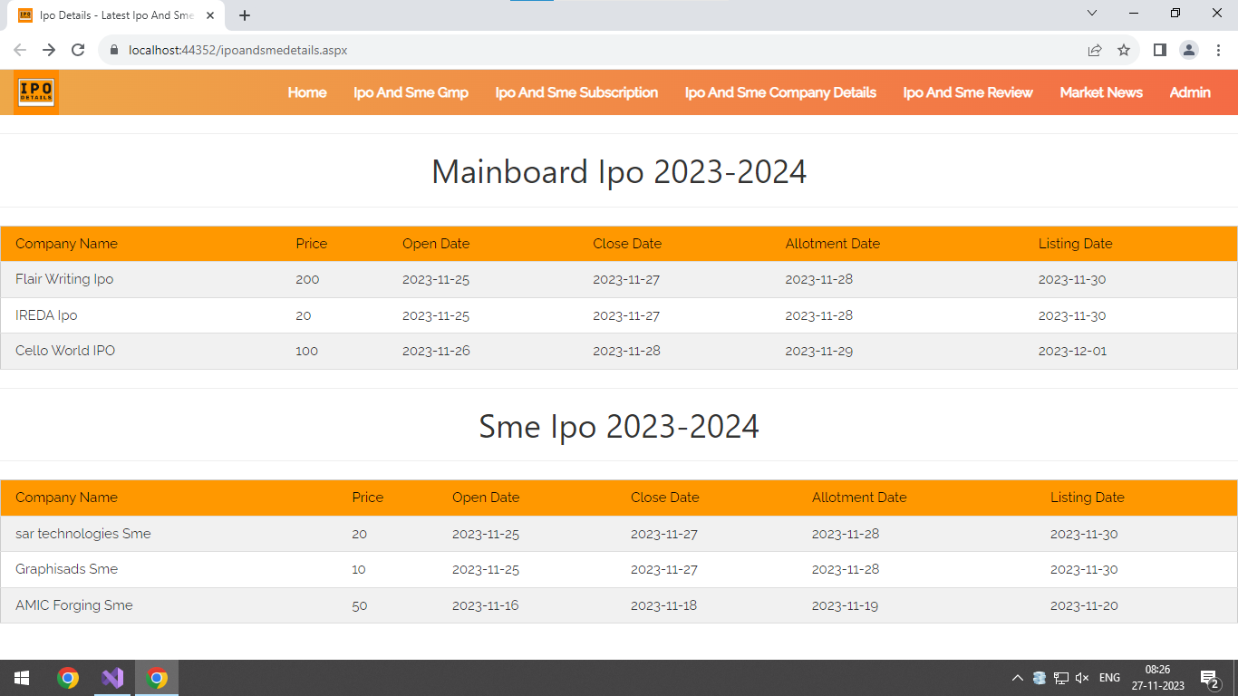

* This is home page of website.
* User can see all the ipo and sme details here like company name,price,open date,close date,allotment date and listing date.

**Gmp Page :**

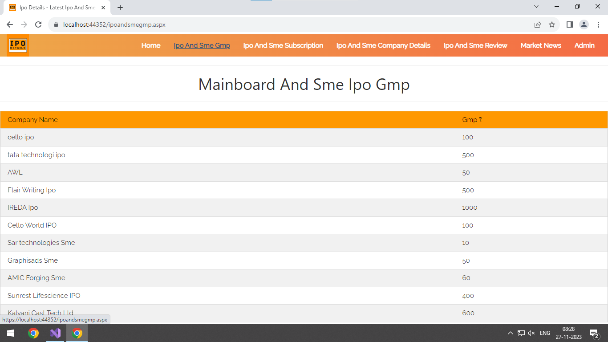

* This is Gmp page of website.
* User can see all the ipo and sme Gmp here.

**Subscription Page :**

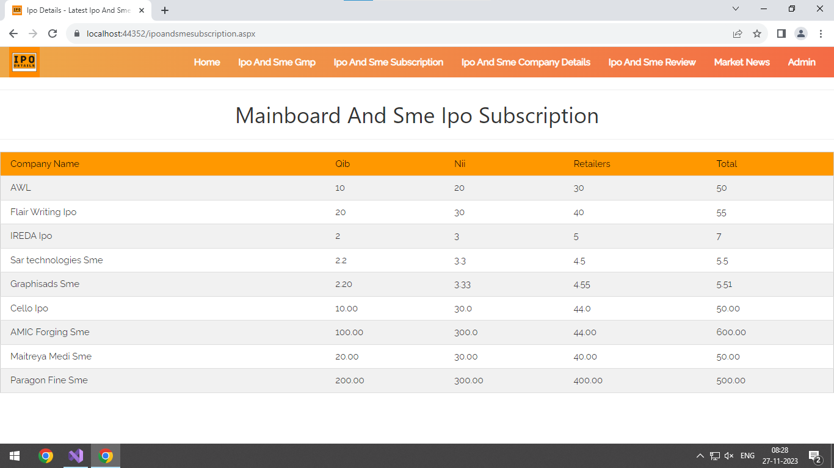

* This is subscription page of website.
* User can see all the ipo and sme Subscription here.

**Company Data Page :**

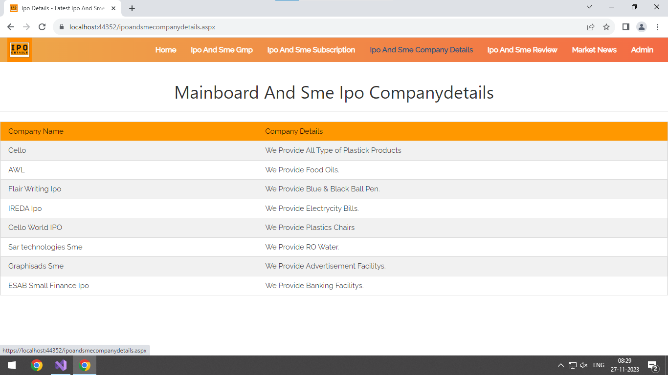

* This is companydetails page.
* User can see ipo and sme company details.

**Review Page :**

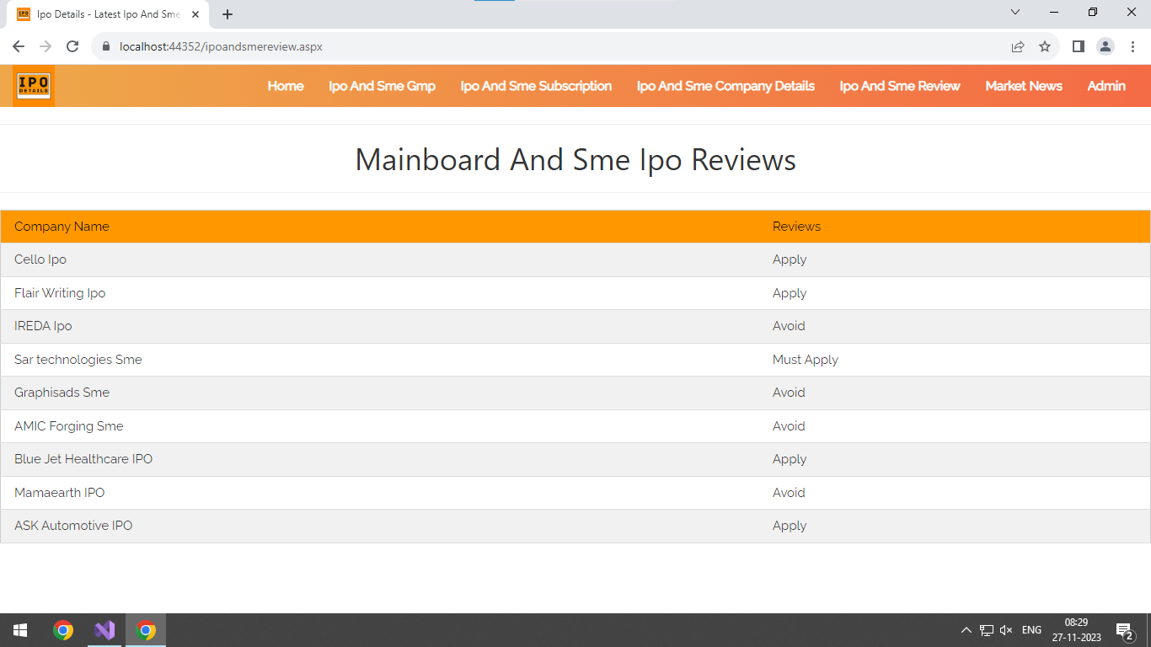

* This is review page.
* User can see ipo and sme reviews here.

**Market News Page :**

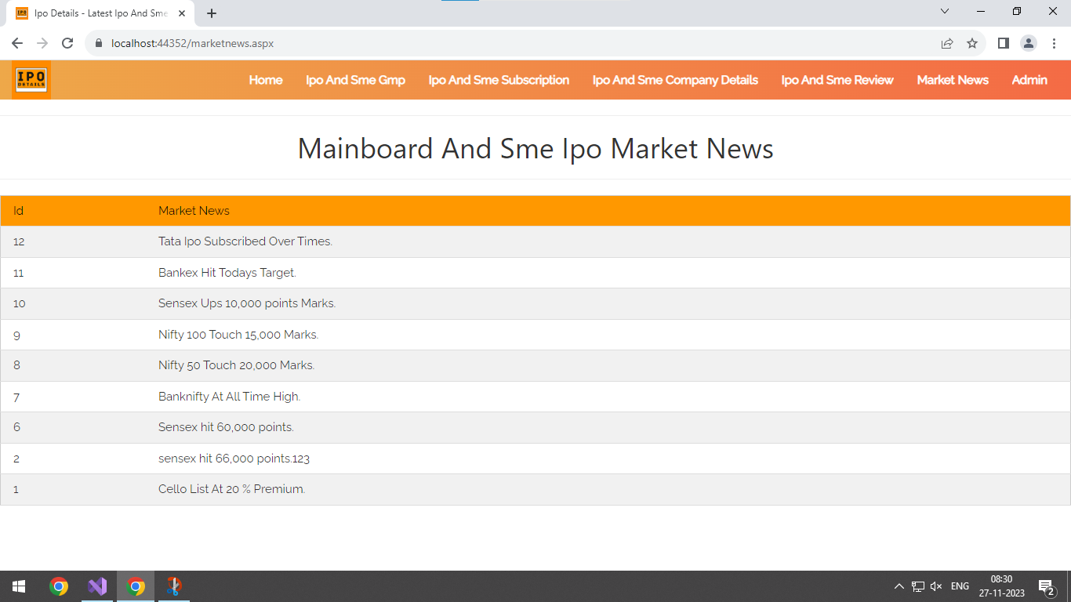

* This is market news page.
* User can see market news here.

**Admin Login Page :**

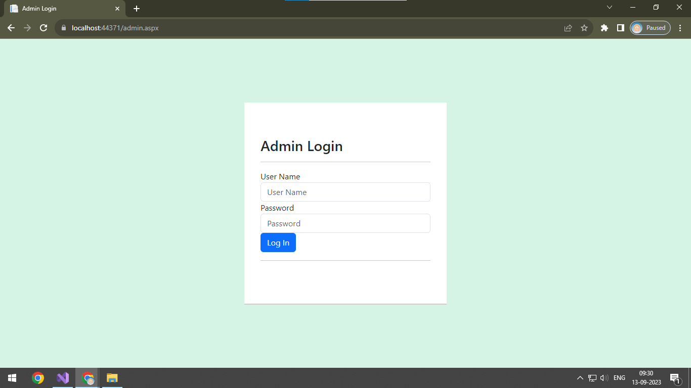

* This is admin login page.
* Type correct username, password and login to admin side.

**Admin Panel :-**

**Ipo data page :**

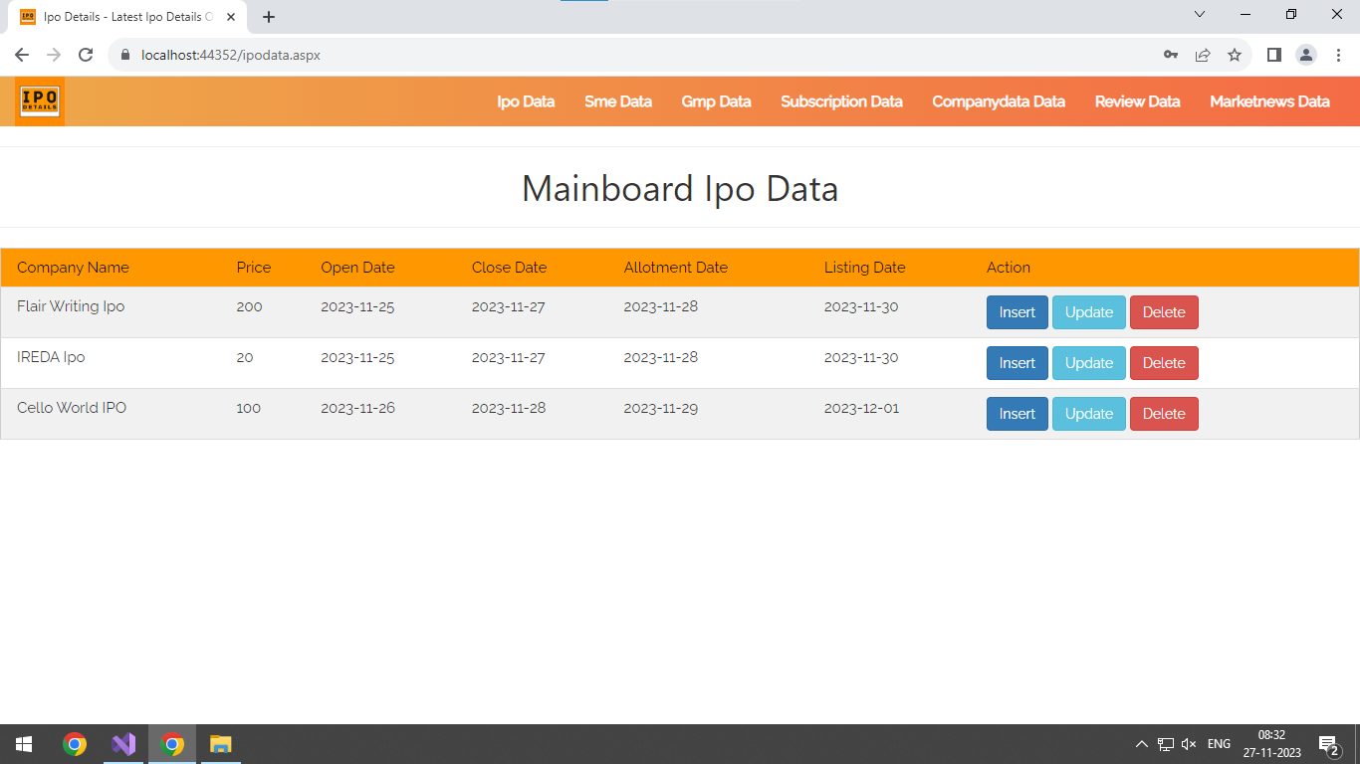

* This page is used for insert, update and delete ipo data.
* Admin can add company name, price, open date, close date, allotment date and listing date from here.
* Admin can delete ipo data from here.

**Sme data page :**

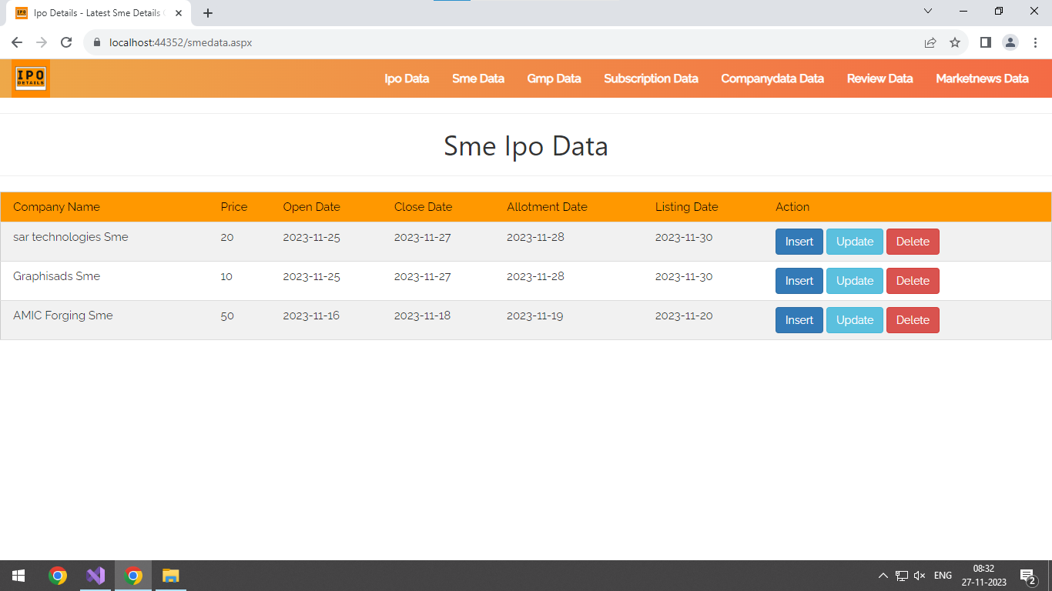

* This page is used for insert,update and delete sme data.
* Admin can add company name, price, open date, close date, allotment date and listing date from here.
* Admin can delete sme data from here.

**Gmp data page :**

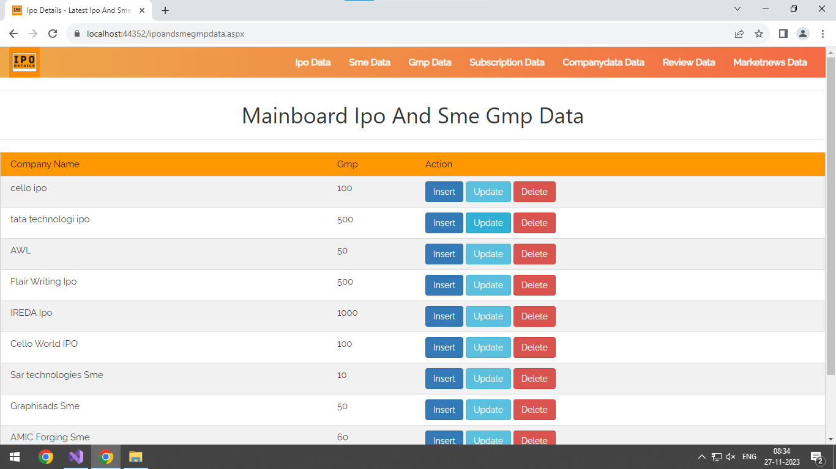

* This page is used for insert,update and delete gmp data.
* Admin can add company name and gmp from here.
* Admin can delete gmp data from here.

**Susbcription data page :**

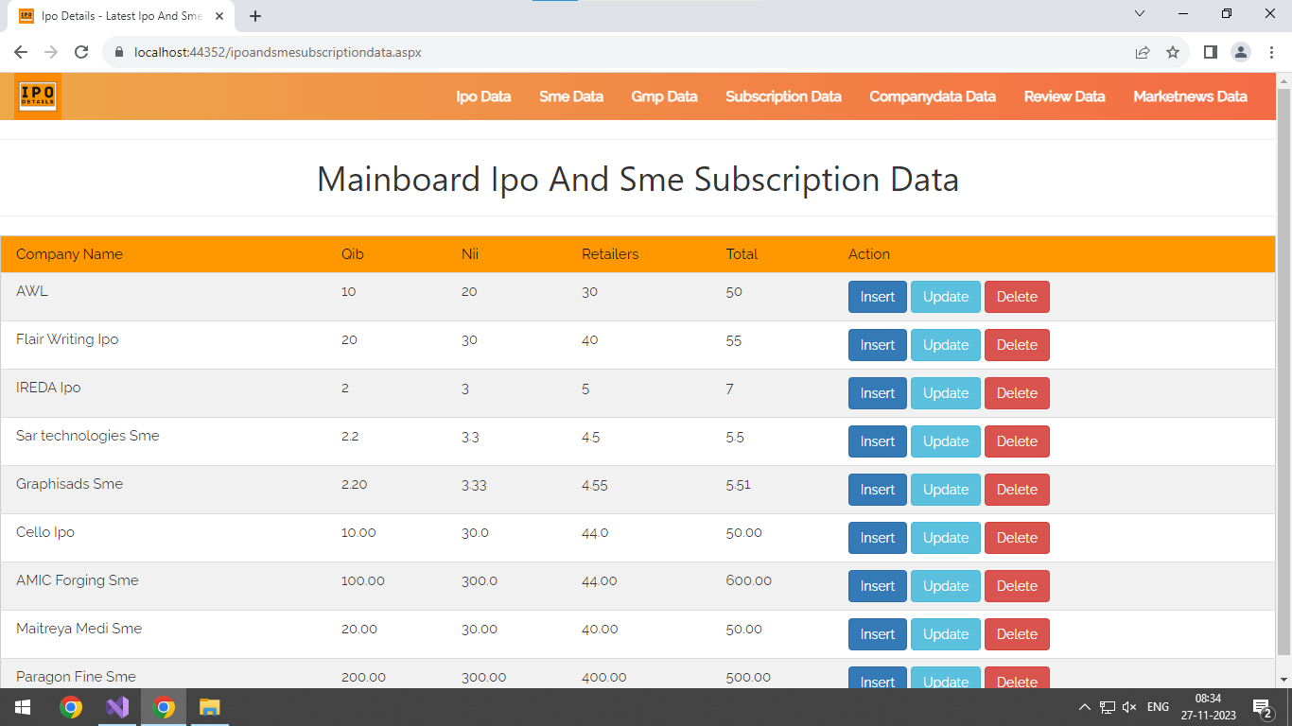

* This page is used for insert,update and delete subscription data.
* Admin can add company name, qib data, nii data, retailers data and total subscription from here.
* Admin can delete subscription data from here.

**Company data page :**

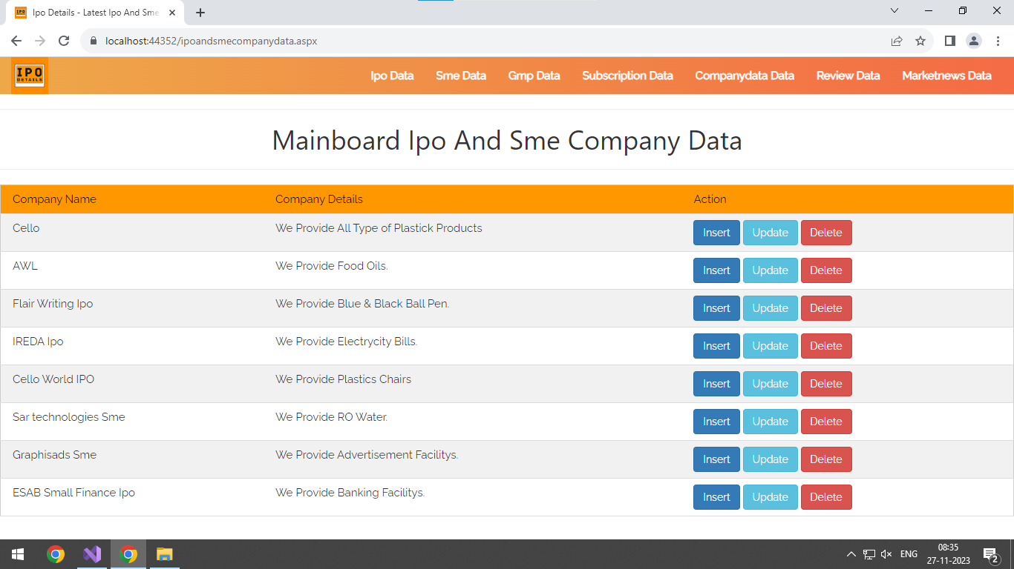

* This page is used for insert,update and delete company data.
* Admin can add company name and company details from here.
* Admin can delete company data from here.

**Review data page :**

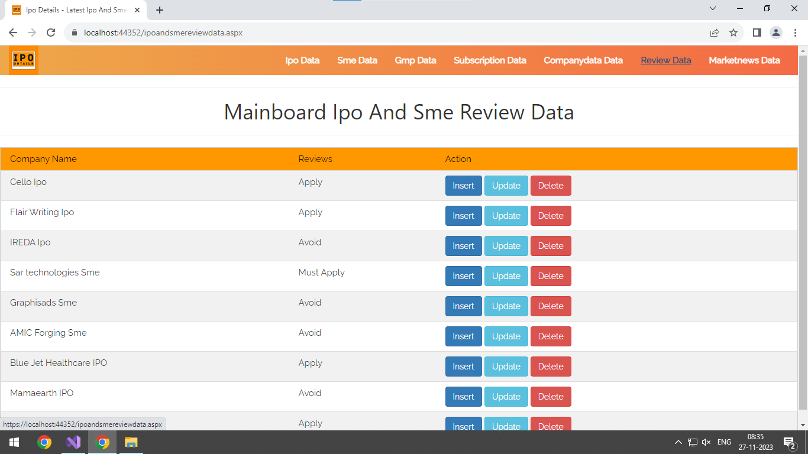

* This page is used for insert,update and delete ipo and sme review data.
* Admin can add company name and review from here.
* Admin can delete review from here.

**Insert market news data page :**

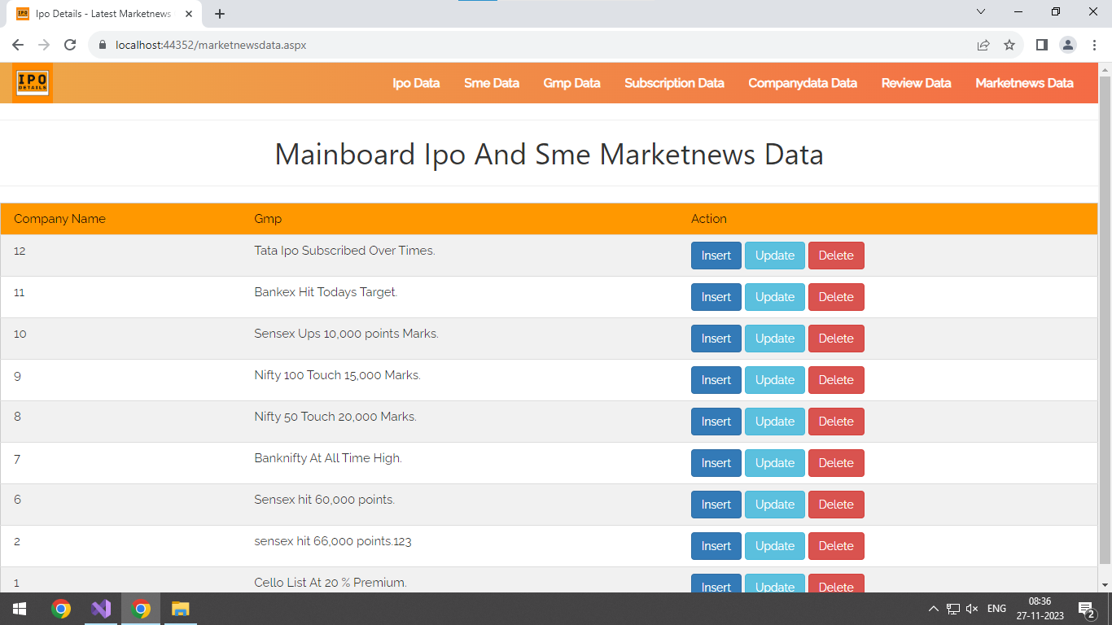

* This page is used for insert,update and delete market news data.
* Admin can add date and market news from here.
* Admin can delete market news from here.

**Future Enhancement**

* We will provide facility to user can directly apply ipo and sme from

our website.

* We will provide facility to user can check their ipo and sme allotment

status from our website.

**Limitations Of Project**

* Data not perfect refresh.
* Live ipo and sme subscription is not available.

**Webliography**

* [Bootstrap · The most popular HTML, CSS, and JS library in the world. (getbootstrap.com)](https://getbootstrap.com/)
* [W3Schools Online Web Tutorials](https://www.w3schools.com/)
* [IPO Dashboard (Main board IPO at BSE and NSE) (chittorgarh.com)](https://www.chittorgarh.com/ipo/ipo_dashboard.asp)

**Bibliography**

* ASP.NET – Wrox Publication
* Pro ASP.NET Core Mvc 2 Book By Adam Freeman