Flask and MongoDB Assignment
Student Information
Name: Brijesh Panchal
Course: DevOps
Assignment: Flask and MongoDB
Date: 20 September 2026

Task 1: JSON API Route
- Create a Flask application with an /api route. When this route is accessed, it should return a JSON list. The data should be stored in a backend file, read from it, and sent as a response.
Ans: Open http://localhost:5000/api
You should see data like:
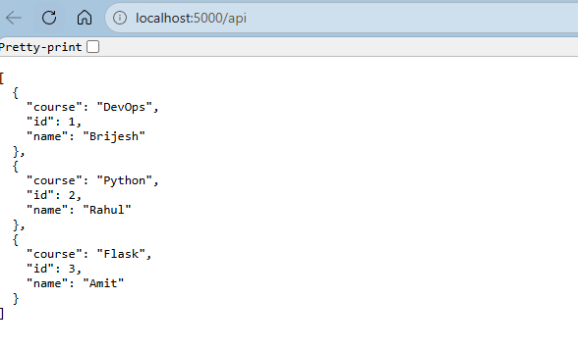
We have created below code to view api page. It will load data from the data.json file.
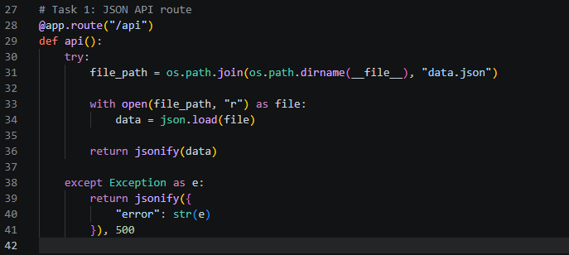

Task 2: Frontend Form with MongoDB Atlas
- Create a form on the frontend that, when submitted, inserts data into MongoDB Atlas.
Ans: we have home/default page with (/). That is rendering index.html page.
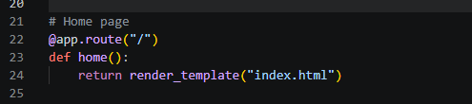
- Run the project on http://localhost:5000/ and enter the data Name, Email and Course.
from the below page.
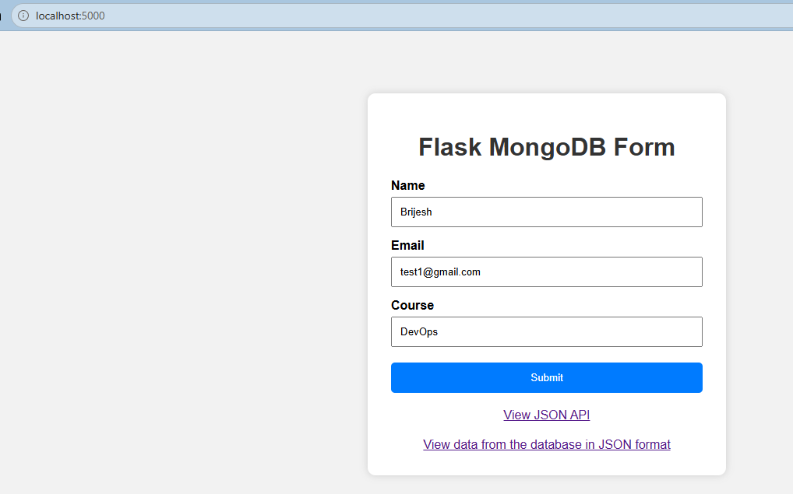
- Fill the data and click on submit. And you will see the message like: Data submitted successfully.
- 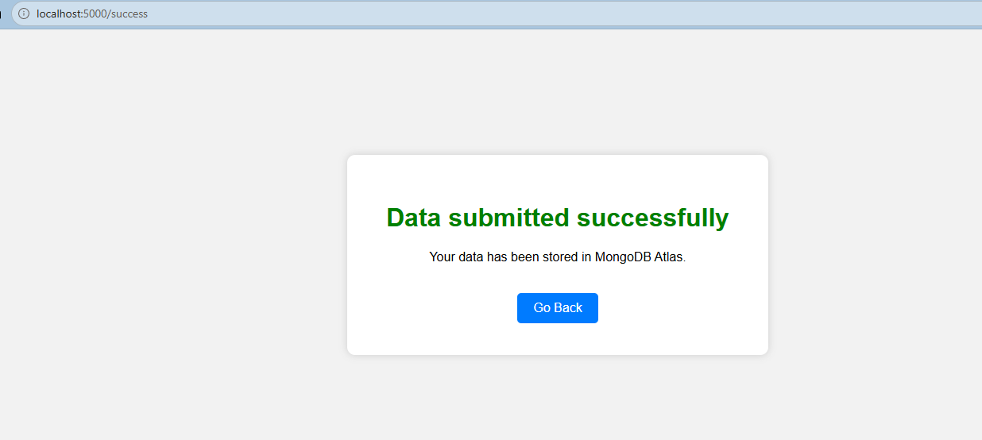
- And this time the url would be Success page. Also it will insert data on the mongodb database.
- 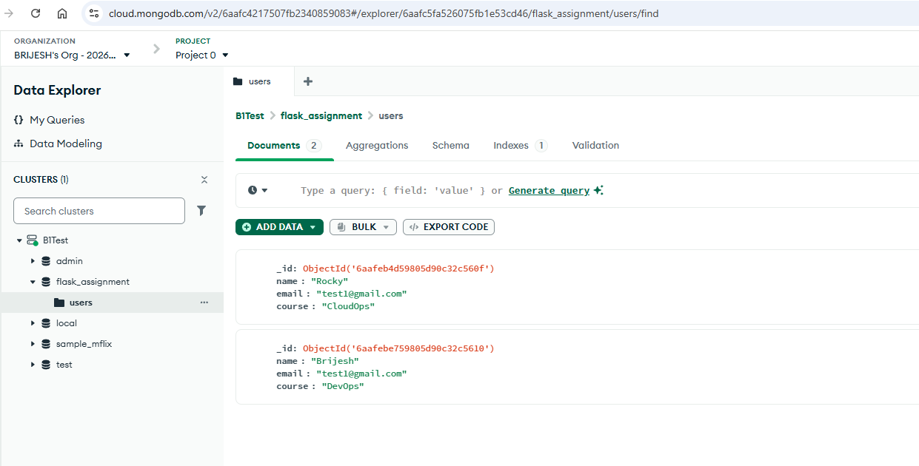

- On success: the user should be redirected to another page displaying the message “Data submitted successfully”.
Ans:
- On submit click you will see the message like: Data submitted successfully.
- On submission it will required all the 3 input textbox. Required filed validation is done by below code. Under app.py >> /submit route.
- 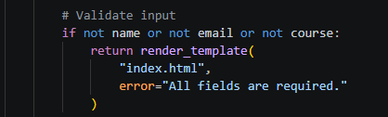
- 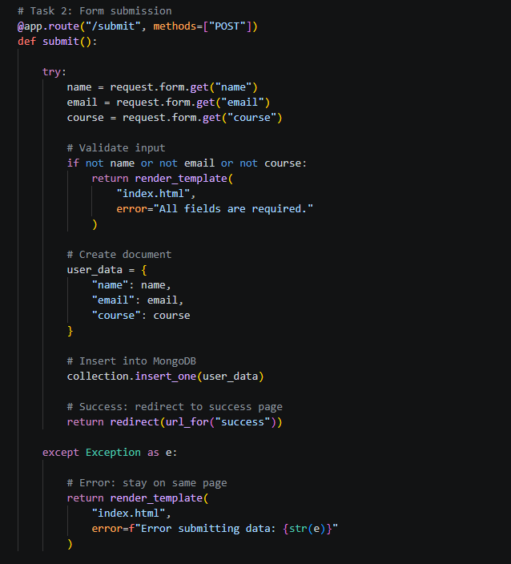

- On error: display the error on the same page without redirection.
Ans:
- When we click on submit button without filling data. It will give message like All Fields are required message.
- On submission it will be required all the 3-input textbox. Required filed validation is done by below code. Under app.py >> /submit route.
- Output:
- 