# **Unsupervised learning**

* In the case of both classification and regression problems, we are trying to find a function that is used to predict yi when xis are given as the input. Both of these are supervised learning problems, where the models are trained with a target variable.
* The basic and simplest definition of Unsupervised learning is:
  + Unsupervised learning uses machine learning algorithms to analyze and cluster unlabeled data sets.
  + These algorithms discover hidden patterns in data without the need for human intervention (hence, they are “unsupervised”).
* Unsupervised learning deals with data that is unlabelled or hasn’t a target variable.

# **Clustering**

* The process of grouping any kind of data based on the similarity in their features, automatically, without human expertise, is called **clustering**. It is a type of **unsupervised learning**.
* Intuitively, clustering is dividing a population into groups such that the points in one group are similar to each other. Each group is called a **cluster**.
  + The points in the same cluster are more closer and similar to each other.
  + The points in different clusters are more distant and distinct from each other.
* So, the task in clustering is grouping the points of a similar kind based on our definition of similarity. For example,

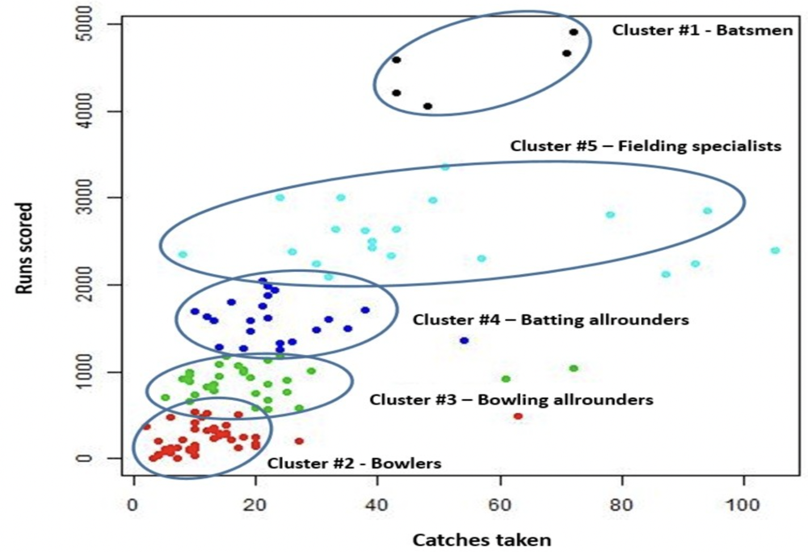

In the image, we can see clusters of different kind of players on the basis of runs scored and catch taken.

* Since there is no ground truth data and nothing to compare with, we decide if a cluster is good or bad if it simply makes some **business sense.**
* The similarity in clustering can be defined as the closeness of data points with each other.
* **Similarity** can be measured using different distance metrics like euclidean distance, manhattan distance, and hamming distance.

**Distances used while clustering:**

* **Inter-cluste**r distance represents the distance between two clusters
  + Distance between average values of the clusters.
  + Distance between closest points from the clusters (min distance)
  + Distance between farthest points from the clusters (max distance)
* **Intra-cluster** distance represents the distance within a certain cluster. Basically, it measures how tightly the points of clusters are packed.
  + Average distance between the points of a cluster.
  + Distance between farthest points of a cluster

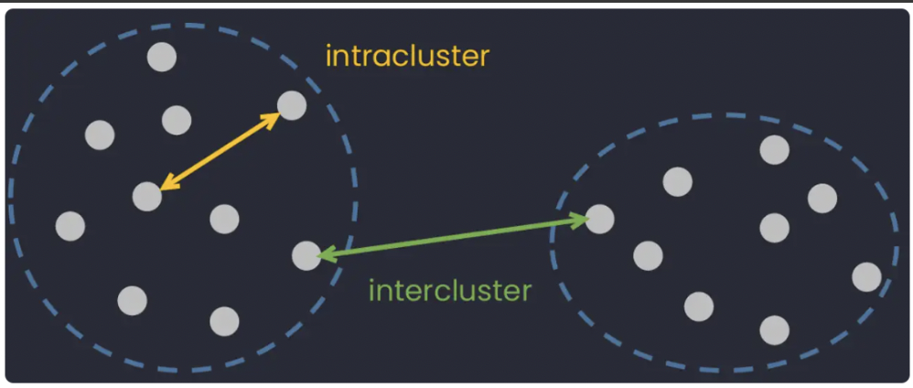

* Having only one inter or intra-cluster distance won’t tell us how good or bad our clusters therefore we need a metric to evaluate our clusters.

# **Introduction to K-Means**

* K-Means clustering is one of the most popular and simplest clustering algorithms. The value 'K' in the K-means algorithm denotes the number of clusters.
* In k-means data is divided into k clusters where each cluster has a centroid which is basically the average of all the points in the cluster.
* The centroid (Ci) of the cluster (Si) can be defined as

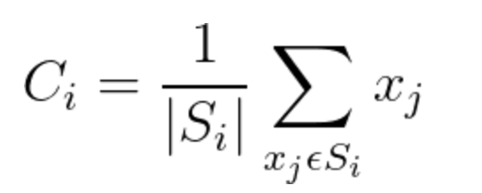, where |Si| represents the number of points belonging to the ith cluster.

* K-Means assign only one cluster to each point.
* In K-Means, we perform a certain number of iterations and in each iteration, we perform the following steps.
  + Every point is assigned to the cluster centroid closest to it.
  + Update the centroid.
  + Repeat the above two steps until convergence.

# **Lloyd’s algorithm (K-means algorithm)**

* This algorithm is used to cope with the problem of updating the centers.
* It has 4 basic steps:
* **Initialization**: Randomly initialize **k** centers from the dataset.

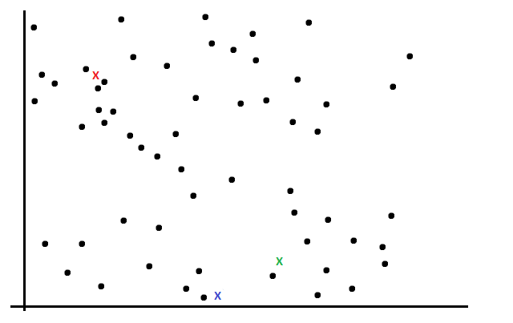

* **Assignment**: For each point, we find the distance of existing centroids from it and assign the point to that cluster whose centroid has the minimum distance.

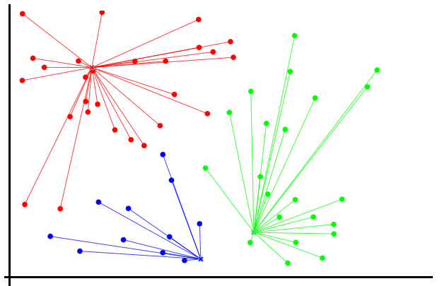

* **Update** the centroidsof the clusters by taking the average of points from each cluster.

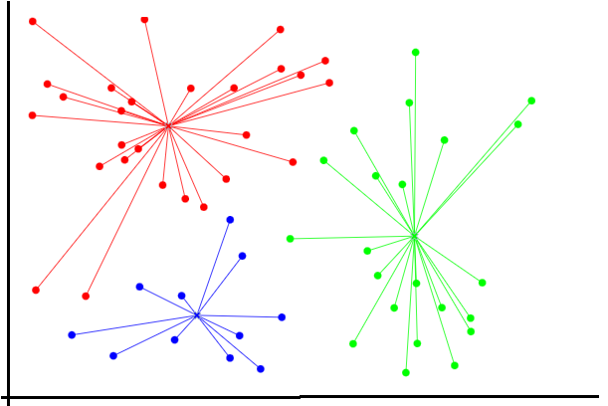

* Repeat the previous two steps until convergence (the center of new cluster centroids stops changing their positions).

**ANIMATION LINK:** <http://tech.nitoyon.com/en/blog/2013/11/07/k-means/>

# **Within-cluster sum of squares (WCSS)**

* The within-cluster sum of squares is a measure of the variability of the data points within each cluster. It is given as



where **xij** is the **jth** point belonging to the **ith** cluster and **mi** is the number of points in the **ith** cluster.

* A **variation** of the above formula can be as follows:



where, **d(xij, ci )** is representing a distance metric (any of euclidean, manhattan, etc.) that is calculating the distance between the point **xij** and the centroid **ci** of the cluster.

# **Elbow method**

* It is a method to determine the optimal number of clusters (**k**) for k-means clustering.
* We perform the k-means clustering for a range of values of **k** and for each iteration, we calculate the value of the WCSS metric.
* When the value of WCSS is plotted against a range of **k** values, we get a plot looking like an elbow.

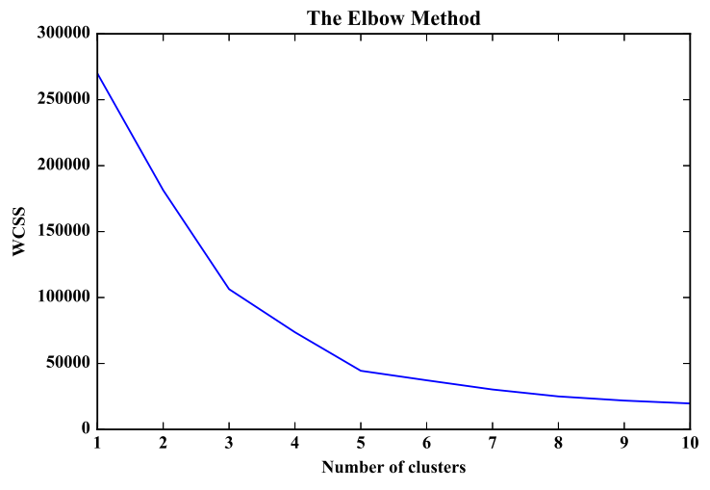

* We can clearly see that the WCSS value decreases as the number of clusters (k) increases.
* At some point on the graph, there is a sharp change in the slope (k = 5) after which the change in slope is very small. The k value corresponding to this point is the optimal K value or an **optimal** number of clusters.
* If we do not get a sharp change in the slope of the elbow plot while using the WCSS metric on the y-axis, we can try using the **Silhouette score** to get significant results or to get confidence in our decision.