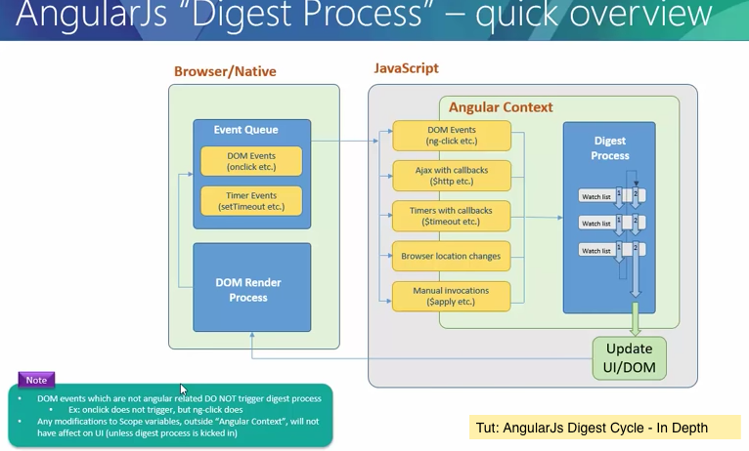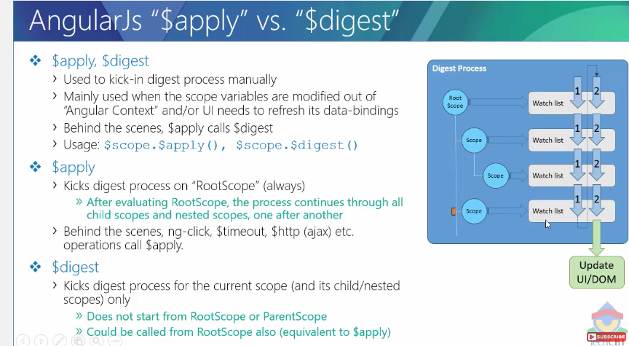

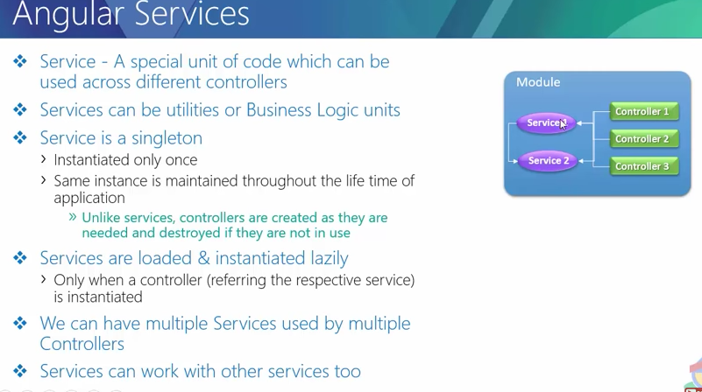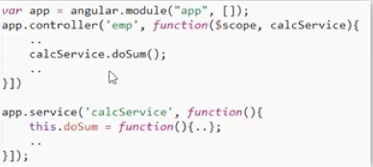

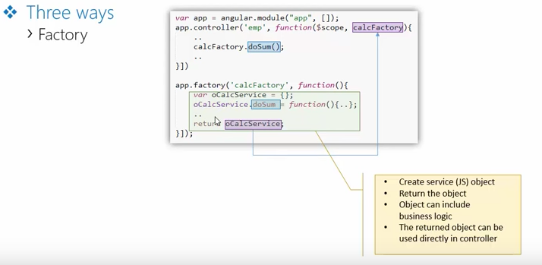

**Factory vs. service :**

1. in the factory you create object and return to controller , in otherway its our responsibility to create object and return .
2. In service, you don’t create object , you just create method with this object , angular framework take to create object while injection.