# Name: Brijesh Rohit

**Asmission n0.: U19CS009**

# CN Assignment – 8

# Make topologies depicting static routing and dynamic routing. Write down all the steps along with screenshot.

**Static Routing:**

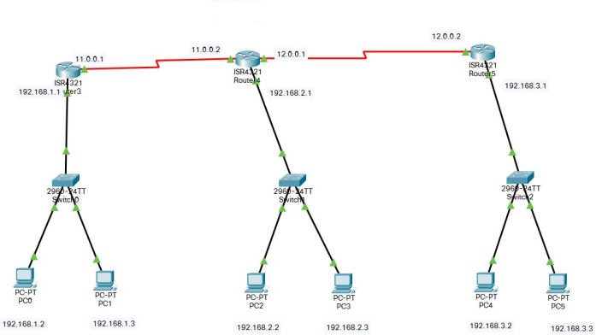

Create network shown in the above image. For that we require more than 2 ports in router but router has only 2 ports so we need to add ports in router.

# Adding port in router:

Turn off switch and then add NIM-2T to the router. It will increase ports in router. Now turn on the switch. Complete this procedure for all three routers. Then create network shown as above.

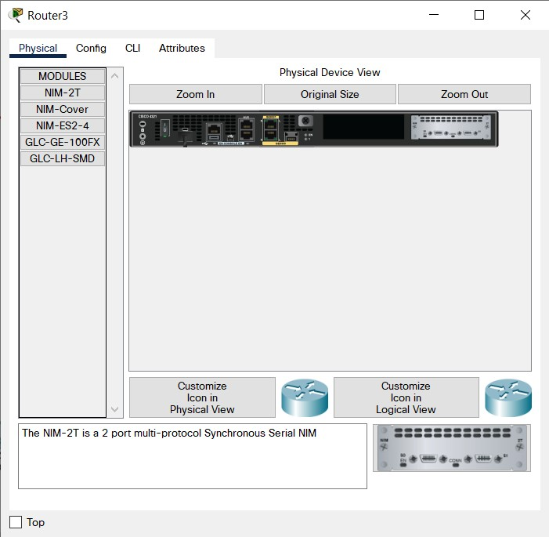

# Give IP address:

Give IP shown in 1st image to router. For that click on router and go to the config. Turn on port status and give the IPv4 address. Subnet mask will generate automatically. Do this for all connected ports of all the routers.

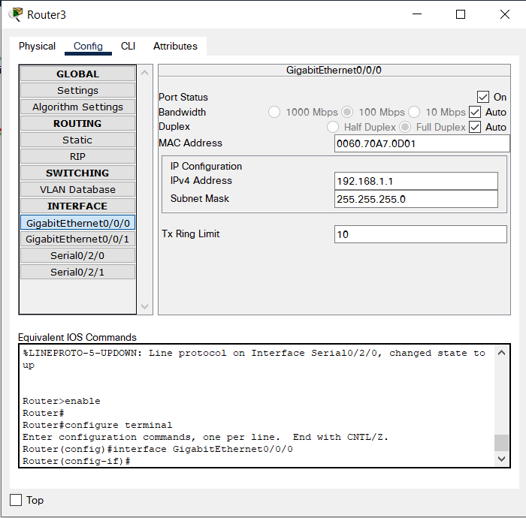

Now give IP address to all the pc connected to network. Also set default gateway of all the pcs.

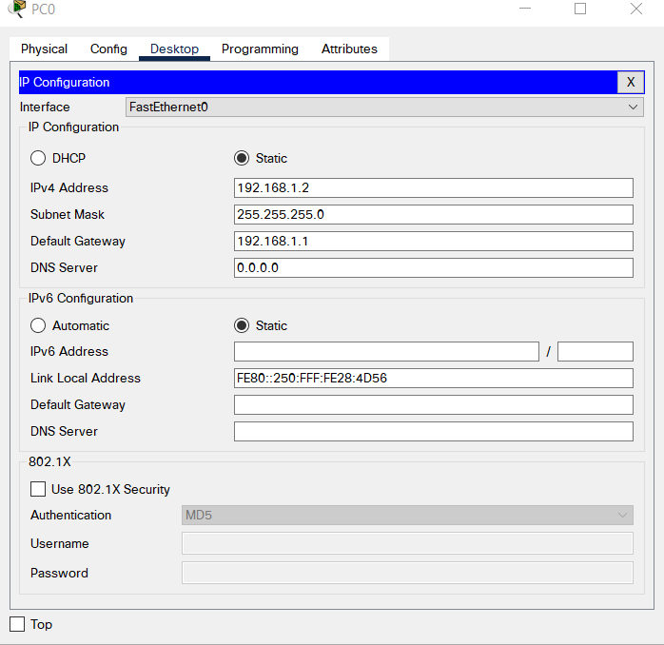

# Creating static routes:

Click on router and go to the static inside Config > Routing.

Add Network address mask and next hop address and add static route. Do this for all the static routes.

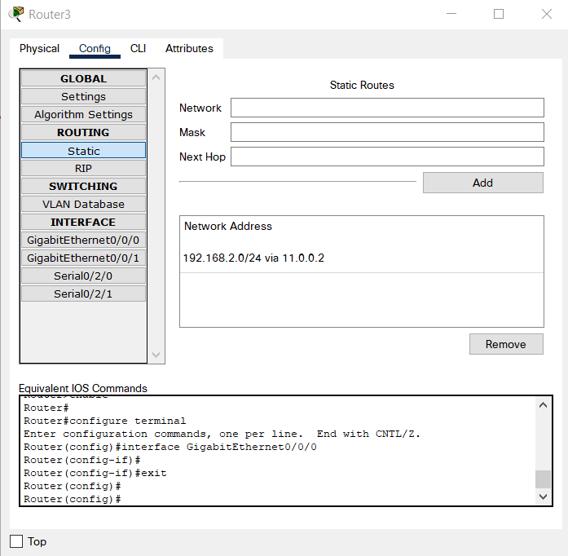

Now, as all the routes are done you can send package with in this network.

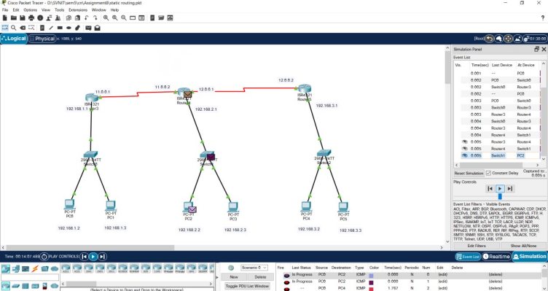

Sending package from PC0 to PC2.

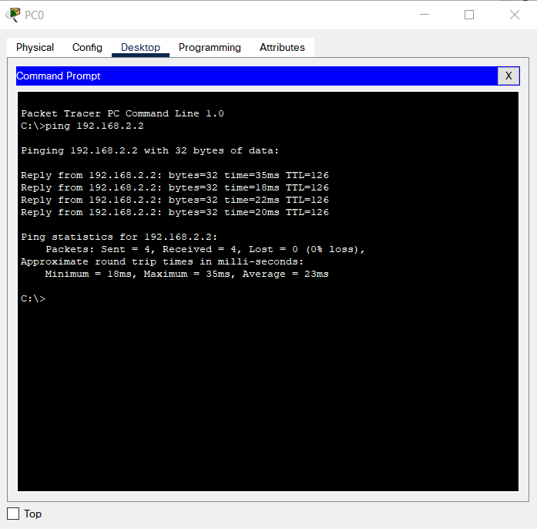

# Dynamic Routing:



Creating a network shown in above image.

# Adding Port to router:

Switch off router and add HWIC-2T to the router and switch on router. This will add 2 extra ports to the router. Do this for all routers.

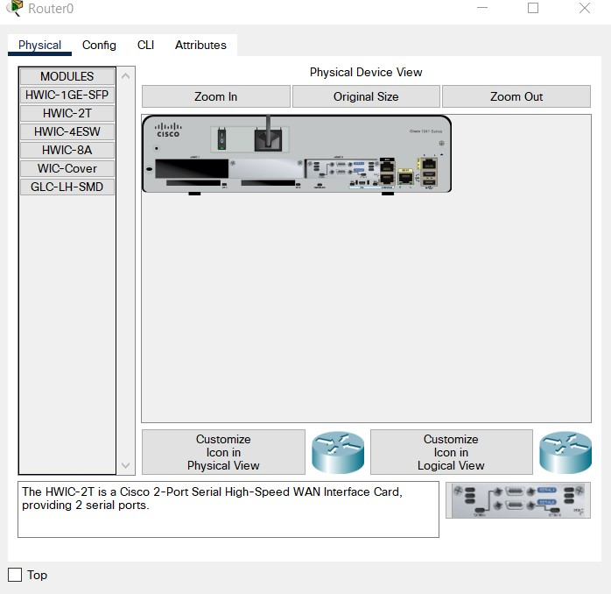

# Give IP address:

Click on router and go to Config. Set IPv4 address and turn on port status. Do this for all required ports of routers.

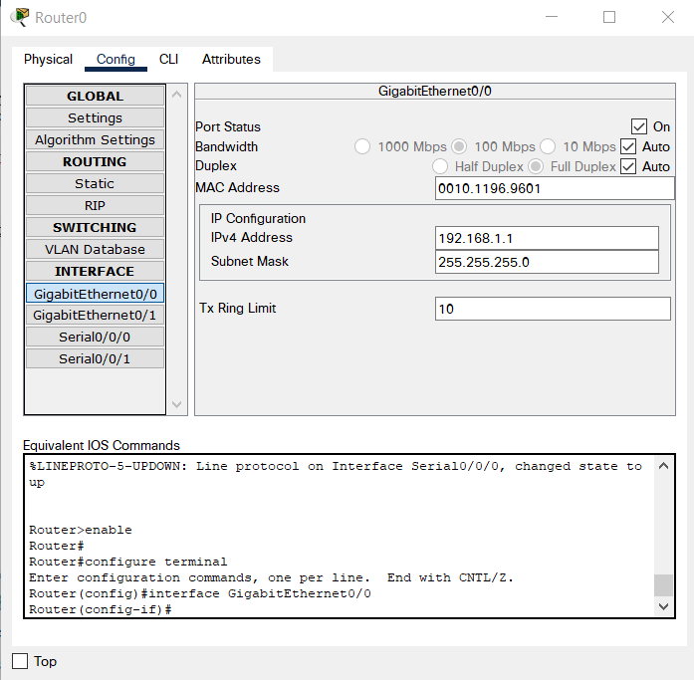

Now click on PC. Go to Desktop > IP Config and set IPv4 address. Also set default gateway.

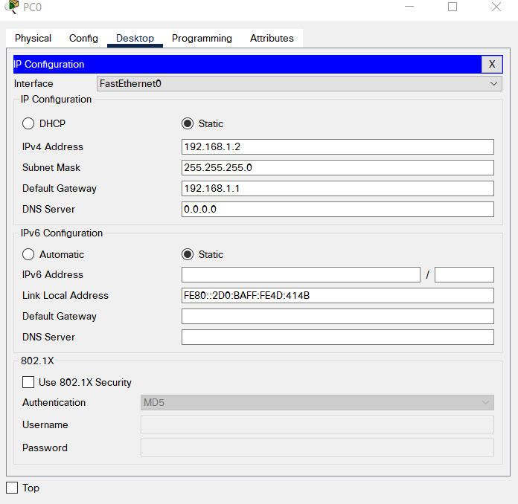

# Creating Dynamic Routes:

Click on router. Go to Config > Routing and add all the network address which are present in this network. Do this for all routers.

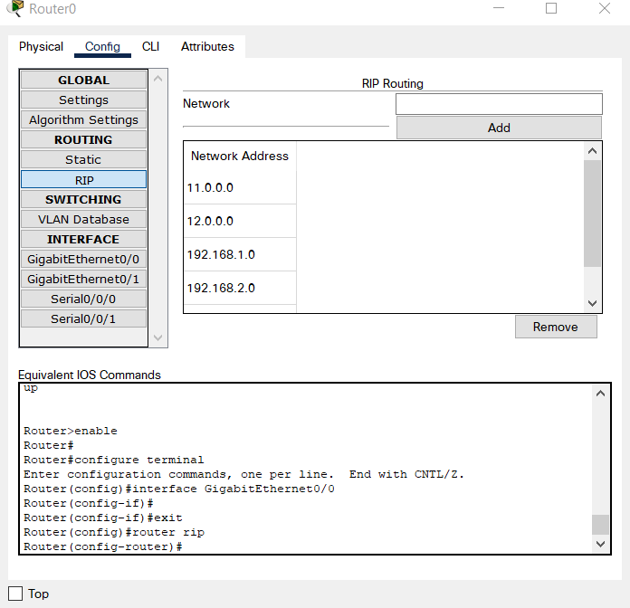

Now we can send packages within network.

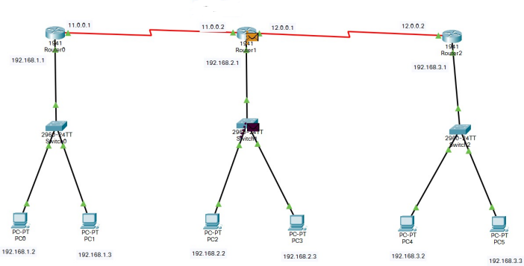

Sending package from PC0 to PC2.

