**Name : Brijesh Rameshbhai Rohit**

**Admission number : U19CS009**

**CN-ASSIGNMENT-09**

**Create Manual to create two network topologies.  
1. single network connected to one Router. Router should work as DHCP server and assign ip address.**

**=>**

1. **Layout**

Plot a simple network connecting to a single router as shown

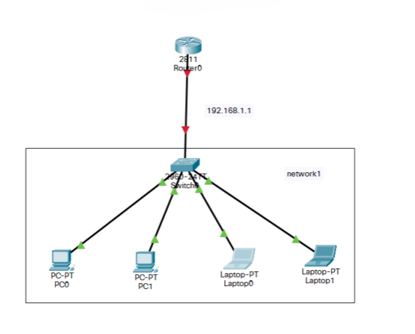

1. **IP configuration of Router**

Now set the IP of the Router connecting to the Network to 192.168.1.1 using GUI or CLI.

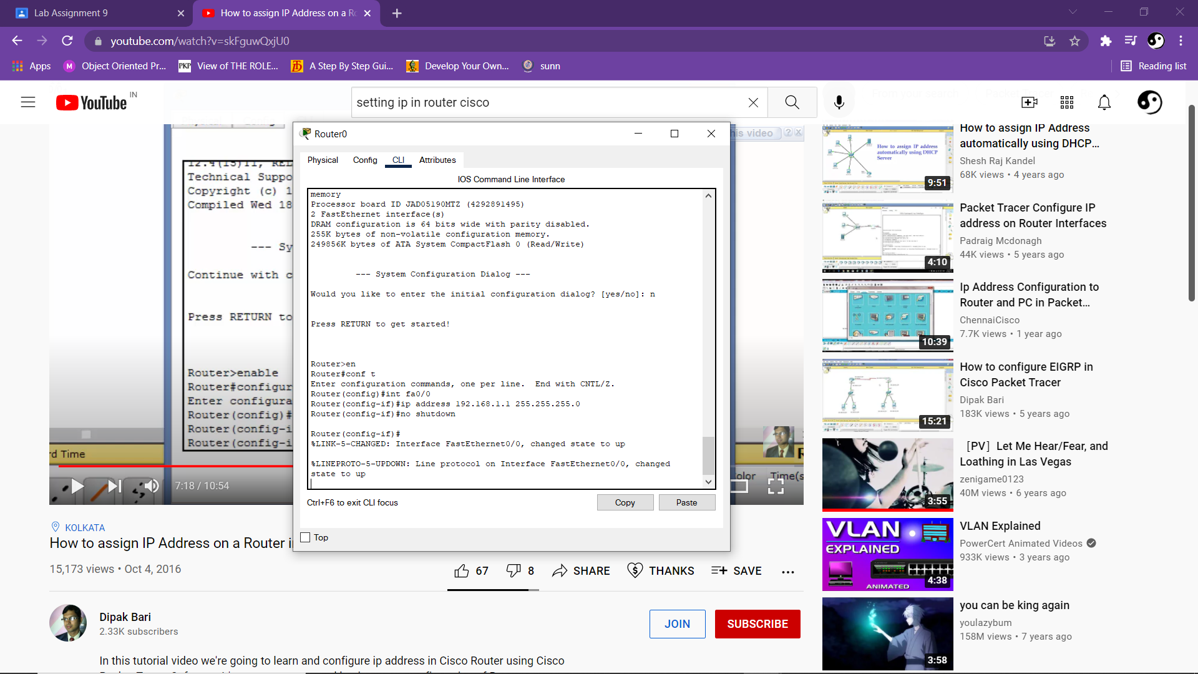

This would change the red marking on the connection between switch and router to green indicating that the connection is successful.

1. **DHCP configuration**

Now use the following command to create a DHCP pool with the network 192.168.1.1 and subnet mask 255.255.255.0

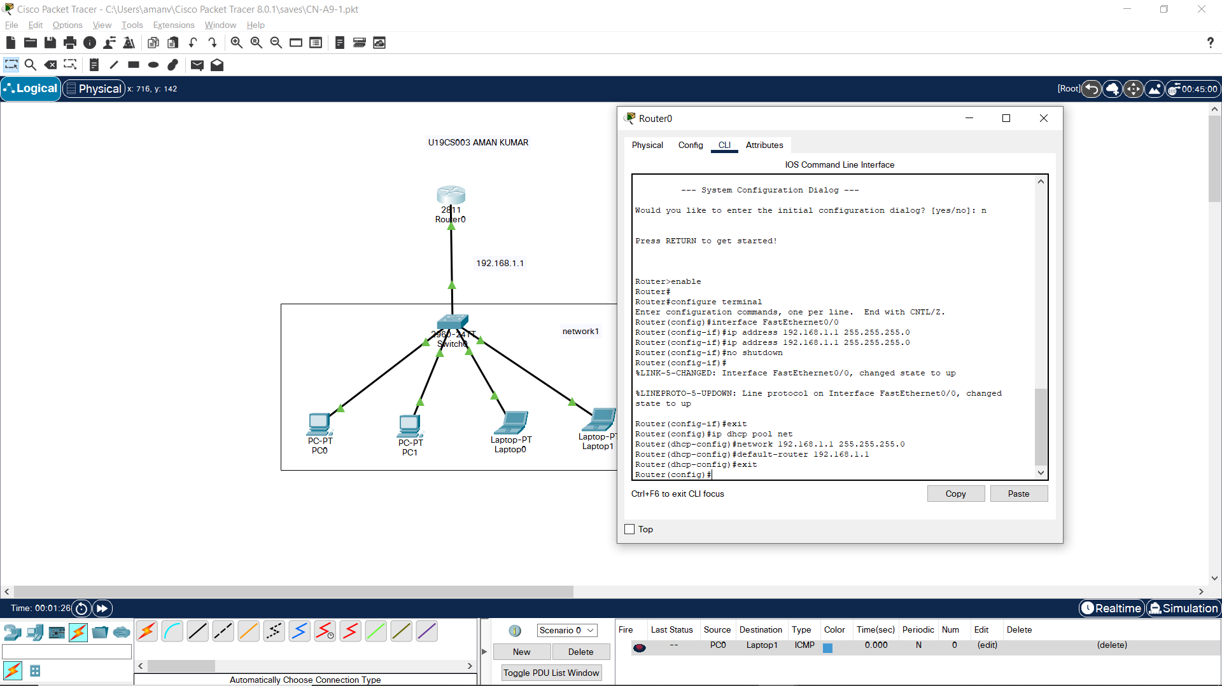

Once this is completed, we must change the property of end devices from static to DHCP.

*REQUESTING IP*

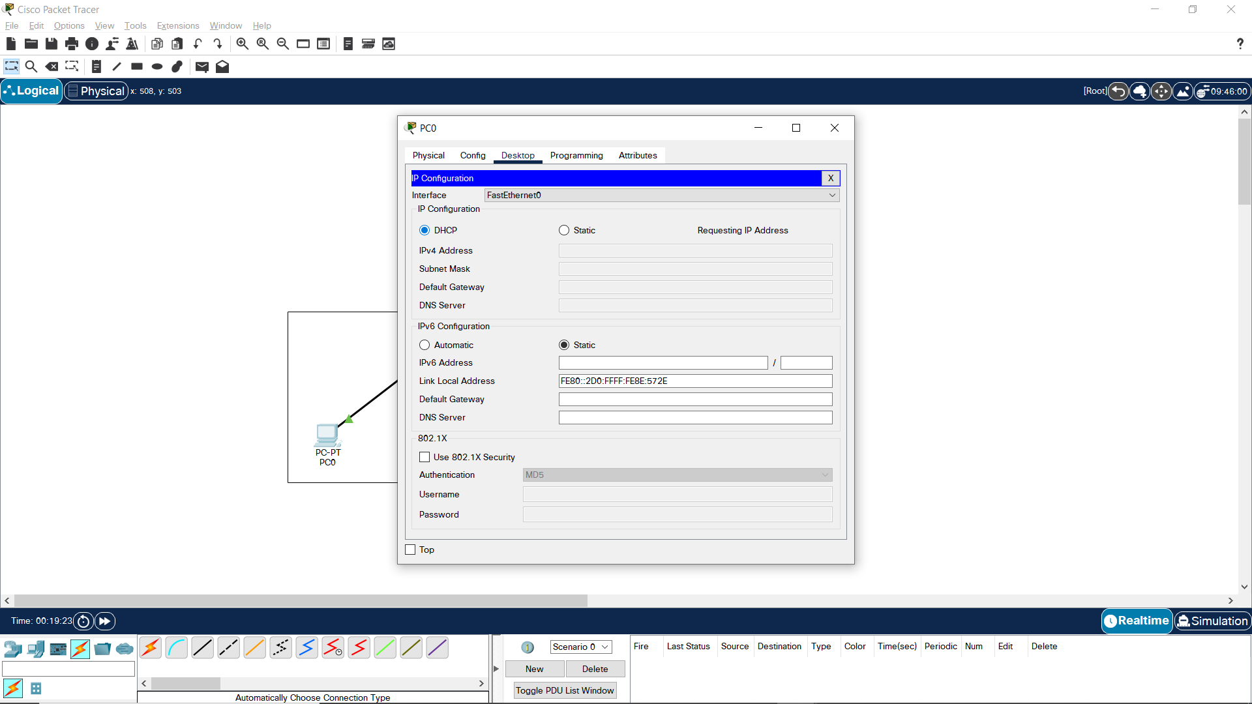

*SUCCESSFUL REQUEST*

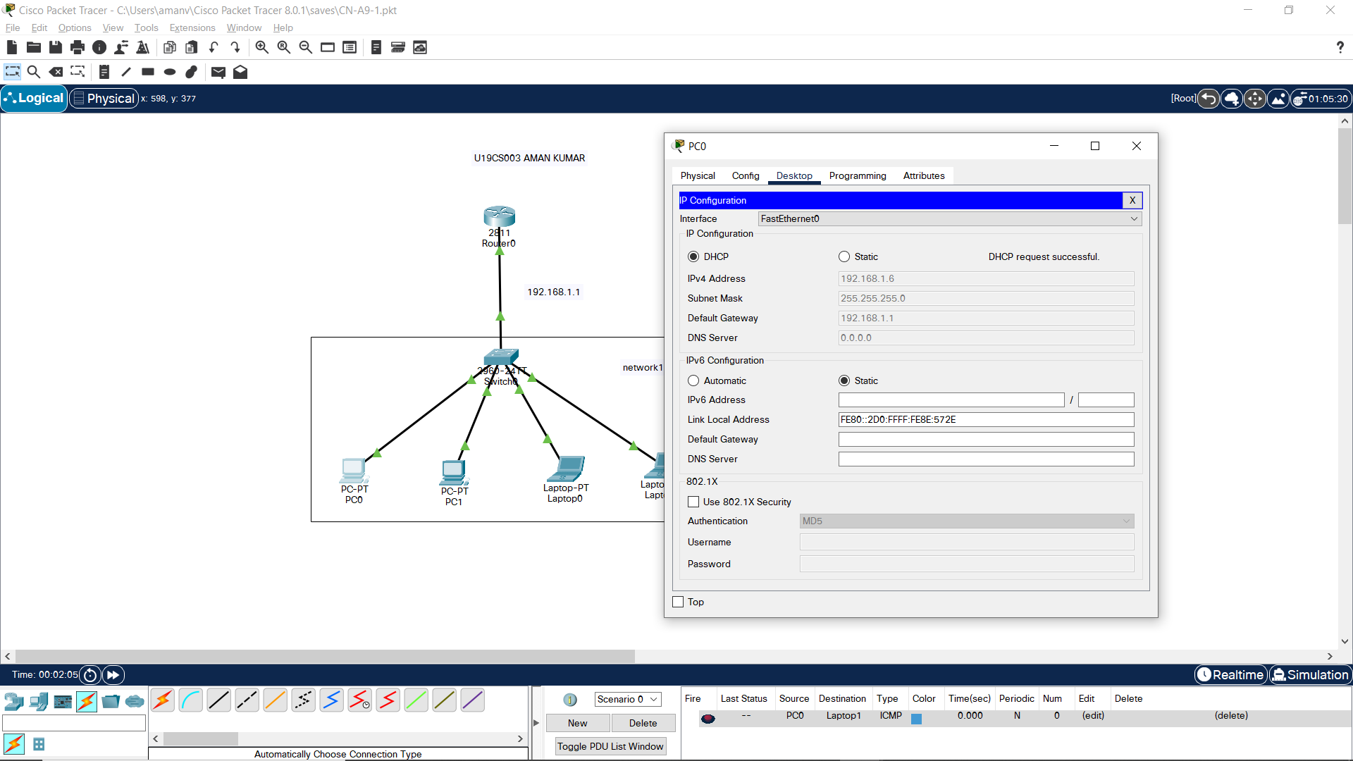

This will allow any new device which is being added to the network to get its own unique IP address automatically.

1. **Simulation**

Pinging Laptop1 from PC0

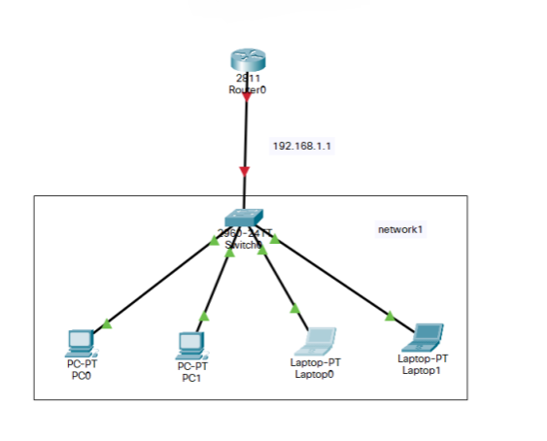

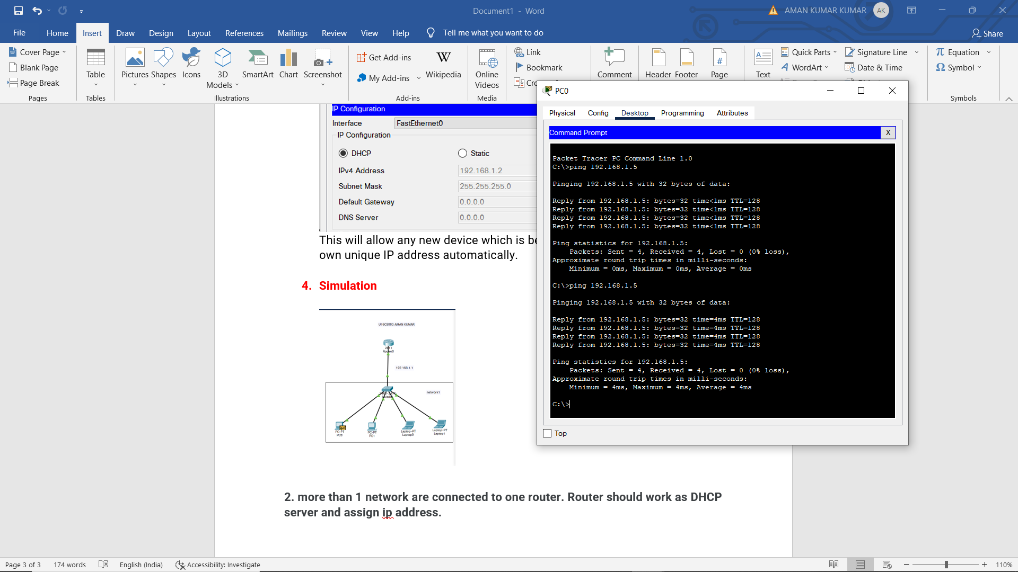

**2. more than 1 network are connected to one router. Router should work as DHCP server and assign ip address.**

**=>**

* + - 1. **Layout**

Create a 2 (or more)network and connect them to router (if more than 2 networks are there use appropriate modules to connect them)

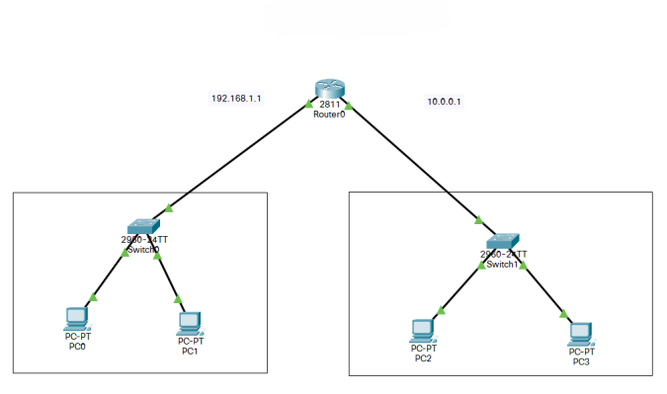

* + - 1. **IP configuration of Router**

Set IP of each port to respective default gateway.

Here we would take “192.168.1.1” and “10.0.0.1”

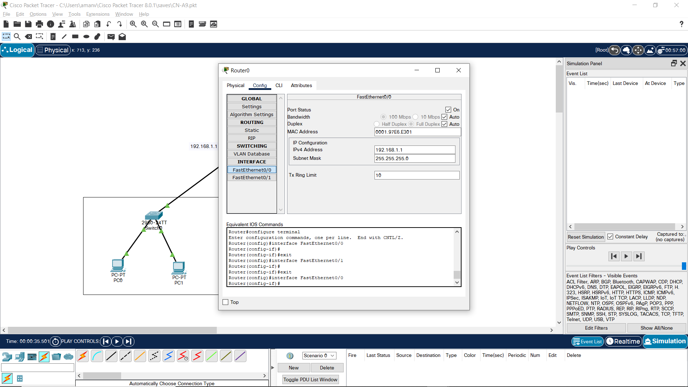

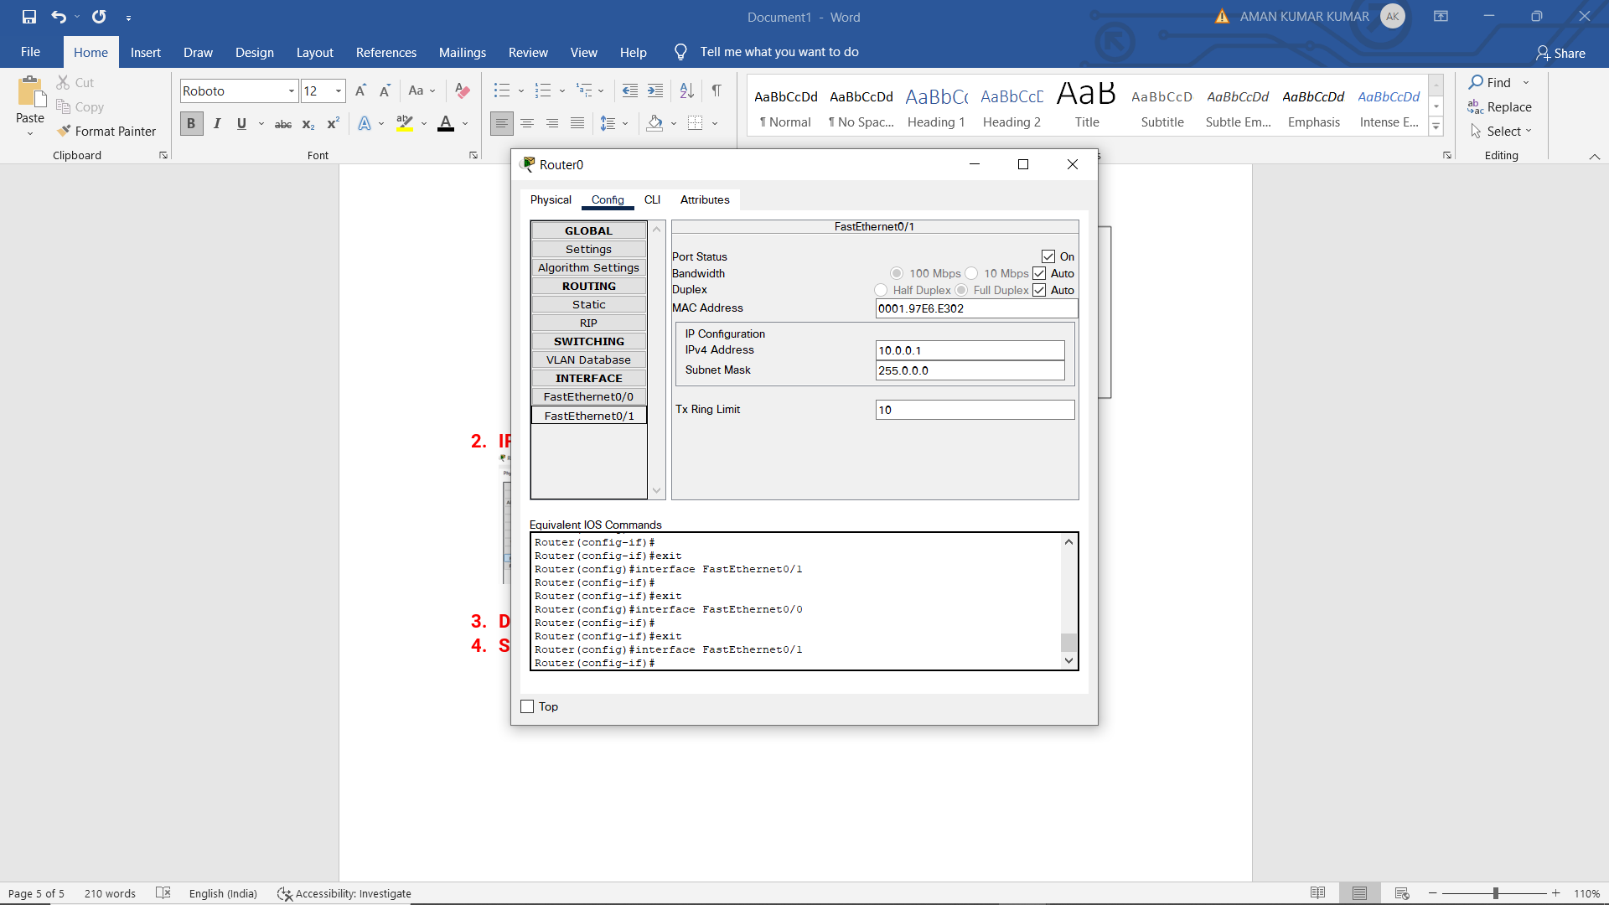

* + - 1. **DHCP Configuration**

Create two DHCP pool since there are 2 different networks connected via router.

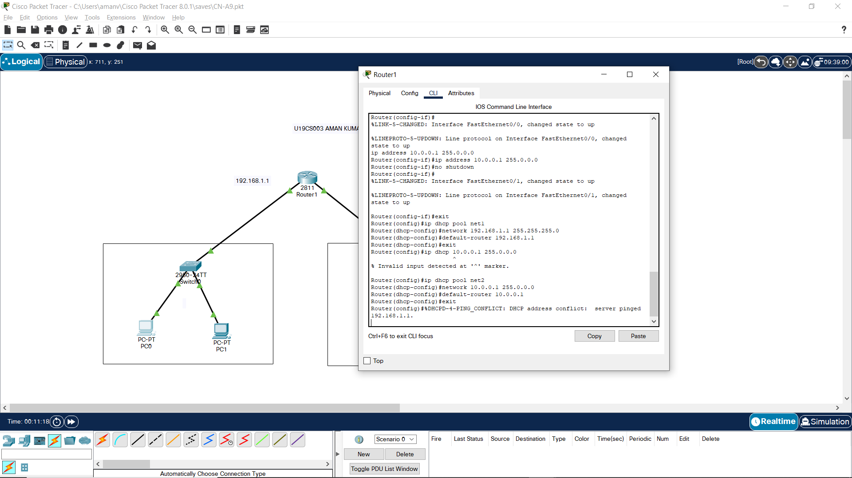

Once this is completed, all left is changing the IP config of devices from static to DHCP.

*Requesting IP Address:*

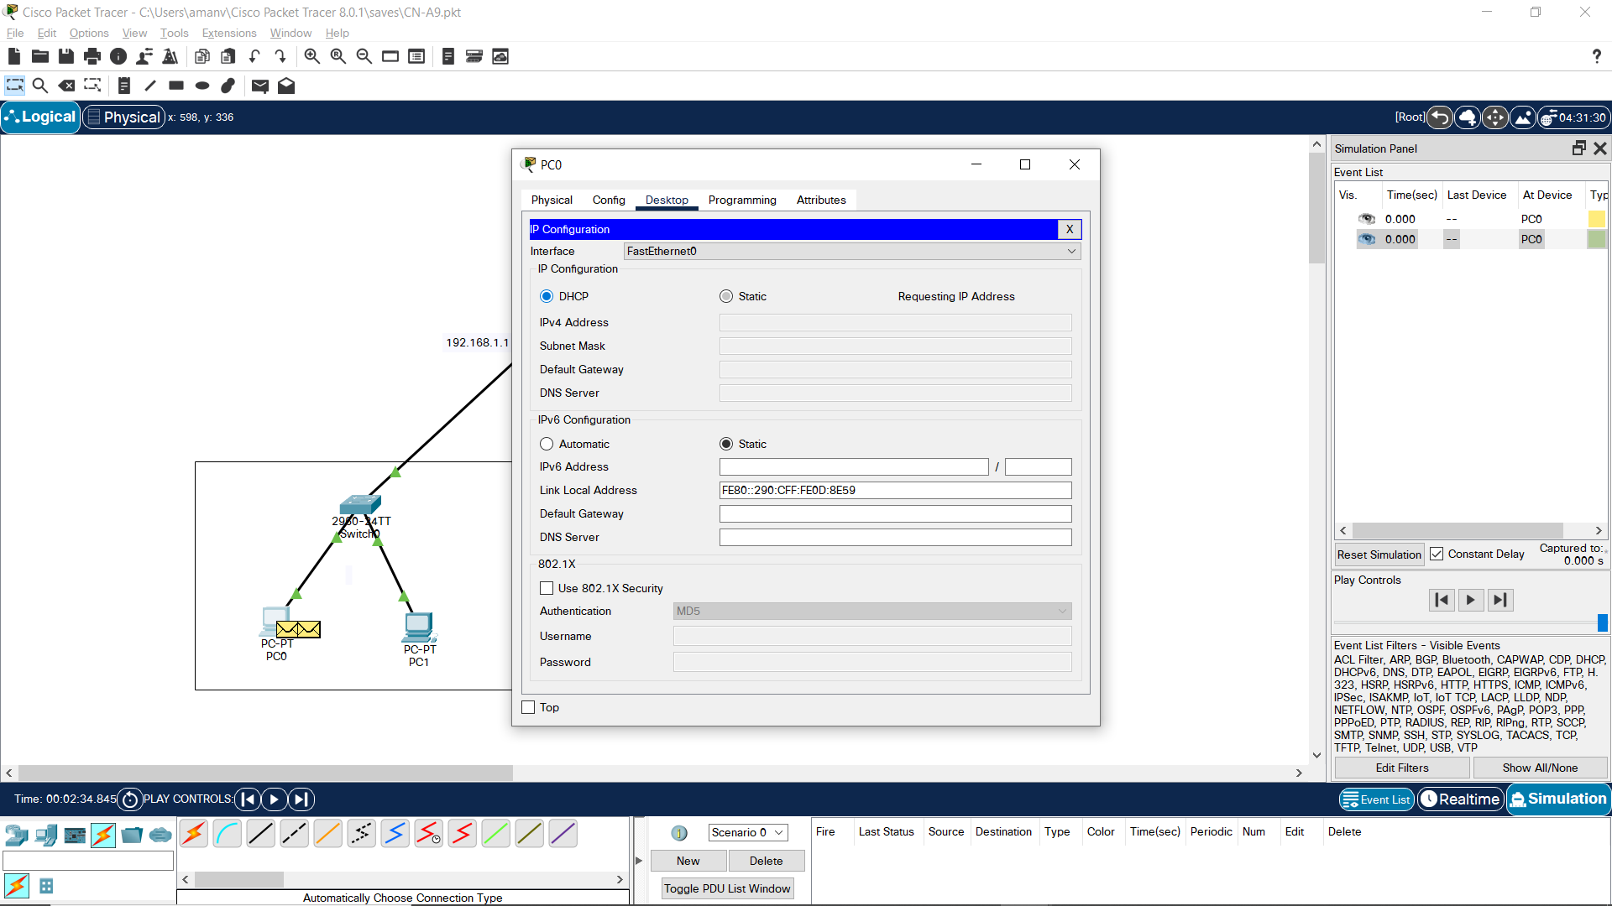

*Request Successful:*

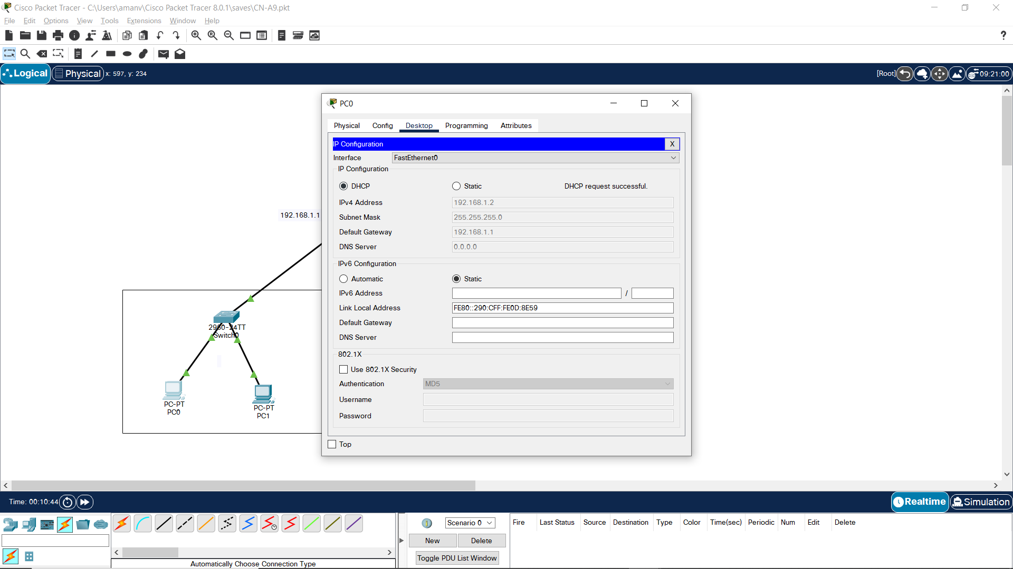

* + - 1. **Simulation**

Pinging PC2 from PC0.



