**Name: Brijesh Rameshbhai Rohit**

**Admission number: U19CS009**

**CN-ASSIGNMENT-10**

Create Manual to create network topology  
Minimum 3 networks should be connected to one router and DHCP server should be responsible for assigning IP address to all the systems in topology.  
Perform one transmission between two systems belonging to different networks

1. **Layout:**

Following is network created:

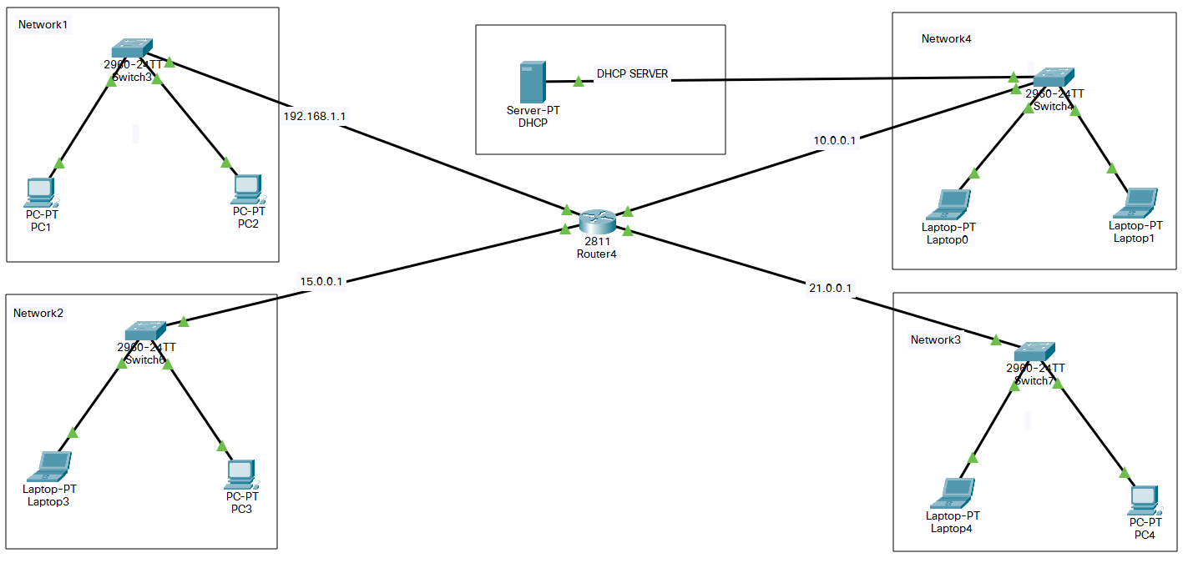

To connect more than 2 networks with routers we need to add modules to it.

We are using router 2811 so go to the physical configuration and add module “NM-2FE2W” which enables 2 more fastethernet ports.

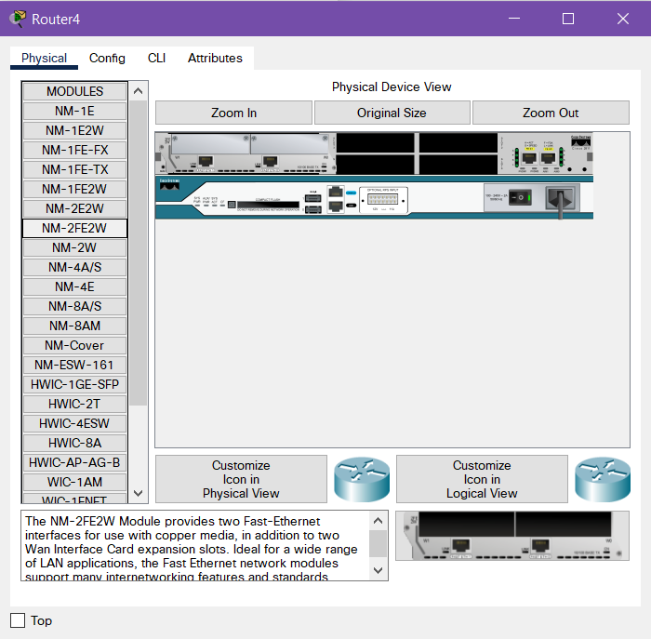

Once this is complete you should be able to add 4 different networks to the router.

1. **DHCP Server Configuration**

Select the Server to open its configuration terminal and then select setting and set it to static with default gateway as “10.0.0.1” (the network server is connected to).

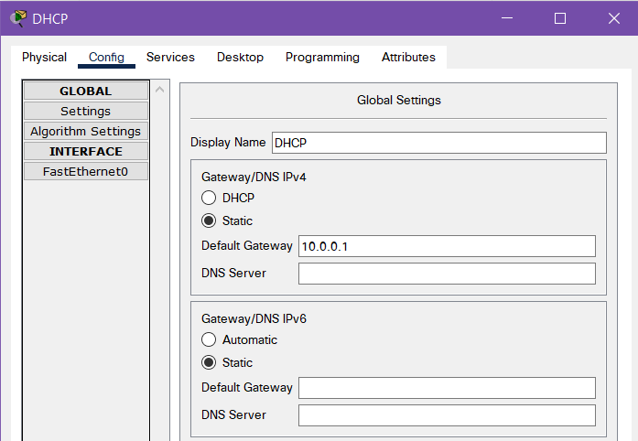

Then select FastEthernet0 and set the IPv4 address to 10.0.0.2 with subnet mask 255.0.0.0 which is also in static. Then set the port status to “ON”.

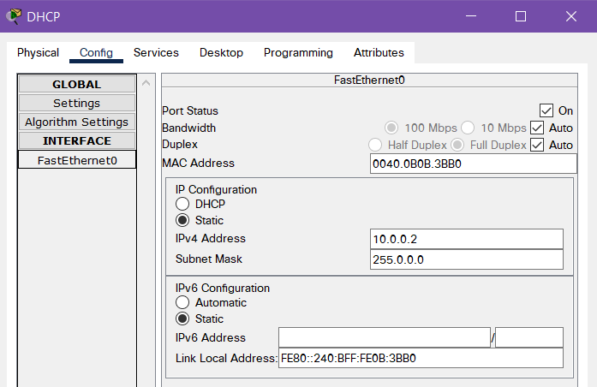

Now select Services from top bar and then select DHCP.

And now set the starting IP of each network.

Here we would set for 4 networks “192.168.1.1”, ”15.0.0.1”, ”21.0.0.1”, ”10.0.0.1”.

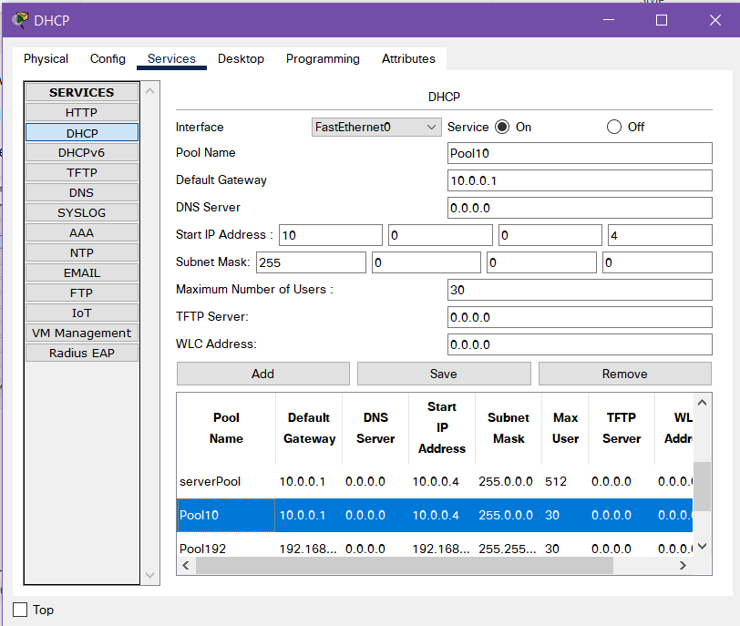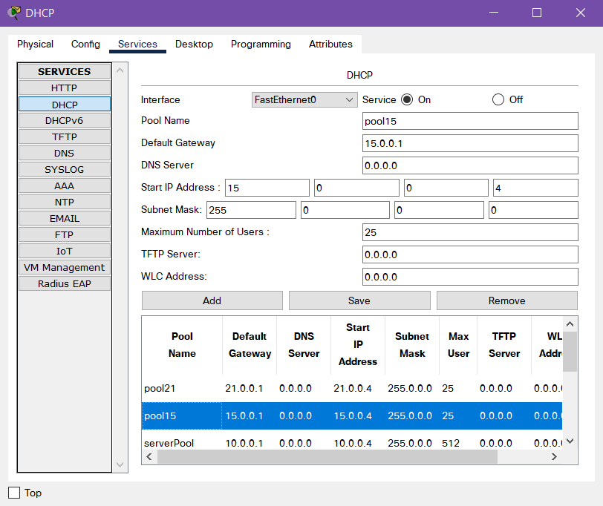

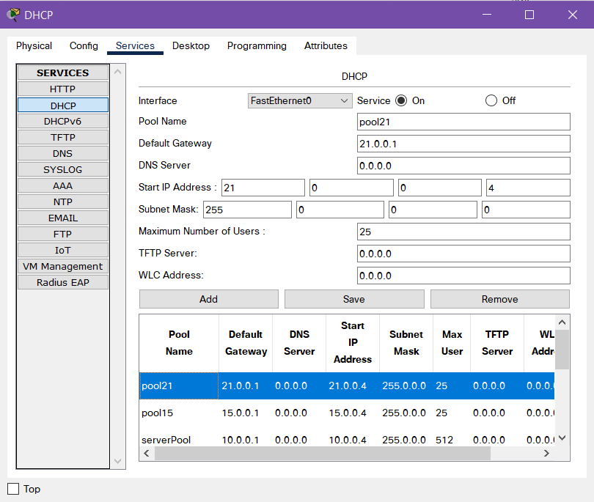 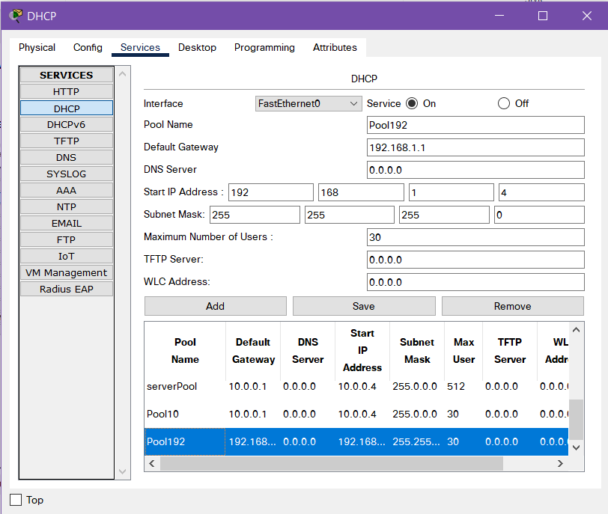

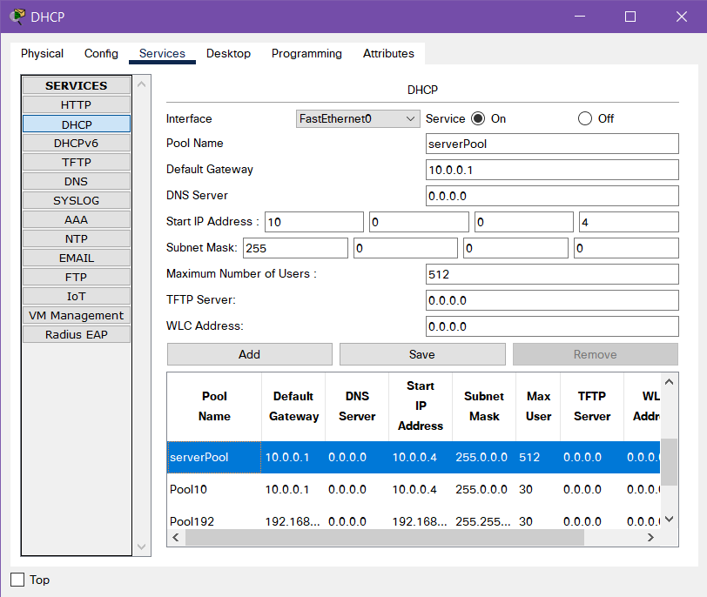

After all the DHCP pools are created, set the service status to “ON”

1. **Router Configuration**

Now that the server is set, we need to configure out router accordingly so first, set the Ips Each port according to figure in Layout above. Do the same to all ports as shown below.

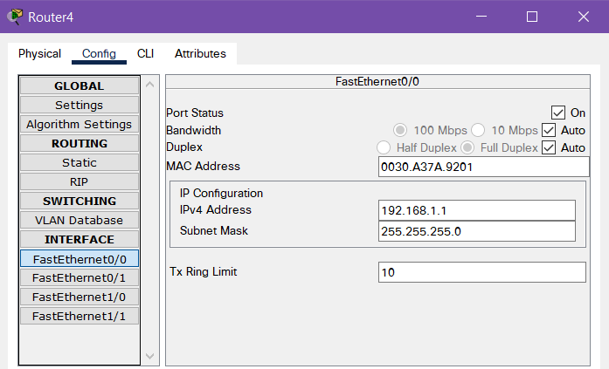

In CLI run following commands:

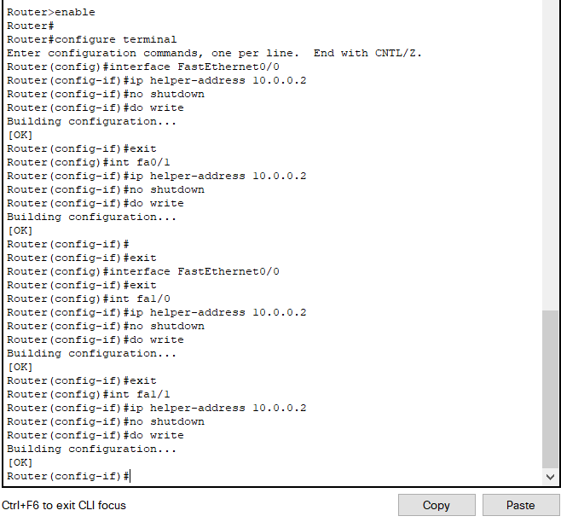

This should make any DHCP IP request from any network to go directly to the server.

1. **End Device Configuration**

Set the IP config mode from static to DHCP as shown.

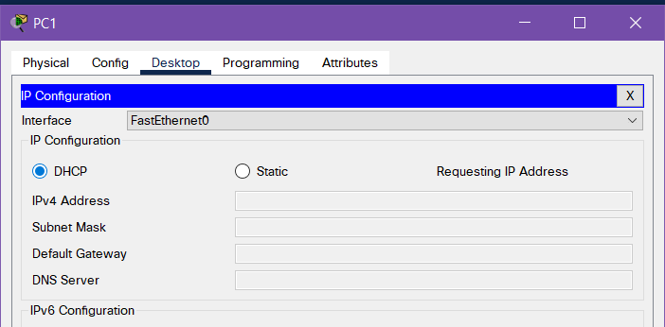

After few seconds it should get assigned a unique IP. Do this to all the end devices.

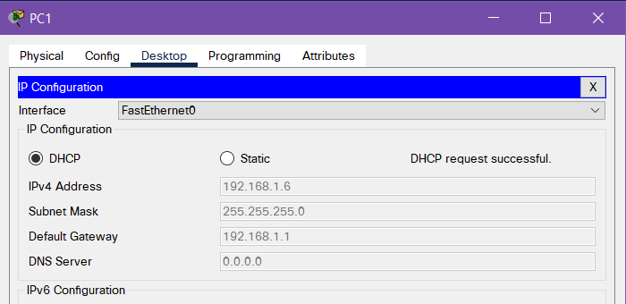

1. **Simulation**

From PC1 with IP 192.168.1.6 we would ping Laptop3 with IP 21.0.0.4

