**Name: Brijesh Rameshbhai Rohit**

**Admission NO.: U19CS009**

**OS-LAB-ASSIGNMENT-03**

**(1) Shell script Program to accept a character and check whether it is an**

**Lower case alphabet**

**Upper case alphabet**

**A digit**

**Special symbol**

**Vowel**

**Using case control structure**

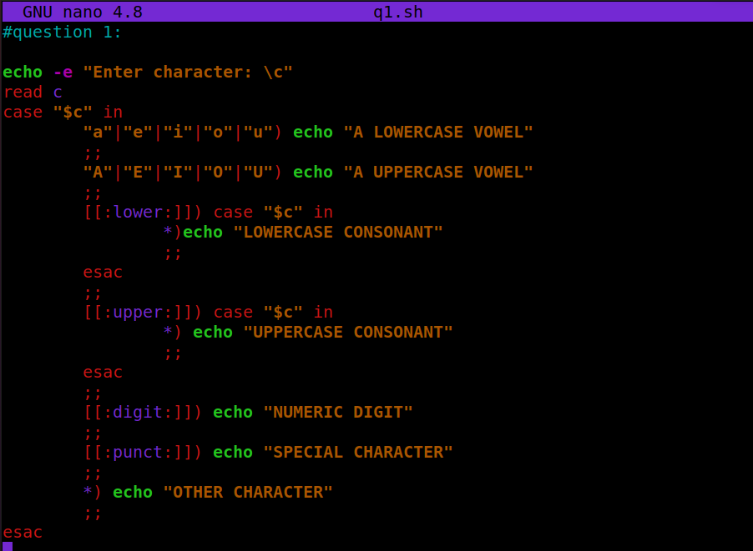

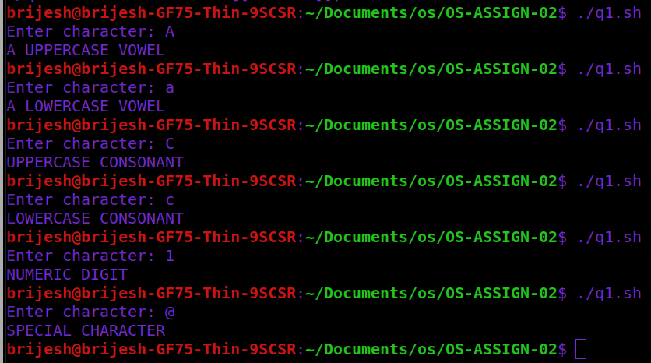

**(2) Using case esac structure**

**Find the number of users logged into the system**

**Print the calendar for current year**

**Print the date**

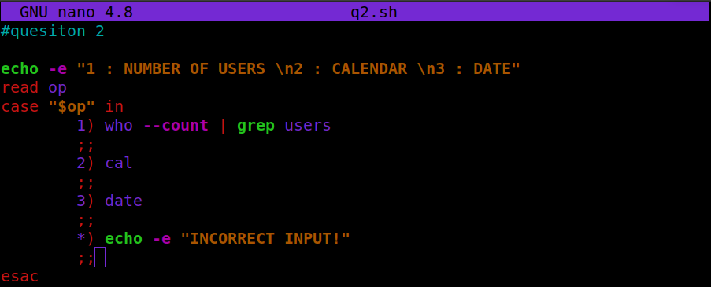

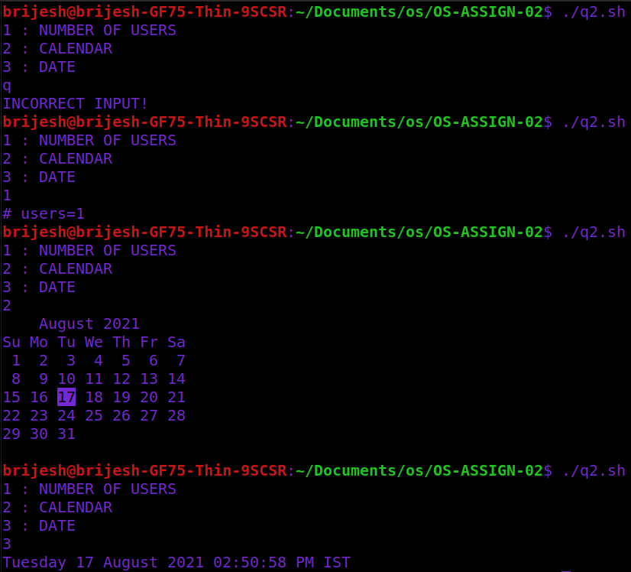

**(3) Shell Script Program to check whether given file is a directory or not.**

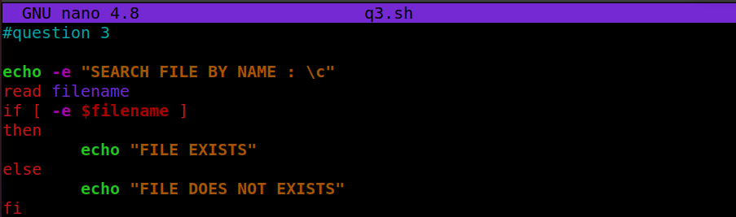

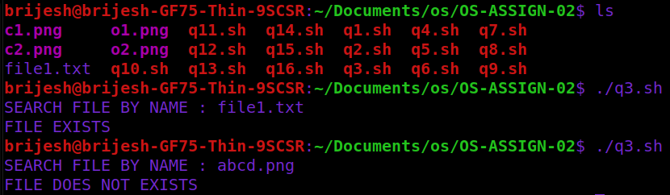

**(4) Shell Script Program to Count number of files in a Directory.**

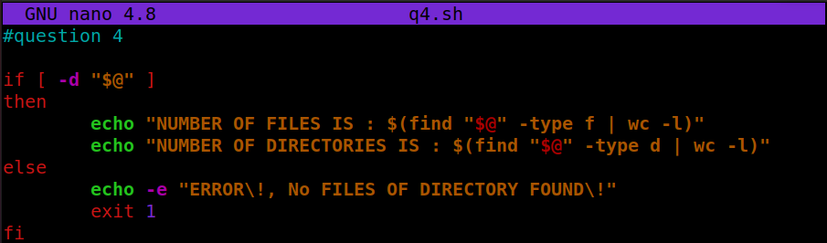

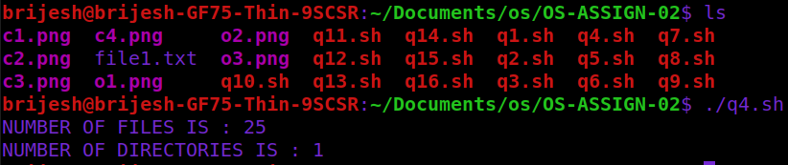

**(5) Shell Script Program to copy contents of one file to another.**

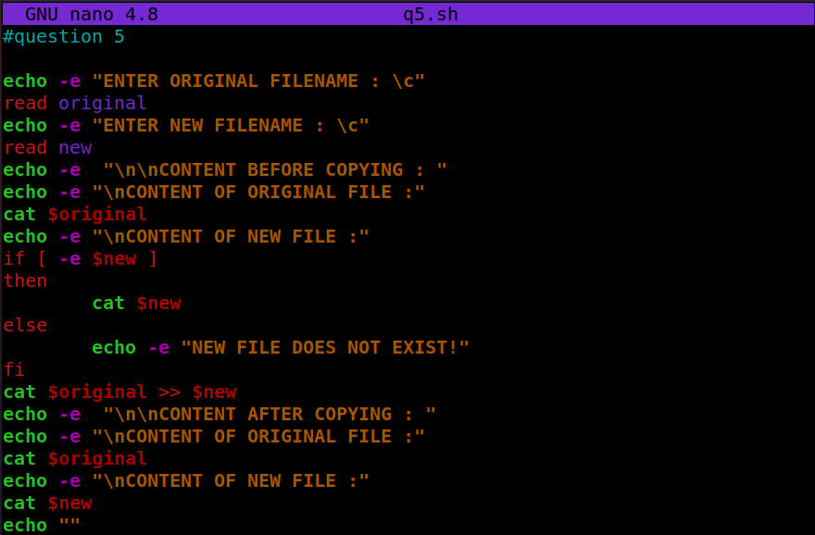

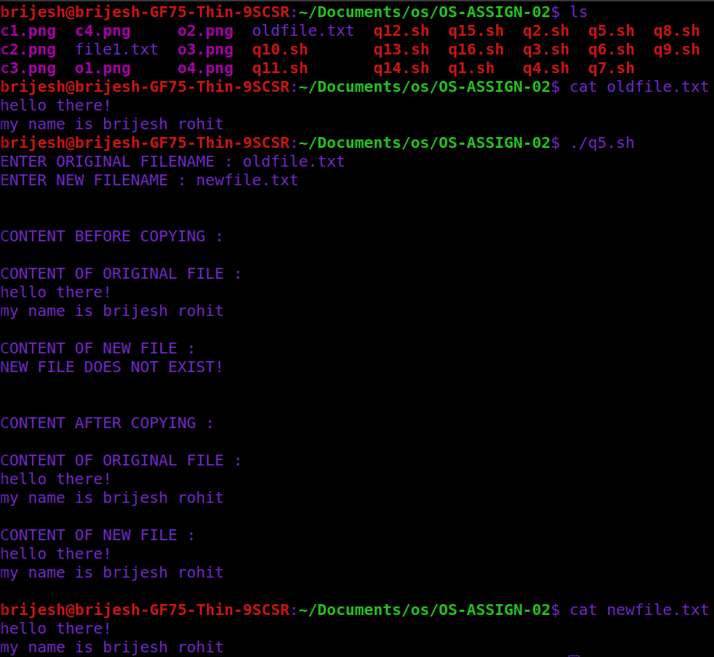

**(6) Write a shell script to add two numbers supplied by user and supplied as command line argument.**

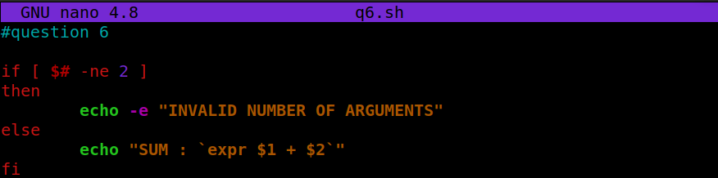

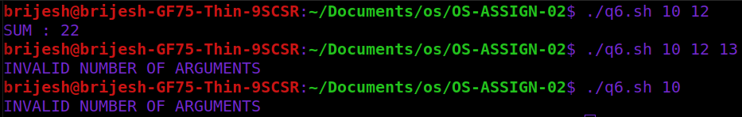

**(7) Write a shell script to find out biggest number form given three numbers. Numbers are supplied by command line argument.**

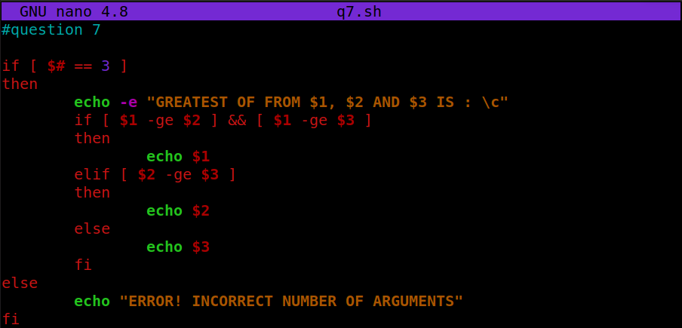

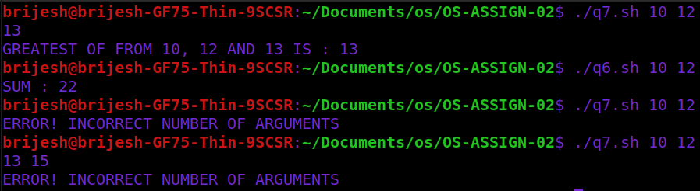

**(8) Implement simple calculator. Numbers are supplied by command line argument.**

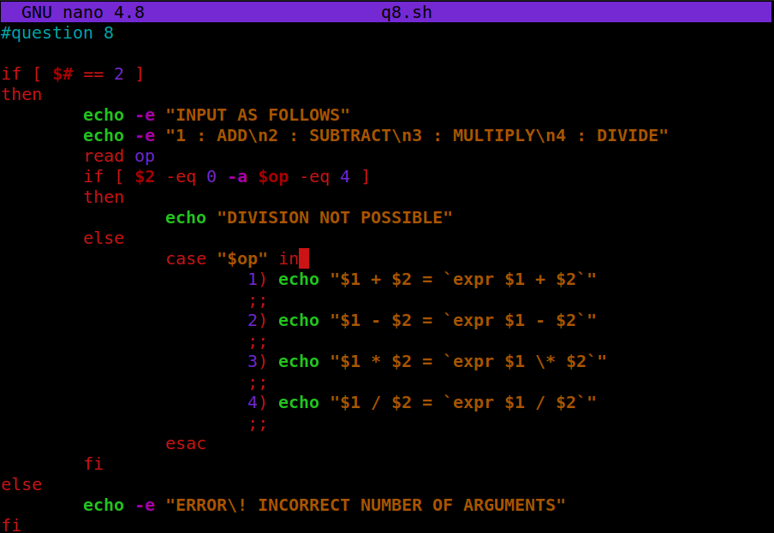

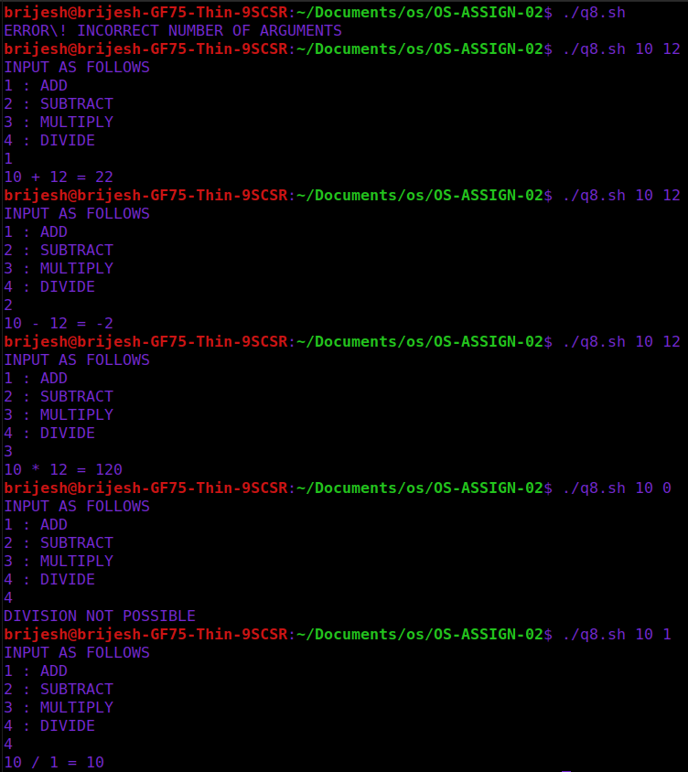

**(9) Write a shell script to print numbers in descending order using while loop.**

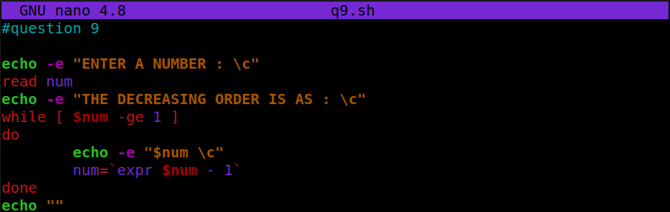

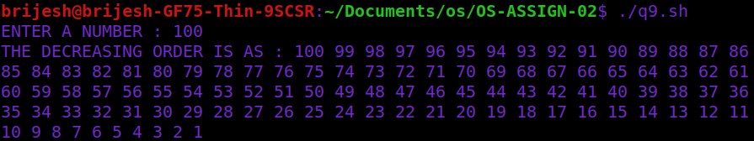

**(10) Write a shell script to create a simple calculator using switch-case statement.**

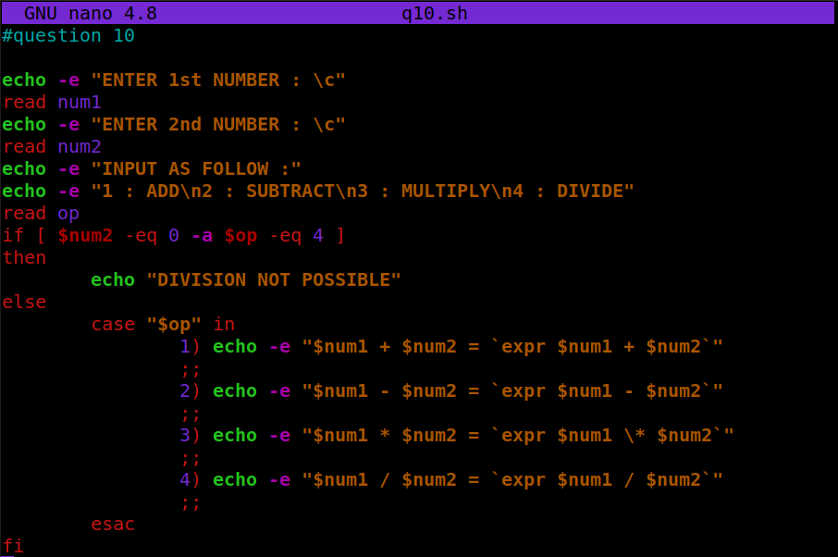

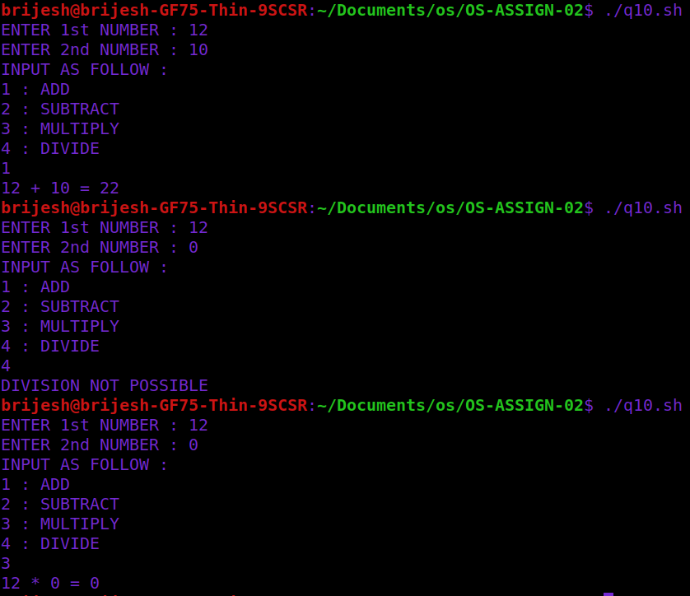

**(11) Write a shell script to print given number in reverse order.**

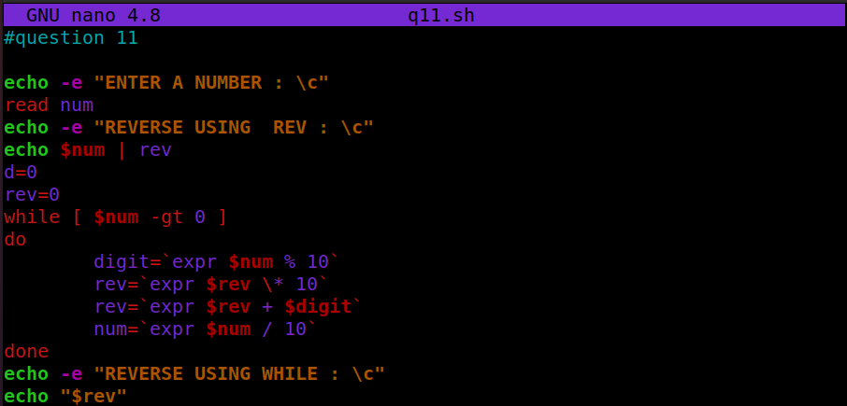

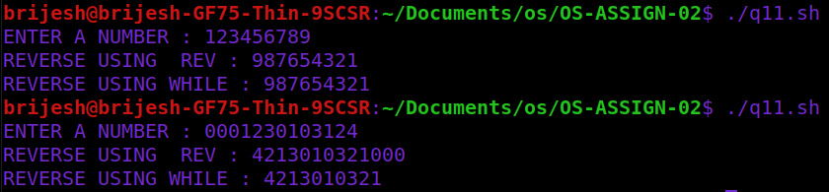

**(12) Write a shell script to print sum of all digits of a given number.**

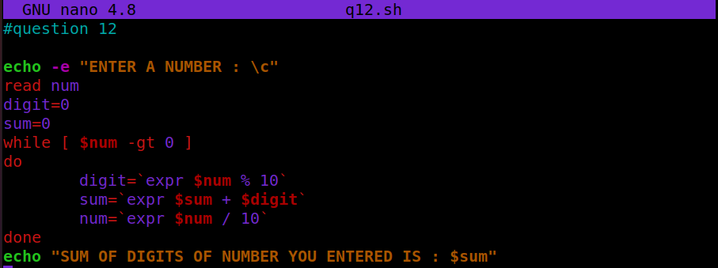

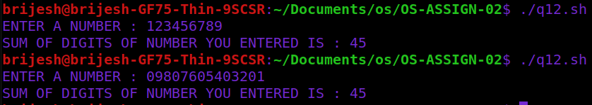

**(13) Find the factorial value of given input number.**

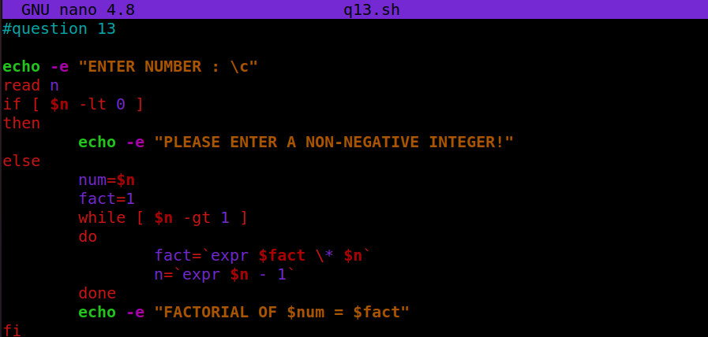

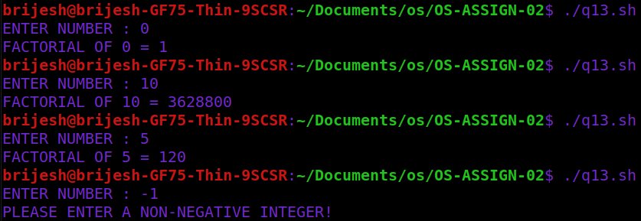

**(14) Generate and display Fibonacci series.**

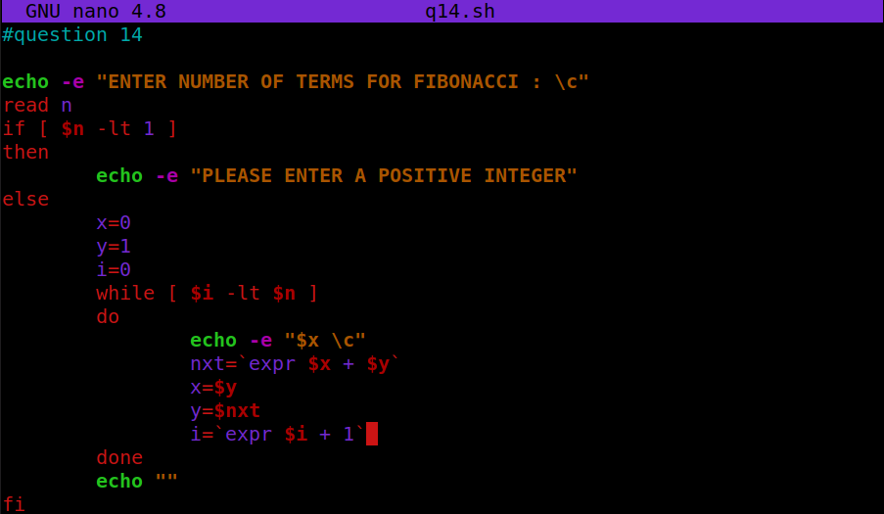

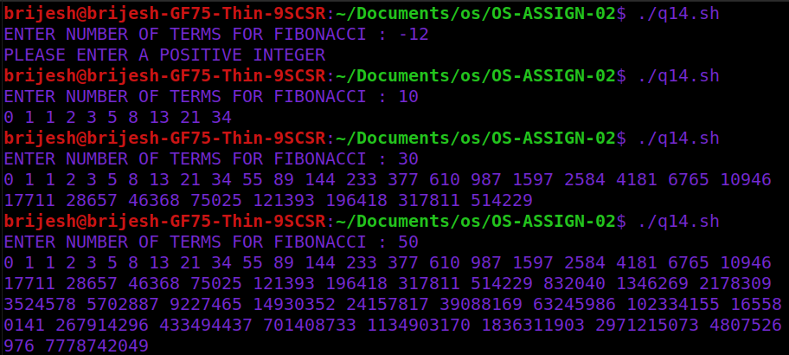

**(15) Display all even numbers within given range.**

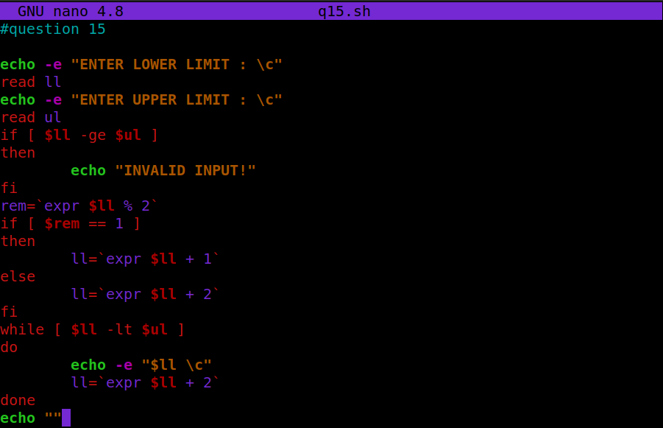

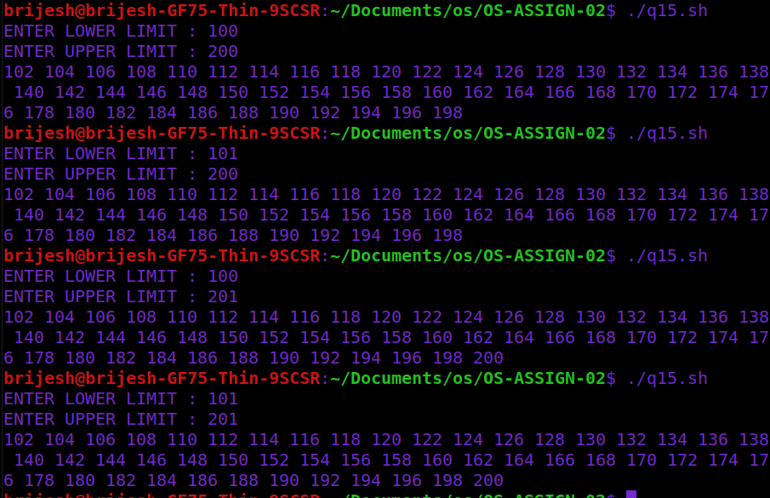

**(16) Find out number of characters, words and lines from a given file.**

