**Name: Brijesh Rameshbhai Rohit**

**Admission NO.: U19CS009**

**OS-LAB-ASSIGNMENT-03**

**1) Write a shell script, which finds the prime factors of a given number.**

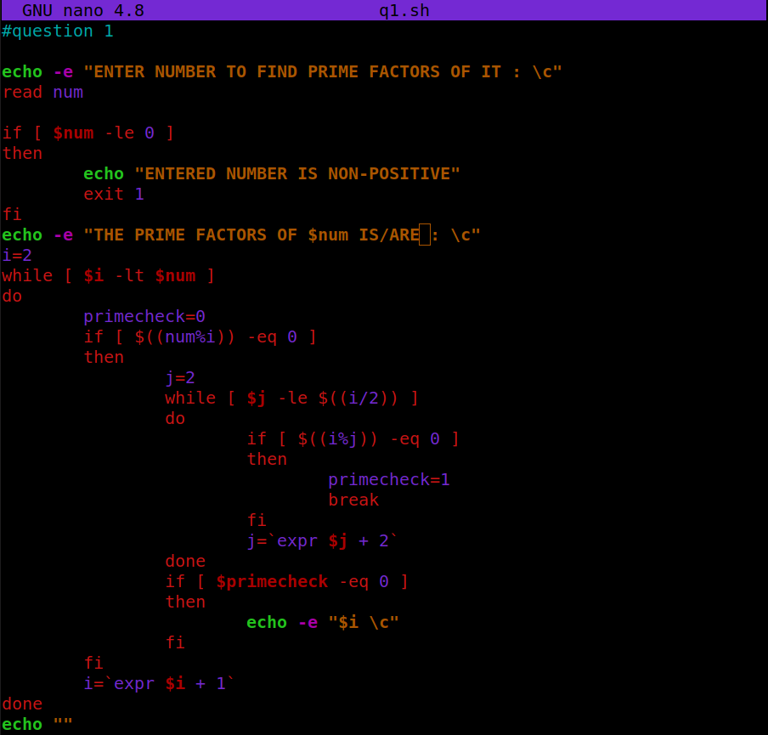

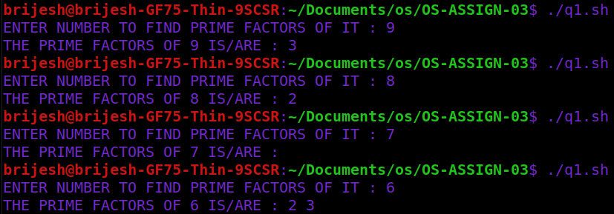

**2) Write a shell script that accepts a positive integer value from the user, say 34, and prints out all the divisors of 34 as a list:**

**Enter a positive integer: 34**

**The divisors of 34 are: 1, 2, 17, and 34**

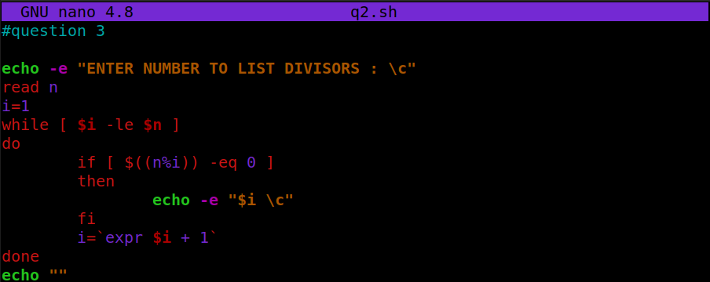

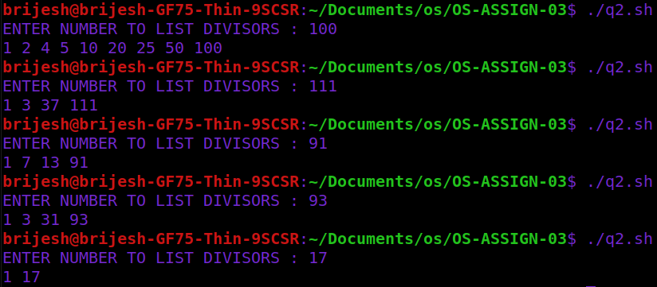

**3) Write a shell script, which prints good morning or good evening depending on the login time of the user.**

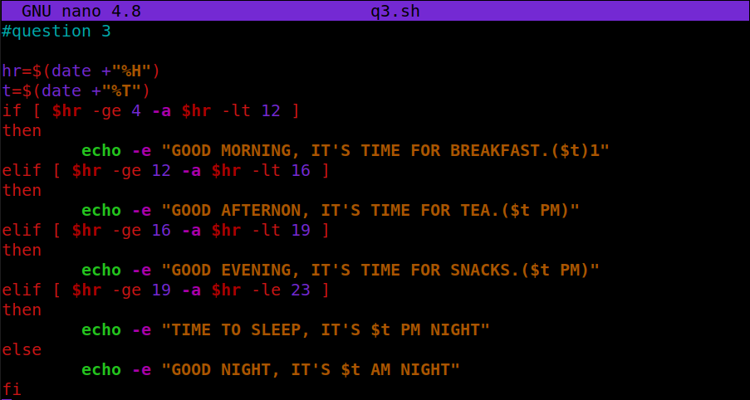



**4) A shell script, which takes as command line input a number n, and a word. It then prints the word n times, once on each line.**

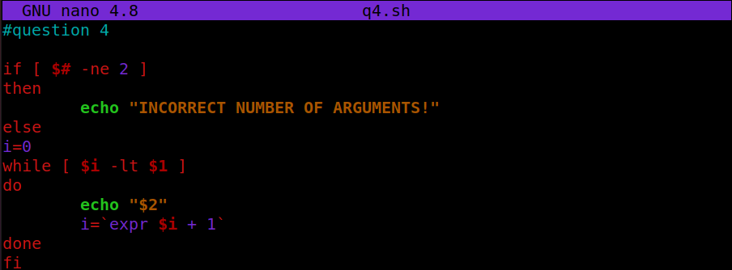

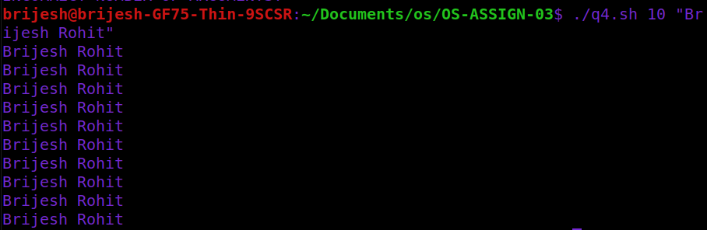

**5) Write a shell script, which finds the total number of blank lines in the given file.**

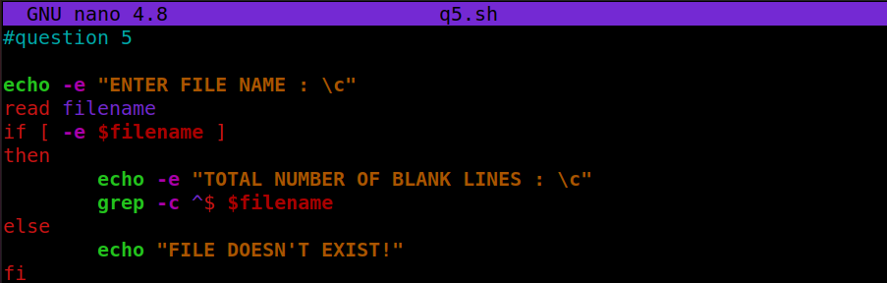

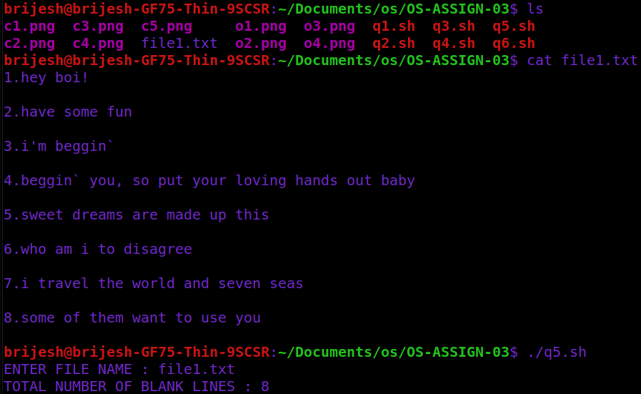

**6) A shell script, which reports the names and sizes of all the files in a directory whose size exceeds 1000 bytes, in descending order of their sizes and the total number of such files.**

