**Name: Brijesh Rohit**

**Admission no.: U19CS009**

**ARTIFICIAL INTELLIGENCE - ASSIGNMENT - 1**

**Design State Space Search for Water Jug Problem and Implement same problem in prolog.**

**Problem: There are two jugs of volume A litre and B litre. Neither has any measuring mark on it.There is a pump that can be used to fill the jugs with water.How can you get exactly of water into the Assuming that we have unlimited supply of water.**

**For e.g., one having the capacity to hold 3 gallons of water and the other has the capacity to hold 4 gallons of water. There is no other measuring equipment available and the jugs also do not have any kind of marking on them. So, the agent’s task here is to fill the 4-gallon jug with 2 gallons of water by using only these two jugs and no other material. Initially, both our jugs are empty.**

**CODE=>**

|  |
| --- |
| %U19CS009 BRIJESH_ROHIT  %invalid states considering capacity of Jug A is 4L anf Jug B is 3L  water_jug(X,Y):-X>4,Y<3,write('Jug A Overflowed\n').  water_jug(X,Y):-X<4,Y>3,write('Jug 2 Overflowed\n').  water_jug(X,Y):-X>4,Y>3,write('Both Jugs Overflowed\n').  %goal state  water_jug(X,Y):- X=:=2,Y=:=0,write('\nGoal Achieved\n\n').  %static path to final state  water_jug(X,Y):-  X=:=0,Y=:=0,write("\nFill Jug B Then, Jug A: 0 and Jug B: 3\n"),water_jug(0,3);  X=:=0,Y=:=3,write("\nPour water in Jug A from Jug B Then, Jug A: 3 and Jug B: 0\n"),water_jug(3,0);  X=:=3,Y=:=0,write("\nFill Jug B Then, Jug A: 3 and Jug B: 3\n"),water_jug(3,3);  X=:=3,Y=:=3,write("\nPour water in Jug A from Jug B Then, Jug A: 4 and Jug B: 2\n"),water_jug(4,2);  X=:=4,Y=:=2,write("\nEmpty Jug A Then, Jug A: 0 and Jug B: 2\n"),water_jug(0,2);  X=:=0,Y=:=2,write("\nPour water in Jug A from Jug B Then, Jug A: 2 and Jug B: 0\n"),water_jug(2,0);  X=:=4,Y=:=0,write("\nPour water in Jug B from Jug A Then, Jug A: 1 and Jug B: 3\n"),water_jug(1,3);  X=:=1,Y=:=3,write("\nEmpty Jug B Then, Jug A: 1 and Jug B: 0\n"),water_jug(1,0);  X=:=1,Y=:=0,write("\nPour water in Jug B from Jug A Then, Jug A: 0 and Jug B: 1\n"),water_jug(0,1);  X=:=0,Y=:=1,write("\nFill Jug A Then, Jug A: 4 and Jug B: 1\n"),water_jug(4,1);  X=:=4,Y=:=1,write("\nPour water in Jug B from Jug A Then, Jug A: 2 and Jug B: 3\n"),water_jug(2,3);  X=:=2,Y=:=3,write("\nEmpty Jug B Then, Jug A: 2 and Jug B: 0\n"),water_jug(2,0).  %other state other than set path.  water_jug(X,Y):-  X=:=2,Y>0,write('Jug A: 2 & Jug B: 0 (Emptied Jug B)\n'),water_jug(2,0);  X=:=1,Y=:=1,write('Jug A: 2 & Jug B: 0 (Poured water in Jug A from Jug B)\n'),water_jug(2,0);  X=:=2,Y>0,write('Jug A: 2 & Jug B: 0(Emptied Jug B)\n'),water_jug(2,0);  X>0,Y=:=2,write('Jug A: 0 & Jug B: 2(Emptied Jug A)\n'),water_jug(0,2);  X>0,Y=:=3,write('Jug A: 0 & Jug B: 3(Emptied Jug A)\n'),water_jug(0,3);  X>0,Y=:=1,write('Jug A: 4 & Jug B: 1(Filled Jug A)\n'),water_jug(4,1).  :-write("Enter the initial states of Jug A : "),read(A),  write("\nEnter the initial states of Jug B : "),read(B),  write("\nInitial state of Jugs are :"),  write("\nJug A: "),write(A),  write(" & Jug B: "),write(B),  write("\n"),water_jug(A,B). |

**OUTPUT=>**

**(0,0)**

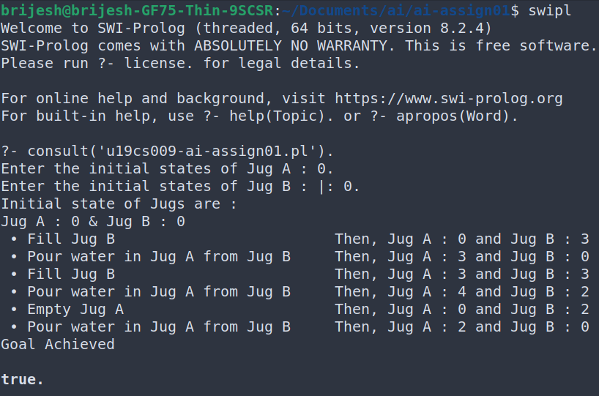

**(2,3)**

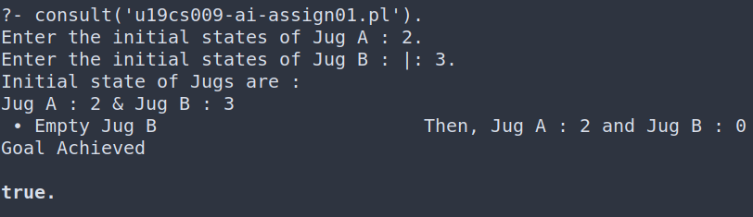

**(3,3)**

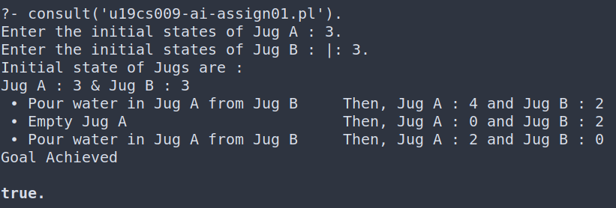

**Error (5,4)**

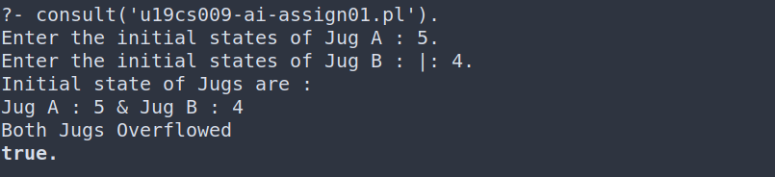

**Error (1,6)**

