**Name: Brijesh Rohit**

**Admission no.: U19CS009**

**ARTIFICIAL INTELLIGENCE - ASSIGNMENT -2**

**Use SWI – Prolog for answering the following questions (load the rules in the file familytree.pl):**

**1. Is Albert a parent of Peter?**

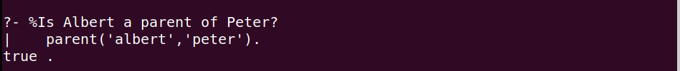

**2. Who is the child of Jim?**

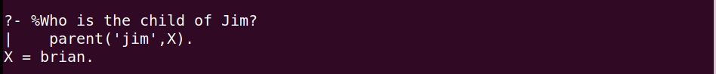

**3. Who are the parents of Brian?**

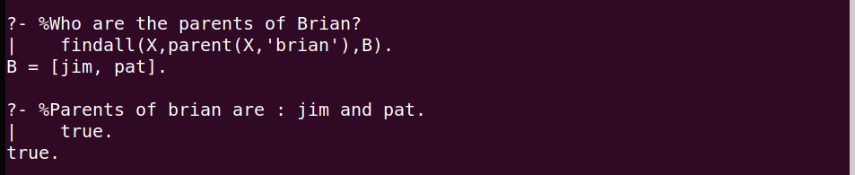

**4. Is Irene a grandparent of Brian?**

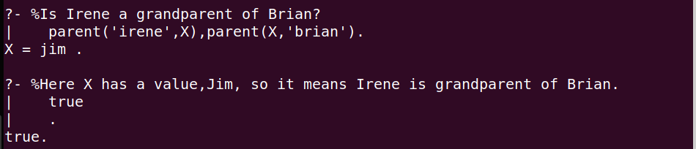

**Yes, Irene is a grandparent of Brian.**

**5. Find all the grandchildren of Irene.**

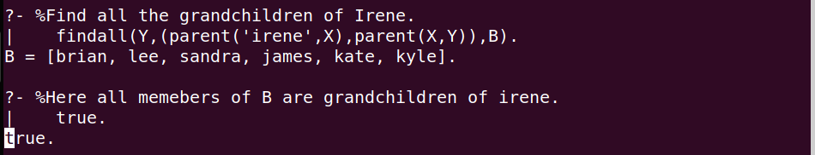

**6. Now add the following rule to familytree.pl and re-consult:**

**older(Person1, Person2) :- yearOfBirth(Person1, Year1), yearOfBirth(Person2, Year2), Year2 > Year1.**

**7. Who is older than Pat?**

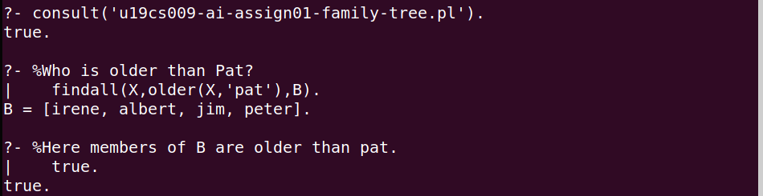

**8. Who is younger than Darren?**

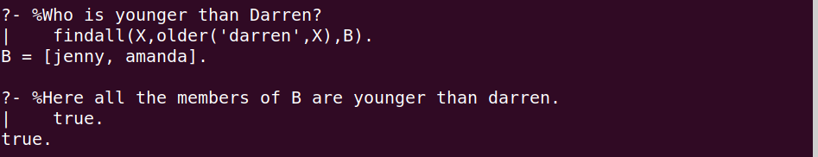

**9. List the siblings of Sandra.**

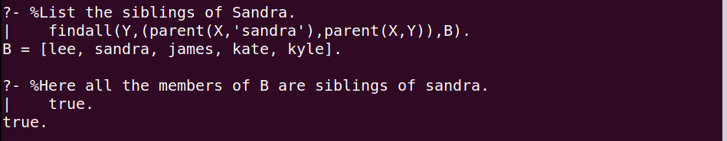

**10. Who is the older brother of Sandra?**

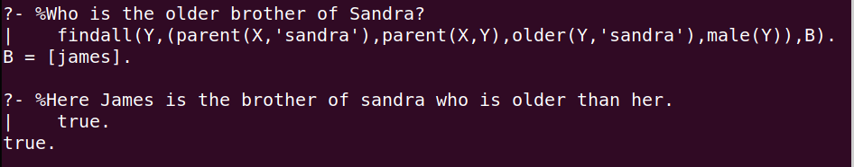

**11. Find the predecessors of Kyle.**

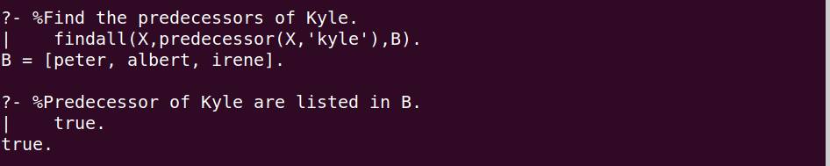

**12. Does Kate have a sister?**

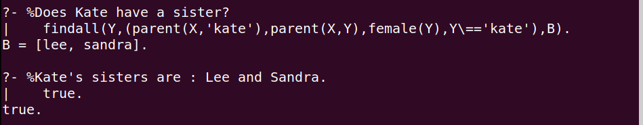

**13. How many females and males are there in the knowledge base?**

