**Name: Brijesh Rameshbhai Rohit**

**Admission number: U19CS009**

**ARTIFICIAL INTELLIGENCE**

**ASSIGNMENT - 05**

**1.     Perform Towers of Hanoi.**

|  |
| --- |
| %U19CS009  %BRIJESH ROHIT  move(1,X,Y,_) :-  write('Move top disk from '),  write(X), write(' to '),  write(Y),nl.  move(N,X,Y,Z) :-  N>1,  M is N-1,  move(M,X,Z,Y),  move(1,X,Y,_),  move(M,Z,Y,X).  execute:-  write('Move top disk from tower A to tower C'),nl.  toh(N):-  N=:=1  ->execute  ;move(N,'tower A','tower C','tower B'). |

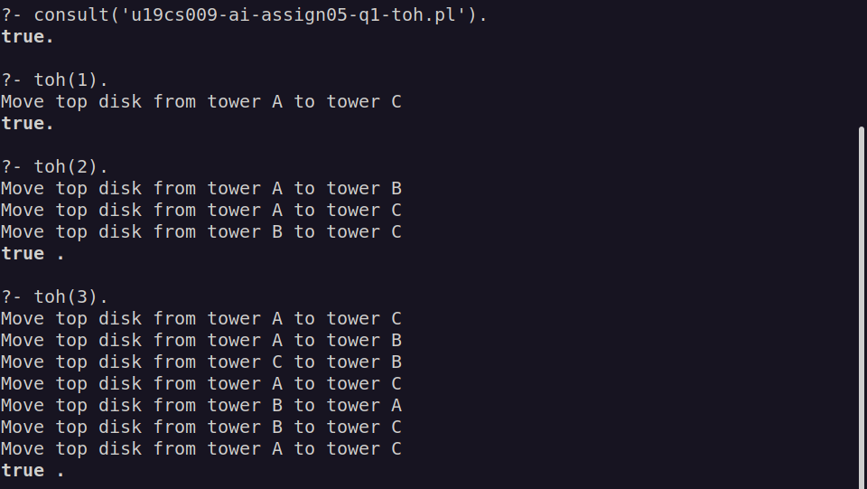

**2.     WAP to check whether the number is present in the list or not.**

|  |
| --- |
| %U19CS009  %BRIJESH ROHIT  mem(X,[]):-  write(X),  write("'IS NOT' member of givem List"),  nl.  mem(X,[X|_]):-  write(X),  write(" 'IS' member of givem List"),  nl.  mem(X,[_|T]) :-  mem(X,T). |

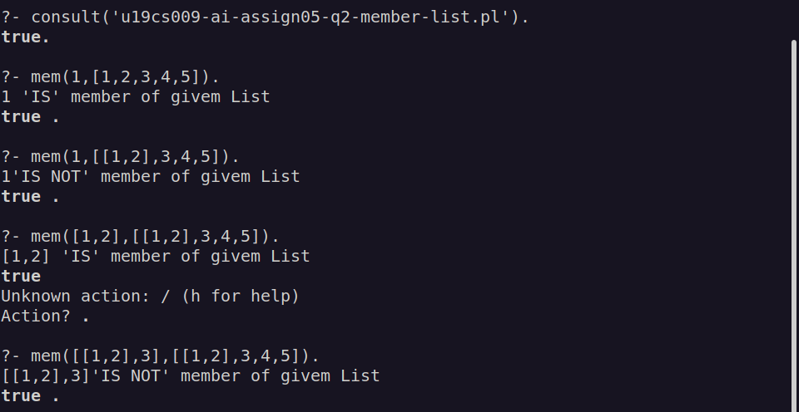

**3.    WAP to add a number in the list.**

|  |
| --- |
| %U19CS009  %BRIJESH ROHIT  concatMem([],X, [X]).  concatMem([Y|T1], X,[Y|T2]) :-  concatMem(T1, X,T2). |

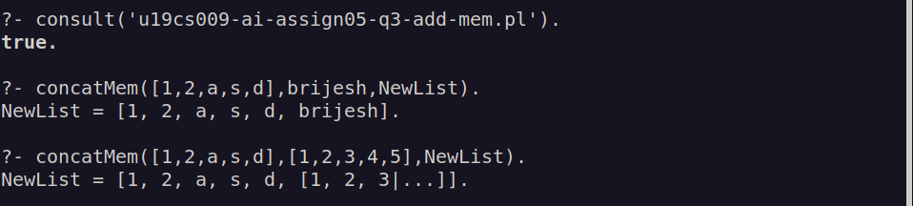

**4.     WAP to concat two lists and store the result in third list.**

|  |
| --- |
| %U19CS009  %BRIJESH ROHIT  concateList(L1,L2,L3):-  append(L1,L2,L3). |

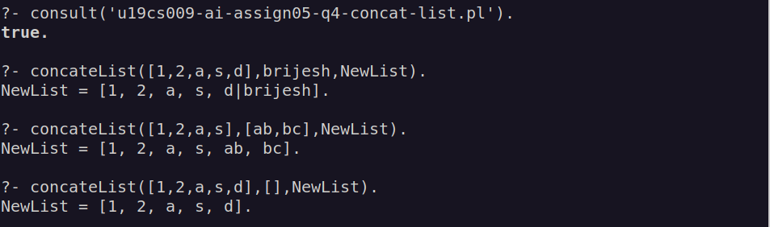

**5.     WAP to delete an element from the list.**

|  |
| --- |
| %U19CS009  %Brijesh Rohit  delEleAtIndex(1,[_|T],T).  delEleAtIndex(P,[X|Y],[X|R]):-  P1 is P-1,  delEleAtIndex(P1,Y,R).  delEle(A, [A|B], B).  delEle(A, [B, C|D], [B|E]) :-  delEle(A, [C|D], E). |

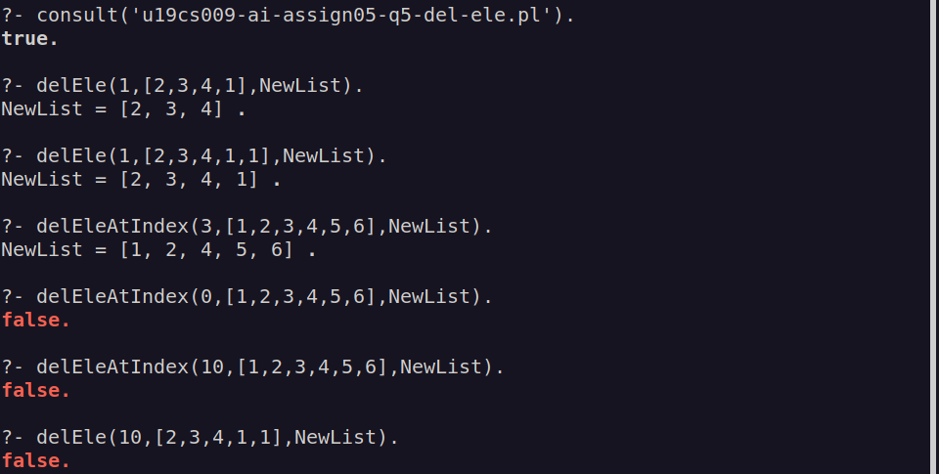

**6.     WAP to sum the elements of a list of numbers.**

|  |
| --- |
| %U19CS009  %Brijesh Rohit  sumList([],0).  sumList([H|T],Sum) :-  sumList(T,Sum1),  Sum is H + Sum1. |

