**Name: Brijesh Rameshbhai Rohit**

**Admission number: U19CS009**

**ARTIFICIAL INTELLIGENCE**

**ASSIGNMENT - 06**

**Monkey is on the floor, at the door. A block is on the floor, at the window. Bananas are hanging from the roof in the middle of the room.**

**Task is to get monkey bananas.**

**CODE=>**

| %U19CS009  %BRIJESH ROHIT  %%%%%%%%%%%%%%%%%%%%%%%%%%%%%%%%%%%%%%%%%%%%%%%%%%%%%%%%%%%%%%%%%%  % Description %  %state(Pm1,Pm2,Pb,flag).  %Pm1 = Position of Monkey in the room (at door, at window, at middle).  %Pm2 = Position of Monkey in the room (on box, on floor).  %Pb = Position of Box in the room.  %flag = Whether monkey has the banana or not (has, hasnot).  %%%%%%%%%%%%%%%%%%%%%%%%%%%%%%%%%%%%%%%%%%%%%%%%%%%%%%%%%%%%%%%%%%  %move(initial state, action to perform, next state).  move(  state(middle,box,middle,hasnot),  grab,  state(middle,box,middle,has)  ).  move(  state(P,floor,P,H),  climb,  state(P,box,P,H)  ).  move(  state(P1,floor,P1,H),  push(P1,P2),  state(P2,floor,P2,H)  ).  move(  state(P1,floor,B,H),  walk(P1,P2),  state(P2,floor,B,H)  ).  %predicate to display steps according to action M.  %action(action performed)  action(M):-  M=walk(P1,P2),  write("walk \t "),  write(P1),  write(" \t "),  write(P2).  action(M):-  M=push(P1,P2),  write("push \t "),  write(P1),  write(" \t "),  write(P2).  action(M):-  M=grab,  write("grab "),  write(" -"),  write(" \t "),  write("-").  action(M):-  M=climb,  write("climb "),  write(" -"),  write(" \t "),  write("-").  %predicate to display the Steps.  display([]).  display([H1|[]],[H2|[]]):-  nl,  write(H2),  write(" \t"),  action(H1).  display([H1|T1],[H2|T2]):-  display(T1,T2),  nl,  write(H2),  write(" \t"),  action(H1).  %canget(State,List to append action predicate,List to append current  %state predicate).  canget(state(_,_,_,has),L,L1):-  display(L,L1),  nl,  write("\nMonkey got the banana!"),  nl.  canget(S,T,T1):-  move(S,M,S1),  canget(S1,[M|T],[S|T1]).  %start(State). predicate to start the program.  start(S1):-  write("\nInitial State: "),  write(S1),  nl,nl,  write("Current State\t\t\t\tAction\t Old Position\t New Position"),  canget(S1,[],[]). |
| --- |

OUTPUT=>

1. Initial state

* Monkey at door
* Monkey on floor
* Box at window
* Monkey does not have the banana

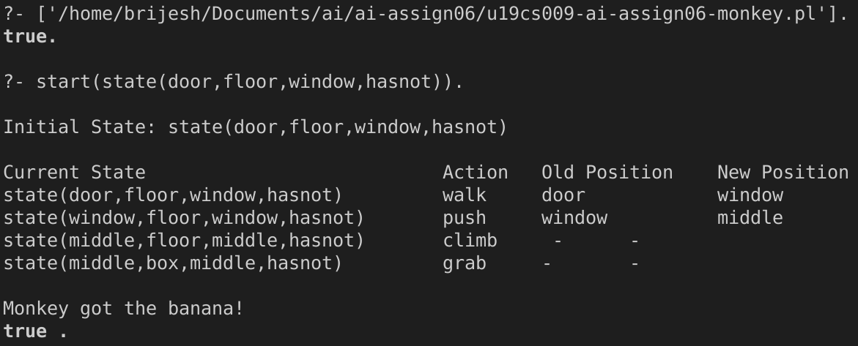

2. Initial state

* Monkey at window
* Monkey on floor
* Box at window
* Monkey does not have the banana

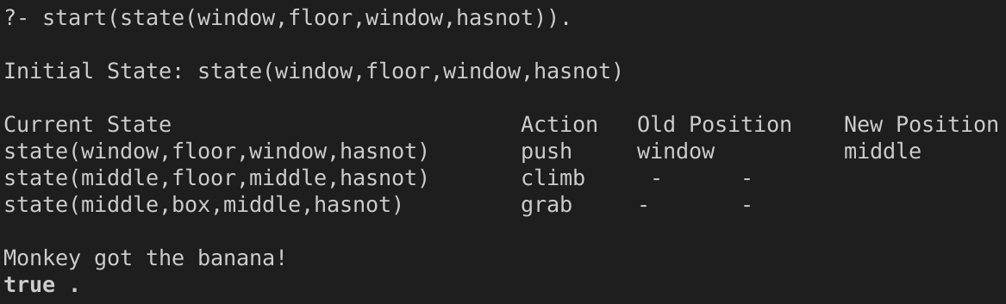

3. Initial state

* Monkey at middle
* Monkey on floor
* Box at window
* Monkey does not have the banana

