**Name: Brijesh Ramesbhai Rohit**

**Admission number: U19CS009**

**AI-ASSIGNMENT-08**

**Implement N queens problem using below algorithms in prolog.**

**Compare the complexity of both algorithms.**

**Which algorithm is best suited for implementing the N queens problem and why?**

**1. Breadth First Search**

**CODE :**

| **nqueen:-**  **write("Enter N: "),**  **read(N),**  **helper([],[],0,0,N,Added),**  **write(Added),nl,**  **solve(Added,N).**  **len([_|T],L):-**  **len(T,L1),**  **L is L1+1.**  **addEle(A,List,NewList):-**  **append(List,[A],NewList).**  **solve([],_):-**  **write("No solution exists"),nl.**  **solve([Board|Rem],N):-**  **len(Board,L1),nl,**  **L1 =:= N ->**  **write("Answer: "),**  **write(Board),nl;**  **len(Board,L2),**  **helper(Rem,Board,L2,0,N,Added),**  **write(Added),nl,**  **solve(Added,N).**  **helper(Boards,_,_,N,N,Boards).**  **helper(Boards,Board,R,C,N,Added):-**  **%write(R),nl,**  **C < N,**  **ok(R,C,Board,0) ->**  **addEle(C,Board,NewBoard),**  **addEle(NewBoard,Boards,NewBoards),**  **C1 is C+1,**  **helper(NewBoards,Board,R,C1,N,Added);**  **C2 is C+1,**  **helper(Boards,Board,R,C2,N,Added).**  **ok(_,_,[],_).**  **ok(R,C,[H|T],N):-**  **H =\= C,**  **N =\= R,**  **Sum1 is R + C,**  **Sum2 is H + N,**  **Sum1 =\= Sum2,**  **Diff1 is R - C,**  **Diff2 is N-H,**  **Diff1 =\= Diff2,**  **N1 is N+1,**  **ok(R,C,T,N1).** |
| --- |

**OUTPUT :**

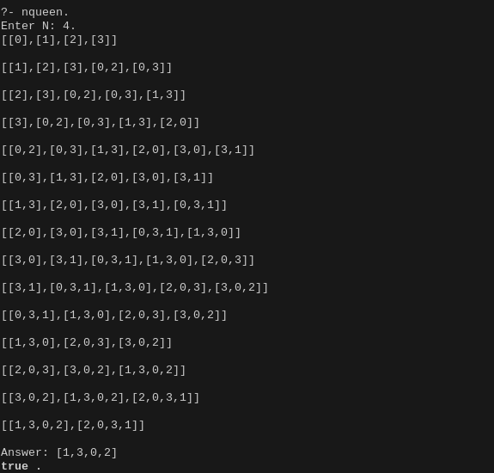

**2. Depth First Search**

| **addEle(A,List,NewList):-**  **append(List,[A],NewList).**  **solve(Board,N,_,Board,N).**  **solve(Board,R,C,Ans,N):-**  **ok(R,C,Board,0),**  **addEle(C,Board,NewBoard),**  **R1 is R+1,**  **solve(NewBoard,R1,0,Ans,N).**  **solve(Board,R,C,Ans,N):-**  **C < N-1,**  **C1 is C+1,**  **solve(Board,R,C1,Ans,N).**  **ok(_,_,[],_).**  **ok(R,C,[H|T],N):-**  **H =\= C,**  **N =\= R,**  **Sum1 is R + C,**  **Sum2 is H + N,**  **Sum1 =\= Sum2,**  **Diff1 is R - C,**  **Diff2 is N-H,**  **Diff1 =\= Diff2,**  **N1 is N+1,**  **ok(R,C,T,N1).**  **:-**  **write("Enter N: "),**  **read(N),**  **solve([],0,0,Ans,N),**  **write(Ans).** |
| --- |

**OUTPUT :**

