**Name: Brijesh Rameshbhai Rohit**

**Admission number: U19CS009**

**AI-ASSIGNMENT-09**

Implement 8 Puzzle problem using below algorithms in prolog. Compare the complexity of both algorithms. Which algorithm is best suited for implementing 8 Puzzle problem and why?

1. DFS

Code:

|  |
| --- |
| hswap([A1,A2,A3],1,[A2,A1,A3]).  hswap([A1,A2,A3],2,[A1,A3,A2]).  vswap([A1,A2,A3],[B1,B2,B3],1,[B1,A2,A3],[A1,B2,B3]).  vswap([A1,A2,A3],[B1,B2,B3],2,[A1,B2,A3],[B1,A2,B3]).  vswap([A1,A2,A3],[B1,B2,B3],3,[A1,A2,B3],[B1,B2,A3]).  goal([[1,2,3],[4,5,6],[7,8,w]]).  getcells([H1,H2,H3],[H1,H2,H3]).  dfs(Path,Node,Path,_,_,_):-      goal(Node).  %RIGHT  dfs(Path,Node,Sol,I,J,K):-      I>0,I=<3,J>0,J<3,      % K<5,K1 is K+1,      % write(Node),nl,      getcells(Node,[A,B,C]),      (          (I==1)->(              hswap(A,J,X),not(member([X,B,C],Path)),J1 is J+1,dfs([[X,B,C]|Path],[X,B,C],Sol,I,J1,K)              );          (I==2)->(              hswap(B,J,X),not(member([A,X,C],Path)),J1 is J+1,dfs([[A,X,C]|Path],[A,X,C],Sol,I,J1,K)              );          (I==3)->(              hswap(C,J,X),not(member([A,B,X],Path)),J1 is J+1,dfs([[A,B,X]|Path],[A,B,X],Sol,I,J1,K)              )            ),!.  %DOWN  dfs(Path,Node,Sol,I,J,K):-      I>0,I<3,J>0,J=<3,      % K<5,K1 is K+1,      % write(Node),nl,      getcells(Node,[A,B,C]),      (          (I==2)->(          vswap(B,C,J,X,Y),not(member([A,X,Y], Path)),I1 is I+1,dfs([[A,X,Y]|Path],[A,X,Y],Sol,I1,J,K)              );          (I==1)->(              vswap(A,B,J,X,Y),not(member([X,Y,C], Path)),I1 is I+1,dfs([[X,Y,C]|Path],[X,Y,C],Sol,I1,J,K)              )      ),!.  %UP  dfs(Path,Node,Sol,I,J,K):-      I>1,I=<3,J>0,J=<3,      % K<5,K1 is K+1,      % write(Node),nl,      getcells(Node,[A,B,C]),      (          (I==2)->(          vswap(A,B,J,X,Y),not(member([X,Y,C], Path)),I1 is I-1,dfs([[X,Y,C]|Path],[X,Y,C],Sol,I1,J,K)              );          (I==3)->(              vswap(B,C,J,X,Y),not(member([A,X,Y], Path)),I1 is I-1,dfs([[A,X,Y]|Path],[A,X,Y],Sol,I1,J,K)              )      ),!.  %LEFT  dfs(Path,Node,Sol,I,J,K):-      I>0,I=<3,J>1,J=<3,      % K<5,K1 is K+1,      % write(Node),nl,      getcells(Node,[A,B,C]),      (          J1 is J-1,          (I==1)->(              hswap(A,J1,X),not(member([X,B,C],Path)),dfs([[X,B,C]|Path],[X,B,C],Sol,I,J1,K)              );          (I==2)->(              hswap(B,J1,X),not(member([A,X,C],Path)),dfs([[A,X,C]|Path],[A,X,C],Sol,I,J1,K)              );          (I==3)->(              hswap(C,J1,X),not(member([A,B,X],Path)),dfs([[A,B,X]|Path],[A,B,X],Sol,I,J1,K)              )            ),!.  print([A,B,C]):-      write(A),nl,write(B),nl,write(C),nl,nl.  display([]).  display([H|T]):-      display(T),      print(H).  solve(Node,I,J):-      dfs([],Node,Sol,I,J,0),print(Node),display(Sol). |

Output:

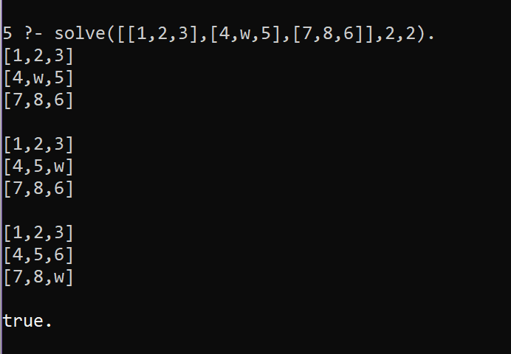

2. BFS

Code:

|  |
| --- |
| %U19CS009  %BRIJESH ROHIT  %PREDICATE TO PERFORM HORIZONAL SWAP  hswap([A1,A2,A3],1,[A2,A1,A3]).  hswap([A1,A2,A3],2,[A1,A3,A2]).  %PREDICATE TO PERFORM VERTICAL SWAP  vswap([A1,A2,A3],[B1,B2,B3],1,[B1,A2,A3],[A1,B2,B3]).  vswap([A1,A2,A3],[B1,B2,B3],2,[A1,B2,A3],[B1,A2,B3]).  vswap([A1,A2,A3],[B1,B2,B3],3,[A1,A2,B3],[B1,B2,A3]).  %FINAL GOAL STATE  goal([[1,2,3],[4,5,6],[7,8,w],[3,3]]).  %PREDICATE TO CHECK IF VALUES ARE SAME OR NOT  sets(X,X).  %PREDICATE TO GET RIGHT POSSIBILITY  getright([A,B,C,[I,J]],Right):-      I>0,I=<3,J>0,J<3,      (          (I==1)->              hswap(A,J,X),J1 is J+1,sets([X,B,C,[I,J1]],Right);          (I==2)->              hswap(B,J,X),J1 is J+1,sets([A,X,C,[I,J1]],Right);          (I==3)->              hswap(C,J,X),J1 is J+1,sets([A,B,X,[I,J1]],Right)      ).  getright(_,[]).  %PREDICATE TO GET LEFT POSSIBILITY  getleft([A,B,C,[I,J]],Left):-      I>0,I=<3,J>1,J=<3,      J1 is J-1,      (          (I==1)->              hswap(A,J1,X),sets([X,B,C,[I,J1]],Left);          (I==2)->              hswap(B,J1,X),sets([A,X,C,[I,J1]],Left);          (I==3)->              hswap(C,J1,X),sets([A,B,X,[I,J1]],Left)      ).    getleft(_,[]).  %PREDICATE TO GET UP POSSIBILITY  getup([A,B,C,[I,J]],Up):-      I>1,I=<3,J>0,J=<3,      (          (I==2)->              vswap(A,B,J,X,Y),I1 is I-1,sets(Up,[X,Y,C,[I1,J]]);          (I==3)->              vswap(B,C,J,X,Y),I1 is I-1,sets(Up,[A,X,Y,[I1,J]])      ),!.  getup(_,[]).  %PREDICATE TO GET DOWN POSSIBILITY  getdown([A,B,C,[I,J]],Down):-      (          (I==2)->          vswap(B,C,J,X,Y),I1 is I+1,sets([A,X,Y,[I1,J]],Down);          (I==1)->              vswap(A,B,J,X,Y),I1 is I+1,sets([X,Y,C,[I1,J]],Down)      ),!.  getdown(_,[]).  %PREDICATE TO APPEND  append([],X,X).  append([H|T],N,[H|T1]):-      append(T,N,T1).  %PREICATE TO PRINT THE SOLUTION  print([A,B,C,_]):-      write(A),nl,write(B),nl,write(C),nl,nl.  display([]).  display([H|T]):-      display(T),      print(H).  %TO GET LIST OF ADJACENT NODES OF THE CURRENT NODE  extend([Node|Path],NewPaths):-      bagof(          [NewNode,Node|Path],              (                  (                      (getup(Node,X),sets(X,NewNode),not(sets(NewNode,[])));                      (getdown(Node,X),sets(X,NewNode),not(sets(NewNode,[])));                      (getleft(Node,X),sets(X,NewNode),not(sets(NewNode,[])));                      (getright(Node,X),sets(X,NewNode),not(sets(NewNode,[])))                  ),                  not(member(NewNode,[Node|Path]))              ),NewPaths          ),!.  extend(_,[]).  %PERFORMING BFS  bfs([[Node|Path]|_],[Node|Path],_):-      goal(Node),write("\ndone\n"),!.  bfs([Path|Paths],Sol,K):-      K<3,K1 is K+1,      extend(Path,NewPath),      append(Paths,NewPath,Path1),      bfs(Path1,Sol,K1).  %SOLVING FUNCTION  solve(Node):-      bfs([[Node]],X,0)      ,display(X). |

Output:

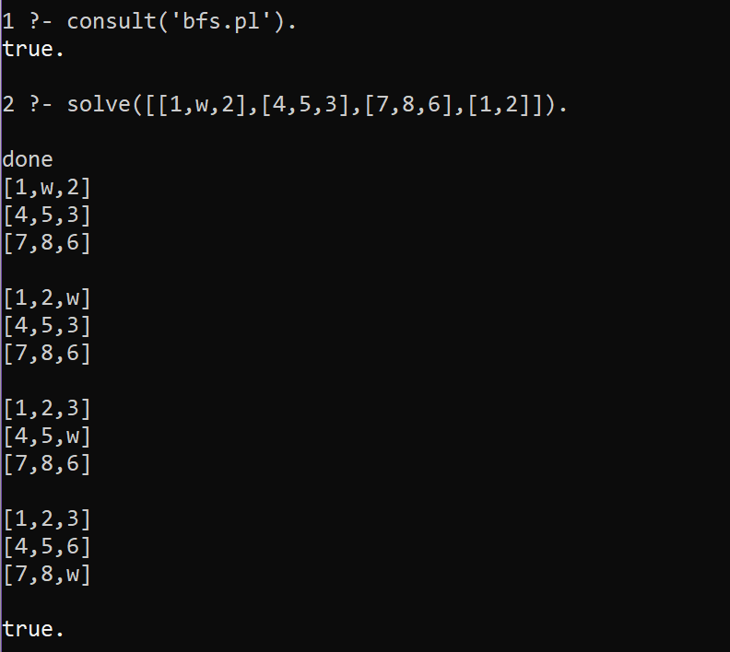

3. Uniform Cost Search

**Since cost of each step in this 8-puzzle problem is same, Uniform cost search will be same as breadth first search.**

**CONCLUSION:**

**Time-Complexity:**

**Depth First Search: O(bM).**

**Breadth First Search: O(bD).**

**Uniform Cost Search: O(bD).**

**b:** Number of Branches. (On average for 3x3 matrix it is 3).

**M: Maximum depth of the tree**

**D:** Depth at which goal state lies.

If time and space complexity are not the issue then BFS is better as it would return shortest path to our goal state which was not possible with DFS (DFS would have returned the 1st possible path to goal state rather than the shortest one).