**Name: Brijesh Rohit**

**Admission no: U19CS009**

**CV-ASSIGNMENT-03**

Apply PCA on the dataset of face images given. There are 40 images in the dataset. Experiment by selecting a different number of principle components while performing dimensionality reduction. Reconstruct few of the original images using the dimensionality reduced data and observe the reconstruction capability. Show original image and the reconstructed image side by side in the submission pdf. Also mention the number of principle components used.

**CODE :**

| **# U19CS009**  **# BRIJESH ROHIT**  **import numpy as np**  **from PIL import Image**  **import matplotlib.image as mplib**  **import matplotlib.pyplot as plt**  **import random**  **plt.rcParams.update({'figure.max_open_warning': 0})**  **def Extract(Img_mean,L,e,N_comp):**  **# Sorting according to eigen values**  **Indices = np.argsort(L)[::-1]**  **L_sorted = L[Indices]**  **e_sorted = e[:,Indices]**  **# Selecting 1st N_comp eigen vectors**  **E = e_sorted[:,0:N_comp]**  **# Calulating Reduced Image Matrix**  **Img_Red = np.dot(E.transpose() , Img_mean.transpose() ).transpose()**  **return Img_Red,E**  **def eigen_Cal(Img_mean ):**  **# Calculating Covariance**  **cov_mat = np.cov(Img_mean , rowvar = False)**  **# Calculating Eigen Values and Eigen Vectors**  **L , e = np.linalg.eigh(cov_mat)**  **return L,e**  **img=[]**  **for x in range(1,41):**  **X=Image.open("Images for Assignment/f"+str(x)+".pgm")**  **X=np.asarray(X)**  **X=X.flatten()**  **img.append(X)**  **img_arr=np.array(img)**  **Img_mean = img_arr - np.mean(img_arr , axis = 0)**  **# GETTING EIGEN VALUES AND VECTORS**  **L,e=eigen_Cal(Img_mean)**  **# GETTING REDUCED IMAGE FOR COMPONENTS COUNT = 100**  **P1,E1=Extract(Img_mean,L,e,100)**  **final1=np.dot(P1,E1.transpose())**  **# GETTING REDUCED IMAGE FOR COMPONENTS COUNT = 200**  **P2,E2=Extract(Img_mean,L,e,200)**  **final2=np.dot(P2,E2.transpose())**  **print("Matrix Size of 40 images of dimension [112,92] before PCA : ",img_arr.shape,"\n")**  **print("Matrix Size of 40 images of dimension [112,92] after PCA : ",P1.shape,", ",P2.shape,"\n")**  **# PLOTTING IMAGE**  **plt.figure(figsize=(20,20))**  **for x in range(0,40):**  **Img_org=img_arr[x].reshape([112,92])**  **Img_red1=final1[x].reshape([112,92])**  **Img_red2=final2[x].reshape([112,92])**  **f, axarr = plt.subplots(1,3)**  **axarr[0].set_title("Original Image")**  **axarr[1].set_title("(100)")**  **axarr[2].set_title("(200)")**  **axarr[0].imshow(Img_org)**  **axarr[1].imshow(Img_red1)**  **axarr[2].imshow(Img_red2)**  **# GETTING REDUCED IMAGE FOR COMPONENTS COUNT = 1000**  **P3,E3=Extract(Img_mean,L,e,1000)**  **final3=np.dot(P3,E3.transpose())**  **# GETTING REDUCED IMAGE FOR COMPONENTS COUNT = 5000**  **P4,E4=Extract(Img_mean,L,e,5000)**  **final4=np.dot(P4,E4.transpose())**  **print("Matrix Size of 40 images of dimension [112,92] before PCA : ",img_arr.shape,"\n")**  **print("Matrix Size of 40 images of dimension [112,92] after PCA : ",P3.shape,", ",P4.shape,"\n")**  **# PLOTTING IMAGE**  **plt.figure(figsize=(20,20))**  **for x in range(0,40):**  **Img_org=img_arr[x].reshape([112,92])**  **Img_red1=final3[x].reshape([112,92])**  **Img_red2=final4[x].reshape([112,92])**  **f, axarr = plt.subplots(1,3)**  **axarr[0].set_title("Original Image")**  **axarr[1].set_title("(1000)")**  **axarr[2].set_title("(5000)")**  **axarr[0].imshow(Img_org)**  **axarr[1].imshow(Img_red1)**  **axarr[2].imshow(Img_red2)** |
| --- |

**OUTPUT : For number of principle component = 100 and 200**

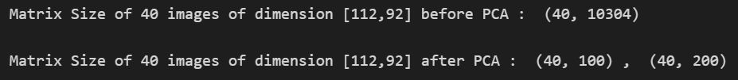

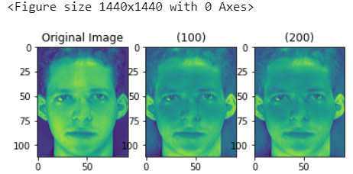

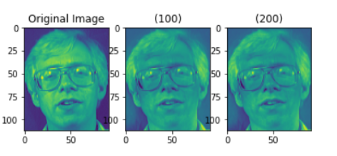

**OUTPUT : For number of principle component = 1000 and 5000**

