**Distributed System**

**Lab Assignment-1**

**BRIJESH ROHIT**

**U19CS009**

**Connection-Oriented Service**

There is a sequence of operation to be followed by the users of connection-oriented service. These are: 1. Connection is established.

2. Information is sent.

3. Connection is released.

In connection-oriented service we have to establish a connection before starting the communication. When connection is established, we send the message or the information and then we release the connection. Connection oriented service is more reliable than connectionless service. We can send the message in connection-oriented service if there is an error at the receiver's end. Example of connection oriented is TCP (Transmission Control Protocol) protocol.

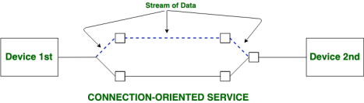

Suppose, a sender wants to send data to the receiver. Then, first, the sender sends a request packet to a receiver in the form of an SYN packet. After that, the receiver responds to the sender's request with an (SYN-ACK) signal/packets. That represents the confirmation is received by the receiver to start the communication between the sender and the receiver. Now a sender can send the message or data to the receiver.

Similarly, a receiver can respond or send the data to the sender in the form of packets. After successfully exchanging or transmitting data, a sender can terminate the connection by sending a signal to the receiver. In this way, we can say that it is a reliable network service.

TCP is a connection-oriented protocol that allows communication between two or more computer devices by establishing connections in the same or different networks. It is the most important protocol that uses internet protocol to transfer the data from one end to another. Hence, it is sometimes referred to as TCP/IP. It ensures that the connection is established and maintained until the data packet is transferring between the sender and receiver is complete.

TCP HEADER

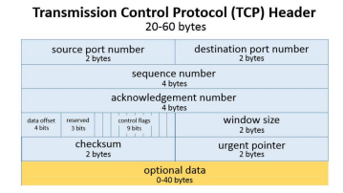

Connectionless Service

A connection is similar to a postal system, in which each letter takes along different route paths from the source to the destination address. Connectionless service is used in the network system to transfer data from one end to another end without creating any connection. So, it does not require establishing a connection before sending the data from the sender to the receiver. It is not a reliable network service because it does not guarantee the transfer of data packets to the receiver, and data packets can be received in any order to the receiver. Therefore, we can say that the data packet does not follow a defined path. In connectionless service, the transmitted data packet is not received by the receiver due to network congestion, and the data may be lost.

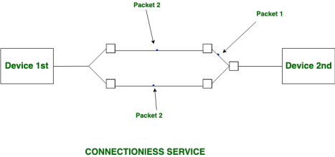

For example, a sender can directly send any data to the receiver without establishing any connection because it is a connectionless service. Data sent by the sender will be in the packet or data streams containing the receiver's address. In connectionless service, the data can be travelled and received in any order. However, it does not guarantee to transfer of the packets to the right destination.

The UDP (User Datagram Protocol) is a connectionless protocol that allows communication between two or more devices without establishing any connection. In this protocol, a sender sends the data packets to the receiver that holds the destination address. A UDP does not ensure to deliver the data packets to the correct destination, and it does not generate any acknowledgment about the sender's data. Similarly, it does not acknowledge the receiver about the data. Hence, it is an unreliable protocol.

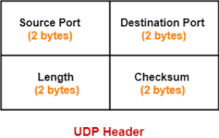

**Differences between Connectionless and Connection-oriented Connectionless**

1. No authentication necessary

2. No guarantees of delivery

3. Less Reliable

4. Message Based

5. Analogous to postal

6. Bursts to communication

7. Congestion is possible

8. Packets do not follow same route

9. Low range bandwidth adequate

**Connection-oriented**

1. Authentication necessary

2. Checks whether message is received, sends again if error occurs 3. More Reliable

4. Stream Based

5. Analogous to telephone

6. Long and steady

7. Congestion is not possible

8. Packets follow same route

9. High range bandwidth adequate