**Name: Brijesh Rameshbhai Rohit**

**Admission number: U19CS009**

**DISTRIBUTED SYSTEMS**

**ASSIGNMENT 2**

Execute all commands on Linux terminal and note down the functionality of each.

1. Basic Unix/Linux commands:

* ls :  list directory contents.

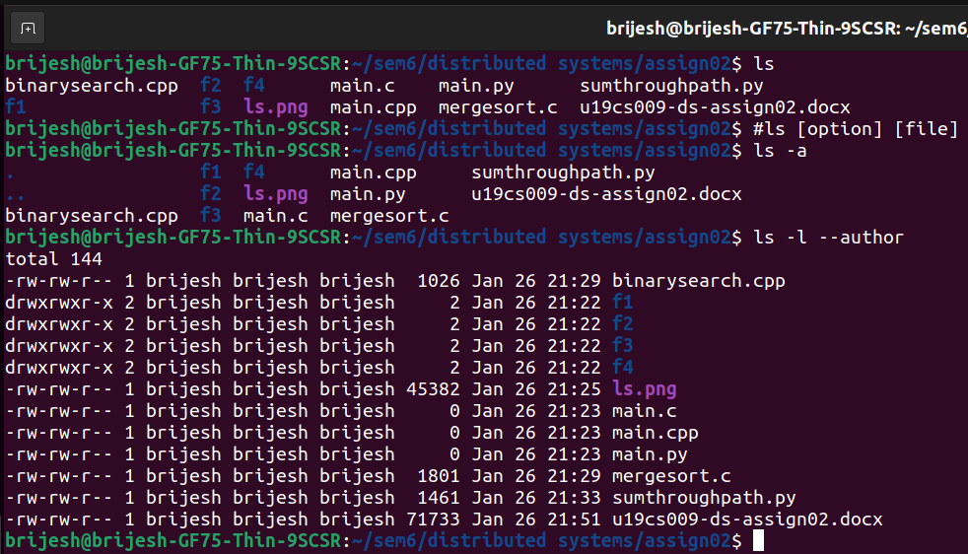

* date : print or set the system date and time.

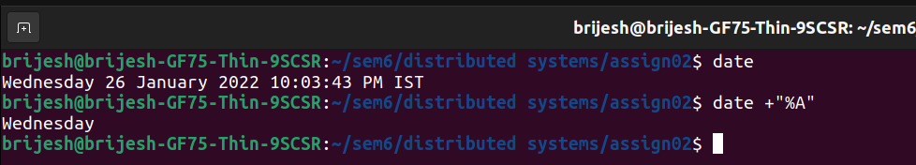

* help : The help command just displays information about shell built-in commands and their patterns.

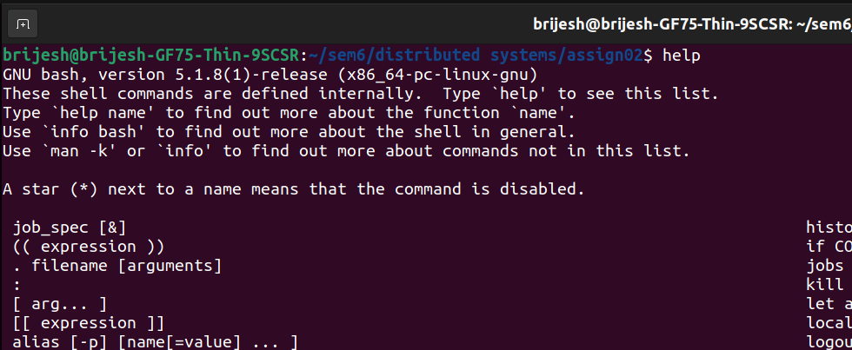

* info : The info command is used under Linux or Unix to read multi page documentation and act as help viewer working on a command line interface

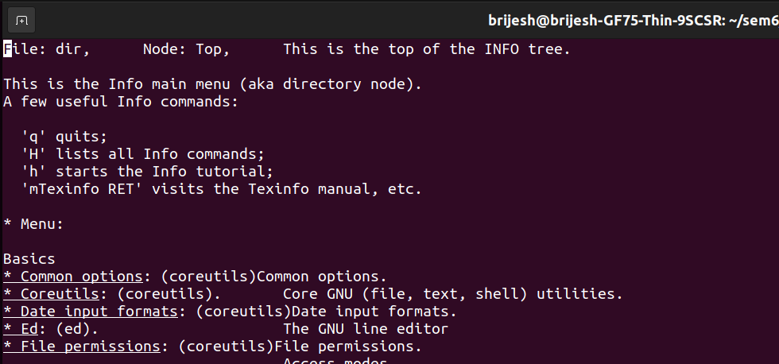

* man : This command in Linux is used to display the user manual of any command that we can run on the terminal.

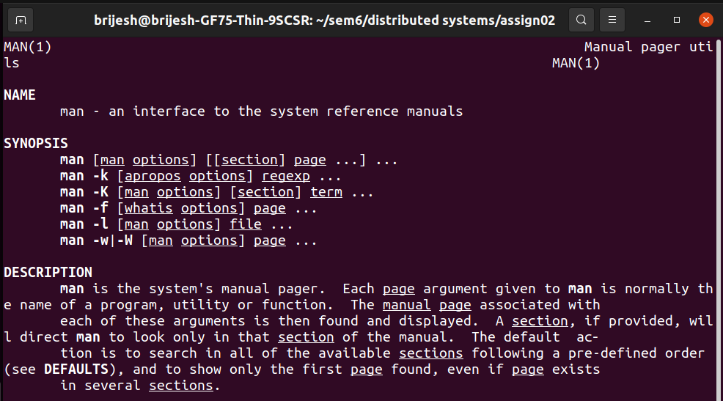

* who : The Linux "who" command lets you display the users currently logged in to your UNIX or Linux operating system.

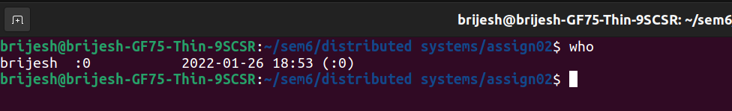

* pwd : It prints the path of the working directory, starting from the root.

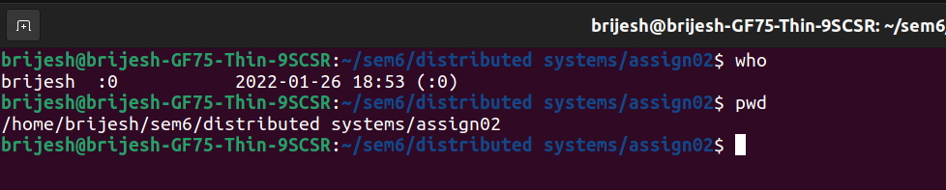

* cat : cat command allows us to create single or multiple files, view content of a file, concatenate files and redirect output in terminal or files.

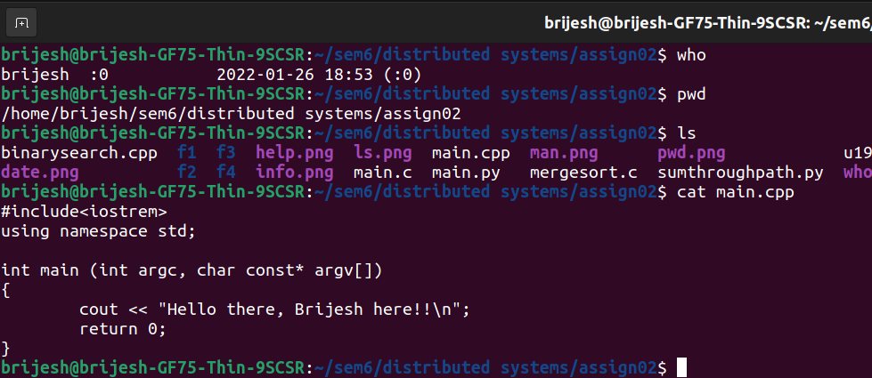

* more : more command is used to view the text files in the command prompt, displaying one screen at a time in case the file is large.

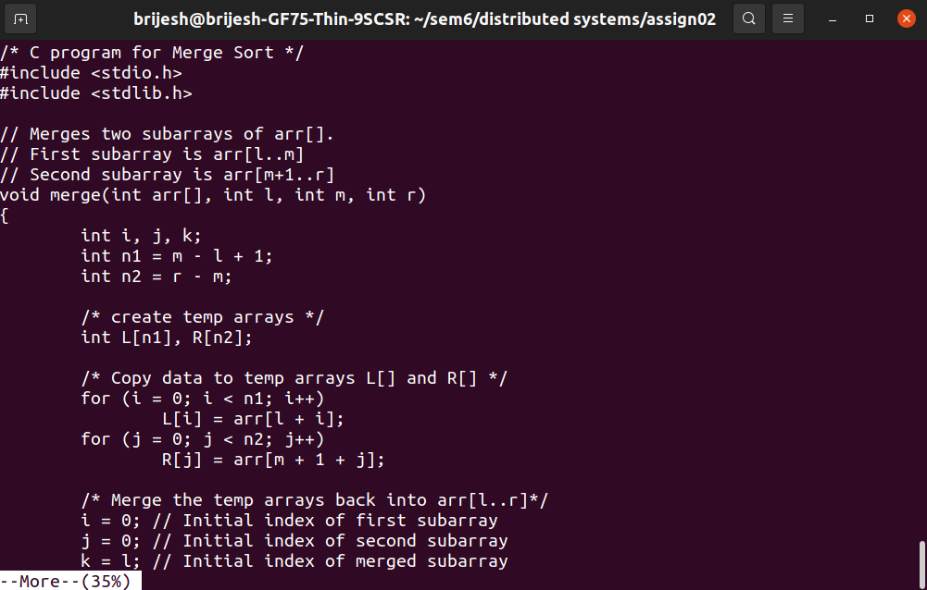

* mv : mv stands for move. mv is used to move one or more files or directories from one place to another in a file system like UNIX.

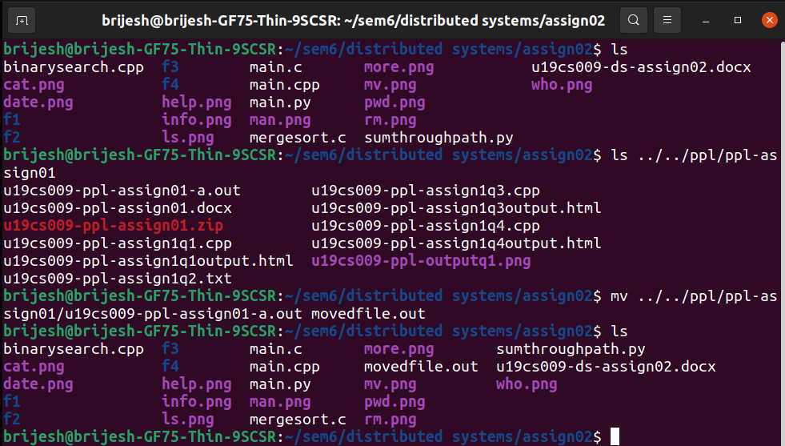

* rm : rm command is used to remove objects such as files, directories, symbolic links and so on from the file system like UNIX.

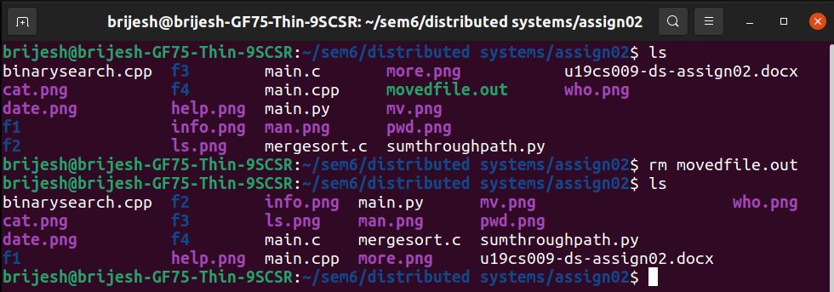

* chmod : the chmod command is used to change the access mode of a file.

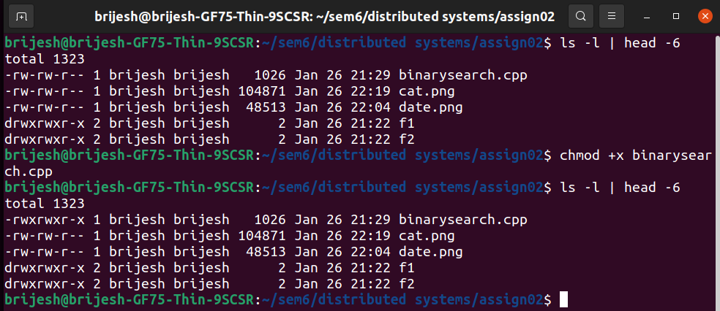

* whoami : It displays the username of the current user when this command is invoked.

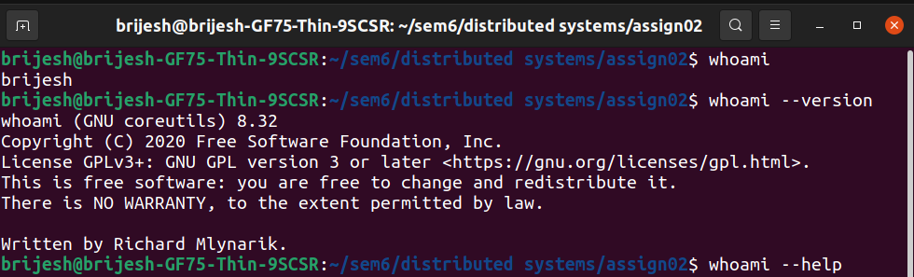

* logout : logout command allows you to programmatically logout from your session. causes the session manager to take the requested action immediately.

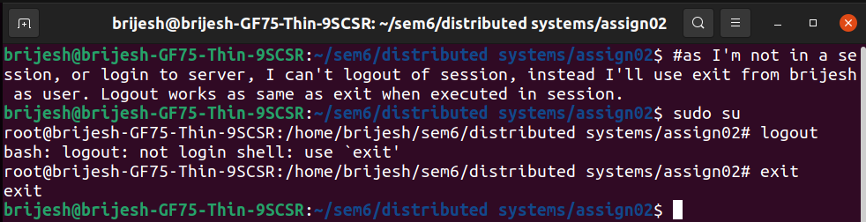

* wc : The wc command in UNIX is a command line utility for printing newline, word and byte counts for files

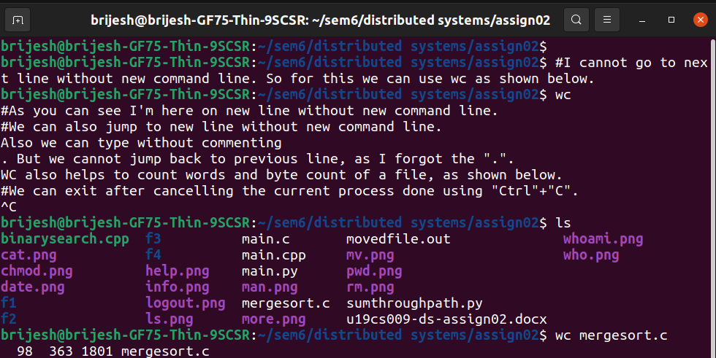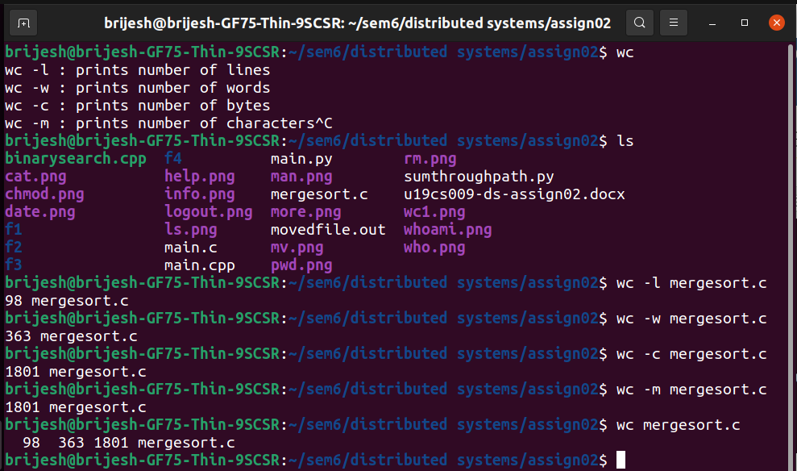

* grep : The grep filter searches a file for a particular pattern of characters, and displays all lines that contain that pattern.

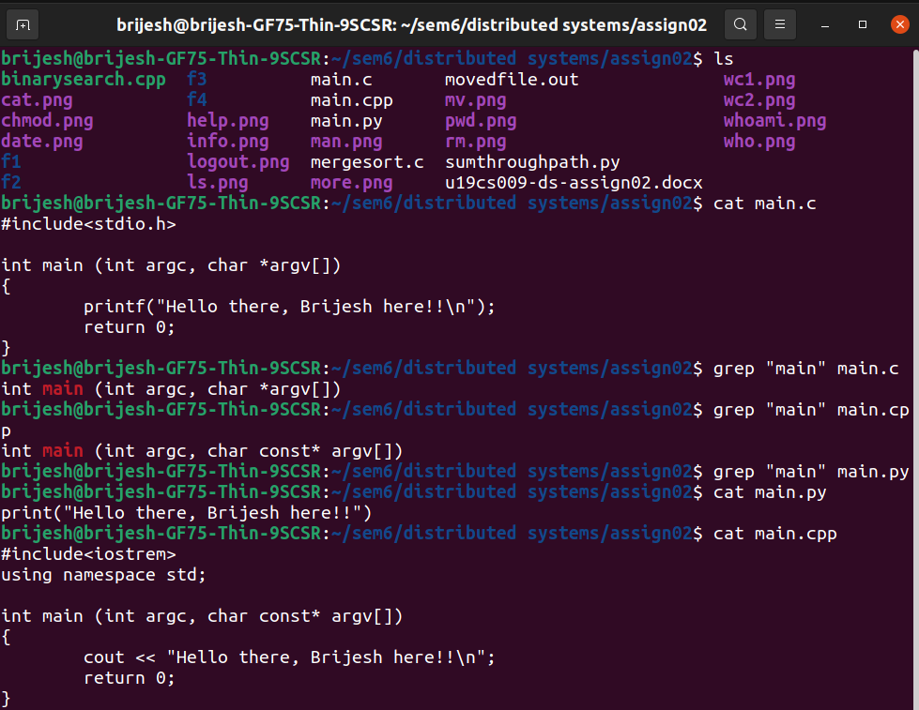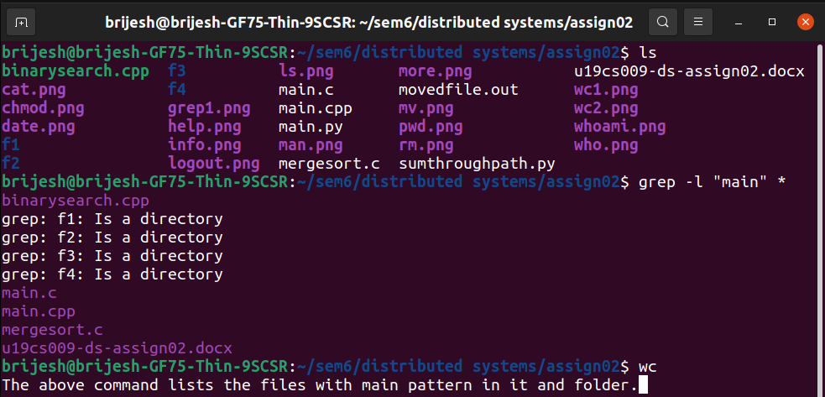

* sort : sort command is used to sort a file, arranging the records in a particular order.

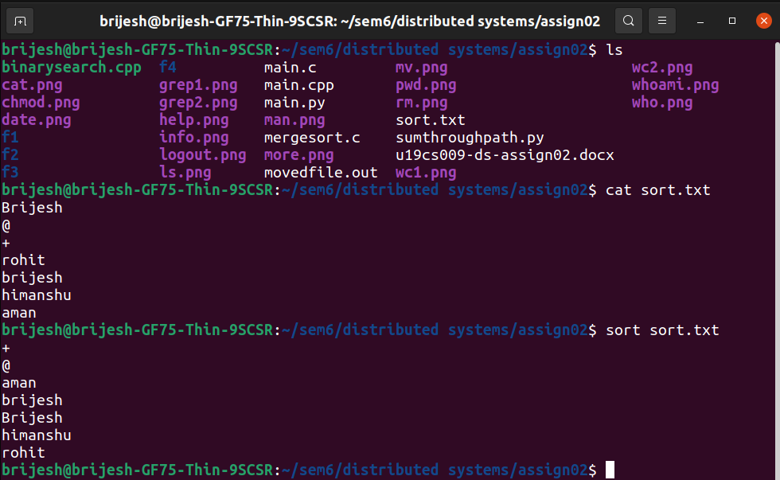

* mkdir : mkdir command in Linux allows the user to create directories.

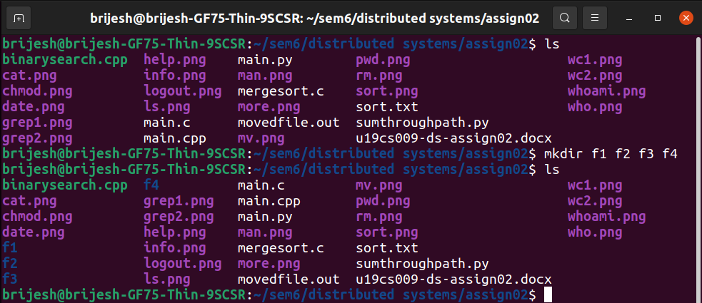

* rmdir : rmdir command in Linux allows the user to delete directories present in the filesystem.

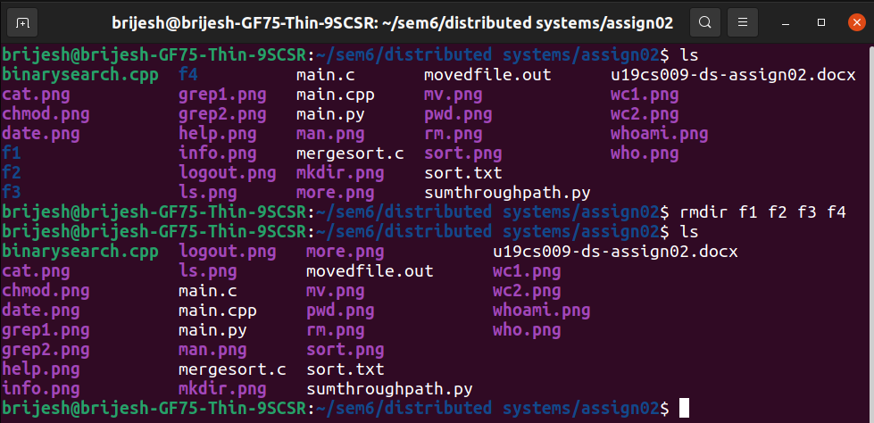

* cd : This command in linux is used to change current working directory.

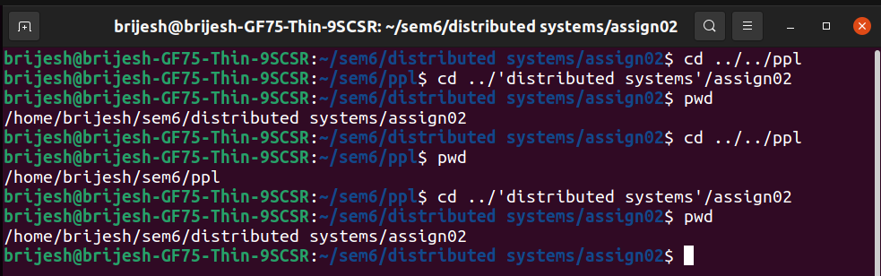

* tail : The tail command, as the name implies, print the last N number of data of the given input.

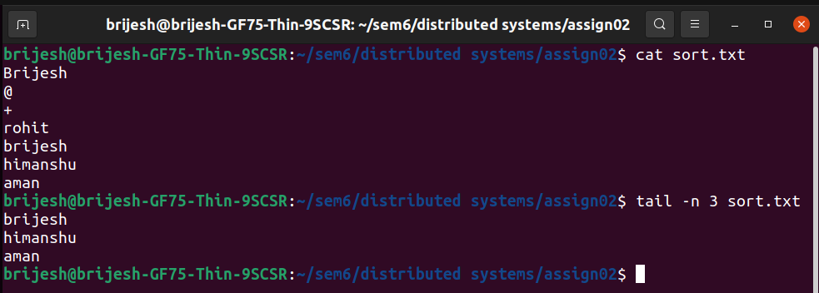

* cmp : cmp command in Linux/UNIX is used to compare the two files byte by byte and helps you to find out whether the two files are identical or not.

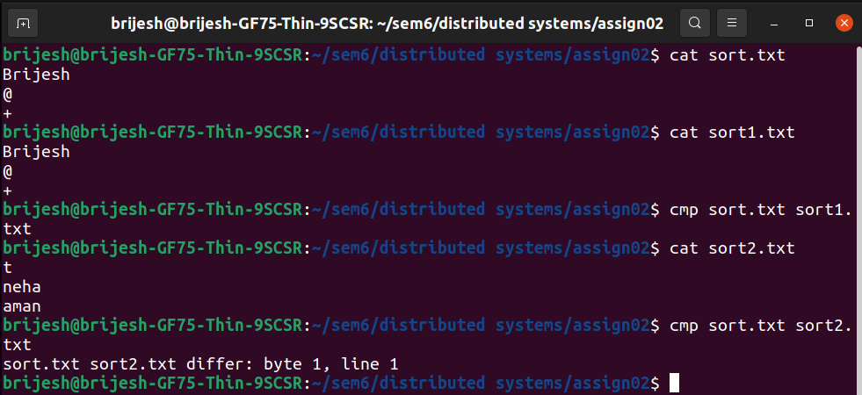

* diff : diff stands for difference. This command is used to display the differences in the files by comparing the files line by line.

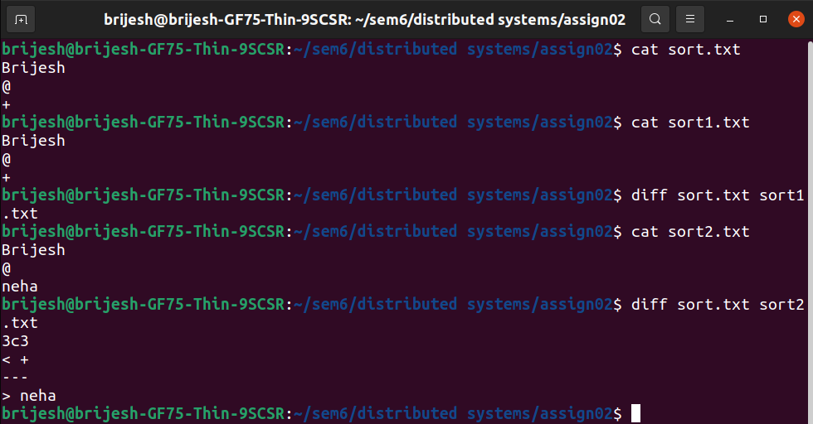

* cp : This command is used to copy files or group of files or directory.

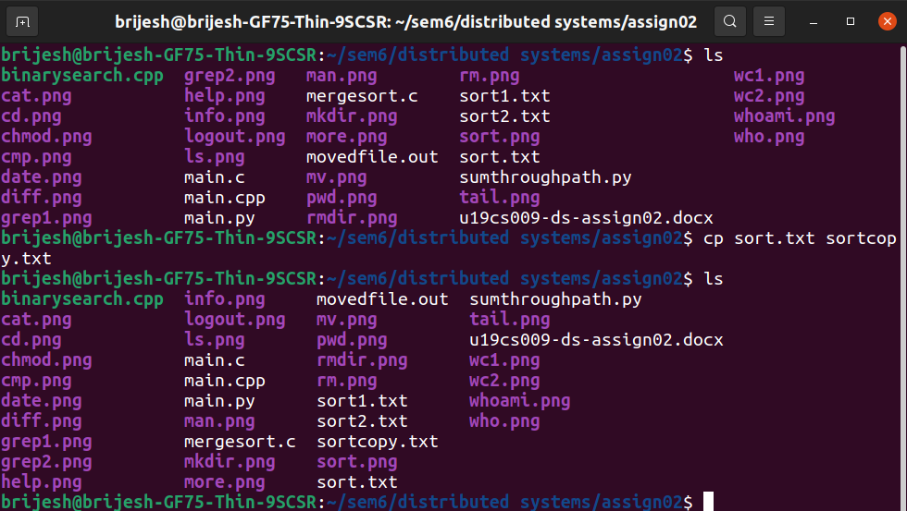

* clear : This command is used to clear the contents of terminal.

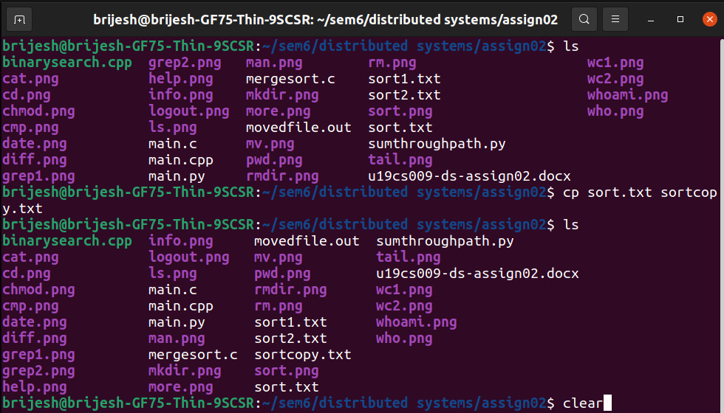

* df : The df command (short for disk free), is used to display information related to file systems about total space and available space.

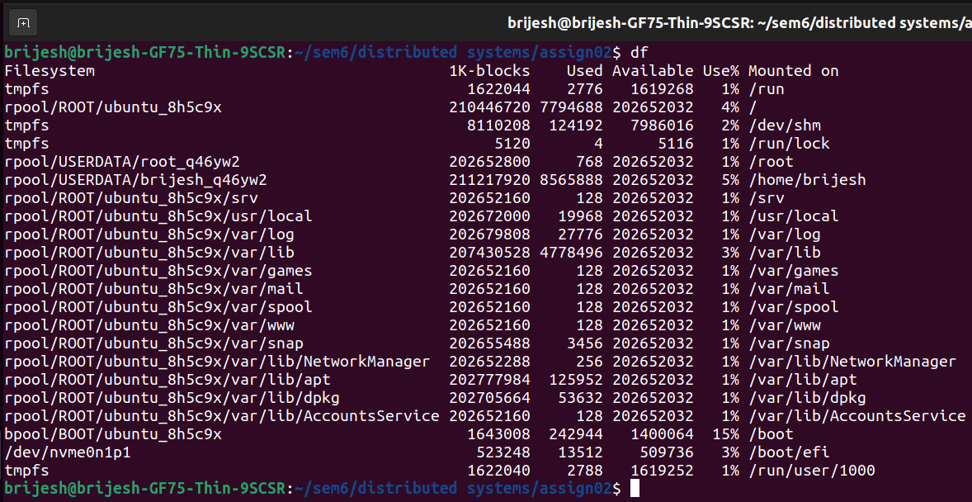

* du : du command, short for disk usage, is used to estimate file space usage.

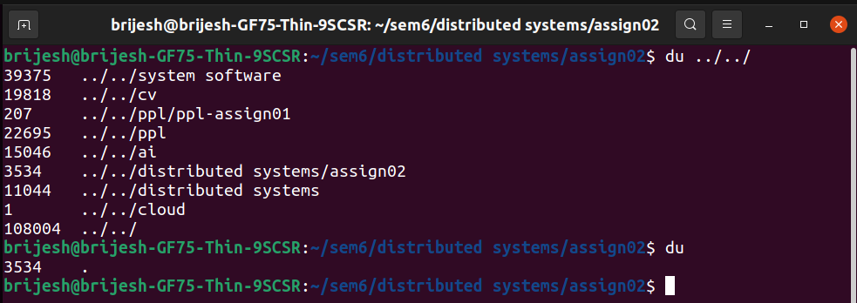

* uname : The command uname displays the information about the system.

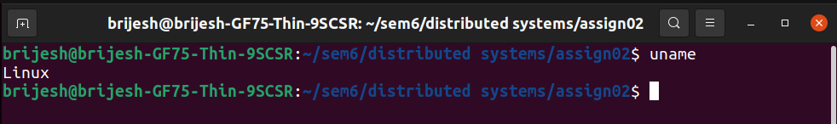

* apt-get : apt-get is a command-line tool which helps in handling packages in Linux.

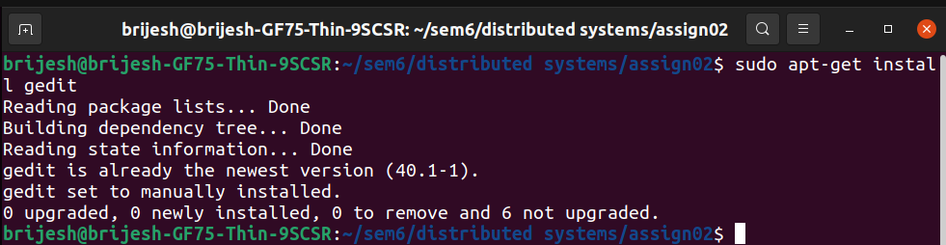

* find : It can be used to find files and directories and perform subsequent operations on them.

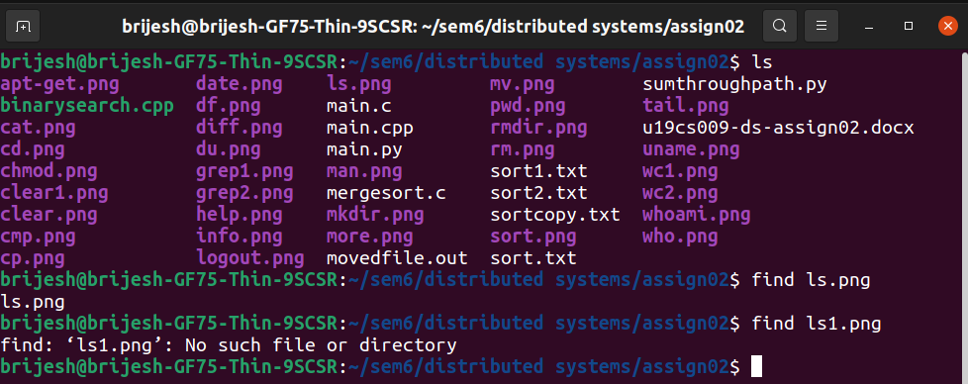

* wget : Wget is the non-interactive network downloader which is used to download files from the server even when the user has not logged on to the system and it can work in the background without hindering the current process.

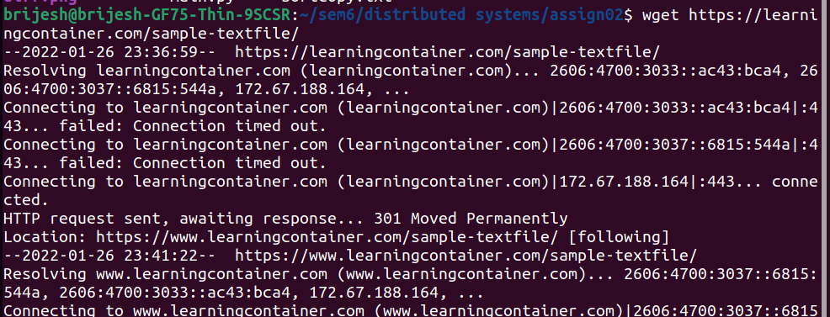

* top :top command is used to show the Linux processes. It provides a dynamic real-time view of the running system:

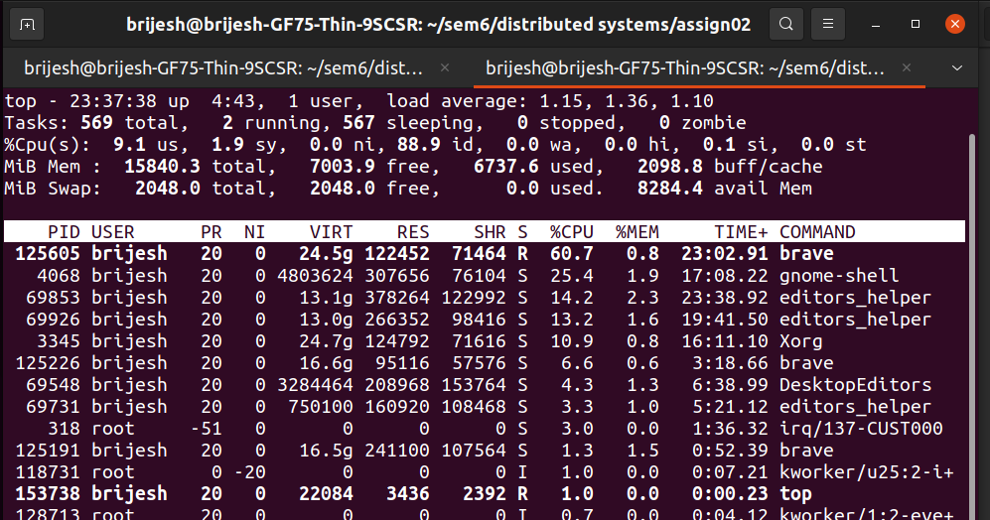

* mpstate : mpstat is a command that is used to report processor related statistics. It accurately displays the statistics of the CPU usage of the system.

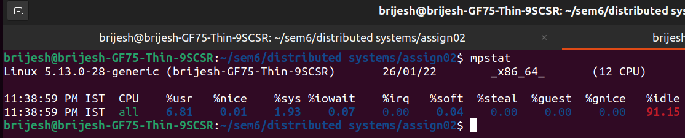

* netstat : Netstat command displays various network related information such as

network connections, routing tables, interface statistics, masquerade connections, multicast memberships etc.,

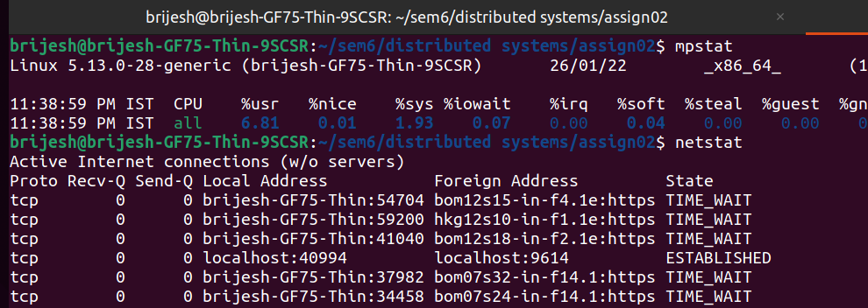

* sar : It can be used to monitor Linux system’s resources like CPU usage, Memory utilization, I/O devices consumption, Network monitoring, Disk usage, process and thread allocation, battery performance, Plug and play devices, processor performance, file system and more.

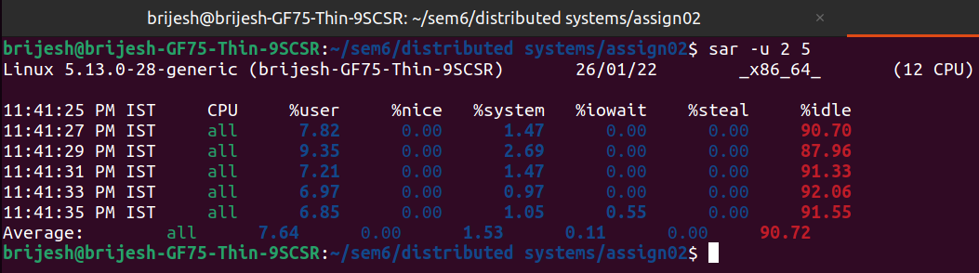

* chown : It is used to change the owner and group of the file specified by the file descriptor or path.

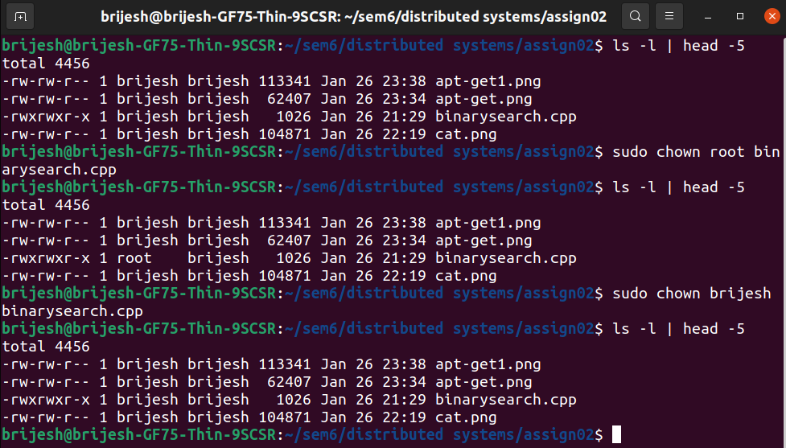

1. Linux commands related with process:

* ps : ps command is used to list the currently running processes and their PIDs along with some other information depends on different options.

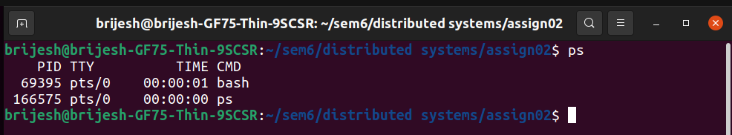

* kill : kill command in Linux (located in /bin/kill), is a built-in command which is used to terminate processes manually.

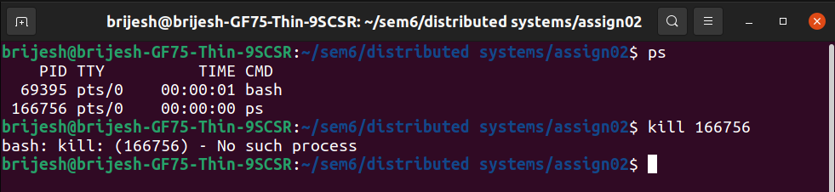

* Background processing with &. : To run a command in the background, add the ampersand symbol (&) at the end of the command: The shell job ID (surrounded with brackets) and process ID will be printed on the terminal:

