**Name: Brijesh Rohit**

**Admission no.: U19CS009**

**DISTRIBUTED SYSTEMS - ASSIGNMENT - 4**

**Implement echo client-server message passing application. Message sent from client should be displayed on server and then program should terminate.**

**1. Write a server (TCP) C Program that opens a listening socket and waits to serve client.**

**CODE=>**

|  |
| --- |
| //U19CS009  //Brijesh Rohit  #include<stdio.h>  #include<stdlib.h>  #include<sys/types.h>  #include<sys/socket.h>  #include<unistd.h>  #include<netinet/in.h>  int main() {  //creating a socket for server  int server_socket, client_socket;  server_socket = socket(AF_INET, SOCK_STREAM, 0);  if (server_socket < 0)  {  perror("--> Server error !!!\n");  exit(1);  }  //define server_address and client_address  struct sockaddr_in server_address, client_address;  server_address.sin_family = AF_INET;  server_address.sin_port = htons(9002);  //passing port number 9002  server_address.sin_addr.s_addr = INADDR_ANY;  //specifing local machine address  //binding socket with specific IP and port number  int bind_connection = bind(server_socket, (struct sockaddr *)&server_address, sizeof(server_address));  printf("Bind to the port number : 9002");  //listening to connection  listen(server_socket, 4);  printf("\nListening...........\n");  //accept a connection  int size_client_addr = sizeof(client_address);  client_socket = accept(server_socket, (struct sockaddr *)&client_address, &size_client_addr);  printf(".....Client is connected.....\n");  //recive data from client  char response_client[256];  recv(client_socket, &response_client, sizeof(response_client), 0);  //last parameter is optional so putting 0  //print out the data received from client  printf("Message from client : ");  printf("%s", response_client);  printf("\n");  //close the socket  close(server_socket);  printf("\nClient disconnected…………..\n");  return 0;  } |

**2. Write a client (TCP) C Program that connects with the server program knowing IP address and port number.**

**CODE=>**

|  |
| --- |
| //U19CS009  //Brijesh Rohit  #include<stdio.h>  #include<stdlib.h>  #include<sys/types.h>  #include<sys/socket.h>  #include<unistd.h>  #include<netinet/in.h>  int main() {  //Creating a socket for client  int no_socket;  no_socket = socket(AF_INET, SOCK_STREAM, 0);  //specifing address for client socket  struct sockaddr_in client_address;  client_address.sin_family = AF_INET;  client_address.sin_port = htons(9002);  //passing port number 9002  client_address.sin_addr.s_addr = INADDR_ANY;  //specifing local machine address  int connection_status = connect(no_socket, (struct sockaddr *)&client_address, sizeof(client_address));  // 0 OK -1 error  //Checking whether there is an error in connection  if (connection_status < 0)  {  perror("--->There was an error making connection with the remote socket\n\n");  exit(1);  }  printf("Connected to the server.......\n");  //send data to server  char send_server[256];  printf("Enter the message to send : ");  scanf("%s", send_server);  send(no_socket, send_server, sizeof(send_server), 0);  printf("\n");  //close the connection  close(no_socket);  printf("\n Disconnected from server.......\n");  return 0;  } |

**3. Get the input string from console on client and send it to server, server displays the same string.**

**Waiting for client to respond**

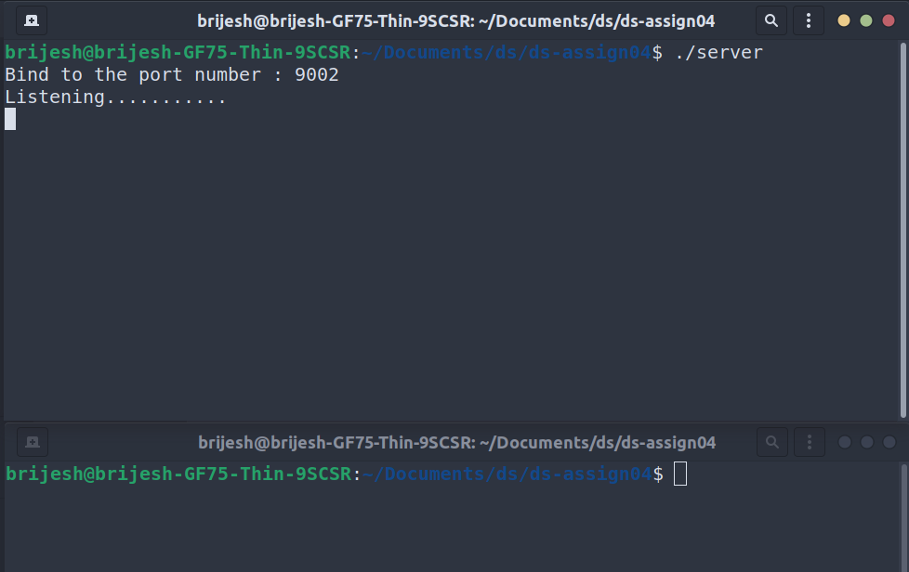

**Client connected and connection established**

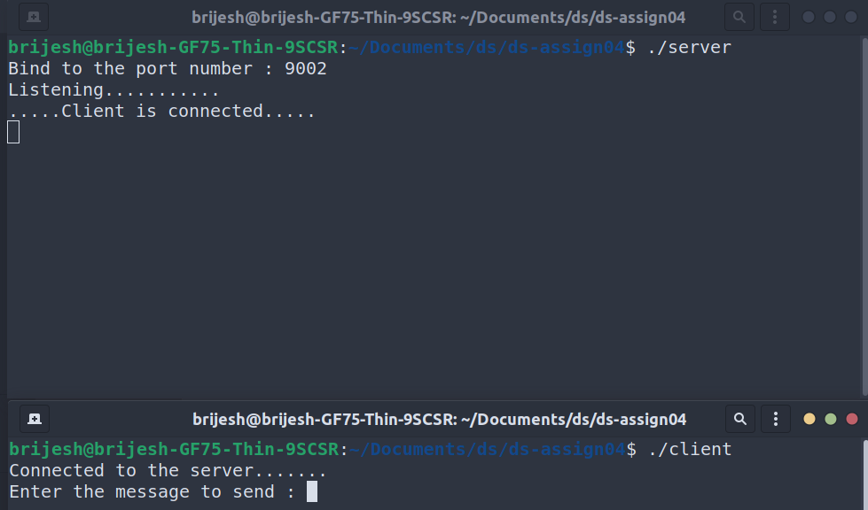

**Requested completed and message exchanged, and network ended.**

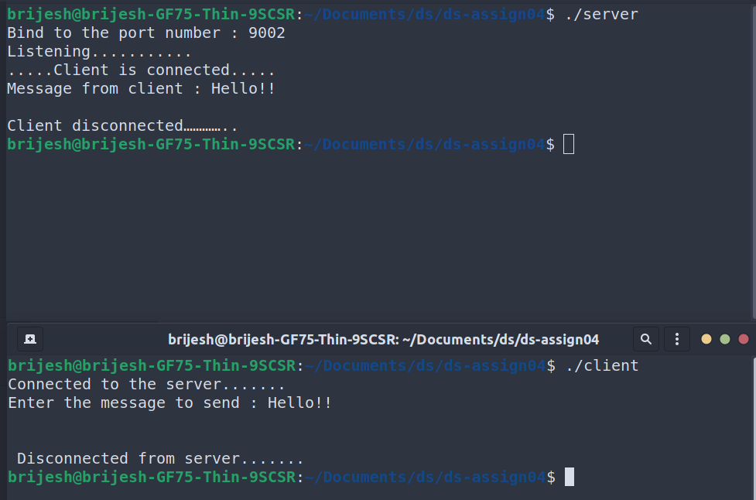

**In case of error on client side, connection automatically ends and nothing is passed.**

