**Name: Brijesh Rameshbhai Rohit**

**Admission number: U19CS009**

**DISTRIBUTED SYSTEMS**

**ASSIGNMENT - 06**

**Simulate RPC (Create any one procedure on remote machine and call it from local machine)**

**List of programs for RPC**

**1. Find out the factorial of given number.**

**CODE :**

| **struct number**  **{**  **int num;**  **};**  **program FACTORIAL_PROG{**  **version FACTORIAL_VERS{**  **int factorial(number)=1;**  **}=1;**  **}=0x84562877;** |
| --- |

**CODE - SERVER**

| /*  * This is sample code generated by rpcgen.  * These are only templates and you can use them  * as a guideline for developing your own functions.  */  #include "factorial.h"  int *  factorial_1_svc(number *argp, struct svc_req *rqstp)  {  static int result;  /*  * insert server code here  */    int flag = 1;  if(argp->num < 0)  {  printf("Factorial of negative numbers are not calculated!!!\n");  flag = 0;  }  result = 1;  for(int i = 2 ; i <= argp->num ; i++)  result *= i;  if(flag)  printf("%d! = %d\n", argp->num, result);  return &result;  } |
| --- |

**CODE - CLIENT**

| /*  * This is sample code generated by rpcgen.  * These are only templates and you can use them  * as a guideline for developing your own functions.  */  #include "factorial.h"  void  factorial_prog_1(char *host, int num1)  {  CLIENT *clnt;  int *result_1;  number factorial_1_arg;  #ifndef DEBUG  clnt = clnt_create (host, FACTORIAL_PROG, FACTORIAL_VERS, "udp");  if (clnt == NULL) {  clnt_pcreateerror (host);  exit (1);  }  #endif /* DEBUG */  int flag = 1;  factorial_1_arg.num = num1;  result_1 = factorial_1(&factorial_1_arg, clnt);  if (result_1 == (int *) NULL) {  clnt_perror (clnt, "call failed");  }  else  {  if(num1 < 0)  {  printf("Factorial of negative is not possible!!!\n");  flag = 0;  }  else  {  printf("Factorial of %d : %d\n", num1, *result_1);  }  }  #ifndef DEBUG  clnt_destroy (clnt);  #endif /* DEBUG */  }  int  main (int argc, char *argv[])  {  char *host;  if (argc < 2) {  printf ("usage: %s server_host\n", argv[0]);  exit (1);  }  host = argv[1];  int num1;  char ch = 'y';  while (ch=='y')  {  system("clear");  printf("Please enter an integer : ");  scanf("%d", &num1);  factorial_prog_1 (host, num1);  printf("Do you want to calculate factorial again ? (y/n) : ");  scanf("%s", &ch);  }  exit (0);  } |
| --- |

**OUTPUT :**

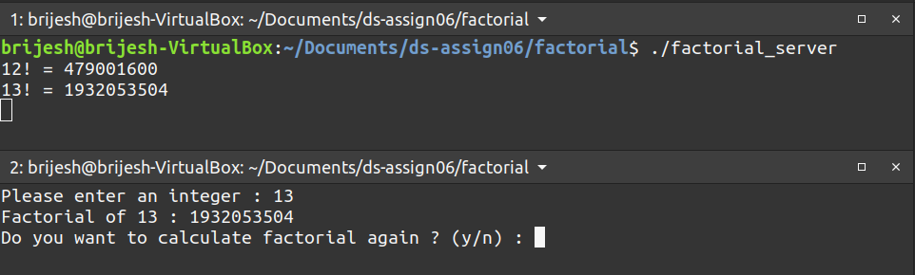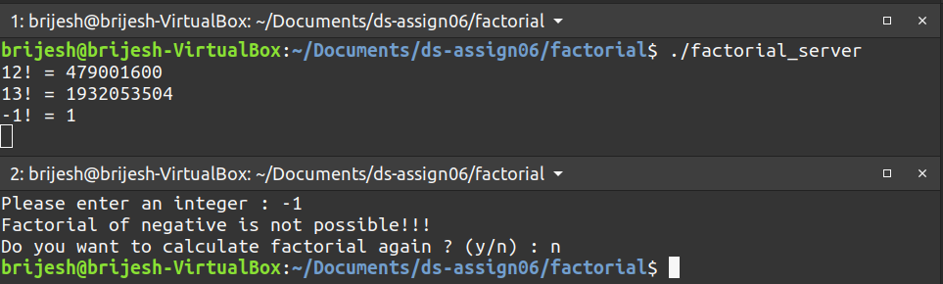

**2. Implement Calculator (Basic operation).**

**CODE :**

| **struct inputs{**  **float num1;**  **float num2;**  **char operator;**  **};**    **program CALCULATE_PROG{**  **version CALCULATE_VER{**  **float CALCULATE(inputs)=1;**  **}=1;**  **}=0x2fffffff;** |
| --- |

**CODE - SERVER**

| /*  * This is sample code generated by rpcgen.  * These are only templates and you can use them  * as a guideline for developing your own functions.  */  #include "calculate.h"  float * calculate_1_svc(inputs *argp, struct svc_req *rqstp)  {  static float result;  float a = argp->num1;  float b = argp->num2;  char op = argp->operator;  int flag = 1;  if(op=='+')  result = a+b;  else if(op=='-')  result = a-b;  else if(op=='*')  result = a*b;  else  {  if(b==0)  {  printf("Division with 0 is invalid!!!\n");  flag = 0;  }  }    if(flag)  printf("%f %c %f = %f\n",a, op, b, result);    return &result;  } |
| --- |

**CODE - CLIENT**

| /*  * This is sample code generated by rpcgen.  * These are only templates and you can use them  * as a guideline for developing your own functions.  */  #include "calculate.h"  void  calculate_prog_1(char *host, float a, float b, char op)  {  CLIENT *clnt;  float *result_1;  inputs calculate_1_arg;  #ifndef DEBUG  clnt = clnt_create (host, CALCULATE_PROG, CALCULATE_VER, "udp");  if (clnt == NULL) {  clnt_pcreateerror (host);  exit (1);  }  #endif /* DEBUG */  calculate_1_arg.num1 = a;  calculate_1_arg.num2 = b;  calculate_1_arg.operator = op;  result_1 = calculate_1(&calculate_1_arg, clnt);  if (result_1 == (float *) NULL) {  clnt_perror (clnt, "call failed");  }  else  {  int flag = 1;  if(op=='/')  {  if(b==0)  {  printf("Division with 0 is invalid!!!\n");  flag = 0;  }  }  if(flag)  {  printf("%f %c %f = %f",a, op, b, *result_1);  }  }  #ifndef DEBUG  clnt_destroy (clnt);  #endif /* DEBUG */  }  int  main (int argc, char *argv[])  {  char *host;  if (argc < 2) {  printf ("usage: %s server_host\n", argv[0]);  exit (1);  }  host = argv[1];    char op;  float a, b;  int ch=1;  while(ch)  {  system("clear");  printf("'+' : Addition\n");  printf("'-' : Subtraction\n");  printf("'*' : Multiplication\n");  printf("'/' : Division\n");  printf("Enter first number : ");  scanf("%f", &a);  printf("Enter second number : ");  scanf("%f", &b);  printf("Enter operator : ");  scanf("%s", &op);  calculate_prog_1 (host, a, b, op);  printf("\nDo calculations again ? (1/0) : ");  scanf("%d", &ch);  }  printf("Hope you enjoyed our SERVICE!!\n");  exit (0);  } |
| --- |

**OUTPUT :**

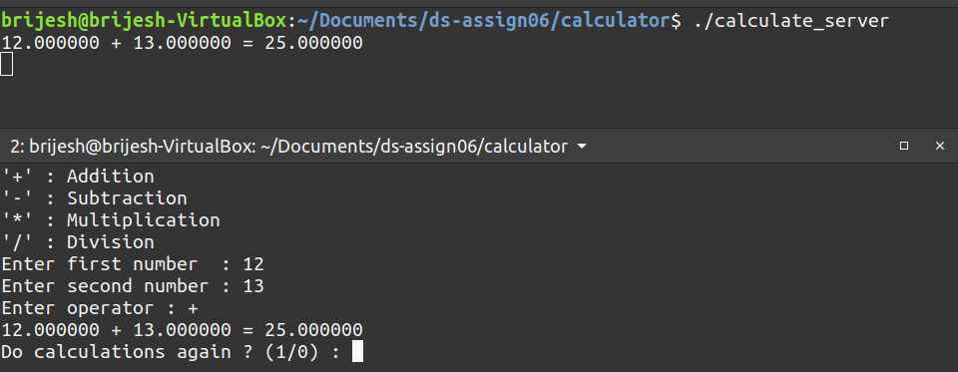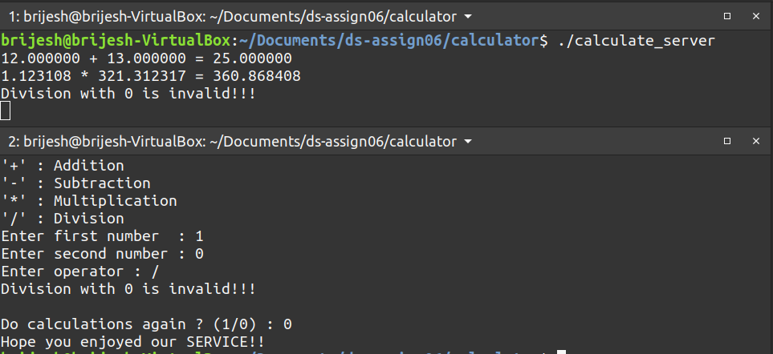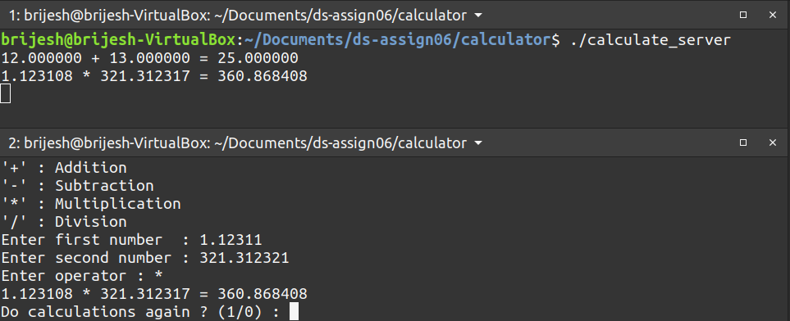

**3. Find out whether given number is Prime Number or not.**

**CODE :**

| **struct number{**  **int num;**  **};**  **program PRIME_PROG{**  **version PRIME_VERS{**  **int prime(number)=1;**  **}=1;**  **}=0x2f2f2f2f;** |
| --- |

**CODE - SERVER**

| /*  * This is sample code generated by rpcgen.  * These are only templates and you can use them  * as a guideline for developing your own functions.  */  #include "prime.h"  int *  prime_1_svc(number *argp, struct svc_req *rqstp)  {  static int result;  result=1;  if(argp->num < 1)  {  printf("Entered number is not positive!!\n");  result = 0;  return &result;  }  else if(argp->num == 1)  {  printf("1 is non-prime!!!\n");  result = 0;  return &result;  }  int n = 1;  while(n*n <= argp->num)  n++;  for(int i = 2 ; i <= n ; i++)  {  if(argp->num%i==0)  {  result = 0;  printf("%d is non-prime!!!\n", argp->num);  return &result;  }  }  printf("%d is PRIME!!!\n", argp->num);  return &result;  } |
| --- |

**CODE - CLIENT**

| /*  * This is sample code generated by rpcgen.  * These are only templates and you can use them  * as a guideline for developing your own functions.  */  #include "prime.h"  void  prime_prog_1(char *host, int num1)  {  CLIENT *clnt;  int *result_1;  number prime_1_arg;  #ifndef DEBUG  clnt = clnt_create (host, PRIME_PROG, PRIME_VERS, "udp");  if (clnt == NULL) {  clnt_pcreateerror (host);  exit (1);  }  #endif /* DEBUG */  int flag = 1;  prime_1_arg.num = num1;  result_1 = prime_1(&prime_1_arg, clnt);  if (result_1 == (int *) NULL) {  clnt_perror (clnt, "call failed");  }  if(num1 < 1)  {  printf("Prime characteristic is only for Positive integers!!!!\n");  }  else  {  if(*result_1)  {  printf("%d is a PRIME!!\n", num1);  }  else  {  printf("%d is non-prime\n", num1);  }  }  #ifndef DEBUG  clnt_destroy (clnt);  #endif /* DEBUG */  }  int  main (int argc, char *argv[])  {  char *host;  if (argc < 2) {  printf ("usage: %s server_host\n", argv[0]);  exit (1);  }  host = argv[1];  char ch='y';  int num;  while(ch=='y')  {  system("clear");  printf("Please enter an integer : ");  scanf("%d", &num);  prime_prog_1 (host, num);  printf("Do you want to check more prime numbers ? (y/n) : ");  scanf("%s", &ch);  }    exit (0);  } |
| --- |

**OUTPUT :** 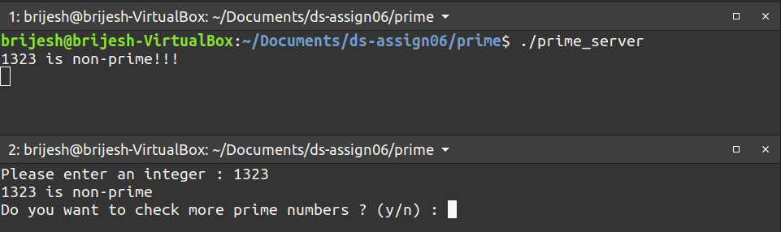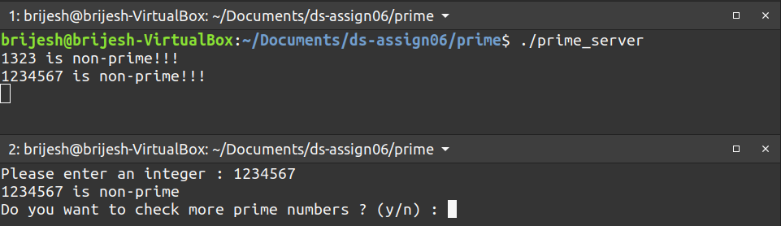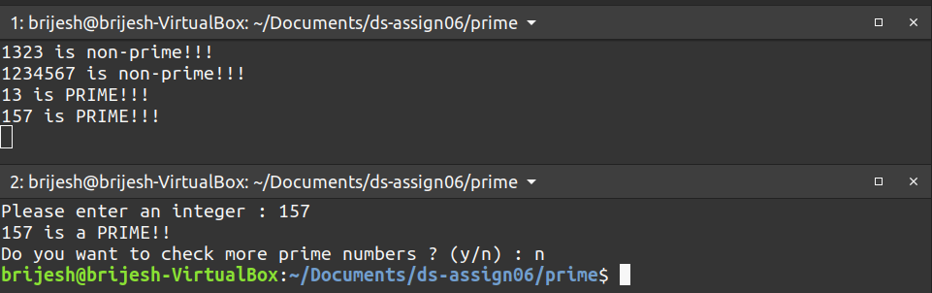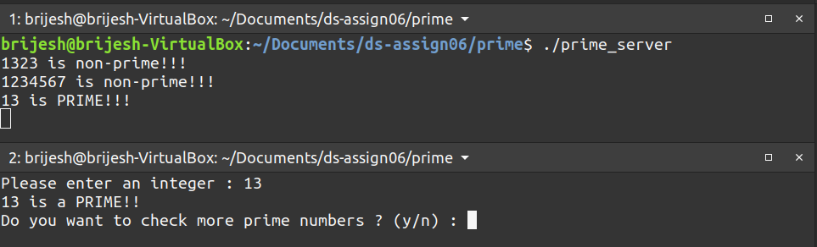

**4. Print out the Fibonacci series till the given number.**

**CODE :**

| **struct fibonacci{**  **int n;**  **};**  **program FIB_PROG{**  **version FIB_VERS{**  **int fib(fibonacci)=1;**  **}=1;**  **}=0x2f2f2f2f;** |
| --- |

**CODE - SERVER**

| /*  * This is sample code generated by rpcgen.  * These are only templates and you can use them  * as a guideline for developing your own functions.  */  #include "fib.h"  int *  fib_1_svc(fibonacci *argp, struct svc_req *rqstp)  {  static int result;  int n=argp->n;  if(n<=2)  result=1;  else  {  int cur=1,prev=1,i=2,temp;  while(i<n)  {  temp=cur;  cur=cur+prev;  prev=temp;  i++;  }  result=cur;  }  return &result;  } |
| --- |

**CODE - CLIENT**

| /*  * This is sample code generated by rpcgen.  * These are only templates and you can use them  * as a guideline for developing your own functions.  */  #include "fib.h"  void  fib_prog_1(char *host, int n)  {  CLIENT *clnt;  int *result_1;  fibonacci fib_1_arg;  #ifndef DEBUG  clnt = clnt_create (host, FIB_PROG, FIB_VERS, "udp");  if (clnt == NULL) {  clnt_pcreateerror (host);  exit (1);  }  #endif /* DEBUG */  fib_1_arg.n = 1;  printf("Fibonacci series till %d : ", n);  result_1 = fib_1(&fib_1_arg, clnt);  if (result_1 == (int *) NULL) {  clnt_perror (clnt, "call failed");  }  else  {  int i = 2;  while (*result_1<n)  {  printf(" %d",*result_1);  fib_1_arg.n=i;  result_1 = fib_1(&fib_1_arg, clnt);  i++;  }  printf("\n");  }  #ifndef DEBUG  clnt_destroy (clnt);  #endif /* DEBUG */  }  int  main (int argc, char *argv[])  {  char *host;  if (argc < 2) {  printf ("usage: %s server_host\n", argv[0]);  exit (1);  }  host = argv[1];  int n;  char ch='y';  while(ch=='y')  {  system("clear");  printf("Enter a number : ");  scanf("%d",&n);  fib_prog_1 (host,n);  printf("Do you want to repeat? (y/n): ");  scanf("%s",&ch);  }  exit (0);  } |
| --- |

**OUTPUT :**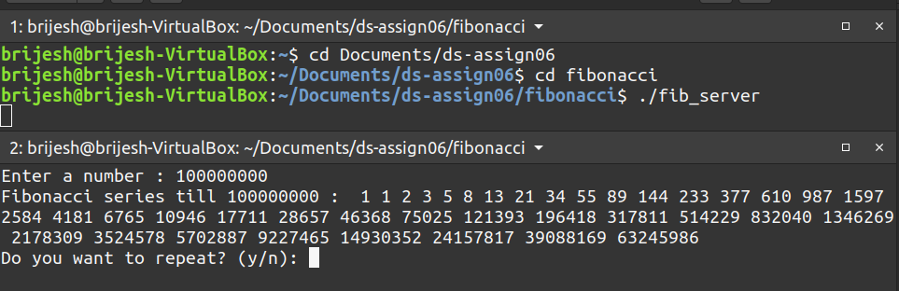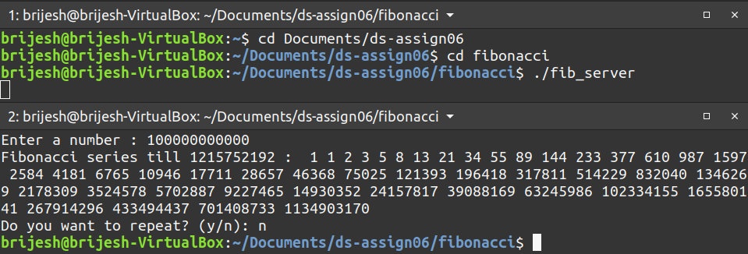

**5. Find the maximum value of an array of integers using RPC.**

**CODE :**

| **struct maxarray{**  **int size;**  **int arr[100];**  **};**  **program MAXARRAY_PROG{**  **version MAXARRAY_VERS{**  **int max(maxarray)=1;**  **}=1;**  **}=0x2f2f2f2f;** |
| --- |

**CODE - SERVER**

| /*  * This is sample code generated by rpcgen.  * These are only templates and you can use them  * as a guideline for developing your own functions.  */  #include "max.h"  int *  max_1_svc(maxarray *argp, struct svc_req *rqstp)  {  static int result;  result = argp->arr[0];  int n = argp->size;  for(int i = 1 ; i < n ; i++)  {  if(result < argp->arr[i])  result = argp->arr[i];  }  printf("Max element : %d\n", result);  return &result;  } |
| --- |

**CODE - CLIENT**

| /*  * This is sample code generated by rpcgen.  * These are only templates and you can use them  * as a guideline for developing your own functions.  */  #include "max.h"  void  maxarray_prog_1(char *host, int n)  {  CLIENT *clnt;  int *result_1;  maxarray max_1_arg;  #ifndef DEBUG  clnt = clnt_create (host, MAXARRAY_PROG, MAXARRAY_VERS, "udp");  if (clnt == NULL) {  clnt_pcreateerror (host);  exit (1);  }  #endif /* DEBUG */  max_1_arg.size = n;  printf("Please enter %d elements : ", n);  for (int i = 0; i < n; i++)  scanf("%d", &max_1_arg.arr[i]);  result_1 = max_1(&max_1_arg, clnt);  if (result_1 == (int *) NULL) {  clnt_perror (clnt, "call failed");  }  else  {  printf("Largest element in the array : %d\n", *result_1);  }  #ifndef DEBUG  clnt_destroy (clnt);  #endif /* DEBUG */  }  int  main (int argc, char *argv[])  {  char *host;  if (argc < 2) {  printf ("usage: %s server_host\n", argv[0]);  exit (1);  }  host = argv[1];  char ch='y';  int n=0;  while (ch=='y')  {  system("clear");  printf("Please enter size of array : ");  scanf("%d", &n);  if(n < 1 || n>100)  {  while (n<1)  {  printf("Please enter positive integer [1-100] : ");  scanf("%d", &n);  }  }  n%=101;  maxarray_prog_1 (host, n);  printf("Do you want to repeat ? (y/n) : ");  scanf("%s", &ch);  }  exit (0);  } |
| --- |

**OUTPUT :**