**Name: Brijesh Rameshbhai Rohit**

**Admission number: U19CS009**

**DISTRIBUTED SYSTEMS**

**ASSIGNMENT - 07**

**Simulate RPC (Create any one procedure on remote machine and call it from local machine)**

**Code=>**

| **struct input**  **{**  **int choice;**  **char str1[50];**  **char str2[50];**  **int num1;**  **int num2;**  **int year;**  **int arr[100];**  **};**  **struct output**  **{**  **int flag;**  **int gcd;**  **float sqrt;**  **int num1;**  **int num2;**  **int max;**  **int min;**  **float avg;**  **char str[100];**  **int arr[100];**  **};**  **program EXEC_PROG{**  **version EXEC_VERS{**  **output exec(input)=1;**  **}=1;**  **}=0x2f2f2f2f;** |
| --- |

**CLIENT SIDE CODE =>**

| **/\***  **\* This is sample code generated by rpcgen.**  **\* These are only templates and you can use them**  **\* as a guideline for developing your own functions.**  **\*/**  **#include "birju.h"**  **void**  **exec_prog_1(char *host, int ch)**  **{**  **CLIENT *clnt;**  **output *result_1;**  **input exec_1_arg;**  **#ifndef DEBUG**  **clnt = clnt_create (host, EXEC_PROG, EXEC_VERS, "udp");**  **if (clnt == NULL) {**  **clnt_pcreateerror (host);**  **exit (1);**  **}**  **#endif /* DEBUG */**  **exec_1_arg.choice=ch;**  **switch (ch)**  **{**  **case 1:**  **printf("Please enter the string : ");**  **scanf("%s", exec_1_arg.str1);**  **break;**  **case 2:**  **printf("Please enter a year : ");**  **scanf("%d", &exec_1_arg.year);**  **break;**  **case 3:**  **printf("Please enter first integer : ");**  **scanf("%d", &exec_1_arg.num1);**  **printf("Please enter second integer : ");**  **scanf("%d", &exec_1_arg.num2);**  **break;**  **case 4:**  **printf("Please enter a number : ");**  **scanf("%d", &exec_1_arg.num1);**  **break;**    **case 5:**  **printf("Please enter first number : ");**  **scanf("%d", &exec_1_arg.num1);**  **printf("Please enter second number : ");**  **scanf("%d", &exec_1_arg.num2);**  **printf("Values before swap are : %d %d\n", exec_1_arg.num1, exec_1_arg.num2);**  **break;**  **case 6:**  **printf("Please enter number of elements : ");**  **scanf("%d", &exec_1_arg.year);**  **printf("Please enter %d elements : ", exec_1_arg.year);**  **for(int i = 0 ; i < exec_1_arg.year && i < 20; i++)**  **{**  **scanf("%d", &exec_1_arg.arr[i]);**  **}**  **break;**  **case 7:**  **printf("Please enter first string : ");**  **scanf("%s", exec_1_arg.str1);**  **printf("Please enter second string : ");**  **scanf("%s", exec_1_arg.str2);**  **break;**  **case 8:**  **printf("Please enter first string : ");**  **scanf("%s", exec_1_arg.str1);**  **printf("Please enter second string : ");**  **scanf("%s", exec_1_arg.str2);**  **break;**    **case 9:**  **printf("Please enter first string : ");**  **scanf("%s", exec_1_arg.str1);**  **printf("Please enter second string : ");**  **scanf("%s", exec_1_arg.str2);**  **break;**    **case 10:**  **printf("Please enter number of elements : ");**  **scanf("%d", &exec_1_arg.year);**  **printf("Please enter %d elements : ", exec_1_arg.year);**  **for(int i = 0 ; i < exec_1_arg.year ; i++)**  **{**  **scanf("%d", &exec_1_arg.arr[i]);**  **}**  **break;**  **default:**  **printf("Please enter a valid choice!!\n");**  **return;**  **break;**  **}**  **result_1 = exec_1(&exec_1_arg, clnt);**  **if (result_1 == (output *) NULL) {**  **clnt_perror (clnt, "call failed");**  **}**  **switch (ch)**  **{**  **case 1:**  **if(result_1->flag)**  **printf("%s is Palindrome!!\n", exec_1_arg.str1);**  **else**  **printf("%s is not a Palindrome!!\n", exec_1_arg.str1);**  **break;**  **case 2:**  **if(result_1->flag)**  **printf("%d is a LEAP!!\n", exec_1_arg.year);**  **else**  **printf("%d is not LEAP!!\n", exec_1_arg.year);**  **break;**  **case 3:**  **printf("GCD(%d,%d) : %d\n", exec_1_arg.num1, exec_1_arg.num2, result_1->gcd);**  **break;**  **case 4:**  **printf("Square root of %d : %f\n", exec_1_arg.num1,result_1->sqrt);**  **break;**  **case 5:**  **printf("Values after swap are : %d %d\n", result_1->num1, result_1->num2);**  **break;**  **case 6:**  **printf("Maximum value in array : %d", result_1->max);**  **printf("\nMinimum Value in array : %d", result_1->min);**  **printf("\nAverage of all the values : %f\n", result_1->avg);**  **break;**  **case 7:**  **if(result_1->flag > 0)**  **printf("'%s' is greater than '%s'!!\n", exec_1_arg.str1, exec_1_arg.str2);**  **else if(result_1->flag == 0)**  **printf("Both strings are same!!\n");**  **else**  **printf("'%s' is greater than '%s'!!\n", exec_1_arg.str2, exec_1_arg.str1);**  **break;**  **case 8:**  **if(result_1->flag)**  **printf("%s string is substring of %s!!\n", exec_1_arg.str2, exec_1_arg.str1);**  **else**  **printf("%s string is not substring of %s!!\n", exec_1_arg.str2, exec_1_arg.str1);**  **break;**  **case 9:**  **printf("Concatenated string : %s\n", result_1->str);**  **break;**  **case 10:**  **printf("Reverse of array : ");**  **for(int i = 0 ; i < exec_1_arg.year ; i++)**  **printf("%d ", result_1->arr[i]);**  **printf("\n");**  **break;**  **default:**  **printf("Bye Bye!!\n");**  **return;**  **break;**  **}**    **#ifndef DEBUG**  **clnt_destroy (clnt);**  **#endif /* DEBUG */**  **}**  **int**  **main (int argc, char *argv[])**  **{**  **char *host;**  **if (argc < 2) {**  **printf ("usage: %s server_host\n", argv[0]);**  **exit (1);**  **}**  **host = argv[1];**  **int ch;**  **char op='y';**  **while (op=='y')**  **{**  **system("clear");**  **printf("1 : To check if a string is palindrome.\n");**  **printf("2 : Find if a year is leap.\n");**  **printf("3 : find gcd of two number.\n");**  **printf("4 : find square root of a given number.\n");**  **printf("5 : Swap two variables without third variable.\n");**  **printf("6 : Calculate maximum, mminimum and average.\n");**  **printf("7 : Compare two strings.\n");**  **printf("8 : Find whether a second string is substring.\n");**  **printf("9 : Concatenate two strings.\n");**  **printf("10 : Reverse elements of array.\n");**  **printf("Please enter your choice : ");**  **scanf("%d", &ch);**  **exec_prog_1 (host,ch);**  **printf("Do you want to continue? (y/n) : ");**  **scanf("%s", &op);**  **}**  **printf("Hope you liked our service!!\n");**  **exit (0);**  **}** |
| --- |

**SERVER SIDE CODE=>**

| **/\***  **\* This is sample code generated by rpcgen.**  **\* These are only templates and you can use them**  **\* as a guideline for developing your own functions.**  **\*/**  **#include "birju.h"**  **#include <string.h>**  **int isPalindrome(char str[])**  **{**  **int l=0;**  **int h = strlen(str)-1;**  **while (h>l)**  **{**  **if (str[l++] != str[h--])**  **return 0;**  **}**  **return 1;**  **}**  **int isLeap(int year)**  **{**  **if(year%400==0 || (year%100!=0 && year%4 == 0))**  **return 1;**  **return 0;**  **}**  **int gcd1(int a, int b)**  **{**  **if(a==0)**  **return b;**  **return gcd1(b%a,a);**  **}**  **int isSubstr(char *str1,char *str2)**  **{**  **int i=0,j;**  **int n1=strlen(str1);**  **int n2=strlen(str2);**  **int flag;**  **for (i = 0; i <= n1 - n2; i++)**  **{**  **for (j = i; j < i + n2; j++)**  **{**  **flag = 1;**  **if (str1[j] != str2[j - i])**  **{**  **flag = 0;**  **break;**  **}**  **}**  **if (flag == 1)**  **break;**  **}**  **return flag;**  **}**  **float findsqrt(float number)**  **{**  **float temp, sq_rt;**  **sq_rt = number / 2;**  **temp = 0;**  **while(sq_rt != temp){**  **temp = sq_rt;**  **sq_rt = ( number/temp + temp) / 2;**  **}**  **return sq_rt;**  **}**  **output \***  **exec_1_svc(input *argp, struct svc_req *rqstp)**  **{**  **static output result;**  **int ch = argp->choice;**  **switch (ch)**  **{**  **case 1:**  **result.flag = isPalindrome(argp->str1);**  **if(result.flag)**  **printf("%s is Palindrome!!\n", argp->str1);**  **else**  **printf("%s is not a Palindrome!!\n", argp->str1);**  **break;**  **case 2:**  **result.flag = isLeap(argp->year);**  **if(result.flag)**  **printf("%d is a LEAP!!\n", argp->year);**  **else**  **printf("%d is not a LEAP!!\n", argp->year);**  **break;**  **case 3:**  **result.gcd = gcd1(argp->num1, argp->num2);**  **printf("GCD[%d,%d] : %d\n", argp->num1, argp->num2, result.gcd);**  **break;**  **case 4:**  **result.sqrt = findsqrt(argp->num1);**  **printf("Square root of %d : %f\n", argp->num1, result.sqrt);**  **break;**  **case 5:**  **result.num1 = argp->num2;**  **result.num2 = argp->num1;**  **printf("Numebers swapped successfully!!\n");**  **break;**  **case 6:**  **result.min = argp->arr[0];**  **result.max = argp->arr[0];**  **result.avg = argp->arr[0];**  **for(int i = 1 ; i < argp->year ; i++)**  **{**  **if(result.max < argp->arr[i])**  **result.max = argp->arr[i];**  **if(result.min > argp->arr[i])**  **result.min = argp->arr[i];**  **result.avg+=argp->arr[i];**  **}**  **result.avg/=argp->year;**  **printf("MAX : %d", result.max);**  **printf("\nMIN : %d", result.min);**  **printf("\nAVG : %f\n", result.avg);**  **break;**  **case 7:**  **result.flag = strcmp(argp->str1, argp->str2);**  **if(result.flag > 0)**  **printf("%s > %s\n", argp->str1, argp->str2);**  **else if(result.flag == 0)**  **printf("%s = %s\n", argp->str1, argp->str2);**  **else**  **printf("%s < %s\n", argp->str1, argp->str2);**  **break;**  **case 8:**  **result.flag = isSubstr(argp->str1, argp->str2);**  **if(result.flag)**  **printf("%s is substring of %s\n", argp->str2, argp->str1);**  **else**  **printf("%s is not substring of %s\n", argp->str2, argp->str1);**  **break;**  **case 9:**  **strcpy(result.str,"");**  **strcat(result.str,argp->str1);**  **strcat(result.str,argp->str2);**  **printf("Concatenated string : %s\n", result.str);**  **break;**  **case 10:**  **printf("Original array : ");**  **for(int i = 0 ; i < argp->year ; i++)**  **{**  **printf("%d ", argp->arr[i]);**  **}**  **printf("\n");**  **for(int i = 0 ; i < argp->year ; i++)**  **{**  **result.arr[i] = argp->arr[argp->year-1-i];**  **}**  **printf("Reverse array is : ");**  **for(int i = 0 ; i < argp->year ; i++)**  **{**  **printf("%d ",result.arr[i]);**  **}**  **printf("\n");**  **break;**  **default:**  **printf("Invalid input!!\n");**  **break;**  **}**  **return &result;**  **}** |
| --- |

**1. String is palindrome or not.**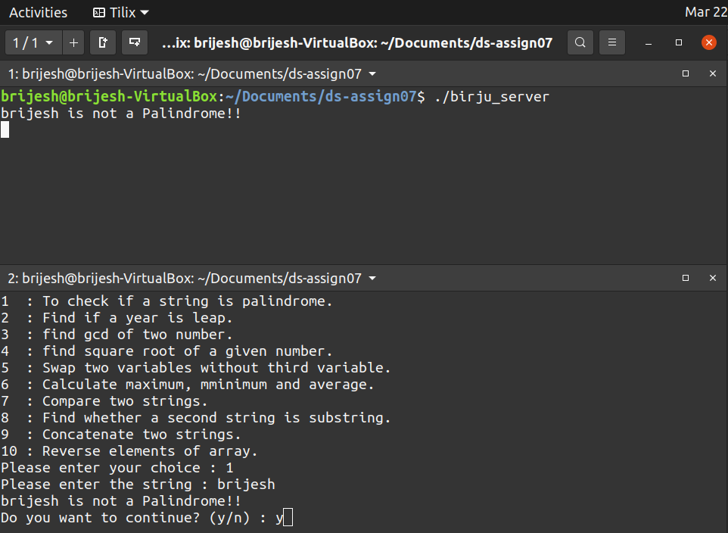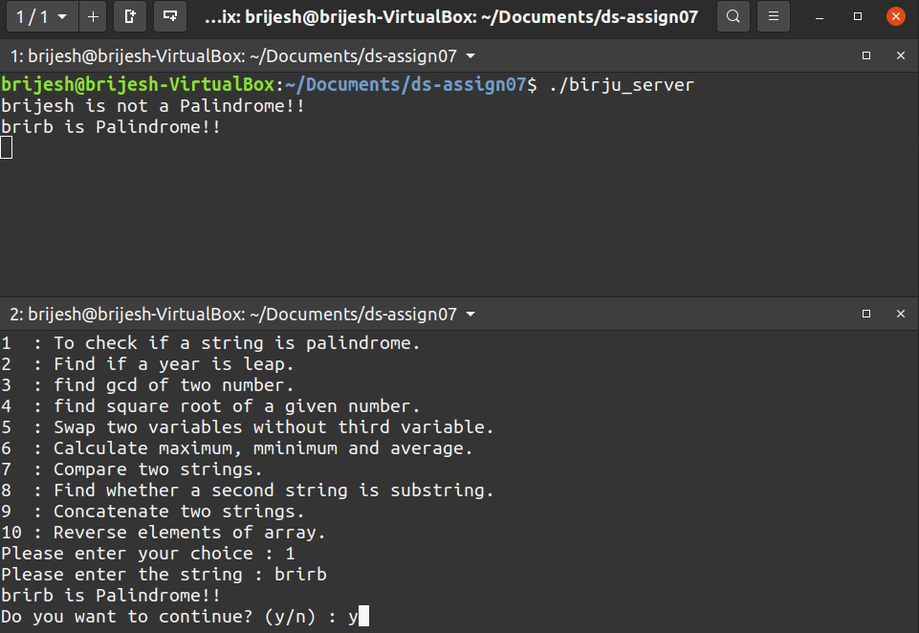

**2. Find out if a given year is a Lear Year or not.**

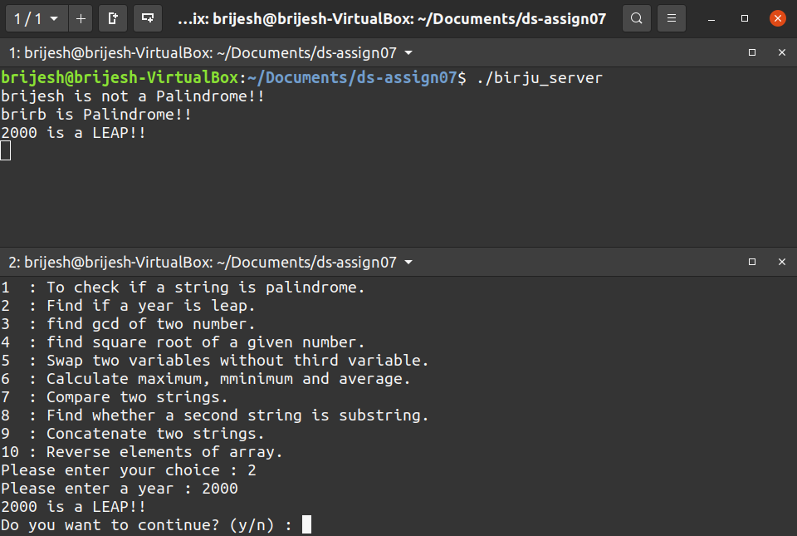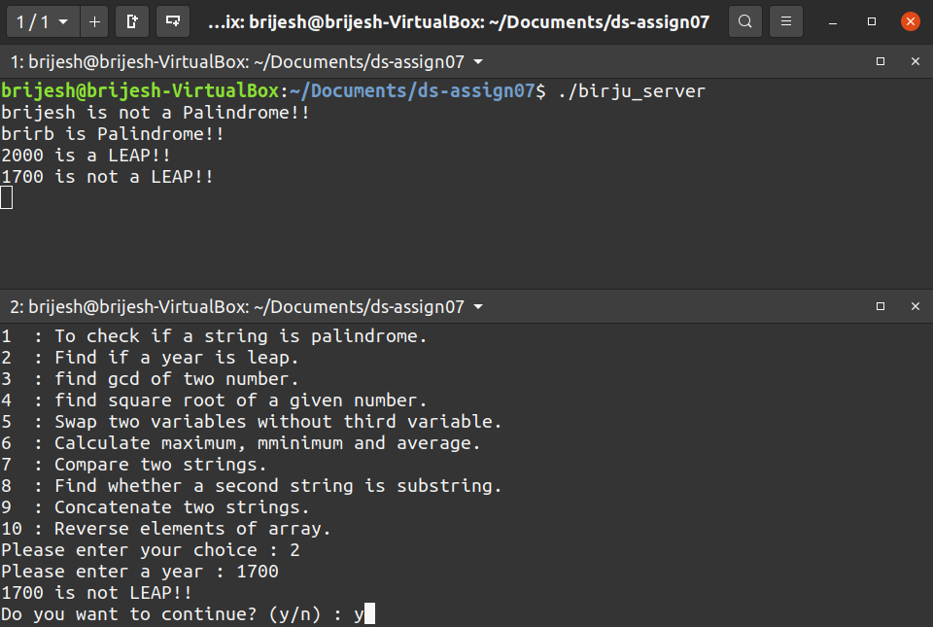

**3. Find out the GCD of a given number.**

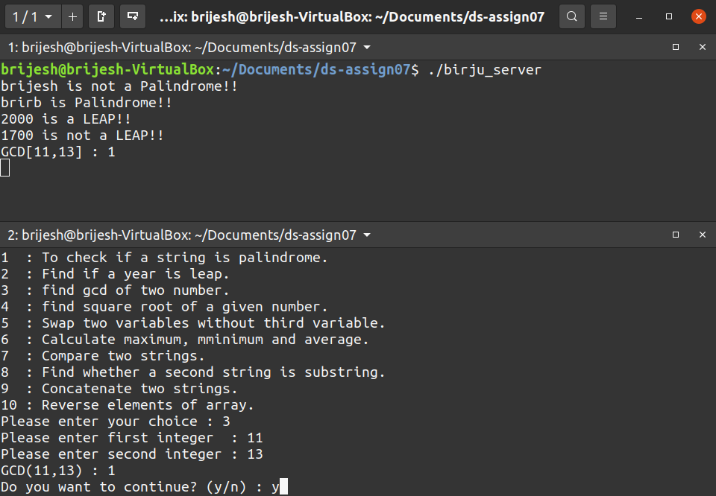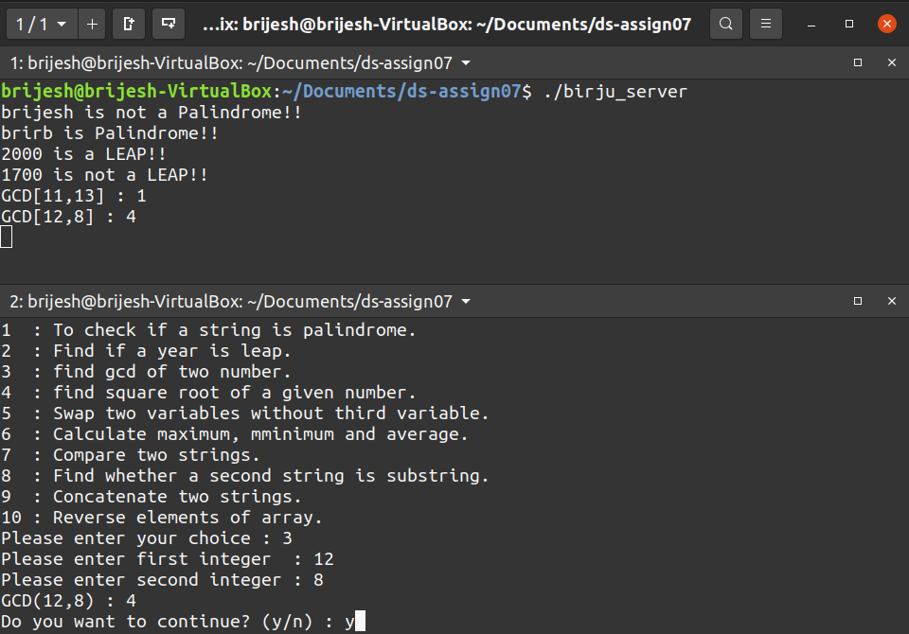

**4. Find out the Square root of a given number.**

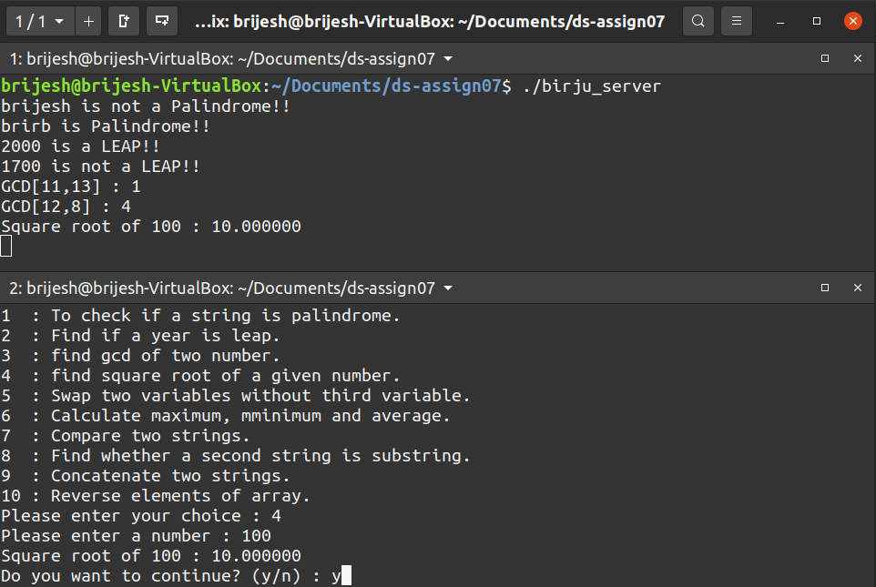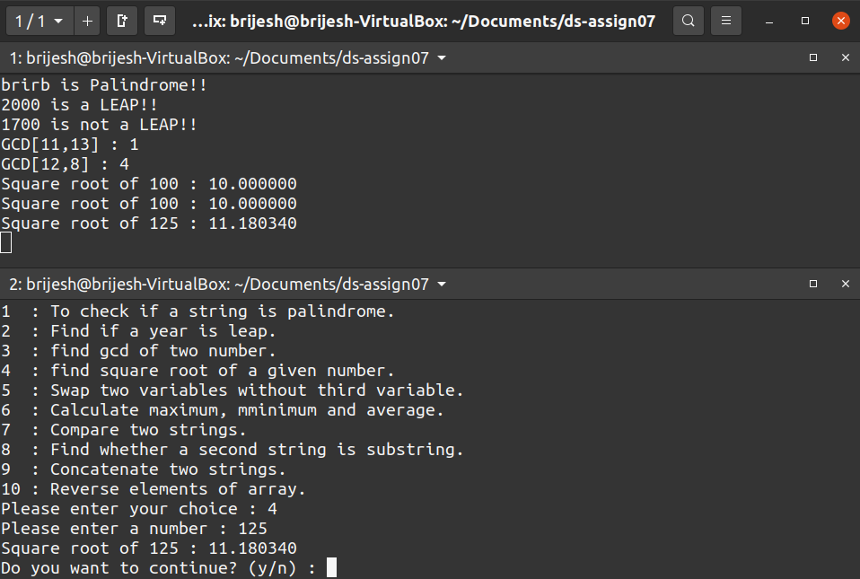

**5. Swap two variables without using the 3rd variable.**

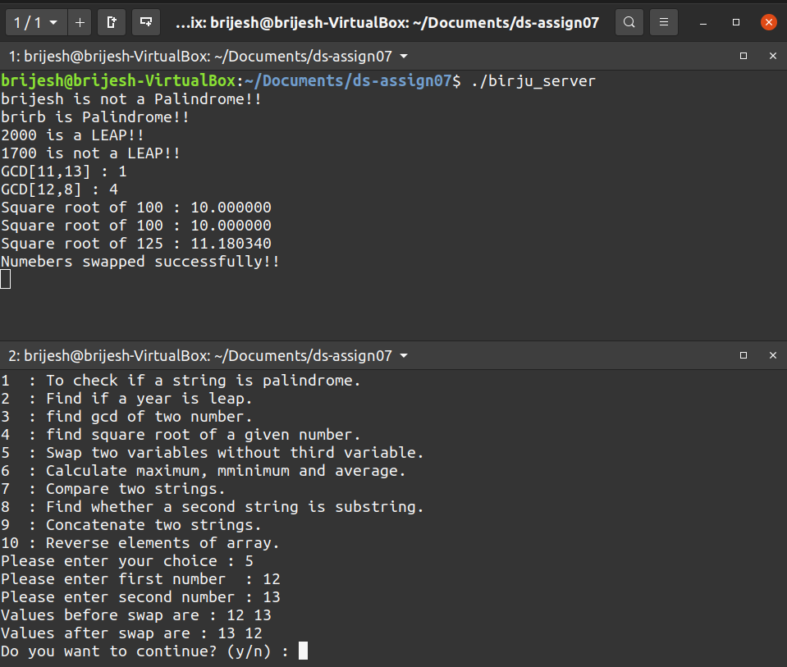

**6. Calculate Maximum, Minimum, average of given array.**

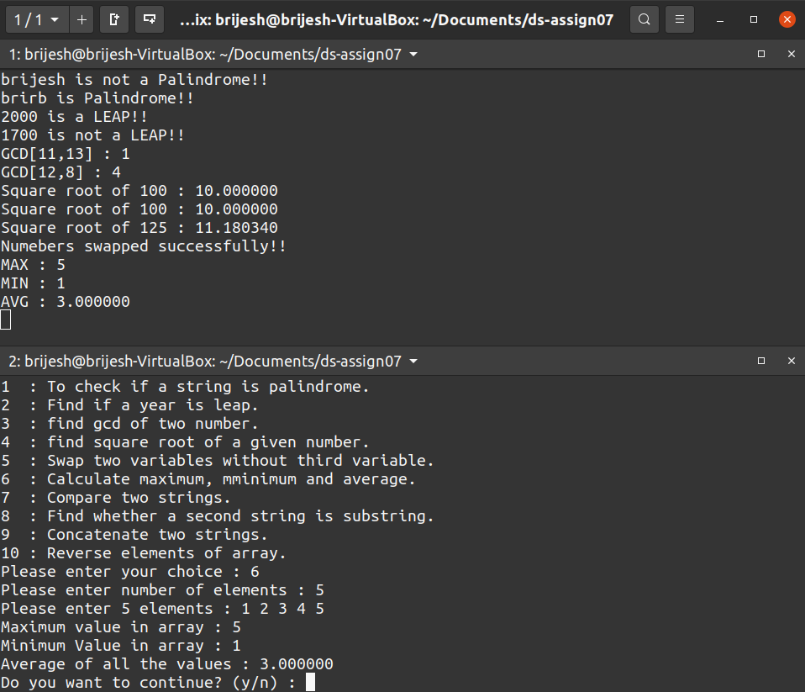

**7. Compare the given two strings.**

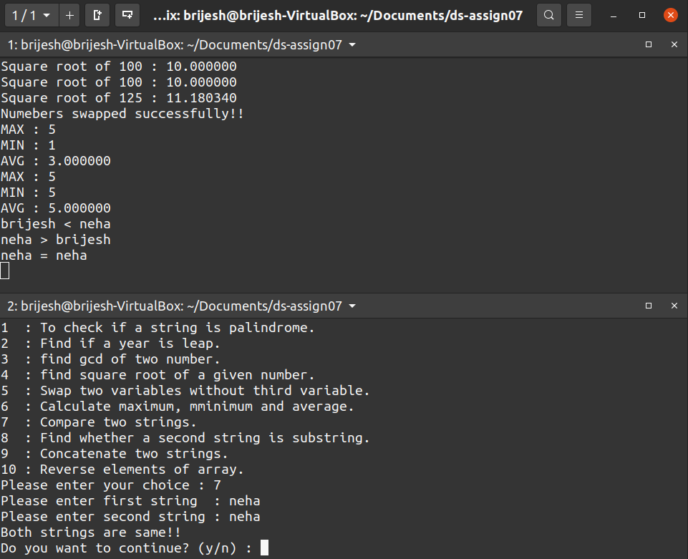

**8. Find out whether a given string is substring or not.**

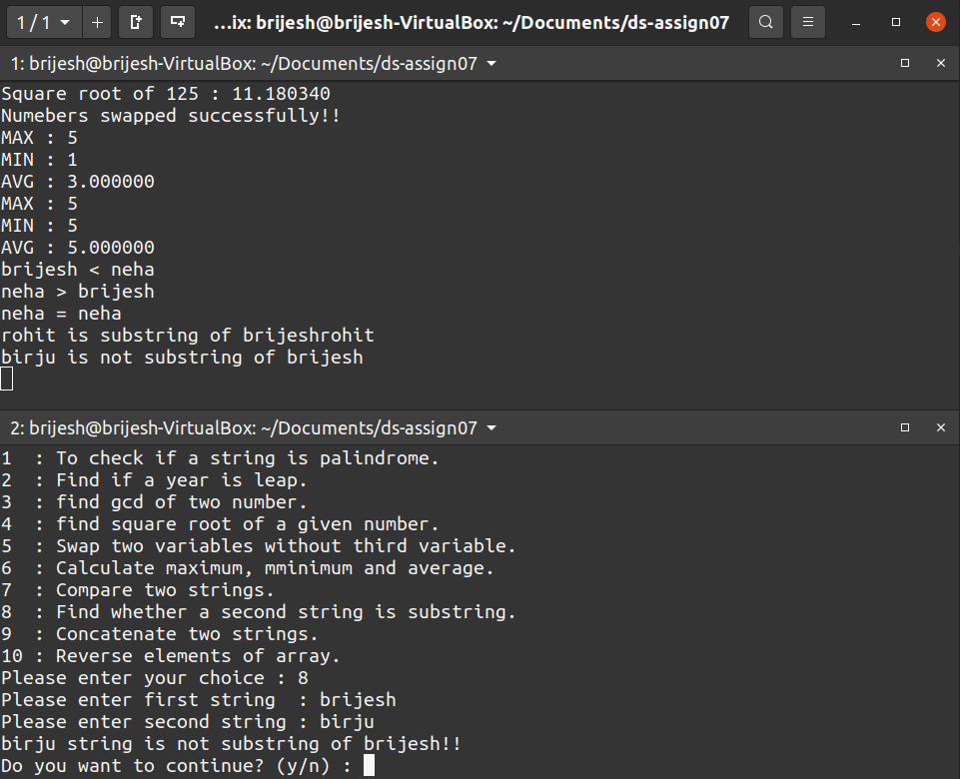

**9. Concatenate the two strings.**

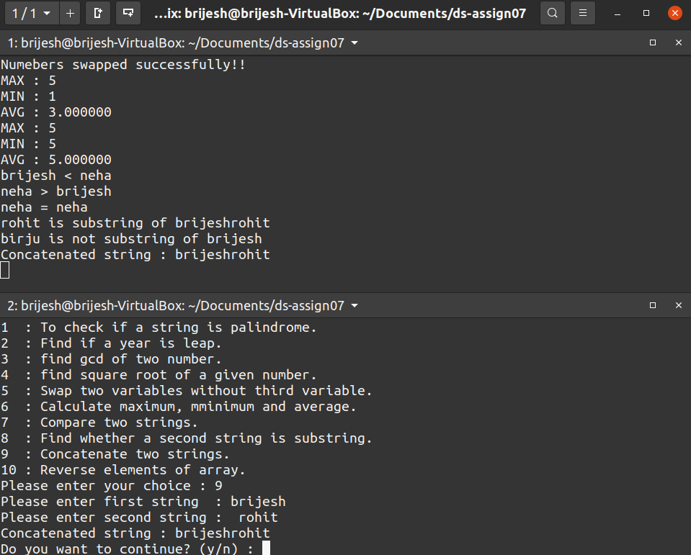

**10. Reverse the elements of an array.**

