**Name: Brijesh Rameshbhai Rohit**

**Admission number : U19CS009**

**DS-ASSIGNMENT-08**

1. Implement Lamport’s clock synchronization algorithm and discuss its time complexity.

**CODE :**

| // U19CS009  // Brijesh Rohit  #include <iostream>  using namespace std;  void lamportClock(int e1, int e2)  {  int event[e1][e2];  int proc1[e1], proc2[e2];  // Initial timestamps for 1st process  for (int i = 0; i < e1; i++)  proc1[i] = i + 1;  // Initial timestamps for 2nd process  for (int i = 0; i < e2; i++)  proc2[i] = i + 1;  // event[i][j] = 1, if message is sent from ei to ej  // event[i][j] = -1, if message is received by ei from ej  // event[i][j] = 0, otherwise  cout << "\n------- Events of process P1 and P2 interacting --------\n";  cout << "\n\t";  for (int i = 0; i < e2; i++)  {  cout << "e2" << i + 1 << "\t";  }  for (int i = 0; i < e1; i++)  {  cout << "\ne1" << i + 1;  for (int j = 0; j < e2; j++)  {  cin >> event[i][j];  }  }  // updating timestamps  for (int i = 0; i < e1; i++)  {  for (int j = 0; j < e2; j++)  {  if (event[i][j] == 1)  {  proc2[j] = max(proc2[j], proc1[i] + 1);  for (int k = j + 1; k < e2; k++)  proc2[k] = proc2[k - 1] + 1;  }  else if (event[i][j] == -1)  {  proc1[i] = max(proc1[i], proc2[j] + 1);  for (int k = i + 1; k < e1; k++)  proc1[k] = proc1[k - 1] + 1;  }  }  }  // display timestamps  printf("\nTimestamps of events of process P1 : ");  for (int i = 0; i < e1; i++)  cout << proc1[i] << " ";  printf("\nTimestamps of events of process P2 : ");  for (int j = 0; j < e2; j++)  cout << proc2[j] << " ";  cout << "\n";  }  // Lamport Clock Algorithm for 2 process  int main()  {  unsigned int e1, e2;  cout << "Enter no of events for process 1 : ";  cin >> e1;  cout << "Enter no of events for process 2 : ";  cin >> e2;  lamportClock(e1, e2);  return 0;  } |
| --- |

**Note:-**

**event[i][j] = 1, if message is sent from ei to ej**

**event[i][j] = -1, if message is received by ei from ej**

**event[i][j] = 0, otherwise**

**OUTPUT :**

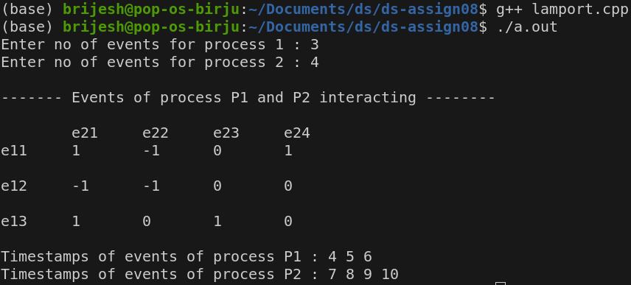

**Time Complexity:-**

**For 2 process:**

**No of events in process 1 = E1**

**No of events in process 2 = E2**

**Time Complexity = O(E1*E2*(E1+E2))**