**Name: Brijesh Rameshbhai Rohit**

**Admission number: U19CS009**

**PRINCIPLES OF PROGRAMMING LANGUAGES**

**ASSIGNMENT 2**

**Q1. In order to access the memory address of a variable, val , prepend it with & sign. For example, &val returns the memory address of val. This memory address is assigned to a pointer and can be shared among functions. For example, int *p = &val assigns the memory address of val to pointer p. To access the content of the memory pointed to, prepend the variable name with a *. For example, *p will return the value stored in val and any modification to it will be performed on val. Create a program with function update having parameters as int *a & int *b Modify the values in memory so that a contains their sum and b contains their absolute difference.**

**CODE=>**

|  |
| --- |
| **//U19CS009**  **//Brijesh Rohit**  **#include<bits/stdc++.h>**  **using namespace std;**  **void update(int *a, int *b)**  **{**  **int temp = *a;**  **\*a += *b;**  **\*b = abs(temp - (*b));**  **}**  **int main()**  **{**  **int a, b;**  **cout << "Enter values of 'a' : ";**  **cin >> a ;**  **cout << "Enter values of 'b' : ";**  **cin >> b;**  **int *p1 = &a;**  **int *p2 = &b;**  **update(p1, p2);**  **cout << "\nNew value of 'a' : " << a;**  **cout << "\nNew value of 'b' : " << b;**  **cout << "\n";**  **return 0;**  **}** |

**OUTPUT=>**

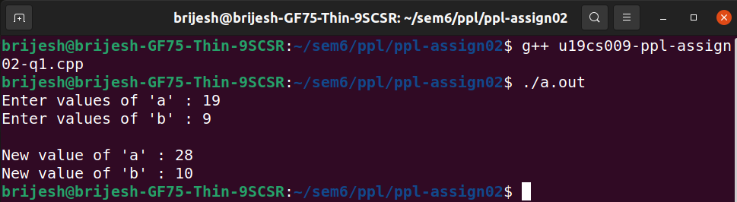

**Q2. Write a program with two classes HotelRoom and HotelApartment denoting respectively a standard hotel room and a hotel apartment. An instance of any of these classes has two parameters: bedrooms and bathrooms denoting respectively the number of bedrooms and the number of bathrooms in the room.**

**The prices of a standard hotel room and hotel apartment are given as:**

* **Hotel Room: 50 x bedrooms + 100 x bathrooms.**
* **Hotel Apartment: The price of a standard room with the same number bedrooms and bathrooms plus 100.**

**For example, if a standard room costs 200, then an apartment with the same number of bedrooms and bathrooms costs 300.**

**Write a program to return the correct profit. Make necessary assumptions wherever necessary**

**CODE=>**

|  |
| --- |
| **//U19CS009**  **//Brijesh Rohit**  **#include<bits/stdc++.h>**  **using namespace std;**  **class Hotel**  **{**  **public:**  **int bedroom;**  **int bathroom;**  **};**  **class HotelRoom : public Hotel**  **{**  **public:**  **HotelRoom(int numOfBed, int numOfBath)**  **{**  **this->bedroom = numOfBed;**  **this->bathroom = numOfBath;**  **}**  **int cost_of_Room()**  **{**  **return (this->bedroom * 50) + (this->bathroom * 100);**  **}**  **};**  **class HotelApartment: public HotelRoom**  **{**  **public:**  **HotelApartment(int numOfBed, int numOfBath): HotelRoom(numOfBed, numOfBath) {}**  **int cost_of_Apartment()**  **{**  **return (this->cost_of_Room()) + (int)100;**  **}**  **};**  **int main()**  **{**  **int n, ch, profit = 0;**  **cout << "\nEnter Booking Details!!\n\n";**  **cout << "Enter number of booking requests : ";**  **cin >> n;**  **while (n--)**  **{**  **cout << "\nPlease enter booking type!\n";**  **cout << "1 : Standard Room.\t\t";**  **cout << "2 : Apartment.\t\t";**  **cout << "3 : Exit.\nEnter your choice : ";**  **cin >> ch;**  **if (ch > 3 || ch < 1)**  **{**  **cout << "\n\nEnter valid Choice!!";**  **n++;**  **}**  **int numOfBed, numOfBath;**  **cout << "Enter number of bedrooms : ";**  **cin >> numOfBed;**  **cout << "Enter number of bathrooms : ";**  **cin >> numOfBath;**  **if (ch == 1)**  **{**  **HotelRoom hroom(numOfBed, numOfBath);**  **profit += hroom.cost_of_Room();**  **}**  **else if (ch == 2)**  **{**  **HotelApartment hapart(numOfBed, numOfBath);**  **profit += hapart.cost_of_Apartment();**  **}**  **else**  **{**  **cout << "\nThank You!!";**  **cout << "\nHope you ENJOYED the service!!\n\n";**  **break;**  **}**  **if(n==0)**  **{**  **cout << "\nThank You!!";**  **cout << "\nHope you ENJOYED the service!!\n\n";**  **break;**  **}**  **}**  **cout << "The Gross profit is : " << profit;**  **cout << "\n\n";**  **return 0;**  **}** |

**OUTPUT=>**

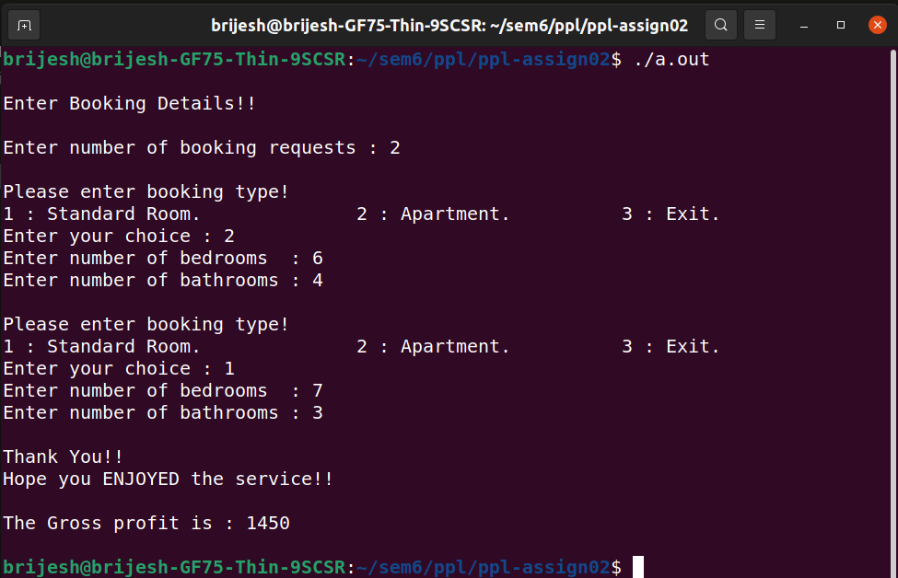

**Q3. Write a class to represent a vector (a series of float values). Include member functions to perform the following tasks:**

* **To create the vector**
* **To modify the value of a given element.**
* **To multiply by a scalar value.**
* **To display the vector in the form (10, 20, 30,…)**

**CODE=>**

|  |
| --- |
| **//U19CS009**  **//Brijesh Rohit**  **#include<bits/stdc++.h>**  **using namespace std;**  **class Vector {**  **int size;**  **float *arr;**  **public:**  **Vector(int size)**  **{**  **this->size = size;**  **}**  **void createVector()**  **{**  **this->arr = new float[this->size];**  **cout << "\nMemory allocated Successfully!!\n";**  **for (int i = 0; i < this->size; i++)**  **{**  **cout << "Enter the element : ";**  **cin >> this->arr[i];**  **}**  **cout << "\n";**  **}**  **void displayVector()**  **{**  **int i;**  **cout << "\nThe vector is : [ ";**  **for ( i = 0; i + 1 < this->size; i++)**  **{**  **cout << this->arr[i] << ", ";**  **}**  **cout << this->arr[i] << " ]" << endl;**  **}**  **void modifyData(int index, int value)**  **{**  **if (index < 0 || index > this->size)**  **{**  **cout << "\nIndex is Invalid!!";**  **return;**  **}**  **this->arr[index] = value;**  **this->displayVector();**  **}**    **void multiplyVector(int scaler)**  **{**  **for (int i = 0; i < this->size; i++)**  **{**  **this->arr[i] *= scaler;**  **}**  **this->displayVector();**  **}**  **void deleteVector()**  **{**  **delete []this->arr;**  **}**  **};**  **int main()**  **{**  **int n;**  **cout << "Enter the size of vector : ";**  **cin >> n;**  **Vector v(n);**  **cout << "\nCreating Vector!!";**  **v.createVector();**  **v.displayVector();**  **int ch = 0;**  **while(1) {**  **cout << "\nPlease enter vector operations according to following.";**  **cout << "\n1 : Display vector.\t2 : Modify an element.";**  **cout << "\n3.Multiply by scaler.\t4.Exit.\nEnter your choice : ";**  **cin >> ch;**  **if (ch < 0 || ch > 4)**  **{**  **cout << "\nInvalid Choice!!" << endl;**  **cout << "\nDo you want to exit ?";**  **cout << "\n1 : Yes.\n2 : No, continue service.\nEnter your choice : ";**  **int exit;**  **cin >> exit;**  **if(exit)**  **{**  **cout << "\nThank You!!";**  **cout << "\nHope you ENJOYED the service!!\n\n";**  **break;**  **}**  **else**  **continue;**  **}**  **if (ch == 1)**  **{**  **v.displayVector();**  **}**  **else if (ch == 2)**  **{**  **int i, val;**  **cout << "Enter the index to be modified : ";**  **cin >> i;**  **cout << "Enter the new value : ";**  **cin >> val;**  **v.modifyData(i, val);**  **}**  **else if (ch == 3)**  **{**  **int sc;**  **cout << "Enter the scalar value : ";**  **cin >> sc;**  **v.multiplyVector(sc);**  **}**  **if(ch == 4)**  **{**  **cout << "\nThank You!!";**  **cout << "\nHope you ENJOYED the service!!\n\n";**  **break;**  **}**  **}**  **v.deleteVector();**  **return 0;**  **}** |

**OUTPUT=>**

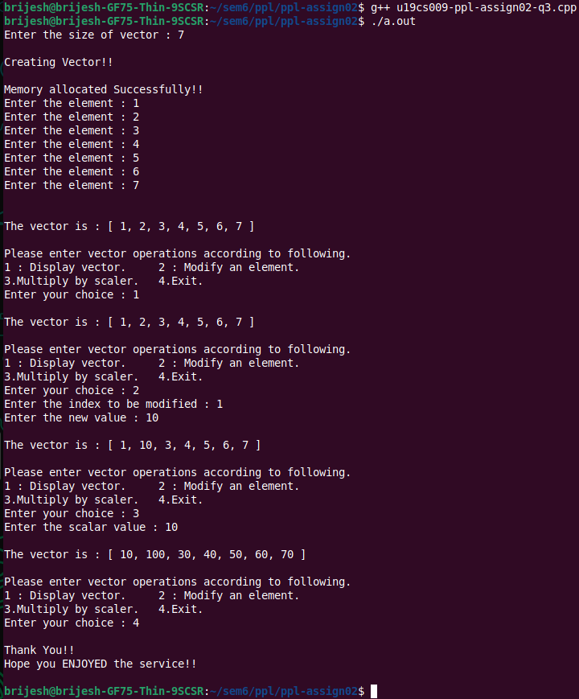

**Q4. A book shop maintains the inventory of books that are being sold at the shop. The list includes details such as author, title, price, publisher and stock position. Whenever a customer wants a book, the sales person inputs the title and author and the system searches the list and displays whether it is available or not. If it is not, an appropriate message is displayed. If it is, then the system displays the book details and requests for the number of copies required. If the requested copies book details and requests for the number of copies required. If the requested copies are available, the total cost of the requested copies is displayed; otherwise the message “Required copies not in stock” is displayed. Design a system using a class called books with suitable member functions and Constructors. Use new operators in constructors to allocate memory space required. Implement C++ program for the system.**

**Improve the system design to incorporate the following features:**

* **The price of the books should be updated as and when required. Use a member function to implement this.**
* **The stock value of each book should be automatically updated as soon as a transaction is completed.**
* **The number of successful and unsuccessful transactions should be recorded for the purpose of statistical analysis. Use static data members to keep count of transactions.**
* **Also demonstrate the use of pointers to access the members.**

**CODE=>**

|  |
| --- |
| **//U19CS009**  **//Brijesh Rohit**  **#include<bits/stdc++.h>**  **using namespace std;**  **class Book**  **{**  **int number_of_books;**  **string *author;**  **string *title;**  **string *publisher;**  **int *price;**  **int *stock;**  **static int successful_transaction;**  **static int unsuccessful_transaction;**  **public:**  **Book(int num)**  **{**  **this->number_of_books = num;**  **this->author = new string[num];**  **this->title = new string[num];**  **this->price = new int[num];**  **this->publisher = new string[num];**  **this->stock = new int[num];**  **}**  **void listBook()**  **{**  **for (int i = 0; i < (this->number_of_books); i++)**  **{**  **cout << "\nEnter Details of Book " << i + 1 << " : \n";**  **cout << "Enter title of the Book : ";**  **cin >> this->title[i];**  **cout << "Enter author of the Book : ";**  **cin >> this->author[i];**  **cout << "Enter publisher of the Book : ";**  **cin >> this->publisher[i];**  **cout << "Enter the price of the Book : ";**  **cin >> this->price[i];**  **cout << "Enter stock of the Book available : ";**  **cin >> this->stock[i];**  **}**  **}**  **void displayDetails()**  **{**  **cout << "Details:\n";**  **for (int i = 0; i < (this->number_of_books ); i++)**  **{**  **cout << "\n----------------------------------------------------\n";**  **cout << "----------------------------------------------------\n";**  **cout << "Title : " << this->title[i];**  **cout << "\nAuthor : " << this->author[i];**  **cout << "\nPublisher : " << this->publisher[i];**  **cout << "\nPrice : " << this->price[i];**  **cout << "\nStock Available : " << this->stock[i];**  **cout << "\n----------------------------------------------------\n";**  **cout << "----------------------------------------------------\n";**  **}**  **}**  **int checkIndex(int index)**  **{**  **if (index < 0 || index > this->number_of_books)**  **{**  **return 0;**  **}**  **return 1;**  **}**  **int searchBook(string title, string author)**  **{**  **for (int i = 0; i < this->number_of_books; i++)**  **{**  **if (title.compare(this->title[i]) == 0 && author.compare(this -> author[i]) == 0)**  **{**  **return i;**  **}**  **}**  **return -1;**  **}**  **void updatePrice(int i, int price)**  **{**  **if (!checkIndex(i)) {**  **cout << "Inavlid index!!" << endl;**  **return;**  **}**  **this->price[i] = price;**  **}**  **void bookDetail(int index)**  **{**  **if (!checkIndex(index)) {**  **cout << "Inavlid index!!" << endl;**  **return;**  **}**  **cout << "\n----------------------------------------------------\n";**  **cout << "----------------------------------------------------\n";**  **cout << "Title : " << this->title[index];**  **cout << "\nAuthor : " << this->author[index];**  **cout << "\nPublisher : " << this -> publisher[index];**  **cout << "\nPrice : " << this->price[index];**  **cout << "\nStock Available : " << this->stock[index];**  **cout << "\n----------------------------------------------------\n";**  **cout << "----------------------------------------------------\n";**  **}**    **void buyBook(int index, int copies)**  **{**  **if (!checkIndex(index)) {**  **cout << "Inavlid index!!" << endl;**  **return;**  **}**  **if (copies > (this->stock[index]))**  **{**  **cout << "Transaction failed!!( Not enough in stock ) " << endl;**  **this->unsuccessful_transaction++;**  **return;**  **}**  **cout << "Transaction Successful!! " << endl;**  **this->successful_transaction++;**  **this->stock[index] -= copies;**  **}**    **void statistic()**  **{**  **cout << "\nTotal number of Successful transactions : " << successful_transaction;**  **cout << "\nTotal number of Unsuccessful transactions : " << unsuccessful_transaction << endl;**  **}**    **void deletelist()**  **{**  **delete []author;**  **delete []title;**  **delete []publisher;**  **delete []price;**  **delete []stock;**  **}**  **};**  **int Book:: successful_transaction{0};**  **int Book:: unsuccessful_transaction{0};**  **int main()**  **{**  **int n, ch;**  **cout << "Enter number of books : ";**  **cin >> n;**  **Book b(n);**  **b.listBook();**  **system("CLS");**  **while(1)**  **{**  **cout << "\nPlease enter vector operations according to following.";**  **cout << "\n1 : Display List.\t2 : Search Book.\t3 : Display Book Details.";**  **cout << "\n4 : Update Price.\t5 : Buy Book. \t6 : Display Statistics.";**  **cout << "\n7 : Exit\nEnter your choice : ";**  **cin >> ch;**  **system("CLS");**  **string title, author;**  **int index, price, copies;**  **if ( ch == 1)**  **{**  **b.displayDetails();**  **}**  **else if (ch == 2)**  **{**  **cout << "Enter Title of the Book : ";**  **cin >> title;**  **cout << "Enter author of the Book : ";**  **cin >> author;**  **index = b.searchBook(title, author);**  **if (index == -1)**  **{**  **cout << "\nBook Not found!!\n";**  **}**  **else**  **{**  **cout << "Index of book is : " << index << endl;**  **}**  **}**  **else if ( ch == 3)**  **{**  **cout << "Enter the index of the Book : ";**  **cin >> index;**  **b.bookDetail(index);**  **}**  **else if ( ch == 4)**  **{**  **cout << "Enter the index of the Book : ";**  **cin >> index;**  **cout << "Enter the price of the Book : ";**  **cin >> price;**  **b.updatePrice(index, price);**  **}**  **else if ( ch == 5)**  **{**  **cout << "Enter the index of the Book : ";**  **cin >> index;**  **cout << "Enter number of copies of the Book : ";**  **cin >> copies;**  **b.buyBook(index, copies);**  **}**  **else if (ch == 6)**  **b.statistic();**  **else if (ch == 7)**  **{**  **b.deletelist();**  **break;**  **}**  **else**  **{**  **cout << "\nInvalid Choice!!" << endl;**  **cout << "\nDo you want to exit ?";**  **cout << "\n1 : Yes.\n2 : No, continue service.\nEnter your choice : ";**  **int exit;**  **cin >> exit;**  **if(exit)**  **{**  **b.deletelist();**  **cout << "\nThank You!!";**  **cout << "\nHope you ENJOYED the service!!\n\n";**  **break;**  **}**  **else**  **continue;**  **}**  **}**  **system("CLS");**  **return 0;**  **}** |

**OUTPUT=>**

1. **Inserting Books**

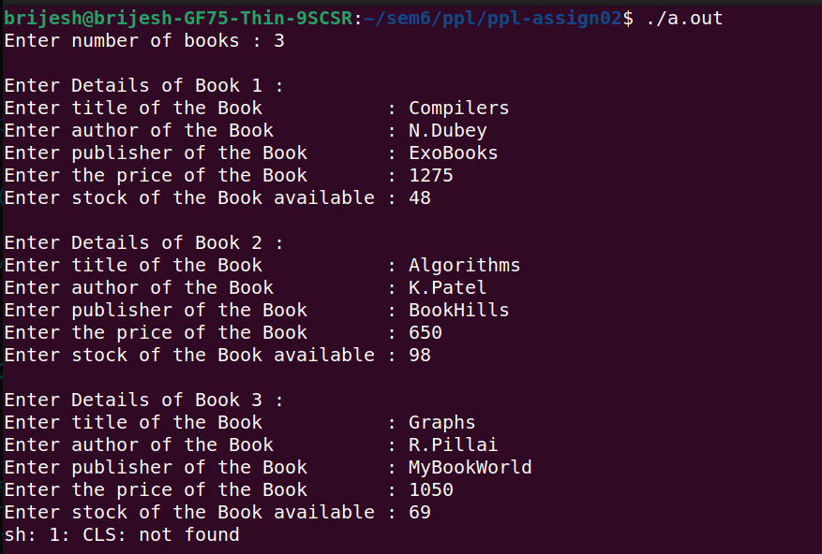

1. **Display Details of all Books**

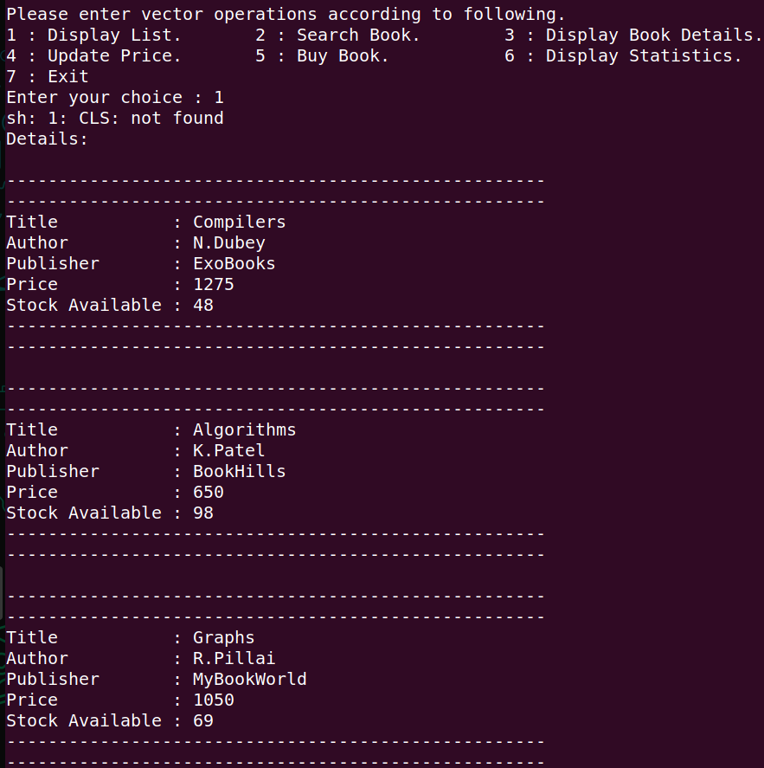

1. **Search a Book**

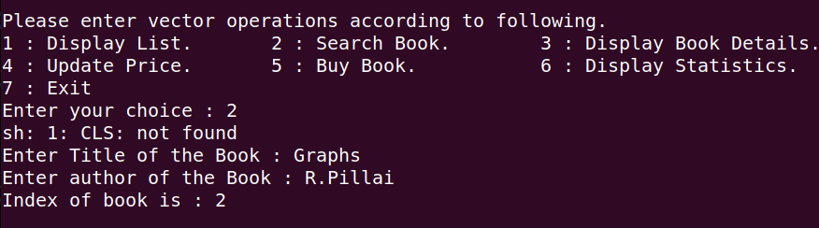

1. **Display Details of Single Book**

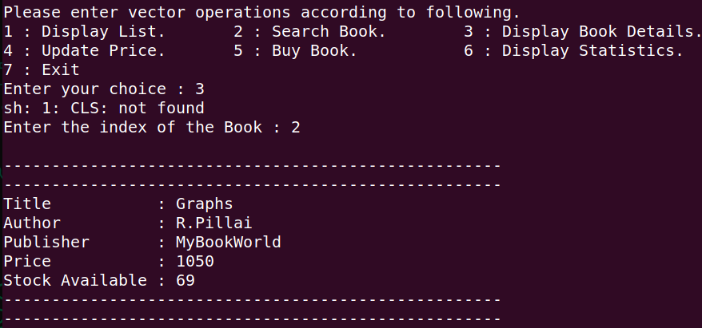

1. **Update Price of Single Book**

**As seen in the first output image, the original price was only 650, which is update to 950.**

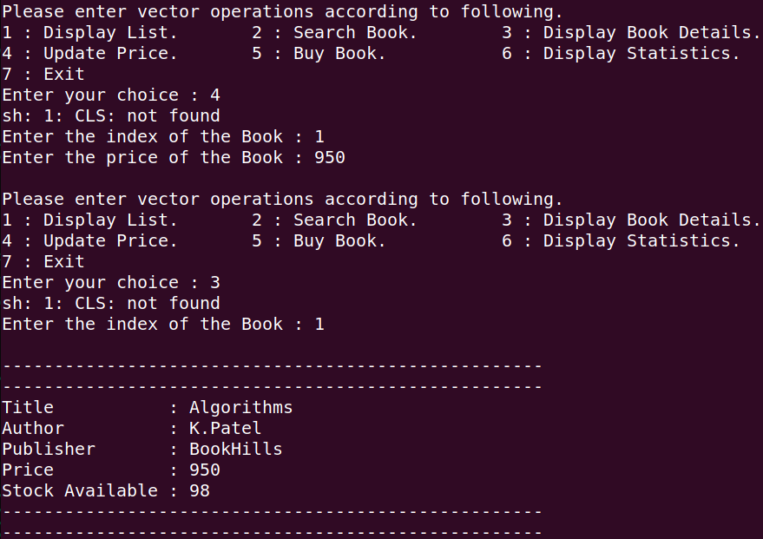

1. **Buy a Book**

**Before transaction, “Compilers” books were 48 and after transaction, [buying 10 books] books are 38.**

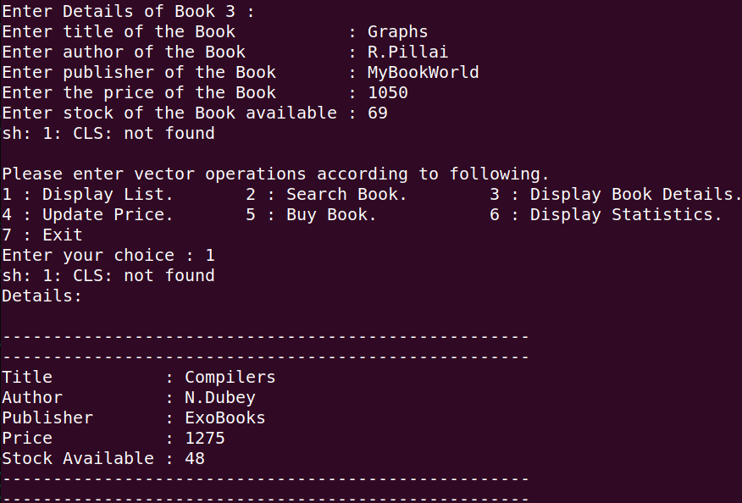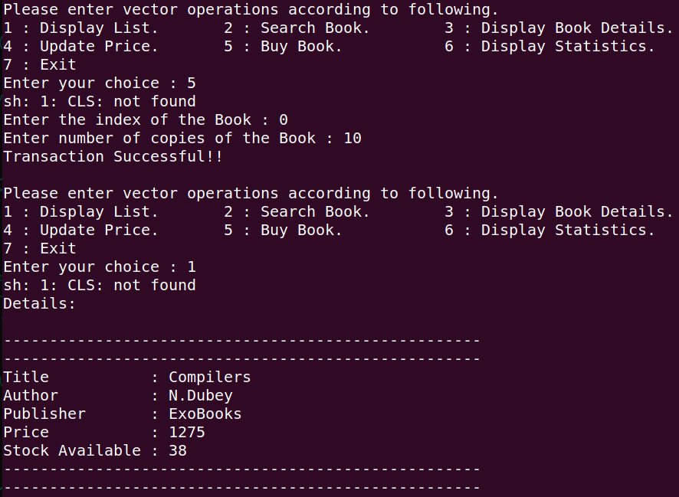

**As seen in this image, “Graphs” books were 69 before transaction, and after transaction, it is 66, i.e, we bought 5 books.**

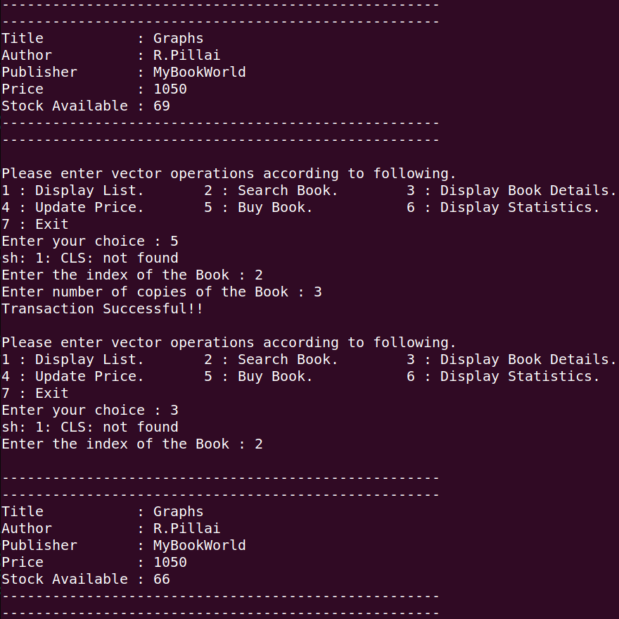

1. **Display Statistics**

**As seen below, “Graphs” books were only 66, but we tried to buy 70, and transaction was not successful. So total successful transactions were 2, one of “Compilers” and one of “Graphs”, and unsuccessful transactions were 1, which is shown below, which is of “Graphs” book.**

