**Name: Brijesh Rohit**

**Admission no.: U19CS009**

**PRINCIPLES OF PROGRAMMING LANGUAGES**

**ASSIGNMENT 3**

1.Write a code that performs username validation for a website. When the username is too short it should throw an exception such that it prints Too short: n (where n is the length of the given username). The final program should print Valid (if the username is valid), Invalid (if the username is invalid), or Too short: n (where  is the length of the too-short username). Make necessary assumptions if required.

**CODE=>**

|  |
| --- |
| //U19CS009  //Brijesh Rohit  #include<bits/stdc++.h>  using namespace std;  class users {  int count;  vector<string> unames;  public:  users()  {  count = 0;  }  bool checkuser(string uname)  {  auto isUser = find(this->unames.begin(), this->unames.end(), uname);  if (isUser == unames.end())return true;  return false;  }  int verify_username(string uname)  {  //MIN LENGTH IS 5  if (uname.length() < 5)  {  return -1;  }  if (!isalpha(uname[0]) && uname[0] != '_')  {  return 0;  }  for (int i = 1; i < uname.length(); i++)  {  if (!isalnum(uname[0]) && uname[0] != '_' && uname[0] != '.')  {  return 0;  }  }  if (!checkuser(uname))  {  return 0;  }  return 1;  }  void adduser(string uname)  {  if (this->verify_username(uname) == 0 || this->verify_username(uname) == -1)  {  return;  }  this->count++;  this->unames.push_back(uname);  }  };  int main()  {  users u;  string s[5] = {"brijesh", "birju", "B@1234", "Bw_12__231"};  for (int i = 0; i < 5; i++)  u.adduser(s[i]);  //USER INPUT  string s1;  cout << "Enter an username : ";  cin >> s1;  if (u.verify_username(s1) == -1)  {  cout << "Too Short : " << s1.length() << endl;  }  else if (u.verify_username(s1) == 0)  {  cout << "Invalid" << endl;  }  else  {  cout << "Valid" << endl;  }  return 0;  } |

**OUTPUT=>**

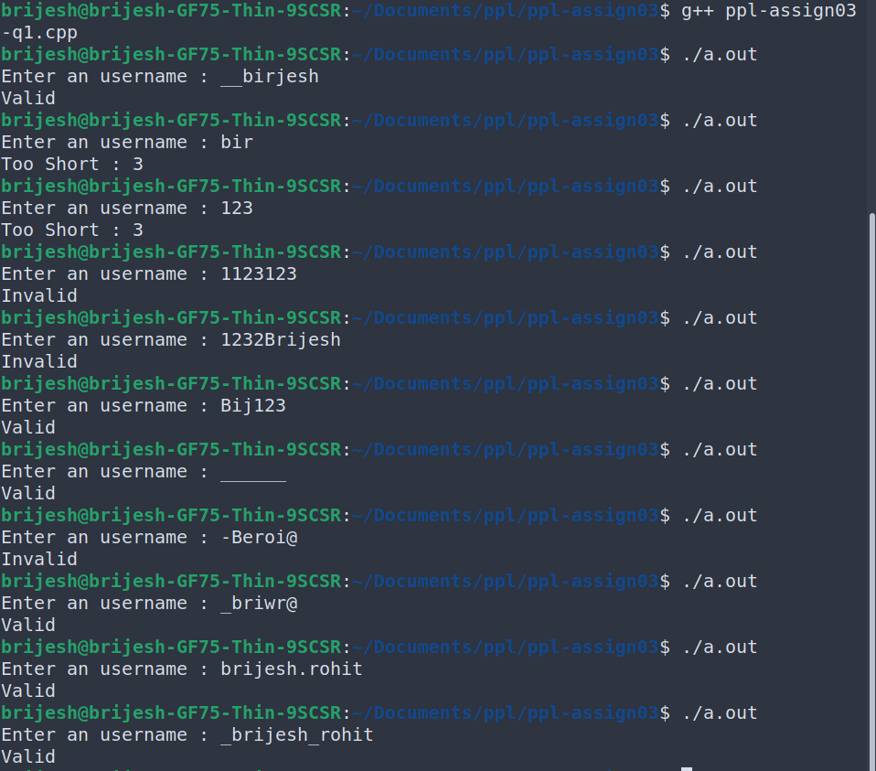

2.You are required to handle error messages while working with a small computational server that performs complex calculations. It has a function that takes 2 large numbers as its input and returns a numeric result. Unfortunately, there are various exceptions that may occur during execution. Write a program so that it prints appropriate error messages. The expected behavior is defined as follows:

* If the compute function runs fine with the given arguments, then print the result of the function call.
* If it fails to allocate the memory that it needs, print Not enough memory.
* If any other standard C++ exception occurs, print Exception: S where S is the exception's error message.
* If any non-standard exception occurs, print Other Exceptions.

**CODE=>**

|  |
| --- |
| //U19CS009  //Brijesh Rohit  #include <bits/stdc++.h>  using namespace std;  int complexCalc(int a, int b)  {  int c = pow(a, b);  int prod = 1;  for (int i = 0; i < a + b; i++)prod *= a;  return prod / b;  }  int main()  {  int a, b;  cout << "Enter Value a and b : ";  cin >> a >> b;  try {  int n = complexCalc(a, b);  cout << "The result of complexCalc() : " << n << endl;  }  //catching bad alloc  catch (bad_alloc & b) {  cerr << "Bad memory allocation : " << b.what() << endl;  }  //catching std exception  catch (exception & e)  {  cerr << "Standard Exception Caught : " << e.what() << endl;  }  //catching other exception  catch (...)  {  cerr << "Other Exception" << endl;  }  return 0;  } |

**OUTPUT=>**

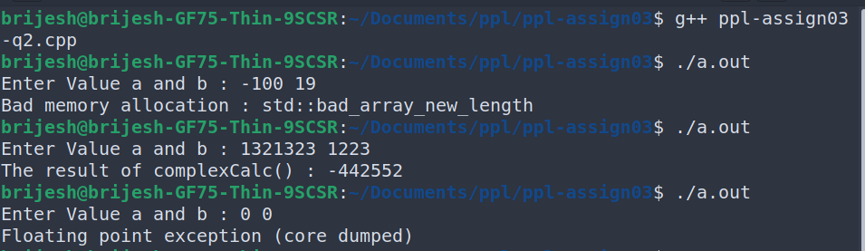

3.Create a class Polar that represents the points on the plane as polar coordinates (radius and angles). Create an overloaded + operator for addition of two Polar quantities. "Adding" two points on the plane can be accomplished by adding their X coordinates and then adding their Y coordinates. This gives the X and Y coordinates of the "answer." Thus you'll need to convert two sets of polar coordinates to rectangular coordinates, add them, then convert the resulting rectangular representation back to polar. You need to use the following trigonometric formulae:

x = r*cos(a);

y = r*sin(a);

a = atan(y/x); //arc tangent

r = sqrt(x*x + y*y);

**CODE=>**

|  |
| --- |
| //U19CS009  //Brijesh Rohit  #include <bits/stdc++.h>  using namespace std;  const float pi = 3.14159; //value of pi  class Polar {  float radius; //in unit length  float angle; //in radians  public:  Polar (float r, float th)  {  this->radius = r;  this->angle = th;  }  void setRadius(float r )  {  this->radius = r;  }  float getRadius()  {  return this->radius;  }  void setAngle(float t )  {  this->angle = t;  }  float getTheta()  {  return this->angle;  }  pair<float, float> ConvToRect()  {  float x = (this->radius) * cos(this->angle);  float y = (this->radius) * sin(this->angle);  return make_pair(x, y);  }  //operator overloading  Polar operator + (Polar obj2)  {  pair<float, float> p1 = this->ConvToRect();  pair<float, float> p2 = obj2.ConvToRect();  float x, y;  x = p1.first + p2.first;  y = p1.second + p2.second;  Polar P(0, 0);  float r, th;  r = sqrt(x * x + y * y);  th = float(atan2(y, x));  P.setRadius(r);  P.setAngle(th);  return P;  }  void display()  {  cout << "Radius : " << this->getRadius();  cout << "\tAngle : " << this->getTheta();  }  };  int main()  {  float r, th;    cout << "Enter first Polar coordinates (r,th)): ";  cin >> r >> th;  Polar p1(r, th);    cout << "Enter second Polar coordinate (r,th)): ";  cin >> r >> th;  Polar p2(r, th);    Polar p3(0, 0);  cout << "The three polar coordinates are :\n";  cout << "p1 : ";  p1.display();  cout << "\n";  cout << "p2 : ";  p2.display();  cout << "\n";  cout << "p3 : ";  p3.display();  cout << "\n";    cout << "p3 is changed to sum of p1 and p2.\n";  p3 = p1 + p2;  cout << "Addition of both coordinates : ";  p3.display();  cout << "\n";  return 0;  } |

**OUTPUT=>**

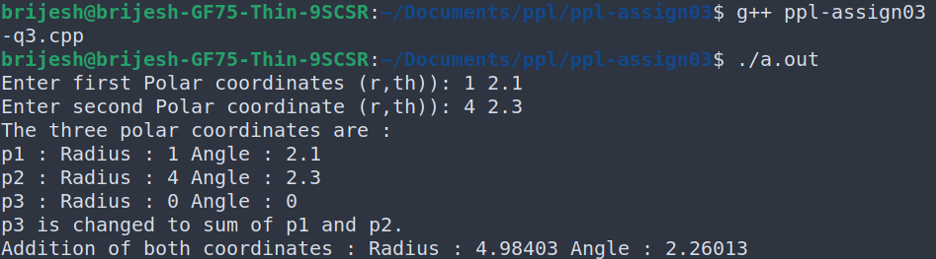

4. A file contains a list of telephone numbers in the following form:

John 23456

Ken 9846

The names contain only one word and the names and telephone numbers are separated by white spaces. Write a program to read a file and display its contents in two columns. The names should be left justified and the number right justified.

**CODE=>**

|  |
| --- |
| //U19CS009  //Brijesh Rohit  #include<bits/stdc++.h>  using namespace std;  void display()  {  ifstream in;  in.open("file.txt");  string s;  while (in)  {  //fetching line in s.  getline(in, s);  int i;  int flag = 0;  string temp, temp1;  //finding first word  for ( i = 0; i < s.length(); i++)  {  if (s[i] == ' ')  {  break;  }  temp += s[i];  }  temp[i] = '\0';  //left align  cout << setw(15) << left << temp;  //finding phone number  for (int j = i; j < s.length(); j++)  {  temp1 += s[j];  }  //right align  cout << setw(15) << right << temp1 << endl;  }  }  int main()  {  display();  return 0;  } |

**OUTPUT=>**

**1.file.txt**

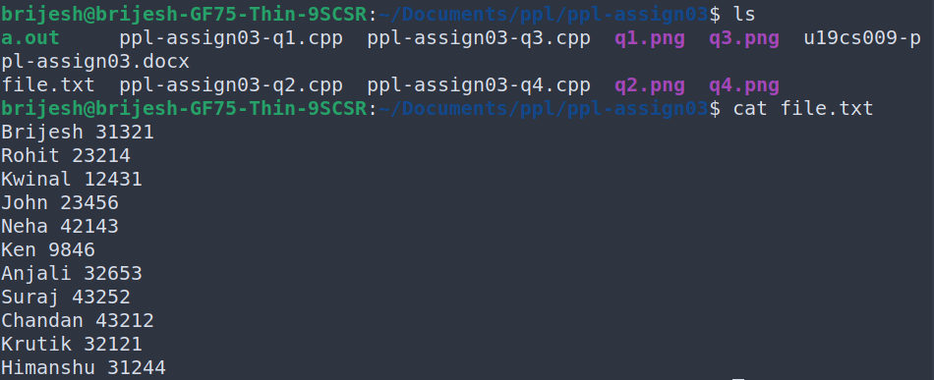

**2.terminal output**

