**Name : Brijesh Rameshbhai Rohit**

**Admission number: U19CS009**

# **PINCIPLES OF PROGRAMMING LANGUAGES**

## **Assignment - 07**

For the given family tree, do as directed using PROLOG:

* Write the predicates using the following relations:

1. parent/2

2. male/1

3. female/1

4. husband/2

|  |
| --- |
| %U19CS009  %BRIJESH ROHIT  %Taken from previous assignment  female(mary).  female(sandra).  female(juliet).  female(lisa).  male(peter).  male(paul).  male(dick).  male(bob).  male(harry).  parent(bob, lisa).  parent(bob, paul).  parent(bob, mary).  parent(juliet, lisa).  parent(juliet, paul).  parent(juliet, mary).  parent(peter, harry).  parent(lisa, harry).  parent(mary, dick).  parent(mary, sandra).  husband(peter,lisa).  husband(bob,juliet). |

* Write the rules using above relations for the following:

1. Child

|  |
| --- |
| %child(X child of Y).  child(X,Y):-  parent(Y,X). |

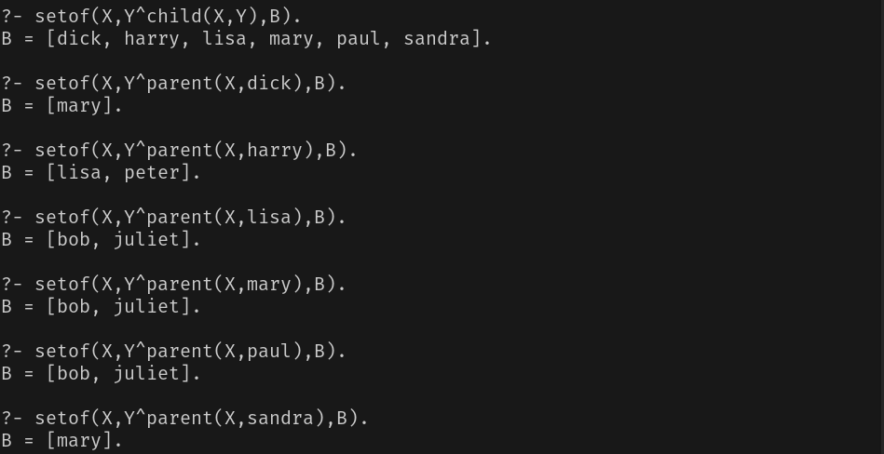

2. Mother

|  |
| --- |
| % mother(X mother of Y).  mother(X,Y):-  female(X),  parent(X,Y). |

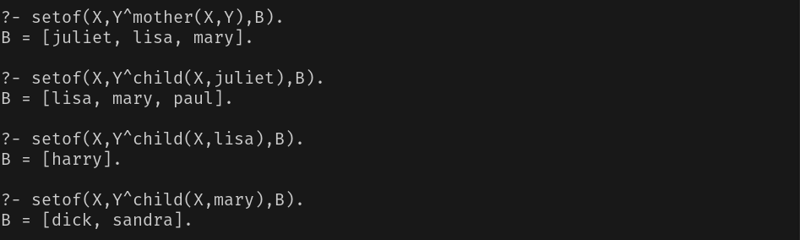

3. Father

|  |
| --- |
| % father (X father of Y).  father(X,Y):-  parent(X,Y),  male(X). |

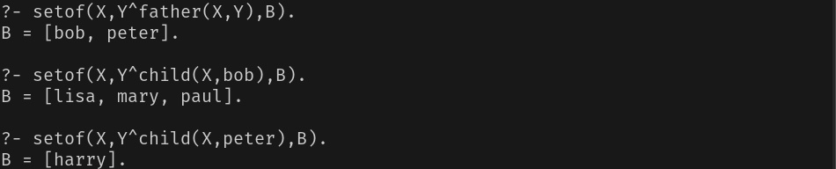

4. Wife

|  |
| --- |
| % wife (X wife of Y).  wife(X,Y):-  female(X),  husband(Y,X). |

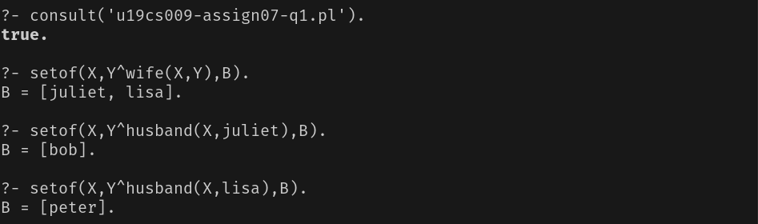

5. Son

|  |
| --- |
| % son (X son of Y).  son(X,Y):-  male(X),  child(X,Y). |

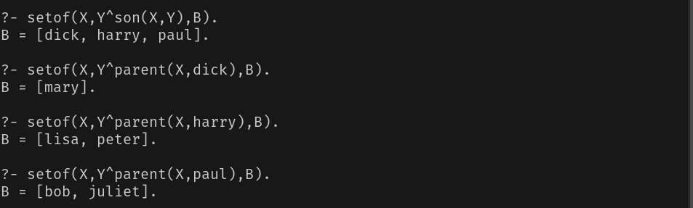

6. Daughter

|  |
| --- |
| % daughter (X daughter of Y).  daughter(X,Y):-  female(X),  child(X,Y). |

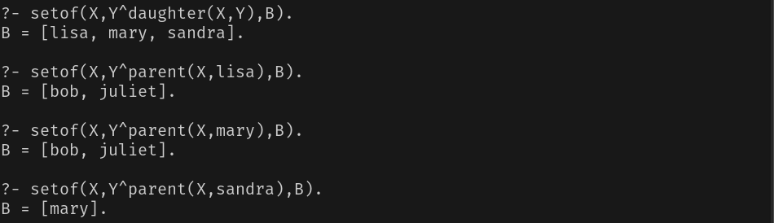

7. Brother

|  |
| --- |
| % brother (X brother of Y).  brother(X,Y):-  son(X,Z),  parent(Z,Y),  X\==Y. |

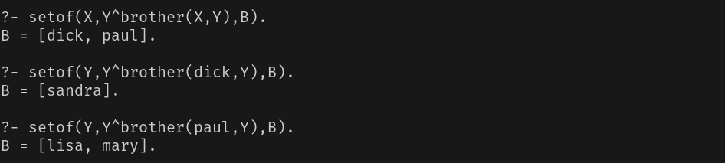

8. Sister

|  |
| --- |
| % sister (X sister of Y).  sister(X,Y):-  daughter(X,Z),  parent(Z,Y),  X\==Y. |

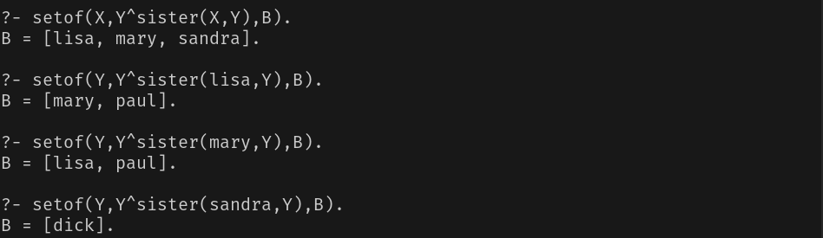

9. Uncle

|  |
| --- |
| % uncle (X uncle of Y).  uncle(X,Y):-  brother(X,Z),  child(Y,Z). |

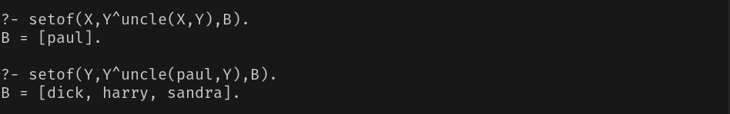

10. Aunt

|  |
| --- |
| % aunt (X aunt of Y).  aunt(X,Y):-  sister(X,Z),  child(Y,Z). |

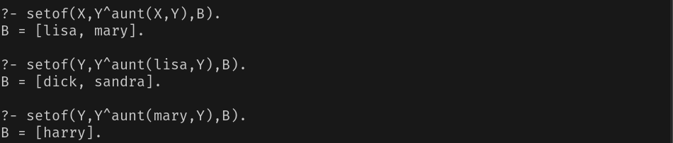

11. Nephew

|  |
| --- |
| % nephew (X nephew of Y).  nephew(X,Y):-  male(X),  uncle(Y,X);  male(X),  aunt(Y,X). |

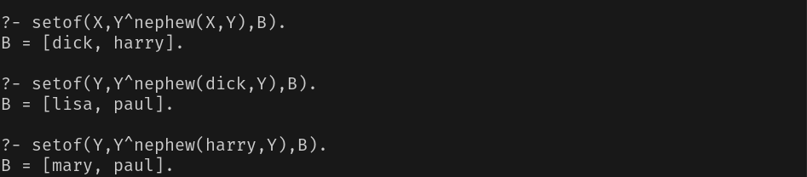

12. Niece

|  |
| --- |
| % niece (X niece of Y).  niece(X,Y):-  female(X),  uncle(Y,X);  female(X),  aunt(Y,X). |

