**Name: Brijesh Rameshbhai Rohit**

**Admission number: U19CS009**

**PPL-ASSIGNMENT-08**

1. Write a prolog program to implement a Menu Driven Calculator.

| %U19CS009  %BRIJESH ROHIT  add(A,B,Sum):-  Sum is A+B.  sub(A,B,Diffs):-  Diffs is A-B.  mul(A,B,Prod):-  Prod is A*B.  div(A,B,Quo):-  Quo is A/B.  start:-  write("Please enter first number : "),  read(A),  write("Please enter second number : "),  read(B),  write("Please enter\n"),  write("1 : Add two numbers\n"),  write("2 : Subtract two numbers\n"),  write("3 : Multiply two numbers\n"),  write("4 : Divide two numbers\n"),  write("Enter your choice: "),  read(C),  (C=:=1 ->  (add(A,B,Sum),  write("Addition : "),  write(Sum),nl)  ; C=:=2 ->  (sub(A,B,Diff),  write("Difference : "),  write(Diff),nl)  ; C=:=3 ->  (mul(A,B,Prod),  write("Product : "),  write(Prod),nl)  ; C=:=4 ->  (B=:=0 ->  write("Division not possible!!\n")  ; div(A,B,Quo),  write("Quotient : "),  write(Quo),nl))  ; C=:=5 ->  (  halt  )  ; start.  :-  start. |
| --- |

OUTPUT :

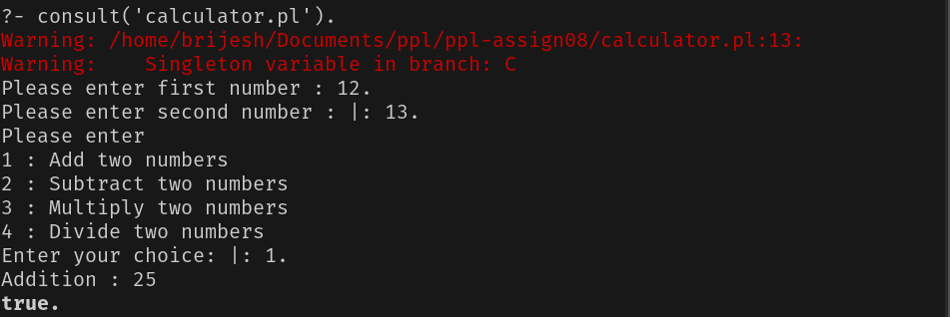

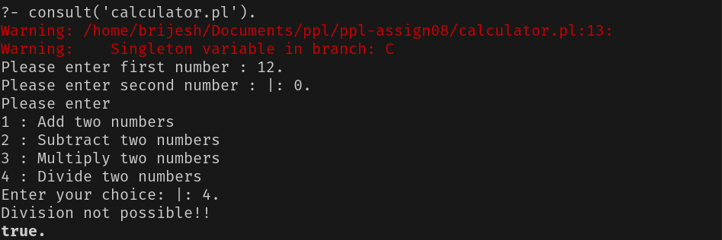

1. Write a prolog program to find maximum and minimum salaries of given 3 employees.

| %U19CS009  %BRIJESH ROHIT  max(A,B,C):-  A>B,  A>C,  write(A).  max(A,B,C):-  A>B,  write(C).  max(_,B,C):-  B>C,  write(B).  max(_,_,C):-  write(C).  min(A,B,C):-  A<B,  A<C,  write(A).  min(A,B,C):-  A<B,  write(C).  min(_,B,C):-  B<C,  write(B).  min(_,_,C):-  write(C).  maxmin(A,B,C):-  write("Max salary : "),  max(A,B,C),nl,  write("Min salary : "),  min(A,B,C).  :-  write("Please enter first employee's salary : "),  read(A),  write("Please enter second employee's salary : "),  read(B),  write("Please enter third employee's salary : "),  read(C),  maxmin(A,B,C). |
| --- |

OUTPUT :

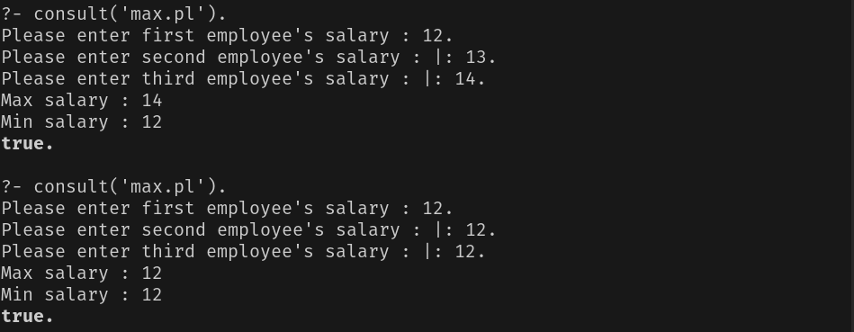

1. Write a prolog program to check whether a given number is odd or even.

| %U19CS009  %BRIJESH ROHIT  check_even(N):-  Y is N//2,Y*2=:=N  ->format('~w is even.~n',[N]);  format('~w is odd.~n',[N]).  :-  write('Please enter a number : '),  read(A),  check_even(A). |
| --- |

OUTPUT:

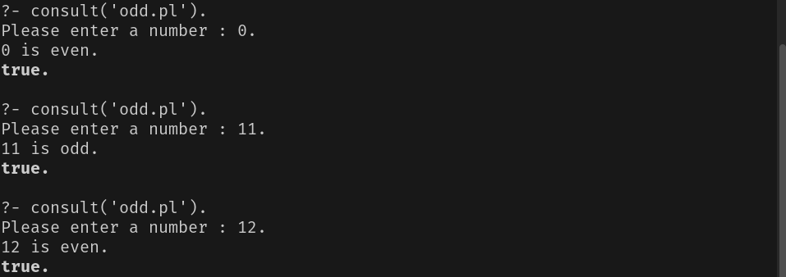

1. Write a prolog program to check whether a given year is a leap year or not.

| %U19CS009  %BRIJESH RHOIT  leap(Y):-  Y mod 400 =:= 0 , write("It is a Leap Year!!\n");  Y mod 100 =:= 0 , write("It is not a Leap Year!!\n");  Y mod 4 =:= 0 , write("It is a Leap Year!!\n");  write("It is not a Leap Year!!\n").  :-  write("Please enter a year : "),  read(Y),  leap(Y). |
| --- |

OUTPUT :

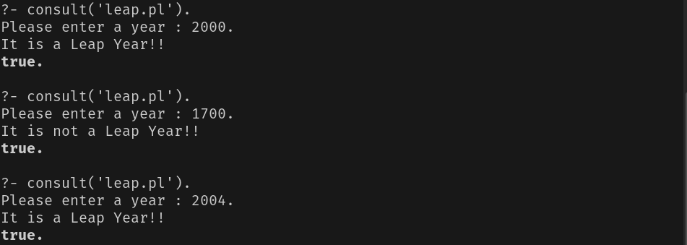

1. Write a prolog program to give grade to a student based on total marks given:

* 00 - 80 Grade A
* 60 - 79 Grade B
* 35 - 59 Grade C
* 1 - 35 Grade D

| %U19CS009  %BRIJESH ROHIT  check(P):-  P=<100,P>=80, write("A"),nl;  P<80,P>=60, write("B"),nl;  P<60,P>=35, write("C"),nl;  write("D"),nl.  :-  write("Please enter percentage : "),  read(P),  write("Your Grade : "),  check(P). |
| --- |

OUTPUT :

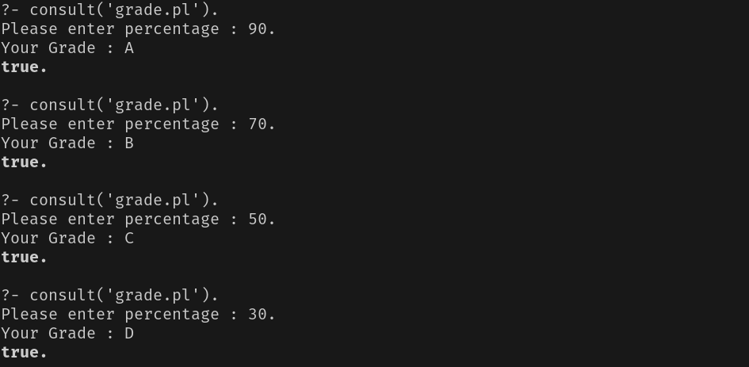

1. Write a prolog program to take values of length and breadth of a rectangle from the user and check if it is square or not.

| %U19CS009  %BRIJESH ROHIT  check(L,B):-  L=:=B  -> write("It is a square!!\n")  ; write("It is not a square!!\n").  :-  write("Enter Length : "),  read(L),  write("Enter Breadth : "),  read(B),  check(L,B). |
| --- |

OUTPUT :

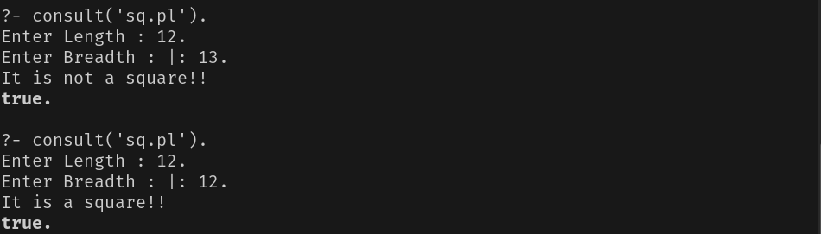

1. Write a PROLOG program to calculate the roots of quadratic equation. Consider all possibilities real, equal, imaginary.

| %U19CS009  %BRIJESH ROHIT  roots(A,B,C):-  (B*B-4*A*C) > 0 ->  write("Roots are REAL and UNIQUE!!\n"),  A1 is 2*A,  R1 is ((-B+sqrt(B*B-4*A*C))/(A1)),  R2 is ((-B-sqrt(B*B-4*A*C))/(A1)),  write("Roots : "), write(R1),write(", "),write(R2),nl  ; (B*B-4*A*C) =:= 0 ->  write("Roots are REAL and Equal!!"),nl,  R1 is -B/(2*A),  write("Roots : "), write(R1),write(", "),write(R1),nl  ; (B*B-4*A*C) < 0 ->  write("Roots are Imaginary!!"),nl,  A1 is 2*A,  D1 is (-1)*(B*B-4*A*C),  R1 is ((-B)/A1),  I1 is ((sqrt(D1)/A1)),  write("Roots : "), write(R1), write(" + "), write(I1),write("i and "),  write(R1), write(" - "), write(I1), write("i"),nl.  check(A):-  A=:=0 -> write("A can't be 0\n"),halt;  !.  :-  write("Please enter coefficients of equation 'ax^2 + bx + c':\n"),  write("Please enter value of a : "),  read(A),  check(A),  write("Please enter value of b : "),  read(B),  write("Please enter value of c : "),  read(C),  roots(A,B,C). |
| --- |

OUTPUT :

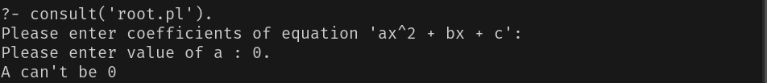

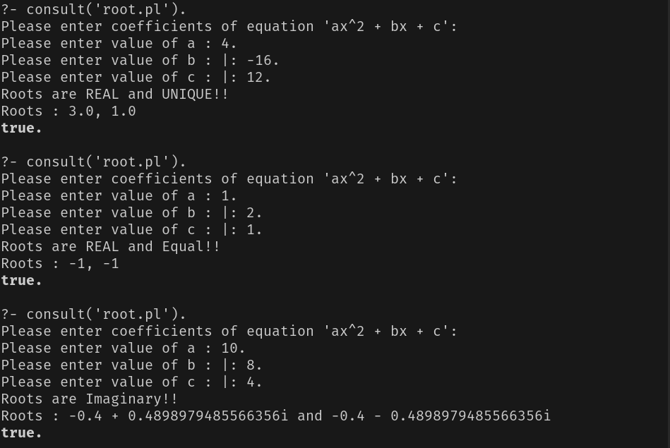

1. Write a PROLOG program to find the number whether the number is positive, negative or Zero.

| %U19CS009  %BRIJESH ROHIT  check(N):-  N=:=0 -> write("You entered 0.\n");  N>0 -> write("You entered Positive number.\n");  N<0 -> write("You entered Negative number.\n").  :-  write("Please enter a number : "),  read(N),  check(N). |
| --- |

OUTPUT :

